
Issue 106 September 2026

Warsop & District
Notes from the Chair

Hello everyone and welcome to September
Hopefully weather is a little cooler for you all. I know my 2 cats are enjoying the drop in temperature!
As you know this month is the AGM (so no speaker) which means I've managed to get through my second year as Chair relatively unscathed so thank you again for all your help and support during this time.
Don't forget that there will again be a Silent Auction at the meeting and proceeds will again be going to good causes so don't forget to bring your purses as there are some lovely items. Also there will be a quiz so don't forget your thinking heads.
See you all at the AGM

The deadline for including articles/information in the next newsletter is Friday 9th October
Send contributions to Chris Shervey. If you have any ideas for new items to include in the newsletter please let me know.

Rota for refreshments and greeting.
This is the rota for the next five months, any problems please contact me, Ann Ayodele.
Thank you to all those who have volunteered to help, without you our meetings would not be enjoyable.

Date | Refreshments 1 | Refreshments 2 | Meet and Greet 1 | Meet and Greet 2
21 Sept | Gillian Stevens | Patricia Ward | Glenys Fearn | Moira Heslop
19 Oct | Yvonne Pannifer | Janet Harford | Christine Wilson | Brenda Pearce
16 Nov | Beatrix Kirby | Lisa Foster | Ann Barnes | Ray White
21 Dec | Marie Louise Hall | Karen Breed | Pauline Wright | Sylvia Ellis

EVENTS
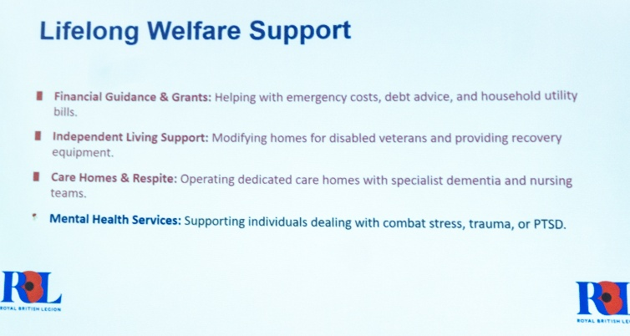
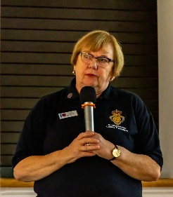
Speaker
Augusts speaker, Elaine Hopkins, gave us a very illuminating talk about the Royal British Legion.

Dates for your diary

Sunday Lunch
Sunday Lunch I had hoped to arrange another Sunday lunch for members by now but life has got in the way a little! Hopefully, I should be able to arrange something for late October. In the meantime, if anyone would like to suggest a venue please get in touch.

Last Night of the Proms Deposits have been paid to the Hostess for this event and I shall collect the balance of £25 each during our October meeting.

Christmas Lunch
Christmas Lunch Deposits for this event have also been paid and the balance of £18 each will be collected in November.

Theatre Group
Newark Palace Theatre presents the musical, "The Picture of Dorian Grey," featuring Kevin Kennedy, (Curly Watts), on Thursday 11th February 2027, 7.30pm. Let me know if you're interested. Thanks, Jen.

Unfortunately, I have been unable to carry out any u3a duties since the last meeting. I had a nasty accident after that meeting and badly damaged one of my eyes. I've had emergency surgery and have been visiting the
Eye Centre at Chesterfield Hospital twice a week since then. My carer, Bob, has been administering about 20 drops each day and we're both getting fed up of it! We're hoping to be able to reduce the drops soon, but I still
need quite a lot of treatment. Hopefully I shall have been able to get a few more things sorted out by October. Best wishes everyone, Jen.
The 521 Singers
Invite you to an evening of song and laughter
at St Tereas’s on Saturday 21st Nov at 6.30
( doors open at 6 0 clock)
Tickets £7
Snacks and drinks at the interval

If you would like a ticket , please see Chris Shervey.
Retford Lions. It's that time of year again when The Retford Lions are promoting their Last Night of the Proms Concert being held at The Well, Hospital Road, Retford DN22 7BD. Saturday September 26th.
Doors open 6pm for 7pm start. Cost £15. Bring your own drinks inc. alcohol if desired.
The Hatfield and Askern Colliery Brass Band are again starring along with favourite South Yorkshire based professional Bass Baritone singer Martin Lamb. We would love to see you on the night which promises to be an enjoyable and fun evening.
Tickets available at The Well Hospital Road, Retford also at
Edinburgh Woollen Mill Carolgate Retford.
If you wish you can pay direct into The Retford Lions account
Retford Lions Club-- Account No. 06808670 Sort code 60-17-28
Reference PromsWarsopU3A
Make a block booking under one name, that's ok and we will issue ticket numbers to you and then collect your tickets on the night.
Also available at wegottickets.com
We Retford Lions would love to see you for a night of enjoyment and fun. (flags supplied)
Our Kind Regards
Bob & Sue Crampton
Retford Lions members.

WELFARE

Get well and bereavement cards continue to be sent to members, I'm sure you all join me in sending our very best wishes. Please do remember to let me know of any members who are unwell or who have lost a loved one. Jen.

Items of Interest
Table Tennis Club- Warsop Health Hub-Mondays 1.30-3.30pm
If you would like to have a go at playing table tennis then please do join Pam Hick and Ian James at the Health Hub each Monday from 1.30-3.30pm. The cost is £4 per person. Bats and balls are provided.
Vibrant Warsop has supported this venture with the purchase of 2 brand new tables. Both Pam and Ian are also members of the U3a (Pam-Warsop & Ian- Forest Town)
You do not need to be a member of the Health Hub- just turn up

Helping Hands
This idea came from a member at the last main meeting as a way to help each other.
For example you may need help with your e.g. garden computer plumbing etc, if you put a request in through the newsletter then hopefully a member can help you out personally or give e.g. the name of a reliable plumber.
Help needed with gardening
Requests to number on front (Chris)
Cups Please will as many of you as
possible bring your own mug for your tea or coffee. This is not only more environmentally friendly but also would save us a lot of money as the paper disposable cups we use are surprisingly expensive. Ann.
Robin Hood Lottery 
Warsop and District U3A is a cause registered with the Robin Hood Lottery.
To buy a ticket you can now register on line at www.robinhoodlottery.co.uk and set up regular payments. If you buy a ticket every week for a year Warsop U3A will receive £26.
Remember the more members that have a go (specifying Warsop & District U3A) the more money we get for our funds.

Raffle.
The raffle made £48 in August. Thank you.
RAFFLE PRIZES NEEDED PLEASE
RAFFLE PRIZES NEEDED .

Books and Jigsaws 50p.
Please note the books are sorted into genres making it easier to find a book you like. The books and jigsaws made £4 in August

September quick quiz all the answers start with g
1 What does GMT stand for?
2 Name of a fairy tale Hansel and ----------?
3 The second largest airport in the UK ?
4 Name of a film The Madness of King ------?
5 Large lake in Italy?
6 A knight of the round table Sir ----- ?
7 An old British sitcom ---------- and Mildred ?
8 Hot water jetting up from holes in earths crust ?
9 Elizabethan theatre (rebuilt in recent times) ?
10 Famous Hollywood actor Cary ------?

September quiz can you name theses television personalities ?



ANSWERS TO LAST MONTHS QUIZ AT END OF NEWSLETTER.
GROUP NEWS
I shall be arranging a little get together of our group leaders in October, probably for coffee and cake at the Cosi Tea Room, in order to thank them for everything they do for our members. Watch this space! Members, don't forget to check what's available, in Warsop or at other, neighbouring u3as.
Please take a look at the folders detailing all the interest groups currently available, there may be something to suit you.
If not, take a look in the North Notts Neighbourhood Network folder which shows all the groups running at neighbouring u3a branches. You are eligible to join any of those groups, providing they are not over subscribed.

COULD ALL GROUP LEADERS PLEASE COLLECT THEIR GROUP LEADERS BADGES WHEN THEY COLLECT THEIR MEMBERSHIP BADGE AND LANYARD. THEN MEMBERS CAN SEE WHO TO SPEAK TO ABOUT A GROUP.( PUT A FACE TO A NAME)
THANK YOU

North Notts Neighbourhood group
The NNNG means that you as a member of Warsop & District can ask to join an interest group in another U3A that is also in the NNNG, as long as the group is not oversubscribed at the time of your request you can join the group without joining the host u3a
The u3as in the NNNG are Mansfield, Sherwood, Dukeries, Rainworth, Forest Town, Ashfield, Sutton in Ashfield, Hucknall, Worksop, Warsop, Retford and Bolsover.

 Strollers
23rd September 2026 -CRESSWELL CRAGS Meet at 10.00 am at the Carrs car park for car share .
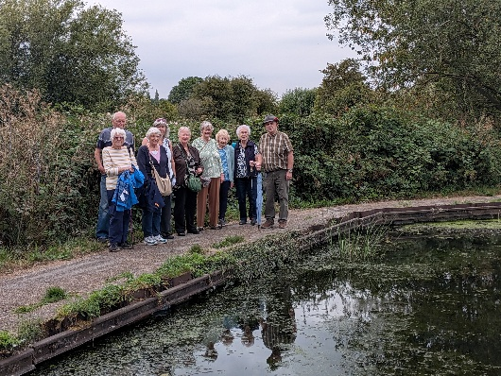
Future walks

September. Creswell Crags
October. Vicar Water
November. Thoresby Country Park
December. No walk

Worksop Canal


Tai Chi Tigers

The Tai Chi group meet every Friday for an hour, 10.30 - 11.30am at St Theresa’s Church hall in Warsop at a cost of £6.
It is for U3A members only.
Tai Chi is a low impact exercise which improves balance, flexibility and co ordination so reduces the likelihood of falls. Mindfulness makes you more aware of your stance and posture and more able to relax, relieving stress.
Come along and have a go, we always have room for new members.
Anne.

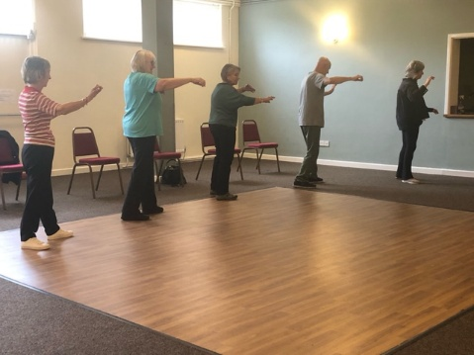
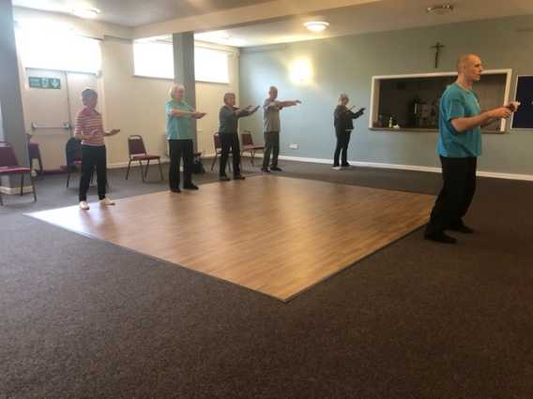

The Social Group

The Social Group met on Friday, 4th September for a trip to Bawtry. We looked round some very nice shops, rather expensive, but nice to browse around and light refreshments were taken at a small friendly cafe, It was a very pleasant afternoon spent with good company. Our next meeting will be back at the Plough on Friday, 2nd October at 1.30 p.m. Further update at the main U3a Meeting. A couple of our photos from our trip to Bawtry.
Betty


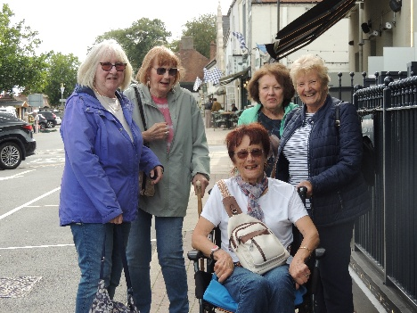
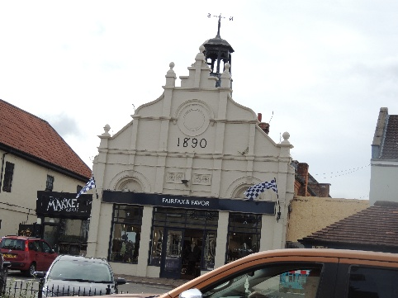

Photography Group
Last months ‘Themed’ challenge was ‘Make um Smile’, set by Joanne.
Joanne Wheatley
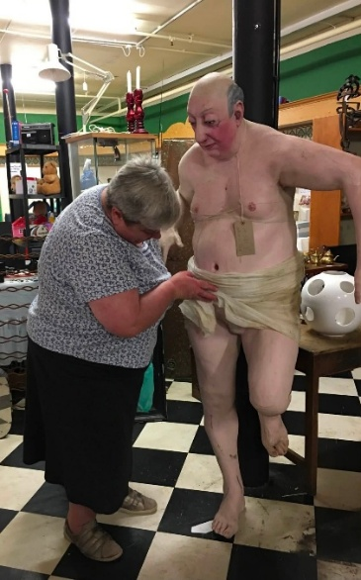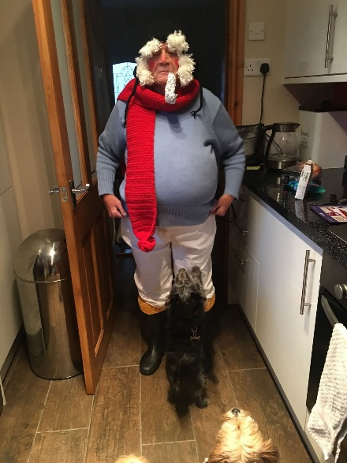
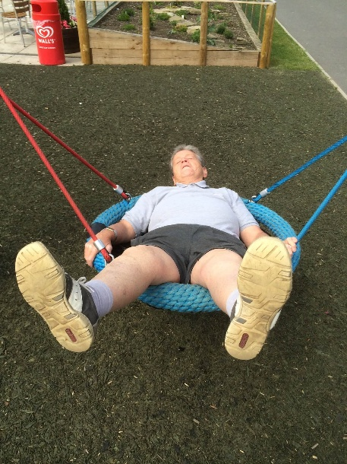
Joyce O’Neil

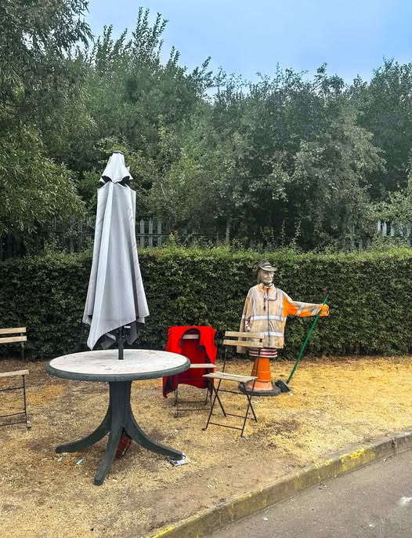
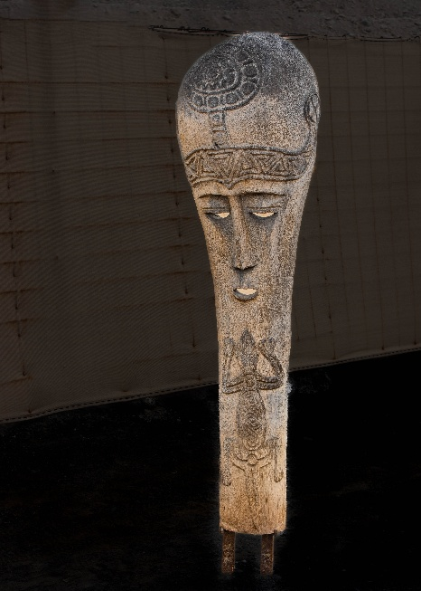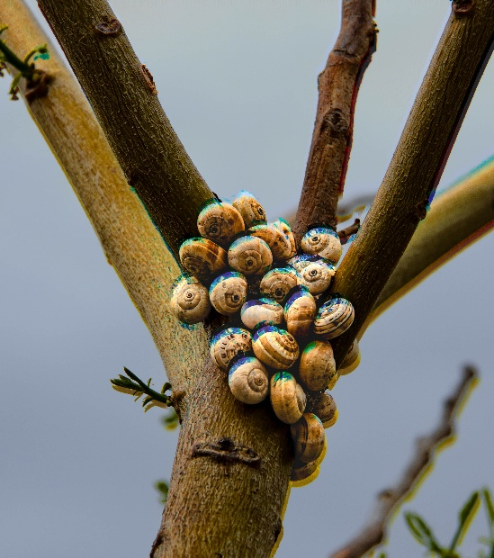
Ken & Mandy Moore

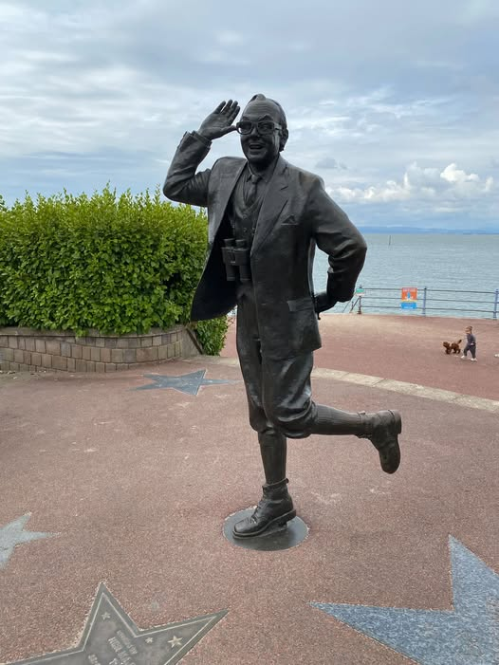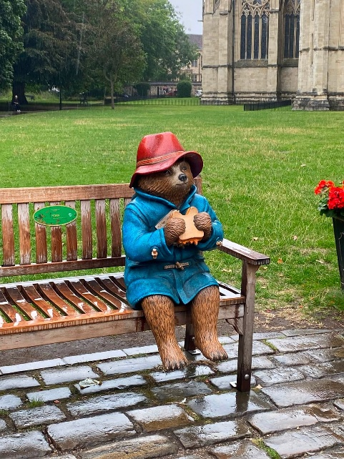

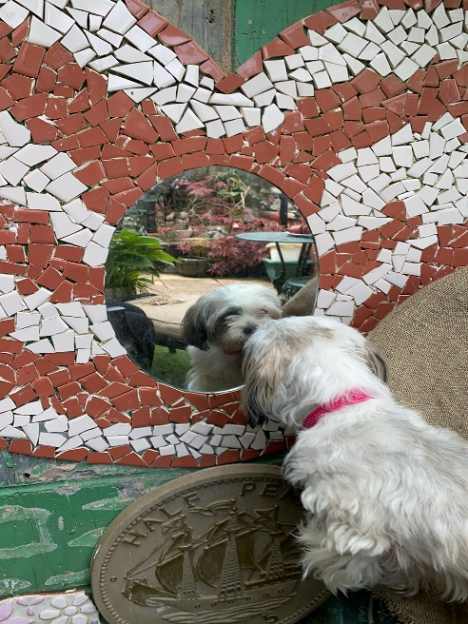

Bob Thomson
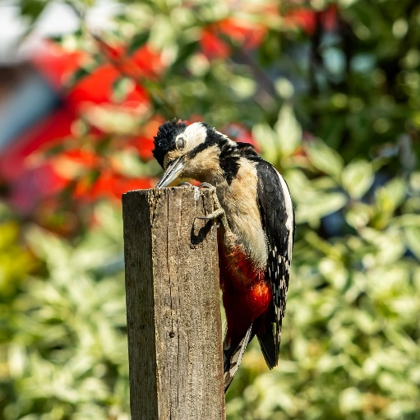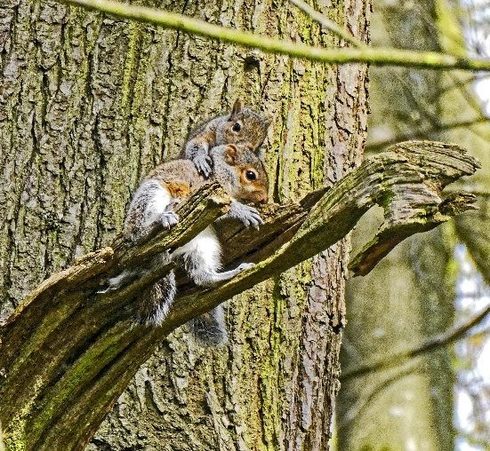
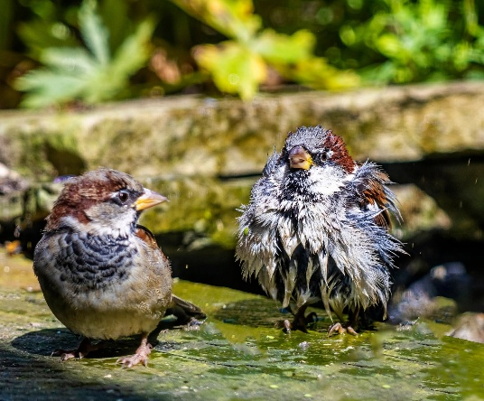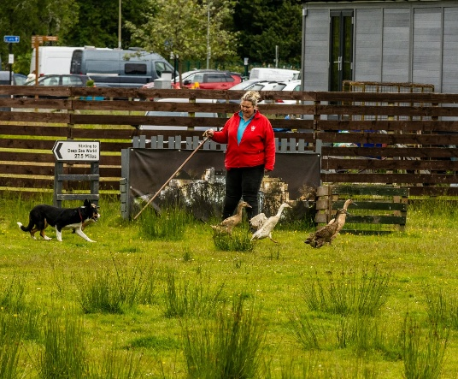

The next ‘Themed’ challenge is ‘SKY- night/ day/ or anything in it that’s different.’
This challenge was set by Ken & Mandy Moore.
Once again this challenge is open to ALL u3a members.


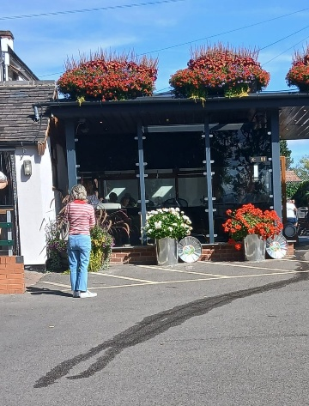
 Garden Group
In September 10 of us went to Reuben Shaw’s garden centre at Moor Green, Nottingham. It was a nice day out, the weather was good and a pleasant garden centre with a good tea room.
October’s visit will be to Cherry Lane garden centre at Retford on the 13th October.

The garden group meets on the second Tuesday of the month at 10am at the Warsop Mill Dam car park and we car share from there.

This year's programme is below.
October 13th... Cherry Lane, Retford
November 10th... Glapwell Garden centre
December 8th... Blue Diamond Garden Centre, East Bridgford.
🌺Anne.


Natural History, Science and Technology.
This month we had a quiz ----- How much do you know about Natural History Science and Technology ? It turned out the group know quite a lot. The first round was 40 questions on NHST, then a cup of tea and a biscuit followed by rounds two and three. Round two was matching inventors with their invention and round three was recognising signs e.g. hot surface. The winner was Ann Ballinger who won this trophy.

2026 | Activity
OCTOBER | Neanderthals
NOVEMBER | Touch
DECEMBER | No meeting
2027
JANUARY | Metamorphic, Igneous or Sedimentary?
FEBRUARY | The Giants of Sherwood


Walking Group


﻿For our August walk we headed slightly over the border into Derbyshire. The walk started from Bolsover Castle from here we went along the footpath before turning into tracks and fields and headed towards Palterton. Stunning scenery along the way due to being so high up and looked across to Sutton Scarsdale and beyond. On arriving in Palterton we were greeted by scarecrows. What an amazing display the village had produced. We then headed back towards Bolsover and finished with a drink and natter just before the rain came down, hence we stayed till it had eased.
Thanks to Sonja for a very enjoyable walk . Brenda

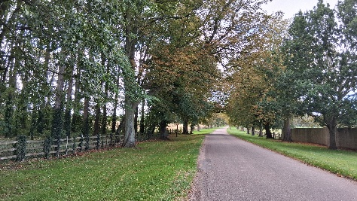
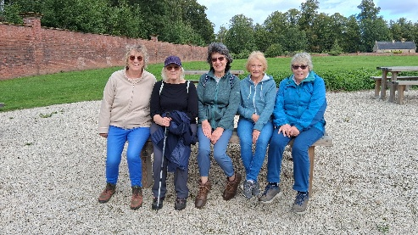

Our next walks
15th October. Brenda Pearce. Boughton Brake
19th November. Jen Long. Vicar Water/Sherwood Pines Brenda

Craft Group
This month the group tried their hand at a Florentine Stitching bookmark. Once they had chosen a pattern and done the tricky first line it was plain sailing. Unfortunately we ran out of time, so they took them home to finish. Here is the stitching they did.

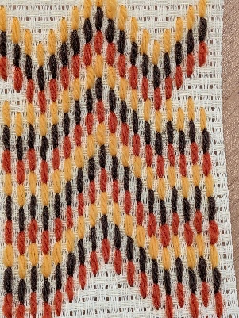
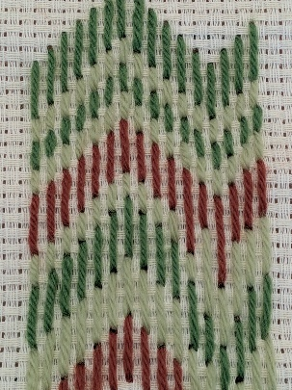
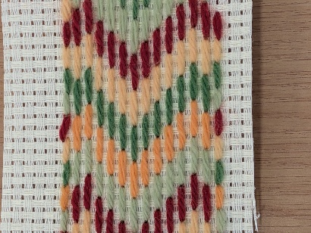

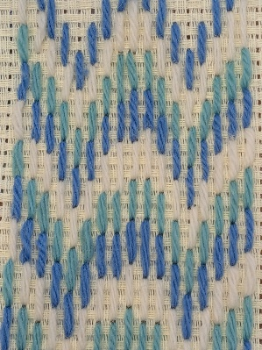
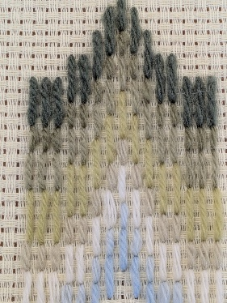
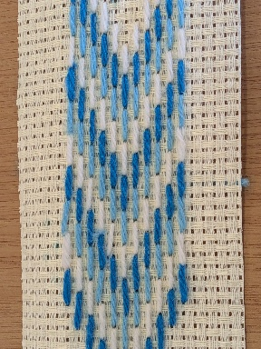

If you would like to join us the only thing you need to bring is a basic sewing kit and a willingness to have a go at anything. All materials are available for a very small donation to the person who brings them, if anything more specialised is required you will be given the opportunity to purchase any item needed yourself, or you can borrow from other group members.

5th October – Cards
2nd November – Christmas Decorations
7th December – Christmas Crafts (to sell at Christmas Party)

Zena.


History Group

Our August meeting was well attended. Chris Weir gave an interesting and informative talk about how local brass bands developed from the musicians in church galleries.
On Tuesday 15th September the group visited Gainsborough Old Hall -------- details of visit in next months newsletter.

2026 - Proposed Calendar of Events for Warsop & District U3A History Group -
Date | Talk/Visit | Venue
20th Oct 2026 | The Tower of London  Chris Shervey | St Theresa’s Church Hall 10am
17th Nov 2026 | Women Win the War – WW1  Grant Cullen | St Theresa’s Church Hall 10am
 | No meeting as very close to Christmas

Speakers for the main meetings
2026

September Annual General Meeting

October All Things Ghostly and Mysterious Joanna Cowell

November My China Bike Ride Jenny Long

December Christmas Party
2027
January Terry Wogan’s Hairweave and other stories Graham Keal

February An on call firefighter and their work within the community. Carl Evans

March Social Time. (Easter Monday)

April ‘The Potty Plotters’ Elaine & Julia (can be found on radio Derby)

Group | Leaders Name | Tel
NATURAL HISTORY SCIENCE AND TECHNOLOGY | Chris Shervey
WALKING GROUP | Brenda Pearce  Pam Hick
STROLLERS | Janet Harford  Pat Magness
HISTORY GROUP | Barbara Spybey
CRAFTS | Zena Inger
GARDENING | Anne Poultney
PHOTOGRAPHY | Rob Thomson
FRIENDSHIP GROUP | Betty Trinder
TAI CHI | Anne Poultney

INTEREST GROUP TIMETABLE
 | MONDAY | TUESDAY | WEDNESDAY | THURSDAY | FRIDAY
1st | 10am – 12pm  CRAFTS GROUP  St Teresa’s Catholic Church hall. Warsop |  |  |  | 2pm  FRIENDSHIP GROUP  The Plough Warsop
2nd |  | 10am  GARDENING GROUP  Venue agreed by members |  | 2 – 3.30  NATURAL HISTORY  SCIENCE AND  TECHNOLOGY  St Teresa’s Catholic Church Hall Warsop
3rd | MAIN MEETING 10.15  Oaklands Centre  Warsop | 10am– 12pm  HISTORY GROUP  St Teresa’sCatholic Church hall. Warsop |  | 10am  WALKING GROUP  Carrs Car Park | 11.am  PHOTOGRAPHY  Venue to be agreed by the members.
4th |  |  | 10.am  STROLLERS  Carrs Car Park
PHOTOGRAPHY GROUP-Please see Newsletter for the online challenge.
TAI CHI Every Friday 10.30am St Teresa’s Catholic Church hall

Committee Members | Role
Lynne Hutchinson | Chairperson
Mel Mitchell | Deputy Chairperson
Irene Clay | Business Secretary
Linda Crossley | Treasurer
Zena Inger | Membership Secretary
Jim Shervey | Speaker Seeker
Jennifer Thomson | Groups co-ordinator
Chris Shervey | Newsletter editor
Ann Ayodele | Social Events
Jennifer Thomson | Welfare Officer
Rob Thomson | Website & Facebook manager
Ann Ayodele | Refreshments rota
Betty Trinder | Social events assistant

Warsop & District U3A is committed to treating all people equally. Anyone wishing to see the Privacy and Data Protection policies may view them on the Warsop.u3asite.uk alternatively please ask Rob.

Website & Facebook
The Warsop & District u3a website can be found at Warsop.u3asite.uk . If any of the group leaders/facilitators would like to advertise/ promote any of their future activities or change the information shown, please contact Bob Thomson

Facebook
Warsop & District U3A has a Facebook Group. It is a private group which can be seen by the public but only members can see who’s in the group and what they post.
What this means is that you have to be invited to join the group or have your request to join accepted. Also you need to be on Facebook which some of you may not be. As a member of the group you will be able to put your own posts on the page, please keep them relevant to the U3A and what it stands for. We would ask that you don't put anything on that is in anyway party political or anything that may be offensive to others who may be of a different creed or religion. Hopefully everyone will join, use the page and find it useful.
One of the things that puts people ‘off’ Facebook, is the ‘bad press’ some of the Social sites get. You can join Facebook, choose only to join the Warsop Facebook page and not be involved in any other site, or Friends requests (usually from people that you have never heard of!) The choice is entirely yours.
To request to join the Warsop u3a Facebook page, contact Bob Thomson.

Answers August quick quiz all answers start with f
1 In which country are Nokia phones made? FINLAND
2 Famous French Chateau near Paris? FONTAINEBLEAU
3 Capital city of Sierra Leone? FREETOWN
4 Type of UK deer? FALLOW
5 Famous Russian goldsmith? FABERGE
6 An Epee is used in which sport? FENCING
7 If A = Alpha B= Bravo F =? FOXTROT
8 British Islands off the coast of S America? FALKLAND ISLANDS
9 A long narrow sea inlet? FJORD
10 A breed of black and white diary cattle? FRESIAN

Answers August quiz can you unscramble these English counties?
- VOEND Devon
- SREOKRHYI Yorkshire
- EDHRONMBLNAUR Northumberland
- USSXES Sussex
- ICARENASLH Lancashire
- RUYSER Surrey
- KFOLONR Norfolk
- ACRLWLNO Cornwall
- TOESDR Dorset
- PHREHMISA Hampshire
- MSTRSOEE Somerset
- SEXSE Essex
- RAUMCIB Cumbria
- GSERMCDBAIIRHE Cambridgeshire
- GHMSNOREIHTITN Nottinghamshire
- NTLURAD Rutland

