
Issue 105 August 2026

Warsop & District
SILENT AUCTION please bring any items for the auction on Monday. All proceeds to local charities. Thank You
Notes from the Chair

Well here we are in August already! And still enjoying the sunshine hopefully.
As you know September brings our AGM and I'd like to encourage as many meetings as possible to come along.
The AGM isn't just about formalities and reports it's your chance to hear what we've achieved over the past year and to have your say to help shape the future of Warsop U3A.
Just a gentle reminder that committee nominations need to be submitted prior to the AGM and if any of you are thinking "I could help with that" then this is your opportunity to give this some thought.
Also don't forget there will be a Silent Auction after the main meeting.
Look forward to seeing you there.

Lynne x

PLEASE NOTE that the AGM is planned for the 21st September. New committee members always welcome. Information and nomination forms are at the end of the newsletter. Agenda and minutes of last years agm are also at the end of the newsletter.

The deadline for including articles/information in the next newsletter is Friday11th September
Send contributions to Chris Shervey. If you have any ideas for new items to include in the newsletter please let me know.

Rota for refreshments and greeting.
This is the rota for the next five months, any problems please contact me, Ann Ayodele.
Thank you to all those who have volunteered to help, without you our meetings would not be enjoyable.

Date | Refreshments 1 | Refreshments 2 | Meet and Greet 1 | Meet and Greet 2
17 Aug | Irene Smith | Tina Saunders | Kathleen Coe | Ann Ballinger
21 Sept | Gillian Stevens | Patricia Ward | Glenys Fearn | Moira Heslop
19 Oct | Yvonne Pannifer | Janet Harford | Christine Wilson | Brenda Pearce
16 Nov | Beatrix Kirby | Lisa Foster | Ann Barnes | Ray White
21 Dec | Marie Louise Hall | Karen Breed | Pauline Wright | Sylvia Ellis

EVENTS

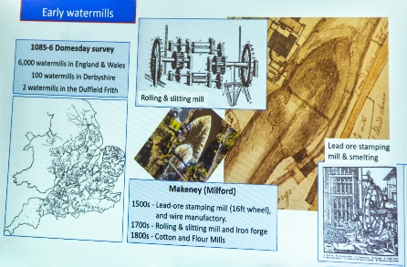
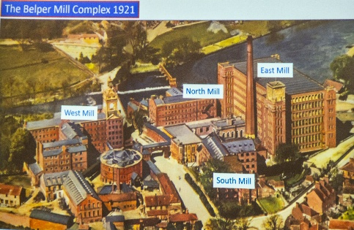
Speaker
Last month Ian Morgan gave us a very informative talk about how Belper Mills developed using the waterpower of the river Derwent.
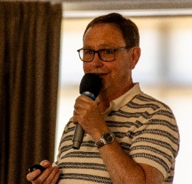

Our speaker for August is Elaine Hopkins, she is going to talk to us about the British Legion

Sunday Lunch
Sunday Lunch I had hoped to arrange another Sunday lunch for members by now but life has got in the way a little! Hopefully, I should be able to arrange something for late October. In the meantime, if anyone would like to suggest a venue please get in touch.

Last Night of the Proms Deposits have been paid to the Hostess for this event and I shall collect the balance of £25 each during our October meeting.

Hamza Yassin, "My Life Behind the Lens." Friday 12th February 2027, 7.30 pm at The Winding Wheel, Chesterfield. A few members of the Photography Group are going to see Hamza, the wildlife photographer, broadcaster and Strictly winner, next February. Seats cost £36.50 and are selling out very quickly. If anyone would like to come I shall need to collect the full payment during our August meeting.

Christmas Lunch
Christmas Lunch Deposits for this event have also been paid and the balance of £18 each will be collected in November.

Theatre Group
Newark Palace Theatre presents the musical, "The Picture of Dorian Grey," featuring Kevin Kennedy, (Curly Watts), on Thursday 11th February 2027, 7.30pm. Let me know if you're interested. Thanks, Jen.

Dates for your diary
Papplewick Pumping Station Classic Motor Cycles and Steam Event, Sunday 30th - Monday 31st August from 10am. Includes live music, food from Spud World, Lincoln Green Brewery Admission £14.00, this includes annual pass. Attend once and attend all future events free for one year. Pre book with the pumping station.

Worksop u3a Swing Band will be playing during afternoon tea at Warsop Parish Centre on September 19th, 2.00pm until 4.30pm. Tickets cost £10 and may be booked through the Parish Centre.

Retford Lions. It's that time of year again when The Retford Lions are promoting their Last Night of the Proms Concert being held at The Well, Hospital Road, Retford DN22 7BD. Saturday September 26th.
Doors open 6pm for 7pm start. Cost £15. Bring your own drinks inc. alcohol if desired.
The Hatfield and Askern Colliery Brass Band are again starring along with favourite South Yorkshire based professional Bass Baritone singer Martin Lamb. We would love to see you on the night which promises to be an enjoyable and fun evening.
Tickets available at The Well Hospital Road, Retford also at
Edinburgh Woollen Mill Carolgate Retford.
If you wish you can pay direct into The Retford Lions account
Retford Lions Club-- Account No. 06808670 Sort code 60-17-28
Reference PromsWarsopU3A
Make a block booking under one name, that's ok and we will issue ticket numbers to you and then collect your tickets on the night.
Also available at wegottickets.com
We Retford Lions would love to see you for a night of enjoyment and fun. (flags supplied)
Our Kind Regards
Bob & Sue Crampton
Retford Lions members.
Items of Interest
Items for Ukraine
Having just received the latest national newsletter for the U3A I was interested in the article that Botley Hedge End U3A posted regarding their Knit and natter group. They have been busy knitting squares for blankets and making knitted bunnies for Easter to send to the Ukraine. I have now located a local group that collects items ‘Retford helps Ukraine’ they are based at The Well, Retford Baptist Church, Hospital Road, Retford. They are collecting various items (clothing, bedding, over the counter medicines etc) but if anyone would like to knit or crochet 6” or 12” squares to make blankets just let me know. Brenda

July Lunch Cosy Café. Thank you to Brenda and Chris for arranging this. As usual good food and good company. Looking forward to the next one.


Table Tennis Club- Warsop Health Hub-Mondays 1.30-3.30pm
If you would like to have a go at playing table tennis then please do join Pam Hick and Ian James at the Health Hub each Monday from 1.30-3.30pm. The cost is £4 per person. Bats and balls are provided.
Vibrant Warsop has supported this venture with the purchase of 2 brand new tables. Both Pam and Ian are also members of the U3a (Pam-Warsop & Ian- Forest Town)
You do not need to be a member of the Health Hub- just turn up


WELFARE

Get well and bereavement cards continue to be sent to members, I'm sure you all join me in sending our very best wishes. Please do remember to let me know of any members who are unwell or who have lost a loved one. Jen.
Cups Please will as many of you as
possible bring your own mug for your tea or coffee. This is not only more environmentally friendly but also would save us a lot of money as the paper disposable cups we use are surprisingly expensive. Ann.
Robin Hood Lottery 
Warsop and District U3A is a cause registered with the Robin Hood Lottery.
To buy a ticket you can now register on line at www.robinhoodlottery.co.uk and set up regular payments. If you buy a ticket every week for a year Warsop U3A will receive £26.
Remember the more members that have a go (specifying Warsop & District U3A) the more money we get for our funds.

Raffle.
The raffle made £25 in July. Thank you.
RAFFLE PRIZES NEEDED PLEASE
RAFFLE PRIZES NEEDED .

Books and Jigsaws 50p.
Please note the books are sorted into genres making it easier to find a book you like. The books and jigsaws made £5 in July

Helping Hands
This idea came from a member at the last main meeting as a way to help each other.
For example you may need help with your e.g. garden computer plumbing etc, if you put a request in through the newsletter then hopefully a member can help you out personally or give e.g. the name of a reliable plumber. Requests to number on front (Chris)
Help needed with gardening

August quick quiz all answers start with f
1 In which country are Nokia phones made?
2 Famous French Chateau near Paris?
3 Capital city of Sierra Leone?
4 Type of UK deer?
5 Famous Russian goldsmith?
6 An Epee is used in which sport?
7 If A = Alpha B= Bravo F =?
8 British Islands off the coast of S America?
9 A long narrow sea inlet?
10 A breed of black and white diary cattle?
August quiz can you unscramble these English counties?
- VOEND
- SREOKRHYI
- EDHRONMBLNAUR
- USSXES
- ICARENASLH
- RUYSER
- KFOLONR
- ACRLWLNO
- TOESDR
- PHREHMISA
- MSTRSOEE
- SEXSE
- RAUMCIB
- GSERMCDBAIIRHE
- GHMSNOREIHTITN
- NTLURAD

ANSWERS TO LAST MONTHS QUIZ AT END OF NEWSLETTER.
GROUP NEWS
I shall be arranging a little get together of our group leaders in October, probably for coffee and cake at the Cosi Tea Room, in order to thank them for everything they do for our members. Watch this space! Members, don't forget to check what's available, in Warsop or at other, neighbouring u3as.
Please take a look at the folders detailing all the interest groups currently available, there may be something to suit you.
If not, take a look in the North Notts Neighbourhood Network folder which shows all the groups running at neighbouring u3a branches. You are eligible to join any of those groups, providing they are not over subscribed.

COULD ALL GROUP LEADERS PLEASE COLLECT THEIR GROUP LEADERS BADGES WHEN THEY COLLECT THEIR MEMBERSHIP BADGE AND LANYARD. THEN MEMBERS CAN SEE WHO TO SPEAK TO ABOUT A GROUP.( PUT A FACE TO A NAME)
THANK YOU

INTEREST GROUPS INFORMATION
North Notts Neighbourhood group
The NNNG means that you as a member of Warsop & District can ask to join an interest group in another U3A that is also in the NNNG, as long as the group is not oversubscribed at the time of your request you can join the group without joining the host u3a
The u3as in the NNNG are Mansfield, Sherwood, Dukeries, Rainworth, Forest Town, Ashfield, Sutton in Ashfield, Hucknall, Worksop, Warsop, Retford and Bolsover.

 Strollers
Our July walk was in Sherwood Pines. Although again it was a very warm day, the trees provided very welcome shade and our group of 8 enjoyed a very pleasant amble through the forest followed by drinks, cakes and a chat.

26th August 2026 - Worksop Canal Meet at 10.00 am at the Carrs car park for car share to Worksop

Future walks
August. Worksop Canal
September. Creswell Crags
October. Vicar Water
November. Thoresby Country Park
December. No walk

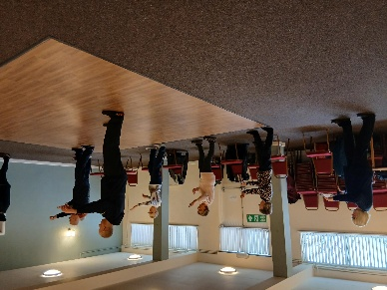

Tai Chi Tigers

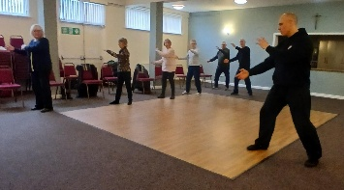
NO Classes on August 21st and August 28th.

The Tai Chi group meets at St Theresa's Church Hall in Warsop, usually every Friday from 10.30am to 11.30 at a cost of £6. Members of the U3A only.

The exercises are helpful in improving balance and preventing falls. It helps with flexibility, co-ordination and fitness. Although the movements are slow and low impact they do have an effect on the way we move, stand and breathe.
Stress relief and relaxation mean that you will feel better after the class and more energised, always room for new members, come along and try it. We do have a laugh as well and don't take ourselves too seriously.
Anne.

The Social Group
The Social Group will have had their August meeting by the time this goes to print. It will be decided at this meeting whether the proposed trip to Bawtry is possible for our September meeting on Friday the 4th. If anyone is interested in this trip to Bawtry just to have a look round the shops and have a cup of tea or coffee and a cake please do let me know at the next U3a main meeting. We would meet at The Carrs at 1.30 p.m. to car share. If anyone is interested in going and is willing to drive this would be much appreciated as we are a bit short on drivers at the moment. I will update at the U3a meeting when I know what response we get and if we have sufficient cars to make this possible. Betty

Photography Group
This months ‘Themed’ online challenge was ‘ New & Old’ set by Joyce.
Joyce O’neil
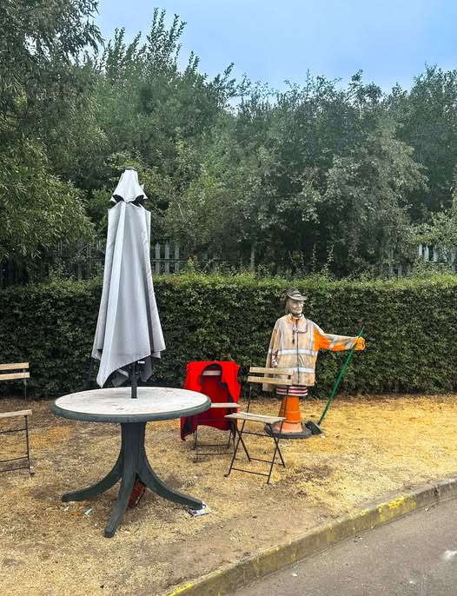
Joanne Wheatley
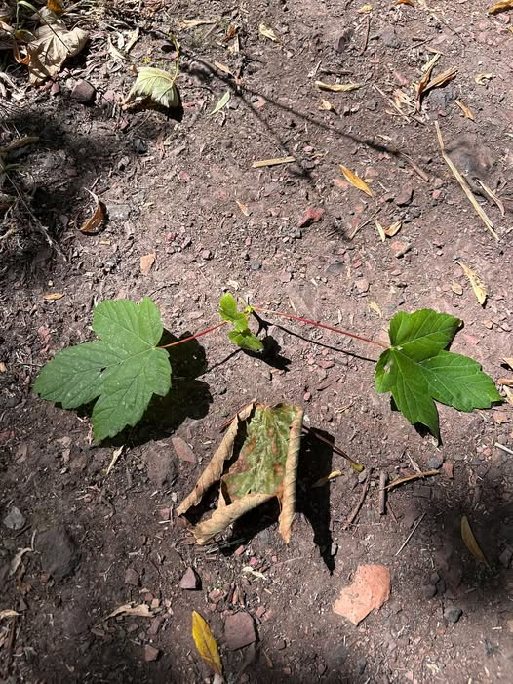
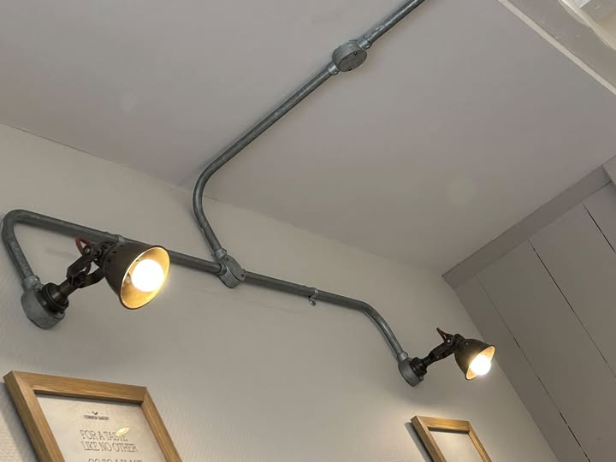
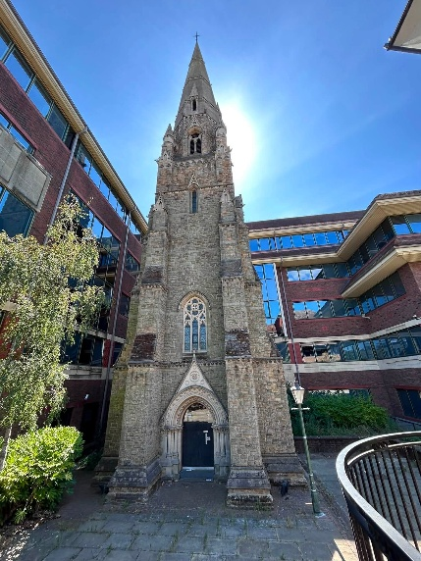
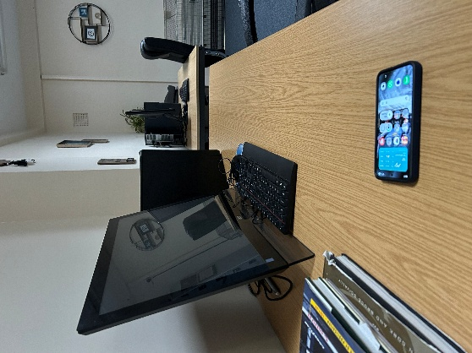
Ken & Mandy Moore
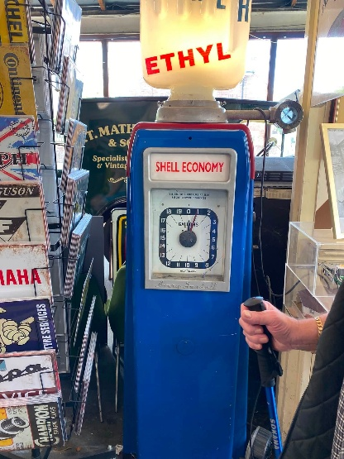
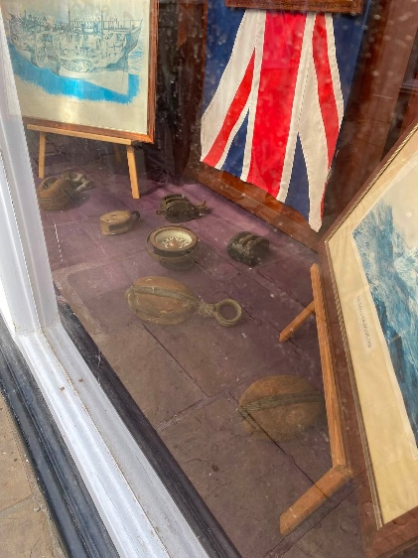

Bob Thomson
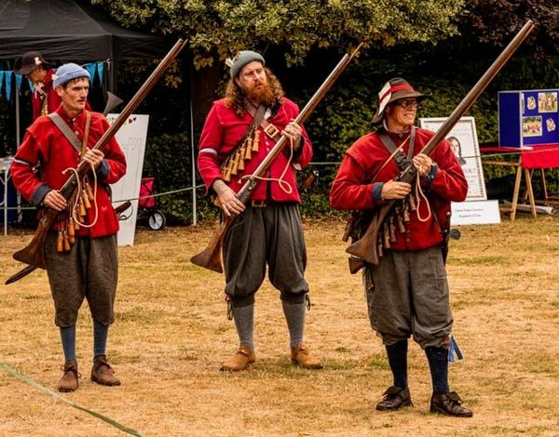
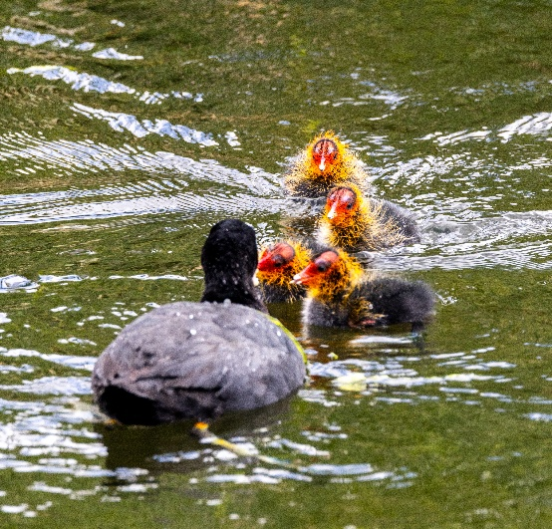
The next ‘Themed’ challenge is ‘Make em smile / laugh’. Set by Joanne.

 Garden Group
The garden group meets on the second Tuesday of the month at 10am at the Warsop Mill Dam car park and we car share from there.

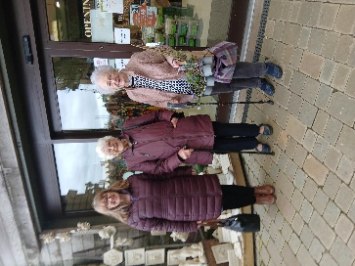
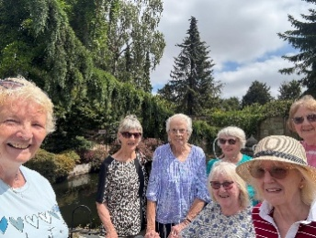
In July several members of the group went to Walkers garden centre with landscape walk and had a most enjoyable day. It's a very large garden centre with 2 restaurants and the landscape walk looks spectacular from the photos.
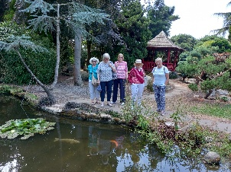
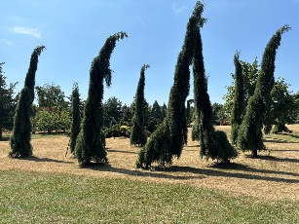

On September 8th we shall be going to Reuben Shaw at Moorgreen , Nottingham.

This year's programme is below.
September 8th... Reuben Shaw and sons, Moorgreen
October 13th... Cherry Lane, Retford
November 10th... Glapwell Garden centre
December 8th... Blue Diamond Garden Centre, East Bridgford.
🌺Anne.


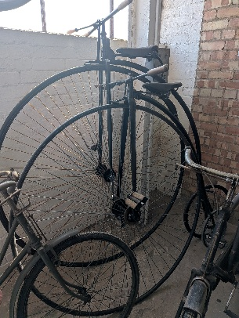
Natural History, Science and Technology.

On a very hot Friday (thank goodness it was cool inside) we had an enjoyable trip to Clipstone Headstocks. We started in the Raleigh bike museum where they have bikes from Penny Farthings to Choppers. We then went in the Raleigh car museum (I didn’t know Raleigh used to make cars).

We then moved onto the WWI section, during WWI Clipstone was the largest army training camp in England- 30,000 soldiers there at any one time. I was particularly interested in the items that have been dug up on the camp site over the years----- buttons cap badges tin mugs pipes and all sorts off other things.
Next was the WWII section, the museum houses a large number of military vehicles.


Then we went into the old colliery workings, very dark and atmospheric. The winding room upstairs is vast (they hold concerts in there) it houses the 2 wheels that lifted the coal and took the miners up and down. Originally they worked by steam and later by electricity.
To stand under the Headstocks and look up you realise how tall they are (according to our guide the tallest in the world) and impressive.
We agreed that the hour long tour was not really long enough to take everything in.

2026 | Activity
SEPTEMBER | How much do you know about NHS+T?
OCTOBER | Neanderthals
NOVEMBER | Touch
DECEMBER | No meeting
2027
JANUARY | Metamorphic, Igneous or Sedimentary?
FEBRUARY | The Giants of Sherwood


Walking Group

﻿Once again we started one of our walks from Welbeck Garden Centre. Originally we were going to do Belph Brook a six mile walk but due to the weather forecast predicted as being in the high twenties it was decided the alternative South Tunnel walk would be a better option. Although a linear walk it offered different views from each direction walked. A pleasant way to spend a morning and of course we had a drink and natter in the courtyard when we had completed the walk.

Not many months left on this year’s programme so it will soon be time to put together our program for next year. Any ideas, suggestions, and offers to be walk leader are always welcome.

Our next walks
20th August - Bolsover. Note a change to the original programme
17th September. Val Buckinger. Pleasley Trail
15th October. Brenda Pearce. Boughton Brake
19th November. Jen Long. Vicar Water/Sherwood Pines Brenda

Craft Group

The group had a lovely morning putting the world to rights on Monday 3rd August, as there was only 6 of us and nothing had been planned due to unforeseen circumstances we decided to just have a drink, natter and of course biscuits thanks to Gill.

Next month the group is undertaking Florentine Embroidery with the help of Chris Shervey. Unfortunately I wont be able to attend.

If you would like to join us the only thing you need to bring is a basic sewing kit and a willingness to have a go at anything. All materials are available for a very small donation to the person who brings them, if anything more specialised is required you will be given the opportunity to purchase any item needed yourself, or you can borrow from other group members.

The craft group meets the first Monday of the month 10am – 12noon St Theresa’s catholic church, Clumber Street, Warsop. NG20 0LX. The carpark is on Ridgeway and there is a set of steps down to the hall. If you do have mobility issues it may be better to park in either the library or main car park in Warsop.
Future itinerary 2026
7th September – Florentine Embroidery
5th October – Christmas Cards
2nd November – Christmas Decorations
7th December – Christmas Crafts (to sell at Christmas Party)
Looking forward to seeing you at the next meeting on Monday 17th August.
Zena.


History Group

The History Group was given a talk by Denis Hill on the Mansfield to Pinxton railway. It is England’s oldest continuously running commercial railway, since completion in 1819. Originally intended to transport textiles from Mansfield’s mills, it has since provided transport for various goods, including of course coal, in addition to intermittently providing a passenger service. A notable feature of the railway is that it includes the oldest viaduct in the country, the King’s Mill viaduct, which dates from 1817. The railway continues to be a thriving business. About 30 years ago it was extended north to Worksop as part of the Robin Hood line.
We wish Denis a happy retirement and thank him sincerely for the many talks he has enriched us with over the years, always showing great enthusiasm and a deep knowledge of his subjects.
The history group’s next meeting is on Tuesday 18th August at 10am at St Teresa’s church hall when Chris Weir will be giving a talk entitled ‘The Band Played On.’ We look forward to seeing you there.
2026 - Proposed Calendar of Events for Warsop & District U3A History Group -
Date | Talk/Visit | Venue
18th Aug 2026 | The Bands Played On  Chris Weir | St Theresa’s Church Hall 10am
15th Sept 2026 | Visit to Gainsborough Old Hall | TBA
20th Oct 2026 | The Tower of London  Chris Shervey | St Theresa’s Church Hall 10am
17th Nov 2026 | Women Win the War – WW1  Grant Cullen | St Theresa’s Church Hall 10am
 | No meeting as very close to Christmas

Speakers for the main meetings
2026

August The British Legion Elaine Hopkins

September Annual General Meeting

October All Things Ghostly and Mysterious Joanna Cowell

November My China Bike Ride Jenny Long

December Christmas Party
2027
January Terry Wogan’s Hairweave and other stories Graham Keal

February An on call firefighter and their work within the community. Carl Evans

March Social Time. (Easter Monday)

April ‘The Potty Plotters’ Elaine & Julia (can be found on radio Derby)

Group | Leaders Name | Tel
NATURAL HISTORY SCIENCE AND TECHNOLOGY | Chris Shervey
WALKING GROUP | Brenda Pearce  Pam Hick
STROLLERS | Janet Harford  Pat Magness
HISTORY GROUP | Barbara Spybey
CRAFTS | Zena Inger
GARDENING | Anne Poultney
PHOTOGRAPHY | Rob Thomson
FRIENDSHIP GROUP | Betty Trinder
TAI CHI | Anne Poultney

INTEREST GROUP TIMETABLE
 | MONDAY | TUESDAY | WEDNESDAY | THURSDAY | FRIDAY
1st | 10am – 12pm  CRAFTS GROUP  St Teresa’s Catholic Church hall. Warsop |  |  |  | 2pm  FRIENDSHIP GROUP  The Plough Warsop
2nd |  | 10am  GARDENING GROUP  Venue agreed by members |  | 2 – 3.30  NATURAL HISTORY  SCIENCE AND  TECHNOLOGY  St Teresa’s Catholic Church Hall Warsop
3rd | MAIN MEETING 10.15  Oaklands Centre  Warsop | 10am– 12pm  HISTORY GROUP  St Teresa’sCatholic Church hall. Warsop |  | 10am  WALKING GROUP  Carrs Car Park | 11.am  PHOTOGRAPHY  Venue to be agreed by the members.
4th |  |  | 10.am  STROLLERS  Carrs Car Park
PHOTOGRAPHY GROUP-Please see Newsletter for the online challenge.
TAI CHI Every Friday 10.30am St Teresa’s Catholic Church hall

Committee Members | Role
Lynne Hutchinson | Chairperson
Mel Mitchell | Deputy Chairperson
Irene Clay | Business Secretary
Linda Crossley | Treasurer
Zena Inger | Membership Secretary
Jim Shervey | Speaker Seeker
Jennifer Thomson | Groups co-ordinator
Chris Shervey | Newsletter editor
Ann Ayodele | Social Events
Jennifer Thomson | Welfare Officer
Rob Thomson | Website & Facebook manager
Ann Ayodele | Refreshments rota
Betty Trinder | Social events assistant

Warsop & District U3A is committed to treating all people equally. Anyone wishing to see the Privacy and Data Protection policies may view them on the Warsop.u3asite.uk alternatively please ask Rob.
Website & Facebook
The Warsop & District u3a website can be found at Warsop.u3asite.uk . If any of the group leaders/facilitators would like to advertise/ promote any of their future activities or change the information shown, please contact Bob Thomson
Facebook
Warsop & District U3A has a Facebook Group. It is a private group which can be seen by the public but only members can see who’s in the group and what they post.
What this means is that you have to be invited to join the group or have your request to join accepted. Also you need to be on Facebook which some of you may not be. As a member of the group you will be able to put your own posts on the page, please keep them relevant to the U3A and what it stands for. We would ask that you don't put anything on that is in anyway party political or anything that may be offensive to others who may be of a different creed or religion. Hopefully everyone will join, use the page and find it useful.
One of the things that puts people ‘off’ Facebook, is the ‘bad press’ some of the Social sites get. You can join Facebook, choose only to join the Warsop Facebook page and not be involved in any other site, or Friends requests (usually from people that you have never heard of!) The choice is entirely yours.
To request to join the Warsop u3a Facebook page, contact Bob Thomson.

Answers July quiz All the answers contain a number eg Christmas Song ---- The 12 days Of Christmas.
1 7pm BBC Programme? ONE SHOW
2 Goldilock’s associates? THREE BEARS
3 George Clooney film? OCEANS ELEVEN
4 Baked beans soups etc? 57 VARITIES
5 Barker and Corbett? TWO RONNIES
6 John Buchan novel? THE 39 STEPS
7 The Magi? THREE WISE MEN
8 Reading Writing and Arithmetic? THE 3 R’S
9 Yule Brynner film? THE MAGNIFICENT SEVEN
10 Greed Sloth etc? THE SEVEN DEADLY SINS
11 Alexander Dumas novel? THE THREE MUSKETEERS
12 Enid Blyton characters? (2 answers) FAMOUS FIVE SECRET SEVEN
13 Music by Tchaikovsky? 1812 OVERTURE
14 A play by Shakespere? TWO GENTLEMEN OF VERONA
15 Pyramids Colossus of Rome etc? SEVEN WONDERS OF THE WORLD
16 Pirate’s treasure coins ? PIECES OF EIGHT
17 Pawnbrokers sign? THREE BALLS
18 Jules Verne travel novel? AROUND THE WORLD IN 80 DAYS
19 Residence of the Prime minister? 10 DOWNING ST
20 Marilyn Monroe film? SEVEN YEAR ITCH
21 Old television quiz show? 15 TO 1

Answers July quick quiz All answers start with the letter E
1 In the human body where will you find rods and cones? EYES
2 Old TV advert – go to work on an EGG
3 Famous racecourse in Surrey? EPSOM
4 County town of Devon? EXETER
5 City famous for it’s comedy festival? EDINBURGH
6 South American Country? ECUADOR
7 An island where Napoleon was exiled? ELBA
8 Who reigned for 325 days? EDWARD VIII
9 Who was the Greek god of love? EROS
10 The French call it La Manche what do we call it? ENGLISH CHANNEL

Notice of Warsop and District Annual General Meeting (AGM)
Monday 21st September 2026 10.15am at Oaklands, Oaklands Lane,Warsop, NG20 OJE
It will soon be time for the AGM and these papers are in preparation for the event.
At the AGM the membership has to vote in the four Honorary officer posts of Chair, Vice-Chair, Treasurer and Business Secretary.
The current officers, Lynne Hutchinson - Chair, Mel Mitchell - Vice-Chair, Vacant - Business secretary Linda Crossley – Treasurer
All of these positions are open for nominations and the nominating and seconding process is necessary for each office. More positions are available and nominations would be most welcome from members wishing to join the committee in a non-officer role. Which means that you would be able to take on a role or be available to help other committee members as needed, which will ultimately lessen the load on each individual.
The nomination forms are included with this document, the completed forms must be returned to - Lyne Hutchinson, by the 17thAugust 2026. The votes will then be taken at the AGM.
The committee holds at least 3 meetings a year, sometimes more, usually lasting about 2 hours.
The role of the committee is to ensure that Warsop & District u3a runs as well as it can for the members. If you feel that you would like to join the committee come and talk to one of the current team.
The current positions are (there can be up to 15 committee members):
Committee Members | Role
Lynne Hutchinson | Chairperson
Mel Mitchell | Vice Chairperson
Vacant | Business Secretary
Linda Crossley | Treasurer
Zena Inger | Membership Secretary
Chris Shervey | Newsletter Editor
Ann Ayodele | Refreshments & Meeters + Greeters. Social Events Organiser
Jennifer Thomson | Groups co-ordinator
Betty Trinder | Social Events
Bob Thomson | Website and Face-book manager
Jim Shervey | Speaker Organiser

NOMINATION FOR HONORARY OFFICER- Chair/Vice chair/Business secretary/Treasurer
NOMINATION FOR COMMITTEE MEMBER- Committee member or named role

Post nominated for (Choose from above)-

Name of Nominee-

Signature

Address

Telephone

Email

Name of proposer

Signature

Name of Seconder

Signature

Return to the Chairperson- Lyne Hutchinson.

Warsop u3a Agenda for the AGM
Monday 21st September 2026
Oaklands Centre
10.15 a.m

1. Welcome by Chair
2. Apologies for absence
3. Approval of minutes from 2025 AGM
4. Matters arising
5. Chair's Annual Report
6. Treasurer's Report and presentation of Annual Accounts to be agreed and signed off.
7. Election of Committee
CHAIR
VICE CHAIR
SECRETARY
TREASURER
COMMITTEE MEMBERS
8.Any other business
9. Closing remarks

Minutes of Warsop and District U3A Annual General Meeting held on Monday 15th September 2025
The Chair opened the meeting and thanked everyone for their support over the past year. There were 49 members and 1 visitor in attendance.
Minutes of the previous AGM: These were accepted with amendment of Anne Poultney being the person who had raised the idea off a Tai Chi Group and not Ann Ayodele.
Approval of minutes proposed by Zena Inger and seconded by Chris Wilson. Minutes were duly signed.
Chairs Report: Lynne said Oaklands venue still appropriate for our needs and can see no reason to move. Membership last year 89 but this year down to 82 this year.
Need to try to increase this so any ideas are welcome. Having a stall at Vibrant Warsop venue suggested by Bob Thomson which committee members will be helping with to promote ourselves.
Financially we are still healthy as our treasurer Linda will outline in her report. Groupwise we still seem to be operating well whether there be 5 or 20 members so please continue to give your support. You never know what you might achieve. Speakers have generally been good over the past year. Both informative and interesting (though I have seen the odd one of you nodding on occasions).
Events not organised in usual groups Trips organised by Ann to York and Buxton. Both great days out and weather was kind. Pity not better attended and had to cancel river cruise because of lack of interest. Pity when cost was so low. 80th ve day anniversary great day hosted by Jim and Chris Shervey so thanks as always for your hospitality. Rum distillery organised by Brenda. Glad I wasn't driving as it was pretty potent stuff. Christmas meal organised by Jen at Hostess well attended and booked up well for this year.
Quiz nights unfortunately petered out somewhat but Ann willing to give it another try. Maybe afternoons might be better.
Lynne extended a special thank you to all the Committee who go over and beyond to keep our group running taking on different roles. So as usual asking if any of you could step up and help in any way it would be appreciated however small your contribution might be.
Several of our members already do this for example Chris, Brenda and Ray so thanks to you all.
Lynne finished by thanking all the members for their ongoing help and support this year. Couldn't have done it without you"

Treasurers Report and Annual Accounts: These were circulated to members and Zena Inger to sign as approved.

Election of Officers and Committee Members: There had been no new nominations received for either Officers or Committee Members so the current committee will remain in post without the need for a ballot. June Whittle has decided to step down from the committee but is willing to help wherever needed. The Chair thanked June for all her past service.

Chair: Lynne Hutchinson
Vice Chair: Mel Mitchell
Business Secretary: Irene Clay
Treasurer: Linda Crossley
Membership Secretary: Zena Inger

Committee:
Jim Shervey
Chris Shervey
Rob Thomson
Jen Thomson
Betty Trinder
Ann Ayodele

A.O.B: Ann said that the recent Quiz Nights had not been well attended. As Mark Hickenbotham has now returned to run the Plough Inn, it was suggested that Quiz Nights might be held there in future.

Date of next AGM Monday 21st September 2026 at 10,15am in the Oaklands Centre.
Meeting closed at 10.30am

Proposed:

Seconded:

