
Issue 104 July 2026

Warsop & District
Notes from the Chair
"Good morning and welcome to your July newsletter. Hope you're all having a lovely summer and are enjoying the lovely weather.
As I write this I've just returned from a very enjoyable weekend in the West Midlands with my daughter and son-in-law. Brunch by the canal watching dragon boat racing, football and to finish dinner at The Ivy. Loved every minute of it!
Getting back to reality just an early reminder that the AGM will be held at 10 am on Monday 21st September and nomination forms for committee members will be available soon. There will also be a silent auction at the meeting so any donations would be appreciated.
Looking forward to seeing you all soon.
Lynne x

PLEASE NOTE that the AGM is planned for the 21st September. New committee members always welcome. Information and nomination forms are at the end of the newsletter.

The deadline for including articles/information in the next newsletter is Friday 8th August
Send contributions to Chris Shervey. If you have any ideas for new items to include in the newsletter please let me know.

Rota for refreshments and greeting.
This is the rota for the next six months, any problems please contact me, Ann Ayodele.
Thank you to all those who have volunteered to help, without you our meetings would not be enjoyable.

Date | Refreshments 1 | Refreshments 2 | Meet and Greet 1 | Meet and Greet 2
20 July | Trish Ward | Mandy Moore | Janice Richardson | Wendy Sterland
17 Aug | Irene Smith | Tina Saunders | Kathleen Coe | Ann Ballinger
21 Sept | Gillian Stevens | Patricia Ward | Glenys Fearn | Moira Heslop
19 Oct | Yvonne Pannifer | Janet Harford | Christine Wilson | Brenda Pearce
16 Nov | Beatrix Kirby | Lisa Foster | Ann Barnes | Ray White
21 Dec | Marie Louise Hall | Karen Breed | Pauline Wright | Sylvia Ellis

EVENTS
WARSOP WILDLIFE RESCUE TEAM
The team has had to temporarily close due to lack of funds. Their veterinary bills are huge, as are ongoing food bills and without public support they simply can't continue. Hopefully one of two members of the team will pop in to our July meeting to give a very brief insight in to the amazing work they do and the cost of this vital work. If you care about our wildlife please come prepared to make a donation. Every little helps, thank you.

ITEMS OF INTEREST
Speakers
Peter Savage gave the talk in June and it was very well received, with plenty of audience participation.
The theme was ‘Do You Remember’ and it seems plenty of people did.
Peter himself did not take any payment for giving the talk, but did ask for donations for ‘Medical Detection Dogs.
Dear Peter,

I am writing to thank you on behalf of Medical Detection Dogs for the wonderful donation of £150.22 following your talk on 15th June 2026 to the Warsop & District U3A. I understand that Everything you raised is sent to us at Medical Detection Dogs including your £85.00 speaker fee and the very generous £65.22 from the retiring collection. Our grateful thanks, and appreciation to you and all concerned.

See the excerpt from the thank you letter below.
This months speaker is Ian Jackson. He is going to talk to us about ‘Belpers Extraordinary Waterpower Story’

Trip to the Beaver Enclosure, Idle Valley Nature Reserve.
The summer solstice saw 4 intrepid members head off in search of European Beavers in Retford. We braved vicious briar patches and potentially vicious Long Horn Cattle in our quest to find these creatures, hunted to extinction in the UK during the 1500s. (Their name lives on in place names, such as Bevercotes or Beverley.) Killing Beavers was very profitable throughout the Middle Ages. One dead Beaver fetched a good price for its fur, another price for its flesh and a payment equivalent to a year's wage for each of its two scent glands producing castoreum, a secretion used in medicine and perfume. A final price was paid simply for killing the Beaver as it was classed as vermin. Its meat was especially valuable during Lent, when eating meat was prohibited on religious grounds. As Beavers and Otters are aquatic mammals they were classed as fish in those times! The first 8 Beavers came to Retford from a failed re-wilding attempt in Scotland. The Beavers themselves had flourished and created valuable eco systems for other flora and fauna, but were once again the victims of indiscriminate killing by humans, as shooting Beavers was not made illegal until recently. The original 8 Beavers have thrived within their huge, escape proof enclosure and now number at least 18. The exact number is unknown, as they have built their lodges on islands and are rarely captured on the wildlife cameras. Some will be trapped and relocated so that new animals may be introduced to broaden the gene pool. The lakes within the enclosure are deep enough to offer protection so no dams have been built. (Beavers don't know that Bears and Wolves are now extinct in the UK, so they still seek the protection offered by deep water.) Beavers rarely stray more than 20 metres from the water's edge and the trees they fell or coppice in this margin open up the canopy, allowing reed beds to flourish providing shelter for birds. Consequently Bitterns have been seen in the enclosure, thanks to the furry engineers. (Beavers coppiced trees long before man discovered how beneficial this was.) Their work also enables many plants to thrive in the cleared areas, enabling other species of insects and animals to flourish. In different areas of the country where Beavers have been introduced and built dams they have done so much good in preventing flooding. (They have even been observed digging up and re-planting flag iris rhizomes, to stabilise the banks, particularly around their lodges. They are the animal kingdom's builders, architects, engineers and gardeners!) Sadly, we didn't see any Beavers, but our guide, Leo, was able to find footprints and fresh droppings for us to inspect. He also showed us many examples of trees and sticks felled or gnawed by Beavers. He imparted so much information that we felt somewhat overawed by the intelligence and thinking ability of these elusive creatures.
Silent Auction
At the AGM in September we will be having our annual Silent Auction (proceeds to local charities). If you have any items to auction please bring them to the July/August main meetings.

SOCIAL EVENTS
Last Night of the Proms at The Hostess, Saturday 7th November. Doors open 6.30pm. I have secured the last 15 places available at this popular event. The cost is £35 each for a 3 course meal, followed by a selection of rousing music from Shirebrook Colliery Miner's Welfare Band. I must collect a £10 deposit from those wishing to attend and priority will be given to u3a members. Any remaining places may be taken by members' guests, (just one per member.)

Christmas Lunch
Also at The Hostess, Friday 18th December, 12.00pm, £23.00. Menu attached at the end of the newsletter. I have secured 20 places for lunch and entertainment at the Hostess. Deposit required of £5 each. I must collect the deposits for both the above events at our July meeting, thanks, Jen.

Theatre Group
Newark Palace Theatre presents the musical, "The Picture of Dorian Grey," featuring Kevin Kennedy, (Curly Watts), on Thursday 11th February 2027, 7.30pm. Let me know if you're interested. Thanks, Jen.

Items for Ukraine
Having just received the latest national newsletter for the U3A I was interested in the article that Botley Hedge End U3A posted regarding their Knit and natter group. They have been busy knitting squares for blankets and making knitted bunnies for Easter to send to the Ukraine. I have now located a local group that collects items ‘Retford helps Ukraine’ they are based at The Well, Retford Baptist Church, Hospital Road, Retford. They are collecting various items (clothing, bedding, over the counter medicines etc) but if anyone would like to knit or crochet 6” or 12” squares to make blankets just let me know. Brenda


Table Tennis Club- Warsop Health Hub-Mondays 1.30-3.30pm
If you would like to have a go at playing table tennis then please do join Pam Hick and Ian James at the Health Hub each Monday from 1.30-3.30pm. The cost is £4 per person. Bats and balls are provided.
Vibrant Warsop has supported this venture with the purchase of 2 brand new tables. Both Pam and Ian are also members of the U3a (Pam-Warsop & Ian- Forest Town)
You do not need to be a member of the Health Hub- just turn up


WELFARE

Get well and bereavement cards continue to be sent to members, I'm sure you all join me in sending our very best wishes. Please do remember to let me know of any members who are unwell or who have lost a loved one. Jen.
Robin Hood Lottery 
Warsop and District U3A is a cause registered with the Robin Hood Lottery.
To buy a ticket you can now register on line at www.robinhoodlottery.co.uk and set up regular payments. If you buy a ticket every week for a year Warsop U3A will receive £26.
Remember the more members that have a go (specifying Warsop & District U3A) the more money we get for our funds.

Cups Please will as many of you as
possible bring your own mug for your tea or coffee. This is not only more environmentally friendly but also would save us a lot of money as the paper disposable cups we use are surprisingly expensive. Ann.

Books and Jigsaws 50p.
Please note the books are sorted into genres making it easier to find a book you like. The books and jigsaws made £7.30 in June

Raffle.
The raffle made £37 in June. Thank you.
RAFFLE PRIZES NEEDED PLEASE
RAFFLE PRIZES NEEDED .

July quiz All the answers contain a number eg Christmas Song ---- The 12 days
Of Christmas.
1 7pm BBC Programme?
2 Goldilock’s associates?
3 George Clooney film?
4 Baked beans soups etc?
5 Barker and Corbett?
6 John Buchan novel?
7 The Magi?
8 Reading Writing and Arithmetic?
9 Yule Brynner film?
10 Greed Sloth etc?
11 Alexander Dumas novel?
12 Enid Blyton characters? (2 answers)
13 Music by Tchaikovsky?
14 A play by Shakespere?
15 Pyramids Colossus of Rome etc?
16 Pirate’s treasure coins ?
17 Pawnbrokers sign?
18 Jules Verne travel novel?
19 Residence of the Prime minister?
20 Marilyn Monroe film?
21 Old television quiz show?

July quick quiz All answers start with the letter E
1 In the human body where will you find rods and cones?
2 Old TV advert – go to work on an ------?
3 Famous racecourse in Surrey?
4 County town of Devon?
5 City famous for it’s comedy festival?
6 South American Country?
7 An island where Napoleon was exiled?
8 Who reigned for 325 days?
9 Who was the Greek god of love?
10 The French call it La Manche what do we call it?

ANSWERS TO LAST MONTHS QUIZ AT END OF NEWSLETTER.

GROUP NEWS
Please take a look at the folders detailing all the interest groups currently available, there may be something to suit you. If not, take a look in the North Notts Neighbourhood Network folder which shows all the groups running at neighbouring u3a branches. You are eligible to join any of those groups, providing they are not over subscribed.

COULD ALL GROUP LEADERS PLEASE COLLECT THEIR BADGES WHEN THEY COLLECT THEIR LANYARDS. THEN MEMBERS CAN SEE WHO TO SPEAK TO ABOUT A GROUP.
THANK YOU

INTEREST GROUPS INFORMATION

North Notts Neighbourhood group
The NNNG means that you as a member of Warsop & District can ask to join an interest group in another U3A that is also in the NNNG, as long as the group is not oversubscribed at the time of your request you can join the group without joining the host u3a
The u3as in the NNNG are Mansfield, Sherwood, Dukeries, Rainworth, Forest Town, Ashfield, Sutton in Ashfield, Hucknall, Worksop, Warsop, Retford and Bolsover.

 Strollers
Unfortunately the June walk was cancelled because of the heat. For the next walk meet at 10.00 am at the Carrs car park for car share.

Programme for 2026

July Kings Mill Reservoir
August . Vicar Water
September Creswell Crags
October Worksop Canal
November. Thoresby Country Park
Note Walks may be subject to change.


Tai Chi Tigers

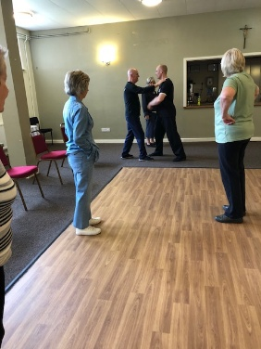
Tai Chi class at St Theresa’s church hall for members of the U3A only.
We meet every Friday from 10.30 - 11.30 am at a cost of £6.
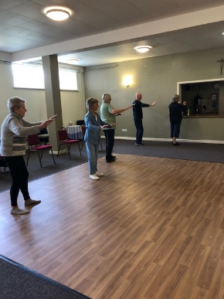
Tai Chi is very good for improving balance which helps to prevent falls. It helps with muscle strength, concentration, co-ordination and fitness. Mindfulness and stress relief are also important. You will find that an hour of Tai Chi will leave you feeling less stressed and more energetic. Come along and have a go, we always have room for new members. Although we learn more every week we don’t take ourselves too seriously and have a laugh as well.
from everyday cares and good for mindfulness. We always have room for new members, come along and have a go.

The Social Group
Five members of the Friendship Group met on Friday, 3rd July for lunch at The Plough, and two other members joined us later for a general chat. It was discussed about changing the name of the group and it was decided that we would call it the Social Group to cover a variety of activities. Due to present circumstances and a lack of interest at the last U3a Meeting for a trip to the Well /dressings it was decided not to go ahead with this idea.. The next meeting will be on Friday, 7th August, 1.30 p.m. at The Plough for lunch. If anyone is interested to join us either for lunch or afterwards for a general get together, all are welcome but if you want lunch please let me know. Betty.

Bridge Club
The Dukeries u3a Bridge Group meet on the Second and Fourth Tuesday of each month at the Jubilee Hall (NG22 9AP) from 1 – 4PM. The cost of each session is currently £3.

Photography Group
This months ‘Themed’ challenge was ‘WATER’, set by Betty.
Ken & Mandy Moore.
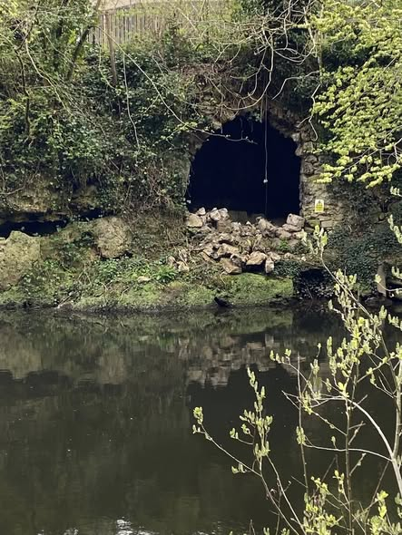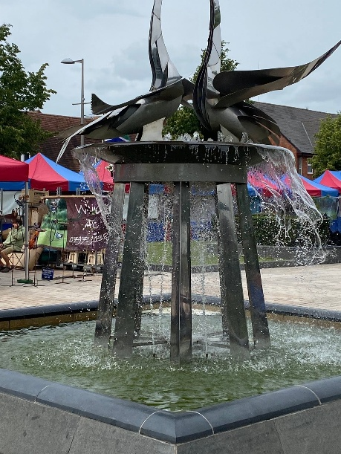
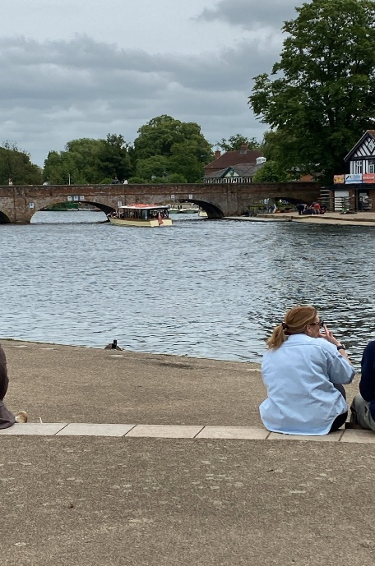
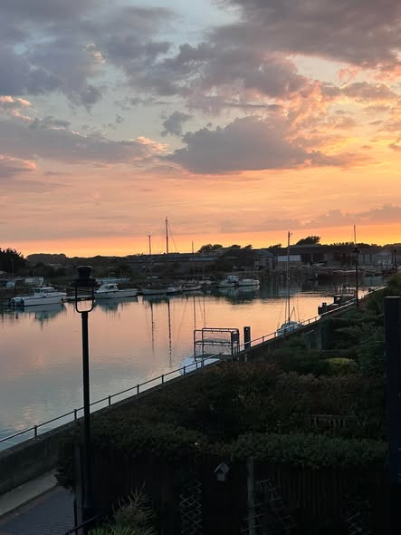
Joanne Wheatley

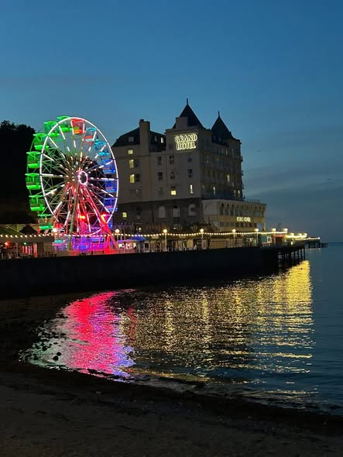

Joyce O’Neil




Betty Trinder
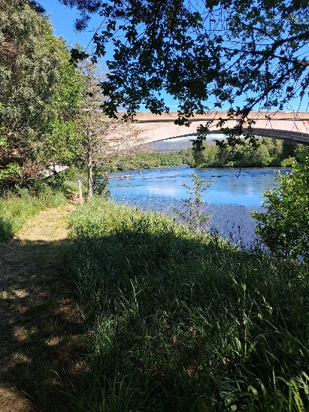

Jim Shervey
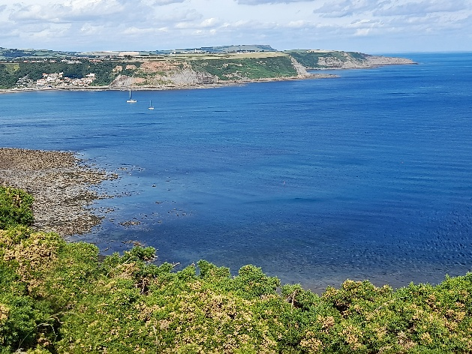

Bob Thomson



The next ‘Themed’ challenge is ‘ New & Old’, set by Joyce. All u3a member are welcome to join in!

 Garden Group
This year's programme is below.
August 11th... Northern Garden centre, Worksop
September 8th... Reuben Shaw and sons, Moorgreen
October 13th... Cherry Lane, Retford
November 10th... Glapwell Garden centre
December 8th... Blue Diamond Garden Centre, East Bridgford.
🌺Anne.


Natural History, Science and Technology.

No report due to the July meeting being cancelled.
2026 | Activity
AUGUST | Visit to Clipstone Headstocks
SEPTEMBER | How much do you know about NHS+T?
OCTOBER | Neanderthals
NOVEMBER | Touch
DECEMBER | No meeting
2027
JANUARY | Metamorphic, Igneous or Sedimentary?
FEBRUARY | The Giants of Sherwood


Walking Group

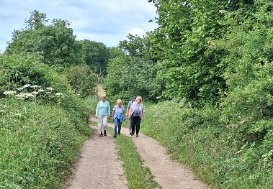
﻿Our June walk was lead by Val. Originally we were going to head for the Major Oak but by consensus an alternative route was planned. What a pleasant walk the substitute turned out to be. Starting from The Carrs we headed towards Warsop Vale and followed the paths along the old pit tip and into the village. From there we continued through the fields towards Sookholme/Sookholme Lane. The new housing development has now taken away some of the lane but it was interesting to see how the building work has progressed. We then followed the footpath along the river bank towards our starting /end point. Brenda

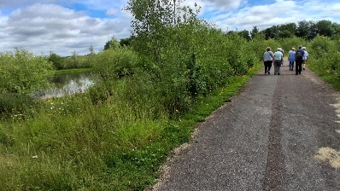
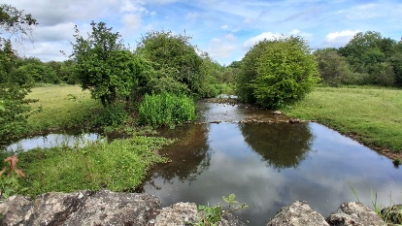

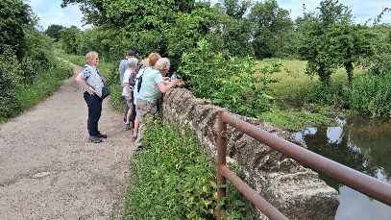

Our next walks

Thursday 20th August - Bolsover. Note a change to the original programme

WALKING GROUP – 3RD THURSDAY OF THE MONTH 2026

Craft Group

Thank you to Brenda for showing us how to make these lovely broches.

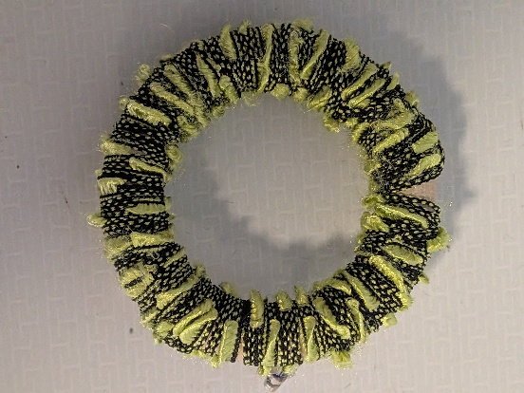

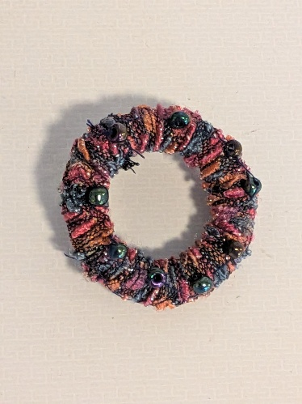

It was an enjoyable 2 hours.

If you would like to join us the only thing you need to bring is a basic sewing kit and a willingness to have a go at anything. All materials are available for a very small donation to the person who brings them, if anything more specialised is required you will be given the opportunity to purchase any item needed yourself, or you can borrow from other group members.
Future itinerary 2026
3rd August – Tissue Paper Flowers
7th September – Florentine Embroidery
5th October – Christmas Cards
2nd November – Christmas Decorations
7th December – Christmas Crafts (to sell at Christmas Party)
Looking forward to seeing you at the next meeting… Zena.

History Group

We were out and about in Mansfield Woodhouse for our June history meeting, discovering the history of the village.
Local historian Denis Hill Led part of the walk around the oldest part of Woodhouse, whilst our group member Ervin led the second part of the walk along High Street, Portland street and Welbeck Rd
We learned how the village had moved from its original site following a great fire in the 1300s. The church, once in the centre of the village, now sits to one side of it as the villagers rebuilt their homes following the course of a stream. At one time the stream ran openly through the centre of the village. We saw cat slide roofs, 17th century chamfered mullioned windows and stout oak beams indicating much older buildings lurking behind more recent facades.
Remnants of long gone trades remain in the village with the maltings the framework knitter cottages, the blacksmith's yard and the farmworkers dwellings. The names of the courtyards immortalised the families who once lived there.
The little village has its claims to fame too! Links with Bess of Hardrick led to some wealthy families settling there in Tudor times. The Lord of the Manor, John Digby, was knighted due to his loyalty to Charles I during the civil English Civil War. The King’s personally appointed Wolf hunter lived in the village, his house remains to this day and is marked with a blue badge. It was stoned from the Woodhouse quarry which was used to build the Houses of Parliament due to its being of superior quality.


Our next meeting is on July the 21st of July at 10am at St Theresa's Church Hall. Dennis will be visiting us one last time before his retirement to speak about the history of the Mansfield to Worksop railway we hope you will join us.

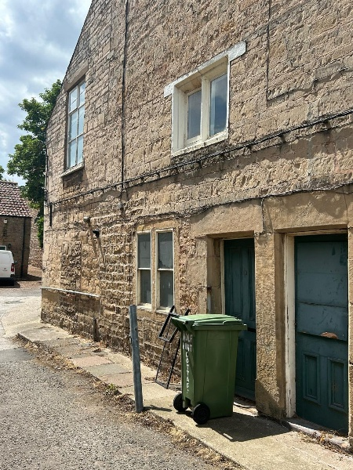

2026 - Proposed Calendar of Events for Warsop & District U3A History Group -
Date | Talk/Visit | Venue
21st July 2026 | Mansfield to Worksop Railway  Denis Hill | St Theresa’s Church Hall 10am
18th Aug 2026 | The Bands Played On  Chris Weir | St Theresa’s Church Hall 10am
15th Sept 2026 | Visit to Gainsborough Old Hall | TBA
20th Oct 2026 | The Tower of London  Chris Shervey | St Theresa’s Church Hall 10am
17th Nov 2026 | Women Win the War – WW1  Grant Cullen | St Theresa’s Church Hall 10am
 | No meeting as very close to Christmas

Speakers for the main meetings
2026

July Belpers Extraordinary Waterpower Story Ian Jackson

August The British Legion Elaine Hopkins

September Annual General Meeting

October All Things Ghostly and Mysterious Joanna Cowell

November My China Bike Ride Jenny Long

December Christmas Party
2027
January Terry Wogan’s Hairweave and other stories Graham Keal

February An on call firefighter and their work within the community. Carl Evans

March Social Time. (Easter Monday)

April ‘The Potty Plotters’ Elaine & Julia (can be found on radio Derby)

Group | Leaders Name | Tel
NATURAL HISTORY SCIENCE AND TECHNOLOGY | Chris Shervey
WALKING GROUP | Brenda Pearce  Pam Hick
STROLLERS | Janet Harford  Pat Magness
HISTORY GROUP | Barbara Spybey
CRAFTS | Zena Inger
GARDENING | Anne Poultney
PHOTOGRAPHY | Rob Thomson
FRIENDSHIP GROUP | Betty Trinder
TAI CHI | Anne Poultney

INTEREST GROUP TIMETABLE
 | MONDAY | TUESDAY | WEDNESDAY | THURSDAY | FRIDAY
1st | 10am – 12pm  CRAFTS GROUP  St Teresa’s Catholic Church hall. Warsop |  |  |  | 2pm  FRIENDSHIP GROUP  The Plough Warsop
2nd |  | 10am  GARDENING GROUP  Venue agreed by members |  | 2 – 3.30  NATURAL HISTORY  SCIENCE AND  TECHNOLOGY  St Teresa’s Catholic Church Hall Warsop
3rd | MAIN MEETING 10.15  Oaklands Centre  Warsop | 10am– 12pm  HISTORY GROUP  St Teresa’sCatholic Church hall. Warsop |  | 10am  WALKING GROUP  Carrs Car Park | 11.am  PHOTOGRAPHY  Venue to be agreed by the members.
4th |  |  | 10.am  STROLLERS  Carrs Car Park
PHOTOGRAPHY GROUP-Please see Newsletter for the online challenge.
TAI CHI Every Friday 10.30am St Teresa’s Catholic Church hall

Committee Members | Role
Lynne Hutchinson | Chairperson
Mel Mitchell | Deputy Chairperson
Irene Clay | Business Secretary
Linda Crossley | Treasurer
Zena Inger | Membership Secretary
Jim Shervey | Speaker Seeker
Jennifer Thomson | Groups co-ordinator
Chris Shervey | Newsletter editor
Ann Ayodele | Social Events
Jennifer Thomson | Welfare Officer
Rob Thomson | Website & Facebook manager
Ann Ayodele | Refreshments rota
Betty Trinder | Social events assistant

Warsop & District U3A is committed to treating all people equally. Anyone wishing to see the Privacy and Data Protection policies may view them on the Warsop.u3asite.uk alternatively please ask Rob.
Website & Facebook
The Warsop & District u3a website can be found at Warsop.u3asite.uk . If any of the group leaders/facilitators would like to advertise/ promote any of their future activities or change the information shown, please contact Bob Thomson

Facebook
Warsop & District U3A has a Facebook Group. It is a private group which can be seen by the public but only members can see who’s in the group and what they post.
What this means is that you have to be invited to join the group or have your request to join accepted. Also you need to be on Facebook which some of you may not be. As a member of the group you will be able to put your own posts on the page, please keep them relevant to the U3A and what it stands for. We would ask that you don't put anything on that is in anyway party political or anything that may be offensive to others who may be of a different creed or religion. Hopefully everyone will join, use the page and find it useful.
One of the things that puts people ‘off’ Facebook, is the ‘bad press’ some of the Social sites get. You can join Facebook, choose only to join the Warsop Facebook page and not be involved in any other site, or Friends requests (usually from people that you have never heard of!) The choice is entirely yours.
To request to join the Warsop u3a Facebook page, contact Bob Thomson.
June quiz This story about Tom contains hidden words----- all are things you wear on the head.

Tom drove from his job on network television and parked his car at the park, took a swig of his drink and glanced around. On a nearby table a crow noisily complained, but it did not seem to disturb anyone. The crow had no fear of the people around it seemed to know it was a safe zone. Tom ambled slowly enjoying the cool evening breeze, when he
saw some squirrels, he had some nuts and oranges in his ruck sack, he wondered if he fed oranges and nuts to them they would come closer. After feeding the squirrels Tom walked on, noticing the path was messy , most people are capable of using a litter bin he thought to himself. Then he noticed on the path there was confetti a rare sight in the park maybe they had been taking wedding photos.
Tom had been attending concerts in the park for years and today he was waiting for a friend who oddly had not been to one before. Tom hoped that they would enjoy the concert and stop hating classical music.
They asked the orchestra what they would be playing and Toms friend was pleased that he recognised some of the works.

June quick quiz All the answers start with D
1 The smallest state in USA? DELAWARE
2 Extinct bird, named from the Portugese for stupid? DODO
3 What is a muntjac? A DEER
4 Who had a dog named K9? DR WHO
5 Which character in a nineteenth century novel landed in Whitby? DRACULA
6 A type of tea? DARJEELING
7 Condition resulting from lack of fluids in the body? DEHYDRATION
8 A famous French designer? (surname) DIOR
9 Dog breed whose name means badger hound? DACHSHUND
10 Author of childrens book Matilda? (surname) DAHL

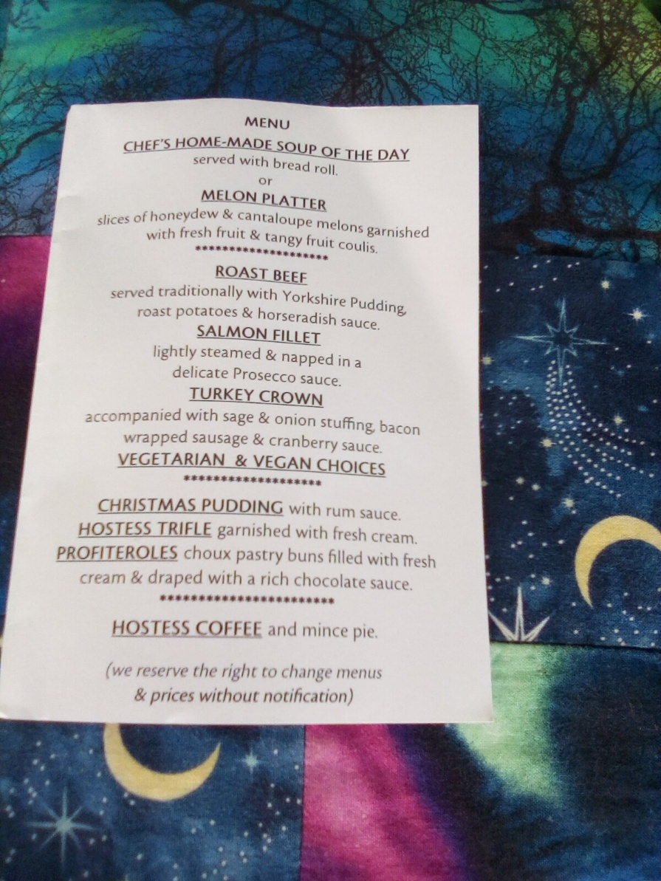

Notice of Warsop and District Annual General Meeting (AGM)
Monday 21st September 2026 10.15am at Oaklands, Oaklands Lane,Warsop, NG20 OJE
It will soon be time for the AGM and these papers are in preparation for the event.
At the AGM the membership has to vote in the four Honorary officer posts of Chair, Vice-Chair, Treasurer and Business Secretary.
The current officers, Lynne Hutchinson - Chair, Mel Mitchell - Vice-Chair, Vacant - Business secretary Linda Crossley – Treasurer
All of these positions are open for nominations and the nominating and seconding process is necessary for each office. More positions are available and nominations would be most welcome from members wishing to join the committee in a non-officer role. Which means that you would be able to take on a role or be available to help other committee members as needed, which will ultimately lessen the load on each individual.
The nomination forms are included with this document, the completed forms must be returned to - Lyne Hutchinson, Chair person. By the 17thAugust 2026. The votes will then be taken at the AGM.
The committee holds at least 3 meetings a year, sometimes more, usually lasting about 2 hours.
The role of the committee is to ensure that Warsop & District u3a runs as well as it can for the members. If you feel that you would like to join the committee come and talk to one of the current team.
The current positions are (there can be up to 15 committee members):
Committee Members | Role
Lynne Hutchinson | Chairperson
Mel Mitchell | Vice Chairperson
Vacant | Business Secretary
Linda Crossley | Treasurer
Zena Inger | Membership Secretary
Chris Shervey | Newsletter Editor
Ann Ayodele | Refreshments & Meeters + Greeters. Social Events Organiser
Jennifer Thomson | Groups co-ordinator
Betty Trinder | Social Events
Bob Thomson | Website and Face-book manager
Jim Shervey | Speaker Organiser

NOMINATION FOR HONORARY OFFICER- Chair/Vice chair/Business secretary/Treasurer
NOMINATION FOR COMMITTEE MEMBER- Committee member or named role

Post nominated for (Choose from above)-

Name of Nominee-

Signature

Address

Telephone

Email

Name of proposer

Signature

Name of Seconder

Signature

Return to the Chairperson- Lyne Hutchinson.

