
Issue 102 May 2026

Warsop & District
Notes from the Chair
Good morning everyone and welcome to the May newsletter.

So far it's been a busy month with various outings, meetings and activities and this remains one of our greatest strengths.
I'd like to thank all our group leaders and volunteers for the time and energy they put into organising these events.
Our first Sunday lunch outing was held at the Dukeries Lodge in Edwinstowe and was well attended. The meal and service were excellent so thanks again to Jen for organising this.
Looking ahead we will be planning more activities which I hope you will find the time to attend.
Finally thank you all for your continued support and encouragement. It's what makes Warsop U3A such a vibrant and friendly community
Lynne
Membership renewals 2026
The current membership year ends at the end of March, so anyone who has not renewed after the April meeting will be taken off the circulation lists, (this does not prevent you rejoining at a later date)
I will be handing out new cards from May onwards.
Zena

The deadline for including articles/information in the next newsletter is Friday 5th June
Send contributions to Chris Shervey. If you have any ideas for new items to include in the newsletter please let me know.

Rota for refreshments and greeting.
This is the rota for the next four months, any problems please contact me, Ann Ayodele, on 07359720273.
Thank you to all those who have volunteered to help, without you our meetings would not be enjoyable.

Date | Refreshments 1 | Refreshments 2 | Meet and Greet 1 | Meet and Greet 2
18th May | Karen Breed | Beatrix Kirby | Pauline Wright | Joanne Wheatley
15th June | Pauline England | Barbara Hartshorn | Raymond White | Ann Barnes
20th July | Trish Ward | Mandy Moore | Janice Richardson | Wendy Sterland
17th Aug | Irene Smith | Tina Saunders | Kathleen Coe | Ann Ballinger

EVENTS

IDLE VALLEY NATURE RESERVE BEAVER TOURS.
Tickets have now been purchased for those wishing to visit the Beaver enclosure at the Idle Valley Nature Reserve. This will take place on Sunday 21st June at 10.30am.

ITEMS OF INTEREST

Speakers
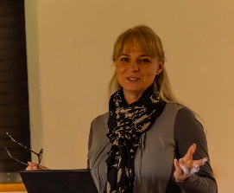
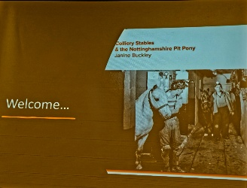
The speaker last month, Janine Buckley, gave us a very instructive talk on the life of a ‘Pit Pony’. If you missed it there was a free book to go with the talk, so you may be able to borrow a book to catch up on the topic.

This month the talk is titled ‘Rivers just keep rollin along’ presented by Phil Crompton
London Theatre Breaks
The Theatre Group is currently dormant as it is without a leader. However, I'm happy to book tickets for the occasional show.

"Mamma Mia!" is showing at The Royal Concert Hall, Nottingham this Autumn, but tickets are selling very quickly.
There is still some availability for the matinee performance at 2pm on Thursday 8th October priced at £64.00 each.
If anyone would like to go I shall need to collect the full amount at our May monthly meeting.
Jen.

Items for Ukraine
Having just received the latest national newsletter for the U3A I was interested in the article that Botley Hedge End U3A posted regarding their Knit and Knatter group. They have been busy knitting squares for blankets and making knitted bunnies for Easter to send to the Ukraine. I have now located a local group that collects items ‘Retford helps Ukraine’ they are based at The Well, Retford Baptist Church, Hospital Road, Retford. They are collecting various items (clothing, bedding, over the counter medicines etc) but if anyone would like to knit or crochet 6” or 12” squares to make blankets just let me know. Brenda

Lunch at the Cosy Tearooms
A lunch at the Cosy Tea Rooms has been organised for Tuesday 14th July. 12.15pm for 12.30pm.
Pay Chris and Brenda at the June meeting. There are only 22 places available.


Table Tennis Club- Warsop Health Hub-Mondays 1.30-3.30pm
If you would like to have a go at playing table tennis then please do join Pam Hick and Ian James at the Health Hub each Monday from 1.30-3.30pm. The cost is £4 per person. Bats and balls are provided.
Vibrant Warsop has supported this venture with the purchase of 2 brand new tables. Both Pam and Ian are also members of the U3a (Pam-Warsop & Ian- Forest Town)
You do not need to be a member of the Health Hub- just turn up!


WELFARE

Please let me know of any members who are ill or who have been bereaved. This is so that I may send them our best wishes. Jen.

Cups Please will as many of you as
possible bring your own mug for your tea or coffee. This is not only more environmentally friendly but also would save us a lot of money as the paper disposable cups we use are surprisingly expensive. Ann.
Robin Hood Lottery 
Warsop and District U3A is a cause registered with the Robin Hood Lottery.
To buy a ticket you can now register on line at www.robinhoodlottery.co.uk and set up regular payments. If you buy a ticket every week for a year Warsop U3A will receive £26.
Remember the more members that have a go (specifying Warsop & District U3A) the more money we get for our funds.

Books and Jigsaws 50p.
We made £4 at the April meeting thank you. Please note the books are sorted into genres making it easier to find a book you like.

Raffle.
The raffle made £42 in April Thank you
RAFFLE PRIZES NEEDED PLEASE
RAFFLE PRIZES NEEDED .

PLEASE NOTE THERE ARE NO JIGSAWS OR BOOKS AT THE MAY MEETING.

May quiz complete the missing pair e.g. adam and --------? eve.
- ROMEO and -------------?
- PUNCH and --------------?
- FLORA and -------------?
- PROCTOR and ---------?
- LAUNCELOT and ---------?
- A BOW and -----------?
- JUDGE and ---------?
- SAMSON and ---------?
- TWEEDLEDUM and ----------?
- LOCK and ---------?
- LAUREL and -------?
- A BALL and --------?
- JACK and -------?
- ASSAULT and --------?
- POPEYE and -----------?
- RODGERS and -------?
- TOM and --------?
- MORECAMBE and ------?
- HUE and -------?
- SIMON and ----------?
- ANTHONY and -------?
- CURDS and ------?
- GILBERT and --------?
- CASTOR and ------?
- FLORA and -----?

May quick quiz all the answers start with c
1 Saffron comes from a?
2 Who benefits from the work of UNICEF?
3 A firework named after a saint ?
4 From which language does the word tea come?
5 A yacht with two hulls?
6 Part of the body also called the thorax?
7 Which crop is attacked by a Boll Weevil?
8 The symbol at the beginning of a musical stave?
9 A pure white sedimentary rock ?
10 A famous silent film star?

ANSWERS TO LAST MONTHS QUIZ AT END OF NEWSLETTER.

GROUP NEWS
COULD ALL GROUP LEADERS PLEASE COLLECT THEIR BADGES WHEN THEY COLLECT THEIR LANYARDS. THEN MEMBERS CAN SEE WHO TO SPEAK TO ABOUT A GROUP.
THANK YOU

INTEREST GROUPS INFORMATION
Some of our groups are suffering from dwindling numbers at the moment, let's hope that the warmer weather and lighter evenings will encourage us to get out and about a bit more.
Please take a few minutes to look at the groups' folders to see what's happening.
Perhaps some of you may have interests not covered by existing Interest Groups, please let me have your suggestions for new groups.
Jen
North Notts Neighbourhood group

The NNNG are putting an event on in Sherwood Forest, Edwinstowe, on 17th June. See The flyer for details.This is the second event like this they have provided in the Forest, the previous event was 2 years ago and was a great success.

The NNNG means that you as a member of Warsop & District can ask to join an interest group in another U3A that is also in the NNNG, as long as the group is not oversubscribed at the time of your request you can join the group without joining the host u3a
The u3as in the NNNG are Mansfield, Sherwood, Dukeries, Rainworth, Forest Town, Ashfield, Sutton in Ashfield, Hucknall, Worksop, Warsop, Retford and Bolsover.

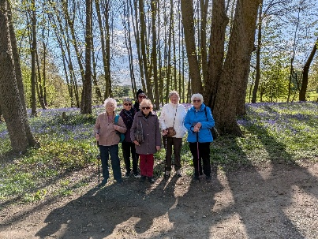
 Strollers
Our April walk took us to Rufford Park. It was a lovely morning and the bluebells were in full bloom. We enjoyed our walk through the woods down to the Mill for refreshments before returning by the lake and Abbey to spend a little time in the garden centre. A very pleasant morning. Our next stroll will be as follows: 27th May - Newstead Abbey Meet at 10.00 am at the Carrs car park for car share to Newstead
Please meet at the Carrs as usual for car share to Rufford Country Park.

Programme for 2026
May Newstead Abbey
June Sherwood Pines
July Kings Mill Reservoir
August. Vicar Water
September Creswell Crags
October Worksop Canal
November. Thoresby Country Park Note:
Walks may be subject to change.


Tai Chi Tigers

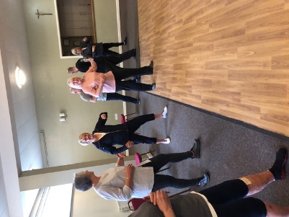
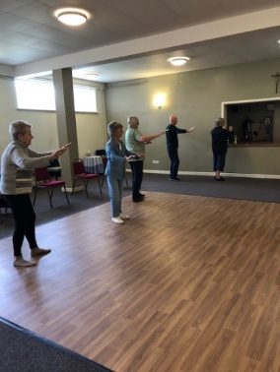
Tai Chi class for U3A members only.
Tai Chi Tigers meet every Friday at St Theresa’s Church Hall in Warsop from 10.30 to 11.30am at a cost of £6.
Tai Chi is good for well-being and helps with improving balance and preventing falls. One hour a week is enough for stress relief and relaxation, it’s a respite from everyday cares and good for mindfulness. We always have room for new members, come along and have a go.
The Friendship Group
The Friendship Group had a meeting on Friday, 1st May, 5 members attended and we had a discussion about how to move forward and hopefully keep the Group running. It was decided that for the June meeting we would meet for lunch at The Plough at 1.30 p.m. and then if anyone wishes to we could perhaps have a game or two afterwards and a general chat about what else the group could do to encourage more members to join us. If you wish to come for lunch on the 5th June please let me know at the May U3A main meeting as I need to give the Plough an idea of how many meals would be required. Hopefully we would eat in the back room and have the room until 4 o'clock if required. Anyone wishing to come just for lunch would be welcome. Another suggestion was a visit to the well dressings, please let me have your thoughts on this. Obviously this would need some planning as soon as possible, and it would be very much dependent on numbers interested and the cost of hiring a coach. Watch this space for further developments.

Betty
Bridge Club
The Dukeries u3a Bridge Group meet on the Second and Fourth Tuesday of each month at the Jubilee Hall (NG22 9AP) from 1 – 4PM. The cost of each session is currently £3.

Photography Group
This months ‘Themed’ online challenge is ‘Odds in nature’, set by Ken & Mandy Moore.
This can be ODD numbers, ODD things or things in ODD places!
Ken & Mandy Moore.

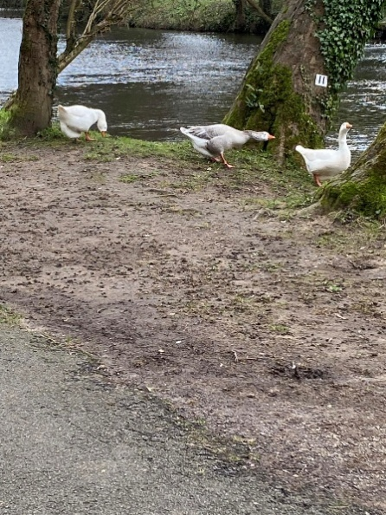
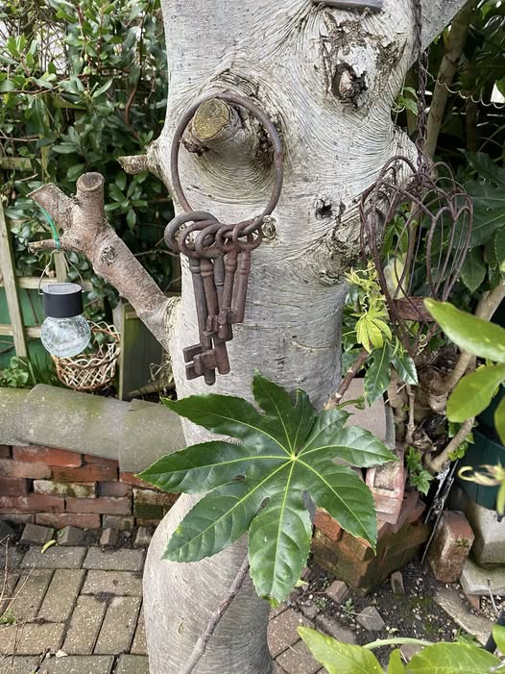

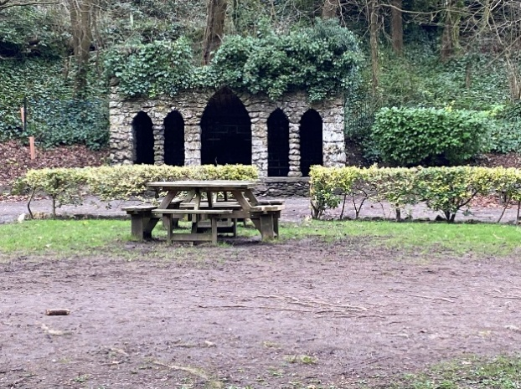


Jen Thomson.

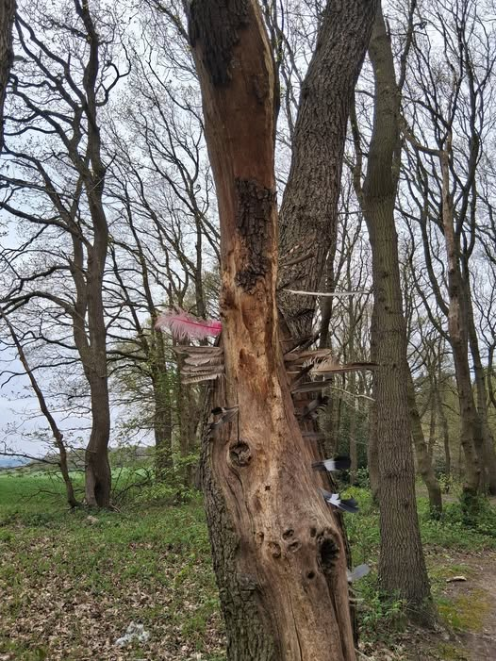

Chris Shervey.
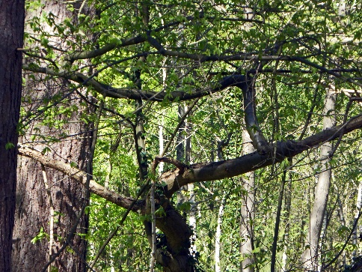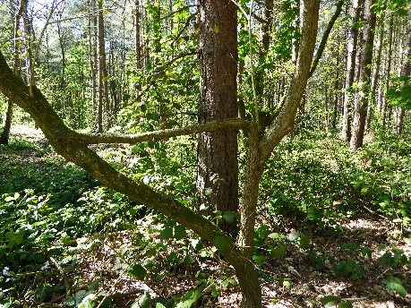

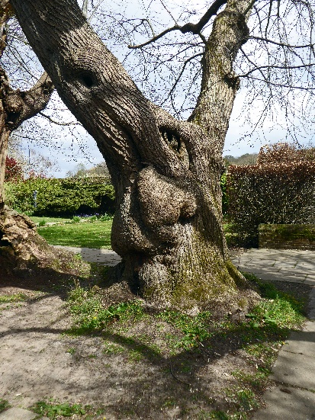

Joanne Wheatley.
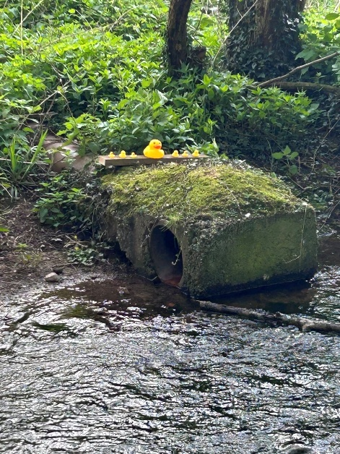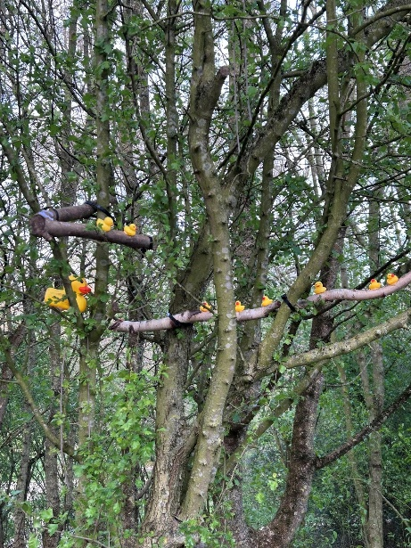

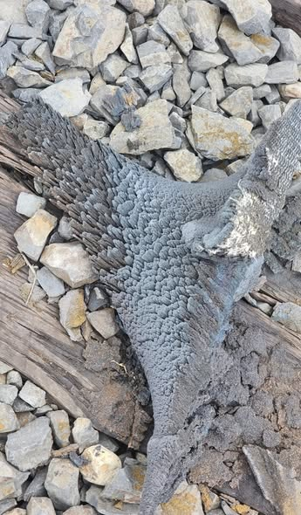
Betty Trinder.


Joyce O’Neil.
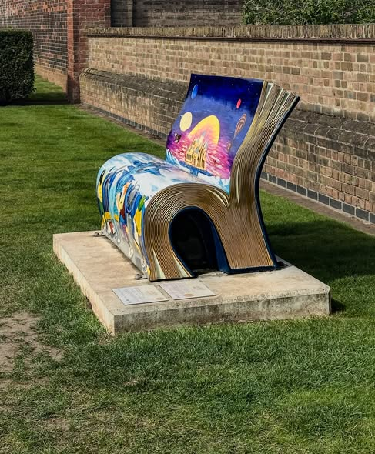
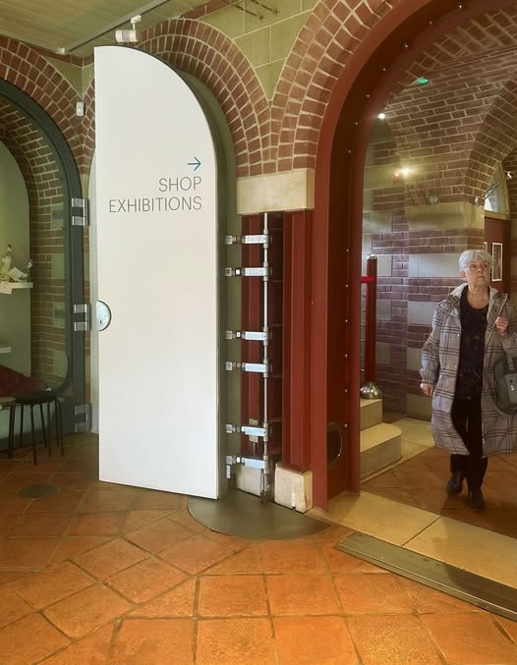

Bob Thomson.


A Big Thanks to ALL who have contributed to this challenge.
The next online ‘Themed’ challenge, which once again is open to ALL u3a members, is
‘A splash of colour!’
Hopefully we will see some colourful vibrant images to catch the eye!
The next ‘Face to Face’ meeting will be at the ‘Spirit of Wartime’ event held at Thoresby park on Saturday 16th May 2026. Meeting at the Conqueror tank at the entrance to the Court yard at 11am. Parking is on the events field, not the usual car park, and is £5.00 for all day parking.


 Garden Group
The garden group meets on the second Tuesday of the month at the Carrs car park in Warsop at 10am and we carshare from there.
I’m April we we went to Pennell’s garden centre in Lincoln. We started as usual with coffee then had a look around the garden centre which is huge. We had lunch in the restaurant and arrived back in Warsop about 4pm.

In June we shall be going to Dunstan Hall garden centre near Chesterfield.
Anne.
This year's programme is below.
June 9th.... Dunstan Hall, Chesterfield
July 14th... Walkers Nursery and landscape walk
August 11th... Northern Garden centre, Worksop
September 8th... Reuben Shaw and sons, Moorgreen
October 13th... Cherry Lane, Retford
November 10th... Glapwell Garden centre
December 8th... Blue Diamond Garden Centre, East Bridgford.
🌺Anne.

Natural History, Science and Technology.

This month Ann Ayodele gave us a talk on trees. We started with a quiz, from pictures of leaves we had to identify the tree. Jim did best identifying 9 out of 10. We learnt about the different trees in woodlands. How trees survive best in an urban environment. Also how a tree is coppiced and the uses of coppiced wood.

Photos of our trip to Tucks brewery in April.


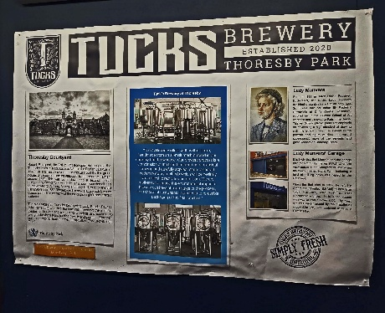

2026 | Activity
June | Birds of Prey Chris Shervey


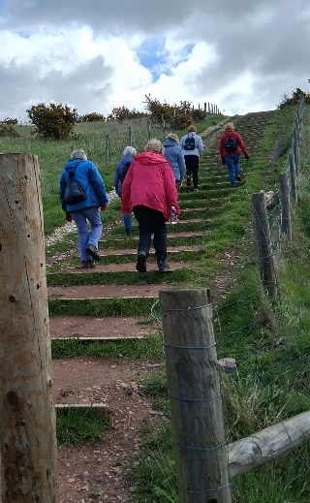
Walking Group
Our April walk sure threw up some pleasant surprises.
Thoresby Vale Country Park a new 350 acre green space on the former Thoresby Colliery Site (1925 -1915). It now features 39 hectares of restored woodland, heathland and wildflower meadows. There are good scenic viewpoints from the top and we could clearly see Clipstone Headstocks, Creswell Quarry and Thoresby Hall. The work is ongoing with more paths planned for the future.
Near the end of the walk we came across Vale the Viper which lined the path with painted stones which you are welcome to add to.

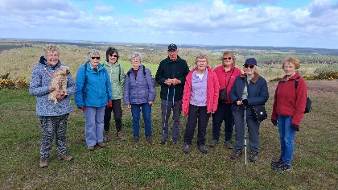
I’m sure a good time was had by all and an enjoyable social morning.
Walk date | Walk Leader | Walk | Distance
21st May | Pat/Bea | Mansfield Woodhouse circular | 4 miles
18th June | Val | Warsop - Major Oak | 4.5 miles
16th July | Brenda | Belph Brook or (South Tunnel) | 6 miles (4 miles)
20th August | Gerald | TBC
17th September | Val | Pleasley Pit | 6 miles
15th October | Brenda | Boughton Brake | 4.5 miles
19th November | Jen | Vicar Water – Sherwood Pines
 |  | NO WALK
 | Walks can be subject to change

Our next walk is centred around Woodhouse. As usual we will leave The Carrs at 10.00, or Mansfield Woodhouse train station at 10.15. Hope you can make it.
Brenda
WALKING GROUP – 3RD THURSDAY OF THE MONTH 2026
Craft Group







This month we made papercraft birds.



If you would like to join us the only thing you need to bring is a basic sewing kit and a willingness to have a go at anything. All materials are available for a very small donation to the person who brings them, if anything more specialised is required you will be given the opportunity to purchase any item needed yourself, or you can borrow from other group members.
Future itinerary 2026
1st June – TBD
6th July – Broches
3rd August – Tissue Paper Flowers
7th September – Florentine Embroidery
5th October – Christmas Cards
2nd November – Christmas Decorations
7th December – Christmas Crafts (to sell at Christmas Party)
Looking forward to seeing you at the next meeting… Zena

History Group

Our meeting on Tuesday 21st April was well attended. Denis Hill came to speak to us about Watermills of Mansfield, of which there were thirteen I believe! This is the topic of Denis’ latest book which will be the published in September. Unfortunately, I recently received news from Denis that he will no longer be giving public talks after the end of this year. We will greatly miss him but, we are lucky enough to have two more dates booked with Denis later this year.
Our next meeting is on Tuesday 19th May, 10am at St Teresa’s church hall in Warsop when we welcome Colin as our speaker. Some of you will remember Colin is one of the guides at Hardwick Hall and spoke to us last year about the houses of Bess of Hardwick. His topic this time is Arbella. A rather sad tale of the granddaughter of Bess of Hardwick and cousin to James 1. We look forward to seeing you there. Tea, coffee and biscuits available as always thanks to David. New members most welcome.
Barbara & Tamar 

2026 - Proposed Calendar of Events for Warsop & District U3A History Group -
Date | Talk/Visit | Venue
16th Jun 2026 | Visit  Mansfield Woodhouse Trail | Meeting point tba
21st July 2026 | Mansfield to Worksop Railway  Denis Hill | St Theresa’s Church Hall 10am
18th Aug 2026 | The Bands Played On  Chris Weir | St Theresa’s Church Hall 10am
15th Sept 2026 | Visit to Gainsborough Old Hall | TBA
20th Oct 2026 | The Tower of London  Chris Shervey | St Theresa’s Church Hall 10am
17th Nov 2026 | Women Win the War – WW1  Grant Cullen | St Theresa’s Church Hall 10am
 | No meeting as very close to Christmas

Speakers for the main meetings
2026
May Rivers just keep rollin’ along Phil Crompton

June Do You Remember (a light-hearted presentation with audience involvement spanning
the past 80 or so years). Peter Savage

July Belpers Extraordinary Waterpower Story Ian Jackson

August The British Legion Elaine Hopkins

September Annual General Meeting

October All Things Ghostly and Mysterious Joanna Cowell

November My China Bike Ride Jenny Long

December Christmas Party
2027
January Terry Wogan’s Hairweave and other stories Graham Keal

February An on call firefighter and their work within the community. Carl Evans

March

April ‘The Potty Plotters’ Elaine & Julia (can be found on radio Derby)

Group | Leaders Name | Tel
NATURAL HISTORY SCIENCE AND TECHNOLOGY | Chris Shervey
WALKING GROUP | Brenda Pearce  Pam Hick
STROLLERS | Janet Harford  Pat Magness
HISTORY GROUP | Barbara Spybey
CRAFTS | Zena Inger
GARDENING | Anne Poultney
PHOTOGRAPHY | Rob Thomson
FRIENDSHIP GROUP | Betty Trinder
TAI CHI | Anne Poultney

INTEREST GROUP TIMETABLE
 | MONDAY | TUESDAY | WEDNESDAY | THURSDAY | FRIDAY
1st | 10am – 12pm  CRAFTS GROUP  St Teresa’s Catholic Church hall. Warsop |  |  |  | 2pm  FRIENDSHIP GROUP  The Plough Warsop
2nd |  | 10am  GARDENING GROUP  Venue agreed by members |  | 2 – 3.30  NATURAL HISTORY  SCIENCE AND  TECHNOLOGY  St Teresa’s Catholic Church Hall Warsop
3rd | MAIN MEETING 10.15  Oaklands Centre  Warsop | 10am– 12pm  HISTORY GROUP  St Teresa’sCatholic Church hall. Warsop |  | 10am  WALKING GROUP  Carrs Car Park | 11.am  PHOTOGRAPHY  Venue to be agreed by the members.
4th |  |  | 10.am  STROLLERS  Carrs Car Park
PHOTOGRAPHY GROUP-Please see Newsletter for the online challenge.
TAI CHI Every Friday 10.30am St Teresa’s Catholic Church hall

Committee Members | Role
Lynne Hutchinson | Chairperson
Mel Mitchell | Deputy Chairperson
Irene Clay | Business Secretary
Linda Crossley | Treasurer
Zena Inger | Membership Secretary
Jim Shervey | Speaker Seeker
Jennifer Thomson | Groups co-ordinator
Chris Shervey | Newsletter editor
Ann Ayodele | Social Events
Jennifer Thomson | Welfare Officer
Rob Thomson | Website & Facebook manager
Ann Ayodele | Refreshments rota
Betty Trinder | Social events assistant

Warsop & District U3A is committed to treating all people equally. Anyone wishing to see the Privacy and Data Protection policies may view them on the Warsop.u3asite.uk alternatively please ask Rob.

Website & Facebook
The Warsop & District u3a website can be found at Warsop.u3asite.uk . If any of the group leaders/facilitators would like to advertise/ promote any of their future activities or change the information shown, please contact Bob Thomson

Facebook
Warsop & District U3A has a Facebook Group. It is a private group which can be seen by the public but only members can see who’s in the group and what they post.
What this means is that you have to be invited to join the group or have your request to join accepted. Also you need to be on Facebook which some of you may not be. As a member of the group you will be able to put your own posts on the page, please keep them relevant to the U3A and what it stands for. We would ask that you don't put anything on that is in anyway party political or anything that may be offensive to others who may be of a different creed or religion. Hopefully everyone will join, use the page and find it useful.
One of the things that puts people ‘off’ Facebook, is the ‘bad press’ some of the Social sites get. You can join Facebook, choose only to join the Warsop Facebook page and not be involved in any other site, or Friends requests (usually from people that you have never heard of!) The choice is entirely yours.
To request to join the Warsop u3a Facebook page, contact Bob Thomson.
Answers April quiz- Find the 5 letter word that links the 3 words in each question. The missing word can go before or after e.g. oven velvet puppet, missing word is glove.
1 upright grand stool PIANO
2 world degree party THIRD
3 match decimal high POINT
4 watch gang stitch CHAIN
5 war stripper gloss PAINT
6 open spider plant HOUSE
7 fire clock smoke ALARM
8 royal baby mould JELLY
9 water ivory crane TOWER
10 steering prayer clamp WHEEL
11 circle parade evening DRESS
12 chase tiger tissue PAPER
13 walking French insect STICK
14 second shop show FLOOR
15 bad orange group BLOOD
16 lime sea belt GREEN
17 optic gas centre NERVE
18 right acute iron ANGLE
19 magnetic true riding NORTH
20 bulb meter first LIGHT
21 bullet black carpet MAGIC
22 scarlet swamp pitch FEVER
23 war fan music DANCE
24 green sauce crab APPLE
25 nurse safe first NIGHT

Answers April Quick quiz All the answers start with B.
1 What is a devils coach horse? A BEETLE
2 What is the collective name for Netherlands Belgium Luxemburg ? BENELUX
3 What runs through the streets of Pamplona every July? BULLS
4 What colour is a female blackbird? BROWN
5 What animal is sometimes called a brock? BADGER
6 Name of Swedish tennis player from the 70’s? BJORN BORG
7 Initiation of a Jewish boy into manhood? BARMITZVAH
8 Host city of 1992 Olympics? BARCELONA
9 Hollywood block buster starring Charlton Heston? BEN HUR
10 Game evolved from rounders? BASEBALL

