
Issue 103 June 2026

Warsop & District
Notes from the Chair
" Hello and welcome to June and the start of summer bringing with it longer days and hopefully the return of warmer weather.
Obviously summer brings more opportunities for our outdoor groups and social activities. So I would encourage you all to take advantage of any of these on offer and even consider trying something new.
Just as a heads up could you please take a moment to read the entire newsletter especially in respect of the rotas for meet and greet and refreshments to ensure you are aware when you are on duty.
Finally I wish you all a happy and healthy June
Best wishes
Lynne x"

Membership renewals 2026
The membership year ended at the end of March, so anyone who has not renewed after the April meeting will be taken off the circulation lists, (this does not prevent you rejoining at a later date).
I will be handing out new cards from May onwards.
Zena

The deadline for including articles/information in the next newsletter is Friday 10th July
Send contributions to Chris Shervey. If you have any ideas for new items to include in the newsletter please let me know.

Rota for refreshments and greeting.
This is the rota for the next 3 months, any problems please contact me, Ann Ayodele, on 07359720273.
Thank you to all those who have volunteered to help, without you our meetings would not be enjoyable.

Date | Refreshments 1 | Refreshments 2 | Meet and Greet 1 | Meet and Greet 2
15th June | Pauline England | Barbara Hartshorn | Raymond White | Ann Barnes
20th July | Trish Ward | Mandy Moore | Janice Richardson | Wendy Sterland
17th Aug | Irene Smith | Tina Saunders | Kathleen Coe | Ann Ballinger

EVENTS

IDLE VALLEY NATURE RESERVE BEAVER TOURS.
Reminder the visit to the Beaver enclosure at the Idle Valley Nature Reserve. This will take place on Sunday 21st June at 10.30am.

ITEMS OF INTEREST

Speakers

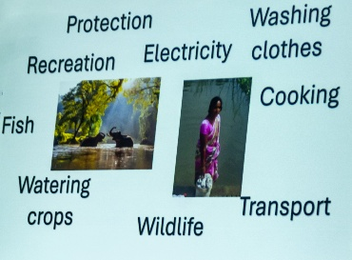
The talk in May was given by Phil Crompton He gave a very interesting talk titled’ Rivers just keep rollin along’ with slides about the state of the rivers in this country and world wide, many of which are heavily polluted by agriculture and industry. He also pointed out that there are a number of small groups around the world that are trying to reduce or stop the pollution and highlighted how they are trying to achieve this end. There were 2 mini quizzes, one 'name to singer' who sang songs mentioning rivers, and another 'Where is this bridge'. Both got the members joining in shouting out the answers. Overall the talk went down well!

The talk this month will be given by Peter Savage.
Titled- ‘Do You Remember’
A light-hearted presentation with audience involvement spanning the past 80 or so years.

Theatre Group
The Theatre Group is currently dormant as it is without a leader. However, I'm happy to book tickets for the occasional show
Jen.

Items for Ukraine
Having just received the latest national newsletter for the U3A I was interested in the article that Botley Hedge End U3A posted regarding their Knit and natter group. They have been busy knitting squares for blankets and making knitted bunnies for Easter to send to the Ukraine. I have now located a local group that collects items ‘Retford helps Ukraine’ they are based at The Well, Retford Baptist Church, Hospital Road, Retford. They are collecting various items (clothing, bedding, over the counter medicines etc) but if anyone would like to knit or crochet 6” or 12” squares to make blankets just let me know. Brenda

Lunch at the Cosy Tearooms
A lunch at the Cosy Tea Rooms has been organised for Tuesday 14th July. 12.15pm for 12.30pm.
Pay Chris and Brenda at the June meeting. There are only 22 places available.


Table Tennis Club- Warsop Health Hub-Mondays 1.30-3.30pm
If you would like to have a go at playing table tennis then please do join Pam Hick and Ian James at the Health Hub each Monday from 1.30-3.30pm. The cost is £4 per person. Bats and balls are provided.
Vibrant Warsop has supported this venture with the purchase of 2 brand new tables. Both Pam and Ian are also members of the U3a (Pam-Warsop & Ian- Forest Town)
You do not need to be a member of the Health Hub- just turn up!
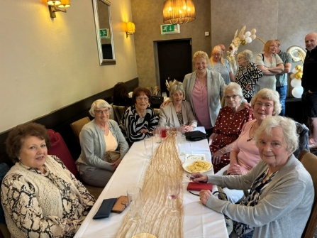
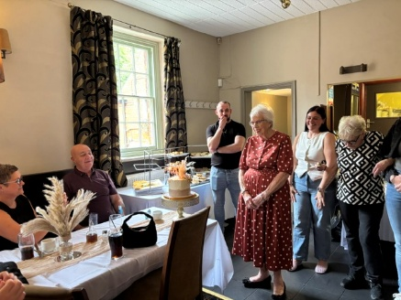
HAPPY BIRTHDAY Gill Alsop
It looks like a good time was had by all at her 90th birthday party.


WELFARE

Please let me know of any members who are ill or who have been bereaved. This is so that I may send them our best wishes. Jen.

Cups Please will as many of you as
possible bring your own mug for your tea or coffee. This is not only more environmentally friendly but also would save us a lot of money as the paper disposable cups we use are surprisingly expensive. Ann.
Robin Hood Lottery 
Warsop and District U3A is a cause registered with the Robin Hood Lottery.
To buy a ticket you can now register on line at www.robinhoodlottery.co.uk and set up regular payments. If you buy a ticket every week for a year Warsop U3A will receive £26.
Remember the more members that have a go (specifying Warsop & District U3A) the more money we get for our funds.

Books and Jigsaws 50p.
Please note the books are sorted into genres making it easier to find a book you like. No Books and Jigsaws in May.

Raffle.
The raffle made £? in May Thank you.
RAFFLE PRIZES NEEDED PLEASE
RAFFLE PRIZES NEEDED .

June quiz This story about Tom contains hidden words----- all are things you wear on the head.

Tom drove from his job on network television and parked his car at the park, took a swig of his drink and glanced around. On a nearby table a crow noisily complained, but it did not seem to disturb anyone. The crow had no fear of the people around it seemed to know it was a safe zone. Tom ambled slowly enjoying the cool evening breeze, when he
saw some squirrels, he had some nuts and oranges in his ruck sack, he wondered if he fed oranges and nuts to them they would come closer. After feeding the squirrels Tom walked on, noticing the path was messy , most people are capable of using a litter bin he thought to himself. Then he noticed on the path there was confetti a rare sight in the park maybe they had been taking wedding photos.
Tom had been attending concerts in the park for years and today he was waiting for a friend who oddly had not been to one before. Tom hoped that they would enjoy the concert and stop hating classical music.
They asked the orchestra what they would be playing and Toms friend was pleased t he recognised some of the works.

June quick quiz All the answers start with D
1 The smallest state in USA?
2 Extinct bird, named from the Portugese for stupid?
3 What is a muntjac?
4 Who had a dog named K9?
5 Which character in a nineteenth century novel landed in Whitby?
6 A type of tea?
7 Condition resulting from lack of fluids in the body?
8 A famous French designer? (surname)
9 Dog breed whose name means badger hound?
10 Author of childrens book Matilda? (surname)
ANSWERS TO LAST MONTHS QUIZ AT END OF NEWSLETTER.

GROUP NEWS
COULD ALL GROUP LEADERS PLEASE COLLECT THEIR BADGES WHEN THEY COLLECT THEIR LANYARDS. THEN MEMBERS CAN SEE WHO TO SPEAK TO ABOUT A GROUP.
THANK YOU

INTEREST GROUPS INFORMATION
The annual "Interest Groups Matter" meeting, for Groups Coordinators and Group Leaders was held on 1st June. I was unable to attend this year, but have been sent feedback from the organiser, including an emailed copy of the Group Leaders handbook. If any of our valued volunteers, who put so much effort into running our groups, would like a copy, please let me know. I shall be organising the annual meeting of our Group Leaders very soon, more information in the next newsletter. This is mainly to thank them for all their hard work, (coffee and cake will be the main feature of the meeting). Jen

North Notts Neighbourhood group

The NNNG are putting an event on in Sherwood Forest, Edwinstowe, on 17th June. See The flyer for details.This is the second event like this they have provided in the Forest, the previous event was 2 years ago and was a great success.

The NNNG means that you as a member of Warsop & District can ask to join an interest group in another U3A that is also in the NNNG, as long as the group is not oversubscribed at the time of your request you can join the group without joining the host u3a
The u3as in the NNNG are Mansfield, Sherwood, Dukeries, Rainworth, Forest Town, Ashfield, Sutton in Ashfield, Hucknall, Worksop, Warsop, Retford and Bolsover.

 Strollers
Due to the hot weather our group of 6 decided to have a gentle stroll round the Carrs. With the gentle breeze it was a very pleasant walk round the playing field and by the river. We then proceeded to the Dukeries garden centre for refreshments and it was really lovely sitting outside in the shade. Not a very energetic morning but a really sociable outing. Next walk - 24th June - Sherwood Pines Meet at the Carrs car park at 10.00 am for car share to Sherwood Pines

Programme for 2026
June Sherwood Pines
July Kings Mill Reservoir
August. Vicar Water
September Creswell Crags
October Worksop Canal
November. Thoresby Country Park Note:
Walks may be subject to change.


Tai Chi Tigers

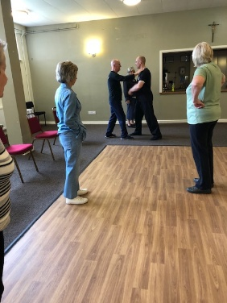
Tai Chi class at St Theresa’s church hall for members of the U3A only.
We meet every Friday from 10.30 - 11.30 am at a cost of £6.
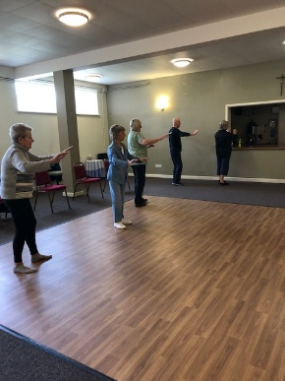
Tai Chi is very good for improving balance which helps to prevent falls. It helps with muscle strength, concentration, co-ordination and fitness. Mindfulness and stress relief are also important. You will find that an hour of Tai Chi will leave you feeling less stressed and more energetic. Come along and have a go, we always have room for new members. Although we learn more every week we don’t take ourselves too seriously and have a laugh as well.
from everyday cares and good for mindfulness. We always have room for new members, come along and have a go.
The Friendship Group
The Friendship Group met for lunch at the Plough on Friday, 5th June and the six members attending enjoyed their meal and general chat. A discussion was held on the proposal for a trip to some well dressings possibly sometime in July/August. It would be helpful if anyone who definitely would like such a trip give their name to Jen Long at the main U3a meeting on the 15th June, I will not be at the meeting but Jen has a list of Well Dressings with dates if you are interested. Preference for dates and where to visit would be helpful. Our next Group meeting will be at the Plough for lunch again on the 3rd July at 1.30 p.m. followed by a general chat and games if anyone is interested.
Betty

Bridge Club
The Dukeries u3a Bridge Group meet on the Second and Fourth Tuesday of each month at the Jubilee Hall (NG22 9AP) from 1 – 4PM. The cost of each session is currently £3.

Photography Group
Last months ‘Themed’ challenge was ‘A Splash of Colour’. The ‘Face to Face’ meeting was at the SPIRIT OF WARTIME event held at Thoresby park on 16/17th May 2026.
Ken & Mandy Moore
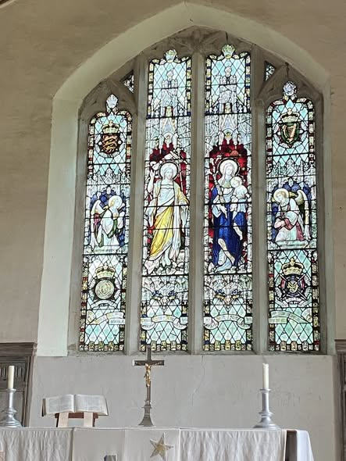


Jen Thomson
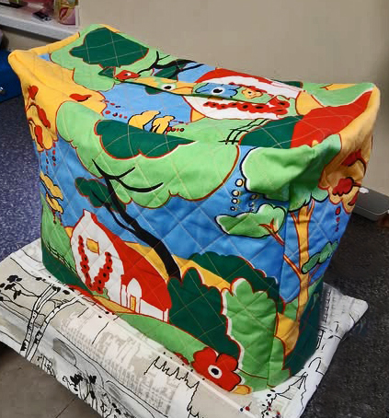



Jim & Chris Shervey
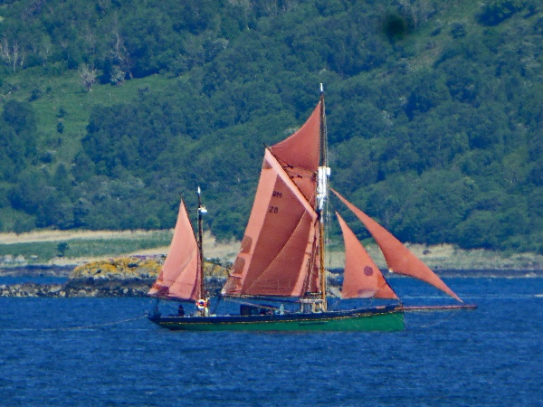


Joanne Wheatley


Betty Trinder
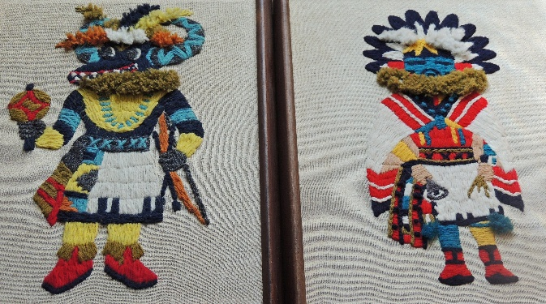


Joyce O’Neil
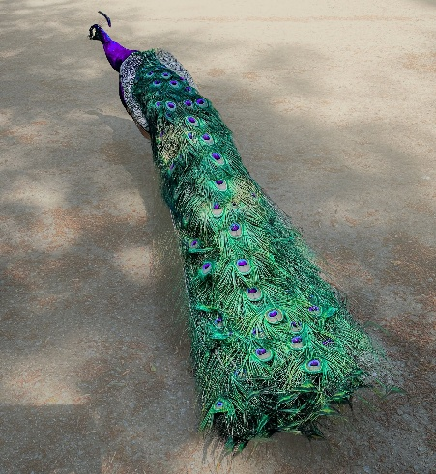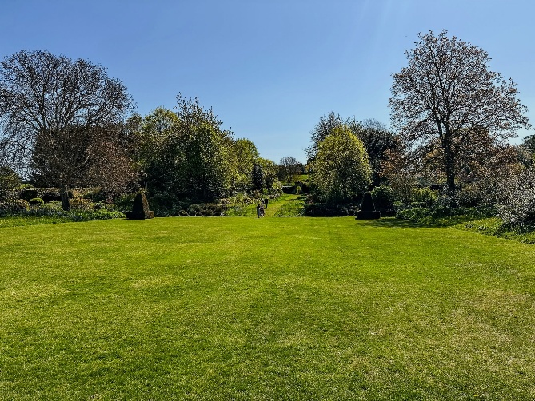



Bob Thomson
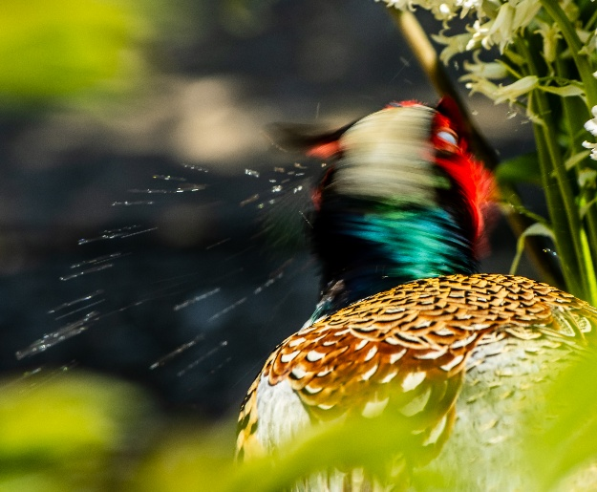

Spirit of Wartime
Joane Wheatley
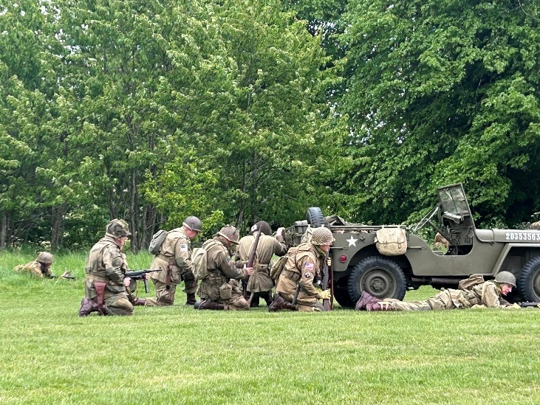

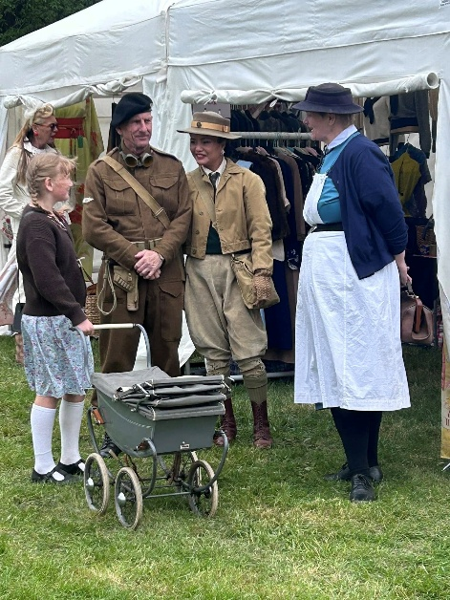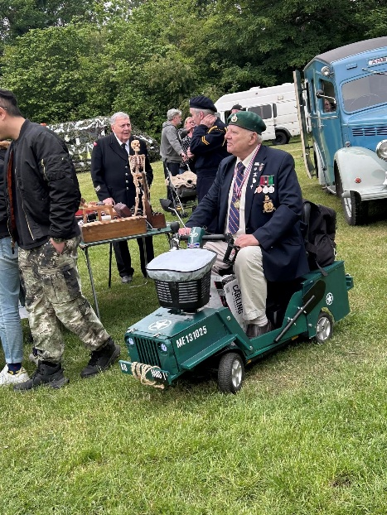
Bob Thomson
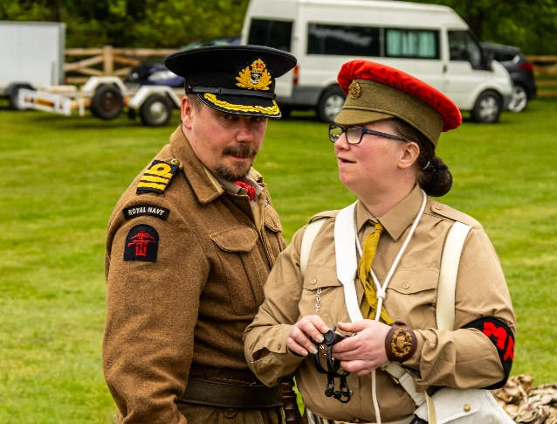
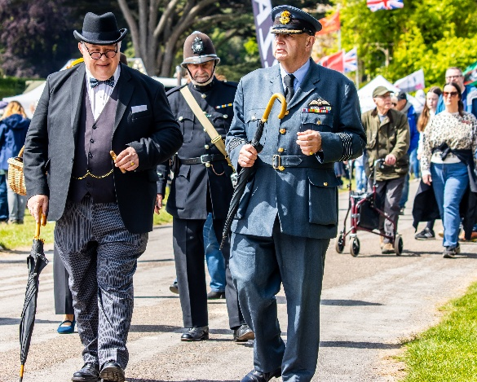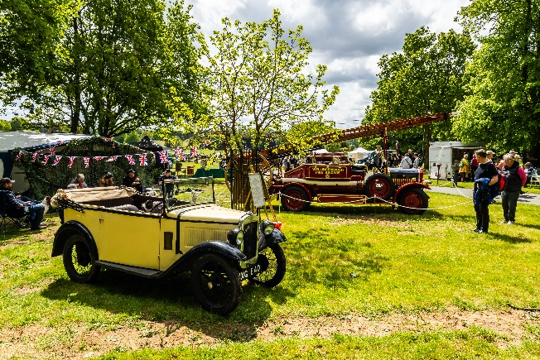
The next ‘Themed’ challenge has been set by Betty. The theme is ‘WATER’.
Once again the challenge is open to ALL u3a members, so why not get out your phone/camera and give it ago!

 Garden Group
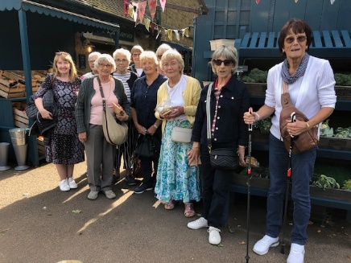
The garden group meets at the Carrs on the second Tuesday of the month at 10 am and we carshare from there.

In May we went to Tansley Barn and Matlock garden centres. As usual we began with coffee and cake and a look around the garden centre then moved on for lunch. We had a lovely day, the weather was good and we arrived back in Warsop about 4pm.
This year's programme is below.
July 14th... Walkers Nursery and landscape walk
August 11th... Northern Garden centre, Worksop
September 8th... Reuben Shaw and sons, Moorgreen
October 13th... Cherry Lane, Retford
November 10th... Glapwell Garden centre
December 8th... Blue Diamond Garden Centre, East Bridgford.
🌺Anne.

Natural History, Science and Technology.

Our talk this month was on Birds of Prey. There are 20 species of Birds of Prey in Britain, divided into Hawks Falcons Eagles Owls and Ospreys. The difference between a hawk and a falcon is the hawks have broader rounded wings for soaring and gliding. While a falcon is built for speed with pointed wings. The smallest British birds of prey are Kestrels and Merlins, a Merlin being not much larger than a blackbird. The largest are the Eagles --- Golden Eagles and White Tailed Eagles with wingspans of 7ft and 8ft.
Although Birds of Prey are protected by law we learnt about their widespread persecution, the Hen Harriers being the most affected. We heard about organisations who are trying to combat the persecution and finally the impact of reintroducing birds of prey across Britain.

2026 | Activity
JULY | The Giants of Sherwood Forest
AUGUST | Visit to Clipstone Headstocks
SEPTEMBER | How much do you know about NHS+T?
OCTOBER | To be decided
NOVEMBER | Touch
DECEMBER | No meeting


Walking Group
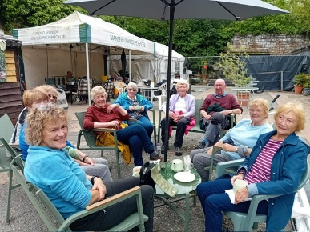
For our May walk we started from Mansfield Woodhouse and followed paths along the old pit tip and headed towards Pleasley . As an unexpected stop we made a slight detour and visited the Mansfield Wildlife Rescue located at Pleasley Vale. The staff were very helpful and gave us an insite into the work being carried out together with the history of the site. In past years it was a stop for steam trains to take onboard water which were travelling to and from the mills. After our stop we made our way back towards our homeward bound destination. A lovely walk lead by Pat and one which will definitely be on the calendar to do again at some point .
Brenda
Our next walks
Thursday 18th June - Warsop/Major Oak.

Thursday 16th July - Belph Brook (6 miles) or South Tunnel (4 miles) Please bring a drink and snack for this walk as longer than usual

Thursday 20th August - Bolsover. Note a change to the original programme

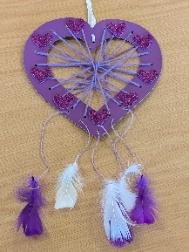
WALKING GROUP – 3RD THURSDAY OF THE MONTH 2026
Craft Group



In June we had an enjoyable meeting making dreamcatchers.
If you would like to join us the only thing you need to bring is a basic sewing kit and a willingness to have a go at anything. All materials are available for a very small donation to the person who brings them, if anything more specialised is required you will be given the opportunity to purchase any item needed yourself, or you can borrow from other group members.
Future itinerary 2026
6th July – Broches
3rd August – Tissue Paper Flowers
7th September – Florentine Embroidery
5th October – Christmas Cards
2nd November – Christmas Decorations
7th December – Christmas Crafts (to sell at Christmas Party)
Looking forward to seeing you at the next meeting… Zena.

History Group

Our last meeting was held on Tuesday 19th May when our speaker was Colin. Some of you may know Colin he is one of the volunteer guides at Hardwick Hall and he is extremely knowledgeable about Bess of Hardwick and her heritage.
Colin gave a superb talk about Arbella Stuart, granddaughter of Bess. A tragic story of someone whose strong claim to the throne of England made her a political pawn and denied her happiness. Her story ended tragically with her starving to death in the Tower of London.
As cousin to James 1 some would argue her claim to the throne was stronger than his following the death of Elizabeth 1.The English constitution at the time stipulated the heir must be born in England; unlike Arbella, James was born in Scotland.
We speculated how history would have changed had she become Arbella 1. Perhaps no gunpowder plot or English. Civil War! What would our political system have looked like today?
Thank you to everyone who came along. Also, a big thank you to David, who was at the hall from 7am tackling a flood to make sure the hall was fit for us to hold our meeting.

Our next meeting is on Tuesday 16th June when we will be walking the Mansfield Woodhouse History Trail with Denis. We will meet outside Mansfield Woodhouse library at 10am. We look forward to seeing you there. New members welcome too.
Barbara & Tamar 😊
2026 - Proposed Calendar of Events for Warsop & District U3A History Group -
Date | Talk/Visit | Venue
16th Jun 2026 | Visit  Mansfield Woodhouse Trail | Meeting point tba
21st July 2026 | Mansfield to Worksop Railway  Denis Hill | St Theresa’s Church Hall 10am
18th Aug 2026 | The Bands Played On  Chris Weir | St Theresa’s Church Hall 10am
15th Sept 2026 | Visit to Gainsborough Old Hall | TBA
20th Oct 2026 | The Tower of London  Chris Shervey | St Theresa’s Church Hall 10am
17th Nov 2026 | Women Win the War – WW1  Grant Cullen | St Theresa’s Church Hall 10am
 | No meeting as very close to Christmas

Speakers for the main meetings
2026
June Do You Remember (a light-hearted presentation with audience involvement spanning
the past 80 or so years). Peter Savage

July Belpers Extraordinary Waterpower Story Ian Jackson

August The British Legion Elaine Hopkins

September Annual General Meeting

October All Things Ghostly and Mysterious Joanna Cowell

November My China Bike Ride Jenny Long

December Christmas Party
2027
January Terry Wogan’s Hairweave and other stories Graham Keal

February An on call firefighter and their work within the community. Carl Evans

March To be arranged

April ‘The Potty Plotters’ Elaine & Julia (can be found on radio Derby)

Group | Leaders Name | Tel
NATURAL HISTORY SCIENCE AND TECHNOLOGY | Chris Shervey
WALKING GROUP | Brenda Pearce  Pam Hick
STROLLERS | Janet Harford  Pat Magness
HISTORY GROUP | Barbara Spybey
CRAFTS | Zena Inger
GARDENING | Anne Poultney
PHOTOGRAPHY | Rob Thomson
FRIENDSHIP GROUP | Betty Trinder
TAI CHI | Anne Poultney

INTEREST GROUP TIMETABLE
 | MONDAY | TUESDAY | WEDNESDAY | THURSDAY | FRIDAY
1st | 10am – 12pm  CRAFTS GROUP  St Teresa’s Catholic Church hall. Warsop |  |  |  | 2pm  FRIENDSHIP GROUP  The Plough Warsop
2nd |  | 10am  GARDENING GROUP  Venue agreed by members |  | 2 – 3.30  NATURAL HISTORY  SCIENCE AND  TECHNOLOGY  St Teresa’s Catholic Church Hall Warsop
3rd | MAIN MEETING 10.15  Oaklands Centre  Warsop | 10am– 12pm  HISTORY GROUP  St Teresa’sCatholic Church hall. Warsop |  | 10am  WALKING GROUP  Carrs Car Park | 11.am  PHOTOGRAPHY  Venue to be agreed by the members.
4th |  |  | 10.am  STROLLERS  Carrs Car Park
PHOTOGRAPHY GROUP-Please see Newsletter for the online challenge.
TAI CHI Every Friday 10.30am St Teresa’s Catholic Church hall

Committee Members | Role
Lynne Hutchinson | Chairperson
Mel Mitchell | Deputy Chairperson
Irene Clay | Business Secretary
Linda Crossley | Treasurer
Zena Inger | Membership Secretary
Jim Shervey | Speaker Seeker
Jennifer Thomson | Groups co-ordinator
Chris Shervey | Newsletter editor
Ann Ayodele | Social Events
Jennifer Thomson | Welfare Officer
Rob Thomson | Website & Facebook manager
Ann Ayodele | Refreshments rota
Betty Trinder | Social events assistant

Warsop & District U3A is committed to treating all people equally. Anyone wishing to see the Privacy and Data Protection policies may view them on the Warsop.u3asite.uk alternatively please ask Rob.
Website & Facebook
The Warsop & District u3a website can be found at Warsop.u3asite.uk . If any of the group leaders/facilitators would like to advertise/ promote any of their future activities or change the information shown, please contact Bob Thomson
Facebook
Warsop & District U3A has a Facebook Group. It is a private group which can be seen by the public but only members can see who’s in the group and what they post.
What this means is that you have to be invited to join the group or have your request to join accepted. Also you need to be on Facebook which some of you may not be. As a member of the group you will be able to put your own posts on the page, please keep them relevant to the U3A and what it stands for. We would ask that you don't put anything on that is in anyway party political or anything that may be offensive to others who may be of a different creed or religion. Hopefully everyone will join, use the page and find it useful.
One of the things that puts people ‘off’ Facebook, is the ‘bad press’ some of the Social sites get. You can join Facebook, choose only to join the Warsop Facebook page and not be involved in any other site, or Friends requests (usually from people that you have never heard of!) The choice is entirely yours.
To request to join the Warsop u3a Facebook page, contact Bob Thomson.
May quiz complete the missing pair e.g. adam and --------? eve.
- ROMEO and JULIET
- PUNCH and JUDY
- FLORA and FAUNA
- PROCTOR and GAMBLE
- LAUNCELOT and GUINEVER

- A BOW and ARROW
- JUDGE and JURY
- SAMSON and DELILAH
- TWEEDLEDUM and TWEEDLEDEE
- LOCK and KEY
- LAUREL and HARDY
- A BALL and CHAIN
- JACK and JILL
- ASSAULT and BATTERY
- POPEYE and OLIVE OYL
- RODGERS and HAMMERSTEIN
- TOM and JERRY
- MORECAMBE and WISE
- HUE and CRY
- SIMON and GARFUNKEL
- ANTHONY and CLEOPATRA
- CURDS and WHEY
- GILBERT and SULLIVAN
- CASTOR and POLLUX
May quick quiz all the answers start with c
1 Saffron comes from a? CROCUS
2 Who benefits from the work of UNICEF? CHILDREN
3 A firework named after a saint ? CATHERINE WHEEL
4 From which language does the word tea come? CHINESE
5 A yacht with two hulls? CATARMARAN
6 Part of the body also called the thorax? CHEST
7 Which crop is attacked by a Boll Weevil? COTTON
8 The symbol at the beginning of a musical stave? CLEF
9 A pure white sedimentary rock ? CHALK
10 A famous silent film star? CHARLIE CHAPLIN

