
Issue 100 March 2026

Warsop & District


100
This is the 100th issue of the Warsop & District u3a newsletter.
I edited the first issue in December 2017.
Thank you to all group leaders and everyone who has contributed to the last 100 issues.
I hope you have found the articles interesting and informative and will continue to do so.
Here’s to issue 200
Best wishes to all members.
Chris S

Notes from the Chair
Good morning everyone
As we move into March we can finally feel Spring is in its way. Longer days and a little more sunshine and perhaps a renewed sense of energy after the long wet winter we've had.
March is always a good time to look ahead and with that in mind we have upcoming events and activities planned which we would encourage you to attend and get involved in. Participation keeps us active not just physically but mentally and socially too.
Thanks to you all for being such a big part of Warsop U3a and let's continue to make it a place of friendship and enjoyment.
Lynne xxx
Membership renewals 2026
This month is the last to get your membership renewals done for 2026
Hi. It is time to be thinking about when you are going to renew your membership.
You will be pleased to hear that we are able to keep the cost of membership at £20.00 for full membership or £16.00 for joint members with proof of full membership at another u3a. (Please make a note on the form of whether you are a full or associate member, please have the membership card from your full membership u3a to show)
The current membership year ends at the end of March, so anyone who has not renewed after the April meeting will be taken off the circulation lists, (this does not prevent you rejoining at a later date).
If you have not already done so please collect your renewal form at the meeting. Payment with cash is preferable (as the Post Office no longer accepts paying in by cheque). Please have the correct money if possible. You can also pay by cheque made payable to Warsop & District u3a, please make sure to date and sign the cheque.
I will be handing out new cards from May onwards.
Anyone who can’t or don’t attend the General meeting can print the form attached, this can then be printed, the completed form can be sent along with a signed and dated CHEQUE to Warsop & District u3a Membership Secretary. (If you don’t have a printer then please call me and I will post a form out to you, which will need to be returned as above).
Make sure that you tick or cross all boxes as I need this information for records. If any boxes are not marked then I will assume that you don’t want to receive the TAT magazine etc…
Please make sure that you date and sign both cheques and renewal forms. If there are two people on the form then please will both parties sign and date the form.
Zena.

The deadline for including articles/information in the next newsletter is Friday 3rd April.
Send contributions to Chris Shervey. If you have any ideas for new items to include in the newsletter please let me know.

Rota for refreshments and greeting.
Refreshments and Meet and Greet Rota
This is the rota for the next four months, any problems please contact me, Ann Ayodele.
Thank you to all those who have volunteered to help, without you our meetings would not be enjoyable.

Date | Refreshments 1 | Refreshments 2 | Meet and Greet 1 | Meet and Greet 2
16thMarch | Yvonne Pannifer | Janet Harford | Moira Heslop | Glenys Fearn
20th April | Angelina Taylor | Sonja Attwood | Ann Holland | William Taylor
18th May | Karen Breed | Beatrix Kirby | Pauline Wright | Jill Greer
15th June | Pauline England | Barbara Hartshorn | Raymond White | Ann Barnes

EVENTS

IDLE VALLEY NATURE RESERVE BEAVER TOURS.
Tickets have now been purchased for those wishing to visit the Beaver enclosure at the Idle Valley Nature Reserve. This will take place on Sunday 21st June at 10.30am.

ITEMS OF INTEREST

Speakers
Our speaker last month, Mike Higginbottom, took us on a tour of canals and railways in North Derbyshire sharing their history and how they worked.

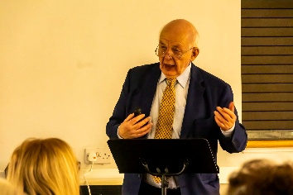
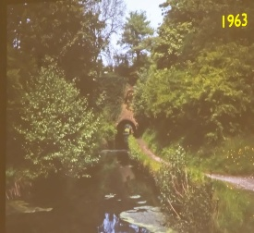

This month we are ‘Dining With Chaucers Pilgrims’ with Judith Hedley guiding us.

Networks Newsletter for the East Midlands
Included with this newsletter, as a second attachment, is the first copy of the ‘Networks Newsletter for the East Midlands’. Worth a read.

RECRUITMENT In order to increase membership the committee are going to discuss holding an event to showcase what we do with emphasis on the interest groups available. This event could be combined with a regular monthly meeting and will involve our group leaders. The initial discussion will take place at the end of our March meeting and it would be very much appreciated if group leaders could stay behind for a while to contribute to the discussion.

SUNDAY LUNCHES
Bob and I enjoyed Sunday Lunch at the Dukeries Lodge, Edwinstowe, recently so I thought we'd make that our first venue for lunch on Sunday 26th April. Their full menu is always available, along with traditional Sunday roasts and a specials board. Gluten free and vegetarian/vegan options available.
A sample of the Sunday menu is attached at the end of the newsletter. I shall collect a £5 deposit from anyone wishing to go at the March and April meetings. Members may bring a non-member guest.
LONDON THEATRE BREAKS
Several coach companies offer trips to London to see a couple of shows with overnight accommodation. Cost is usually around £250. If anyone is interested please let me know. Jen.

Nottinghamshire County Show - 9th May 2026
As you may already know the Nottinghamshire County Show celebrates our local agricultural community with attractions including vintage tractors, local food producers, local craft stalls, livestock, equine, traders and more! Our 'community zone' helps bring the people of Nottinghamshire together. It is a hub for various activities showcasing county-wide groups, performers, bands and musicians to entertain visitors all day. The show also features competitions like 'Make Bake & Grow', 'Floral Arts', etc. Really, there is something for everyone.
To view a full schedule of competitions available please visit: https://nottinghamshirecountyshow.com/competitors
As we are trying to get everyone from the Nottinghamshire community excited about the County Show on 9th May 2026 I was hoping that the U3A movement might encourage your wonderful members to visit us ( to buy tickets please visit us here: https://nottinghamshirecountyshow.ticketsrv.co.uk/tickets/62 ).
I personally know that U3A do great work for your members offering them a wide range of events and activities, I hope that you feel the Nottinghamshire County Show could be one of them. For more information please visit our website: https://nottinghamshirecountyshow.com/ .


Table Tennis Club- Warsop Health Hub-Mondays 1.30-3.30pm
If you would like to have a go at playing table tennis then please do join Pam Hick and Ian James at the Health Hub each Monday from 1.30-3.30pm. The cost is £4 per person. Bats and balls are provided.
Vibrant Warsop has supported this venture with the purchase of 2 brand new tables. Both Pam and Ian are also members of the U3a (Pam-Warsop & Ian- Forest Town)
You do not need to be a member of the Health Hub- just turn up!


WELFARE

Please let me know of any members who are ill or who have been bereaved. This is so that I may send them our best wishes. Jen.

Cups Please will as many of you as
possible bring your own mug for your tea or coffee. This is not only more environmentally friendly but also would save us a lot of money as the paper disposable cups we use are surprisingly expensive. Ann.
Robin Hood Lottery 
Warsop and District U3A is a cause registered with the Robin Hood Lottery.
To buy a ticket you can now register on line at www.robinhoodlottery.co.uk and set up regular payments. If you buy a ticket every week for a year Warsop U3A will receive £26.
Remember the more members that have a go (specifying Warsop & District U3A) the more money we get for our funds.

Books and Jigsaws 50p.
We made £8.50 at the February meeting thank you. Please note the books are sorted into genres making it easier to find a book you like.

Raffle.
The raffle made £35 in February. Thank you
RAFFLE PRIZES NEEDED PLEASE
RAFFLE PRIZES NEEDED .

March quiz---- the 100 quiz
1What letter is 100 in Roman numerals?
2 Cent is 100 in which language? Spanish / French
3 Who wrote 100 (and 1) Dalmatians?
4 Cien is 100 in which language? Italian / Spanish
5 True or false a 100 sided shape is called a hectogon?
6 Hundra is 100 in wch language? Swedish / Danish
7 How many men were there in 2023 aged 100 in the UK?
5,600 3,111 2,950
8 Hundert is 100 in which language? Polish / German
9 What is it called in cricket when a batsman scores 100?
10 Cento is 100 in which language? Greek / Italian
11 How long did the 100yrs war last?
100yrs 104yrs 116yrs
12 Hundre is 100 in which language? Danish / Norwegian
13 When did the NSPCC celebrate it’s centenary?
1984 1987 1991
14 Cto is 100 in which language? Russian / Polish
15 How many women were there in 2023 aged 100 in the UK?
10,987 13,180 12,402
16 Ekato is 100 in which language? Russian / Greek
17 When did the RSPCA celebrate it’s centenary?
1920 1924 1954
18 Cem is 100 in which language ? Portugese / Spanish

ANSWERS TO LAST MONTHS QUIZ AT END OF NEWSLETTER.

GROUP NEWS
COULD ALL GROUP LEADERS PLEASE COLLECT THEIR BADGES WHEN THEY COLLECT THEIR LANYARDS. THEN MEMBERS CAN SEE WHO TO SPEAK TO ABOUT A GROUP.
THANK YOU
INTEREST GROUPS INFORMATION
Country Dancing Alfreton u3a has a popular English Country Dancing group and their group leader has agreed to come to Warsop to do a taster session for us. If there is sufficient interest this could evolve into a new interest group. I shall take details of anyone who is interested at the March meeting. Interest Groups Matter Last year 3 of us attended a workshop for Groups Co-ordinators and Interest Group Leaders. It was such a success that it is to be repeated on 1st June this year. Sadly, I can't make it this year but would recommend it to any of our Interest Group Leaders or anyone who has an idea for a new group and would appreciate some guidance in setting up a new group. Poster attached.
Don't forget to check the folders giving details of all groups currently running at Warsop and neighbouring u3as.
I have been in touch with Mansfield District Council about hiring their meeting rooms in Warsop for our group meetings. Their charges for registered charities are just £5.51 per hour. This compares favourably with most room hire charges. Regular users are given a set of keys. If any of our group leaders are considering a change of venue I have contact details. Jen.

If you would like to see more groups forming please let me know or complete the sheet available at general meetings. Thank you, Jen.

North Notts Neighbourhood group
This means that you as a member of Warsop & District can ask to join an interest group in another U3A that is also in the NNNG, as long as the group is not oversubscribed at the time of your request you can join the group without joining the host u3a
The u3as in the NNNG are Mansfield, Sherwood, Dukeries, Rainworth, Forest Town, Ashfield, Sutton in Ashfield, Hucknall, Worksop, Warsop, Retford and Bolsover.

 Strollers
For our February walk we went from the Dukeries garden centre to Creswell Crags. It was a pleasant morning and the snowdrops in the woods were very pretty. 25th March 2026 - Sherwood Forest Meet at 10.00 am at the Carrs car park for car share to Edwinstowe.
Programme for 2026 April Rufford Country Park
May Newstead Abbey
June Sherwood Pines
July Kings Mill Reservoir
August. Vicar Water
September Creswell Crags
October Worksop Canal
November. Thoresby Country Park Note:
Walks may be subject to change

Tai Chi Tigers
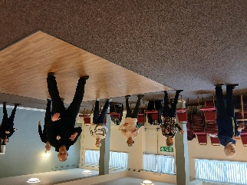

The Tai Chi Tigers are doing well. We meet every Friday at St Theresa's church hall for one hour from 10.30 to 11.30am. The cost is £6.
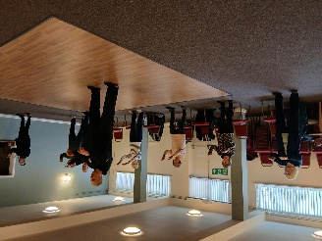
Tai Chi is good for preventing falls as it improves balance, is good for muscle strength and helps concentration. It does us all good to escape the world for an hour , we are beginning to remember the exercises which vary every week with some being repeated more regularly. Phil our trainer is very patient. The exercises can be done seated by anyone less mobile, we don't take ourselves too seriously and have a laugh. Always room for new members, come along and have a go.
Anne.

The Friendship Group
There was no meeting this month.
Betty

Bridge Club
The Dukeries u3a Bridge Group meet on the Second and Fourth Tuesday of each month at the Jubilee Hall (NG22 9AP) from 1 – 4PM. The cost of each session is currently £3.

 Garden Group
The garden group meets on the second Tuesday of the month at the Mill Dam car park in Warsop at 10am and we car share from there.
In February 9 of us went to Tickhill Garden centre , we had a lovely day out as usual starting with coffee and cake, having a look around the garden centre and finishing with lunch. No photos this time as the weather wasn't good .In March we shall be going to Southwell garden centre and Hollybeck nursery.
Anne.
This year's programme is below.
May 12th... Tansley Barn and Matlock Garden Centre
June 9th.... Dunstan Hall, Chesterfield
July 14th... Walkers Nursery and landscape walk
August 11th... Northern Garden centre, Worksop
September 8th... Reuben Shaw and sons, Moorgreen
October 13th... Cherry Lane, Retford
November 10th... Glapwell Garden centre
December 8th... Blue Diamond Garden Centre, East Bridgford.
🌺
Anne.

Natural History, Science and Technology.

This months talk was given by Joyce, on skin inside and out. For something most of us take for granted it is a very complicated organ, in fact it is the largest organ in the body. We learnt why skin is different colours, how we feel through our skin, why it is waterproof, that each internal organ has it’s own covering of skin and much much more.

2026 | Activity
April | Visit to Tucks Brewery Thoresby
May | Trees Ann Ayodele
June | Birds of Prey Chris Shervey


Walking Group
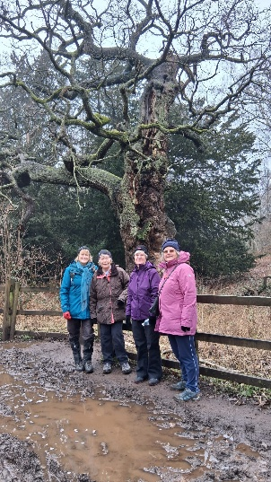
We have a full calendar of walks planned and look forward to seeing old and new members. As usual we leave The Carrs (car park) at 10.00 am prompt.
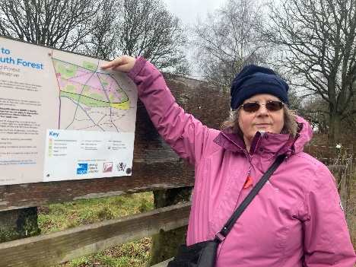
Due to the very muddy conditions of the parking for our proposed February walk it was decided to swap it with April’s walk to Sherwood Forest. Although drizzly to begin with 5 of us enjoyed a 5mile circuit walk round the forest paths and heathland.
Our March walk will be lead by Brenda- Little Gringley, Retford. We leave the Carrs at 10am.
Pam
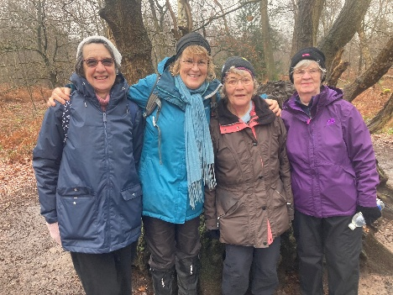
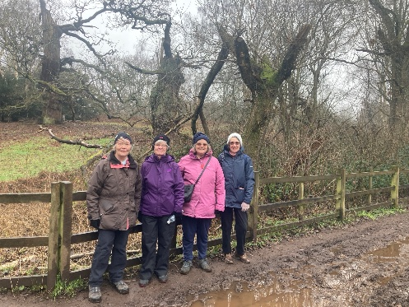
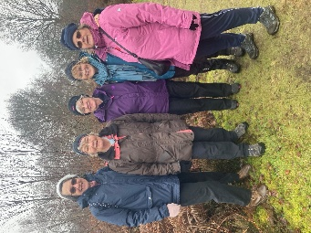

WALKING GROUP – 3RD THURSDAY OF THE MONTH 2026
Walk date | Walk Leader | Walk | Distance
19th March | Brenda | Retford – Little Gringley | 4.5 miles
16th April | Pam | Sherwood | 4.5 miles
21st May | Pat/Bea | Mansfield Woodhouse circular | 4 miles
18th June | Val | Warsop - Major Oak | 4.5 miles
16th July | Brenda | Belph Brook or (South Tunnel) | 6 miles (4 miles)
20th August | Gerald | TBC
17th September | Val | Pleasley Pit | 6 miles
15th October | Brenda | Boughton Brake | 4.5 miles
19th November | Jen | Vicar Water – Sherwood Pines
 |  | NO WALK
 | Walks can be subject to change

Photography Group

The Photography group would like to extend a warm welcome to our 2 new members, Ken & Mandy Moore.
The last online ‘Themed’ challenge was ‘Glass’ set by Betty.

Joanne Wheatley



Joyce O’Neil



Ken & Mandy Moore

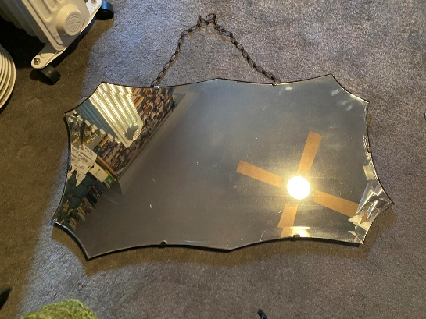
Betty Trinder



Bob Thomson



Chris Shervey



The next ‘Themed’ challenge is set by Joanne
“LOCAL,PRIDE IN YOUR OWN TOWN” - Where was this taken?
It can even be turned into a quiz afterwards.
Once again this is open to All u3a members!

Craft Group

Please note that the meeting in April will be on Monday 13th at 10.45am, this is due to the bank holiday and other hall users on the day.

The group met on Monday 2nd March and we made felt birds. As you can see from the pics each one was different. We had a lot of fun making them and those who struggle a bit had help from others.
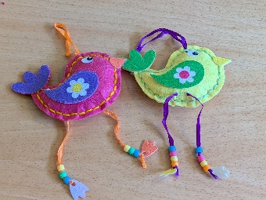
Next month we are making rag wreaths with the help of Brenda. We have been given some homework as well!

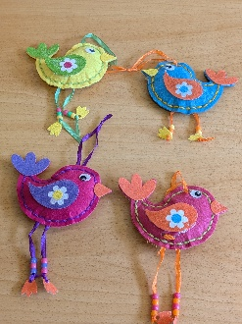
There are also a couple of changes to the itinerary that I will be updating in the near future.

If you would like to join us the only thing you need to bring is a basic sewing kit and a willingness to have a go at anything. All materials are available for a very small donation to the person who brings them, if anything more specialised is required you will be given the opportunity to purchase any item needed yourself, or you can borrow from other group members.
Future itinerary 2026
13th April – Rag Wreath 10.45am – 12.45pm (3rd Monday due to bank holiday)
11th May – Papercraft 10.45am – 12.45pm (3rd Monday due to bank holiday)
1st June – Florentine Embroidery
6th July – Broches
3rd August – Tissue Paper Flowers
7th September – TBC
5th October – Christmas Cards
2nd November – Christmas Decorations
7th December – Christmas Crafts (to sell at Christmas Party)
Looking forward to seeing you at the next meeting…
Zena.


History Group

For our meeting in February we welcomed Paul Jameson from The Battle of Hatfield Society who spoke to us about the investigations they have been undertaking at Cuckney. I know quite a few of our members have expressed interest in this very local project and we are very pleased that Paul was able to come along to speak to us.
Barbara and Tamar
2026 - Proposed Calendar of Events for Warsop & District U3A History Group -
Date | Talk/Visit | Venue
17th Mar 2026 | Visit  Bolsover Castle | Meeting point tba
21st Apr 2026 | Prehistoric Mansfield  Richard | St Theresa’s Church Hall 10am
19th May 2026 | Arbella Stuart  Colin | St Theresa’s Church Hall 10am
16th Jun 2026 | Visit  Mansfield Woodhouse Trail | Meeting point tba
21st July 2026 | Mansfield to Worksop Railway  Denis Hill | St Theresa’s Church Hall 10am
18th Aug 2026 | The Bands Played On  Chris Weir | St Theresa’s Church Hall 10am
15th Sept 2026 | Visit to Gainsborough Old Hall | TBA
20th Oct 2026 | The Tower of London  Chris Shervey | St Theresa’s Church Hall 10am
17th Nov 2026 | Women Win the War – WW1  Grant Cullen | St Theresa’s Church Hall 10am
 | No meeting as very close to Christmas

Speakers for the main meetings
2026
March Dining With Chaucers Pilgrims Judith Hedley

April Nottinghamshire Pit Pony Janine Buckley

May Rivers just keep rollin’ along Phil Crompton

June Do You Remember (a light-hearted presentation with audience involvement spanning
the past 80 or so years). Peter Savage

July Belpers Extraordinary Waterpower Story Ian Jackson

August The British Legion Elaine Hopkins

September Annual General Meeting

October All Things Ghostly and Mysterious Joanna Cowell

November My China Bike Ride Jenny Long

December Christmas Party
Group | Leaders Name | Tel
NATURAL HISTORY SCIENCE AND TECHNOLOGY | Chris Shervey
WALKING GROUP | Brenda Pearce  Pam Hick
STROLLERS | Janet Harford  Pat Magness
HISTORY GROUP | Barbara Spybey
CRAFTS | Zena Inger
GARDENING | Anne Poultney
PHOTOGRAPHY | Rob Thomson
FRIENDSHIP GROUP | Betty Trinder
TAI CHI | Anne Poultney

INTEREST GROUP TIMETABLE
 | MONDAY | TUESDAY | WEDNESDAY | THURSDAY | FRIDAY
1st | 10am – 12pm  CRAFTS GROUP  St Teresa’s Catholic Church hall. Warsop |  |  |  | 2pm  FRIENDSHIP GROUP  The Plough Warsop
2nd |  | 10am  GARDENING GROUP  Venue agreed by members |  | 2 – 3.30  NATURAL HISTORY  SCIENCE AND  TECHNOLOGY  St Teresa’s Catholic Church Hall Warsop
3rd | MAIN MEETING 10.15  Oaklands Centre  Warsop | 10am– 12pm  HISTORY GROUP  St Teresa’sCatholic Church hall. Warsop |  | 10am  WALKING GROUP  Carrs Car Park | 11.am  PHOTOGRAPHY  Venue to be agreed by the members.
4th |  |  | 10.am  STROLLERS  Carrs Car Park
PHOTOGRAPHY GROUP-Please see Newsletter for the online challenge.
TAI CHI Every Friday 10.30am St Teresa’s Catholic Church hall

Committee Members | Role
Lynne Hutchinson | Chairperson
Mel Mitchell | Deputy Chairperson
Irene Clay | Business Secretary
Linda Crossley | Treasurer
Zena Inger | Membership Secretary
Jim Shervey | Speaker Seeker
Jennifer Thomson | Groups co-ordinator
Chris Shervey | Newsletter editor
Ann Ayodele | Social Events
Jennifer Thomson | Welfare Officer
Rob Thomson | Website & Facebook manager
Ann Ayodele | Refreshments rota
Betty Trinder | Social events assistant

Warsop & District U3A is committed to treating all people equally. Anyone wishing to see the Privacy and Data Protection policies may view them on the Warsop.u3asite.uk alternatively please ask Rob.

Website & Facebook
The Warsop & District u3a website can be found at Warsop.u3asite.uk . If any of the group leaders/facilitators would like to advertise/ promote any of their future activities or change the information shown, please contact Bob Thomson

Facebook
Warsop & District U3A has a Facebook Group. It is a private group which can be seen by the public but only members can see who’s in the group and what they post.
What this means is that you have to be invited to join the group or have your request to join accepted. Also you need to be on Facebook which some of you may not be. As a member of the group you will be able to put your own posts on the page, please keep them relevant to the U3A and what it stands for. We would ask that you don't put anything on that is in anyway party political or anything that may be offensive to others who may be of a different creed or religion. Hopefully everyone will join, use the page and find it useful.
One of the things that puts people ‘off’ Facebook, is the ‘bad press’ some of the Social sites get. You can join Facebook, choose only to join the Warsop Facebook page and not be involved in any other site, or Friends requests (usually from people that you have never heard of!) The choice is entirely yours.
To request to join the Warsop u3a Facebook page, contact Bob Thomson.

February quiz--- All ANSWERS contain a COLOUr
1 Actor who played Pike in Dads Army? IAN LAVENDER
2 Professor ? in Cluedo? PLUM
3 Novel by Anne Bronte? AGNES GREY
4 Parliaments man with a “stick” ? BLACK ROD
5 Famous RAF display team? RED ARROWS
6 A Midlands cheese? RED LEICESTER
7 Common garden bird? BLACKBIRD
8 Military police known as ? RED CAPS
9 Song sung by Prince? PURPLE RAIN
10 Geordie beer? NEWCASTLE BROWN
11 Song by the group Scaffold? LILY THE PINK
12 Permit to work in USA? GREEN CARD
13 Former snooker player? JIMMY WHITE
14Another name for Mercury? QUICK SILVER
15 Yorkshire race course? REDCAR
16 Illuminated resort? BLACKPOOL
17 Billy Bunters school? GREY FRIARS
18 Flight recorder? BLACK BOX
19 A Strauss waltz? THE BLUE DANUBE
20 Former Prime minister? GORDON BROWN
21 Transport for the owl and the pussycat? A PEA GREEN BOAT
22 Young deer? FAWN
23 Novel by Anna Sewell? BLACK BEAUTY
24 Elvis’s footwear? BLUS SUEDE SHOES
25 Another name for Ireland? THE EMERALD ISLE
26 Character from Gone With the Wind? SCARLETT O HARA
27 They seek him here they seek him there, Who? THE SCARLET PIMPEREL
28 Where the cenotaph stands? WHITEHALL
29 Environmental campaigners? GREEN PEACE
30 Ian Flemings home? GOLDEN EYE

February quick quiz all answers start with a
1 King of Britons? ARTHUR
2 A Greek philosopher? ARISTOLE
3 A New Zealand Town? AUCKLAND
4 Dam on the river Nile? ASWAN
5 Fruit with 7,500 varieties? APPLE
6 TV family of monsters? ADDAMS FAMILY
7 A President of USA? ADAMS
8 Beautifully Happily Slowly are examples of ? ADVERBS
9 Pioneers of flight --------- and Brown? ALCOCK

10 Palace in Granada Spain? AHLAMBRA

Menu linking to Sunday Lunches in Items of Interest.




