
Issue 101 April 2026

Warsop & District
Notes from the Chair
"Morning and welcome to our April newsletter.
April is my birthday month so it's always been a bit special to me. Its such a beautiful month. Days are getting longer and nature is at its wonderful best. The yellow of the daffodils giving way to the gorgeous bluebells in the woods. Who says blue and green should never be seen together?!
As the weather improves I'm sure our outdoor activities and social events will be appreciated by you all.
Finally thank you again for your great support of Warsop U3A because it's your participation and friendliness that makes this organisation so special so best wishes to you all for a happy and active month.
Lynne xx
Because the newsletter is being sent out a week early this month, any items that have not been included can be included next month.
Membership renewals 2026
This month is the last to get your membership renewals done for 2026
You will be pleased to hear that we are able to keep the cost of membership at £20.00 for full membership or £16.00 for joint members with proof of full membership at another u3a. (Please make a note on the form of whether you are a full or associate member, please have the membership card from your full membership u3a to show)
The current membership year ends at the end of March, so anyone who has not renewed after the April meeting will be taken off the circulation lists, (this does not prevent you rejoining at a later date).
If you have not already done so please collect your renewal form at the meeting. Payment with cash is preferable (as the Post Office no longer accepts paying in by cheque). Please have the correct money if possible. You can also pay by cheque made payable to Warsop & District u3a, please make sure to date and sign the cheque.
I will be handing out new cards from May onwards.

The deadline for including articles/information in the next newsletter is Friday 8th May
Send contributions to Chris Shervey. If you have any ideas for new items to include in the newsletter please let me know.

Rota for refreshments and greeting.
This is the rota for the next five months, any problems please contact me, Ann Ayodele.
Thank you to all those who have volunteered to help, without you our meetings would not be enjoyable.

Date | Refreshments 1 | Refreshments 2 | Meet and Greet 1 | Meet and Greet 2
20th April | Angelina Taylor | Lisa Foster | Ann Holland | William Taylor
18th May | Karen Breed | Beatrix Kirby | Pauline Wright | Jill Greer
15th June | Pauline England | Barbara Hartshorn | Raymond White | Ann Barnes
20th July | Trish Ward | Mandy Moore | Janice Richardson | Wendy Sterland
17th Aug | Irene Smith | Tina Saunders | Kathleen Coe | Ann Ballinger

EVENTS

IDLE VALLEY NATURE RESERVE BEAVER TOURS.
Tickets have now been purchased for those wishing to visit the Beaver enclosure at the Idle Valley Nature Reserve. This will take place on Sunday 21st June at 10.30am.

ITEMS OF INTEREST
Speakers
This month we are finding out about Nottinghamshire Pit Ponies. Janine Buckley is visiting to tell us about the work they did.

SUNDAY LUNCHES
SUNDAY LUNCH 12.30pm 26th April, Dukeries Lodge, Edwinstowe. 16 members have booked for this. Pre orders are required, so could everyone who booked please reply to the email requesting this on or before 20th April. I am unable to take any more names for this event.
LONDON THEATRE BREAKS
Several coach companies offer trips to London to see a couple of shows with overnight accommodation. Cost is usually around £250. If anyone is interested please let me know. Jen.

ITEMS FOR UKRAINE
Having just received the latest national newsletter for the U3A I was interested in the article that Botley Hedge End U3A posted regarding their Knit and Knatter group. They have been busy knitting squares for blankets and making knitted bunnies for Easter to send to the Ukraine. I have now located a local group that collects items ‘Retford helps Ukraine’ they are based at The Well, Retford Baptist Church, Hospital Road, Retford. They are collecting various items (clothing, bedding, over the counter medicines etc) but if anyone would like to knit or crochet 6” or 12” squares to make blankets just let me know. Brenda

Lunch at the Cosy Tearooms
A lunch at the Cosy Tea Rooms has been organised for Tuesday 14th July. 12.15pm for 12.30pm.
Pay Chris and Brenda at the June meeting. There are only 22 places available.


Table Tennis Club- Warsop Health Hub-Mondays 1.30-3.30pm
If you would like to have a go at playing table tennis then please do join Pam Hick and Ian James at the Health Hub each Monday from 1.30-3.30pm. The cost is £4 per person. Bats and balls are provided.
Vibrant Warsop has supported this venture with the purchase of 2 brand new tables. Both Pam and Ian are also members of the U3a (Pam-Warsop & Ian- Forest Town)
You do not need to be a member of the Health Hub- just turn up!


WELFARE

Please let me know of any members who are ill or who have been bereaved. This is so that I may send them our best wishes. Jen.

Cups Please will as many of you as
possible bring your own mug for your tea or coffee. This is not only more environmentally friendly but also would save us a lot of money as the paper disposable cups we use are surprisingly expensive. Ann.
Robin Hood Lottery 
Warsop and District U3A is a cause registered with the Robin Hood Lottery.
To buy a ticket you can now register on line at www.robinhoodlottery.co.uk and set up regular payments. If you buy a ticket every week for a year Warsop U3A will receive £26.
Remember the more members that have a go (specifying Warsop & District U3A) the more money we get for our funds.

Books and Jigsaws 50p.
We made £8 at the March meeting thank you. Please note the books are sorted into genres making it easier to find a book you like.

Raffle.
The raffle made £40 in March. Thank you
RAFFLE PRIZES NEEDED PLEASE
RAFFLE PRIZES NEEDED .

April quiz- Find the 5 letter word that links the 3 words in each question. The missing word can go before or after e.g. oven velvet puppet, missing word is glove.
1 upright grand stool
2 world degree party
3 match decimal high
4 watch gang stitch
5 war stripper gloss
6 open spider plant
7 fire clock smoke
8 royal baby mould
9 water ivory crane
10 steering prayer clamp
11 circle parade evening
12 chase tiger tissue
13 walking French insect
14 second shop show
15 bad orange group
16 lime sea belt
17 optic gas centre
18 right acute iron
19 magnetic true riding
20 bulb meter first
21 bullet black carpet
22 scarlet swamp pitch
23 war fan music
24 green sauce crab
25 nurse safe first
April Quick quiz All the answers start with B.
1 What is a devils coach horse?
2 What is the collective name for Netherlands Belgium Luxemburg ?
3 What runs through the streets of Pamplona every July?
4 What colour is a female blackbird?
5 What animal is sometimes called a brock?
6 Name of Swedish tennis player from the 70’s?
7 Initiation of a Jewish boy into manhood?
8 Host city of 1992 Olympics?
9 Hollywood block buster starring Charlton Heston?
10 Game evolved from rounders?

ANSWERS TO LAST MONTHS QUIZ AT END OF NEWSLETTER.
GROUP NEWS
Unfortunately, several members have not renewed membership this year. This means they are no longer able to participate in our Interest Groups unless they are members of another u3a group within the North Notts Neighbourhood. (Group Leaders have been notified via the WhatsApp group.)
COULD ALL GROUP LEADERS PLEASE COLLECT THEIR BADGES WHEN THEY COLLECT THEIR LANYARDS. THEN MEMBERS CAN SEE WHO TO SPEAK TO ABOUT A GROUP.
THANK YOU

INTEREST GROUPS INFORMATION
All group leaders are invited to attend a workshop at the Newstead Community Centre on Monday 1st June, 9.45am-12.45pm. £5, (cash,) payable on the day.( Warsop and District u3a will reimburse this fee.) Three of us attended this event last year and found it useful and enjoyable. Anyone wishing to attend needs to contact Margot Gale by 18th May, please see attached poster for contact details. The poster can be viewed at the end of the newsletter.
If you would like to see more groups forming please let me know or complete the sheet available at general meetings. Thank you, Jen.

North Notts Neighbourhood group
This means that you as a member of Warsop & District can ask to join an interest group in another U3A that is also in the NNNG, as long as the group is not oversubscribed at the time of your request you can join the group without joining the host u3a
The u3as in the NNNG are Mansfield, Sherwood, Dukeries, Rainworth, Forest Town, Ashfield, Sutton in Ashfield, Hucknall, Worksop, Warsop, Retford and Bolsover.

 Strollers
Please meet at the Carrs as usual for car share to Rufford Country Park.

Programme for 2026
April Rufford Country Park
May Newstead Abbey
June Sherwood Pines
July Kings Mill Reservoir
August. Vicar Water
September Creswell Crags
October Worksop Canal
November. Thoresby Country Park Note:
Walks may be subject to change.


Tai Chi Tigers
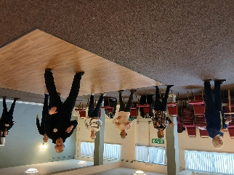

The Tai Chi Tigers are doing well. We meet every Friday at St Theresa's church hall for one hour from 10.30 to 11.30am. The cost is £6.
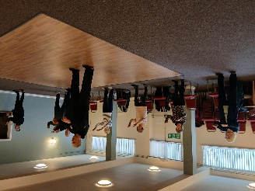
Tai Chi is good for preventing falls as it improves balance, is good for muscle strength and helps concentration. It does us all good to escape the world for an hour , we are beginning to remember the exercises which vary every week with some being repeated more regularly. Phil our trainer is very patient. The exercises can be done seated by anyone less mobile, we don't take ourselves too seriously and have a laugh. Always room for new members, come along and have a go. Anne

The Friendship Group
As the meeting for the Friendship Group fell on Good Friday it was decided not to have a meeting in April. Without more support from members I feel that the Group is likely to fold. It is up to you as members to tell us what you would like the Group to be doing, or a new venue, but bearing in mind that The Plough is free of charge and if we moved elsewhere it would be at a cost. If anyone has any suggestions please get in touch.
Betty

Bridge Club
The Dukeries u3a Bridge Group meet on the Second and Fourth Tuesday of each month at the Jubilee Hall (NG22 9AP) from 1 – 4PM. The cost of each session is currently £3.

 Garden Group
The garden group meets on the second Tuesday of the month at the Mill Dam car park in Warsop at 10am and we car share from there.
Anne.
This year's programme is below.
May 12th... Tansley Barn and Matlock Garden Centre
June 9th.... Dunstan Hall, Chesterfield
July 14th... Walkers Nursery and landscape walk
August 11th... Northern Garden centre, Worksop
September 8th... Reuben Shaw and sons, Moorgreen
October 13th... Cherry Lane, Retford
November 10th... Glapwell Garden centre
December 8th... Blue Diamond Garden Centre, East Bridgford.
🌺
Anne.

Natural History, Science and Technology.

This month we had a trip out to Tuck’s brewery – a micro-brewery in the grounds of Thoresby Park.
Mina our guide was very welcoming and very informative. It was a really enjoyable hour and a half, especially as we got to taste 3 of the 7 beers they brew.
As I was driving I bought some tins to sample at home! Chris

2026 | Activity
May | Trees Ann Ayodele
June | Birds of Prey Chris Shervey


Walking Group
Walk date | Walk Leader | Walk | Distance
21st May | Pat/Bea | Mansfield Woodhouse circular | 4 miles
18th June | Val | Warsop - Major Oak | 4.5 miles
16th July | Brenda | Belph Brook or (South Tunnel) | 6 miles (4 miles)
20th August | Gerald | TBC
17th September | Val | Pleasley Pit | 6 miles
15th October | Brenda | Boughton Brake | 4.5 miles
19th November | Jen | Vicar Water – Sherwood Pines
 |  | NO WALK
 | Walks can be subject to change
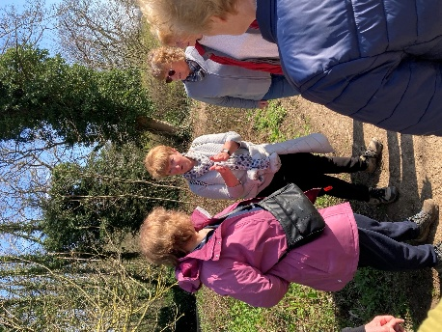
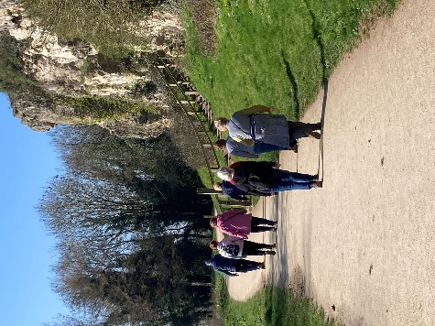
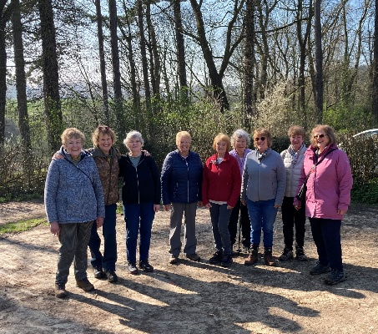
How lucky were we. The weather was perfect, dry, sunny and bright. The original walk was cancelled due to the rain we’d had over the past few weeks making the route impassable in places. However this was changed to the Creswell Loop walk. Meeting up at The Carrs as usual, another walking group was setting off from there. Guess what.. it was Southwell U3A. Even though we had done this walk before it was new to some of the group. Along the route we encountered a few horses from the riding stables doing their thing. Plus it was amazing to see the quarry being transformed as it is being filled. When the walk was finished we encamped in Welbeck courtyard for refreshments. What a lovely way to spend a morning I’m sure we all agreed. Brenda & Pam
We have a full calendar of walks planned and look forward to seeing old and new members. As usual we leave The Carrs (car park) at 10.00 am prompt.
WALKING GROUP – 3RD THURSDAY OF THE MONTH 2026

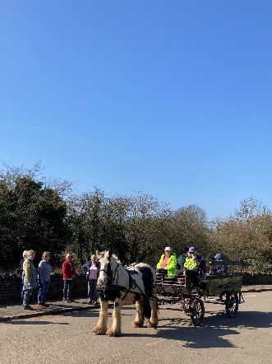
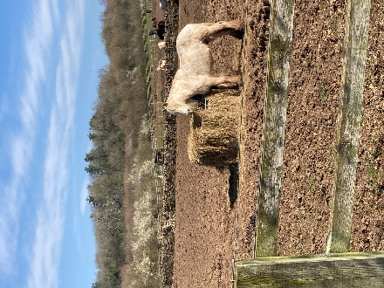
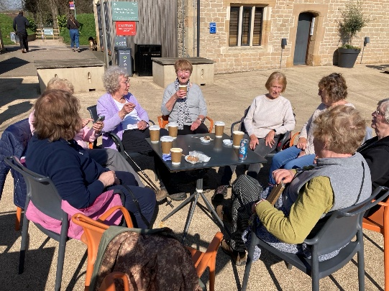
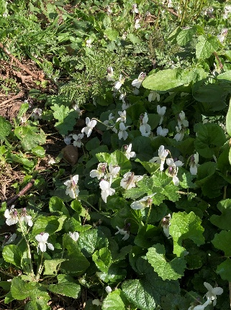

Photography Group
This months online ‘Themed’ challenge was ‘ Pride in your town / Where is this?’ set by Joanne.
Joanne Wheatley
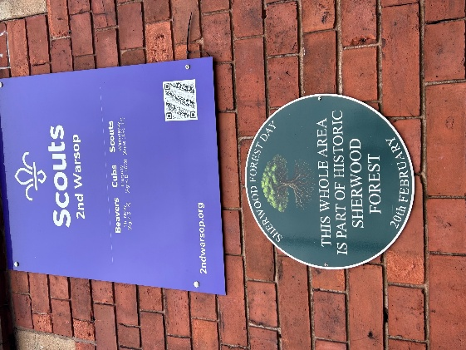
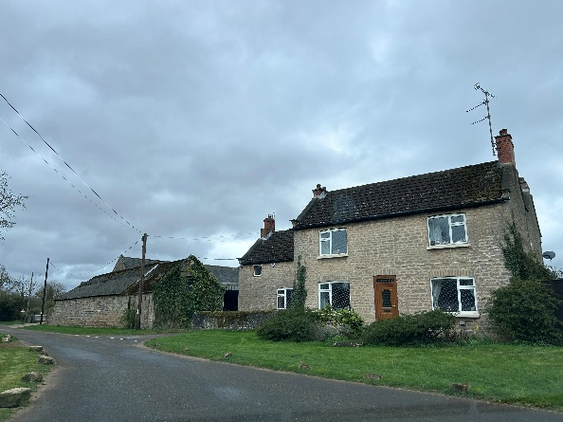

Joyce O’Neil
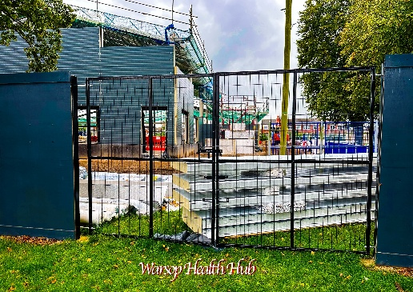


Ken & Mandy Moore
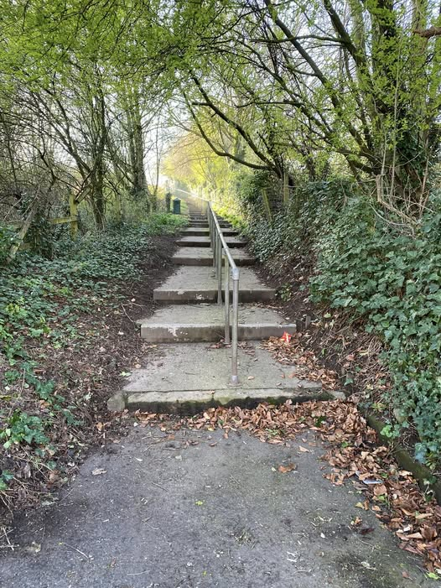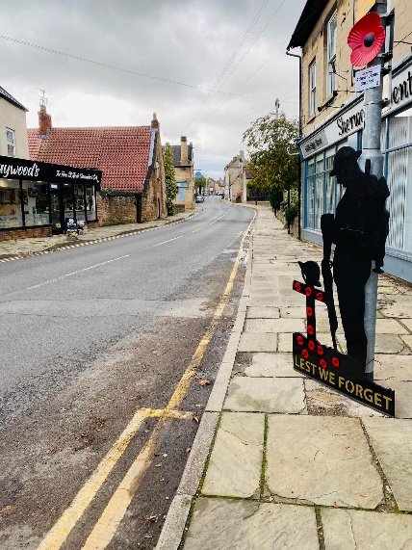

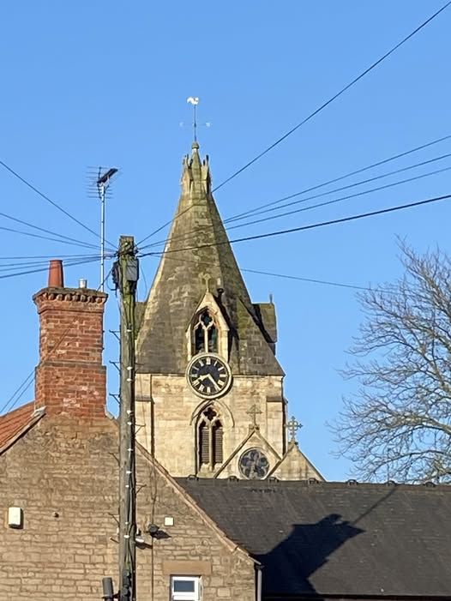

Bob Thomson
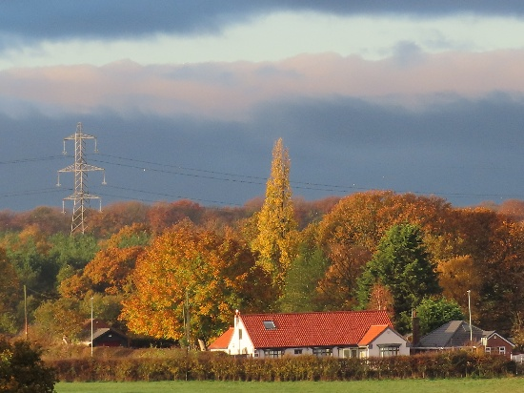
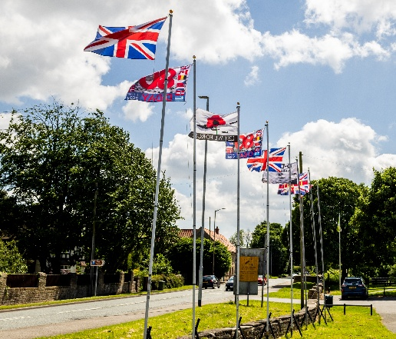
The next ‘Themed’ online challenge is ‘Odds in nature’, set by Ken & Mandy.
This can be odd number of things in nature, things growing in odd places or just something in nature that is a bit odd!
So keep your eyes open and camera ready when you are out and about!
Once again this challenge is open to All u3a members!
Craft Group

Next Monday we are making rag wreaths with the help of Brenda. We have been given some homework as well!
There are also a couple of changes to the itinerary that I will be updating in the near future.
If you would like to join us the only thing you need to bring is a basic sewing kit and a willingness to have a go at anything. All materials are available for a very small donation to the person who brings them, if anything more specialised is required you will be given the opportunity to purchase any item needed yourself, or you can borrow from other group members.
Future itinerary 2026
13th April – Rag Wreath 10.45am – 12.45pm (3rd Monday due to bank holiday)
11th May – Papercraft 10.45am – 12.45pm (3rd Monday due to bank holiday)
1st June – Florentine Embroidery
6th July – Broches
3rd August – Tissue Paper Flowers
7th September – TBC
5th October – Christmas Cards
2nd November – Christmas Decorations
7th December – Christmas Crafts (to sell at Christmas Party)
Looking forward to seeing you at the next meeting.
Zena.


History Group


On the 17th March 2026 the history group enjoyed a visit to Bolsover Castle. We were blessed with a beautiful sunny spring day. Our guide, Beverley, was incredibly knowledgeable about the Cavendish family and gave us an excellent background to the history of the site.
Little Castle
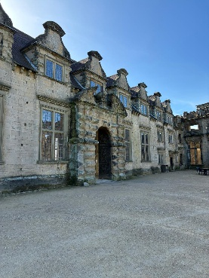
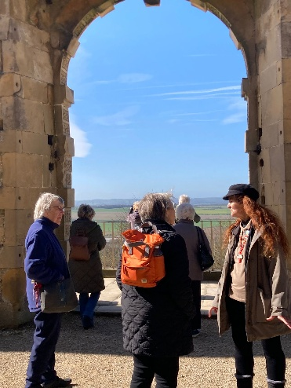
A Norman castle originally stood on this site and was given to William Peverill by Williiam the Conqueror. It later became the property of the Cavendish family. Charles Cavendish was responsible for building the Little Castle within the ruins of this castle as a retreat from his main residence at nearby Welbeck. The castle was inherited by his son, William, 1st Duke of Newcastle. He added state rooms and a Terrace Range to host King Charles 1 and Queen Henrietta Maria.
Equestrian Centre


Charles fought for the King during the English Civil War. Following defeat at Marston Moor he was forced into exile in Belgium. Upon his return to England in 1660 Bolsover had been ruined by the Parliamentarians. Forced to sell his lands in Somerset and Gloucestershire to pay off debt incurred during his exile, William and his second wife, Margaret Cavendish, restored their estates and built the world famous equestrian centre at Bolsover. William was passionate about training horses for corsage, the early form of modern day dressage. The centre is still used today for displays by the horses from nearby Chatsworth.
Enjoying lunch in the cafe
View over Scarsdale

Our next meeting is at St Teresa’s Church Hall on Tuesday, 21st April at 10:00 a.m. Unfortunately, our scheduled speaker is unable to join us due to illness. Instead, Denis Hill will be visiting to give a talk about ‘The Water Mills of Mansfield.’ Dennis has been involved in recent research into this topic and his book on the subject is due to be published in September. We look forward to seeing you there. New members are always welcome.
Barbara & Tamar
2026 - Proposed Calendar of Events for Warsop & District U3A History Group -
Date | Talk/Visit | Venue
21st Apr 2026 | Prehistoric Mansfield  Richard | St Theresa’s Church Hall 10am
19th May 2026 | Arbella Stuart  Colin | St Theresa’s Church Hall 10am
16th Jun 2026 | Visit  Mansfield Woodhouse Trail | Meeting point tba
21st July 2026 | Mansfield to Worksop Railway  Denis Hill | St Theresa’s Church Hall 10am
18th Aug 2026 | The Bands Played On  Chris Weir | St Theresa’s Church Hall 10am
15th Sept 2026 | Visit to Gainsborough Old Hall | TBA
20th Oct 2026 | The Tower of London  Chris Shervey | St Theresa’s Church Hall 10am
17th Nov 2026 | Women Win the War – WW1  Grant Cullen | St Theresa’s Church Hall 10am
 | No meeting as very close to Christmas

Speakers for the main meetings
2026
April Nottinghamshire Pit Pony Janine Buckley

May Rivers just keep rollin’ along Phil Crompton

June Do You Remember (a light-hearted presentation with audience involvement spanning
the past 80 or so years). Peter Savage

July Belpers Extraordinary Waterpower Story Ian Jackson

August The British Legion Elaine Hopkins

September Annual General Meeting

October All Things Ghostly and Mysterious Joanna Cowell

November My China Bike Ride Jenny Long

December Christmas Party
Group | Leaders Name | Tel
NATURAL HISTORY SCIENCE AND TECHNOLOGY | Chris Shervey
WALKING GROUP | Brenda Pearce  Pam Hick
STROLLERS | Janet Harford  Pat Magness
HISTORY GROUP | Barbara Spybey
CRAFTS | Zena Inger
GARDENING | Anne Poultney
PHOTOGRAPHY | Rob Thomson
FRIENDSHIP GROUP | Betty Trinder
TAI CHI | Anne Poultney

INTEREST GROUP TIMETABLE
 | MONDAY | TUESDAY | WEDNESDAY | THURSDAY | FRIDAY
1st | 10am – 12pm  CRAFTS GROUP  St Teresa’s Catholic Church hall. Warsop |  |  |  | 2pm  FRIENDSHIP GROUP  The Plough Warsop
2nd |  | 10am  GARDENING GROUP  Venue agreed by members |  | 2 – 3.30  NATURAL HISTORY  SCIENCE AND  TECHNOLOGY  St Teresa’s Catholic Church Hall Warsop
3rd | MAIN MEETING 10.15  Oaklands Centre  Warsop | 10am– 12pm  HISTORY GROUP  St Teresa’sCatholic Church hall. Warsop |  | 10am  WALKING GROUP  Carrs Car Park | 11.am  PHOTOGRAPHY  Venue to be agreed by the members.
4th |  |  | 10.am  STROLLERS  Carrs Car Park
PHOTOGRAPHY GROUP-Please see Newsletter for the online challenge.
TAI CHI Every Friday 10.30am St Teresa’s Catholic Church hall

Committee Members | Role
Lynne Hutchinson | Chairperson
Mel Mitchell | Deputy Chairperson
Irene Clay | Business Secretary
Linda Crossley | Treasurer
Zena Inger | Membership Secretary
Jim Shervey | Speaker Seeker
Jennifer Thomson | Groups co-ordinator
Chris Shervey | Newsletter editor
Ann Ayodele | Social Events
Jennifer Thomson | Welfare Officer
Rob Thomson | Website & Facebook manager
Ann Ayodele | Refreshments rota
Betty Trinder | Social events assistant

Warsop & District U3A is committed to treating all people equally. Anyone wishing to see the Privacy and Data Protection policies may view them on the Warsop.u3asite.uk alternatively please ask Rob.

Website & Facebook
The Warsop & District u3a website can be found at Warsop.u3asite.uk . If any of the group leaders/facilitators would like to advertise/ promote any of their future activities or change the information shown, please contact Bob Thomson

Facebook
Warsop & District U3A has a Facebook Group. It is a private group which can be seen by the public but only members can see who’s in the group and what they post.
What this means is that you have to be invited to join the group or have your request to join accepted. Also you need to be on Facebook which some of you may not be. As a member of the group you will be able to put your own posts on the page, please keep them relevant to the U3A and what it stands for. We would ask that you don't put anything on that is in anyway party political or anything that may be offensive to others who may be of a different creed or religion. Hopefully everyone will join, use the page and find it useful.
One of the things that puts people ‘off’ Facebook, is the ‘bad press’ some of the Social sites get. You can join Facebook, choose only to join the Warsop Facebook page and not be involved in any other site, or Friends requests (usually from people that you have never heard of!) The choice is entirely yours.
To request to join the Warsop u3a Facebook page, contact Bob Thomson.
Answers March quiz---- the 100 quiz
1What letter is 100 in Roman numerals? C
2 Cent is 100 in which language? Spanish / French
3 Who wrote 100 (and 1) Dalmatians? DODIE SMITH
4 Cien is 100 in which language? Italian / Spanish
5 True or false a 100 sided shape is called a hectogon?
6 Hundra is 100 in wch language? Swedish / Danish
7 How many men were there in 2023 aged 100 in the UK?
5,600 3,111 2,950
8 Hundert is 100 in which language? Polish / German
9 What is it called in cricket when a batsman scores 100? CENTURY
10 Cento is 100 in which language? Greek / Italian
11 How long did the 100yrs war last?
100yrs 104yrs 116yrs
12 Hundre is 100 in which language? Danish / Norwegian
13 When did the NSPCC celebrate it’s centenary?
1984 1987 1991
14 Cto is 100 in which language? Russian / Polish
15 How many women were there in 2023 aged 100 in the UK?
10,987 13,180 12,402
16 Ekato is 100 in which language? Russian / Greek
17 When did the RSPCA celebrate it’s centenary?
1920 1924 1954
18 Cem is 100 in which language ? Portugese / Spanish
