
Issue 99 February 2026

Warsop & District
Notes from the Chair
Dear members

As we move into February I hope this newsletter finds you well and keeping warm during the long winter months?

January was a great start to the New Year with a varied programme and plenty of opportunity to connect after the Festive season. I thought last month's speaker from Age UK was particularly interesting and I hope that some of you have taken advantage of their offers and advice.

As always any new ideas from yourselves would be welcome.

As February is the month of love and pancakes don't forget to give your loved ones an extra hug and don't put too much sugar on your pancakes.

Finally in the words of C.S.Lewis don't forget "You are never too old to set another goal or to dream a new dream "

Lynne x

Membership renewals 2026
Hi. It is time to be thinking about when you are going to renew your membership.

You will be pleased to hear that we are able to keep the cost of membership at £20.00 for full membership or £16.00 for joint members with proof of full membership at another u3a. (Please make a note on the form of whether you are a full or associate member, please have your membership card for your full membership u3a to show)
You will be able to renew your membership at the February, March or April meetings.

The current membership year ends at the end of March, so anyone who has not renewed after the April meeting will be taken off the circulation lists, (this does not prevent you rejoining at a later date).
Please collect your renewal form at the January meeting. Payment can be made either by cheque, made payable to Warsop & District u3a, or with cash (Please have the correct money if possible). I will be handing out new cards from May onwards.

Anyone who can’t or don’t attend the General meeting can print the form attached, this can then be either scanned and attached to an email or, the printed, completed form can be sent along with a signed and dated CHEQUE to Warsop & District u3a Membership Secretary. (If you don’t have a printer then please contact me and I will post a form out to you, which will need to be returned as above).

Make sure that you tick or cross all boxes as I need this information for records. If any boxes are not marked then I will assume that you don’t want to receive the TAT magazine etc…
Please make sure that you date and sign both cheques and renewal forms. If there are two people on the form then please will both parties sign and date the form.
Zena

The deadline for including articles/information in the next newsletter is Friday 6th March. Send contributions to Chris Shervey. If you have any ideas for new items to include in the newsletter please let me know.

Rota for refreshments and greeting.
This is the rota for the next two months, any problems please contact me, Ann Ayodele.
Thank you to all those who have volunteered to help, without you our meetings would not be enjoyable.

Date | Refreshments 1 | Refreshments 2 | Meet and Greet 1 | Meet and Greet 2
16th Feb | Ann Ayodele | Barbara Hartshorn | Chris Wilson | Brenda Pearce
16thMarch | Janet Harford | Yvonne Pannifer | Yvonne Brown | Glenys Fearn

EVENTS

IDLE VALLEY NATURE RESERVE BEAVER TOURS.
Tickets have now been purchased for those wishing to visit the Beaver enclosure at the Idle Valley Nature Reserve. This will take place on Sunday 21st June at 10.30am.

ITEMS OF INTEREST
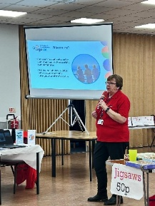
Speakers
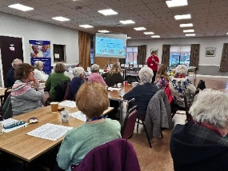
The speaker in January, Elaine Hopkins from Age UK Notts, was very informative with her talk ‘I Thought Nobody Cared!’ Here are a couple of pics of Elaine in action.
This months speaker, Mike Higginbottom is going to give a talk on Waterways and Railways across the Derbyshire Peak

SUNDAY LUNCHES
If anyone would like me to organise an occasional Sunday lunch at any of our local venues I would be happy to do so 3 or 4 times per year. Please let me know if this is of interest to you. Jen.

LONDON THEATRE BREAKS
Several coach companies offer trips to London to see a couple of shows with overnight accommodation. Cost is usually around £250. If anyone is interested please let me know. Jen.

WARSOP HEALTH CENTRE
The meeting about booking appointments at the Health Centre on Tuesday 20th January was well attended. Kevin Gray from the Patients' Participation Group explained that The Department of Health has introduced a new method of booking appointments online. This is mandatory for all surgeries and should have been implemented from 1st October 2025. For those patients with internet access it involves completing a questionnaire, accessed via the Health Centre's website. Those patients without internet access may still ring the Health Centre or visit but the questionnaire must still be completed by the receptionist. Completed questionnaires are then triaged and an appointment offered if appropriate. Kevin is happy to help individuals experiencing difficulties and I have his contact details if anyone would like them. He is also pleased to offer help to anyone needing advice on topics such as state benefits and will help to complete application forms for benefits or disabled parking badges. This is a free service. Jen.


Table Tennis Club- Warsop Health Hub-Mondays 1.30-3.30pm
If you would like to have a go at playing table tennis then please do join Pam Hick and Ian James at the Health Hub each Monday from 1.30-3.30pm. The cost is £4 per person. Bats and balls are provided.
Vibrant Warsop has supported this venture with the purchase of 2 brand new tables. Both Pam and Ian are also members of the U3a (Pam-Warsop & Ian- Forest Town)
You do not need to be a member of the Health Hub- just turn up!


WELFARE

Please let me know if any of our members are unwell or bereaved so that I may send them our good wishes. Jen.

Cups Please will as many of you as
possible bring your own mug for your tea or coffee. This is not only more environmentally friendly but also would save us a lot of money as the paper disposable cups we use are surprisingly expensive. Ann.
Robin Hood Lottery 
Warsop and District U3A is a cause registered with the Robin Hood Lottery.
To buy a ticket you can now register on line at www.robinhoodlottery.co.uk and set up regular payments. If you buy a ticket every week for a year Warsop U3A will receive £26.
Remember the more members that have a go (specifying Warsop & District U3A) the more money we get for our funds.

February quiz--- All ANSWERS contain a COLOUr
1 Actor who played Pike in Dads Army?
2 Professor ? in Cluedo?
3 Novel by Anne Bronte?
4 Parliaments man with a “stick” ?
5 Famous RAF display team?
6 A Midlands cheese?
7 Common garden bird?
8 Military police known as ?
9 Song sung by Prince?
10 Geordie beer?
11 Song by the group Scaffold?
12 Permit to work in USA?
13 Former snooker player?
14Another name for Mercury?
15 Yorkshire race course?
16 Illuminated resort?
17 Billy Bunters school?
18 Flight recorder?
19 A Strauss waltz?
20 Former Prime minister?
21 Transport for the owl and the pussycat?
22 Young deer?
23 Novel by Anna Sewell?
24 Elvis’s footwear?
25 Another name for Ireland?
26 Character from Gone With the Wind?
27 They seek him here they seek him there, Who?
28 Where the cenotaph stands?
29 Environmental campaigners?
30 Ian Flemings home?

February quick quiz all answers start with a
1 King of Britons?
2 A Greek philosopher?
3 A New Zealand Town?
4 Dam on the river Nile?
5 Fruit with 7,500 varieties?
6 TV family of monsters?
7 A President of USA?
8 Beautifully Happily Slowly are examples of ?
9 Pioneers of flight --------- and Brown?
10 Palace in Granada Spain?

ANSWERS TO LAST MONTHS QUIZ AT END OF NEWSLETTER.

GROUP NEWS
COULD ALL GROUP LEADERS PLEASE COLLECT THEIR BADGES WHEN THEY COLLECT THEIR LANYARDS. THEN MEMBERS CAN SEE WHO TO SPEAK TO ABOUT A GROUP.
THANK YOU

Don't forget to check the folders giving details of all groups currently running at Warsop and neighbouring u3as.
I have been in touch with Mansfield District Council about hiring their meeting rooms in Warsop for our group meetings. Their charges for registered charities are just £5.51 per hour. This compares favourably with most room hire charges. Regular users are given a set of keys. If any of our group leaders are considering a change of venue I have contact details. Jen.

If you would like to see more groups forming please let me know or complete the sheet available at general meetings. Thank you, Jen.

North Notts Neighbourhood group
This means that you as a member of Warsop & District can ask to join an interest group in another U3A that is also in the NNNG, as long as the group is not oversubscribed at the time of your request you can join the group without joining the host u3a
The u3as in the NNNG are Mansfield, Sherwood, Dukeries, Rainworth, Forest Town, Ashfield, Sutton in Ashfield, Hucknall, Worksop, Warsop, Retford and Bolsover.

 Strollers
Strollers - 25th February 2026 - Creswell Crags Meet at 10.00 am at The Carrs car park for car share to Dukeries Garden Centre car park


Tai Chi Tigers
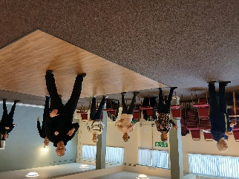

The Tai Chi class is going well, we usually meet every Friday at St Theresa's Church Hall in Warsop for a one hour session from 10.30 to 11.30am at a cost of £6. We may not be meeting on 27th February due to a funeral at the Church on that day.

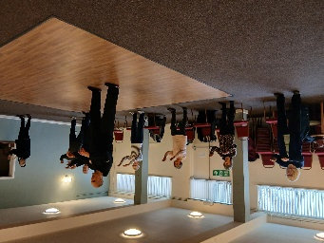
Tai Chi is good for health, although it consists of gentle exercise it is very beneficial and helps with balance, muscle strength and mental health, it helps to prevent falls. It is good to get away from everyday worries for an hour and forget what is going on in the outside world . Although we do concentrate and try to remember the exercises we don't take ourselves too seriously and have a laugh as well. There is always room for new members.
Anne.

The Friendship Group
Unfortunately the Friendship Group was cancelled again due to low number of members intending to come to the February meeting. I feel that as numbers have now gone so low that we need to consider whether we carry on or not. If any members have any ideas on how we might boost numbers or improve the Group I would like them to come forward and talk to me at the next U3A meeting, or if you would like to join the group that would be even better. Generally we meet on the first Friday of the month at The Plough Inn at 2.00 p.m. Betty

Bridge Club
The Dukeries u3a Bridge Group meet on the Second and Fourth Tuesday of each month at the Jubilee Hall (NG22 9AP) from 1 – 4PM. The cost of each session is currently £3.

 Garden Group
We meet at the car park by the Mill Dam in Warsop on the second Tuesday of the month at 10am and car share from there.

For our first meeting this year we went to Dobbies garden centre for coffee and a look around then went to Arrow farm for lunch and discussed this year's programme of trips out.
Our February visit will be to Tickhill garden centre on 10th February.

This year's programme is below.

March 10th.... Southwell Garden Centre - Hollybeck Nursery

April 14th.... Pennell's Garden Centre, Lincoln

May 12th... Tansley Barn and Matlock Garden Centre

June 9th.... Dunstan Hall, Chesterfield

July 14th... Walkers Nursery and landscape walk

August 11th... Northern Garden centre, Worksop

September 8th... Reuben Shaw and sons, Moorgreen

October 13th... Cherry Lane, Retford

November 10th... Glapwell Garden centre

December 8th... Blue Diamond Garden Centre, East Bridgford.
🌺
Anne.

Natural History, Science and Technology.

This month Jim gave us a talk on microwaves and there uses, not only for cooking but for communications. We also had a demo where using a long rope he showed us the different parts of the wave. We learnt that microwaves are part of a bigger family of waves e.g. x rays gamma rays all travelling at the speed of light, with different wave lengths.

2026 | Activity
March | Skin Inside and Out Joyce O’Neill
April | Visit to Tucks Brewery Thoresby
May | Trees Ann Ayodele
June | Birds of Prey Chris Shervey


Walking Group
We have a full calendar of walks planned and look forward to seeing old and new members. As usual we leave The Carrs (car park) at 10.00 am prompt.
Date | Walk Leader | Walk | Distance
19th February | Sonja | Old Oaks in Sherwood Forest
19th March | Brenda | Retford – Little Gringley | 4.5 miles
16th April | Pam | Sherwood | 4.5 miles
21st May | Pat/Bea | Mansfield Woodhouse circular | 4 miles
18th June | Val | Warsop - Major Oak | 4.5 miles
16th July | Brenda | Belph Brook or (South Tunnel) | 6 miles (4 miles)
20th August | Gerald | TBC
17th September | Val | Pleasley Pit | 6 miles
15th October | Brenda | Boughton Brake | 4.5 miles
19th November | Jen | Vicar Water – Sherwood Pines
December |  | NO WALK
 |  | Walks can be subject to change

WALKING GROUP – 3RD THURSDAY OF THE MONTH 2026

Photography Group
On Saturday 17th Jan 2026 the Photography Group visited the Edwinstowe RSPB visitor centre to witness the arrival of the KRAMPUS as they entered Sherwood forest. The KRAMPUS are mythical creatures from the Alpine regions who are the exact opposite of Santa Claus as they punish anyone on the ‘Naughty’ list.
Whilst we awaited their arrival we were kept entertained by the RATTLEJAG Morris dancers who weren’t exactly dressed for the cold damp conditions!
The online ‘Themed’ challenge was ‘Anything associated with Winter’. A few of the photos are shown here, more can be seen in the Photography group folder, on the Warsop u3a Facebook page and on the Warsop u3a website – warsop.u3asite.uk
Joanne Wheatley – Winter

RATTLEJAG/ KRAMPUS
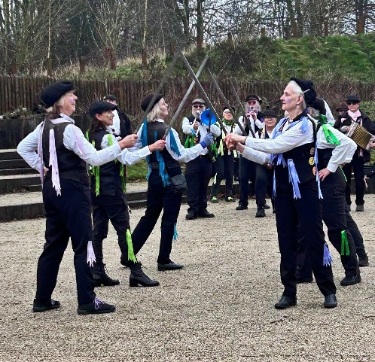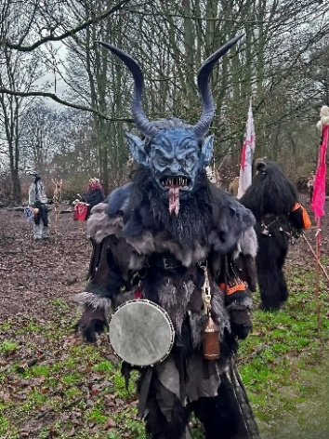

Betty Trinder – RATTLEJAG /KRAMPUS
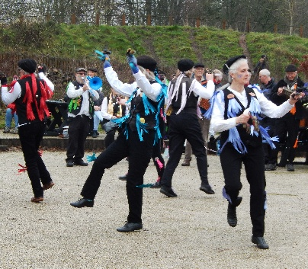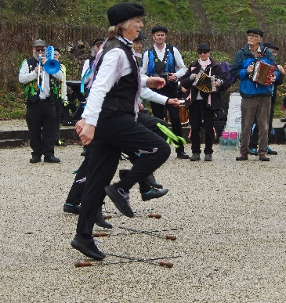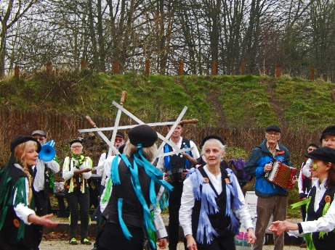
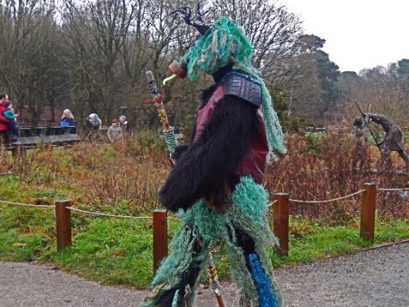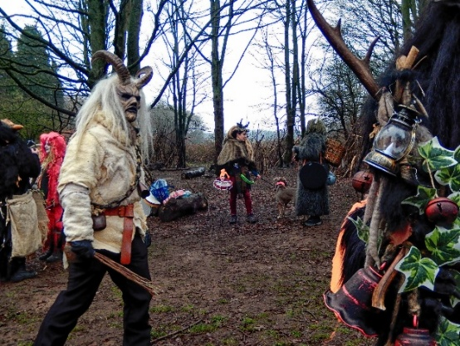
Jen Thomson – Winter Joyce O’Neil - Winter
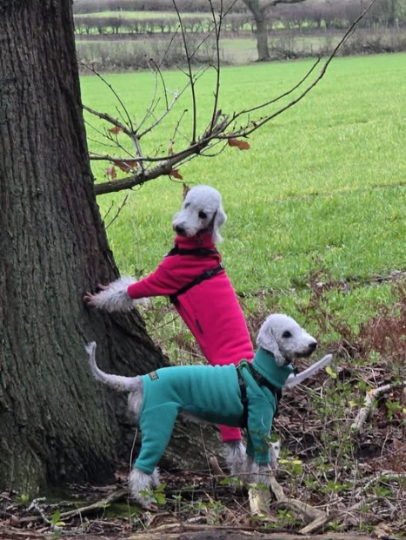

Jim & Chris SHERVEY – Winter

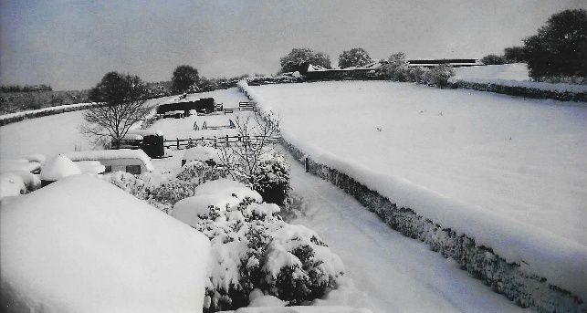
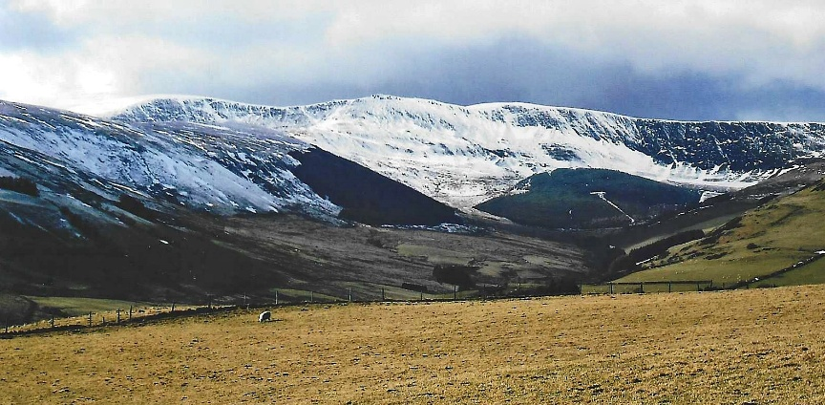

Bob Thomson – Winter

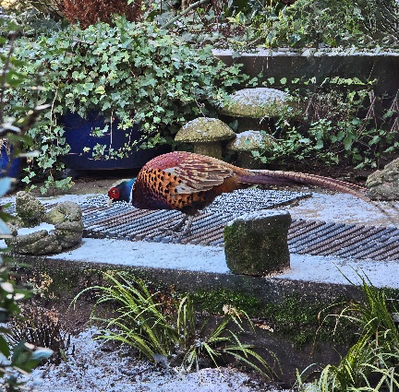

RATTLEJAG/ KRAMPUS
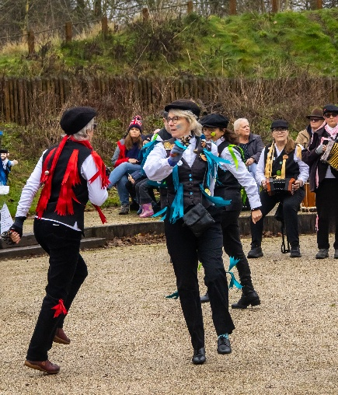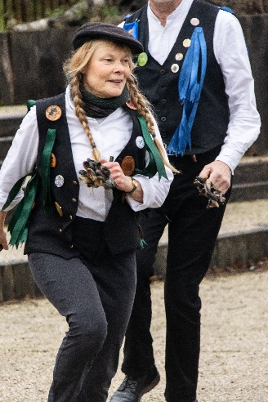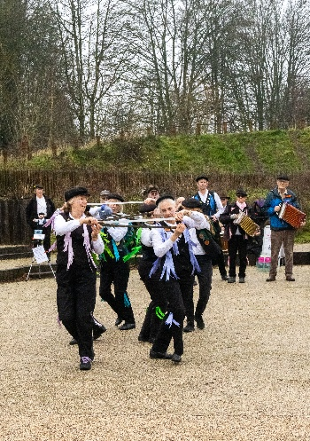

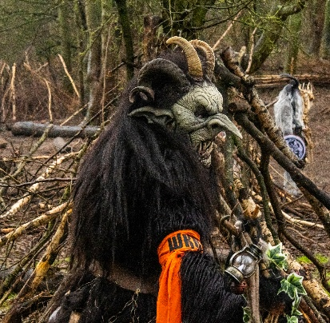
The next ‘Themed’ online challenge will be ‘Glass’ set by Betty Trinder.
As usual All u3a members are welcome to join in the challenge!
Craft Group 

Nine of us met on Monday 2nd February where we decorated photo frames, we all did a lovely job and they all look great.
If you would like to join us the only thing you need to bring is a basic sewing kit and a willingness to have a go at anything. All materials are available for a very small donation to the person who brings them, if anything more specialised is required you will be given the opportunity to purchase any item needed yourself, or you can borrow from other group members.
The craft group meets the first Monday of the month 10am – 12noon St Theresa’s catholic church, Clumber Street, Warsop. NG20 0LX. The carpark is on Ridgeway and there is a set of steps down to the hall. If you do have mobility issues it may be better to park in either the library or main car park in Warsop.
Future itinerary 2026
2nd March – Fabric Easter Decorations
13th April – Rag Wreath (3rd Monday due to bank holiday)
11th May – Papercraft (3rd Monday due to bank holiday)
1st June – Florentine Embroidery
6th July – Broches
3rd August – Tissue Paper Flowers
7th September – TBC
5th October – Christmas Cards
2nd November – Christmas Decorations
7th December – Christmas Crafts (to sell at Christmas Party)
Looking forward to seeing you at the next meeting on Monday 2nd.
Zena.

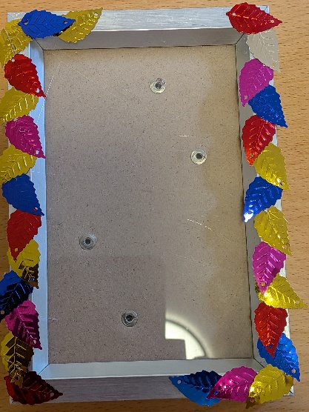

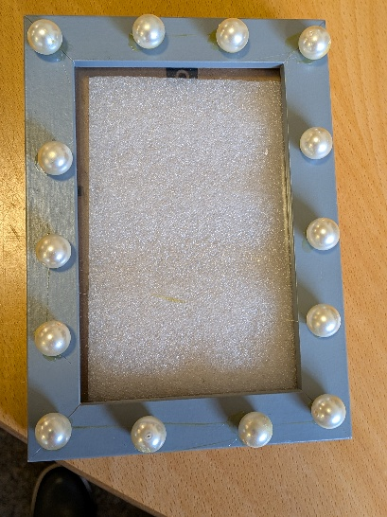







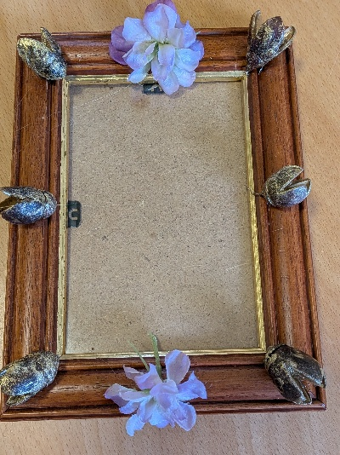


History Group

The history group had their first meeting of the year on Tuesday 20th January which was very well attended.
Denis Hill gave a very interesting talk about Dukes and Dukeries. This linked nicely with our upcoming visit to Bolsover Castle and the life of the Duke of Newcastle.

Our next meeting is on Tuesday 17th of February at 10am at St Teresa’s church hall, Warsop.
Unfortunately, our calendared event has been cancelled due to illness.
However, we are very pleased to say we will be welcoming Paul Jameson from The Battle of Hatfield Society who will be speaking about the investigations they have been undertaking at Cuckney. I know quite a few of our members have expressed interest in this very local project and we are very pleased that Paul is able to come along to speak to us.

Barbara will be collecting payment or deposits from those who have booked a place on the bus for our visit in March to Bolsover Castle.

We look forward to seeing you at our next meeting. All welcome.
Barbara and Tamar
2026 - Proposed Calendar of Events for Warsop & District U3A History Group -
Date | Talk/Visit | Venue
17th Feb 2026 | Norman coins and the Stories they Tell  Dr Anja Thompson-Rohde | St Theresa’s Church Hall 10am
17th Mar 2026 | Visit  Bolsover Castle | Meeting point tba
21st Apr 2026 | Prehistoric Mansfield  Richard | St Theresa’s Church Hall 10am
19th May 2026 | Arbella Stuart  Colin | St Theresa’s Church Hall 10am
16th Jun 2026 | Visit  Mansfield Woodhouse Trail | Meeting point tba
21st July 2026 | Mansfield to Worksop Railway  Denis Hill | St Theresa’s Church Hall 10am
18th Aug 2026 | The Bands Played On  Chris Weir | St Theresa’s Church Hall 10am
15th Sept 2026 | Visit to Gainsborough Old Hall | TBA
20th Oct 2026 | The Tower of London  Chris Shervey | St Theresa’s Church Hall 10am
17th Nov 2026 | Women Win the War – WW1  Grant Cullen | St Theresa’s Church Hall 10am
 | No meeting as very close to Christmas

Speakers for the main meetings
2026
February Waterways and Railways across the Derbyshire Peak Mike Higginbottom

March Dining With Chaucers Pilgrims Judith Hedley

April Nottinghamshire Pit Pony Janine Buckley

May Rivers just keep rollin’ along Phil Crompton

June Do You Remember (a light-hearted presentation with audience involvement spanning
the past 80 or so years). Peter Savage

July Belpers Extraordinary Waterpower Story Ian Jackson

August The British Legion Elaine Hopkins

September Annual General Meeting

October All Things Ghostly and Mysterious Joanna Cowell

November My China Bike Ride Jenny Long

December Christmas Party
Group | Leaders Name | Tel
NATURAL HISTORY SCIENCE AND TECHNOLOGY | Chris Shervey
WALKING GROUP | Brenda Pearce  Pam Hick
STROLLERS | Janet Harford  Pat Magness
HISTORY GROUP | Barbara Spybey
CRAFTS | Zena Inger
GARDENING | Anne Poultney
PHOTOGRAPHY | Rob Thomson
FRIENDSHIP GROUP | Betty Trinder
TAI CHI | Anne Poultney

INTEREST GROUP TIMETABLE
 | MONDAY | TUESDAY | WEDNESDAY | THURSDAY | FRIDAY
1st | 10am – 12pm  CRAFTS GROUP  St Teresa’s Catholic Church hall. Warsop |  |  |  | 2pm  FRIENDSHIP GROUP  The Plough Warsop
2nd |  | 10am  GARDENING GROUP  Venue agreed by members |  | 2 – 3.30  NATURAL HISTORY  SCIENCE AND  TECHNOLOGY  St Teresa’s Catholic Church Hall Warsop
3rd | MAIN MEETING 10.15  Oaklands Centre  Warsop | 10am– 12pm  HISTORY GROUP  St Teresa’sCatholic Church hall. Warsop |  | 10am  WALKING GROUP  Carrs Car Park | 11.am  PHOTOGRAPHY  Venue to be agreed by the members.
4th |  |  | 10.am  STROLLERS  Carrs Car Park
PHOTOGRAPHY GROUP-Please see Newsletter for the online challenge.
TAI CHI Every Friday 10.30am St Teresa’s Catholic Church hall

Committee Members | Role
Lynne Hutchinson | Chairperson
Mel Mitchell | Deputy Chairperson
Irene Clay | Business Secretary
Linda Crossley | Treasurer
Zena Inger | Membership Secretary
Jim Shervey | Speaker Seeker
Jennifer Thomson | Groups co-ordinator
Chris Shervey | Newsletter editor
Ann Ayodele | Social Events
Jennifer Thomson | Welfare Officer
Rob Thomson | Website & Facebook manager
Ann Ayodele | Refreshments rota
Betty Trinder | Social events assistant

Warsop & District U3A is committed to treating all people equally. Anyone wishing to see the Privacy and Data Protection policies may view them on the Warsop.u3asite.uk alternatively please ask Rob.

Website & Facebook
The Warsop & District u3a website can be found at Warsop.u3asite.uk . If any of the group leaders/facilitators would like to advertise/ promote any of their future activities or change the information shown, please contact Bob Thomson

Facebook
Warsop & District U3A has a Facebook Group. It is a private group which can be seen by the public but only members can see who’s in the group and what they post.
What this means is that you have to be invited to join the group or have your request to join accepted. Also you need to be on Facebook which some of you may not be. As a member of the group you will be able to put your own posts on the page, please keep them relevant to the U3A and what it stands for. We would ask that you don't put anything on that is in anyway party political or anything that may be offensive to others who may be of a different creed or religion. Hopefully everyone will join, use the page and find it useful.
One of the things that puts people ‘off’ Facebook, is the ‘bad press’ some of the Social sites get. You can join Facebook, choose only to join the Warsop Facebook page and not be involved in any other site, or Friends requests (usually from people that you have never heard of!) The choice is entirely yours.
To request to join the Warsop u3a Facebook page, contact Bob Thomson.

ANSWERS January quiz Answer the clues to work out the
name of a bird.
1 Rouse a little cat KITTIWAKE
2 Out of breath PUFFIN
3 Nothing in cricket DUCK
4 Boast CROW
5 Magician MERLIN
6 Wise one OWL
7 Country that is good to eat TURKEY
8 What a happy dog may do WAGTAIL
9 Tie up by a river/domestic fowl MOORHEN
10 The ancient Mariners bird ALBATROS
11 Is it getting fat? GOOSE
12 After eating you ------ SWALLOW
13 Ladle the account SPOONBILL
14 Bird from the tower RAVEN
15 Roman/USA emblem EAGLE
16 Just a letter JAY
17 Grumble GROUSE
18 Fast SWIFT
19 For lifting things CRANE
20 Dark colour BLACKBIRD

ANSWERS January quick quiz letters---- what do these letters stand for?
- ENT EAR NOSE and THROAT
- BA BATCHELOR of ARTS
- NASA NATIONAL AERONAUTICS and SPACE ADMINISTRATION
- M (Roman Numerals) 1,000
- GMT GREENWICH MEANTIME
- MD MEDICAL DOCTOR
- ETA ESTIMATED TIME OF ARRIVAL
- Bsc BATCHELOR of SCIENCE
- SOS SAVE OUR SOULS
- D (Roman numerals) 500

