
Issue 98 January 2026

Warsop & District
Notes from the Chair
Good morning and a Happy New Year to you all.
I hope you all enjoyed the Christmas and New Year celebrations and are looking forward to the year ahead.
Our monthly meetings remain an important part of Warsop U3A life and provide us all with a chance to socialise, listen to interesting speakers and keep up to date with news and events. Therefore the Committee and myself encourage members to attend whenever possible and bring along any family or friends who might be interested in joining us.
Looking ahead we are always open to new ideas so if you had any suggestions or would like to be more involved please don't hesitate to speak to one of our committee members.
Finally on behalf of the committee I wish you all a happy, healthy and prosperous year ahead and we all look forward to seeing you at our meetings and activities throughout 2026.
Lynne

Membership renewals 2026
Hi. It is time to be thinking about when you are going to renew your membership.A
You will be pleased to hear that we are able to keep the cost of membership at £20.00 for full membership or £16.00 for joint members with proof of full membership at another u3a.
You will be able to renew your membership at the February, March or April meetings.
The current membership year ends at the end of March, so anyone who has not renewed after the April meeting will be taken off the circulation lists, (this does not prevent you rejoining at a later date).
Please collect your renewal form at the January meeting. Payment can be made either by cheque, made payable to Warsop & District u3a, or with cash (Please have the correct money if possible). I will be handing out new cards from May onwards.
Anyone who can’t or doesn’t attend the General meeting can contact the Warsop & District u3a Membership Secretary, using the Warsop u3a website – Warsop.u3asite.uk
Make sure that you tick or cross all boxes as I need this information for records. If any boxes are not marked then I will assume that you don’t want to receive the TAT magazine etc…
Please make sure that you date and sign both cheques and renewal forms. If there are two people on the form then please will both parties sign and date the form.

The deadline for including articles/information in the next newsletter is Friday 6th February. Send contributions to Chris Shervey. If you have any ideas for new items to include in the newsletter please let me know.

Rota for refreshments and greeting.
This is the rota for the next three months, any problems please contact me, Ann Ayodele.
Thank you to all those who have volunteered to help, without you our meetings would not be enjoyable.

Date | Refreshments 1 | Refreshments 2 | Meet and Greet 1 | Meet and Greet 2
19th Jan | Karen Breed | Beatrix Kirby | Raymond White | Ann Barnes
16th Feb | Audrey Gilbert | Janet Harford | Chris Wilson | Brenda Pearce
16thMarch | Ann Ayodele | Barbara Hartshorn | Yvonne Brown | Glenys Fearn

EVENTS

IDLE VALLEY NATURE RESERVE BEAVER TOURS.
There are 16 spaces left, at time of writing, for the guided tour of the Beaver Enclosure at Idle Valley Nature Reserve, Retford, on Sunday 21st June at 10.30am.
Full price is £25 each and I shall collect this from anyone wanting to go at the January meeting. I have been told that groups of 5 or 10 qualify for discounts, so I shall issue refunds if we can get sufficient interest.
There is a car park next to the enclosure but the ground inside is likely to be quite rough. Hopefully it won't be muddy in June. Jen.
ITEMS OF INTEREST
Warsop u3a Christmas events
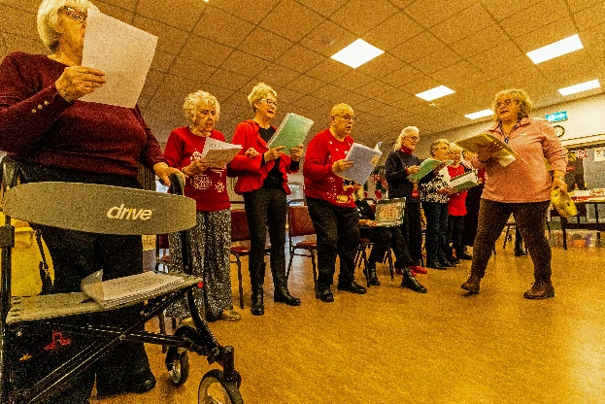
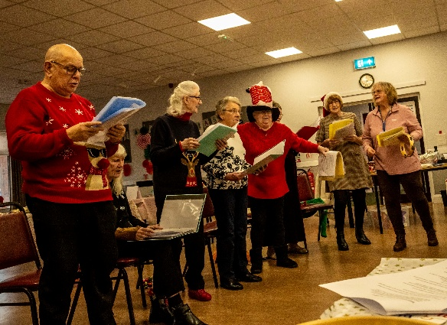
Party at the Oaklands

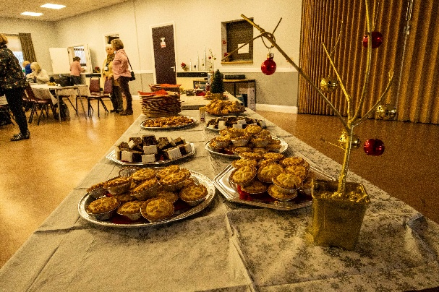
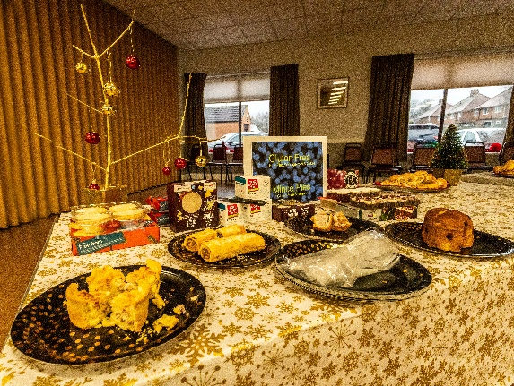

Christmas Dinner at the Hostess

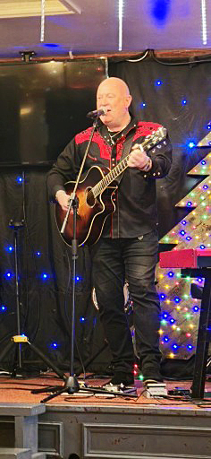



HEALTH MATTERS
Problems booking appointments or ordering repeat prescriptions at the Health Centre?
Kevin Gray of the Patient Participation Group from the local Health centre has kindly agreed to come to explain our rights when trying to contact the Health Centre.
Kevin has given me a date when he is available, 20th January, 10.30 till 1.00pm.
The Burns Community Centre has been booked for our meeting
All welcome.
Jen Thomson


Table Tennis Club- Warsop Health Hub-Mondays 1.30-3.30pm
If you would like to have a go at playing table tennis then please do join Pam Hick and Ian James at the Health Hub each Monday from 1.30-3.30pm. The cost is £4 per person. Bats and balls are provided.
Vibrant Warsop has supported this venture with the purchase of 2 brand new tables. Both Pam and Ian are also members of the U3a (Pam-Warsop & Ian- Forest Town)
You do not need to be a member of the Health Hub- just turn up!


WELFARE

I'm pleased to say that I haven't been notified of any illnesses or bereavements since we last met.
However, if you do know of any members who are unwell or who have suffered a bereavement, please let me know. I will then send them our best wishes. Jen.

Cups Please will as many of you as
possible bring your own mug for your tea or coffee. This is not only more environmentally friendly but also would save us a lot of money as the paper disposable cups we use are surprisingly expensive. Ann.
Robin Hood Lottery 
Warsop and District U3A is a cause registered with the Robin Hood Lottery.
To buy a ticket you can now register on line at www.robinhoodlottery.co.uk and set up regular payments. If you buy a ticket every week for a year Warsop U3A will receive £26.
Remember the more members that have a go (specifying Warsop & District U3A) the more money we get for our funds.

Raffle.
The raffle made £75 in December. Thank you
RAFFLE PRIZES NEEDED PLEASE
RAFFLE PRIZES NEEDED .

January quiz Answer the clues to work out the name of a bird.

1 Rouse a little cat
2 Out of breath
3 Nothing in cricket
4 Boast
5 Magician
6 Wise one
7 Country that is good to eat
8 What a happy dog may do
9 Tie up by a river/domestic fowl
10 The ancient Mariners bird
11 Is it getting fat?
12 After eating you ------
13 Ladle the account
14 Bird from the tower
15 Roman/USA emblem
16 Just a letter
17 Grumble
18 Fast
19 For lifting things
20 Dark colour

January quick quiz letters---- what do these letters stand for?
- ENT
- BA
- NASA
- M (Roman Numerals)
- GMT
- MD
- ETA
- Bsc
- SOS
- D (Roman numerals)

ANSWERS TO LAST MONTHS QUIZ AT END OF NEWSLETTER.

GROUP NEWS
COULD ALL GROUP LEADERS PLEASE COLLECT THEIR BADGES WHEN THEY COLLECT THEIR LANYARDS. THEN MEMBERS CAN SEE WHO TO SPEAK TO ABOUT A GROUP.
THANK YOU

Don't forget to check the folders giving details of all groups currently running at Warsop and neighbouring u3as.
If you would like to see more groups forming please let me know or complete the sheet available at general meetings. Thank you, Jen.

North Notts Neighbourhood group
This means that you as a member of Warsop & District can ask to join an interest group in another U3A that is also in the NNNG, as long as the group is not oversubscribed at the time of your request you can join the group without joining the host u3a
The u3as in the NNNG are Mansfield, Sherwood, Dukeries, Rainworth, Forest Town, Ashfield, Sutton in Ashfield, Hucknall, Worksop, Warsop, Retford and Bolsover.

 Strollers
There will be no stroll in January. Our next walk is as follows:-
25th February 2026 - Creswell Crags
Meet at 10.00 am at The Carrs car park for car share to Dukeries car park.

The Friendship Group
Our next meeting will be the first Friday in February.
Betty


Tai Chi Tigers

The Tai Chi Tigers meet at St Theresa’s Church Hall every Friday from 10.30 - 11.30am at a cost of £6.

Tai Chi helps with balance and preventing falls, also concentration is improved and relaxation. Although it is a very gentle form of exercise it has a good effect on body and brain. Most of the exercises can be done while seated for anyone less mobile, new members are always welcome. We always try hard to remember the exercises but don’t take ourselves too seriously and have a laugh as well.
We had 3 weeks off over Christmas and the New Year but returned this week 9th January despite the weather.
Anne.
Bridge Club
The Dukeries u3a Bridge Group meet on the Second and Fourth Tuesday of each month at the Jubilee Hall (NG22 9AP) from 1 – 4PM. The cost of each session is currently £3.

 Garden Group
In December we visited the Blue Diamond garden centre at East Bridgford on the 2nd as an extra trip out because we had a Christmas lunch booked at Rose Cottage on our usual day out which was the 9th. We had a lovely lunch and an enjoyable day.
Our January trip is on 13th to Dobbies for coffee and a look round then hopefully to Arrow farm for lunch weather permitting. We shall plan our visits for 2026 while we are out so the itinerary for this year will be in February‘s newsletter.

February trip out will be 10th, we usually try to find some snowdrops in February.
We normally meet on the second Tuesday of the month at the car park by the Carrs in Warsop at 10 am, car sharing from there.
Anne.


Natural History, Science and Technology.

This month Trevor Smith from Ravenshead u3acame and gave a very interesting talk (& showed us 2 short films) on the history of cheese making. I for one didn’t realise all the complicated processes and time it takes from cow to the cheese in the shop.
2026 | Activity
February | What are Microwaves? Jim Shervey
March | Skin Inside and Out Joyce O’Neill

Walking Group
We have a full calendar of walks planned and look forward to seeing old and new members. As usual we leave The Carrs (car park) at 10.00 am prompt.
Our first walk of the year is staying local, starting and ending at the car park. The route we will take is weather dependent.
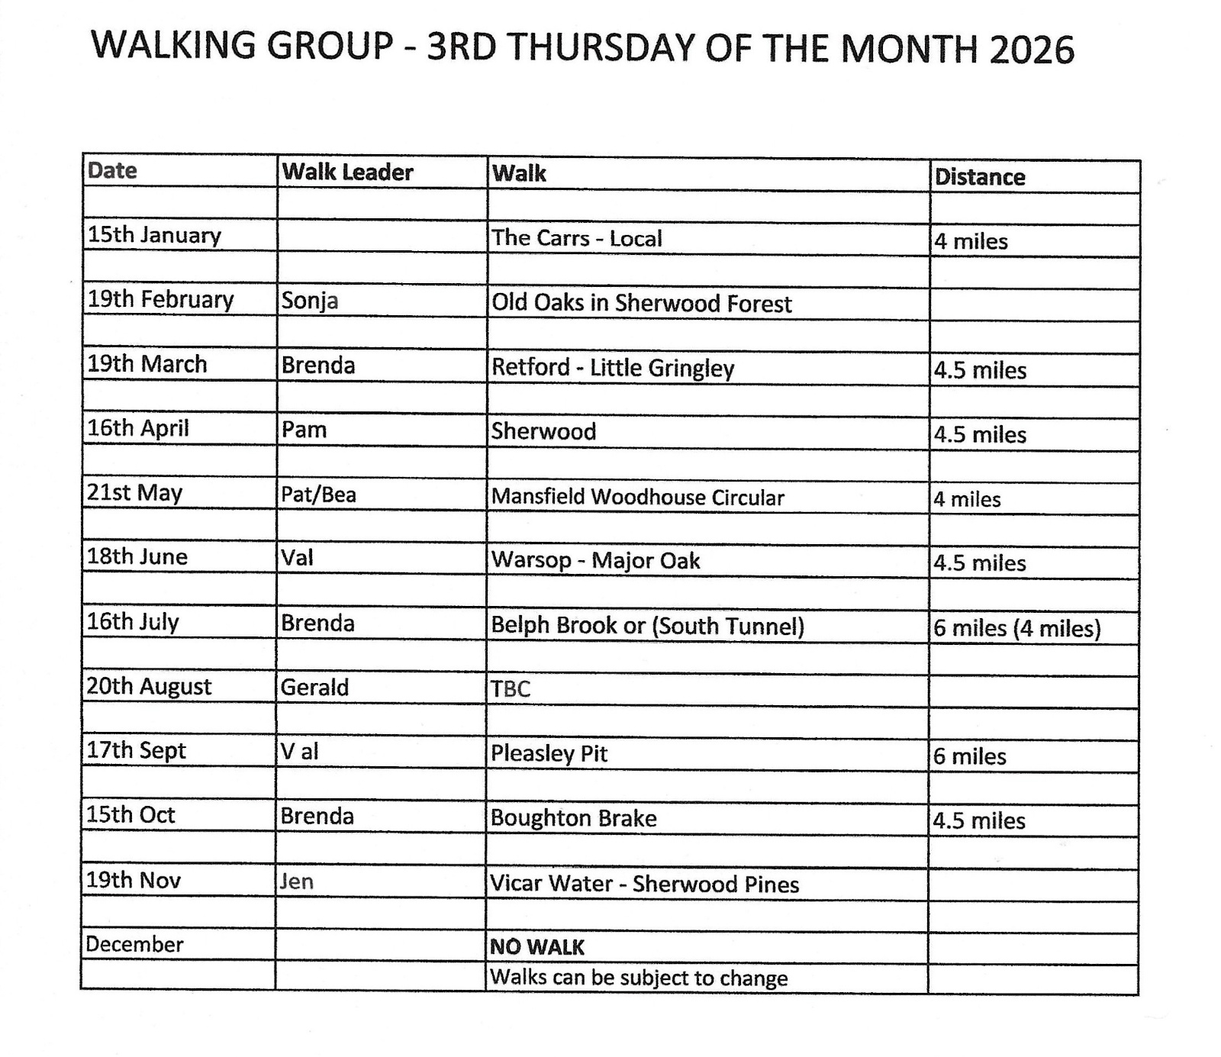

Photography Group
Due to various commitments and Christmas festivities the Photography group did not meet ‘Face to Face’ last month, but the online ‘Themed’ challenge carried on. The theme was ‘Anything that begins with J’

Joanne Wheatley – Juggernauts, Jumper& Jowls.



Joyce O’Neill – Jars & Jokers.



Jim & Chris Shervey – Jugs & Jessicas January birthday.
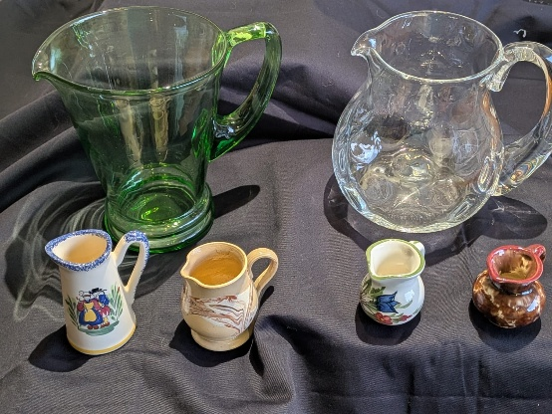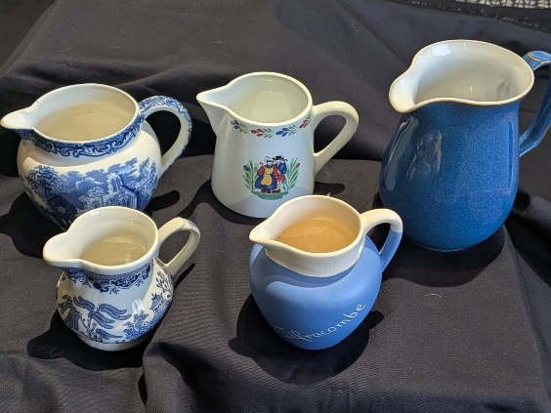


Bob Thomson – Jay, Jars, Jet stream & Jumping spider.
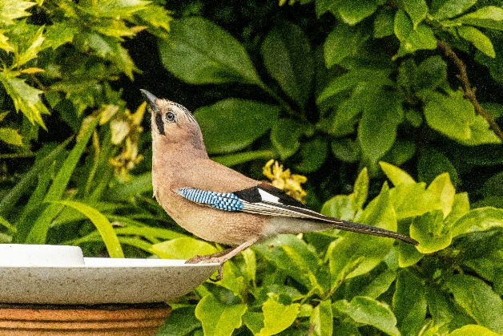

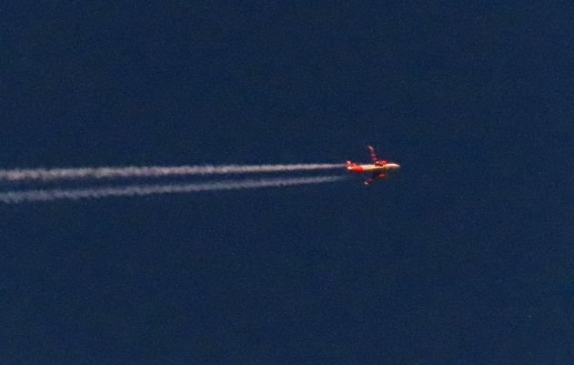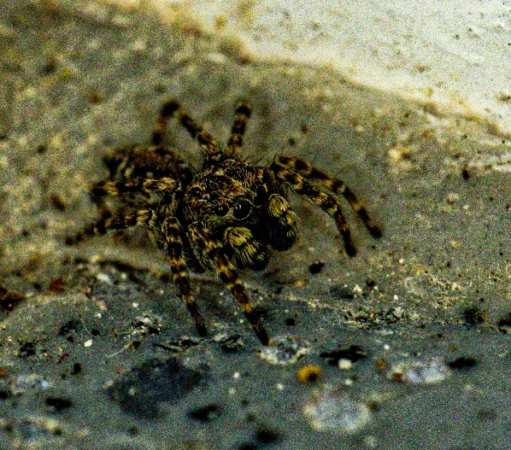
The next ‘Themed’ online challenge is ‘ Things that you associate with WINTER’
As usual this challenge is open to All u3a members, all you need is the camera in your phone and something that you think might fit the challenge!

Craft Group
This month we had a natter & a coffee and decided on our program of crafts for 2026.

Date | Topic
February | Decorating photo frames
March | Easter decorations
April | Rag Wreath
May | Papercraft
June | Florentine Embroidery book mark
July | Brooches
August | Tissue paper flowers
September | To be decided
October | Christmas cards
November | Christmas decorations
December | Christmas crafts ( for u3a party---to sell for local charities)

If you would like to join us the only thing you need to bring is a basic sewing kit and a willingness to have a go at anything. All materials are available for a very small donation to the person who brings them, if anything more specialised is required you will be given the opportunity to purchase any item needed yourself, or you can
borrow from other group members.



History Group
Happy New Year!
The history group held their final meeting of the year on Tuesday 16th December 2025. Chris Weir gave a fascinating talk about, ‘Lace, Slums and the Occasional Riot’. The meeting was well attended.
Our next meeting is on Tuesday, 20th January 2026 at 10am at St Teresa’s Church, Warsop. Our speaker this month is Denis Hill who will be speaking about, ‘Dukeries and their Dukes’. We look forward to seeing you there.
Barbara & Tamar
2026 - Proposed Calendar of Events for Warsop & District U3A History Group -
Date | Talk/Visit | Venue
20th Jan 2026 | Dukeries and their Dukes-  Denis Hill | St Theresa’s Church Hall 10am
17th Feb 2026 | Norman coins and the Stories they Tell  Dr Anja Thompson-Rohde | St Theresa’s Church Hall 10am
17th Mar 2026 | Visit  Bolsover Castle | Meeting point tba
21st Apr 2026 | Prehistoric Mansfield  Richard | St Theresa’s Church Hall 10am
19th May 2026 | Arbella Stuart  Colin | St Theresa’s Church Hall 10am
16th Jun 2026 | Visit  Mansfield Woodhouse Trail | Meeting point tba
21st July 2026 | Mansfield to Worksop Railway  Denis Hill | St Theresa’s Church Hall 10am
18th Aug 2026 | The Bands Played On  Chris Weir | St Theresa’s Church Hall 10am
15th Sept 2026 | Visit to Gainsborough Old Hall | TBA
20th Oct 2026 | The Tower of London  Chris Shervey | St Theresa’s Church Hall 10am
17th Nov 2026 | Women Win the War – WW1  Grant Cullen | St Theresa’s Church Hall 10am
 | No meeting as very close to Christmas

Speakers for the main meetings

2026
January I Thought Nobody Cared! Elaine Hopkins, Age UK Notts

February Waterways and Railways across the Derbyshire Peak
Mike Higginbottom

March Dining With Chaucers Pilgrims Judith Hedley

April Nottinghamshire Pit Pony Janine Buckley

May Rivers just keep rollin’ along Phil Crompton

June Do You Remember (a light-hearted presentation with audience involvement spanning
the past 80 or so years). Peter Savage

July Belpers Extraordinary Waterpower Story Ian Jackson

August

September Annual General Meeting

October All Things Ghostly and Mysterious Joanna Cowell

November My China Bike Ride Jenny Long

December Christmas Party

Group | Leaders Name | Tel
NATURAL HISTORY SCIENCE AND TECHNOLOGY | Chris Shervey
WALKING GROUP | Brenda Pearce  Pam Hick
STROLLERS | Janet Harford  Pat Magness
HISTORY GROUP | Barbara Spybey
CRAFTS | Zena Inger
GARDENING | Anne Poultney
PHOTOGRAPHY | Rob Thomson
FRIENDSHIP GROUP | Betty Trinder
TAI CHI | Anne Poultney

INTEREST GROUP TIMETABLE
 | MONDAY | TUESDAY | WEDNESDAY | THURSDAY | FRIDAY
1st | 10am – 12pm  CRAFTS GROUP  St Teresa’s Catholic Church hall. Warsop |  |  |  | 2pm  FRIENDSHIP GROUP  The Plough Warsop
2nd |  | 10am  GARDENING GROUP  Venue agreed by members |  | 2 – 3.30  NATURAL HISTORY  SCIENCE AND  TECHNOLOGY  St Teresa’s Catholic Church Hall Warsop
3rd | MAIN MEETING 10.15  Oaklands Centre  Warsop | 10am– 12pm  HISTORY GROUP  St Teresa’sCatholic Church hall. Warsop |  | 10am  WALKING GROUP  Carrs Car Park | 11.am  PHOTOGRAPHY  Venue to be agreed by the members.
4th |  |  | 10.am  STROLLERS  Carrs Car Park
PHOTOGRAPHY GROUP-Please see Newsletter for the online challenge.
TAI CHI Every Friday 10.30am St Teresa’s Catholic Church hall

Committee Members | Role
Lynne Hutchinson | Chairperson
Mel Mitchell | Deputy Chairperson
Irene Clay | Business Secretary
Linda Crossley | Treasurer
Zena Inger | Membership Secretary
Jim Shervey | Speaker Seeker
Jennifer Thomson | Groups co-ordinator
Chris Shervey | Newsletter editor
Ann Ayodele | Social Events
Jennifer Thomson | Welfare Officer
Rob Thomson | Website & Facebook manager
Ann Ayodele | Refreshments rota
Betty Trinder | Social events assistant

Warsop & District U3A is committed to treating all people equally. Anyone wishing to see the Privacy and Data Protection policies may view them on the Warsop.u3asite.uk alternatively please ask Rob.

Website & Facebook
The Warsop & District u3a website can be found at Warsop.u3asite.uk . If any of the group leaders/facilitators would like to advertise/ promote any of their future activities or change the information shown, please contact Bob Thomson
Facebook
Warsop & District U3A has a Facebook Group. It is a private group which can be seen by the public but only members can see who’s in the group and what they post.
What this means is that you have to be invited to join the group or have your request to join accepted. Also you need to be on Facebook which some of you may not be. As a member of the group you will be able to put your own posts on the page, please keep them relevant to the U3A and what it stands for. We would ask that you don't put anything on that is in anyway party political or anything that may be offensive to others who may be of a different creed or religion. Hopefully everyone will join, use the page and find it useful.
One of the things that puts people ‘off’ Facebook, is the ‘bad press’ some of the Social sites get. You can join Facebook, choose only to join the Warsop Facebook page and not be involved in any other site, or Friends requests (usually from people that you have never heard of!) The choice is entirely yours.
To request to join the Warsop u3a Facebook page, contact Bob Thomson.

ANSWERS Christmas quiz
- How many ghosts visit Scrooge in Dickens Christmas Carol? FOUR
- How many points does the word Christmas score in Scrabble? 16
- Which carol is this? GNWYMNR The vowels are missing and the
letters are jumbled up. AWAY IN A MANGER
- Who came travelling in Chris de Burghs famous Xmas song? SPACEMAN
- Which of the reindeer’s name means thunder? DONNER
- What time is the kings speech broadcast? 3PM
- What star sign are you if your birthday is Xmas day? CAPRICORN
- Which country gifts a Xmas tree to London every year? NORWAY
- Name the three wise men? CASPER MELCHOIR BALTHAZAR
- Which ballet is traditionally performed at this time of year? NUTCRACKER
- Which species of bird often features on a Xmas card? ROBIN
- Where do the Royal family spend Xmas? SANDRINGHAM
- In which modern day country is Nazereth? ISRAEL
- In which pantomime would you find Baron Hardup? CINDERELLA
- The song White Christmas is from which film? WHITE CHRISTMAS
- Which reindeer have names starting with C? CUPID COMET
- In the Xmas song who was mommy kissing under the mistletoe? SANTA CLAUS
- Where do Poinsettias originate from? MEXICO
- What is the more common name for St Stephens day? BOXING DAY
- In the carol Good King Wenceslas where does the poor man live? BY ST AGNES FOUNTAIN
- Silent is an anagram of which Xmas decoration? TINSEL
- In Japan they celebrate Xmas by going to KFC, true or false? TRUE
- What gift is given on day 4 in The Twelve Days of Christmas? 4 CALLING BIRDS
- Complete the title of this film MIRACLE on 34th street?
- What colour Xmas did Elvis Presley sing about? BLUE

