
Issue 96 November 2025

Warsop & District
Notes from the Chair

Hello to you all
By the time you read this bonfire night will be over and my poor little cat might come out from under the sofa; bless her! Can only mean one thing though and that's countdown to Christmas. I love everything about it though hubby is very much a Bah Humbug but he's easily ignored!
Big thank yous are in order to Chris and Brenda who organised a very well attended lunch at the Cosi tea room on Clumber Street who opened specially for us. Well worth a visit for lovely food and fantastic friendly staff.
Hope you are all sorting your Christmas jumpers for the December meeting and don't forget to leave room for a few mince pies.
See you all soon
Lynne xx

The deadline for including articles/information in the next newsletter is Friday 5th December. Send contributions to Chris Shervey . If you have any ideas for new items to include in the newsletter please let me know.

Rota for refreshments and greeting.
This is the rota for the next five months, any problems please contact me, Ann Ayodele.
Thank you to all those who have volunteered to help, without you our meetings would not be enjoyable.

Date | Refreshments 1 | Refreshments 2 | Meet and Greet 1 | Meet and Greet 2
17th Nov | Angelina Taylor | Sonja Attwood | Ann Holland | William Taylor
15th Dec | Wendy Sterland | Ann Ayodele | Pauline Wright | Jill Greer
19th Jan | Karen Breed | Beatrix Kirby | Raymond White | Ann Barnes
16th Feb | Audrey Gilbert | Janet Harford | Chris Wilson | Brenda Pearce
16thMarch | Ann Ayodele | Barbara Hartshorn | Yvonne Brown | Glenys Fearn

EVENTS
Christmas Lunch 2025
CHRISTMAS LUNCH Friday December 19th,11.45 am for 1200. The Hostess.
I shall be collecting the balance of £17 each from those who have not yet paid at the November and December meetings, Jen.

IDLE VALLEY NATURE RESERVE BEAVER TOURS.

I know several members were disappointed that this seemed to be unsuitable for those with mobility issues.
Consequently I got in touch with the organiser and it seems I had been misinformed by the Ranger. He had told me that the enclosure is a 3 kilometre walk from the main car park at the Idle Valley Nature Reserve. This is correct, but apparently there is another car park situated next to the enclosure, this makes the tour accessible for most people.
A couple of tours are planned for next year and I plan to book places for anyone interested on Sunday 21st June at 10.30am. Tours cost £25 each and last up to 2 hours. We have been offered a discount of up to 20%, depending on numbers. I shall collect full payment at our January meeting and will issue refunds once the amount of the discount has been calculated.
Something to look forward to, especially as beavers are at their most active during Spring and Summer. Jen.

ITEMS OF INTEREST

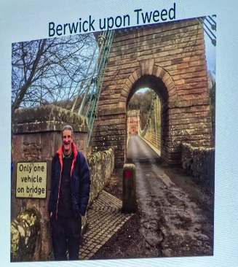

Guest speakers

The October speaker, Jon Cook, gave us an interesting insight into some of the more bizarre boundaries and borders around the world.

The speaker for November is Patricia Hall, with a talk titled ’ A Good Laugh’


Table Tennis Club- Warsop Health Hub-Mondays 1.30-3.30pm
If you would like to have a go at playing table tennis then please do join Pam Hick and Ian James at the Health Hub each Monday from 1.30-3.30pm. The cost is £4 per person. Bats and balls are provided.
Vibrant Warsop has supported this venture with the purchase of 2 brand new tables. Both Pam and Ian are also members of the U3a (Pam-Warsop & Ian- Forest Town)
You do not need to be a member of the Health Hub- just turn up!


WELFARE

A card has been sent to another member diagnosed with cancer. I'm sure everyone joins me in sending her our very best wishes.
Please let me know about any unwell or bereaved members so that our good wishes may be sent.
Jen.
Crafts
If anyone has any crafts they would like to sell. Please bring to the December meeting.
Cups Please will as many of you as
possible bring your own mug for your tea or coffee. This is not only more environmentally friendly but also would save us a lot of money as the paper disposable cups we use are surprisingly expensive. Ann.
Robin Hood Lottery 
Warsop and District U3A is a cause registered with the Robin Hood Lottery.
To buy a ticket you can now register on line at www.robinhoodlottery.co.uk and set up regular payments. If you buy a ticket every week for a year Warsop U3A will receive £26.
Remember the more members that have a go (specifying Warsop & District U3A) the more money we get for our funds.

Raffle.
The raffle made in £47 October. Thank you
RAFFLE PRIZES NEEDED PLEASE
RAFFLE PRIZES NEEDED .

Books and Jigsaws 50p.
We made £9.80 at the October meeting thank you. Please note the books are sorted into genres making it easier to find a book you like.

November quick Quiz All answers start with Z except for one.

1 Character from childrens programme Magic Roundabout?
2 Film starring Michael Caine?
3 Island of NE coast of Africa?
4 Port in Belgium?
5 Bluish White Metal?
6 Native people of South Africa?
7 A variable line, with angles that make a ?
8 A male British tennis player of the 1930’s?
9 Domestic breed of cattle found in Africa and Asia?
10 Formerly Northern Rhodesia?

Riddles for autumn ? ? ?
1 What is the best book to read in Autumn?
2 How did the tree get a new job?
3 Why did the apple pie go to the dentist?
4 How do trees get on the internet?
5 How do you fix a broken pumpkin?

November quiz CAN YOU NAME THESE FAMOUS PEOPLE?



ANSWERS TO LAST MONTHS QUIZZES/RIDDLES AT END OF NEWS LETTER.

GROUP NEWS
COULD ALL GROUP LEADERS PLEASE COLLECT THEIR BADGES WHEN THEY COLLECT THEIR LANYARDS. THEN MEMBERS CAN SEE WHOTO SPEAK TO ABOUT A GROUP.
THANK YOU

The annual meeting of group leaders was held at the Cosi Tea Room on 6th November. Group leaders were reminded of a few regulations concerning financial records and health and safety issues whilst enjoying a hot drink and delicious cakes.
Without the efforts of our group leaders we would have no u3a, their hard work is much appreciated.
If anyone has any suggestions for new groups, (or one off workshops similar to the smart phone training held in September,) please let me, Jen, know.

North Notts Neighbourhood group
This means that you as a member of Warsop & District can ask to join an interest group in another U3A that is also in the NNNG, as long as the group is not oversubscribed at the time of your request you can join the group without joining the host u3a
The u3as in the NNNG are Mansfield, Sherwood, Dukeries, Rainworth, Forest Town, Ashfield, Sutton in Ashfield, Hucknall, Worksop, Warsop, Retford and Bolsover.

 Strollers
Our October walk was in Sherwood Pines. It was a very pleasant morning and our group of 7 had a very enjoyable walk through the woods seeing a variety of interesting fungi on the way, followed by coffee and a chat.

26th November = Thoresby Country Park
Meet 10.00 am at the Carrs Car Park for car share to Thoresby

Future walks:=
November Thoresby Park
December. No walk

The Friendship Group
By the time you read this the Friendship Group will have had their meeting on the 7th November. The next meeting will be at The Plough on Friday the 5th December at 2.00 p.m.
Betty


Tai Chi Tigers

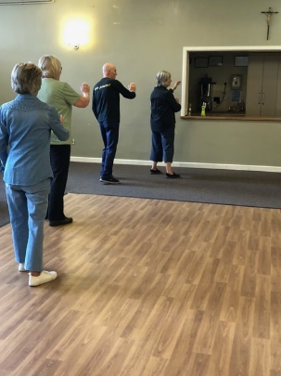
Tai Chi Tigers meet every Friday at St. Theresa’s Church Hall, Warsop.
We are there from 10.30 - 11.30am and the cost is £6.

Tai Chi is very good for health and mental health. An hour away from daily worries and problems it is good for relaxation but helps with concentration as we learn the exercises. It is very good for balance and movement control and is known to reduce falls. Most of the exercises can be done seated for those of us who are less mobile.
We do have a laugh as well, always room for new members, we would love to welcome you into our group.

Bridge Club
The Dukeries u3a Bridge Group meet on the Second and Fourth Tuesday of each month at the Jubilee Hall (NG22 9AP) from 1 – 4PM. The cost of each session is currently £3.

Garden Group
The gardens group meet on the second Tuesday of the month.
We meet at 10 am at the Mill Dam car park in Warsop and car share from there. We visit garden centres and sometimes gardens usually locally within an hour of travel.
Our last trip out was to Trowell garden centre. After a journey around Nottingham or so it seemed, ( thank goodness for Google maps!) we arrived at a small lane which seemed to go into some sort of industrial estate. What a surprise when we reached a large very full car park. It is a large garden centre with a large cafe and we had a really good day starting with coffee and snacks as usual, a look around the garden centre and a nice lunch.

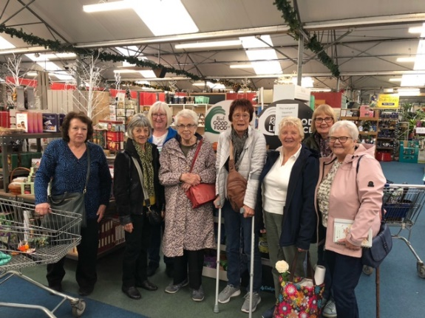
Our December outing will be on the first Tuesday which is the 2nd December when we are going to Blue Diamond garden centre at East Bridgford because we have a Christmas lunch booked for the 9th December.
Anne

We normally meet on the second Tuesday of the month at the car park by the Mill Dam in Warsop at 10 am, car sharing from there.
Anne.
Programme for future garden group visits:
December 9th, Blue Diamond garden centre, East Bridgford.
Anne.


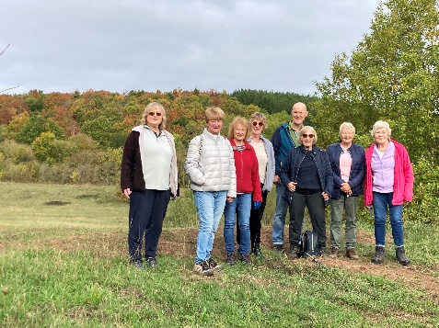
Walking Group
When we at last got to the meet up point due to roadworks, that was the beginning of our adventure. What a wonderful day to spend a morning. The weather was perfect unlike the previous month and the scenery was beautiful. The trees were taking on their autumn colours and made our walk all the more glorious. The walk was called Shirebrook Woods who would have thought it was the old pit tip. How lucky are we to have this on our doorstep. We walked approximately 4 miles and didn’t get lost so that made it a bonus.
Our last walk of the year is round Boughton Brake.

After the November U3A meeting can all concerned with the walking group meet to plan the 2026 programme. Your input and support is vital.
Brenda & Pam

We will be putting the 2026 calendar together soon. Any suggestions for future walks would be welcome.

Future walk dates (We leave The Carrs at 10.00 am prompt)

Date. Walk Leader. Walk. Distance

20th Nov. Brenda. Boughton Brake. 4 miles

Brenda



Natural History, Science and Technology.
Ann Ayodele gave a very interesting talk on Fungi. We all agreed that they are a fascinating life form – no they are not a plant. We learnt they are a classification all to themselves.
The uses of fungi are varied and surprising. Ann brought samples for us to look at which showed the differences in size, texture and colour that can be found in different fungi.

2025 | Activity
December | No Meeting
January 2026 | The Science of Cheese Making Trevor Smith
February | What are Microwaves? Jim Shervey
March | Skin Inside and Out Joyce O’Neill

Photography Group
The online ‘Themed’ challenge for last month was ‘Technology’, set by Joyce.
Joyce O’Neill – Robots & Motherboard

Jo-anne Wheatley – Computer & Mobile phone / Manual & Electric wheel chairs
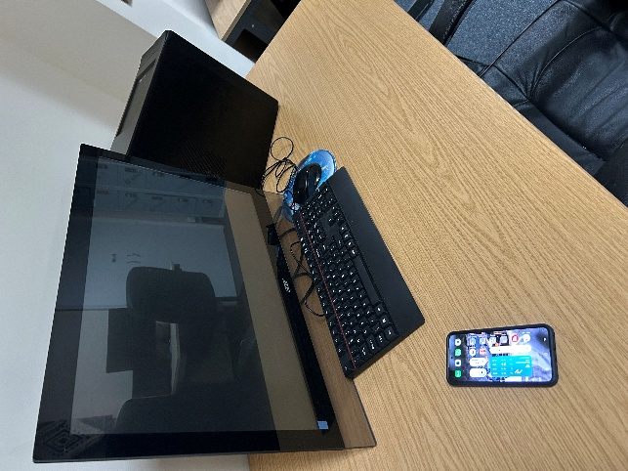
Wind Turbines

Bob Thomson – Cooking Victorian style & 2026

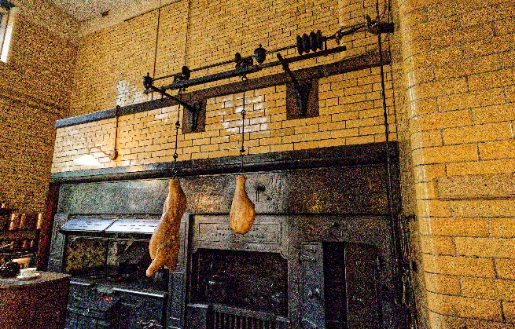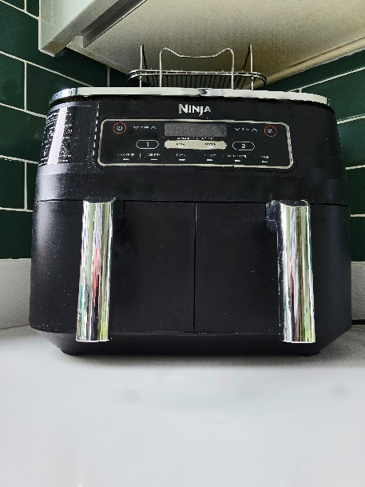

Transport – Medieval & Modern
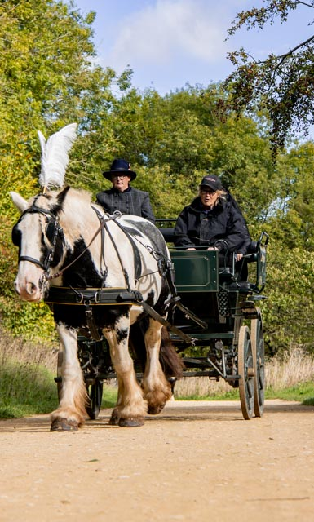
The next ‘Themed’ challenge, set by Betty will be ‘The Festive Season – Christmas’.
Once again All u3a members are welcome to join in!

Craft Group

There were 10 members at the November meeting where we made stained glass window effect decorations. Thanks to Anne for bringing all the supplies needed and giving us the information and knowledge to have a go.



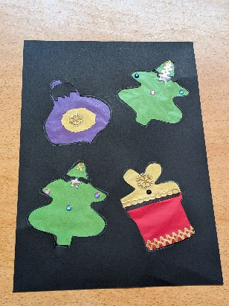



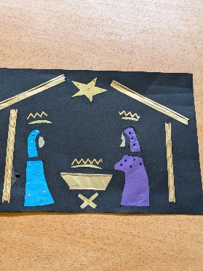
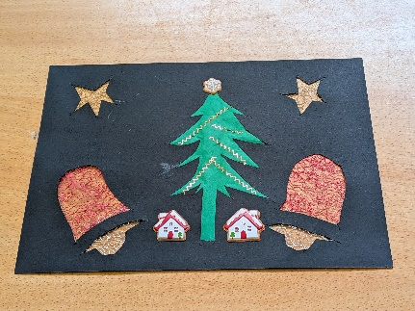
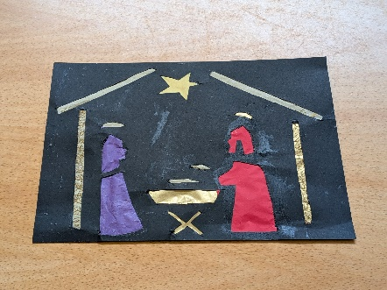

The next meeting is on Monday 3rd December. We will be making milk bottle top Christmas trees with Brenda, who will be showing us how.
If you would like to join us the only thing you need to bring is a basic sewing kit and a willingness to have a go at anything. All materials are available for a very small donation to the person who brings them, if anything more specialised is required you will be given the opportunity to purchase any item needed yourself, or you can borrow from other group members.
The craft group meets the first Monday of the month 10am – 12noon St Theresa’s catholic church, Clumber Street, Warsop. NG20 0LX. The carpark is on Ridgeway and there is a set of steps down to the hall. If you do have mobility issues it may be better to park in either the library or main car park in Warsop.
Future itinerary 2025
December – Milk Bottle Top Trees
January – The meeting will be for discussing what activities we would like to try for 2026. (any ideas welcome ladies!)
Zena.


History Group
The October meeting did not take place due to the venue being unavailable.
18th Nov 2025 | Chris Weir – Lace Slums and the Occasional Riot. Victorian Nottingham | St Theresa’s Church Hall 10am
16th Dec 2025 | Chris Weir Mud, Munitions and Memorial WW1 | St Theresa’s Church Hall 10am

Speakers for the main meetings
2025
November A Good Laugh Patricia Hall

December Christmas Party

2026
January I Thought Nobody Cared! Elaine Hopkins, Age UK Notts

February Waterways and Railways across the Derbyshire Peak
Mike Higginbottom

March Dining With Chaucers Pilgrims Judith Hedley

April Nottinghamshire Pit Pony Janine Buckley

May Rivers just keep rollin’ along Phil Crompton

June Do You Remember (a light-hearted presentation with audience involvement spanning
the past 80 or so years). Peter Savage

July Belpers Extraordinary Waterpower Story Ian Jackson

August

September Annual General Meeting

October All Things Ghostly and Mysterious Joanna Cowell

November My China Bike Ride Jenny Long

December Christmas Party

Group | Leaders Name | Tel
NATURAL HISTORY SCIENCE AND TECHNOLOGY | Chris Shervey
WALKING GROUP | Brenda Pearce  Pam Hick
STROLLERS | Janet Harford  Pat Magness
HISTORY GROUP | Barbara Spybey
CRAFTS | Zena Inger
GARDENING | Anne Poultney
PHOTOGRAPHY | Rob Thomson
FRIENDSHIP GROUP | Betty Trinder
TAI CHI | Anne Poultney

INTEREST GROUP TIMETABLE
 | MONDAY | TUESDAY | WEDNESDAY | THURSDAY | FRIDAY
1st | 10am – 12pm  CRAFTS GROUP  St Teresa’s Catholic Church hall. Warsop |  |  |  | 2pm  FRIENDSHIP GROUP  The Plough Warsop
2nd |  | 10am  GARDENING GROUP  Venue agreed by members |  | 2 – 3.30  NATURAL HISTORY  SCIENCE AND  TECHNOLOGY  St Teresa’s Catholic Church Hall Warsop
3rd | MAIN MEETING 10.15  Oaklands Centre  Warsop | 10am– 12pm  HISTORY GROUP  St Teresa’sCatholic Church hall. Warsop |  | 10am  WALKING GROUP  Carrs Car Park | 11.am  PHOTOGRAPHY  Venue to be agreed by the members.
4th |  |  | 10.am  STROLLERS  Carrs Car Park
PHOTOGRAPHY GROUP-Please see Newsletter for the online challenge.
TAI CHI Every Friday 10.30am St Teresa’s Catholic Church hall

Committee Members | Role
Lynne Hutchinson | Chairperson
Mel Mitchell | Deputy Chairperson
Irene Clay | Business Secretary
Linda Crossley | Treasurer
Zena Inger | Membership Secretary
Jim Shervey | Speaker Seeker
Jennifer Thomson | Groups co-ordinator
Chris Shervey | Newsletter editor
Ann Ayodele | Social Events
Jennifer Thomson | Welfare Officer
Rob Thomson | Website & Facebook manager
Ann Ayodele | Refreshments rota
Betty Trinder | Social events assistant

Warsop & District U3A is committed to treating all people equally. Anyone wishing to see the Privacy and Data Protection policies may view them on the Warsop.u3asite.uk alternatively please ask Rob.

Website & Facebook
The Warsop & District u3a website can be found at Warsop.u3asite.uk . If any of the group leaders/facilitators would like to advertise/ promote any of their future activities or change the information shown, please contact Bob Thomson

Facebook
Warsop & District U3A has a Facebook Group. It is a private group which can be seen by the public but only members can see who’s in the group and what they post.
What this means is that you have to be invited to join the group or have your request to join accepted. Also you need to be on Facebook which some of you may not be. As a member of the group you will be able to put your own posts on the page, please keep them relevant to the U3A and what it stands for. We would ask that you don't put anything on that is in anyway party political or anything that may be offensive to others who may be of a different creed or religion. Hopefully everyone will join, use the page and find it useful.
One of the things that puts people ‘off’ Facebook, is the ‘bad press’ some of the Social sites get. You can join Facebook, choose only to join the Warsop Facebook page and not be involved in any other site, or Friends requests (usually from people that you have never heard of!) The choice is entirely yours.
To request to join the Warsop u3a Facebook page, contact Bob Thomson.

Answers October quiz can you unscramble the name of theses sports?
- LFOLBTOA Football
- CEYHKO Hockey
- LOOP Polo
- ORKOSEN Snooker
- NTHIRALAT Triathlon
- SQHASU Squash
- ECKIRCT Cricket
- TMNIBNODA Badminton
- LGINRUC Curling
- YRHCERA Archery
- WMSIGMIN Swimming
- RHSEO GCARNI Horse riding
- SGFINIH Fishing
- KAYGNIKA Kayaking
- SBALBLTKAE Basketball
- HTAANORM Marathon
- LBTELAN Netball
- DHYERGNOU CGINRA Greyhound Racing
- NDVIIG Diving
- KNISIG Skiing
- NTEINS Tennis
- YGURB Rugby
- RTASD Darts
- MALURFO ENO Formula One
- NGCYICL Cycling

Answers October quick quiz all answers start with letter Y except for one.

- A favourite with Sunday lunch? YORKSHIRE PUDDING
- The Vikings called it Jorvik, the Romans called it Eborracum what do we call it? YORK
- A large spiky garden plant? YUKKA
- A shaggy coated oxen? YAK
- The largest national park in USA? YELLOWSTONE
- Irish poet and dramatist WB --------? YEATS
- Surname of Evita? PERON
- Site of a battle in WW1 ? YPRES
- Correct title of the Beefeaters at the Tower of London? YEOMAN OF THE GUARD
- One of the oldest universities in USA? YALE

