

Issue 97 December 2025

Warsop & District

MERRY
CHRISTMAS





Notes from the Chair
Good morning everyone
So here it is Merry Christmas once again so as we come to the end of another year I'd like to take a moment to thank you for your support and involvement in our U3a group.
This year has shown the strength of our community spirit. Our group leaders, volunteers and committee members have given their time and energy to keep everything running smoothly.
So whether you've attended meetings and groups, helped organise events, led a group or just spread a smile and a kind word you've all contributed.
So as we head into the Festive season on behalf of myself and the Committee we would like to wish all a very Merry Christmas and a Healthy and Happy New Year.

Lynne x

The deadline for including articles/information in the next newsletter is Friday 9th January. Send contributions to Chris Shervey. If you have any ideas for new items to include in the newsletter please let me know.

Rota for refreshments and greeting.
This is the rota for the next four months, any problems please contact me, Ann Ayodele.
Thank you to all those who have volunteered to help, without you our meetings would not be enjoyable.

Date | Refreshments 1 | Refreshments 2 | Meet and Greet 1 | Meet and Greet 2
15th Dec | Wendy Sterland | Sonja Attwood | Pauline Wright | Jill Greer
19th Jan | Karen Breed | Beatrix Kirby | Raymond White | Ann Barnes
16th Feb | Audrey Gilbert | Janet Harford | Chris Wilson | Brenda Pearce
16thMarch | Ann Ayodele | Barbara Hartshorn | Yvonne Brown | Glenys Fearn

EVENTS
Christmas Lunch 2025
CHRISTMAS LUNCH Friday 19th December, 11.45 for 12.00 at the Hostess.
THERE IS ONE PLACE AVAILABLE, due to illness. Please seek me out at the December meeting if you would like to take this place, full payment of £22 will be required. This could be for yourself, if you hadn't booked a place, or for a guest if you have booked and would like to bring a guest.
35 of us have this to look forward to, a 3 course lunch followed by entertainment, all for £22!
Just one person has not yet paid their outstanding balance of £17. I shan't name and shame, but please let me have your payment at our December meeting. Jen.

IDLE VALLEY NATURE RESERVE BEAVER TOURS.

I know several members were disappointed that this seemed to be unsuitable for those with mobility issues.
Consequently I got in touch with the organiser and it seems I had been misinformed by the Ranger. He had told me that the enclosure is a 3 kilometre walk from the main car park at the Idle Valley Nature Reserve. This is correct, but apparently there is another car park situated next to the enclosure, this makes the tour accessible for most people.
A couple of tours are planned for next year and I plan to book places for anyone interested on Sunday 21st June at 10.30am. Tours cost £25 each and last up to 2 hours. We have been offered a discount of up to 20%, depending on numbers. I shall collect full payment at our January meeting and will issue refunds once the amount of the discount has been calculated.
Something to look forward to, especially as beavers are at their most active during Spring and Summer. Jen.

ITEMS OF INTEREST
HEALTH MATTERS
Finding it difficult to make an appointment or request a repeat prescription?
If you use Warsop Health Centre you may have been told that it is no longer possible to make appointments or request prescriptions in person at the Health Centre or by telephone. All contact has to be made via their website, but what do you do if you don't use the internet?
I spoke to Kevin Gray of the Meden Patient's Participation Group and he kindly agreed to attend a meeting to discuss your concerns and offer some advice. Please let me know if this is something you would like me to organise in the New Year. Jen.

Warsop Health & Well being event.
On Saturday 22nd November 2025 members of the Warsop & District u3a committee were in attendance at a Health and Wellbeing event, being held in the Warsop Health Hub, Carr Lane, Warsop to try and promote our u3a.
The weather didn’t help as it was a cold and rainy day, so public attendance was low.
Our stall did attract enquiries from one or two people, but not as many as the event organisers had hoped for!
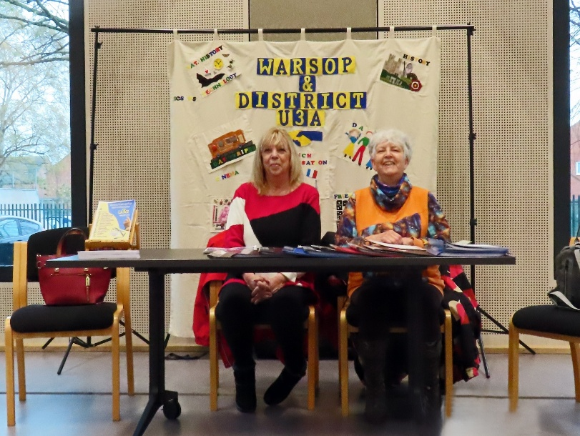


Table Tennis Club- Warsop Health Hub-Mondays 1.30-3.30pm
If you would like to have a go at playing table tennis then please do join Pam Hick and Ian James at the Health Hub each Monday from 1.30-3.30pm. The cost is £4 per person. Bats and balls are provided.
Vibrant Warsop has supported this venture with the purchase of 2 brand new tables. Both Pam and Ian are also members of the U3a (Pam-Warsop & Ian- Forest Town)
You do not need to be a member of the Health Hub- just turn up!


WELFARE

Get well wishes have been sent to another poorly member since our last meeting. Let's hope all our members who aren't feeling too well at the moment soon feel better.
I wish everyone A Merry Christmas and a Happy, Healthy New Year.
Please let me know about any unwell or bereaved members so that our good wishes may be sent.
Jen.

Crafts
If anyone has any crafts they would like to sell. Please bring to the December meeting.
Cups Please will as many of you as
possible bring your own mug for your tea or coffee. This is not only more environmentally friendly but also would save us a lot of money as the paper disposable cups we use are surprisingly expensive. Ann.
Robin Hood Lottery 
Warsop and District U3A is a cause registered with the Robin Hood Lottery.
To buy a ticket you can now register on line at www.robinhoodlottery.co.uk and set up regular payments. If you buy a ticket every week for a year Warsop U3A will receive £26.
Remember the more members that have a go (specifying Warsop & District U3A) the more money we get for our funds.

Raffle.
The raffle made £43 in November. Thank you
RAFFLE PRIZES NEEDED PLEASE
RAFFLE PRIZES NEEDED .

Books and Jigsaws 50p.
We made £13.50 at the November meeting thank you. Please note the books are sorted into genres making it easier to find a book you like.


Christmas quiz
- How many ghosts visit Scrooge in Dickens Christmas Carol?
- How many points does the word Christmas score in Scrabble?
- Which carol is this? GNWYMNR The vowels are missing and the
letters are jumbled up.
- Who came travelling in Chris de Burghs famous Xmas song?
- Which of the reindeer’s name means thunder?
- What time is the kings speech broadcast?
- What star sign are you if your birthday is Xmas day?
- Which country gifts a Xmas tree to London every year?
- Name the three wise men?
- Which ballet is traditionally performed at this time of year?
- Which species of bird often features on a Xmas card?
- Where do the Royal family spend Xmas?
- In which modern day country is Nazereth?
- In which pantomime would you find Baron Hardup?
- The song White Christmas is from which film?
- Which reindeer have names starting with C?
- In the Xmas song who was mommy kissing under the mistletoe?
- Where do Poinsettias originate from?
- What is the more common name for St Stephens day?
- In the carol Good King Wenceslas where does the poor man live?
- Silent is an anagram of which Xmas decoration?
- In Japan they celebrate Xmas by going to KFC, true or false?
This Photo by Unknown Author is licensed under CC BY-SA-NC
- What gift is given on day 4 in The Twelve Days of Christmas?
- Complete the title of this film ---------- on 34th street?
- What colour Xmas did Elvis Presley sing about?

ANSWERS TO LAST MONTHS QUIZZES/RIDDLES AT END OF NEWS LETTER.

GROUP NEWS
COULD ALL GROUP LEADERS PLEASE COLLECT THEIR BADGES WHEN THEY COLLECT THEIR LANYARDS. THEN MEMBERS CAN SEE WHO TO SPEAK TO ABOUT A GROUP.
THANK YOU

North Notts Neighbourhood group
This means that you as a member of Warsop & District can ask to join an interest group in another U3A that is also in the NNNG, as long as the group is not oversubscribed at the time of your request you can join the group without joining the host u3a
The u3as in the NNNG are Mansfield, Sherwood, Dukeries, Rainworth, Forest Town, Ashfield, Sutton in Ashfield, Hucknall, Worksop, Warsop, Retford and Bolsover.

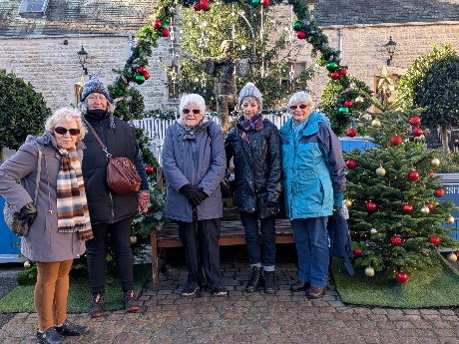
 Strollers
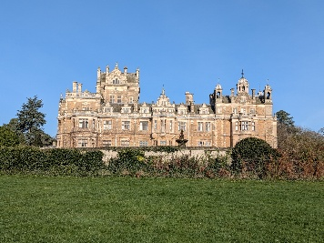
Our November walk was in Thoresby Country Park. It was a very pleasant morning and not too cold. Our stroll took us round by the cricket pavilion and grazing in the field behind the pavilion was a herd of deer, brown and white, many with large antlers. We continued to the bridge over the river and back to the Courtyard which was looking very Christmassy with trees, lights and other decorations. We finished a very pleasant morning with, of course, coffee and cake.

There will be no walk in December.

The Friendship Group
The Friendship Group meeting scheduled to take pace on the 5th December was cancelled due to insufficient members expected to attend. It has been decided that no meeting will be held in January due to the date being the day after New Years Day. Our next meeting will be the first Friday in February.
Best wishes to all for the Festive Season.
Betty


Tai Chi Tigers

The Tai Chi Tigers meet usually every Friday at St Theresa’s church hall in Warsop for 1 hour from 10.30 - 11.30 at a cost of £6. There will be no meeting on 26th December or 2nd January.

Tai chi is good for balance and preventing falls. It helps with concentration and relaxation with an escape from life and every day worries for 1 hour each week. We are a cheerful group and have a laugh. Most of the exercises can be done seated by anyone less mobile and new members are always welcome

Bridge Club
The Dukeries u3a Bridge Group meet on the Second and Fourth Tuesday of each month at the Jubilee Hall (NG22 9AP) from 1 – 4PM. The cost of each session is currently £3.

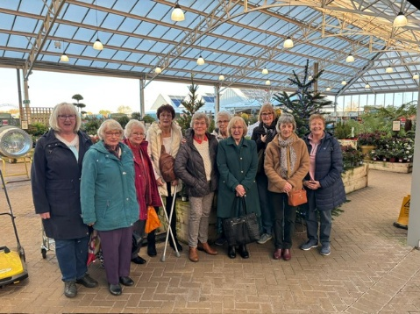
Garden Group
The garden group meets on the second Tuesday of the month at the Carrs car park by the Mill Dam in Warsop at 10 am.
We visit mainly local garden centres and gardens .
On November 11th we went to Brookfield garden centre at Mapperley, on 2nd December 10 group members went to the Blue Diamond garden centre at East Bridgford. We usually start with coffee then have a browse around the garden centre before having lunch. We were lucky with the weather and catered for very well in the restaurant. This was an extra trip out as we have booked a Christmas lunch on our usual day on 9th December .
In January we shall have a lunch out and arrange the programme for 2026.

We normally meet on the second Tuesday of the month at the car park by the Mill Dam in Warsop at 10 am, car sharing from there.
Anne.


Natural History, Science and Technology.
2025 | Activity
December | No Meeting
January 2026 | The Science of Cheese Making Trevor Smith
February | What are Microwaves? Jim Shervey
March | Skin Inside and Out Joyce O’Neill


Walking Group
We gathered at The Carrs as usual for our November walk but was undecided if we should go as it had started to snow. Being the troopers we are, it was decided to make a start and should the weather be against us we would abandon the walk.
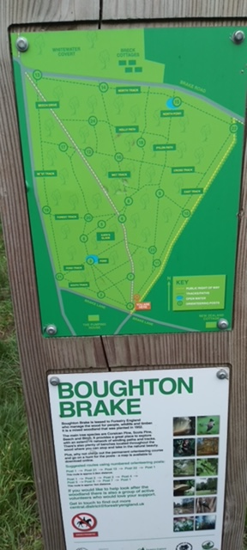
What a good decision, the weather made a turn for the better with blue skies and sunshine for the majority of the walk. The walk started from Boughton Brake, then followed the footpath skirting the Walesby Activity Centre taking us into Walesby before heading back towards Ollerton and onto Boughton Brake.
It was a case of Boughton is so bracing (not Skegness). It was agreed that we were glad we ventured out.

On behalf of Pam and myself we would like to thank all in the walking group for the past year of support and making our outings so special and we look forward to the year ahead.
Brenda

Brenda

Photography Group
Due to varying reasons, mainly the weather the Photography group did not meet ‘Face to Face’ last month. The online ‘Themed’ challenge continued with this months theme being ‘ The Festive season – Christmas’ which was set by Betty.
Jim & Chris Shervey


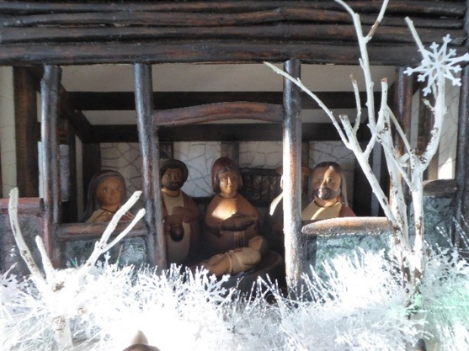

Betty Trinder



Jo-anne Wheatley


Joyce O’Neill


Bob Thomson





The next online ‘ Themed’ challenge will be ‘ Anything beginning with J’
Once again this challenge is open to All u3a members!

Craft Group
Another year nearly over and 8 members met on Monday 3rd December to make milk bottle top Christmas trees. We had a lot of tops between us as we had been collecting them for ages ready for the make. We had a lovely morning chatting, laughing and generally having a good time, we made a good selection of trees as you can seen on the front page.
Thanks for Lisa for the tasty mince pies she brought to have with our tea’s and a big thank you for your help with supplying the refreshments during the year.
If you would like to join us the only thing you need to bring is a basic sewing kit and a willingness to have a go at anything. All materials are available for a very small donation to the person who brings them, if anything more specialised is required you will be given the opportunity to purchase any item needed yourself, or you can borrow from other group members.
The craft group meets the first Monday of the month 10am – 12noon St Theresa’s catholic church, Clumber Street, Warsop. NG20 0LX. The carpark is on Ridgeway and there is a set of steps down to the hall. If you do have mobility issues it may be better to park in either the library or main car park in Warsop.
Future itinerary 2026
January – The meeting will be for discussing what activities we would like to try for 2026. (any ideas welcome ladies!)
Merry Christmas.



History Group
At our November meeting we welcomed Chris Weir who gave a fascinating talk entitled ‘Mud, Munitions and Memorials’. Chris worked at the Nottingham Archives for a number of years and his talk focused on his research there about the experiences of local men and women who served abroad in World War 1, the local businesses who adapted their factories to make ammunition to supply the British forces and the local women who carried out the dangerous job of making munitions. We learned about the Zeppelin raids on Nottingham and the surrounding areas, local prisoner of war camps and lesser known memorials to the sacrifices made by local people.

Chris will be joining us again on Tuesday the 16th of December at 10am at Saint Teresa's church hall, I last meeting of the year, to talk about ‘Lace, Slums and the Occasional riot’.
We look forward to seeing you there.

Barbara and Tamar

16th Dec 2025 | Chris Weir Mud, Munitions and Memorial WW1 | St Theresa’s Church Hall 10am

Speakers for the main meetings
2025
December Christmas Party

2026
January I Thought Nobody Cared! Elaine Hopkins, Age UK Notts

February Waterways and Railways across the Derbyshire Peak
Mike Higginbottom

March Dining With Chaucers Pilgrims Judith Hedley

April Nottinghamshire Pit Pony Janine Buckley

May Rivers just keep rollin’ along Phil Crompton

June Do You Remember (a light-hearted presentation with audience involvement spanning
the past 80 or so years). Peter Savage

July Belpers Extraordinary Waterpower Story Ian Jackson

August

September Annual General Meeting

October All Things Ghostly and Mysterious Joanna Cowell

November My China Bike Ride Jenny Long

December Christmas Party

Group | Leaders Name | Tel
NATURAL HISTORY SCIENCE AND TECHNOLOGY | Chris Shervey
WALKING GROUP | Brenda Pearce  Pam Hick
STROLLERS | Janet Harford  Pat Magness
HISTORY GROUP | Barbara Spybey
CRAFTS | Zena Inger
GARDENING | Anne Poultney
PHOTOGRAPHY | Rob Thomson
FRIENDSHIP GROUP | Betty Trinder
TAI CHI | Anne Poultney

INTEREST GROUP TIMETABLE
 | MONDAY | TUESDAY | WEDNESDAY | THURSDAY | FRIDAY
1st | 10am – 12pm  CRAFTS GROUP  St Teresa’s Catholic Church hall. Warsop |  |  |  | 2pm  FRIENDSHIP GROUP  The Plough Warsop
2nd |  | 10am  GARDENING GROUP  Venue agreed by members |  | 2 – 3.30  NATURAL HISTORY  SCIENCE AND  TECHNOLOGY  St Teresa’s Catholic Church Hall Warsop
3rd | MAIN MEETING 10.15  Oaklands Centre  Warsop | 10am– 12pm  HISTORY GROUP  St Teresa’sCatholic Church hall. Warsop |  | 10am  WALKING GROUP  Carrs Car Park | 11.am  PHOTOGRAPHY  Venue to be agreed by the members.
4th |  |  | 10.am  STROLLERS  Carrs Car Park
PHOTOGRAPHY GROUP-Please see Newsletter for the online challenge.
TAI CHI Every Friday 10.30am St Teresa’s Catholic Church hall

Committee Members | Role
Lynne Hutchinson | Chairperson
Mel Mitchell | Deputy Chairperson
Irene Clay | Business Secretary
Linda Crossley | Treasurer
Zena Inger | Membership Secretary
Jim Shervey | Speaker Seeker
Jennifer Thomson | Groups co-ordinator
Chris Shervey | Newsletter editor
Ann Ayodele | Social Events
Jennifer Thomson | Welfare Officer
Rob Thomson | Website & Facebook manager
Ann Ayodele | Refreshments rota
Betty Trinder | Social events assistant

Warsop & District U3A is committed to treating all people equally. Anyone wishing to see the Privacy and Data Protection policies may view them on the Warsop.u3asite.uk alternatively please ask Rob.

Website & Facebook
The Warsop & District u3a website can be found at Warsop.u3asite.uk . If any of the group leaders/facilitators would like to advertise/ promote any of their future activities or change the information shown, please contact Bob Thomson
Facebook
Warsop & District U3A has a Facebook Group. It is a private group which can be seen by the public but only members can see who’s in the group and what they post.
What this means is that you have to be invited to join the group or have your request to join accepted. Also you need to be on Facebook which some of you may not be. As a member of the group you will be able to put your own posts on the page, please keep them relevant to the U3A and what it stands for. We would ask that you don't put anything on that is in anyway party political or anything that may be offensive to others who may be of a different creed or religion. Hopefully everyone will join, use the page and find it useful.
One of the things that puts people ‘off’ Facebook, is the ‘bad press’ some of the Social sites get. You can join Facebook, choose only to join the Warsop Facebook page and not be involved in any other site, or Friends requests (usually from people that you have never heard of!) The choice is entirely yours.
To request to join the Warsop u3a Facebook page, contact Bob Thomson.
Answers November quick Quiz All answers start with Z except for one.
1 Character from childrens programme Magic Roundabout? ZEBEDEE
2 Film starring Michael Caine? ZULU
3 Island of NE coast of Africa? ZANZIBAR
4 Port in Belgium? ZEBRUGGE
5 Bluish White Metal? ZINC
6 Native people of South Africa? ZULUS
7 A variable line, with angles that make a ? ZIG ZAG
8 A male British tennis player of the 1930’s? FRED PERRY
9 Domestic breed of cattle found in Africa and Asia? ZEBU
10 Formerly Northern Rhodesia? ZAMBIA

Answers to Riddles for autumn ? ? ?
1 What is the best book to read in Autumn? GOURD OF THE RINGS
2 How did the tree get a new job? RIGHT QUA LEAF ICATIONS
3 Why did the apple pie go to the dentist? IT NEEDED A FILLING
4 How do trees get on the internet? THEY LOG ON
5 How do you fix a broken pumpkin? GIVE IT A PUMPKIN PATCH

ANSWERS November quiz CAN YOU NAME THESE FAMOUS PEOPLE?
1 Alan Titchmarsh 2 Marilyn Monroe 3 Maureen Lipman
4 Adrian Dunbar 5 Fiona Bruce 6 Clare Balding
7 George Clooney 8 Ken Bruce 9 Jo Brand
10 Jon Snow 11 Pablo Picasso 12 Patrick Grant/Esme Young
13 Lee Mack 14 Ellie Simmonds 15 Rob Brydon
16 Peter Wright 17 Dickie Bird 18 Davina McCall
19 Tony Hancock 20 Luciano Pavarotti 21 Lucy Worslety
22 Alexander Armstrong 23 Joanna Lumley
24 Anton du Beke / Motsi Mabuse / Craig Revell Horwood / Shirley Ballas
25 Alison Steadman 26 Michael Portillo 27 Tim Peake




