
Issue 94 September 2025

Warsop & District
Notes from the Chair

" Hello to you all
As I'm looking out of the window this morning the weather has unfortunately changed for the worse but at least the plants and the lawn will be happy!
As you all know this month is the AGM so no speaker. This also marks my year as Chair and goodness didn't that go fast! You'll be glad to know that I'm not as scared of you all now so thank you all so much for all your help and support over this time.
Don't forget Silent Auction this month and there have already been some lovely item donated so please give generously as all the proceeds will be going to local charities.
See you all at the AGM
Lynne x"

The deadline for including articles/information in the next newsletter is Friday 10th October. Send contributions to Chris Shervey . If you have any ideas for new items to include in the newsletter please let me know.

Rota for refreshments and greeting.
This is the rota for the next four months, any problems please contact me, Ann Ayodele.
Thank you to all those who have volunteered to help, without you our meetings would not be so enjoyable.

Date | Refreshments 1 | Refreshments 2 | Meet and Greet 1 | Meet and Greet 2
15th Sept | Ann Ayodele | Janet Harford | Moira Heslop | Ann Poultney
20th Oct | Yvonne Pannifer | Zena Inger

EVENTS
Christmas Lunch 2025
Christmas Lunch, The Hostess, Friday 19th December, 11.45am for 12.00.
The final number for this event is now 33.
I need everyone's balance of £17 each on or before our December meeting. Thanks, Jen.

LUNCH AND CHATTER
We have arranged a private booking at the Cosi Tea Room, Clumber Street, Warsop.
Date: Tuesday 4th November 2025

Time: 12.30 till 14.00
A limited menu will be on offer -
Quiche with side salad
Cottage Pie with vegetables and gravy
Jacket Potato with a choice of Tuna & Mayo, Cheese or Beans with a side salad
This includes tea or coffee
Cakes and specialty coffee with be charged extra
All for an unbelievable price of £6.50
Bookings being taken at the October monthly meeting. Together with menu choice and payment in full.
It’s your U3A so come along, meet new people and support this event and help a local business.
Chris & Brenda

ITEMS OF INTEREST

SILENT AUCTION FOR LOCAL CHARITIES SEPT MEETING ( AFTER THE AGM)
Thank you to everyone who has donated items for the auction. Please bring your wallet/purses , ALL money raised is going to local charities.

The Great North Road
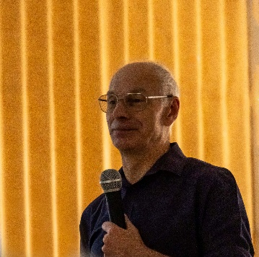
At the August meeting Ian Morgan gave us a very interesting talk about the ‘Great North Road’ in Nottinghamshire, how it has changed over time and the events that have occurred over that time.
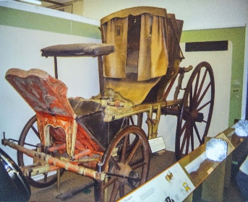


The pictures show what part of the Great North Road looks like today and the type of carriage that may have travelled along the road.
Barn Dance at Forest Town u3a
Forest Town are having a barn dance on Saturday 18th October at the Arena.
Cost £15 including food. If anyone is interested see Jim and he will provide the contact details.


Table Tennis Club- Warsop Health Hub-Mondays 1.30-3.30pm
If you would like to have a go at playing table tennis then please do join Pam Hick and Ian James at the Health Hub each Monday from 1.30-3.30pm. The cost is £4 per person. Bats and balls are provided.
Vibrant Warsop has supported this venture with the purchase of 2 brand new tables. Both Pam and Ian are also members of the U3a (Pam-Warsop & Ian- Forest Town)
You do not need to be a member of the Health Hub- just turn up!

FREE Well rotted horse manure. Speak to Jim!
Robin Hood Lottery 
Warsop and District U3A is a cause registered with the Robin Hood Lottery.
To buy a ticket you can now register on line at www.robinhoodlottery.co.uk and set up regular payments. If you buy a ticket every week for a year Warsop U3A will receive £26.
Remember the more members that have a go (specifying Warsop & District U3A) the more money we get for our funds.

Cups Please will as many of you as
possible bring your own mug for your tea or coffee. This is not only more environmentally friendly but also would save us a lot of money as the paper disposable cups we use are surprisingly expensive. Ann.

Books and Jigsaws 50p. We made £5 at the August meeting thank you. Please note the books are sorted into genres making it easier to find a book you like.

WELFARE
Raffle. Raffle in August £40 thank you
RAFFLE PRIZES NEEDED PLEASE
RAFFLE PRIZES NEEDED .

Fortunately I haven't had to send any get well wishes or condolences since last month, but please do let me know of any members who are unwell or have been bereaved so that I may send them our best wishes. Jen

September quiz All these songs have the name of a town country or river in them.

1 Are you going to S---- F--------? Scott McKenzie
2 W--------- Cathedral Roger Whittaker
3 Streets of L-------- Ralph McTell
4 White cliffs of D------ Vera Lynn
5 Is this the way to A--------- Tony Christie
6 It’s a long way to T--------- Popular WW1 song
7 S-------- boat song Traditional song
8 Only 24hrs from T-------- Gene Pitney
9 Kids in A--------- Kim Wilde
10 S------- Fair Traditional song
11 V-------- Ultravox
12 O------- flow Enya
13 M-------- Bee Gees
14 B------ Freddie Mercury/ Monseratt Caballe
15 N------ city limits Ike and Tina Turner
16 P------- freedom Elton John
17 I don’t want to go to C-------- Elvis Costello
18 W-------- line man Glen Campbell
19 Viva L---- V------ Elvis Presley
20 W------- sunset The kinks
21 Fairytale of N--- Y---- The Pogues/Kirsty McColl
22 G------- on my mind Ray Charles
23 I love P---- in the spring time Cole Porter
24 Tulips from A----- Max Bygraves
25 Midnight train to G----- Gladys Knight and the Pips
26 Last train to C------ Monkees
27 G------ Glen Campbell

September quick quiz all answers start with x except for one.

1 A wooden percussion instrument?
2 Abbreviation of Christmas?
3 Picture of bones?
4 French town famous for it’s tapestry?
5 King of Persia born 519BC
6 Olivia Newton John song?
7 Comic book heroes?
8 Chemical element, discovered 1898?
9 Hatred of foreigners?
10 TV talent show?

September riddles?
1 What has words but never speaks?
2 What did the ocean say to the sand?
3 What word starts with E ends with E but only holds a single letter?

ANSWERS TO LAST MONTHS QUIZZES/RIDDLES AT END OF NEWS LETTER.

GROUP NEWS
COULD ALL GROUP LEADERS PLEASE COLLECT THEIR BADGES WHEN THEY COLLECT THEIR LANYARDS. THEN MEMBERS CAN SEE WHOTO SPEAK TO ABOUT A GROUP.
THANK YOU

Groups Information
The meeting for our group leaders is booked for 11am on Thursday 6th November at the Cosi Cafe on Clumber Street.
If anyone has any ideas for new interest groups please let me know. Jen.

Mobile Phone Workshop
The second session will be on 18th September at 10.30am in the Oaklands.
There are still places available so please let me know if you'd like to come.

North Notts Neighbourhood group
This means that you as a member of Warsop & District can ask to join an interest group in another U3A that is also in the NNNG, as long as the group is not oversubscribed at the time of your request you can join the group without joining the host u3a
The u3as in the NNNG are Mansfield, Sherwood, Dukeries, Rainworth, Forest Town, Ashfield, Sutton in Ashfield, Hucknall, Worksop, Warsop, Retford and Bolsover.

Strollers 
Our August stroll saw 8 members visiting Sherwood Forest. It was a very pleasant morning and we enjoyed our walk to the Major Oak where we had a short rest. It was very sad to see the tree with no leaves due to the hot summer. We then continued to the Craft Centre for coffee and a chat.
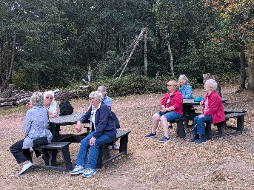
September 24th - Dumfries Garden Centre - walk to be decided
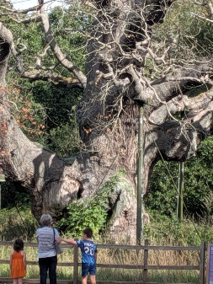
Meet at 10.00 am at the Carrs car park for car share to Dukeries
Future walks:=
October. Clumber Park (to be confirmed)
November Thoresby Park
December. No walk


Tai Chi Tigers

Tai Chi is going well, we have a lovely group of enthusiastic people but there is always room for new members, please do come along and join in. Tai Chi is good for balance and helps to prevent falls. It aids concentration and strengthens muscles. While we enjoy the exercise we do have a laugh as well.
We had a break of 2 weeks at the end of August and returned today, 5th September with renewed energy.
We meet every Friday at St Theresa’s hall in Warsop from
10.30 - 11.30 am at a cost of £6.

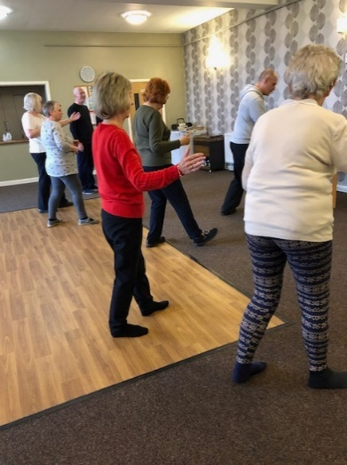


The Friendship Group 
The Friendship Group met on the 5th September after a break of a couple of months. 5 members attended and enjoyed an afternoon of cards and a natter. We would like to see a few new faces at our meetings and if you think you have some different ideas to offer or just want somewhere to spend a pleasant afternoon with friends do come and join us. Our next meeting will be at the Plough on Friday, 3rd October at 2.00 p.m.
Bridge Club
The Dukeries u3a Bridge Group meet on the Second and Fourth Tuesday of each month at the Jubilee Hall (NG22 9AP) from 1 – 4PM. The cost of each session is currently £3.

All U3a members are welcome to attend.


Natural History, Science and Technology.
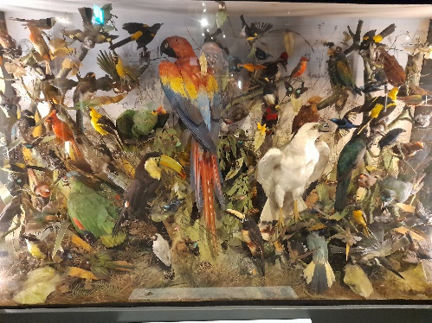
This month we went to Mansfield Museum, our tour started in the store rooms first the natural history room were hundreds of birds and animals are. These are the legacy of the Victorians fascination for taxidermy. The collections came from two local collectors. In the social history room we rummaged among old household artifacts and a wonderful collection of tins made by the Metal Box Company of Mansfield. Then into the museum, first the Birds of the World display and then the Dinosaur display. We finished the tour off with a welcome cup of coffee.
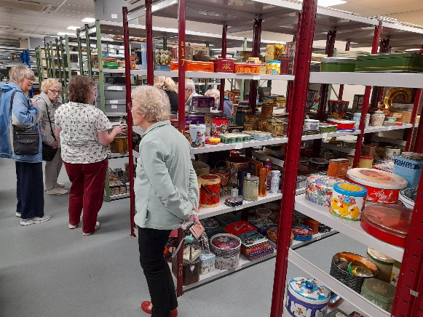
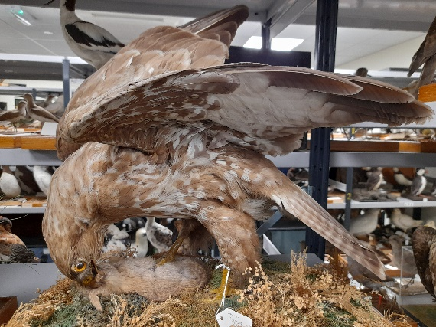

2025 | Activity
October 9th | Sounds & Hearing
November 13th | Mycology – study of Fungi
December | No Meeting
January 2026 | The Science of Cheese Making


Garden Group 
On Tuesday 12th August several members of the garden group went to Glapwell garden centre. We had coffee and cake then had a look around the plants and garden ornaments. It was a very hot day so we were glad not to have travelled too far. We then went on to the Dukeries garden centre for lunch and looked around their plants and various shopping outlets.

Next week on Tuesday September 9th we shall be going to Chatsworth garden centre so we shall have already been as you read this newsletter.
We plan to go to Trowell garden centre on Tuesday 14th October.
We meet at the car park near the Mill Dam in Warsop at 10 am on the second Tuesday of the month and car share from there.





Programme for future garden group visits:

October 14th, Trowell garden centre.
November 11th, Brookfields garden centre.
December 9th, Blue Diamond garden centre, East Bridgford.
All the above may be subject to change.
Anne.

Photography Group
This months Themed Online Challenge , set by Joanne & Kath is ‘Things that Fly’.
Joanne Wheatley –


Joyce O’Neill

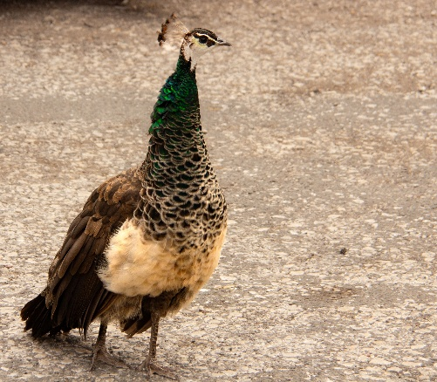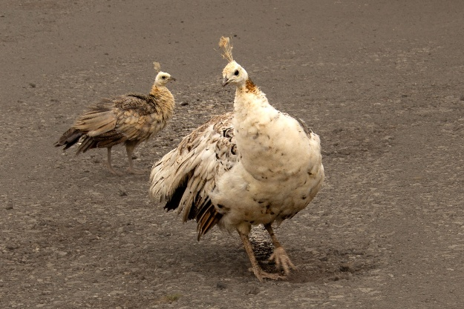
Bob Thomson
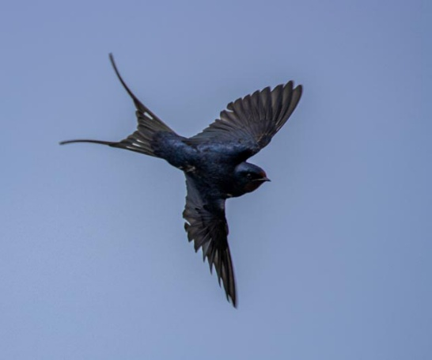
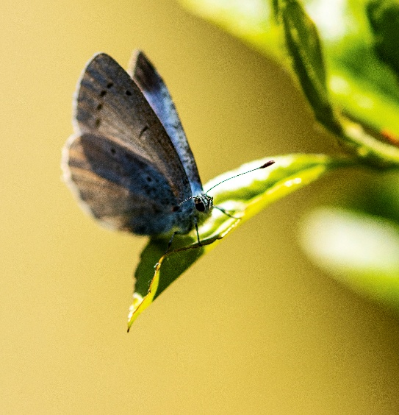

The next Themed Online Challenge is ‘ Signs of Autumn’.
Once again this challenge is open to All u3a members

Craft Group 
There were 9 members at the September meeting. We had an enjoyable morning making crochet squares, button and thread collage pictures, and some simply helped others and had a chat.
The next meeting is on Monday 6th October when we will be will be making either pop- up cards or fabric pumpkins to keep with the season.
If you would like to join us the only thing you need to bring is a basic sewing kit and a willingness to have a go at anything. All materials are available for a very small donation to the person who brings them, if anything more specialised is required you will be given the opportunity to purchase any item needed yourself, or you can borrow from other group members.
The craft group meets the first Monday of the month 10am – 12noon St Theresa’s catholic church, Clumber Street, Warsop. NG20 0LX. The carpark is on Ridgeway and there is a set of steps down to the hall. If you do have mobility issues it may be better to park in either the library or main car park in Warsop.
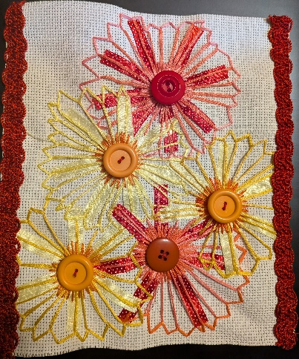
Future itinerary 2025
October – Pop-up cards/Fabric pumpkins
November – TBC
December – Milk Bottle Top Trees
Zena


Walking Group
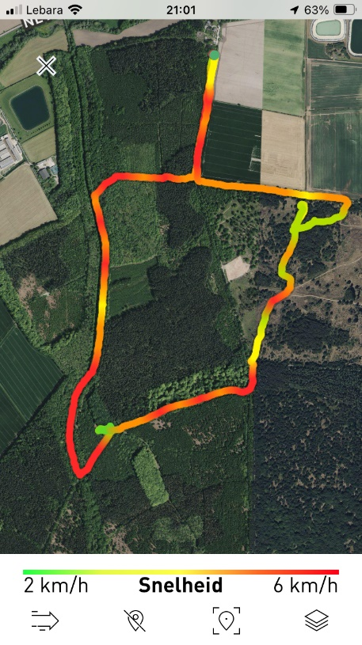
Twelve of us started our walk from Budby pumping station, the weather was cool, some cloud and a bit of sunshine, perfect for a nice walk!
The first part of the walk was through the woods to Hangar Hill, also know by the old name of Thynghowe. It is a place in the woods where the Vikings used to gather. Some of us had been here before and we shared the information we had about it while we were standing on the hillside.
We contined our walk and arrived at Budby Heath. The month chosen for this walk was August because there would be a good chance that the heather would be in bloom, and it was!
We really enjoyed this beautiful area in Sherwood forest and after a good walk of 4 miles we arrived back at our cars.
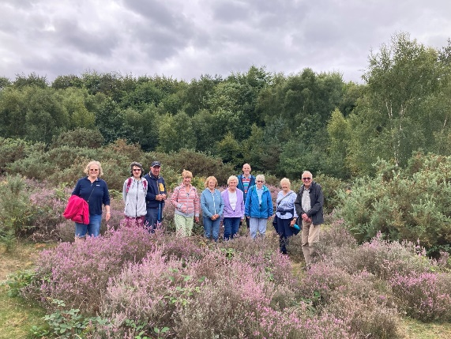
We had a lovely morning together, enjoying good company, beautiful local nature and a bit of Viking history.
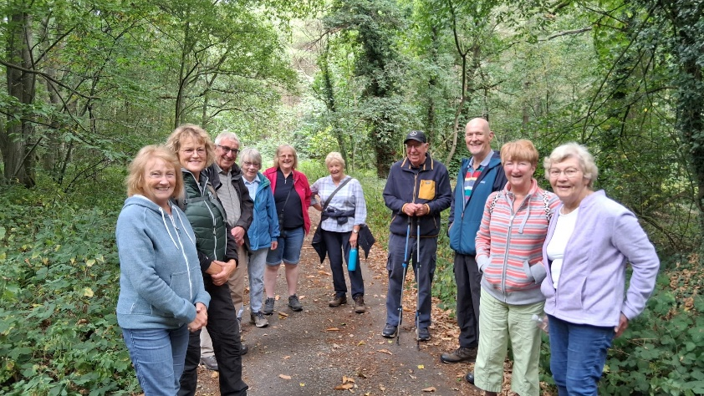

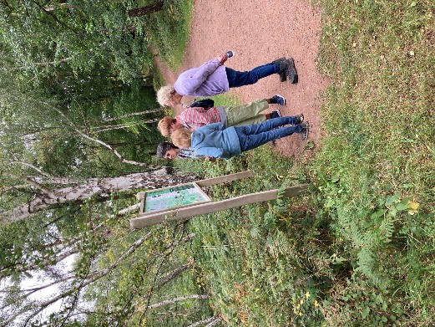

Future walk dates (We leave The Carrs at 10.00 am prompt)

Date. Walk Leader. Walk. Distance

18th Sept. Brenda/Pam. Shirebrook Wood. 4.5 miles
16th Oct. TBC
20th Nov. Brenda. Boughton Brake. 4 miles
Brenda


History Group

For our August meeting the history group enjoyed an interesting talk given by Denis Hill about the life of the poet Lord Byron.
In September we are going on a visit to the Denby Pottery Village where we will find out about the history of Denby pottery with a visit to their museum.
Barbara & Tamar
16th Sept 2025 | Visit Denby Pottery
21st Oct 2025 | Chris Weir Mud, Munitions and Memorial WW1 | St Theresa’s Church Hall 10am
18th Nov 2025 | Chris Weir – Lace Slums and the Occasional Riot. Victorian Nottingham | St Theresa’s Church Hall 10am
16th Dec 2025 | No meeting as very close to Christmas

Speakers for the main meetings
2025

September Annual General Meeting and Silent Auction

October Bordering on the Ridiculous Jon Cook

November To be arranged.

December Christmas Party

Group | Leaders Name | Tel
NATURAL HISTORY SCIENCE AND TECHNOLOGY | Chris Shervey
WALKING GROUP | Brenda Pearce  Pam Hick
STROLLERS | Janet Harford  Pat Magness
HISTORY GROUP | Barbara Spybey
CRAFTS | Zena Inger
GARDENING | Anne Poultney
PHOTOGRAPHY | Rob Thomson
FRIENDSHIP GROUP | Betty Trinder
TAI CHI | Anne Poultney

INTEREST GROUP TIMETABLE
 | MONDAY | TUESDAY | WEDNESDAY | THURSDAY | FRIDAY
1st | 10am – 12pm  CRAFTS GROUP  St Teresa’s Catholic Church hall. Warsop |  |  |  | 2pm  FRIENDSHIP GROUP  The Plough Warsop
2nd |  | 10am  GARDENING GROUP  Venue agreed by members |  | 2 – 3.30  NATURAL HISTORY  SCIENCE AND  TECHNOLOGY  St Teresa’s Catholic Church Hall Warsop
3rd | MAIN MEETING 10.15  Oaklands Centre  Warsop | 10am– 12pm  HISTORY GROUP  St Teresa’sCatholic Church hall. Warsop |  | 10am  WALKING GROUP  Carrs Car Park | 11.am  PHOTOGRAPHY  Venue to be agreed by the members.
4th |  |  | 10.am  STROLLERS  Carrs Car Park
THEATRE GROUP - Location and time as announced.
PHOTOGRAPHY GROUP-Please see Newsletter for the online challenge.
TAI CHI Every Friday 10.30am St Teresa’s Catholic Church hall

Committee Members | Role
Lynne Hutchinson | Chairperson
Mel Mitchell | Deputy Chairperson
Irene Clay | Business Secretary
Linda Crossley | Treasurer
Zena Inger | Membership Secretary
Jim Shervey | Speaker Seeker
Jennifer Thomson | Groups co-ordinator
Chris Shervey | Newsletter editor
Ann Ayodele | Social Events
Jennifer Thomson | Welfare Officer
Rob Thomson | Website & Facebook manager
Ann Ayodele | Refreshments rota
June Whittle | Raffle
Betty Trinder | Social events assistant

Warsop & District U3A is committed to treating all people equally. Anyone wishing to see the Privacy and Data Protection policies may view them on the Warsop.u3asite.uk alternatively please ask Rob.
Facebook
Warsop & District U3A has a Facebook Group. It is a private group which can be seen by the public but only members can see who’s in the group and what they post.
What this means is that you have to be invited to join the group or have your request to join accepted. Also you need to be on Facebook which some of you may not be. As a member of the group you will be able to put your own posts on the page, please keep them relevant to the U3A and what it stands for. We would ask that you don't put anything on that is in anyway party political or anything that may be offensive to others who may be of a different creed or religion. Hopefully everyone will join, use the page and find it useful.
One of the things that puts people ‘off’ Facebook, is the ‘bad press’ some of the Social sites get. You can join Facebook, choose only to join the Warsop Facebook page and not be involved in any other site, or Friends requests (usually from people that you have never heard of!) The choice is entirely yours.
To request to join the Warsop u3a Facebook page, contact Bob Thomson.

Website & Facebook
The Warsop & District u3a website can be found at Warsop.u3asite.uk . If any of the group leaders/facilitators would like to advertise/ promote any of their future activities or change the information shown, please contact Bob
Thomson
Answers August quick quiz all answers start with w except one.
1 Famous wall in Jerusalem? WAILING WALL
2 Marsupial belonging to Kangeroo family? WALLABY
3 Financial district of New York? WALL STREET
4 Painter of the Soup Can picture (surname) ? WHARHOL
5 Actor famous for Westerns 1907-79 (surname) WAYNE
6 Famous British pottery? WORDSWORTH
7 Type of painting medium? WATER COLOURS
8 Method of joining metals together? WELDING
9 Painter of The Last Supper 1452-1519? LEONARDO DA VINCI
10 In folklore people who turn into wolves are called? WEREWOLVES

Answers August quiz things in a shop e.g. go on cooking ---- bacon
1 An old sailor ? SALT
2 Eastern Ladies? SULTANAS
3 A golf term? TEA
4 A kiss with zero either side? OXO
5 Description of a goat? BUTTER
6 Seen on a trap? CHEESE
7 Strong waves? CURRANTS
8 Urges On? EGGS
9 Cricket fixtures? MATCHES
10 Say the word to start? SAGO
11 Squeeze tightly? SQUASH
12 Levitated Posy? SELF RAISING FLOUR
13 Impudence? SAUCE
14 As like twins? PEAS
15 Old weapon and part of a plant? ARROW ROOT

Answers August riddles ? ? ?
1What occurs once in a minute twice in a moment and never in a thousand years? M
2 What starts with T ends wi th T and has T in it? TEAPOT
3 What room has no windows or doors? MUSHROOM

