
Issue 95 October 2025

Warsop & District
Notes from the Chair
"Morning to you all.

Firstly thank you so much to all of you who attended the AGM and gave so generously to the Silent Auction the proceeds from which will be donated to local charities.
Can't believe how quickly this year has gone by and now on countdown to the Christmas again. Although we obviously have Halloween and Bonfire night before then neither of which I look forward to personally but I know many people do enjoy them. Fingers crossed the weather will stay fine as I do love to walk in the woods at this time of year especially when the chestnuts are ready. We are lucky to live in such a beautiful county!
This will be my second year as Chair so thanks for having me again and I can't tell you how grateful I am for the support you have all given me so far.
Look forward to seeing you at the October meeting.

Lynne

The deadline for including articles/information in the next newsletter is Friday 7th November. Send contributions to Chris Shervey. If you have any ideas for new items to include in the newsletter please let me know.

Rota for refreshments and greeting.
This is the rota for the next six months, any problems please contact me, Ann Ayodele.
Thank you to all those who have volunteered to help, without you our meetings would not be enjoyable.

Date | Refreshments 1 | Refreshments 2 | Meet and Greet 1 | Meet and Greet 2
27th Oct | Yvonne Pannifer | Zena Inger | Moira Heslop | Ann Poultney
17th Nov | Angelina Taylor | Sonja Attwood | Ann Holland | William Taylor
15th Dec | Wendy Sterland | Ann Ayodele | Pauline Wright | Jill Greer
19th Jan | Karen Breed | Beatrix Kirby | Raymond White | Ann Barnes
16th Feb | Audrey Gilbert | Janet Harford | Chris Wilson | Brenda Pearce
16thMarch | Ann Ayodele | Barbara Hartshorn | Yvonne Brown | Glenys Fearn

EVENTS
Christmas Lunch 2025
CHRISTMAS LUNCH Friday December 19th,11.45 am for 1200. The Hostess.
I shall be collecting the balance of £17 each from those who have not yet paid at the November and December meetings, Jen.

Halloween Scary Film
Newark Palace Theatre is screening the 1922 film, "Nosferatu" on Friday October 31st at 7.30pm. This is a silent film, based on Dracula, but there will be a live performance of a specially composed sound track by Minima Ensemble. Tickets are £22 plus a minimal booking fee. If anyone would like to go I shall need to collect £22 each at the October meeting. There are still seats available but I shall check availability again before taking payment, Jen.

IDLE VALLEY NATURE RESERVE BEAVER TOURS.
This reserve, in Retford, has a very large enclosure housing a family of beavers. They arrange guided tours, costing £25 each, of this enclosure periodically but cannot guarantee sightings of the beavers.
The next tour is Sunday 7th December at 10.30am - 12.30pm.
I'm happy to book for anyone who would like to go but would need full payment at the October meeting. I shall check availability before the meeting.
CAVEAT, the enclosure is 3 kilometres from the car park. It is very large and very wild, no man made paths and uneven wetland. Stout waterproof boots required! Unfortunately, it isn't suitable for people with mobility issues.
If the December date is fully booked I shall enquire about dates for next year, Jen.

LUNCH AND CHATTER

At the Cosi Tea Room, Clumber Street, Warsop.
Date: Tuesday 4th November 2025
Time: 12.30 till 14.00
This is now fully booked, but if you wish to go on a reserve list please speak to us at the October meeting.

Chris & Brenda

Quiz Night
I am planning a quiz night for Thursday 4th July, 7.00pm, at The Plough, Warsop. I will start to sell tickets at our next monthly meeting on Monday 20th May, and again at the June monthly meeting.
Tickets are £6.00 each for the supper, with our usual choice of a baked potato with trimmings or pie and peas. Guests are welcome to be included. Ann Ayodele.

ITEMS OF INTEREST
SILENT AUCTION FOR LOCAL CHARITIES
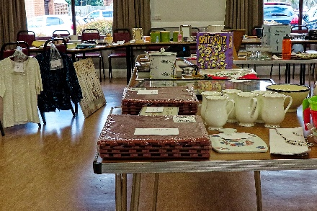
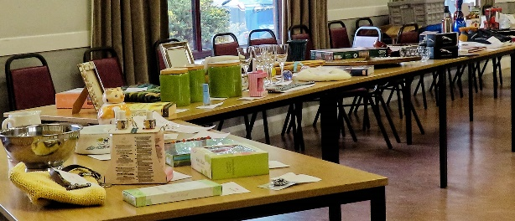
The silent auction after the AGM raised £ 205.95. This will be distributed to local groups and charities. Thank you to all who donated and bought items. (the remaining items were gifted to Oaklands for their stalls)
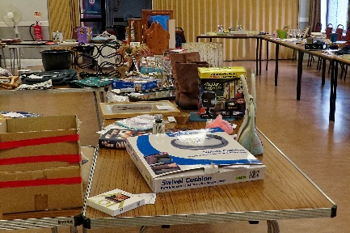

the 521 singers present an evening
of song and laughter,
with Songs from tv and film.
St teresa’s 29th nov 6.30
Tickets £7 / refreshments
(see Chris S)


Table Tennis Club- Warsop Health Hub-Mondays 1.30-3.30pm
If you would like to have a go at playing table tennis then please do join Pam Hick and Ian James at the Health Hub each Monday from 1.30-3.30pm. The cost is £4 per person. Bats and balls are provided.
Vibrant Warsop has supported this venture with the purchase of 2 brand new tables. Both Pam and Ian are also members of the U3a (Pam-Warsop & Ian- Forest Town)
You do not need to be a member of the Health Hub- just turn up!


WELFARE

Get well wishes have been sent to a member who is recovering from a stroke. I'm sure everyone wishes her well.
Don't forget to let me know about any members who become ill or who suffer a bereavement so that I can send our best wishes. Jen.

Help Request. If you feel you have 10 minutes to spare to help a student at Nottingham Trent University, have a look at the posters on the last page of the newsletter.
Robin Hood Lottery 
Warsop and District U3A is a cause registered with the Robin Hood Lottery.
To buy a ticket you can now register on line at www.robinhoodlottery.co.uk and set up regular payments. If you buy a ticket every week for a year Warsop U3A will receive £26.
Remember the more members that have a go (specifying Warsop & District U3A) the more money we get for our funds.

Cups Please will as many of you as
possible bring your own mug for your tea or coffee. This is not only more environmentally friendly but also would save us a lot of money as the paper disposable cups we use are surprisingly expensive. Ann.

October quiz can you unscramble the name of theses sports?
- LFOLBTOA
- CEYHKO
- LOOP
- ORKOSEN
- NTHIRALAT
- SQHASU
- ECKIRCT
- TMNIBNODA
- LGINRUC
- YRHCERA
- WMSIGMIN
- RHSEO GCARNI
- SGFINIH
- KYGNIKA
- SBALBLTKAE
- HTAANORM
- LBTELAN
- DHYERGNOU CGINRA
- NDVIIG
- KNISIG
- NTEINS
- YGUR
- RTASD
- MALURFO ENO
- NGCYICL

October quick quiz all answers start with letter Y except for one.

- A favourite with Sunday lunch?
- The Vikings called it Jorvik, the Romans called it Eborracum what do we call it?
- A large spiky garden plant?
- A shaggy coated oxen?
- The largest national park in USA?
- Irish poet and dramatist WB --------?
- Surname of Evita?
- Site of a battle in WW1 ?
- Correct title of the Beefeaters at the Tower of London?
- One of the oldest universities in USA?

ANSWERS TO LAST MONTHS QUIZZES/RIDDLES AT END OF NEWS LETTER.

GROUP NEWS
COULD ALL GROUP LEADERS PLEASE COLLECT THEIR BADGES WHEN THEY COLLECT THEIR LANYARDS. THEN MEMBERS CAN SEE WHOTO SPEAK TO ABOUT A GROUP.
THANK YOU

Mobile Phone Workshop
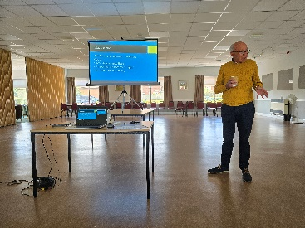
The two smart phone workshops held last month were very successful and my thanks go to Tony, (pictured), and Lorna from Southwell u3a for presenting them.
I think all of us who attended gained some knowledge and lots of confidence in using our phones. We were all particularly excited to learn about Google lens, which not only identifies unknown flora, fauna or other objects but can also translate foreign languages for us! Amazing!
A reminder for group leaders, we are meeting at the Cosi Cafe on Clumber Street, on Thursday 6th November at 11am. This is so those of us who attended a workshop for group leaders can give some feedback, but mostly to treat our group leaders to a lovely drink and cake to thank them for all they do for our members. It is much appreciated.

North Notts Neighbourhood group
This means that you as a member of Warsop & District can ask to join an interest group in another U3A that is also in the NNNG, as long as the group is not oversubscribed at the time of your request you can join the group without joining the host u3a
The u3as in the NNNG are Mansfield, Sherwood, Dukeries, Rainworth, Forest Town, Ashfield, Sutton in Ashfield, Hucknall, Worksop, Warsop, Retford and Bolsover.

 Strollers
Strollers - 22nd October - Sherwood Pines

Meet 10.00 am at The Carrs car park for car share to Sherwood Pines. Everyone welcome.

Future walks:=
November Thoresby Park
December. No walk


Tai Chi Tigers

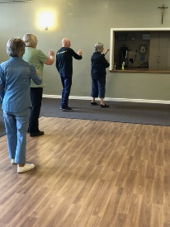
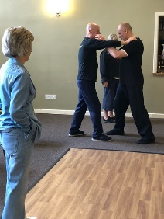
The Tai Chi Tigers meet every Friday at St Theresa’s church hall in Warsop from 10.30 -11.30 am at a cost of £6.

Tai Chi helps with balance, concentration and relaxation. It helps to prevent falls and gives an hours respite from everyday worries. We enjoy the exercises and meditation and learn set moves. New members are always welcome, most of the exercises can be done while sitting.

I’ve just heard from Ann Marie at St Theresa’s that the hall will be closed week beginning 20th October for decorating. This means that we shan’t be there on Friday 24th October.
Anne

The Friendship Group
The Friendship Group met on Friday, 3rd October when we welcomed a new member to the group. The next meeting will be on Friday, 7th November at The Plough 2.00 p.m.

Bridge Club
The Dukeries u3a Bridge Group meet on the Second and Fourth Tuesday of each month at the Jubilee Hall (NG22 9AP) from 1 – 4PM. The cost of each session is currently £3.



Natural History, Science and Technology.

This months talk was on Ears and Sounds, the first part explaining what sound is Vibrations travelling in waves) and the second part explained how these vibrations are changed by the ear and the brain into the sounds that we hear. A section on earing in animals told us weird and wonderful facts such as the ears of a praying mantis are in it’s chest! After coffee and a chat we finished off with 2 games of Sound Bingo. In game one identifying everyday sounds and game 2 was identifying sounds animals make.

2025 | Activity
November 13th | Mycology – study of Fungi
December | No Meeting
January 2026 | The Science of Cheese Making

Garden Group
In September 11 members of the garden group went to Chatsworth garden centre. As usual we started with coffee and cake then had a look around. The plants looked in really good condition and were reasonably priced so some of us indulged and bought some. Then we looked around the other departments which were varied and interesting. We moved on to the farm shop for lunch which was enjoyable. It was another beautiful day and a good time was had by all.
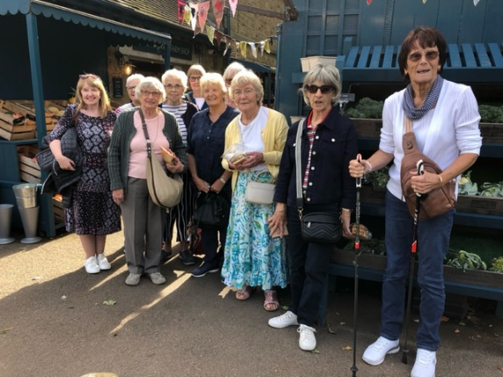
Next trip is 14th October to Trowell garden centre so we shall have been by the time you read this.
On 11th November we will be going to Brookfields garden centre.
We meet on the second Tuesday of the month at the car park by the Mill Dam in Warsop at 10 am, car sharing from there.
Anne.

Programme for future garden group visits:
November 11th, Brookfields garden centre.
December 9th, Blue Diamond garden centre, East Bridgford.
All the above may be subject to change.
Anne.


Walking Group
Unfortunately due to the inclement weather it was decided to cancel the September walk. We will now do the Shirebrook Wood walk in October, Boughton Brake in November as planned. Hope to see you all then.

We will be putting the 2026 calendar together soon. Any suggestions for future walks would be welcome.

Future walk dates (We leave The Carrs at 10.00 am prompt)

Date. Walk Leader. Walk. Distance

20th Nov. Brenda. Boughton Brake. 4 miles

Brenda

Photography Group
On 22nd September 2025 the photography group visited the Idle Valley Nature reserve near Retford. We were fortunate to have good weather, Sunshine & clouds but it stayed dry!
We walked around one of the lakes and take in the autumnal scenery. We also were able to witness the start of the winter migration of the Canada geese.
The online ‘Themed’ challenge was ‘Signs of Autumn’.
Jo-anne Wheatly – Signs of Autumn

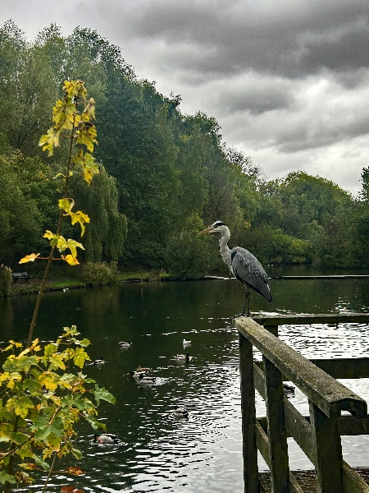
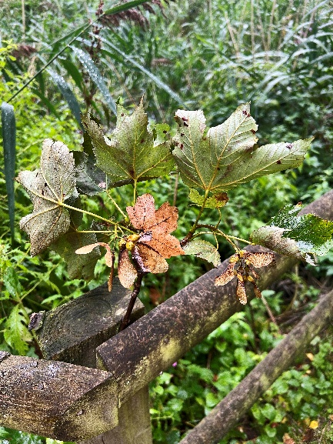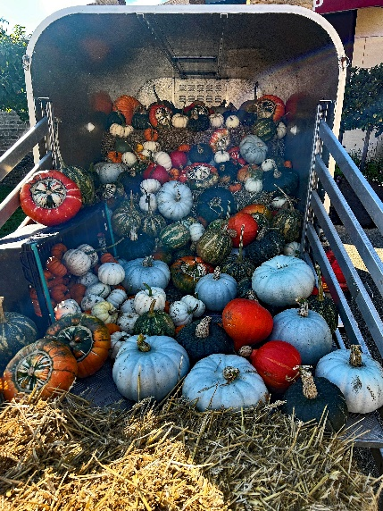

Yvonne Pannifer – Signs of Autumn

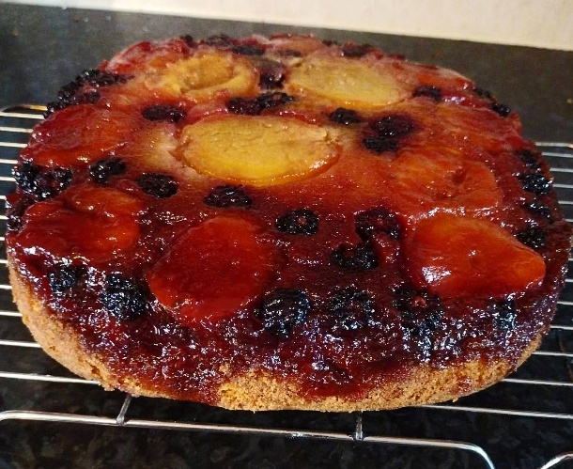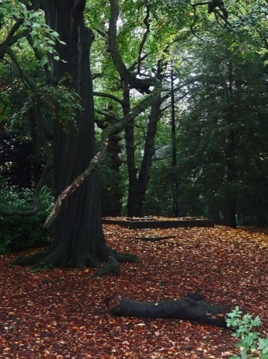



Jim & Chris Shervey – Signs of Autumn

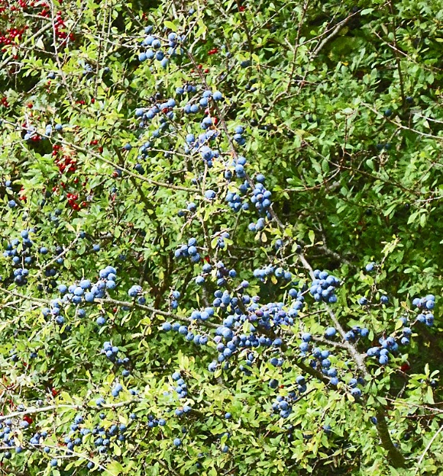

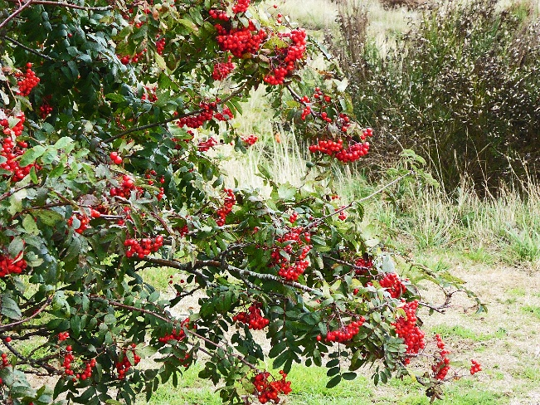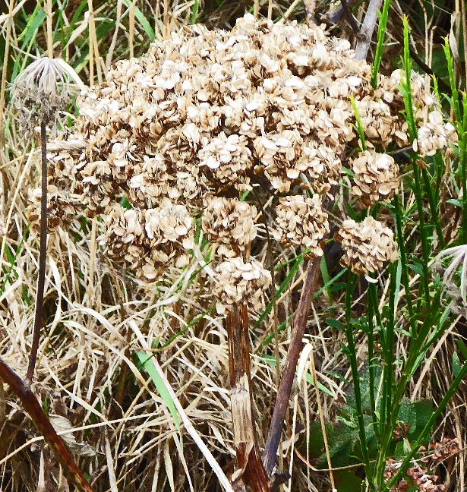

Bob Thomson – Signs of Autumn
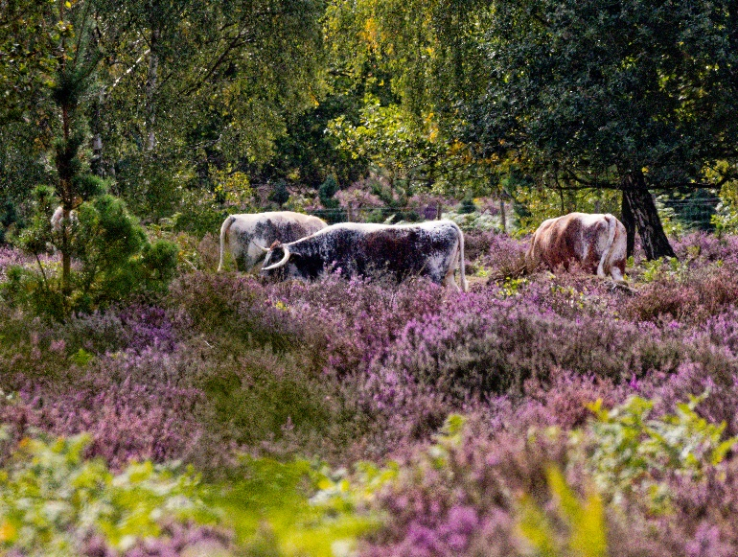
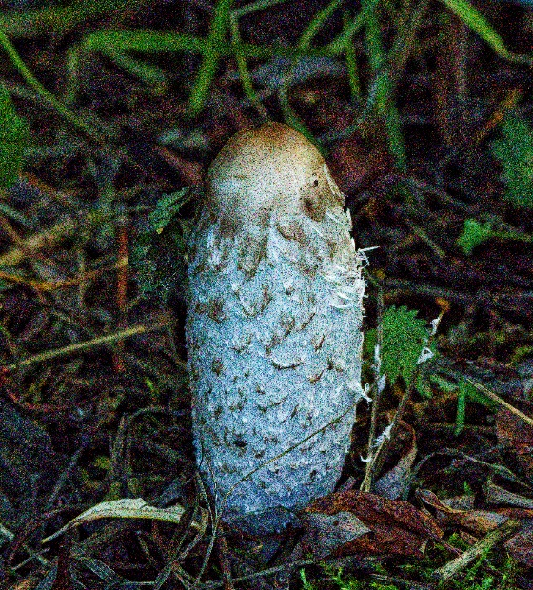

Idle Valley Nature reserve

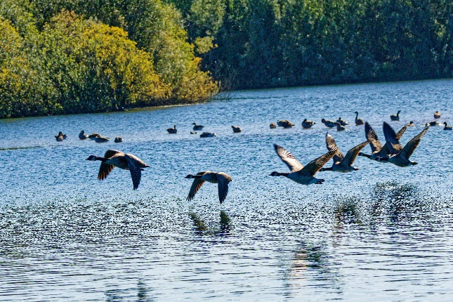


The next online ‘Themed’ challenge has been set by Joyce and is entitled ‘Technology’.
Once again this challenge is open to ALL u3a members!

Craft Group

There were 12 members at the October meeting. In line with the season we made pumpkins from felt. There were a few different colours and types. All enjoyed the morning and we welcomed a new member.

The next meeting is on Monday 3rd November, Anne will be taking us through making stained glass effect window decorations.
If you would like to join us the only thing you need to bring is a basic sewing kit and a willingness to have a go at anything. All materials are available for a very small donation to the person who brings them, if anything more specialised is required you will be given the opportunity to purchase any item needed yourself, or you can borrow from other group members.
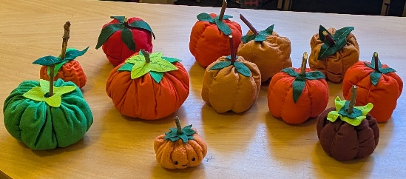
The craft group meets the first Monday of the month 10am – 12noon St Theresa’s catholic church, Clumber Street, Warsop. NG20 0LX. The carpark is on Ridgeway and there is a set of steps down to the hall. If you do have mobility issues it may be better to park in either the library or main car park in Warsop.

Future itinerary 2025
November – Stained glass effect window decorations
December – Milk Bottle Top Trees
Zena.



History Group
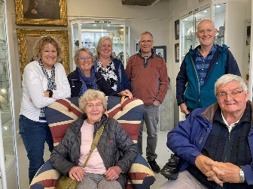
The History group members greatly enjoyed their visits to the Denby pottery village museum in September. We received a very warm welcome from our guide Maria, whose passion for the pottery and its history was positively infectious. As we were a large group and the museum could only accommodate smaller groups at one time we split into three groups. Maria led each group in turn on a tour of the museum, each tour being just under the hour. She brought the history of Denby pottery to life with her wealth of knowledge about the pottery pieces and the people who work there. I think it is true to say that these tours were thoroughly enjoyed by all judging by the comments we heard from the group and the feedback we received after the visit.
Whilst not touring the museum, members visited the pottery cafe where they enjoyed a complimentary drink, visited the Denby factory shop and other shops while some add a go at painting pottery.

Unfortunately we have had to cancel our October meeting as the hall is unavailable. We next meet on Tuesday the 18th of November at Saint Theresa's church hall at 10am. We look forward to seeing you then.
Barbara and Tamar

18th Nov 2025 | Chris Weir – Lace Slums and the Occasional Riot. Victorian Nottingham | St Theresa’s Church Hall 10am
16th Dec 2025 | Chris Weir Mud, Munitions and Memorial WW1 | St Theresa’s Church Hall 10am
Speakers for the main meetings
2025
October Bordering on the Ridiculous Jon Cook

November A Good Laugh Patricia Hall

December Christmas Party

2026
January I Thought Nobody Cared! Elaine Hopkins, Age UK Notts

February

March Dining With Chaucers Pilgrims Judith Hedley

April

May

June

July Belpers Extraordinary Waterpower Story Ian Jackson

August

September Annual General Meeting

October

November

December Christmas Party

Group | Leaders Name | Tel
NATURAL HISTORY SCIENCE AND TECHNOLOGY | Chris Shervey
WALKING GROUP | Brenda Pearce  Pam Hick
STROLLERS | Janet Harford  Pat Magness
HISTORY GROUP | Barbara Spybey
CRAFTS | Zena Inger
GARDENING | Anne Poultney
PHOTOGRAPHY | Rob Thomson
FRIENDSHIP GROUP | Betty Trinder
TAI CHI | Anne Poultney

INTEREST GROUP TIMETABLE
 | MONDAY | TUESDAY | WEDNESDAY | THURSDAY | FRIDAY
1st | 10am – 12pm  CRAFTS GROUP  St Teresa’s Catholic Church hall. Warsop |  |  |  | 2pm  FRIENDSHIP GROUP  The Plough Warsop
2nd |  | 10am  GARDENING GROUP  Venue agreed by members |  | 2 – 3.30  NATURAL HISTORY  SCIENCE AND  TECHNOLOGY  St Teresa’s Catholic Church Hall Warsop
3rd | MAIN MEETING 10.15  Oaklands Centre  Warsop | 10am– 12pm  HISTORY GROUP  St Teresa’sCatholic Church hall. Warsop |  | 10am  WALKING GROUP  Carrs Car Park | 11.am  PHOTOGRAPHY  Venue to be agreed by the members.
4th |  |  | 10.am  STROLLERS  Carrs Car Park
THEATRE GROUP - Location and time as announced.
PHOTOGRAPHY GROUP-Please see Newsletter for the online challenge.
TAI CHI Every Friday 10.30am St Teresa’s Catholic Church hall

Committee Members | Role
Lynne Hutchinson | Chairperson
Mel Mitchell | Deputy Chairperson
Irene Clay | Business Secretary
Linda Crossley | Treasurer
Zena Inger | Membership Secretary
Jim Shervey | Speaker Seeker
Jennifer Thomson | Groups co-ordinator
Chris Shervey | Newsletter editor
 | Social Events
Jennifer Thomson | Welfare Officer
Rob Thomson | Website & Facebook manager
Ann Ayodele | Refreshments rota
Betty Trinder | Social events assistant

Warsop & District U3A is committed to treating all people equally. Anyone wishing to see the Privacy and Data Protection policies may view them on the Warsop.u3asite.uk alternatively please ask Rob.

Website & Facebook
The Warsop & District u3a website can be found at Warsop.u3asite.uk . If any of the group leaders/facilitators would like to advertise/ promote any of their future activities or change the information shown, please contact Bob Thomson

Facebook
Warsop & District U3A has a Facebook Group. It is a private group which can be seen by the public but only members can see who’s in the group and what they post.
What this means is that you have to be invited to join the group or have your request to join accepted. Also you need to be on Facebook which some of you may not be. As a member of the group you will be able to put your own posts on the page, please keep them relevant to the U3A and what it stands for. We would ask that you don't put anything on that is in anyway party political or anything that may be offensive to others who may be of a different creed or religion. Hopefully everyone will join, use the page and find it useful.
One of the things that puts people ‘off’ Facebook, is the ‘bad press’ some of the Social sites get. You can join Facebook, choose only to join the Warsop Facebook page and not be involved in any other site, or Friends requests (usually from people that you have never heard of!) The choice is entirely yours.
To request to join the Warsop u3a Facebook page, contact Bob Thomson.

September quiz All these songs have the name of a town country or river in them.

1 Are you going to SAN FRANCISCO Scott McKenzie
2 WINCHESTER Cathedral Roger Whittaker
3 Streets of LONDON Ralph McTell
4 White cliffs of DOVER Vera Lynn
5 Is this the way to AMARILLO Tony Christie
6 It’s a long way to TIPPERARY Popular WW1 song
7 SKYE boat song Traditional song
8 Only 24hrs from TULSA Gene Pitney
9 Kids in AMERICA Kim Wilde
10 SCARBOROUGH Fair Traditional song
11 VIENNA Ultravox
12 ORINOCO flow Enya
13 MASACHUCETTES Bee Gees
14 BARCELONA Freddie Mercury/ Monseratt Caballe
15 NUTBUSH city limits Ike and Tina Turner
16 PHILADELPHIA freedom Elton John
17 I don’t want to go to CHELSEA Elvis Costello
18 WICHITA line man Glen Campbell
19 Viva LAS VEGAS Elvis Presley
20 WATERLOO sunset The kinks
21 Fairytale of NEW YORK The Pogues/Kirsty McColl
22 GEORGIA on my mind Ray Charles
23 I love PARIS in the spring time Cole Porter
24 Tulips from AMSTERDAM- Max Bygraves
25 Midnight train to GEORGIA Gladys Knight and the Pips
26 Last train to CLARKSVILLE Monkees
27 GALVASTON Glen Campbell

September quick quiz all answers start with x except for one.

1 A wooden percussion instrument? XYLOPHONE
2 Abbreviation of Christmas? XMAS
3 Picture of bones? X RAY
4 French town famous for it’s tapestry? BAYEAUX
5 King of Persia born 519BC XERES
6 Olivia Newton John song? XANADU
7 Comic book heroes? X MEN
8 Chemical element, discovered 1898? XENON
9 Hatred of foreigners? XENOPHOBIA
10 TV talent show? X FACTOR

September riddles?
1 What has words but never speaks? A BOOK
2 What did the ocean say to the sand? IT DIDN’T SAY ANYTHING IT JUST WAVED
3 What word starts with E ends with E but only holds a single letter? ENVELOPE





