
Issue 90 May 2025

Warsop & District
Notes from the Chair

Hello everyone and hope you've all been enjoying the beautiful weather over the past few days and that you all had a nice Easter.I had a lovely Easter spending time with my daughter and son-in-law in the West Midlands. We even got to eat lunch outside and have a few glasses of wine of course. Sorry that it meant my missing the last meeting but I'm well informed that Mel did an excellent job in my absence and the chocolate quiz was excellent.
A few days ago we visited friends in Louth and had a trip into Mablethorpe. I'd forgotten how lovely the coast can be off season as we sat eating our fish and chips on the sea front. Why do they all seem to taste so much better outside? Must do it again soon.
Looking forward to seeing you all again this month.
Lynne

The deadline for including articles/information in the next newsletter is Friday June 6th. Send contributions to Chris Shervey . If you have any ideas for new items to include in the newsletter please let me know.

Rota for refreshments and greeting.
This is the rota for the next two months, any problems please contact me, Ann Ayodele, on 07460760870.
Thank you to all those who have volunteered to help, without you our meetings would not be enjoyable.

Date | Refreshments 1 | Refreshments 2 | Meet and Greet 1 | Meet and Greet 2
19th May | Yvonne Pannifer | Glenys Fearn | Chris Wilson | Brenda Pearce
16th June | Angeline Taylor | Sonia Attwell | William Taylor | Ann Holland

EVENTS

Coach Trip to York. There is a coach trip to York on Thursday 22nd May and we still have places if anyone else wishes to come. Please give me your name and pay at our monthly meeting on 19th May. Pick ups will be from The Oaklands 9.00am, where people can leave their cars, and Tudor Barn 9.10am for anyone else.
The cost for the trip is being subsidised by U3A, it would have been in excess of £13.00 (depending on the number of seats filled up), so the cost for the return trip to York is £8.00 plus the driver’s tip, making it £9.00 total cost. There is still a chance to book a seat, see above
Coach Trip to Buxton There will be a coach trip to Buxton on Thursday 3rd July, the same arrangements for pick ups. Again this is being subsidised by U3A. It would have been in excess of £11.00 depending on how many seats filled, however the cost is £7.00, plus driver’s trip, total cost is £8.00. I will be taking names and money at the monthly meeting and hope enough people will sign up, as I don't have many names as yet. It would be a shame to have to cancel.
Ann.

DropWorks Rum Distillery Tour
I’ve arranged a private tour of the rum distillery if anyone is interested?
Date. Tuesday 24th June 2025
Time. 12.00pm (please arrive for 11.50a.m.)
Cost. £12.50 (cash please)
Venue. DropWorks Rum Distillery, Stone Shed, Welbeck, Worksop, Notts. S80 3LX
I will be taking bookings and payment at the May meeting.
Brenda

ITEMS OF INTEREST

Table Tennis Club- Warsop Health Hub-Mondays 1.30-3.30pm
If you would like to have a go at playing table tennis then please do join Pam Hick and Ian James at the Health Hub each Monday from 1.30-3.30pm. The cost is £4 per person. Bats and balls are provided.
Vibrant Warsop has supported this venture with the purchase of 2 brand new tables. Both Pam and Ian are also members of the U3a (Pam-Warsop & Ian- Forest Town)
You do not need to be a member of the Health Hub- just turn up!

FREE Well rotted horse manure. Speak to Jim.

LOCAL CHARITIES
So far we have supported the following local groups and charities.Age Concern, John Eastwood Hospice Support Group, Cats Protection and Warsop Wildlife Rescue Team.
If there is a LOCAL charity you would like to benefit give the name and contact details to Jim.

Cups Please will as many of you as
possible bring your own mug for your tea or coffee. This is not only more environmentally friendly but also would save us a lot of money as the paper disposable cups we use are surprisingly expensive. Ann.
Robin Hood Lottery 
Warsop and District U3A is a cause registered with the Robin Hood Lottery.
To buy a ticket you can now register on line at www.robinhoodlottery.co.uk and set up regular payments. If you buy a ticket every week for a year Warsop U3A will receive £26.
Remember the more members that have a go (specifying Warsop & District U3A) the more money we get for our funds.

Raffle. The March Raffle raised £43
RAFFLE PRIZES NEEDED PLEASE
RAFFLE PRIZES NEEDED .

Books and Jigsaws 50p. We made £4 at the March meeting thank you. Please note the books are sorted into genres making it easier to find a book you like.

WELFARE
Please let me know about any members who are unwell or who have been bereaved. This is so I can pass on good wishes from everyone. Jen

May quick quiz All the answers start with t except one.
1 How many wives called Anne did Henry VIII have ?
2 What is the name of the mausoleum in Agra, India?
3 Name our famous local poet, 1788 – 1824?
4 Hoofed mammal found in Malaysia and S America?
5 Means by which governments raise funds?
6 Swiss National hero ,very good with a crossbow? (surname)
7 First woman to be British Prime minister?
8 Breed of horses used for racing?
9 A piece of pottery in shape of a person or persons head?
10 British painter 1775-1851? (surname)

May quiz can you name these musicians?




May riddles
1 What band never plays music?

2 What is the end of everything?

3 The 22nd and 24th President of USA had the same parents, but were not brothers. How is this possible?
Answers to last months quizzes and riddles at end of newsletter.

GROUP NEWS
COULD ALL GROUP LEADERS PLEASE COLLECT THEIR BADGES WHEN THEY COLLECT THEIR LANYARDS. THEN MEMBERS CAN SEE WHO TO SPEAK TO ABOUT A GROUP.
THANK YOU
I attend meetings with several other Interest Groups Co-ordinators. Last month we heard more about workshops which Southwell u3a arrange in addition to their regular interest group meetings.
One of their workshops covered smart phones and how to understand your phone and get the best use from it. Would anyone like me to ask if the member from Southwell who presented this workshop would be willing to come to Warsop to deliver the same workshop?
Let me know at the next general meeting and I'll contact him.

Although we in Warsop and District u3a have sufficient interest groups for the size of our membership, it's always nice to offer something new. If anyone has a talent or skill they'd be willing to share in a group or at a one off workshop, please let me know.
Now the weather is improving don't forget we have several outdoor based groups, walking, strolling, garden and photography.
The Photography Group in particular is very low in numbers. If meeting up at a local place of interest to take a few snaps is something you'd enjoy have a look at their folders at the next meeting.

Finally, the Theatre Group is currently without a leader, but I'm hoping to see "The Rocky Horror Show," starring Jason Donovan at Nottingham Theatre Royal on Saturday 9th August at 5.30pm.
If anyone would like me to book them a ticket too, please see me at the next meeting. I'll need full payment on the day in order to secure seats, so bring your cash or cheque books. Prices range from £22 - £56 plus booking fee. If more than 10 seats are booked we qualify for a discount.

I'll bring details of availability to the meeting on May 19th.I am attaching a flyer about a water based exercise class, run by the NHS, at Warsop Health Hub. We can't regard this as one of our groups, but I'm mentioning it as it is open to u3a members who are registered with an appropriate Doctor's surgery.
I have joined and it's good fun and beneficial for maintaining fitness and balance in our senior years. The tutor also runs a free chair based exercise class at the Hub later on the same morning as the water exercises.

If anyone has any suggestions for new groups please let me know.

Jen

North Notts Neighbourhood group
This means that you as a member of Warsop & District can ask to join an interest group in another U3A that is also in the NNNG, as long as the group is not oversubscribed at the time of your request you can join the group without joining the host u3a
The u3as in the NNNG are Mansfield, Sherwood, Dukeries, Rainworth, Forest Town, Ashfield, Sutton in Ashfield, Hucknall, Worksop, Warsop, Retford and Bolsover.

The Friendship Group 
The Friendship Group met on Friday, 2nd May and although we were down to 4 members we still enjoyed the afternoon. The next meeting will be on Friday, 6th June, 2.00 p.m. at The Plough.
Betty

Tai Chi

The Tai Chi group meets every Friday at St Theresa’s hall in Warsop from 10.30 - 11.30 ish, we do tend to run over time.
Tai Chi is good for improving balance and preventing falls. It can be done seated by anyone less mobile. Our trainer Phil varies the exercises each week with enough repetition that we begin to remember them but not so much that it becomes boring and we sometimes have meditation . It’s a break from our hectic lives and we feel refreshed afterwards. We also have a laugh.
Always room for new members.

Bridge Club
The Dukeries u3a Bridge Group meet on the Second and Fourth Tuesday of each month at the Jubilee Hall (NG22 9AP) from 1 – 4PM. The cost of each session is currently £3.
All U3a members are welcome to attend.

Natural History, Science and Technology.
No meeting this month as it was the VE DAY CELEBRATION GARDEN PARTY
2025 | Activity
June 12th | CPR & defibrillators.
July 10th | To be decided
August 14th | Relationship between plants and animals
September 11th | VISIT to Mansfield Museum
October 9th | Ears & Sound
November 13th | Mycology – study of Fungi
December No Meeting

Strollers 
Our April walk took us to Rufford Country Park to see the bluebells and we were not disappointed. The deep blue flowers were in full bloom and formed a thick blue carpet under the trees. Half way through our walk we arrived at the Mill for refreshments before returning to the Abbey and car park.
28th May 2025 - Vicar Water, Clipstone
Meet at 10.00 am at the Carrs Car Park for car share to Vicar Water
Proposed walks for 2025 are as follows:-
28th May. Vicar Water
25th June. Cresswell Crags

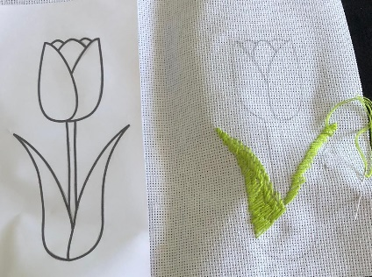
Craft Group 

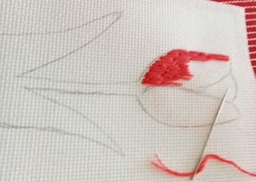
Although there was only 6 members at the meeting on Monday we had a lovely morning.
We had a go at Long/Short stitch, we had a very enjoyable time and the time went so fast as we were all so engrossed in our task. We may be visiting this craft again in the future as some of the members who could not get to the meeting wanted to have a go.

The next meeting is on Monday 2nd June, hope to see you there.

If you would like to join us the only thing you need to bring is a basic sewing kit and a willingness to have a go at anything. All materials are available for a very small donation to the person who brings them, if anything more specialised is required you will be given the opportunity to purchase any item needed yourself, or you can borrow from other group members.

The craft group meets the first Monday of the month 10am – 12noon St Theresa’s catholic church, Clumber Stret, Warsop. NG20 0LX. The carpark is on Ridgeway and there is a set of steps down to the hall. If you do have mobility issues it may be better to park in either the library or main car park in Warsop.
Future itinerary 2025
June – Cardboard Teapots (subject to change)
July – Slow Stitch
August – Clay Models
September – Pop-up Cards
October – TBC
November – TBC
December – Milk Bottle Top Trees
Zena.
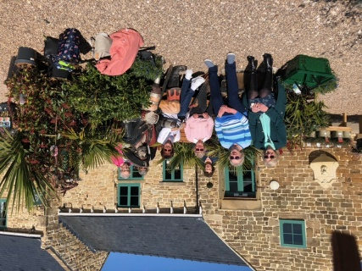
Garden Group 
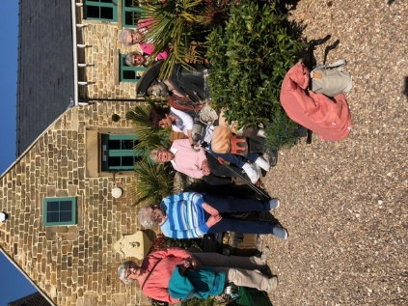
In April the Garden group visited Dunstan Hall garden centre near Chesterfield. It was a lovely day and we were very impressed, it is a lovely garden centre with very helpful and knowledgeable staff. As always we started with coffee and had a good lunch there too. Some of us bought plants and we enjoyed looking around the deli and the gift shop.
June’s trip is to be to Cascade’s Gardens Matlock which is a meditation and bonsai garden inspired by Japanese gardens and Buddhist philosophy.
We meet at the car park near the Mill Dam in Warsop at 10am on the 2nd Tuesday and car share from there.
Programme for future garden group visits:
June 10th, Cascades Gardens, Matlock. Meditation and bonsai centre.
July 8th, Newstead Abbey then the Hutt or the Rushley Inn for lunch.
August 12th, Glapwell garden centre then Harrison’s garden centre , Shirebrook.
September 9th, Chatsworth garden centre.
October 14th, Trowell garden centre.
November 11th, Brookfields garden centre.
December 9th, Blue Diamond garden centre, East Bridgford.
All the above may be subject to change.
Anne.
Photography Group
The online ‘Themed’ challenge this last month was ‘Anything beginning with C’.
Many thanks to Jen Thomson for joining in!
Jo Anne Wheatley – C = Cactus, Cathedral, Cottage & Cross
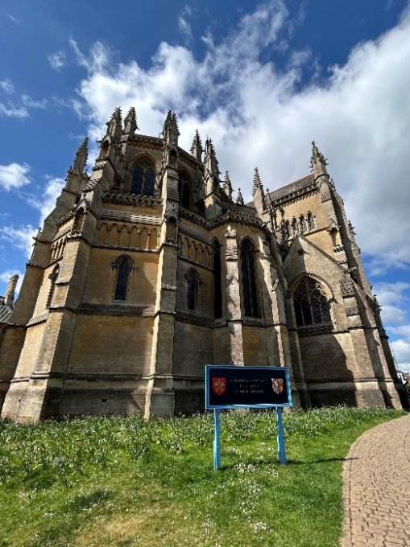
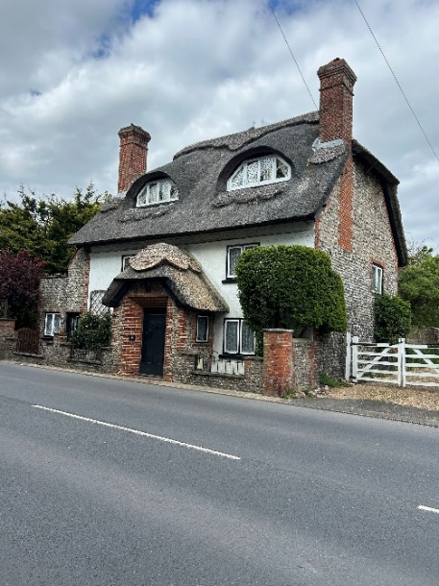
Jen Thomson C - Crab Apple blossom, Clump of Anemones & Carpet of Blue Bells.


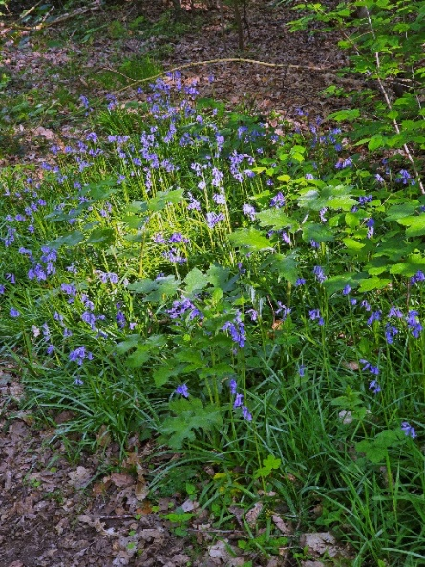

Bob Thomson – C = City Caves, Chrystal Globe, Clumber Chaple & Cat’o’nine tails

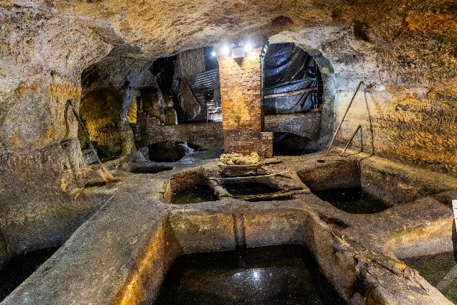

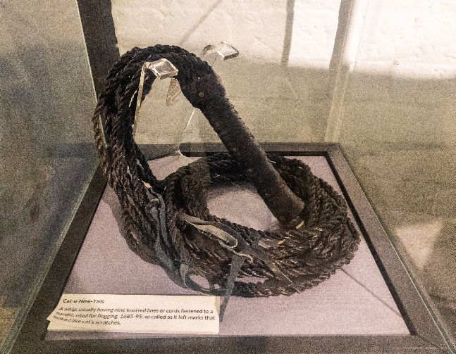

The next ‘Face to Face’ meeting is on Sunday 11th May 25, at the ‘Spirit of Wartime’ event held at Thoresby Park. Meet at 11am in the court Yard.
The next online ‘Themed’ challenge is ‘ Anything beginning with D’

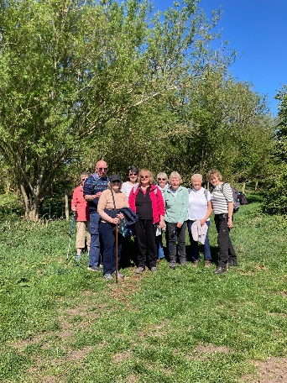

Walking Group

On a lovely sunny Thursday morning 9 walkers set off from The Carrs towards Idle Valley Country park and after a few detours arrived and split into two groups one walking the shorter route around 3 1/2 miles the other the longer route of just over 6 miles. There were bluebells in the woods and ducks and geese on several of the lakes. Finishing in the Cafe for a well earned coffee and cafe. A really sociable and enjoyable day.
Revised list.
Month. Walk Leaders
May. Sherwood. Pam
June. Rowthorne/Hardwick. Brenda
July. Forest Town. Gerald

History Group

The group met on Tuesday 15th April, when Dennis Hill came to speak to us about a recent project undertaken by Kirkby & District Archaeological Group: The Search for Kirkby Castle.
Maps of the area identify an area named ‘Castle Hill’, close to the boundary wall of St Wilfrid’s Church, but no visible remains of a castle are to be seen on the surface.
Having secured a grant from the National Lottery Heritage Fund, Kirkby & District Archaeological Group were able to seek the assistance of professional archaeologists and a geophysical survey group to further investigate the site. Work began in March 2024 with a geophysical survey of the castle site.

The group have produced a booklet entitled ‘Kirkby Castle, Kirkby-in-Ashfield’s Mystery Revealed’ which outlines the findings of this project which is available from Dennis for anyone who missed our talk or would like to know about the findings in more depth. We look forward to seeing Denis next year with an update about this project.
Our next meeting is on Tuesday 20th May at 10am at St Teresa’s Church Hall, Warsop. We will be welcoming Chris Weir who will be taking us on a walk down memory lane with his talk ‘Bygone Shopping in Nottingham.’ We will also be discussing arrangements for our visit to Lincoln on Tuesday 17th June.
We look forward to seeing you there.
Barbara & Tamar

Below is the proposed calendar of events for next year.
20th May 2025 | Chris Weir Bygone Shopping in Nottm | St Theresa’s Church Hall 10am
17th Jun 2025 | Visit to Lincoln Castle and Cathedral | Meet TBA
15th July 2025 | Chris Weir – Lace, Slums and the Occasional Riot. Victorian Nottm | St Theresa’s Church Hall 10am
19th Aug 2025 | Denis Hill The Life of Lord Byron the Poet | St Theresa’s Church Hall 10am
16th Sept 2025 | Visit Denby Pottery Museum?
21st Oct 2025 | Chris Weir Mud, Munitions and Memorial WW1 | St Theresa’s Church Hall 10am
18th Nov 2025 | In house | St Theresa’s Church Hall 10am
16th Dec 2025 | No meeting as very close to Christmas

Speakers for the main meetings

2025

May Tax, Care and Toy Boys. Oliver Hill, Co-op Estate Planning.

June What is a Witch? Laura Simpson

July Warsop Wildlife Rescue Team
A look back to WWRT the 1st year Glenn Slaney

August Footpads, Kings and Highwaymen Ian Morgan

September Annual General Meeting

October The Royal British Legion. Who set it up and what does it do? Gareth Howell

November To be arranged.

December Christmas Party

Group | Leaders Name | Tel
NATURAL HISTORY SCIENCE AND TECHNOLOGY | Chris Shervey
WALKING GROUP | Brenda Pearce  Pam Hick
STROLLERS | Janet Harford  Pat Magness
HISTORY GROUP | Barbara Spybey
CRAFTS | Zena Inger
GARDENING | Anne Poultney
PHOTOGRAPHY | Rob Thomson
FRIENDSHIP GROUP | Betty Trinder
THEATRE GROUP
TAI CHI | Anne Poultney

INTEREST GROUP TIMETABLE
 | MONDAY | TUESDAY | WEDNESDAY | THURSDAY | FRIDAY
1st | 10am – 12pm  CRAFTS GROUP  St Teresa’s Catholic Church hall. Warsop |  |  |  | 2pm  FRIENDSHIP GROUP  The Plough Warsop
2nd |  | 10am  GARDENING GROUP  Venue agreed by members |  | 2 – 3.30  NATURAL HISTORY  SCIENCE AND  TECHNOLOGY  St Teresa’s Catholic Church Hall Warsop
3rd | MAIN MEETING 10.15  Oaklands Centre  Warsop | 10am– 12pm  HISTORY GROUP  St Teresa’sCatholic Church hall. Warsop |  | 10am  WALKING GROUP  Carrs Car Park | 11.am  PHOTOGRAPHY  Venue to be agreed by the members.
4th |  |  | 10.am  STROLLERS  Carrs Car Park
THEATRE GROUP - Location and time as announced.
PHOTOGRAPHY GROUP-Please see Newsletter for the online challenge.
TAI CHI Every Friday 10.30am St Teresa’s Catholic Church hall

Committee Members | Role
Lynne Hutchinson | Chairperson
Mel Mitchell | Deputy Chairperson
Irene Clay | Business Secretary
Linda Crossley | Treasurer
Zena Inger | Membership Secretary
Jim Shervey | Speaker Seeker
Jennifer Thomson | Groups co-ordinator
Chris Shervey | Newsletter editor
Ann Ayodele | Social Events
Jennifer Thomson | Welfare Officer
Rob Thomson | Website & Facebook manager
Ann Ayodele | Refreshments rota
June Whittle | Raffle
Betty Trinder | Social events assistant

Warsop & District U3A is committed to treating all people equally. Anyone wishing to see the Privacy and Data Protection policies may view them on the Warsop.u3asite.uk alternatively please ask Rob.
Facebook
Warsop & District U3A has a Facebook Group. It is a private group which can be seen by the public but only members can see who’s in the group and what they post.
What this means is that you have to be invited to join the group or have your request to join accepted. Also you need to be on Facebook which some of you may not be. As a member of the group you will be able to put your own posts on the page, please keep them relevant to the U3A and what it stands for. We would ask that you don't put anything on that is in anyway party political or anything that may be offensive to others who may be of a different creed or religion. Hopefully everyone will join, use the page and find it useful.
One of the things that puts people ‘off’ Facebook, is the ‘bad press’ some of the Social sites get. You can join Facebook, choose only to join the Warsop Facebook page and not be involved in any other site, or Friends requests (usually from people that you have never heard of!) The choice is entirely yours.
To request to join the Warsop u3a Facebook page, contact Bob Thomson.
Website & Facebook
The Warsop & District u3a website can be found at Warsop.u3asite.uk . If any of the group leaders/facilitators would like to advertise/ promote any of their future activities or change the information shown, please contact Bob Thomson

Answers April riddles
- What has many rings but no fingers? A PHONE
- I sometimes run but I can’t walk, what am I? A NOSE
- Forwards I am heavy backwards I am not, what am I? TON

Answers April quick quiz All the answers start with S except for one.
1 T.V. Programme starring John Thaw and Dennis Waterman? SWEEENEY
2 Extinct large cat? SABRE TOOTH TIGER
3 Town on Guernsey? ST PETER PORT
4 Royal residence in Norfolk? SANDRINGHAM
5 Woodwind instrument with a brass body and keys? SAXOPHONE
6 Author of Black Beauty ( surname) ? Anna SEWELL
7 Yorkshire city famous for making cutlery? SHEFFIELD
8 Car manufacturer who introduced the assembly line? HENRY FORD
9 A Christian relic The ----------- of Turin? SHROUD
10 Which is the correct spelling ? Sacrament or Sacrement

Answers April Quiz One word two meanings, e.g. a wooden pole / a bet= STAKE
1 Type of / Gentle KIND
2 To put clothes on / Bandage DRESSING
3 Climbs / Fish skin SCALE
4 To choose / Tool PICK
5 A dance / Holder for sewing thread REEL
6 Run away suddenly / Door fastening BOLT
7 Provide weapons / Body part ARM
8 Difficult / Solid surface HARD
9 To sieve / Under pressure STRAIN
10 Piece of wood / Record data LOG
11 Give advice / type of government COUNCIL
12 Discard / An out building SHED
13 Thread / A story YARN
14 Journalists / To iron PRESS
15 Castle tower / Payment for lodgings KEEP
16 Bring out (information) / Make a picture DRAW
17 Oar / Walk in sea PADDLE
18 A type of dog / Sore throat HUSKY
19 A cellar / To jump VAULT
20 Melodic tune / What we breathe AIR
21 To decorate a cake / Frozen water ICE
22 To check / A animal doctor VET
23 Front of a ship / Tied ribbon BOW
24 Serious / Last resting place GRAVE
25 Ranked tennis player / Baby plant SEED

