
Issue 92 July 2025

Warsop & District
Notes from the Chair
"Hello everyone and hope you are managing to keep cool in this glorious weather. It's funny but today's weather maps are forever warning us of this extreme weather with fiery maps etc but back in the day we just called it summer and cooled down in the paddling pool on the Carrs or the river down Sookholme. Happy days!
Since I saw you all last I have experienced a trip to the rum distillery on Welbeck Estate and very enjoyable it was too so thanks to Brenda for organising it.
Off to Buxton this week ,thanks to Ann , so looking forward to that too.
Seen you all soon"
Lynne

Please note that the AGM is planned for the 15th September. New committee members always welcome. Information and nomination forms are at the end of the newsletter.

The deadline for including articles/information in the next newsletter is Friday August 8th. Send contributions to Chris Shervey . If you have any ideas for new items to include in the newsletter please let me know.

Rota for refreshments and greeting.
This is the rota for the next four months, any problems please contact me, Ann Ayodele.
Thank you to all those who have volunteered to help, without you our meetings would not be so enjoyable.

Date | Refreshments 1 | Refreshments 2 | Meet and Greet 1 | Meet and Greet 2
21st July | Glenys Fearn | Wendy Sterland | Pauline Wright | Jill Greer
18th Aug | Karen Breed | Beatrix Kirby | Raymond White | Ann Barnes
15th Sept | Audrey Gilbert | Janet Harford | Chris Wilson | Brenda Pearce
20th Oct | Yvonne Pannifer | Zena Inger | Moira Heslop | Ann Poultney

EVENTS

Boat Trip on the Trent
This is scheduled for Thursday 4th September. I have booked 20 seats and there are still quite a lot left. The boat trip is for three hours during which we will enjoy dinner. The cost is £27.25 for a pork or chicken roast dinner, vegetarian lasagne or vegan stuffed pepper, and Black Forest gateau. We are planning to do a car share to Colwick. Again you can contact me to book a place if you cannot attend the July monthly meeting, at which I will be taking names and payments, Ann Ayodele.
Christmas Lunch 2025
I have made a provisional booking at the Hostess for 20 places on Friday 19th December.
I need to collect a £5 deposit from everyone who'd like to attend on Monday 21st July. Guaranteed place for the first 20 to pay the deposit, if more than 20 wish to come I'll check availability and will refund any deposits if the event is fully booked.
Jen

ITEMS OF INTEREST

SILENT AUCTION FOR LOCAL CHARITIES SEPT MEETING ( AFTER THE AGM)
Please bring any items for the auction to the meetings in July and August. Boxes will be placed near the entrance for your items. Thank you.

Speakers. Past and Future


The speaker last month was spellbinding, with her description of what a Witch is and what they get up to.

Unfortunately the published speaker for July is unable to be with us. So instead the talk this month is titled
’An Officer and a Lady’ presented by Carol Brooks.

Another change to the published speakers is the talk about the British Legion scheduled for October is no longer in the schedule. The speaker has moved out of the area.

Table Tennis Club- Warsop Health Hub-Mondays 1.30-3.30pm
If you would like to have a go at playing table tennis then please do join Pam Hick and Ian James at the Health Hub each Monday from 1.30-3.30pm. The cost is £4 per person. Bats and balls are provided.
Vibrant Warsop has supported this venture with the purchase of 2 brand new tables. Both Pam and Ian are also members of the U3a (Pam-Warsop & Ian- Forest Town)
You do not need to be a member of the Health Hub- just turn up!

FREE Well rotted horse manure. Speak to Jim!

Visit to the DropWorks Rum Distillery
Darren, one of the Distillers at the DropWorks Rum distillery based on the Welbeck Estate, guided 12 u3a members on a tour of the works yesterday. It was a tour organised by Brenda, so a BIG thanks to her! Darren was very informative and made it a very interesting 90 minutes. He explained how during the distilling process different grades of alcohol are produced, which then have to be filtered out at different stages of the process to leave a smooth good tasting rum! We were offered samples of the finished product some of which really cleared the sinuses!

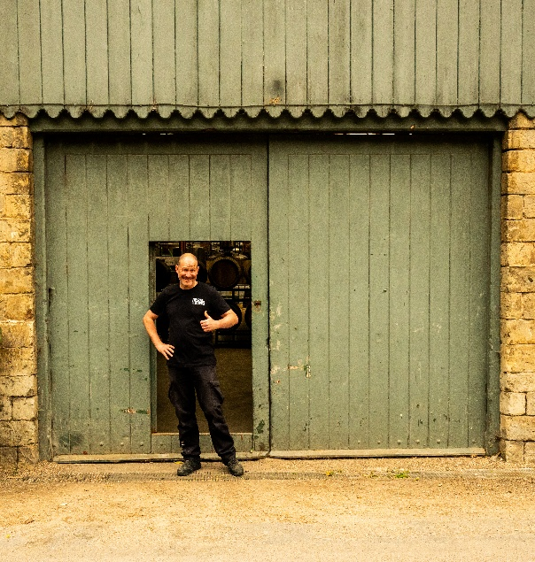



Cups Please will as many of you as
possible bring your own mug for your tea or coffee. This is not only more environmentally friendly but also would save us a lot of money as the paper disposable cups we use are surprisingly expensive. Ann.
Robin Hood Lottery 
Warsop and District U3A is a cause registered with the Robin Hood Lottery.
To buy a ticket you can now register on line at www.robinhoodlottery.co.uk and set up regular payments. If you buy a ticket every week for a year Warsop U3A will receive £26.
Remember the more members that have a go (specifying Warsop & District U3A) the more money we get for our funds.

Raffle. Raffle in June £53 thank you
RAFFLE PRIZES NEEDED PLEASE
RAFFLE PRIZES NEEDED .

Books and Jigsaws 50p. We made £6.50 at theJune meeting thank you. Please note the books are sorted into genres making it easier to find a book you like.

WELFARE

Please let me know about any members who are unwell or who have been bereaved. This is so I can pass on good wishes from everyone. Jen

July quick quiz All answers start with v except for one.
1 Volcano that destroyed Pompeii in AD79?
2 Yorkshire village ,home of the Bronte sisters?
3 WWII missile called flying bomb or ----?
4 Former name of Tasmania?
5 Roman poet who wrote the Aeneid?
6 Country in S America?
7 French author 1828 – 1905?
8 Largest lake in Africa?
9 Name used for country houses in Italy?
10 Keyboard instrument of 16th and 17th centuries?

Answers to last months quizzes and riddles at end of newsletter.

July quiz do you know the occupations of these tv characters?
Eg miss marple -------- amateur detective
- Del Trotter
- Jim Bergerac
- James Herriot
- Frasier
- Father Brown
- Mrs Slocombe
- Basil Fawlty
- Ross Poldark
- Albert Steptoe
- Sister Boniface
- Emma Peel
- Kim Tate
- Mr Hudson
- Rowdy Yates
- Hawkeye Pearce
- Perry Mason
- Mr Hedges
- Peggy Mitchell
- Tom Barnaby
- Mrs Bridges
- Beth Lacey
- Ruby Sunday
- Ugly Betty
- Rigsby
- Richard de Vere
- Lewis
- Mr Carson
- Annie Walker

July riddles
1 What is full of holes and still holds water?

2 Which coat is put on wet?

3 I have towns but no houses, forests but no trees, water but no fish. What am I?
GROUP NEWS
COULD ALL GROUP LEADERS PLEASE COLLECT THEIR BADGES WHEN THEY COLLECT THEIR LANYARDS. THEN MEMBERS CAN SEE WHOTO SPEAK TO ABOUT A GROUP.
THANK YOU

Mobile Phone Workshop
Just a reminder, a workshop to help us better use and understand our phones will be held over 2 weeks on Thursday 11th September and Thursday 18th September from 10.30am to 12.30pm. Both will be held at the Oaklands.
The sessions cover different topics, so ideally you need to attend both sessions. Please let me know if you'd like to attend.

Group Leaders and Groups Coordinators Workshop.
Three of us attended this workshop last month and found it useful and reassuring, we're doing OK here at Warsop!
I've been away since then so haven't had chance to put any information together yet. As soon as I have I shall call a meeting of our hard working group leaders to pass on any tips and to express our thanks for everything they do for our members.
Jen.

If anyone has any suggestions for new groups please let me know.

Jen

North Notts Neighbourhood group
This means that you as a member of Warsop & District can ask to join an interest group in another U3A that is also in the NNNG, as long as the group is not oversubscribed at the time of your request you can join the group without joining the host u3a
The u3as in the NNNG are Mansfield, Sherwood, Dukeries, Rainworth, Forest Town, Ashfield, Sutton in Ashfield, Hucknall, Worksop, Warsop, Retford and Bolsover.

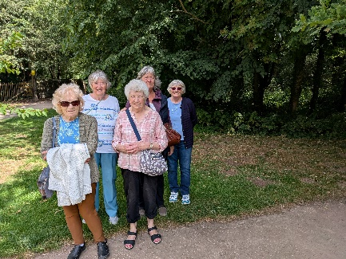
Strollers 
Our June walk was enjoyed by nine members who walked from the Dukeries Garden Centre to Creswell Crags. We had refreshments at the coffee shop before returning to the garden centre. It was a lovely day and not too hot.

23rd July - Thoresby Country Park
Meet at 10.00 am at the Carrs car park for car share to Thoresby.

Future walks:=
July. Thoresby
August Sherwood Forest
September. Sherwood Pines (to be confirmed)
October. Clumber Park (to be confirmed)
November Thoresby Park
December. No walk
The Friendship Group 
The Friendship Group unfortunately did not take place on the 4th July as planned because various members had other commitments and it has been decided to cancel the meeting planned for the 1st August. The next meeting hopefully will be on Friday, 5th September at The Plough 2.00 p.m.


Tai Chi Tigers
The class is going well and we are all improving. Tai Chi is good for improving balance and relieving stress. It helps to prevent falls and keeps the brain and memory active.
Come and join us every Friday at St Theresa’s church hall in Warsop. 10.30 - 11.30am, the cost will be £6 from August. Anne.

Tai Chi is good for helping with balance and preventing falls. It takes away from the every day stresses and helps with concentration. We are gradually learning sets of exercises and different moves although we don’t take ourselves too seriously and have a laugh as well.

It can be done seated by anyone less mobile. Our trainer Phil varies the exercises each week with enough repetition that we begin to remember them but not so much that it becomes boring and we sometimes have meditation . It’s a break from our hectic lives and we feel refreshed afterwards.
Always room for new members.

Bridge Club
The Dukeries u3a Bridge Group meet on the Second and Fourth Tuesday of each month at the Jubilee Hall (NG22 9AP) from 1 – 4PM. The cost of each session is currently £3.
All U3a members are welcome to attend.

Natural History, Science and Technology.
This month Joyce gave us a very interesting talk on why when we have a blood transfusion we can only be given certain types of blood. Then how we get our blood types from our parents, when the combination of their types will result in a certain type In the child. E.g.Father B Mother O Child B or O. Father AB Mother AB Child AB A or B.

2025 | Activity
August 14th | Relationship between plants and animals
September 11th | VISIT to Mansfield Museum
October 9th | Ears & Sound
November 13th | Mycology – study of Fungi
December No Meeting

Craft Group 

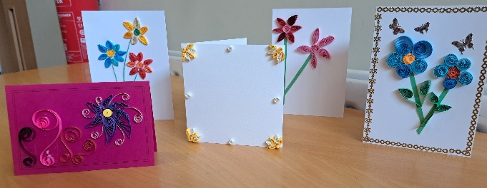

Seven members met on Monday 7TH July to embark on a Quilling exercise. As you can see from the pictures we all had a successful morning. I think we might visit this craft again next year as we all seemed to enjoy ourselves and accomplish something very colourful.
The next meeting is on Monday 4th August when we will be will be undertaking slow stich which Karen will be demonstrating.

If you would like to join us the only thing you need to bring is a basic sewing kit and a willingness to have a go at anything. All materials are available for a very small donation to the person who brings them, if anything more specialised is required you will be given the opportunity to purchase any item needed yourself, or you can borrow from other group members.

The craft group meets the first Monday of the month 10am – 12noon St Theresa’s catholic church, Clumber Street, Warsop. NG20 0LX. The carpark is on Ridgeway and there is a set of steps down to the hall. If you do have mobility issues it may be better to park in either the library or main car park in Warsop.



Future itinerary 2025
August – Slow Stitch
September – Pop-up Cards
October – TBC
November – TBC
December – Milk Bottle Top Trees
Zena.


Garden Group 

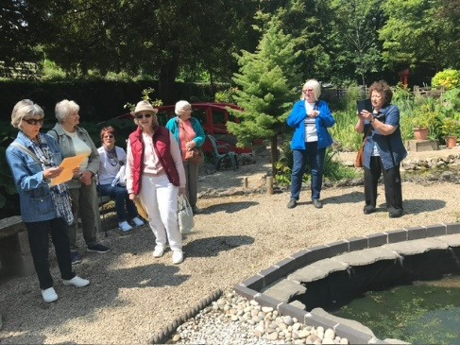
Our July trip was to Newstead Abbey, again we had brilliant weather and a really good day. We started with drinks in the cafe then explored the gardens which was something of an adventure involving stepping stones through the river and many winding paths around the Japanese garden. The formal gardens are immaculate and contain references to Lord Byron and his poetry. Some of us went and stood behind the waterfall which was quite refreshing. We went to Larch Farm for lunch and can highly recommend the food there.

We meet at the car park on the Carrs at 10 am on the second Tuesday of the month and car share from there.

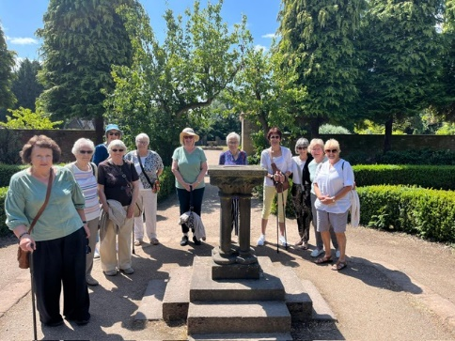
Our trip out in August will be to Glapwell garden centre and to Harrison’s Nursery in Shirebrook.
Anne.
Apologies to anyone missed off the photo.

Programme for future garden group visits:
August 12th, Glapwell garden centre then Harrison’s garden centre , Shirebrook.
September 9th, Chatsworth garden centre.
October 14th, Trowell garden centre.
November 11th, Brookfields garden centre.
December 9th, Blue Diamond garden centre, East Bridgford.
All the above may be subject to change.
Anne.

Photography Group
Warsop & District u3a Photography Group update – July 2025
The group did not meet ‘Face to Face’ last month but the online ‘Themed’ challenge continued.
Last months ‘Theme’ was ‘What I saw on my walk / travels’

Joanne Wheatley ; Sea Gull, Bridge, Statue & Coast!


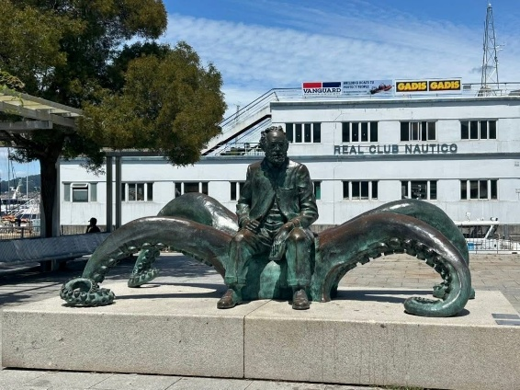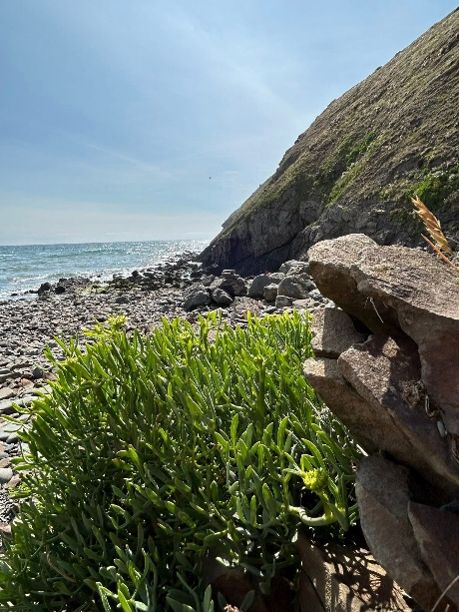

Joyce O’Neill : Flying flowers, Architecture & Pedalos!
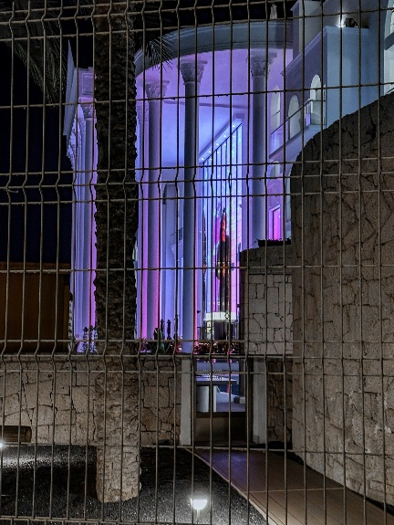



Jen Thomson : Woodland Art & Honeysuckle !
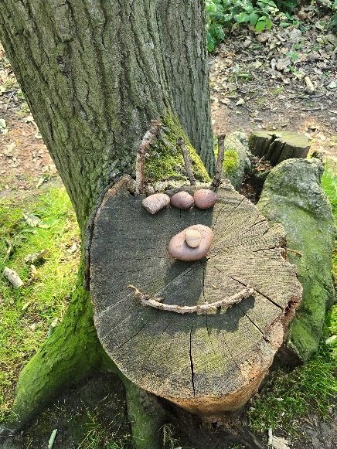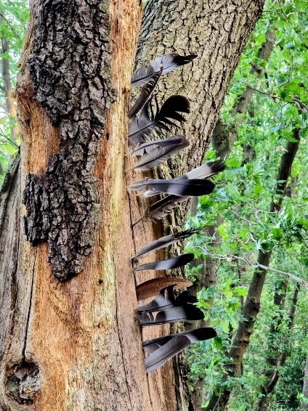
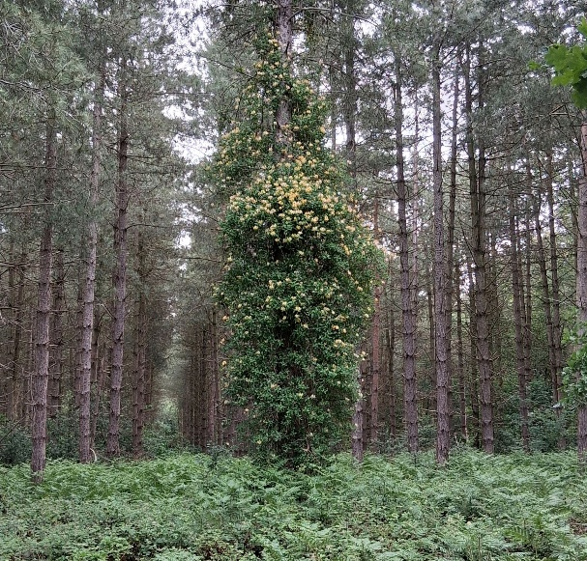

Jim & Chris Shervey : Forest Runner!!!!!!!, It’s good we ‘re out of the Sun, but can we get in the water now? Ship, Tree Trunk & Flowers & Sheep!

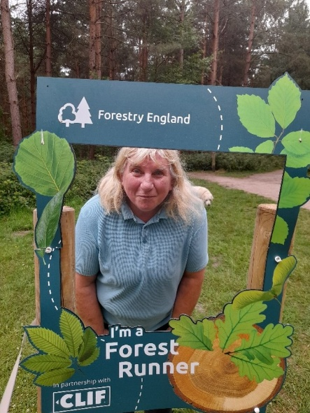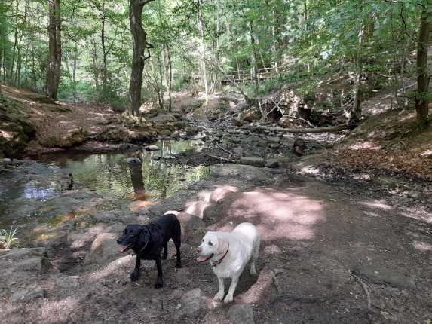

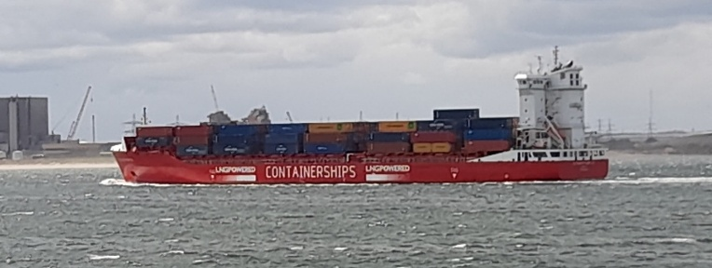
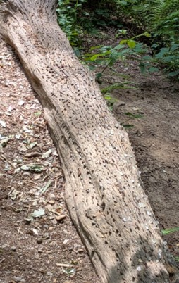
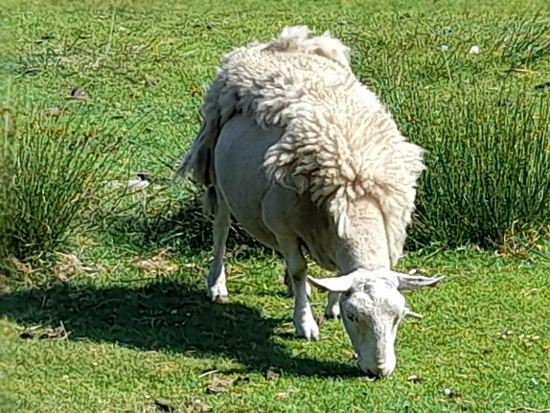
I asked for short back and sides, but only got the sides!!!!!

Betty Trinder: Ornate ceiling, Formal Garden, Waterfall & Japanese garden!



Bob Thomson: Another Place, Puffin, Coots & Rainbow!
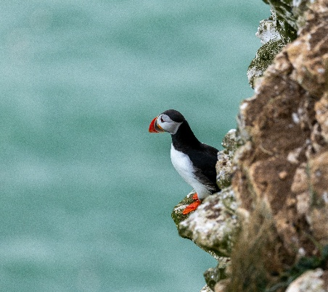
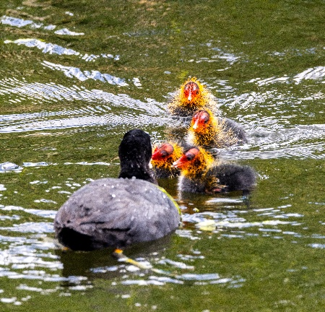
The next online ‘ Themed’ challenge is ‘Ancient / old buildings or sites I have seen’ Old = pre 1900. Once again this challenge is open to ALL u3a members.

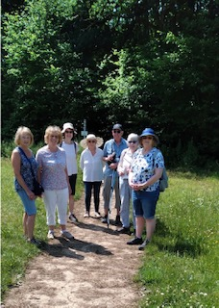

Walking Group
June Walk 2025

What a scorcher!! Yes 8 of us ventured to do the walk on what was the hottest day of the year so far. All prepared with sunscreen, hats and water. The walk started from Rowthorne, from here we walked along the Rowthorne Trail and then onto the Teversal Trail. All easy walking along disused railway lines. We were thankful of the tree canopy that covered most of the route, however we completed the walk before the midday heat.

Next planned walks (we leave The Carrs at 10.00 am prompt)

Date. Walk Leader. Walk
17th July. Gerald. Mansfield Woodhouse
21st Aug. Sonja. Budby/South Forest
18th Sept. TBC
16th Oct. TBC
17th Nov. TBC
Brenda

History Group

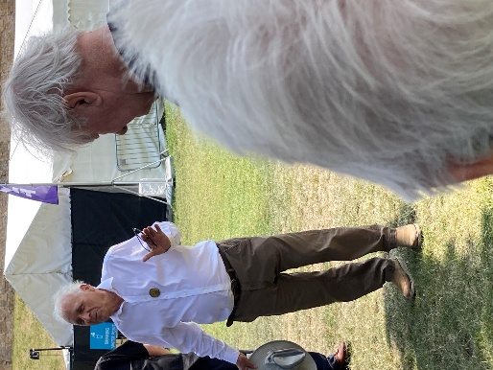
In June members of the history group visited Lincoln Castle. We were blessed with a beautiful sunny day for our trip. Our visit began with a guided tour of the castle grounds with our guide, Tom.
Figure 1 Our guide Tom finds a shady spot to talk
Tom was incredibly knowledgeable and very interesting to listen to. We were treated to a fascinating whistle stop history of the last thousand years of this amazing site, from the Roman fort, which once stood on top of this hill, to the more modern day Georgian and Victorian buildings originally housing the prison and the law courts still used today and standing on the same site as medieval justice was dispensed all those years ago.
Figure 2 Lucy Tower
Lincoln is one of two castles in the country to boast two mottes:
Lucy Tower, named after Lucy Bolingbrook, the Anglo-Norman heiress and Countess of Chester, and the Observation Tower.
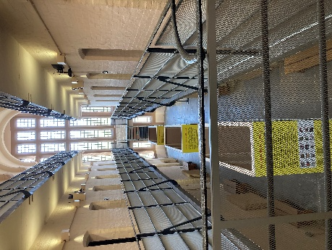
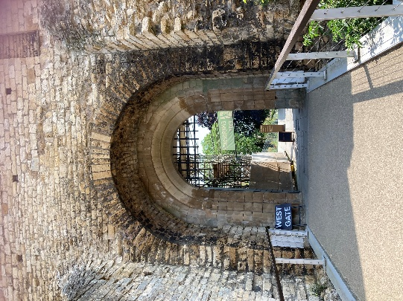

There was the amazing story of Nicola de la Haye, King John’s ‘right hand woman’, who held the castle withstanding not one, but two sieges and sent the French troops packing. Also, we were told about the recently discovered body buried by West Gate – an unsolved medieval murder! In more recent times, the local landlord of the pub next to the West Gate filled in a hole in his back yard using soil from the fortifications and discovered the original Roman West Gate, much to the delight of local archaeologists. The castle bailey had been built over the top of it, keeping it hidden for over 1800 years. This did the landlord no favours as he was sent to prison for defacing a fortification. He felt so aggrieved, he protested during his sentence by refusing to cut his hair and nails. He later returned to Lincoln a very hairy and disillusioned man!
Figure 3 A thousand years of weathering
Figure 4 The West Gate
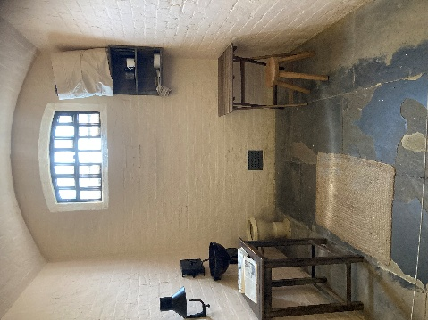

Following lunch in the prison exercise yard we were treated to a visit to the vault where we viewed original copies of the 1215 Magna Carta and the 1217 Charter of the Forest. This was followed by a tour of the Victorian prison and chapel, built on the Pentonville Separate system model.
Figure 5 Prison Chapel - inmates could not speak to anyone. The high wooden partitions kept them separate from one another even in worship.
Figure 6 The Victorian Prison
Figure 7 A Victorian Prison Cell

Barbara & Tamar
Below is the proposed calendar of events for next year.
19th Aug 2025 | Denis Hill The Life of Lord Byron the Poet | St Theresa’s Church Hall 10am
16th Sept 2025 | Visit Denby Pottery
21st Oct 2025 | Chris Weir Mud, Munitions and Memorial WW1 | St Theresa’s Church Hall 10am
18th Nov 2025 | Chris Weir – Lace Slums and the Occasional Riot. Victorian Nottingham | St Theresa’s Church Hall 10am
16th Dec 2025 | No meeting as very close to Christmas

Speakers for the main meetings

2025

July An Officer and a Lady Carol Brooks

August Footpads, Kings and Highwaymen Ian Morgan

September Annual General Meeting

October To be arranged.

November To be arranged.

December Christmas Party

Group | Leaders Name | Tel
NATURAL HISTORY SCIENCE AND TECHNOLOGY | Chris Shervey
WALKING GROUP | Brenda Pearce  Pam Hick
STROLLERS | Janet Harford  Pat Magness
HISTORY GROUP | Barbara Spybey
CRAFTS | Zena Inger
GARDENING | Anne Poultney
PHOTOGRAPHY | Rob Thomson
FRIENDSHIP GROUP | Betty Trinder
THEATRE GROUP
TAI CHI | Anne Poultney

INTEREST GROUP TIMETABLE
 | MONDAY | TUESDAY | WEDNESDAY | THURSDAY | FRIDAY
1st | 10am – 12pm  CRAFTS GROUP  St Teresa’s Catholic Church hall. Warsop |  |  |  | 2pm  FRIENDSHIP GROUP  The Plough Warsop
2nd |  | 10am  GARDENING GROUP  Venue agreed by members |  | 2 – 3.30  NATURAL HISTORY  SCIENCE AND  TECHNOLOGY  St Teresa’s Catholic Church Hall Warsop
3rd | MAIN MEETING 10.15  Oaklands Centre  Warsop | 10am– 12pm  HISTORY GROUP  St Teresa’sCatholic Church hall. Warsop |  | 10am  WALKING GROUP  Carrs Car Park | 11.am  PHOTOGRAPHY  Venue to be agreed by the members.
4th |  |  | 10.am  STROLLERS  Carrs Car Park
THEATRE GROUP - Location and time as announced.
PHOTOGRAPHY GROUP-Please see Newsletter for the online challenge.
TAI CHI Every Friday 10.30am St Teresa’s Catholic Church hall

Committee Members | Role
Lynne Hutchinson | Chairperson
Mel Mitchell | Deputy Chairperson
Irene Clay | Business Secretary
Linda Crossley | Treasurer
Zena Inger | Membership Secretary
Jim Shervey | Speaker Seeker
Jennifer Thomson | Groups co-ordinator
Chris Shervey | Newsletter editor
Ann Ayodele | Social Events
Jennifer Thomson | Welfare Officer
Rob Thomson | Website & Facebook manager
Ann Ayodele | Refreshments rota
June Whittle | Raffle
Betty Trinder | Social events assistant

Warsop & District U3A is committed to treating all people equally. Anyone wishing to see the Privacy and Data Protection policies may view them on the Warsop.u3asite.uk alternatively please ask Rob.
Facebook
Warsop & District U3A has a Facebook Group. It is a private group which can be seen by the public but only members can see who’s in the group and what they post.
What this means is that you have to be invited to join the group or have your request to join accepted. Also you need to be on Facebook which some of you may not be. As a member of the group you will be able to put your own posts on the page, please keep them relevant to the U3A and what it stands for. We would ask that you don't put anything on that is in anyway party political or anything that may be offensive to others who may be of a different creed or religion. Hopefully everyone will join, use the page and find it useful.
One of the things that puts people ‘off’ Facebook, is the ‘bad press’ some of the Social sites get. You can join Facebook, choose only to join the Warsop Facebook page and not be involved in any other site, or Friends requests (usually from people that you have never heard of!) The choice is entirely yours.
To request to join the Warsop u3a Facebook page, contact Bob Thomson.
Website & Facebook
The Warsop & District u3a website can be found at Warsop.u3asite.uk . If any of the group leaders/facilitators would like to advertise/ promote any of their future activities or change the information shown, please contact Bob Thomson
June quiz cats and dogs
1 Where do cats have no tails? ISLE OF MAN
2 What breed of cat featured in Disneys Lady and the tramp? SIAMESE
3 What was the name of the dog in the Tin Tin stories? SNOWY
4 Which breed of dog is this XREBO? BOXER
5 Who wrote the poem on which the musical cats is based? T S ELIOT
6 What was the name of the dog in the Famous Five stories? TIMMY
7 Which ancient civilisation revered cats? EYGPT
8 Which breed of dog do the king and Queen have? JACK RUSSELLS
9 How old is the oldest cat in the world 29yrs 30yrs 31yrs?
10 Which breed of dog is this LARAIDEE ? AIREDALE
11 What was the name of the dog who went into space in 1957? LAIKA
12 What was the name of the dog in childrens programme The Woodentops? SPOTTY
13 What is the name of Dr Who’s dog? K9
14 How many lives is a cat said to have? NINE
15 What is a cross between a Jack Russell and a Pug called? JUG
16 What is the dog called in The Wizard of Oz book/film ? TOTO
17 What was Queen Elizabeths first corgi called Alice Susan Maud ?
18 What was the cat called who had trouble with Jerry the mouse? TOM
19 Which is Britains favourite dog breed? LABRADOR
20 Which breed of dog is this MANLDATAI ? DALMATIAN
21 Which dog breed traditionally rescued people in the mountains of Europe? ST BERNARD
22 Which dog helped Shaggy Freddie Daphne and Velma solve mysteries? SCOOBY DOO
23 The statue of Greyfriars Bobby is in which city? EDINBURGH
24 Which cat was always chasing Tweety Pie in the TV cartoon? SYLVESTER
25 Which dog breed won best in show at Crufts 2025 Australian Shepherd
Giant Schnauzer Bearded Collie ?

June riddles
1What creature is smarter than a talking parrot? SPELLING BEE

2 What rock group has four famous men but none of them sing? MOUNT RUSHMORE

3 What running leads to walking? RUNNING OUT OF PETROL

June quick quiz all answers start with u except for one.
1 A small stringed instrument? UKELELE
2 Name of a pop group whose name is letters and numbers? UB40
3 Degree awarding institutions? UNIVERSITIES
4 Language of Northern India? URDU
5 Species of bat that feeds on blood? VAMPIRE
6 Salt Lake City is the capital of which USA State? UTAH
7 A radioactive element? URANIUM
8 Alternative name of the Moonies Cult? UNIFICATION CHURCH
9 Organisation formed to maintain world peace? UNITED NATIONS
10 A mountain range in Russia? URALS

Notice of Warsop and District Annual General Meeting (AGM)
Monday 15th September 2025 10.15am at Oaklands, Oaklands Lane,Warsop, NG20 OJE
It will soon be time for the AGM and these papers are in preparation for the event.
At the AGM the membership has to vote in the four Honorary officer posts of Chair, Vice-Chair, Treasurer and Business Secretary.
The current officers, Lynne Hutchinson - Chair, Mel Mitchell - Vice-Chair, Irene Clay - Business secretary Linda Crossley – Treasurer
All of these positions are open for nominations and the nominating and seconding process is necessary for each office. More positions are available and nominations would be most welcome from members wishing to join the committee in a non-officer role. Which means that you would be able to take on a role or be available to help other committee members as needed, which will ultimately lessen the load on each individual.
The nomination forms are included with this document, the completed forms must be returned to - Irene Clay,, Business Secretary. By the 18thAugust 2025. The votes will then be taken at the AGM.
The committee holds at least 3 meetings a year, sometimes more, usually lasting about 2 hours.
The role of the committee is to ensure that Warsop & District u3a runs as well as it can for the members. If you feel that you would like to join the committee come and talk to one of the current team.
The current positions are (there can be up to 15 committee members):
Committee Members | Role
Lynne Hutchinson | Chairperson
Mel Mitchell | Vice Chairperson
Irene Clay | Business Secretary
Linda Crossley | Treasurer
Zena Inger | Membership Secretary
Chris Shervey | Newsletter Editor
Ann Ayodele | Refreshments & Meeters + Greeters. Social Events Organiser
Jennifer Thomson | Groups co-ordinator
Betty Trinder | Social Events
June Whittle | Raffle organiser
Bob Thomson | Website and Face-book manager
Jim Shervey | Speaker Organiser

NOMINATION FOR HONORARY OFFICER- Chair/Vice chair/Business secretary/Treasurer
NOMINATION FOR COMMITTEE MEMBER- Committee member or named role

Post nominated for (Choose from above)-

Name of Nominee-

Signature

Address

Telephone

Email

Name of proposer

Signature

Name of Seconder

Signature

Return to the Business Secretary - Irene Clay.

