
Issue 93 August 2025

Warsop & District
Notes from the Chair
"Hello everyone and welcome to our August newsletter. Can't believe it's August already can you?
Since my last notes I have enjoyed a lovely U3a day out to Buxton. The weather stayed kind to us again so thanks again Ann for organising this.
As you probably know I love my football so have to mention our English ladies who did us proud by winning the Euros. Hope the men will take note in the future!
Please don't forget that next month is the AGM so if any of you have any items for the Silent Auction they would be much appreciated.
Understand we will be having another heatwave next week so off now to stock up on sun tan cream.
See you all soon
Lynne x"

Please note that the AGM is planned for the 15th September. New committee members always welcome. Information and nomination forms are at the end of the newsletter.

The deadline for including articles/information in the next newsletter is Friday 5th September. Send contributions to Chris Shervey. If you have any ideas for new items to include in the newsletter please let me know.

Rota for refreshments and greeting.
This is the rota for the next four months, any problems please contact me, Ann Ayodele.
Thank you to all those who have volunteered to help, without you our meetings would not be so enjoyable.

Date | Refreshments 1 | Refreshments 2 | Meet and Greet 1 | Meet and Greet 2
18th Aug | Karen Breed | Beatrix Kirby | Raymond White | Ann Barnes
15th Sept | Ann Ayodele | Janet Harford | Moira Heslop | Ann Poultney
20th Oct | Yvonne Pannifer | Zena Inger

EVENTS

Boat Trip on the Trent
The boat trip has had to be cancelled due to lack of support, Ann Ayodele.
Christmas Lunch 2025
Christmas Lunch, Friday 19th December at the Hostess.
The deposit for 26 of us to attend this festive occasion has been paid. I shall need the balance of £17 each on or before Monday 15th December.
Jen

ITEMS OF INTEREST

SILENT AUCTION FOR LOCAL CHARITIES SEPT MEETING ( AFTER THE AGM)
Please bring any items for the auction to the meeting in August. Boxes will be placed near the entrance for your items. Thank you.
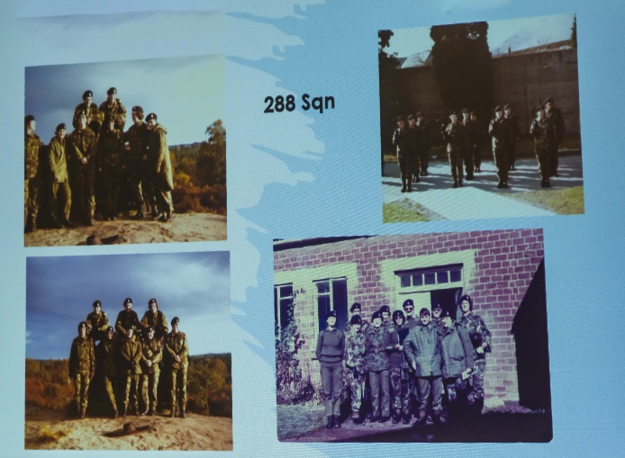
Last Month’s Speaker.
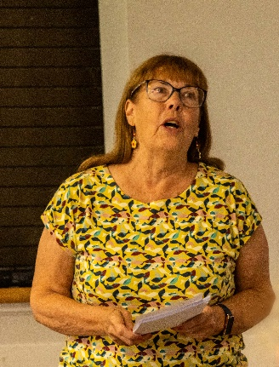
We had a very interesting talk from Carol Brookes about her time as an officer in the Army. Can you spot her in all of the pictures?
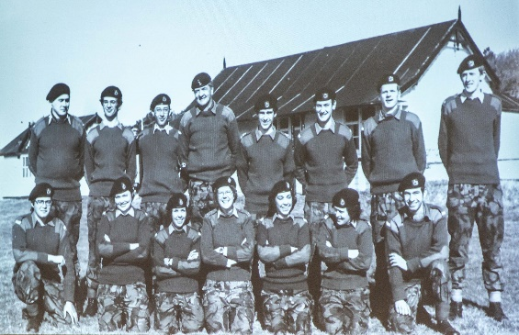

Ashfield u3a Miscellany group have a few spaces for a trip to Stamford on the 12 September leaving Ellis Street, Kirkby at 9am and returning from Stamford at 4pm. The cost is £15 for the coach plus an extra £10 if you want to join a walking tour which at 2pm which will last approx 90 minutes. Total £25 if doing tour. Please contact me if any if your members are interested.

Table Tennis Club- Warsop Health Hub-Mondays 1.30-3.30pm
If you would like to have a go at playing table tennis then please do join Pam Hick and Ian James at the Health Hub each Monday from 1.30-3.30pm. The cost is £4 per person. Bats and balls are provided.
Vibrant Warsop has supported this venture with the purchase of 2 brand new tables. Both Pam and Ian are also members of the U3a (Pam-Warsop & Ian- Forest Town)
You do not need to be a member of the Health Hub- just turn up!

FREE Well rotted horse manure. Speak to Jim.

Cups Please will as many of you as
possible bring your own mug for your tea or coffee. This is not only more environmentally friendly but also would save us a lot of money as the paper disposable cups we use are surprisingly expensive. Ann.

Robin Hood Lottery 
Warsop and District U3A is a cause registered with the Robin Hood Lottery.
To buy a ticket you can now register on line at www.robinhoodlottery.co.uk and set up regular payments. If you buy a ticket every week for a year Warsop U3A will receive £26.
Remember the more members that have a go (specifying Warsop & District U3A) the more money we get for our funds.

Books and Jigsaws 50p. We made £5.70 at the July meeting thank you. Please note the books are sorted into genres making it easier to find a book you like.

Raffle. Raffle in July £32 thank you
RAFFLE PRIZES NEEDED PLEASE
RAFFLE PRIZES NEEDED .

WELFARE

A card expressing our very best wishes has been sent to one of our founder members who is currently undergoing chemotherapy.
Please remember to let me know of any other members who are unwell or who have been bereaved so that our good wishes may be sent to them too. Jen
August quick quiz all answers start with w except one.
1 Famous wall in Jerusalem?
2 Marsupial belonging to Kangeroo family?
3 Financial district of New York?
4 Painter of the Soup Can picture (surname) ?
5 Actor famous for Westerns 1907-79 (surname)
6 Famous British pottery?
7 Type of painting medium?
8 Method of joining metals together?
9 Painter of The Last Supper 1452-1519?
10 In folklore people who turn into wolves are called?

August quiz things in a shop e.g. go on cooking ---- bacon
1 An old sailor ?
2 Eastern Ladies?
3 A golf term?
4 A kiss with zero either side?
5 Description of a goat?
6 Seen on a trap?
7 Strong waves?
8 Urges On?
9 Cricket fixtures?
10 Say the word to start?
11 Squeeze tightly?
12 Levitated Posy?
13 Impudence?
14 As like twins?
15 Old weapon and part of a plant?

August riddles ? ? ?
1What occurs once in a minute twice in a moment and never in a thousand years?
2 What starts with T ends with T and has T in it?
3 What room has no windows or doors?

Well I didn’t know that! Shops ----
The oldest shop in the world is in Japan and began trading in 705AD

The oldest shop in England is The Tulip tree in Kent which began trading in1453. It has been a general store and Post Office and a Tea Room.

The oldest sweet shop in England is in Pateley Bridge Yorkshire and began trading in 1827.

The largest sweet shop in the world is Mand M in London.

The largest shop in the world is the Department store in Busan in South Korea.

Answers to last months quizzes and riddles can be found at the end of the newsletter.

GROUP NEWS
COULD ALL GROUP LEADERS PLEASE COLLECT THEIR BADGES WHEN THEY COLLECT THEIR LANYARDS. THEN MEMBERS CAN SEE WHOTO SPEAK TO ABOUT A GROUP.
THANK YOU

I shall be arranging a meeting for our group leaders at the Cosi Cafe, Clumber Street, Warsop for Thursday 6th November at 11am. The meeting will, of course, include coffee (or tea) and cakes to thank the group leaders for all their hard work during the year and to update them with information from the recent group leaders and coordinators workshop. I hope everyone will be able to attend. Jen

Mobile Phone Workshop
A reminder, two workshops are to take place on consecutive Thursdays, 11th and 18th September at 10.30am in the Oaklands.
There are still places available so please let me know if you'd like to come. Each workshop covers different topics, so ideally you need to be able to attend both. If you can only manage one session you are still welcome to come.

Group Leaders and Groups Coordinators Workshop.
Three of us attended this workshop last month and found it useful and reassuring, we're doing OK here at Warsop!
I've been away since then so haven't had chance to put any information together yet. As soon as I have I shall call a meeting of our hard working group leaders to pass on any tips and to express our thanks for everything they do for our members.
Jen.

If anyone has any suggestions for new groups please let me know.

Jen
North Notts Neighbourhood group
This means that you as a member of Warsop & District can ask to join an interest group in another U3A that is also in the NNNG, as long as the group is not oversubscribed at the time of your request you can join the group without joining the host u3a
The u3as in the NNNG are Mansfield, Sherwood, Dukeries, Rainworth, Forest Town, Ashfield, Sutton in Ashfield, Hucknall, Worksop, Warsop, Retford and Bolsover.

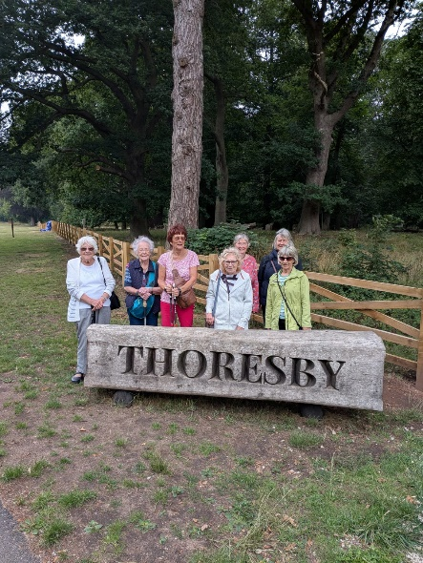
Strollers 
On the July stroll eight members enjoyed a walk in Thoresby Country Park. We had a very pleasant stroll through the woods, down to the river, taking in the path to Perlthorpe Church, then back to Thoresby Courtyard for refreshments. Another very nice sociable morning.

Wednesday 27th August - Sherwood Forest
Meet at The Carrs car park at 10.00 am for car share to Edwinstowe

Future walks:=
August Sherwood Forest
September. Sherwood Pines (to be confirmed)
October. Clumber Park (to be confirmed)
November Thoresby Park
December. No walk
The Friendship Group 
The Friendship Group did not have a meeting in August due to holidays and other commitments.
The next meeting will be on Friday, 5th September at the Plough Inn at 2.00 p.m.


Tai Chi Tigers
Tai Chi Tigers meet at St Theresa’s church hall in Warsop, usually every Friday but we are having a break at the end of August and there will be no class on the 22nd and 29th August. We meet from 10.30 to 11.30 at a cost of £6. Plenty of room for new members and the exercises can be done while seated.

Tai Chi improves balance, flexibility, co-ordination and fitness. It is also good for mindfulness, stress relief and wellbeing. We escape for an hour from our everyday worries and have a laugh as well.

Always room for new members. Anne

Bridge Club
The Dukeries u3a Bridge Group meet on the Second and Fourth Tuesday of each month at the Jubilee Hall (NG22 9AP) from 1 – 4PM. The cost of each session is currently £3.
All U3a members are welcome to attend.

Natural History, Science and Technology.
This month’s talk was a very interesting and entertaining on ‘Relationship between plants and animals’.
We learnt how everything on the planet is dependant on another organism. Usually the dependence is beneficial, but sometimes it only benefits one i.e. in a parasitic way.
2025 | Activity
September 11th | VISIT to Mansfield Museum
October 9th | Sounds & Hearing
November 13th | Mycology – study of Fungi
December | No Meeting
January 2026 | The Science of Cheese Making

Craft Group 

The August meeting make was changed due to personal circumstances. The group did some embroidery hoop collages, a card and a knitted peg doll, as you can see from the picture they made some very colourful items and I heard that they enjoyed the morning together.
The next meeting is on Monday 1st September when we will be will be making pop- up cards.

If you would like to join us the only thing you need to bring is a basic sewing kit and a willingness to have a go at anything. All materials are available for a very small donation to the person who brings them, if anything more specialised is required you will be given the opportunity to purchase any item needed yourself, or you can borrow from other group members.
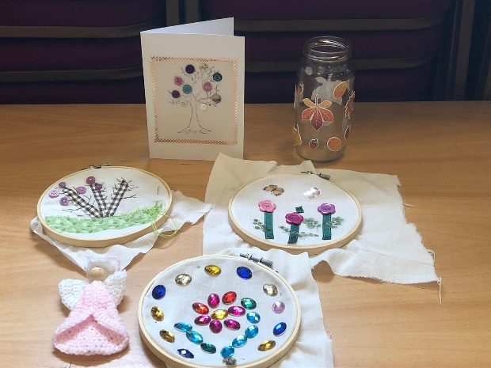
The craft group meets the first Monday of the month 10am – 12noon St Theresa’s catholic church, Clumber Street, Warsop. NG20 0LX. The carpark is on Ridgeway and there is a set of steps down to the hall. If you do have mobility issues it may be better to park in either the library or main car park in Warsop.
Future itinerary 2025
September – Pop-up Cards
October – TBC
November – TBC
December – Milk Bottle Top Trees
Zena.

Garden Group 
August’s trip was to Glapwell garden centre on 12th August.

On September 9th we shall be going to Chatsworth garden centre.

We meet on the second Tuesday of the month at the car park at the Mill Dam in Warsop at 10am and car share from there.

Programme for future garden group visits:
September 9th, Chatsworth garden centre.
October 14th, Trowell garden centre.
November 11th, Brookfields garden centre.
December 9th, Blue Diamond garden centre, East Bridgford.
All the above may be subject to change.
Anne.

Photography Group
Last months online’ Themed’ challenge was ‘ Anything Old or Ancient’.

Joanne Wheatley – Grave of Gunhilda – King Canutes daughter, Bosham Church, Castle and Tower

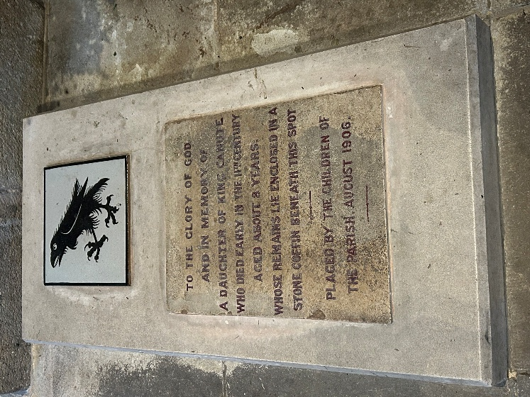
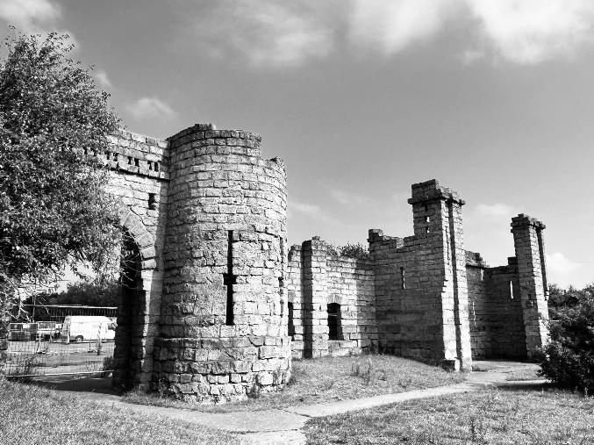
Joyce O’Neill – Ancient City of Verona – Founded in the 1st century BC as a Roman colony.




Bob Thomson – Blackpool Tower - Started in 1891 and completed in 1894.
Flamborough 'New' Lighthouse - built in 1806.
Bridlington Priory - Building began in 1113 and continued over the centuries.…
St Peter & Pauls Church – 11th Century

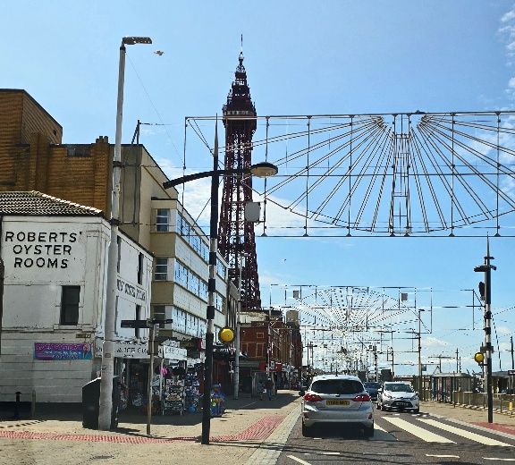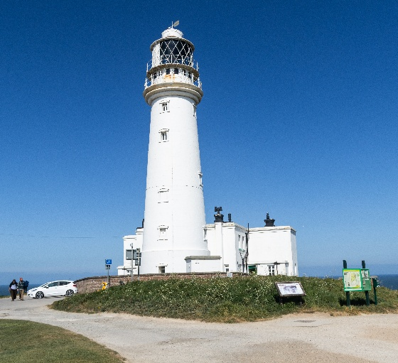



The next ‘Themed’ online challenge, set by Joanne & Cath is ‘Things that fly’.

Once again this challenge is open to ALL u3a members!

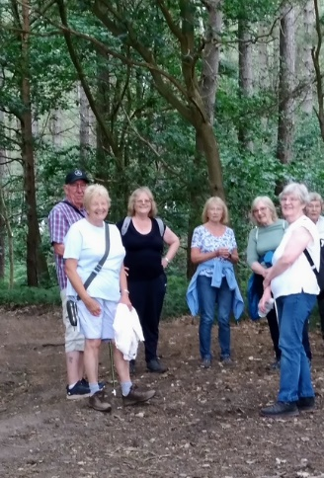

Walking Group
Thank you Mr G (Gerald) for a pleasant magical mystery tour around Peafield Woods. Who knew there was so many hills in Woodhouse we found them all I think in that area but a good time was had by all.
The chatter along the way highlights what our little group is all about. Just some of the comments made enroute. Refreshing, Jolly, Well-being, Laughter, Companionship, Friendly. Long may it continue.

Future walk dates (We leave The Carrs at 10.00 am prompt)

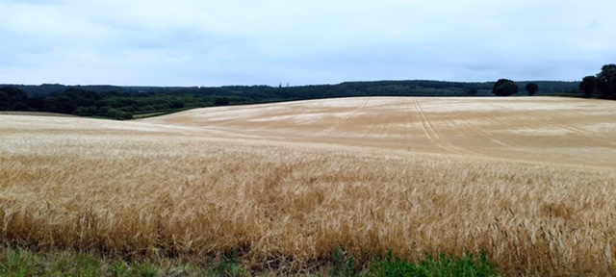
Date. Walk Leader. Walk. Distance
21st August. Sonja. Budby/Sth Forest
18th Sept. Brenda/Pam. Shirebrook Wood. 4.5 miles
16th Oct. TBC
20th Nov. Brenda. Boughton Brake. 4 miles
Brenda

History Group
The history group met on Tuesday 15th July when Grant Cullen, branch secretary of the Chesterfield Western Front Association, was our visiting speaker. Grant is passionate about the history of the World Wars and British railways, interests which stemmed from his childhood in Scotland. He has travelled globally visiting many sites from the World Wars. Grant is also a member of a number of railway associations and has combined his interests of history and railways by writing a six-part series entitled ‘The North British Railway and The Great War’ which was published in the ‘North British Railway Study Group’ Journal. He is currently working on a three-part series entitled the ‘Caledonian Railway in WW1’ for the Caledonian Railway Association magazine. Grant’s talk was about the Quintinshill Rail Disaster near Gretna Green in Dumfriesshire on the 22nd May 1915. This was an horrific collision involving a train carrying troops destined for the First World War battlefields, a local train and an express. This accident claimed the lives of over 200 people and is the worst rail disaster in British history, one which could so easily have been avoided. A moving talk which still has its unresolved mysteries today, such as the identity of the four children, two girls and two boys, whose remains were found in the wreckage of the troop train. They were never claimed or reported missing and their identity remains a mystery to this day. Grant has kindly sent us the magazine article he wrote about this disaster for anyone in our U3A who would like to read it. Anyone interested should contact Tamar. Our next meeting is on Tuesday 19th August at 10am at St Teresa’s church hall when we will be joined once again by Denis Hill. He will be speaking to us about the poet Lord Byron. We look forward to welcoming our regular members and new ones.
Barbara & Tamar

Below is the proposed calendar of events for next year.
19th Aug 2025 | Denis Hill The Life of Lord Byron the Poet | St Theresa’s Church Hall 10am
16th Sept 2025 | Visit Denby Pottery
21st Oct 2025 | Chris Weir Mud, Munitions and Memorial WW1 | St Theresa’s Church Hall 10am
18th Nov 2025 | Chris Weir – Lace Slums and the Occasional Riot. Victorian Nottingham | St Theresa’s Church Hall 10am
16th Dec 2025 | No meeting as very close to Christmas

Speakers for the main meetings

2025

August Footpads, Kings and Highwaymen Ian Morgan

September Annual General Meeting

October To be arranged.

November To be arranged.

December Christmas Party

Group | Leaders Name | Tel
NATURAL HISTORY SCIENCE AND TECHNOLOGY | Chris Shervey
WALKING GROUP | Brenda Pearce  Pam Hick
STROLLERS | Janet Harford  Pat Magness
HISTORY GROUP | Barbara Spybey
CRAFTS | Zena Inger
GARDENING | Anne Poultney
PHOTOGRAPHY | Rob Thomson
FRIENDSHIP GROUP | Betty Trinder
THEATRE GROUP
TAI CHI | Anne Poultney

INTEREST GROUP TIMETABLE
 | MONDAY | TUESDAY | WEDNESDAY | THURSDAY | FRIDAY
1st | 10am – 12pm  CRAFTS GROUP  St Teresa’s Catholic Church hall. Warsop |  |  |  | 2pm  FRIENDSHIP GROUP  The Plough Warsop
2nd |  | 10am  GARDENING GROUP  Venue agreed by members |  | 2 – 3.30  NATURAL HISTORY  SCIENCE AND  TECHNOLOGY  St Teresa’s Catholic Church Hall Warsop
3rd | MAIN MEETING 10.15  Oaklands Centre  Warsop | 10am– 12pm  HISTORY GROUP  St Teresa’sCatholic Church hall. Warsop |  | 10am  WALKING GROUP  Carrs Car Park | 11.am  PHOTOGRAPHY  Venue to be agreed by the members.
4th |  |  | 10.am  STROLLERS  Carrs Car Park
THEATRE GROUP - Location and time as announced.
PHOTOGRAPHY GROUP-Please see Newsletter for the online challenge.
TAI CHI Every Friday 10.30am St Teresa’s Catholic Church hall

Committee Members | Role
Lynne Hutchinson | Chairperson
Mel Mitchell | Deputy Chairperson
Irene Clay | Business Secretary
Linda Crossley | Treasurer
Zena Inger | Membership Secretary
Jim Shervey | Speaker Seeker
Jennifer Thomson | Groups co-ordinator
Chris Shervey | Newsletter editor
Ann Ayodele | Social Events
Jennifer Thomson | Welfare Officer
Rob Thomson | Website & Facebook manager
Ann Ayodele | Refreshments rota
June Whittle | Raffle
Betty Trinder | Social events assistant

Warsop & District U3A is committed to treating all people equally. Anyone wishing to see the Privacy and Data Protection policies may view them on the Warsop.u3asite.uk alternatively please ask Rob.
Facebook
Warsop & District U3A has a Facebook Group. It is a private group which can be seen by the public but only members can see who’s in the group and what they post.
What this means is that you have to be invited to join the group or have your request to join accepted. Also you need to be on Facebook which some of you may not be. As a member of the group you will be able to put your own posts on the page, please keep them relevant to the U3A and what it stands for. We would ask that you don't put anything on that is in anyway party political or anything that may be offensive to others who may be of a different creed or religion. Hopefully everyone will join, use the page and find it useful.
One of the things that puts people ‘off’ Facebook, is the ‘bad press’ some of the Social sites get. You can join Facebook, choose only to join the Warsop Facebook page and not be involved in any other site, or Friends requests (usually from people that you have never heard of!) The choice is entirely yours.
To request to join the Warsop u3a Facebook page, contact Bob Thomson.
Website & Facebook
The Warsop & District u3a website can be found at Warsop.u3asite.uk . If any of the group leaders/facilitators would like to advertise/ promote any of their future activities or change the information shown, please contact Bob Thomson
Answers July quick quiz All answers start with v except for one.
1 Volcano that destroyed Pompeii in AD79? VESUVIUS
2 Yorkshire village ,home of the Bronte sisters? HAWORTH
3 WWII missile called flying bomb or ----? V1
4 Former name of Tasmania? VAN DIEMANS LAND
5 Roman poet who wrote the Aeneid? VIRGIL
6 Country in S America? VENEZUELA
7 French author 1828 – 1905? VERNE (Jules)
8 Largest lake in Africa? VICTORIA
9 Name used for country houses in Italy? VILLA
10 Keyboard instrument of 16th and 17th centuries? VIRGINAL

Answers July quiz do you know the occupations of these tv characters?
Eg miss marple -------- amateur detective
- Del Trotter MARKET TRADER Only Fools and Horses
- Jim Bergerac POLICEMAN Bergerac
- James Herriot VET All Creatures Great and Small
- Frasier THERAPIST Cheers/Frasier
- Father Brown PRIEST/DETECTIVE Father Brown
- Mrs Slocombe SHOP ASSISSANT Are You being served
- Basil Fawlty HOTEL OWNER Fawlty Towers
- Ross Poldark MINE OWNER Poldark
- Albert Steptoe SCRAPMAN Steptoe and Son
- Sister Boniface NUN/FORENSICS EXPERT FOR POLICE Sister Boniface
- Emma Peel SPY The Avengers
- Kim Tate BUISINESS WOMEN Emmerdale
- Mr Hudson BUTLER Upstairs Downstairs
- Rowdy Yates COWBOY Rawhide
- Hawkeye Pearce DOCTOR MASH
- Perry Mason ATTORNEY Perry Mason
- Mr Hedges TEACHER Please Sir
- Peggy Mitchell LANDLADY Eastenders
- Tom Barnaby POLICEMAN Midsummer Murders
- Mrs Bridges COOK Upstairs Downstairs
- Beth Lacey POLICEWOMAN Cagney and Lacey
- Ruby Sunday COMPANION/TIME TRAVELLER Dr Who
- Ugly Betty WORKED IN A PUBLISHING COMPANY Ugly Betty
- Rigsby LANDLORD Rising Damp
- Richard de Vere OWNER OF SUPERMARKKET CHAIN To the Manor Born
- Lewis POLICEMAN Morse/Lewis
- Captain Mainwaring BANK MANAGER Dads Army
- Mr Carson BUTLER Downton Abbey
- Annie Walker LANDLADY Coronation Street

Answers July riddles
1 What is full of holes and still holds water? SPONGE

2 Which coat is put on wet? COAT OF PAINT

3 I have towns but no houses, forests but no trees, water but no fish. What am I?
A MAP

Notice of Warsop and District Annual General Meeting (AGM)
Monday 15th September 2025 10.15am at Oaklands, Oaklands Lane,Warsop, NG20 OJE
It will soon be time for the AGM and these papers are in preparation for the event.
At the AGM the membership has to vote in the four Honorary officer posts of Chair, Vice-Chair, Treasurer and Business Secretary.
The current officers, Lynne Hutchinson - Chair, Mel Mitchell - Vice-Chair, Irene Clay - Business secretary Linda Crossley – Treasurer
All of these positions are open for nominations and the nominating and seconding process is necessary for each office. More positions are available and nominations would be most welcome from members wishing to join the committee in a non-officer role. Which means that you would be able to take on a role or be available to help other committee members as needed, which will ultimately lessen the load on each individual.
The nomination forms are included with this document, the completed forms must be returned to - Irene Clay.,By the 18thAugust 2025. The votes will then be taken at the AGM.
The committee holds at least 3 meetings a year, sometimes more, usually lasting about 2 hours.
The role of the committee is to ensure that Warsop & District u3a runs as well as it can for the members. If you feel that you would like to join the committee come and talk to one of the current team.
The current positions are (there can be up to 15 committee members):
Committee Members | Role
Lynne Hutchinson | Chairperson
Mel Mitchell | Vice Chairperson
Irene Clay | Business Secretary
Linda Crossley | Treasurer
Zena Inger | Membership Secretary
Chris Shervey | Newsletter Editor
Ann Ayodele | Refreshments & Meeters + Greeters. Social Events Organiser
Jennifer Thomson | Groups co-ordinator
Betty Trinder | Social Events
June Whittle | Raffle organiser
Bob Thomson | Website and Face-book manager
Jim Shervey | Speaker Organiser

NOMINATION FOR HONORARY OFFICER- Chair/Vice chair/Business secretary/Treasurer
NOMINATION FOR COMMITTEE MEMBER- Committee member or named role

Post nominated for (Choose from above)-

Name of Nominee-

Signature

Address

Telephone

Email

Name of proposer

Signature

Name of Seconder

Signature

Return to the Business Secretary - Irene Clay.

