
Issue 89 April 2025

Warsop & District


HAPPY EASTER
Notes from the Chair
" Hello everyone and a very happy Easter to you all! As I was christened at the Methodist Chapel on Clumber Street this time of year always brings back happy memories of the lovely services we had there.
April is my favourite month of the year . A time of new growth and beginnings as Spring begins in earnest. It's also the month I was born on a Good Friday many years ago so also special to me personally. Because of that I also will miss seeing you all at the April meeting as my lovely daughter and son-in-law have arranged a special weekend for me in Tettenhall where they live. Hopefully I will see as many of you as possible at the Garden Party on May 8th to celebrate VE day but in the meantime enjoy this lovely weather and don't eat too much chocolate x"

The deadline for including articles/information in the next newsletter is Friday 9th May Send contributions to Chris Shervey. If you have any ideas for new items to include in the newsletter please let me know.
PLEASE NOTE THE MAY NEWSLETTER WILL NOT BE OUT TILL SUNDAY 18TH, AS I AM HOLIDAY THAT WEEK.

Membership renewals 2025
You will be pleased to hear that we are able to keep the cost of membership at £20.00, or £16.00 with proof of membership where the TAT levy has been paid at another u3a.
You will be able to renew your membership at the April meeting. If you can’t make the meetings let me know and we can make arrangements to renew.
The current membership year ends at the end of March, so anyone who has not renewed after the April meeting will be taken off the circulation lists, (this does not prevent you rejoining at a later date).
Please collect an application form as you arrive, fill it in and see me during the coffee break.
Zena Inger

Rota for refreshments and greeting.
Please Note the Changes to the Meet and Greet.
This is the rota for the next three months, any problems please contact me, Ann Ayodele.
Thank you to all those who have volunteered to help, without you our meetings would not be so enjoyable.

Date | Refreshments 1 | Refreshments 2 | Meet and Greet 1 | Meet and Greet 2
21stApril | Sylvia Ellis | Patricia Ward | Gill Greer | Moira Heslop
19th May | Yvonne Pannifer | Glenys Fearn | Chris Wilson | Brenda Pearce
16th June | Angeline Taylor | Sonia Attwell | William Taylor | Ann Holland

EVENTS

Quiz Night. The quiz night has been cancelled due to not many people being able to attend. I will arrange another in six months.

Coach Trip to York. There will be a coach trip to York on Thursday 22nd May, pick ups will be from The Oaklands 9.00am, where people can leave their cars, and Tudor Barn 9.10am for anyone else.
The cost for the trip is being subsidised by U3A, it would have been in excess of £13.00 (depending on the number of seats filled up), so the cost for the return trip to York is £8.00 plus the driver’s tip, making it £9.00 total cost. There is still a chance to book a seat and I will be taking names and money at the April meeting on the 21st April.

Coach Trip to Buxton. There will be a coach trip to Buxton on Thursday 3rd July, the same arrangements for pick ups. Again this is being subsidised by U3A. It would have been in excess of £11.00 depending on how many seats filled, however the cost is £7.00, plus driver’s trip, total cost is £8.00.

I will start taking names and money at the April monthly meeting.

Garden Party to celebrate VE DAY

The garden party will be from 2-4 at Oakroyd Forest Road NG20 0EP.
All welcome, no charge but if you wish to bring a guest it is £5. Tea and coffee will be provided , you may bring other drinks if you wish to. We will be serving afternoon tea. There are also some activities. As usual please bring a chair. The dress code is red white and blue if you wish to.

PLEASE LET US KNOW AT THE MAIN MEETING IF YOU WISH TO COME (so we know how many to cater for) IF YOU ARE NOT THERE ON MON 21st PLEASE CONTACT CHRIS.

DropWorks Rum Distillery Tour
I’ve arranged a private tour of the rum distillery if anyone is interested?
Date. Tuesday 24th June 2025
Time. 12.00pm (please arrive for 11.50a.m.)
Cost. £12.50 (cash please)
Venue. DropWorks Rum Distillery, Stone Shed, Welbeck, Worksop, Notts. S80 3LX
I will be taking bookings and payment at the May meeting.
Brenda

ITEMS OF INTEREST

Table Tennis Club- Warsop Health Hub-Mondays 1.30-3.30pm
If you would like to have a go at playing table tennis then please do join Pam Hick and Ian James at the Health Hub each Monday from 1.30-3.30pm. The cost is £4 per person. Bats and balls are provided.
Vibrant Warsop has supported this venture with the purchase of 2 brand new tables. Both Pam and Ian are also members of the U3a (Pam-Warsop & Ian- Forest Town)
You do not need to be a member of the Health Hub- just turn up!

FREE Well rotted horse manure. Speak to Jim!

LOCAL CHARITIES
So far we have supported the following local groups andcharities.Age Concern, John Eastwood Hospice Support Group, Cats Protection and Warsop Wildlife Rescue Team.
If there is a LOCAL charity you would like to benefit give the name and contact details to Jim.
Cups Please will as many of you as
possible bring your own mug for your tea or coffee. This is not only more environmentally friendly but also would save us a lot of money as the paper disposable cups we use are surprisingly expensive. Ann.
Robin Hood Lottery 
Warsop and District U3A is a cause registered with the Robin Hood Lottery.
To buy a ticket you can now register on line at www.robinhoodlottery.co.uk and set up regular payments. If you buy a ticket every week for a year Warsop U3A will receive £26.
Remember the more members that have a go (specifying Warsop & District U3A) the more money we get for our funds.

Raffle. The March Raffle raised £59
RAFFLE PRIZES NEEDED PLEASE
RAFFLE PRIZES NEEDED .

Books and Jigsaws 50p. We made £7.00 at the March meeting thank you. Please note the books are sorted into genres making it easier to find a book you like.

WELFARE
Please let me know about any members who are unwell or who have been bereaved. This is so I can pass on good wishes from everyone.

April riddles
- What has many rings but no fingers?
- I sometimes run but I can’t walk, what am I?
- Forwards I am heavy backwards I am not, what am I?

April Quiz One word two meanings, e.g. a wooden pole / a bet= STAKE
1 Type of / Gentle
2 To put clothes on / Bandage
3 Climbs / Fish skin
4 To choose / Tool
5 A dance / Holder for sewing thread
6 Run away suddenly / Door fastening
7 Provide weapons / Body part
8 Difficult / Solid surface
9 To sieve / Under pressure
10 Piece of wood / Record data
11 Give advice / type of government
12 Discard / An out building
13 Thread / A story
14 Journalists / To iron
15 Castle tower / Payment for lodgings
16 Bring out (information) / Make a picture
17 Oar / Walk in sea
18 A type of dog / Sore throat
19 A cellar / To jump
20 Melodic tune / What we breathe
21 To decorate a cake / Frozen water
22 To check / A animal doctor
23 Front of a ship / Tied ribbon
24 Serious / Last resting place
25 Ranked tennis player / Baby plant

April quick quiz All the answers start with S except for one.

1 T.V. Programme starring John Thaw and Dennis Waterman?
2 Extinct large cat?
3 Town on Guernsey?
4 Royal residence in Norfolk?
5 Woodwind instrument with a brass body and keys?
6 Author of Black Beauty ( surname) ?
7 Yorkshire city famous for making cutlery?
8 Car manufacturer who introduced the assembly line?
9 A Christian relic The ----------- of Turin?
10 Which is the correct spelling ? Sacrament or Sacrement

Curious Country customs ----- April

BRITANNIA COCONUT DANCERS ---- BACUP LANCASHIRE
This takes place every Easter Saturday, the dancers black their faces, wear turbans black jumpers red and white kilts white socks and clogs. They have wooden discs on their knees and they tap out the rhythms. The dances they perform are said to have been brought to England by Moorish pirates who settled in Cornwall. Their descendants moving to Lancashire for the mining.

BOTTLE KICKING ----- HALLATON LEICESTERSHIRE
The bottles are actually small barrels. There are 2 teams and 3 barrels. The teams have to roll or carry the bottles to the 2 village streams a mile apart. The event lasts several hours, there are no rules, just a free for all! The winning team is announced at the end of the day by a scorer. The winners are then chaired to the town cross and the celebrations begin.

Answers to last months quizzes and riddles at end of newsletter.

GROUP NEWS
COULD ALL GROUP LEADERS PLEASE COLLECT THEIR BADGES WHEN THEY COLLECT THEIR LANYARDS. THEN MEMBERS CAN SEE WHO TO SPEAK TO ABOUT A GROUP.
THANK YOU

I am attaching a flyer about a water based exercise class, run by the NHS, at Warsop Health Hub. We can't regard this as one of our groups, but I'm mentioning it as it is open to u3a members who are registered with an appropriate Doctor's surgery.
I have joined and it's good fun and beneficial for maintaining fitness and balance in our senior years. The tutor also runs a free chair based exercise class at the Hub later on the same morning as the water exercises.

If anyone has any suggestions for new groups please let me know, JEN.

North Notts Neighbourhood group
This means that you as a member of Warsop & District can ask to join an interest group in another U3A that is also in the NNNG, as long as the group is not oversubscribed at the time of your request you can join the group without joining the host u3a
The u3as in the NNNG are Mansfield, Sherwood, Dukeries, Rainworth, Forest Town, Ashfield, Sutton in Ashfield, Hucknall, Worksop, Warsop, Retford and Bolsover.

The Friendship Group 
Five members of the Friendship Group met on the 4th April to play cards and dominoes and have a general natter on varying topics. Our next meeting will be on Friday, 2nd May at The Plough at 2.00 p.m.
Betty

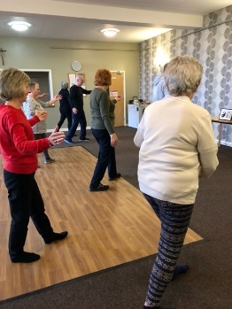
Tai Chi
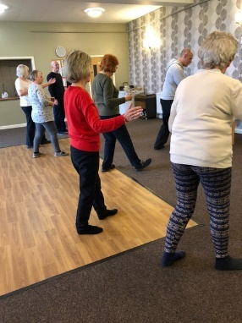
The Tai chi group is going well, we are becoming more confident and better at the exercises. Tai chi is good for balance and helps to prevent falls, it helps with mobility and can be done seated for anyone less mobile. We find it calming and takes away some of the stresses we all have to deal with these days. Saying all that we don’t take ourselves too seriously and have a laugh. Phil our trainer is very patient and will repeat things endlessly for those of us with memory lapses(!)
We meet at St Theresa’s hall every Friday from 10.30 to 11.30 ish and the cost is £5 . New members are always welcome and can join any time.
Anne.

Bridge Club
The Dukeries u3a Bridge Group meet on the Second and Fourth Tuesday of each month at the Jubilee Hall (NG22 9AP) from 1 – 4PM. The cost of each session is currently £3.
All U3a members are welcome to attend.

Natural History, Science and Technology.


This months talk was given by members of the Warsop Wildlife Rescue on hedgehogs. We learnt some very interesting facts about hedgehogs and were all given a pamphlet to take home with the facts in. We also learnt about their work in rescuing hedgehogs and how to spot a hedgehog in distress. The meeting ended with a question and answer session. The WWR are coming to talk at the main meeting in July where they will talk more about their work and the other birds and animals they rescue.

2025 | Activity
May 8th | U3a VE DAY Garden Party
June 12th | CPR & defibrillators.
July 10th | To be decided
August 14th | Relationship between plants and animals
September 11th | VISIT to Mansfield Museum
October 9th | Ears & Sound
November 13th | Mycology – study of Fungi
December No Meeting

Strollers 
On a lovely Spring morning 9 members went to Thoresby Park for a gentle stroll from the car park down to the river. We walked up to the church before returning to the Courtyard for refreshments. Again, another very pleasant and sociable morning.
23rd April - Rufford Park
Meet at the Carrs car park at 10.00 am for car share to Rufford

Proposed walks for 2025 are as follows:-
23rd April. Rufford Park
28th May. Vicar Water
25th June. Cresswell Crags


Craft Group 

Although there was only 9 members at the group on Monday 7th April we had a good making session, and a lovely time. Here are the results -------

The next meeting is on Monday 12th May and I look forward to seeing you all.



If you would like to join us the only thing you need to bring is a basic sewing kit and a willingness to have a go at anything. All materials are available for a very small donation to the person who brings them, if anything more specialised is required you will be given the opportunity to purchase any item needed yourself, or you can borrow from other group members.

Future itinerary 2025
May – Stitch embroidery cards

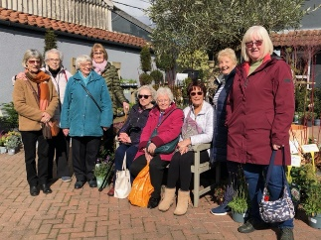
Garden Group 
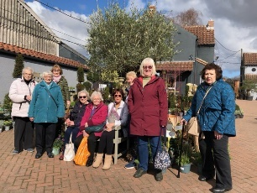
In March the garden group had a trip to Reg Taylor’s garden centre in Southwell. It was a lovely day and we had coffee and scones to start the day and then spent about an hour and a quarter looking around the plants for sale, they also have a large indoor area selling ornaments, jewellery, gifts and cards. We travelled on to Hollybeck nursery where we had lunch then bought more plants and had a good look around. The trip in April is planned to be to Dunstan Hall garden centre near Chesterfield and will have taken place by the time you read this. The weather is looking good.
We meet at the Carrs car park at 10am on the second Tuesday of the month and car share from there.
Anne.

Programme for future garden group visits:
May 13th, Rufford Park, hopefully to see bluebells then Dukeries lodge, Edwinstowe or Dukeries garden centre.
June 10th, Cascades Gardens, Matlock. Meditation and bonsai centre.
July 8th, Newstead Abbey then the Hutt or the Rushley Inn for lunch.
August 12th, Glapwell garden centre then Harrison’s garden centre , Shirebrook.
September 9th, Chatsworth garden centre.
October 14th, Trowell garden centre.
November 11th, Brookfields garden centre.
December 9th, Blue Diamond garden centre, East Bridgford.
All the above may be subject to change.
Anne.

Photography Group

The online ‘Themed’ challenge for the last month was ‘Signs of Spring’.

Joyce O’Neill – Apple tree buds & Flower



Joanne Wheatley – Easter hat & Crocus

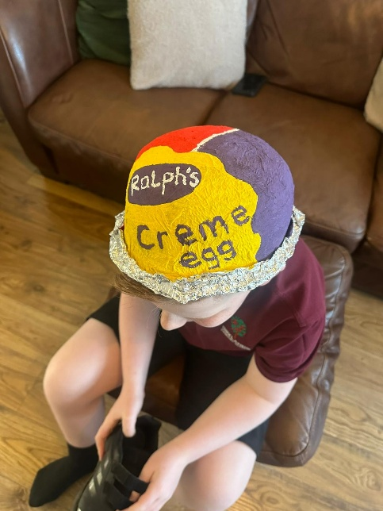

Chris & Jim Shervey – Spring Flowers



Bob Thomson – Daffodil, Cherry Blossom & Fern leaf unfolding


The next ‘Themed’ online challenge, which is open to All u3a members is ‘Anything beginning with C’

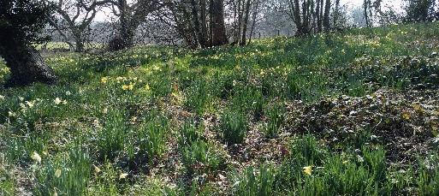

Walking Group
For our March walk we set off on the hottest day of the year so far. Our planned route started from Manor Park in Mansfield Woodhouse, we should have taken the path round the edge of the first field but unfortunately this was not passable, hence change of plan. From there we passed through woodland to the site of Nettleworth Manor and it’s outbuildings before heading towards Peafield Lane and back to our start point.
Due to unforeseen circumstances the walk programme has been altered.
Revised list.
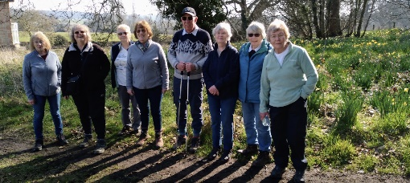
Month. Walk Leaders
April. Idle Valley. Jen/Val
May. Sherwood. Pam
June. Rowthorne/Hardwick. Brenda
July. Forest Town. Gerald

History Group
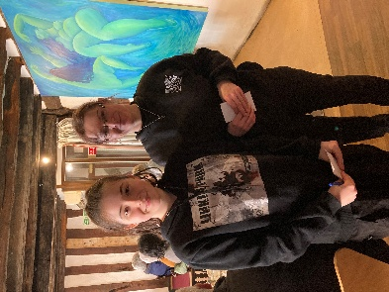
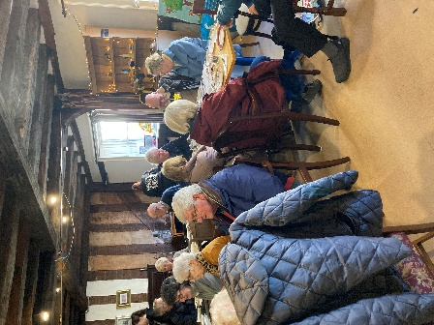
The history group visited Newark’s Governor’s House and town centre for our March meeting. Upon arrival at the Governor’s House, we enjoyed refreshments served by our waitresses, Courtney, Wren, Rosanna and B. There was a choice of vanilla, coffee, chocolate cake or Victoria sponge all made by resident chef, Fraser.



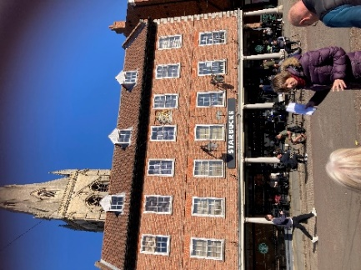
Our guide, Bridget, has made a detailed study of some of the old buildings in the town square and how there uses have changed over time. Here are some photos of the buildings Bridget spoke to us about. We began our tour at the town hall and assembly rooms built in 1776 by John Carr (above left). Inside is the Butter Market with the police cells. Behind the building was the Shambles. The original moot hall (above right) is now a Starbucks. It was renovated by being rebuilt using the original bricks.
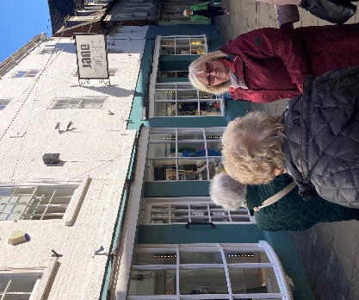

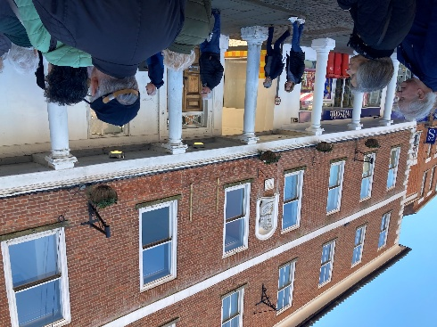

There are numerous coaching inns (above) in Newark due to the town’s proximity to the Great Northern Road (Ermine Street) and A46 (Fosse Way). Above are the King’s Head, Saracen’s Head & Clinton Arms.
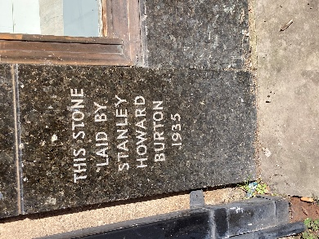

Brass studs on the cobbles mark the
processional way from the mayor’s residence to the church. (left)
Burtons the tailors’ buildings are in the Art Deco style. Each building’s cornerstone bears the name of one of the Burton brothers. (right)
The White Hart Inn, (below) a timber framed building, dates to the fourteenth century. The oldest part is at the rear of the building where a section of timber is exposed.



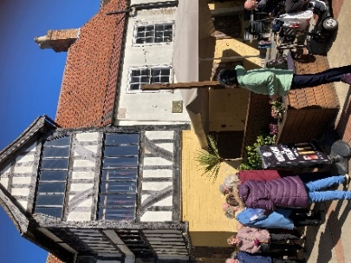


Our last stop was back at the Governors’ House (below).
Originally built in 1474 as a merchants’ house, the property housed the Governors in charge of the Royalist forces at Newark during the English Civil War. Charles I stayed there during this conflict. It has since been a clockmakers and jewellers, residential dwelling, tailors and tobacconists. More recently it is a café. Many of the original medieval features can be seen inside the building, including the garde robe! (toilet)
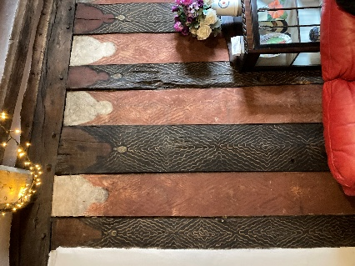

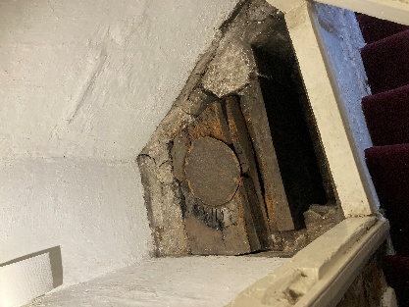
Behind the buildings fronting onto the square are alleyways along which numerous small dwellings stood.

If you are interested in finding out about the history behind some of these ancient buildings in Newark, Bridget will be conducting tours from June. Details can be obtained from the Governor’s House.
Our next history meeting is on Tuesday 15th April at St Teresa’s Church Hall at 10:00 when we will be welcoming Denis Hill who will be speaking about Kirkby Castle. We hope you can join us.
Barbara & Tamar

Below is the proposed calendar of events for next year.
20th May 2025 | Chris Weir Bygone Shopping in Nottm | St Theresa’s Church Hall 10am
17th Jun 2025 | Visit to Lincoln Castle and Cathedral | Meet TBA
15th July 2025 | Chris Weir – Lace, Slums and the Occasional Riot. Victorian Nottm | St Theresa’s Church Hall 10am
19th Aug 2025 | Denis Hill The Life of Lord Byron the Poet | St Theresa’s Church Hall 10am
16th Sept 2025 | Visit Denby Pottery Museum?
21st Oct 2025 | Chris Weir Mud, Munitions and Memorial WW1 | St Theresa’s Church Hall 10am
18th Nov 2025 | In house | St Theresa’s Church Hall 10am
16th Dec 2025 | No meeting as very close to Christmas
Speakers for the main meetings

2025

April Easter Monday-Social time

May Tax, Care and Toy Boys. Oliver Hill, Co-op Estate Planning.

June What is a Witch? Laura Simpson

July Warsop Wildlife Rescue Team
A look back to WWRT the 1st year Glenn Slaney

August Footpads, Kings and Highwaymen Ian Morgan

September Annual General Meeting

October The Royal British Legion. Who set it up and what does it do? Gareth Howell

November To be arranged.

December Christmas Party

Group | Leaders Name | Tel
NATURAL HISTORY SCIENCE AND TECHNOLOGY | Chris Shervey
WALKING GROUP | Brenda Pearce  Pam Hick
STROLLERS | Janet Harford  Pat Magness
HISTORY GROUP | Barbara Spybey
CRAFTS | Zena Inger
GARDENING | Anne Poultney
PHOTOGRAPHY | Rob Thomson
FRIENDSHIP GROUP | Betty Trinder
THEATRE GROUP
TAI CHI | Anne Poultney

INTEREST GROUP TIMETABLE
 | MONDAY | TUESDAY | WEDNESDAY | THURSDAY | FRIDAY
1st | 10am – 12pm  CRAFTS GROUP  St Teresa’s Catholic Church hall. Warsop |  |  |  | 2pm  FRIENDSHIP GROUP  The Plough Warsop
2nd |  | 10am  GARDENING GROUP  Venue agreed by members |  | 2 – 3.30  NATURAL HISTORY  SCIENCE AND  TECHNOLOGY  St Teresa’s Catholic Church Hall Warsop
3rd | MAIN MEETING 10.15  Oaklands Centre  Warsop | 10am– 12pm  HISTORY GROUP  St Teresa’sCatholic Church hall. Warsop |  | 10am  WALKING GROUP  Carrs Car Park | 11.am  PHOTOGRAPHY  Venue to be agreed by the members.
4th |  |  | 10.am  STROLLERS  Carrs Car Park
THEATRE GROUP - Location and time as announced.
PHOTOGRAPHY GROUP-Please see Newsletter for the online challenge.
TAI CHI Every Friday 10.30am St Teresa’s Catholic Church hall

Committee Members | Role
Lynne Hutchinson | Chairperson
Mel Mitchell | Deputy Chairperson
Irene Clay | Business Secretary
Linda Crossley | Treasurer
Zena Inger | Membership Secretary
Jim Shervey | Speaker Seeker
Jennifer Thomson | Groups co-ordinator
Chris Shervey | Newsletter editor
Ann Ayodele | Social Events
Jennifer Thomson | Welfare Officer
Rob Thomson | Website & Facebook manager
Ann Ayodele | Refreshments rota
June Whittle | Raffle
Betty Trinder | Social events assistant

Warsop & District U3A is committed to treating all people equally. Anyone wishing to see the Privacy and Data Protection policies may view them on the Warsop.u3asite.uk alternatively please ask Rob.
Facebook
Warsop & District U3A has a Facebook Group. It is a private group which can be seen by the public but only members can see who’s in the group and what they post.
What this means is that you have to be invited to join the group or have your request to join accepted. Also you need to be on Facebook which some of you may not be. As a member of the group you will be able to put your own posts on the page, please keep them relevant to the U3A and what it stands for. We would ask that you don't put anything on that is in anyway party political or anything that may be offensive to others who may be of a different creed or religion. Hopefully everyone will join, use the page and find it useful.
One of the things that puts people ‘off’ Facebook, is the ‘bad press’ some of the Social sites get. You can join Facebook, choose only to join the Warsop Facebook page and not be involved in any other site, or Friends requests (usually from people that you have never heard of!) The choice is entirely yours.
To request to join the Warsop u3a Facebook page, contact Bob Thomson.
Website & Facebook
The Warsop & District u3a website can be found at Warsop.u3asite.uk . If any of the group leaders/facilitators would like to advertise/ promote any of their future activities or change the information shown, please contact Bob Thomson
Answers March riddles
- What kind of coat is always wet when you put it on? COAT OF PAINT
- Which month has 28 days? ALL OF THEM
- What flowers are kissable? TULIPS ( 2 LIPS)

Answers March quick quiz All the answers except for one start with r
- Rome was founded by which twins? ROMULUS AND REMUS
- Name of Russian mystic and favourite of the Empress Alexandra? RASPUTIN
- Author of Swallows and Amazons? (surname) ARTHUR RANSOME
- Largest big cat in S America? JAGUAR
- Composer of Bolero, made famous by Torvill and Dean? RAVEL
- Day we remember the Armed Forces killed in battle? REMEMBERANCE DAY
- English king nicknamed The Lionheart? RICHARL I
- Chief port of Brazil? RIO DE JANERIO
- Biennial golf match between Europe and USA? RYDER CUP
- Mountain system in N America? ROCKIE MOUNTAINS

Answers. MARCH quiz Can you name these garden birds?


