
Issue 88 March 2025

Warsop & District
Notes from the Chair
Hello to you all.

At last Spring has sprung and it's a lovely day again albeit a bit chilly in the mornings.
Going to be a sporty week for me as, at time of writing, my beloved Nottingham Forest are playing in the FA Cup tonight so fingers crossed for them.
Also on Wednesday my husband and friends are travelling to Nottingham Arena to see Nottingham Panthers play Ice Hockey. Only been once before but remember had difficulty keeping up with play it was so fast. Hopefully a win for Nottingham here as well.
Who says retirement is boring.

Seen you all soon.

Lynne

The deadline for including articles/information in the next newsletter is Friday 11th April Send contributions to Chris Shervey. If you have any ideas for new items to include in the newsletter please let me know.

Membership renewals 2025
Hi. It is time to be thinking about when you are going to renew your membership.
You will be pleased to hear that we are able to keep the cost of membership at £20.00, or £16.00 with proof of membership where the TAT levy has been paid at another u3a.
You will be able to renew your membership at the March or April meetings. If you can’t make the meetings let me know and we can make arrangements to renew.
The current membership year ends at the end of March, so anyone who has not renewed after the April meeting will be taken off the circulation lists, (this does not prevent you rejoining at a later date).
Please collect an application form as you arrive, fill it in and see me during the coffee break.
Zena Inger

Rota for refreshments and greeting.
Please Note the Changes to the Meet and Greet.
This is the rota for the next four months, any problems please contact me, Ann Ayodele.
Thank you to all those who have volunteered to help, without you our meetings would not be enjoyable.

Date | Refreshments 1 | Refreshments 2 | Meet and Greet 1 | Meet and Greet 2
17thMarch | Karen Breed | Audrey Gilbert | Raymond White | Ann Barnes
21stApril | Janet Harford | Patricia Ward | Ann Poultney | Moira Heslop
19th May | Yvonne Pannifer | Glenys Fearn | Chris Wilson | Brenda Pearce
16th June | Angeline Taylor | Sonia Attwell | William Taylor | Ann Holland

EVENTS

Quiz Night. The next quiz night will be on Wednesday April 30th at The Oaklands, 7.00pm to 10.00pm. There will be bingo after the quiz. We will not have the bar but you can bring your own drinks and nibbles will be provided. I shall be taking names at the March and April monthly meetings, there is no charge as U3A are paying for the room rental.
Coach Trip to York. There will be a coach trip to York on Thursday 22nd May, pick ups will be from The Oaklands 9.00am, where people can leave their cars, and Tudor Barn 9.10am for anyone else.
The cost for the trip is being subsidised by U3A, it would have been in excess of £13.00 (depending on the number of seats filled up), so the cost for the return trip to York is £8.00 plus the driver’s tip, making it £9.00 total cost. I will give you more details at the monthly meeting and will be taking names and the payment then.

Coach Trip to Buxton. There will be a coach trip to Buxton on Thursday 3rd July, the same arrangements for pick ups. Again this is being subsidised by U3A. It would have been in excess of £11.00 depending on how many seats filled, however the cost is £7.00, plus driver’s trip, total cost is £8.00.
I will start taking names and money at the March monthly meeting.
Ann

GARDEN PARTY We are planning to hold a garden party on Thursday 8th May to celebrate VE Day. Details to be announced in next newsletter.

ITEMS OF INTEREST
Table Tennis Club- Warsop Health Hub-Mondays 1.30-3.30pm
If you would like to have a go at playing table tennis then please do join Pam Hick and Ian James at the Health Hub each Monday from 1.30-3.30pm. The cost is £4 per person. Bats and balls are provided.
Vibrant Warsop has supported this venture with the purchase of 2 brand new tables. Both Pam and Ian are also members of the U3a (Pam-Warsop & Ian- Forest Town)
You do not need to be a member of the Health Hub- just turn up!

FREE Well rotted horse manure. Speak to Jim.
Cups Please will as many of you as
possible bring your own mug for your tea or coffee. This is not only more environmentally friendly but also would save us a lot of money as the paper disposable cups we use are surprisingly expensive. Ann.
Robin Hood Lottery 
Warsop and District U3A is a cause registered with the Robin Hood Lottery.
To buy a ticket you can now register on line at www.robinhoodlottery.co.uk and set up regular payments. If you buy a ticket every week for a year Warsop U3A will receive £26.
Remember the more members that have a go (specifying Warsop & District U3A) the more money we get for our funds.

Raffle. The Feb Raffle raised £50
RAFFLE PRIZES NEEDED PLEASE
RAFFLE PRIZES NEEDED .

Books and Jigsaws 50p. We made £8.50 at the Feb meeting thank you. Please note the books are sorted into genres making it easier to find a book you like.

WELFARE
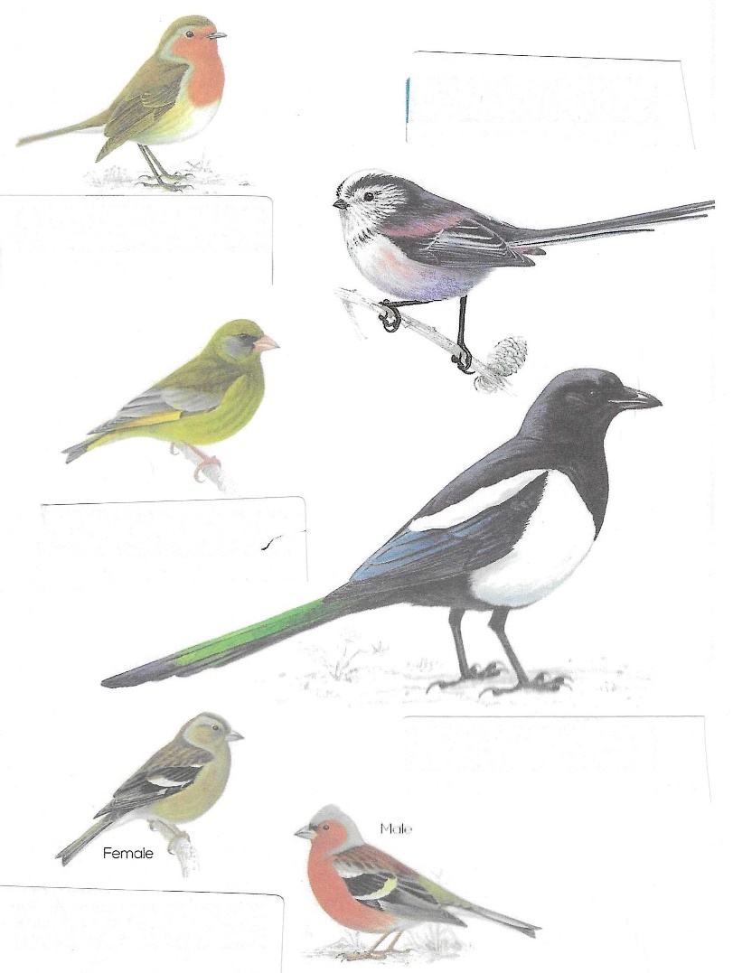
I continue to send best wishes from us all to members who are unwell or who have been bereaved. Please remember to let me know of any member in these circumstances. Jen.

March quiz Can you name these garden birds?
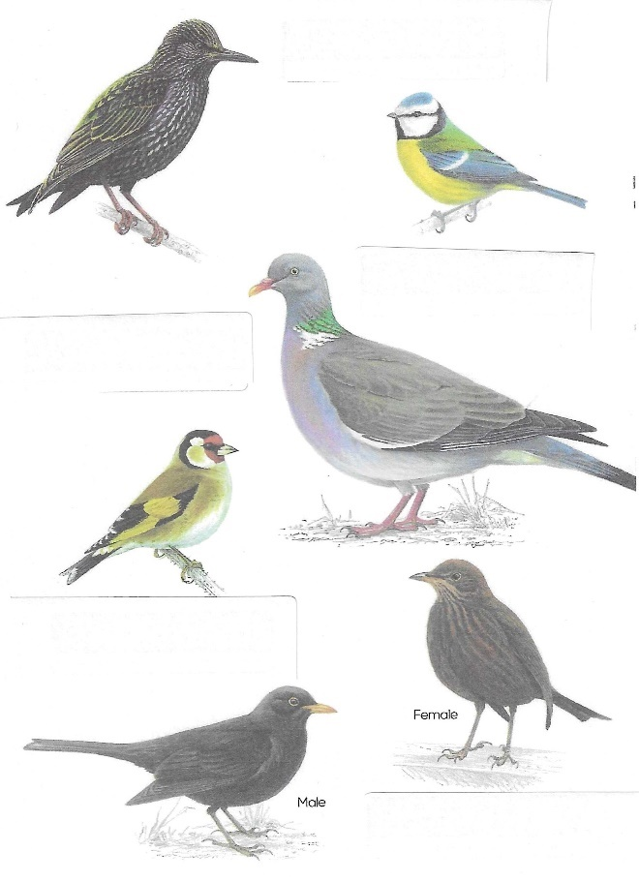

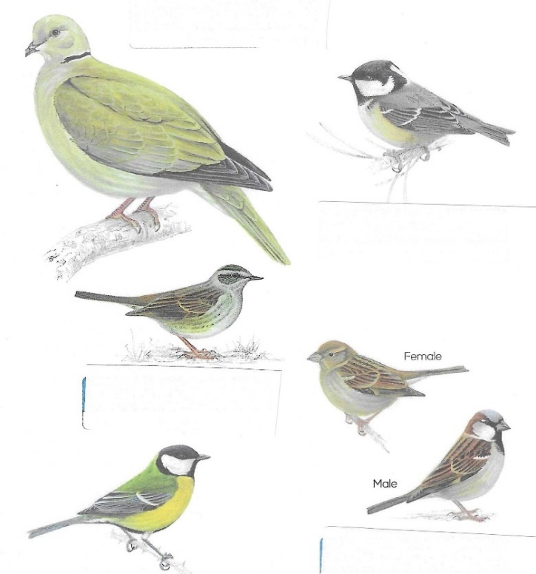

March quick quiz All the answers except for one start with r
- Rome was founded by which twins?
- Name of Russian mystic and favourite of the Empress Alexandra?
- Author of Swallows and Amazons? (surname)
- Largest big cat in S America?
- Composer of Bolero, made famous by Torvill and Dean?
- Day we remember the Armed Forces killed in battle?
- English king nicknamed The Lionheart?
- Chief port of Brazil?
- Biennial golf match between Europe and USA?
- Mountain system in N America?

Well I didn’t know that!
The most common garden bird is the House Sparrow with 5.3 million breeding pairs in the UK.
The goldcrest is the rarest bird with a population of 610,000 breeding pairs.
The Robin is the UK’s favourite bird.

March riddles
1 What kind of coat is always wet when you put it on?

2 Which month has 28 days?

3 What flowers are kissable?
Answers to last months quizzes and riddles at end of newsletter.
GROUP NEWS
COULD ALL GROUP LEADERS PLEASE COLLECT THEIR BADGES WHEN THEY COLLECT THEIR LANYARDS. THEN MEMBERS CAN SEE WHO TO SPEAK TO ABOUT A GROUP.THANK YOU
There is a workshop due to be held on Monday 23rd June in Newstead. It is for group leaders and groups coordinators.
I plan to go, but it would be great if some of our group leaders could come too. Please see the poster attached and either let Margot Gale know if you wish to go or contact me and I'll contact her.
Meanwhile could all group leaders please ensure their information folders are up to date so members thinking of joining your group may see what you have done and what is planned. Thank you, Jen.

If anyone has any suggestions for new groups please let me know.
Nottinghamshire Network of u3as
INTEREST GROUPS MATTER

Do you lead an interest group?
Would you like to lead/convene/facilitate a group?
Are you a groups co-ordinator?

Find out more and join our exciting FREE workshop on Monday 23 June 2025
10 a.m. until 12.45 p.m.
at the Newstead Community Centre
Tilford Road, Newstead Village, NG15 0BS
Programme:
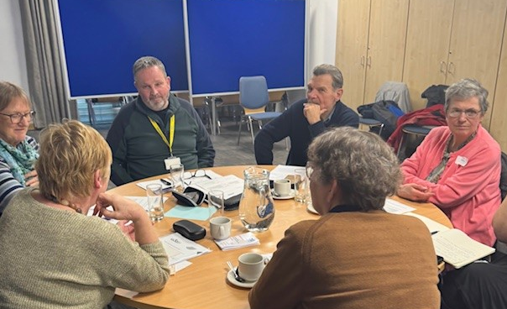
- Presentation on organising groups
- Break out groups
    - Music
    - Science
    - Walking
    - Group co-ordinators
If you would like to join us please contact Margot Gale giving your full name, email address, your u3a and preferred break out group.
The Friendship Group 
The Friendship Group met on Friday, 7th March, two groups of 4 playing a variation of dominoes and card games, some learning new games. The next meeting will be on Friday, 4th April at The Plough 2.00 p.m.
Betty

Tai Chi
The Tai chi group is going very well now, we have a few regular members although there is always room for more. We are enjoying the exercise which is not too strenuous but is very good for improving balance and preventing falls. We have a laugh and don’t take ourselves too seriously but we are improving all the time. Phil our trainer is very patient and explains the reasons each exercise is good for us and never minds repeating the exercises. We meet every Friday at St Theresa’s Church hall from 10.30 - 11.30am. The cost is £5.
Anne.

Bridge Club
The Dukeries u3a Bridge Group meet on the Second and Fourth Tuesday of each month at the Jubilee Hall (NG22 9AP) from 1 – 4PM. The cost of each session is currently £3.
All U3a members are welcome to attend.

Natural History, Science and Technology.
This month we looked at the elements on the PERIODIC TABLE. Playing games of bingo we learnt the symbols of the elements. We were given interesting facts on some of the elements and finished with a Periodic table quiz to see “what we had learnt”!

2025 | Activity
April 10th | Warsop wildlife rescue----Hedgehogs
May 8th | U3a VE DAY Garden Party
June 12th | CPR & defibrillators.
July 10th | To be decided
August 14th | To be decided
September 11th | VISIT to Mansfield Museum
October 9th | Ears & Sound
November 13th | Mycology – study of Fungi
December No Meeting

Theatre Group
Proposed Theatre Trip to see "Cirque"
Monday 28th July, 3pm at The Palace Theatre, Mansfield. £32.
If anyone would like me to book tickets for this show please bring the full payment to the March general meeting.
There are still seats available but they may sell quickly. Jen.

Strollers 
Five members braved a miserable start to the day to go to Sherwood Forest for our February stroll to the Major Oak and back through the woods to the Craft Centre. The weather improved and we had a very pleasant morning ending, of course, with drinks and a chat in the Craft Centre.
26th March - Thoresby Country Park
Meet at 10.00 am at the Carrs car park for car share to Thoresby Country Park "

Proposed walks for 2025 are as follows:-
26th March. Thoresby Country Park
23rd April. Rufford Park
28th May. Vicar Water
25th June. Cresswell Crags


Craft Group 
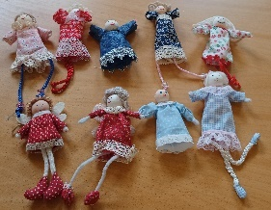
This months activity was led by Anne who gave us instructions on how to make the dolls shown in the pictures.

If you would like to join us the only thing you need to bring is a basic sewing kit and a willingness to have a go at anything. All materials are available for a very small donation to the person who brings them, if anything more specialised is required you will be given the opportunity to purchase any item needed yourself, or you can borrow from other group members.

Future itinerary 2025
April- Easter chicken & rabbit sweet holders
May – Stitch embroidery cards
Zena.


Garden Group 

Photos of snowdrops at Felley Priory.
The garden group meets on the second Tuesday of the month at 10am at the car park by the mill dam in Warsop. We carshare from there. February’s trip was to Felley Priory to see snowdrops, it was a really miserable day but we visited the tea shop while we were there and then went on to Jacksdale garden centre where we had lunch. It was altogether a very enjoyable day.

Programme for future garden group visits:
April 8th, Dunstable Hall garden centre, Chesterfield.
May 13th, Rufford Park, hopefully to see bluebells then Dukeries lodge, Edwinstowe or Dukeries garden centre.
June 10th, Cascades Gardens, Matlock. Meditation and bonsai centre.
July 8th, Newstead Abbey then the Hutt or the Rushley Inn for lunch.
August 12th, Glapwell garden centre then Harrison’s garden centre , Shirebrook.
September 9th, Chatsworth garden centre.
October 14th, Trowell garden centre.
November 11th, Brookfields garden centre.
December 9th, Blue Diamond garden centre, East Bridgford.
All the above may be subject to change.
Anne.
Photography Group
The Photography group did not meet ‘Face to Face’ last month due to members other commitments. The online ‘ Themed’ challenge was ‘Sunrise / Sunset’.
Joanne Wheatley - Sunset




Jim & Chris Shervey – Sunrise / Sunset



Betty Trinder – Sunset


Bob Thomson – Sunrise / Sunset


More photos can be found on the Warsop u3a website at Warsop.u3asite.uk.
The next online ‘Themed’ challenge is ‘Signs of Spring’. Once again this challenge is open to ALL u3a members.

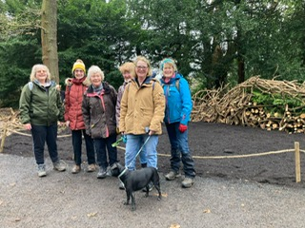

Walking Group
The walk this month was lead by Val and Sonja who took us on paths which we hadn’t followed before. As usual Clumber didn’t disappoint, it is constantly being maintained and altered. The volunteers were busy cutting back the rhododendrons and making fencing/habitat homes with the branches. The purple crocus carpet was a picture. The walk ended at the courtyard cafeteria where we stopped for a drink and natter before we ended the lovely 5 mile.


The next walk on 20th March is Nettleworth/Mansfield Woodhouse. Leaving The Carrs at 10.00 am prompt or The Manor Park car park (off The Faiways) at 10.15am.

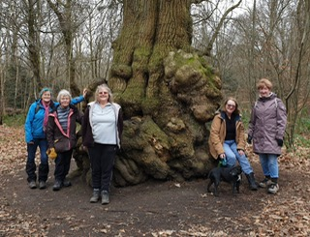
The walking group meets the 3rd Thursday of the month.
Meeting at The Carrs and we leave at 10.00 am prompt.
Date. Walk Leader. Walk. Distance
20th March. Brenda. Nettleworth. 4.5 miles
17th April. To be confirmed
15th May. Val/Jen. Idle Valley. 4 miles
19th June. Brenda. Rowthorne/Hardwick. 4.5 miles
Walks can be subject to change please check the newsletter.
Brenda & Pam

History Group
The history group met on Tuesday 18th February when we were joined by our speaker Colin. Colin is a volunteer at Hardwick Hall and something of an expert on Bess of Hardwick. When we think of Bess we tend to think of her magnificent homes at Chatsworth and Hardwick. Bess, however, had many other homes. Colin took us on a virtual tour of these other properties around the country. These included estates at Tormarton in Gloucestershire, Chew Magna in Somerset, Sutton Court in Stowey and Sheffield Manor.
Colin will be visiting us again next year to tell us the sad tale of Arbella, Bess of Hardwick’s granddaughter.
Our next meeting on 18th March is a visit to Newark. Our guide, Bridget, will be telling us the history of some of the oldest buildings in the town square beginning with the Governor’s house.
Barbara & Tamar

Below is the proposed calendar of events for next year.
18th Mar 2025 | Visit – Newark Governor’s House | Meet TBA
15th Apr 2025 | Denis Hill – Kirkby Castle | St Theresa’s Church Hall 10am
20th May 2025 | Chris Weir Bygone Shopping in Nottm | St Theresa’s Church Hall 10am
17th Jun 2025 | Visit to Lincoln Castle and Cathedral | Meet TBA
15th July 2025 | Chris Weir – Lace, Slums and the Occasional Riot. Victorian Nottm | St Theresa’s Church Hall 10am
19th Aug 2025 | Denis Hill The Life of Lord Byron the Poet | St Theresa’s Church Hall 10am
16th Sept 2025 | Visit Denby Pottery Museum?
21st Oct 2025 | Chris Weir Mud, Munitions and Memorial WW1 | St Theresa’s Church Hall 10am
18th Nov 2025 | In house | St Theresa’s Church Hall 10am
16th Dec 2025 | No meeting as very close to Christmas

Speakers for the main meetings

2025

March Oprah Winfrey Touched My Elbow Graham Keal

April Easter Monday-Social time

May Tax, Care and Toy Boys. Oliver Hill, Co-op Estate Planning.

June What is a Witch? Laura Simpson

July Warsop Wildlife Rescue Team
A look back to WWRT the 1st year Glenn Slaney

August Footpads, Kings and Highwaymen Ian Morgan

September Annual General Meeting

October The Royal British Legion. Who set it up and what does it do? Gareth Howell

November To be arranged.

December Christmas Party

Group | Leaders Name | Tel
NATURAL HISTORY SCIENCE AND TECHNOLOGY | Chris Shervey
WALKING GROUP | Brenda Pearce  Pam Hick
STROLLERS | Janet Harford  Pat Magness
HISTORY GROUP | Barbara Spybey
CRAFTS | Zena Inger
GARDENING | Anne Poultney
PHOTOGRAPHY | Rob Thomson
FRIENDSHIP GROUP | Betty Trinder
THEATRE GROUP
TAI CHI | Anne Poultney

INTEREST GROUP TIMETABLE
 | MONDAY | TUESDAY | WEDNESDAY | THURSDAY | FRIDAY
1st | 10am – 12pm  CRAFTS GROUP  St Teresa’s Catholic Church hall. Warsop |  |  |  | 2pm  FRIENDSHIP GROUP  The Plough Warsop
2nd |  | 10am  GARDENING GROUP  Venue agreed by members |  | 2 – 3.30  NATURAL HISTORY  SCIENCE AND  TECHNOLOGY  St Teresa’s Catholic Church Hall Warsop
3rd | MAIN MEETING 10.15  Oaklands Centre  Warsop | 10am– 12pm  HISTORY GROUP  St Teresa’sCatholic Church hall. Warsop |  | 10am  WALKING GROUP  Carrs Car Park | 11.am  PHOTOGRAPHY  Venue to be agreed by the members.
4th |  |  | 10.am  STROLLERS  Carrs Car Park
THEATRE GROUP - Location and time as announced.
PHOTOGRAPHY GROUP-Please see Newsletter for the online challenge.
TAI CHI Every Friday 10.30am St Teresa’s Catholic Church hall

Committee Members | Role
Lynne Hutchinson | Chairperson
Mel Mitchell | Deputy Chairperson
Irene Clay | Business Secretary
Linda Crossley | Treasurer
Zena Inger | Membership Secretary
Jim Shervey | Speaker Seeker
Jennifer Thomson | Groups co-ordinator
Chris Shervey | Newsletter editor
Ann Ayodele | Social Events
Jennifer Thomson | Welfare Officer
Rob Thomson | Website & Facebook manager
Ann Ayodele | Refreshments rota
June Whittle | Raffle
Betty Trinder | Social events assistant

North Notts Neighbourhood group
This means that you as a member of Warsop & District can ask to join an interest group in another U3A that is also in the NNNG, as long as the group is not oversubscribed at the time of your request you can join the group without joining the host u3a
The u3as in the NNNG are Mansfield, Sherwood, Dukeries, Rainworth, Forest Town, Ashfield, Sutton in Ashfield, Hucknall, Worksop, Warsop, Retford and Bolsover.

Facebook
Warsop & District U3A has a Facebook Group. It is a private group which can be seen by the public but only members can see who’s in the group and what they post.
What this means is that you have to be invited to join the group or have your request to join accepted. Also you need to be on Facebook which some of you may not be. As a member of the group you will be able to put your own posts on the page, please keep them relevant to the U3A and what it stands for. We would ask that you don't put anything on that is in anyway party political or anything that may be offensive to others who may be of a different creed or religion. Hopefully everyone will join, use the page and find it useful.
One of the things that puts people ‘off’ Facebook, is the ‘bad press’ some of the Social sites get. You can join Facebook, choose only to join the Warsop Facebook page and not be involved in any other site, or Friends requests (usually from people that you have never heard of!) The choice is entirely yours.
To request to join the Warsop u3a Facebook page, contact Bob Thomson.

Warsop & District U3A is committed to treating all people equally.
Anyone wishing to see the Privacy and Data Protection policies may view them on the Warsop.u3asite.uk alternatively please ask Rob.

Website & Facebook
The Warsop & District u3a website can be found at Warsop.u3asite.uk . If any of the group leaders/facilitators would like to advertise/ promote any of their future activities or change the information shown, please contact Bob Thomson

Answers February quick quiz all answers start with Q except one

1Pop group that sang We are the Champions? QUEEN
2 Religious sect associated with porridge? QUAKERS
3 Fashion Designer of the 1960’s (surname) ? MARY QUANT
4 Old fashioned writing implement? QUILL
5 Name of the hunchback of Notre Dame? QUASIMODO
6 UK award to industry (firms not individuals) started 1965? QUEENS AWARD
7 Largest species of UK deer? RED DEER
8 Mass of semi liquid sand? QUICKSAND
9 Drug used to treat Malaria? QUININE
10 Abscess on tissue around the tonsils? QUINCY

Answers February quiz
Can you unscramble the name of these usa states?
- INOSUILAA Louisiana
- WNE CXOMEI New Mexico
- DEVANA Nevada
- LMKAHAOO Oklahoma
- REAWEALD Delaware
- EIAMN Maine
- MNOGWIY Wyoming
- IFANICROLA California
- ENROOG Oregon
- NSKSAA Kansas
- ASXTE Texas
- SAALAK Alaska
- OAGEIGR Georgia
- SANBREKA Nebraska
- HUAT Utah
- RIAZANO Arizona
- STANGOHWIN Washington
- RALFODI Florida
- HIODA Idaho
- ERGOON Oregon
- OAIW Iowa

Answers February riddles
1 What can travel the world but never leave the corner? A STAMP

2 What do Alexandra the Great and Winnie the Pooh have in common? THE

3 What is it? No matter how little or how much you use you change it every month?
A CALENDAR

