
Issue 87 February 2025

Warsop & District
Notes from the Chair
Hi everyone
Well that's the longest month of the year over! I'm sure January has more days than any other month!
Now we move into the month of love or, as my husband calls it, total rip off time so I'm expecting cut price flowers on the 15th.
Hopefully weather gets warmer from here on and my old bones will not creak as much.
Look forward to seeing you all soon.

Lynne

The deadline for including articles/information in the next newsletter is Friday 7th March Send contributions to Chris Shervey. If you have any ideas for new items to include in the newsletter please let me know.

Membership renewals 2025
Hi. It is time to be thinking about when you are going to renew your membership.
You will be pleased to hear that we are able to keep the cost of membership at £20.00, or £16.00 with proof of membership where the TAT levy has been paid at another u3a.
You will be able to renew your membership at the February, March or April meetings. If you can’t make the meetings let me know and we can make arrangements to renew.
The current membership year ends at the end of March, so anyone who has not renewed after the April meeting will be taken off the circulation lists, (this does not prevent you rejoining at a later date).
Please collect an application form as you arrive, fill it in and see me during the coffee break.
Zena Inger

Rota for refreshments and greeting.
This is the rota for the next five months, any problems please contact me, Ann Ayodele.
Thank you to all those who have volunteered to help, without you our meetings would not be enjoyable.

Date | Refreshments 1 | Refreshments 2 | Meet and Greet 1 | Meet and Greet 2
17th Feb | Gillian Allsop | Beatrix Kirby | Yvonne Brown | Gill Greer
17thMarch | Karen Breed | Audrey Gilbert | Raymond White | Ann Barnes
21stApril | Janet Harford | Patricia Ward | Chris Wilson | Brenda Pearce
19th May | Yvonne Pannifer | Glenys Fearn | Ann Poultney | Moira Heslop
16th June | Angeline Taylor | Sonia Attwell | William Taylor | Ann Holland

EVENTS
The Quiz held at the Oaklands on Jan 23rd was a really enjoyable event. The bar was open and we had free snacks (crisps left over from the Christmas party!) The quiz went down to a tie break, how many calories in a Big Mac neither team got anywhere near the correct answer but the team nearest to the answer was declared the winners. We then had time for two games of bingo, with chocolates or wine to be won. Thank you Anne for organising it and calling out the bingo.

I am planning a day TRIP TO YORK on Thursday 22nd May.
I would like to get a rough idea of your interest for this by asking for a show of hands at the February meeting. Then I will work out the costs for the trip and take names at the March meeting. Ann Ayodele.

ITEMS OF INTEREST
Table Tennis Club- Warsop Health Hub-Mondays 1.30-3.30pm
If you would like to have a go at playing table tennis then please do join Pam Hick and Ian James at the Health Hub each Monday from 1.30-3.30pm. The cost is £4 per person. Bats and balls are provided.
Vibrant Warsop has supported this venture with the purchase of 2 brand new tables. Both Pam and Ian are also members of the U3a (Pam-Warsop & Ian- Forest Town)
You do not need to be a member of the Health Hub- just turn up!
Cups Please will as many of you as
possible bring your own mug for your tea or coffee. This is not only more environmentally friendly but also would save us a lot of money as the paper disposable cups we use are surprisingly expensive. Ann.
Robin Hood Lottery 
Warsop and District U3A is a cause registered with the Robin Hood Lottery.
To buy a ticket you can now register on line at www.robinhoodlottery.co.uk and set up regular payments. If you buy a ticket every week for a year Warsop U3A will receive £26.
Remember the more members that have a go (specifying Warsop & District U3A) the more money we get for our funds.

Raffle. The January Raffle raised £41
RAFFLE PRIZES NEEDED PLEASE
RAFFLE PRIZES NEEDED .

Books and Jigsaws 50p. We made £6.35 at the January meeting thank you. Please note the books are sorted into genres making it easier to find a book you like.

WELFARE
Since the last newsletter get well wishes have been sent to two members and condolences to a third who has sadly been bereaved.
Don't forget to let me know about any of our members who are unwell, or who have been bereaved, so that our best wishes may be sent to them.
Jen

February quick quiz all answers start with Q except one

1Pop group that sang We are the Champions?
2 Religious sect associated with porridge?
3 Fashion Designer of the 1960’s (surname) ?
4 Old fashioned writing implement?
5 Name of the hunchback of Notre Dame?
6 UK award to industry (firms not individuals) started 1965?
7 Largest species of UK deer?
8 Mass of semi liquid sand?
9 Drug used to treat Malaria?
10 Abscess on tissue around the tonsils?

February quiz
Can you unscramble the name of these usa states?
- INOSUILAA
- WNE CXOMEI
- DEVANA
- LMKAHAOO
- REAWEALD
- EIAMN
- MNOGWIY
- IFANICROLA
- ENROOG
- NSKSAA
- ASXTE
- SAALAK
- OAGEIGR
- SANBREKA
- HUAT
- RIAZANO
- STANGOHWIN
- RALFODI
- HIODA
- ERGOON
- OAIW

Well I didn’t know that!
Largest USA State by area is Alaska 665,384 sq miles
Largest population of a USA State is California 39 million
Smallest USA State by area is Rhode Island 1,045 sq miles
Smallest population of a USA State is Wyoming 590, 000

February riddles
1 What can travel the world but never leave the corner?
2 What do Alexandra the Great and Winnie the Pooh have in common?
3 What is it? No matter how little or how much you use you change it every month?

Answers to last months quizzes and riddles at end of newsletter.

GROUP NEWS
COULD ALL GROUP LEADERS PLEASE COLLECT THEIR BADGES WHEN THEY COLLECT THEIR LANYARDS. THEN MEMBERS CAN SEE WHO TO SPEAK TO ABOUT A GROUP.THANK YOU
I attended a meeting of Groups Coordinators yesterday but there was nothing of interest to pass on.
All our group leaders do a great job of arranging meetings and u3a branches could not function without them, so a heartfelt thank you to all of them.
If anyone has any suggestions for new groups please let me know.

The Friendship Group 
Eight members of the Friendship Group met on the 7th February and played cards and dominoes in two groups of 4.
The next meeting will be on Friday, 7th March at 2.00 p.m. at The Plough as usual.

Betty


Tai Chi
The Tai Chi Tigers (!)
(No, we don’t do any combat)
Meet every Friday at St Theresa’s Church hall , 10.30 - 11.30 at a cost of £5.
Tai Chi ( Qi Gong ) is a gentle exercise with great health benefits. It helps balance and well-being, is good for arthritis and many other problems, also helps to prevent falls.
We do have a laugh as well and sometimes cake!
We welcome new members, it’s possible to join in at any point as the exercises are repeated frequently.

Bridge Club
The Dukeries u3a Bridge Group meet on the Second and Fourth Tuesday of each month at the Jubilee Hall (NG22 9AP) from 1 – 4PM. The cost of each session is currently £3.
All U3a members are welcome to attend.

Natural History, Science and Technology.
WE HAVE MOVED----- TO ST TERESA’S CATHOLIC CHURCH.(unless we have a visit)
THE MEETING IS STILL EVERY SECOND THURSDAY 2-3.30

This month we had a very interesting talk on how the earths continents have moved from being one land mass 170 million years ago to how they are now. We learnt how the continents split apart and how they are still moving today. Through finding fossils of animal and plant life and the same rock formations on different continents scientists realised that at some time they must have been joined.

2025 | Activity
February 13th | The Changing Earth- A Journey through time
March 13th | The Periodic Table
April 10th | Warsop wildlife rescue----Hedgehogs
June 12th | CPR & defibrillators.
September 11th | VISIT to Mansfield Museum
November 13th | Ears & Sound
Other months activities are still to be finalised.

Strollers 
Unfortunately the January stroll was cancelled. The next stroll is in Sherwood Forest. Meet the Carrs 10.00am as usual.
Proposed walks for 2025 are as follows:-
26th February Sherwood Forest
26th March. Thoresby Country Park
23rd April. Rufford Park
28th May. Vicar Water
25th June. Cresswell Crags



Craft Group 
There were 12 members at the meeting on Monday, with 2 new members. Brenda talked us through making flowers using toilet roll inners. It was a bit like Blue Peter! We all managed to complete the task (minus the stem, which we glued on at home) chatting and laughing while cutting and glueing.
Chris arrived during the meeting and made us cups of tea and coffee with Lisa bringing the biscuits, thank you all.


The next meeting is on Monday 3rd of March, hope to see you there.

If you would like to join us the only thing you need to bring is a basic sewing kit and a willingness to have a go at anything. All materials are available for a very small donation to the person who brings them, if anything more specialised is required you will be given the opportunity to purchase any item needed yourself, or you can borrow from other group members.
PLEASE NOTE THE NEW VENUE
The craft group meets the first Monday of the month 10am – 12noon St Theresa’s catholic church, Clumber Stret, Warsop. NG20 0LX. The carpark is on Ridgeway and there is a set of steps down to the hall. If you do have mobility issues it may be better to park in either the library or main car park in Warsop.
Future itinerary 2025
March – Rag dolls
April- Easter chicken & rabbit sweet holders
May – Stitch embroidery cards
Zena.



Garden Group 
The garden group meets on the second Tuesday of the month at the car park on the Carrs near the Mill Dam. We car share to the venue.

We didn’t have a meeting in January as the weather was not good but on
February 11th we plan to visit Felley Priory to see the snowdrops and no doubt we shall have coffee there and buy some plants. We shall then go to Jacksdale garden centre for lunch. We can organise a timetable for future visits while we are out and put this for inclusion in the next newsletter, hopefully there will be photos to include as well.
In March we will visit Hollybeck garden centre.
I forgot to put the photos of our Christmas meal in last month so here they are.

Photography Group
The Photography group did not meet ‘Face to face’ this month, but the online ‘Themed’ challenge continued.
The ‘Themed’ challenge was ‘Anything that begins with A’
The next online Themed challenge is ‘ Sunrise / Sunset’. This challenge is even easier at this time of year as Sunrise is around 7.30am – 8am and Sunset around 5pm.
Once again this challenge is open to ALL u3a members.

Joanne Wheatley – A = Airplane, Arrows & Artificial tree
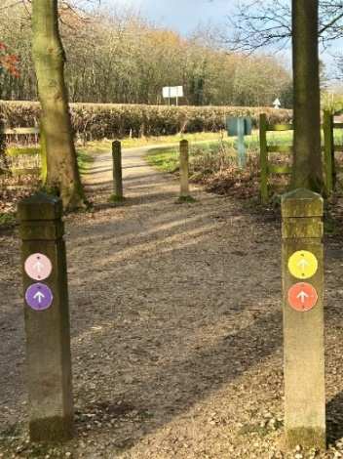

Chris Shervey – A = Aquilegia & Allium


Bob Thomson – A = Apples & Arora Borealis

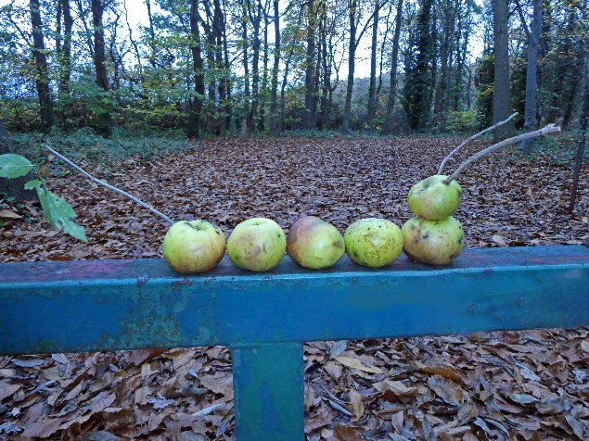


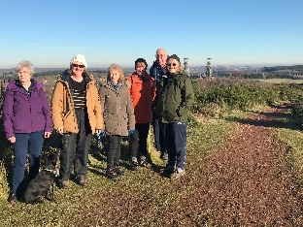


Walking Group
On a lovely sunny crisp morning 7 members of the walking group had a circular walk round Vicar water. We could see for miles and this photograph shows Clipstone head stocks in the back ground.
Sonja
The walking group meets the 3rd Thursday of the month.
Meeting at The Carrs and we leave at 10.00 am prompt.
Date. Walk Leader. Walk. Distance
20th February. Val/Sonja. Clumber. 4.5 miles
20th March. Brenda. Nettleworth. 4.5 miles
17th April. To be confirmed
15th May. Val/Jen. Idle Valley. 4 miles
19th June. Brenda. Rowthorne/Hardwick. 4.5 miles

Walks can be subject to change please check the newsletter.
Brenda & Pam

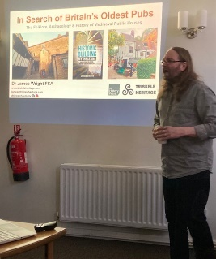
History Group
What could be better on a cold, damp, dark January day than a pub lunch and sitting by an ancient hearth, soaking up the atmosphere in the oldest pub in England: the Trip to Jerusalem? But how true are these claims ? Which is the oldest pub in England? What does the evidence say? What is the difference between a pub, a tavern and an inn?
James Wright visited us for our January meeting and these were some of the questions he answered in his talk, ‘In Search of Britain’s Oldest Pubs.’ The talk was very well attended and enjoyed by history group members. James also had copies of his new book to sell, ‘Historic Building Mythbusting’.
Next month, on Tuesday 18th February 2025, we have a change to our scheduled talks. We will be welcoming our speaker, Colin, who will be talking to us about the houses of Bess of Hardwick. Colin is a volunteer at Hardwick Hall. He was due to visit us last November but unfortunately our meeting was cancelled due to the adverse weather.

We look forward to welcoming you at our February meeting. All welcome.
Barbara & Tamar

Below is the proposed calendar of events for next year.
18th Feb 2025 | Houses of Bess of Hardwick | St Theresa’s Church Hall 10am
18th Mar 2025 | Visit – Newark Governor’s House | Meet TBA
15th Apr 2025 | Denis Hill – Kirkby Castle | St Theresa’s Church Hall 10am
20th May 2025 | Chris Weir Bygone Shopping in Nottm | St Theresa’s Church Hall 10am
17th Jun 2025 | Visit to Lincoln Castle and Cathedral | Meet TBA
15th July 2025 | Chris Weir – Lace, Slums and the Occasional Riot. Victorian Nottm | St Theresa’s Church Hall 10am
19th Aug 2025 | Denis Hill The Life of Lord Byron the Poet | St Theresa’s Church Hall 10am
16th Sept 2025 | Visit Denby Pottery Museum?
21st Oct 2025 | Chris Weir Mud, Munitions and Memorial WW1 | St Theresa’s Church Hall 10am
18th Nov 2025 | In house | St Theresa’s Church Hall 10am
16th Dec 2025 | No meeting as very close to Christmas

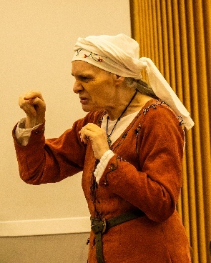
Speakers for the main meetings
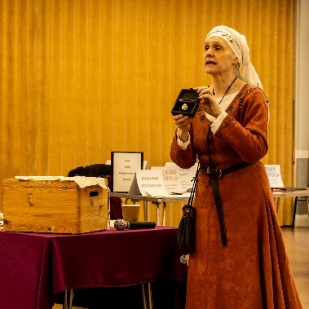

The speaker in January was very interesting, Elaine came dressed for the part and gave the talk in character. Telling us all about Charms and protection in medieval times.

2025

February Knitters, Nailers and Traitors David Skillen

March Oprah Winfrey Touched My Elbow Graham Keal

April Easter Monday-Social time

May Tax, Care and Toy Boys. Oliver Hill, Co-op Estate Planning.

June To be arranged.

July Warsop Wildlife Rescue Team
A look back to WWRT the 1st year Glenn Slaney

August Footpads, Kings and Highwaymen Ian Morgan

September Annual General Meeting

October The Royal British Legion. Who set it up and what does it do? Gareth Howell

November To be arranged.

December Christmas Party

Group | Leaders Name | Tel
NATURAL HISTORY SCIENCE AND TECHNOLOGY | Chris Shervey
WALKING GROUP | Brenda Pearce  Pam Hick
STROLLERS | Janet Harford  Pat Magness
HISTORY GROUP | Barbara Spybey
CRAFTS | Zena Inger
GARDENING | Anne Poultney
PHOTOGRAPHY | Rob Thomson
FRIENDSHIP GROUP | Betty Trinder
THEATRE GROUP
TAI CHI | Anne Poultney
DISCUSSION GROUP | Mary Morris

INTEREST GROUP TIMETABLE
 | MONDAY | TUESDAY | WEDNESDAY | THURSDAY | FRIDAY
1st | 10am – 12pm  CRAFTS GROUP  St Teresa’s Catholic Church hall. Warsop |  |  |  | 2pm  FRIENDSHIP GROUP  The Plough Warsop
2nd |  | 10am  GARDENING GROUP  Venue agreed by members |  | 2 – 3.30  NATURAL HISTORY  SCIENCE AND  TECHNOLOGY  St Teresa’s Catholic Church Hall Warsop
3rd | MAIN MEETING 10.15  Oaklands Centre  Warsop | 10am– 12pm  HISTORY GROUP  St Teresa’sCatholic Church hall. Warsop |  | 10am  WALKING GROUP  Carrs Car Park | 11.am  PHOTOGRAPHY  Venue to be agreed by the members.
4th | 10.30 -12.30  DICUSSION GROUP  Forest Lodge  Edwinstowe |  | 10.am  STROLLERS  Carrs Car Park
THEATRE GROUP - Location and time as announced.
PHOTOGRAPHY GROUP-Please see Newsletter for the online challenge.
TAI CHI Every Friday 10.30am St Teresa’s Catholic Church hall

Committee Members | Role
Lynne Hutchinson | Chairperson
Mel Mitchell | Deputy Chairperson
Irene Clay | Business Secretary
Linda Crossley | Treasurer
Zena Inger | Membership Secretary
Jim Shervey | Speaker Seeker
Jennifer Thomson | Groups co-ordinator
Chris Shervey | Newsletter editor
Ann Ayodele | Social Events
Jennifer Thomson | Welfare Officer
Rob Thomson | Website & Facebook manager
Ann Ayodele | Refreshments rota
June Whittle | Raffle
Betty Trinder | Social events assistant

North Notts Neighbourhood group
This means that you as a member of Warsop & District can ask to join an interest group in another U3A that is also in the NNNG, as long as the group is not oversubscribed at the time of your request you can join the group without joining the host u3a
The u3as in the NNNG are Mansfield, Sherwood, Dukeries, Rainworth, Forest Town, Ashfield, Sutton in Ashfield, Hucknall, Worksop and Warsop.

Facebook
Warsop & District U3A has a Facebook Group. It is a private group which can be seen by the public but only members can see who’s in the group and what they post.
What this means is that you have to be invited to join the group or have your request to join accepted. Also you need to be on Facebook which some of you may not be. As a member of the group you will be able to put your own posts on the page, please keep them relevant to the U3A and what it stands for. We would ask that you don't put anything on that is in anyway party political or anything that may be offensive to others who may be of a different creed or religion. Hopefully everyone will join, use the page and find it useful.
One of the things that puts people ‘off’ Facebook, is the ‘bad press’ some of the Social sites get. You can join Facebook, choose only to join the Warsop Facebook page and not be involved in any other site, or Friends requests (usually from people that you have never heard of!) The choice is entirely yours.
To request to join the Warsop u3a Facebook page, contact Bob Thomson.

Warsop & District U3A is committed to treating all people equally.
Anyone wishing to see the Privacy and Data Protection policies may view them on the Warsop.u3asite.uk alternatively please ask Rob.

Website & Facebook
The Warsop & District u3a website can be found at Warsop.u3asite.uk . If any of the group leaders/facilitators would like to advertise/ promote any of their future activities or change the information shown, please contact Bob Thomson
Answers January quiz---- flowers work out the name of
A flower from the clues.

1Part of a rifle STOCK
2 Part of the eye IRIS
3 Sounds like a lot of sheep FLOCK
4 Photograph the monster SNAPDRAGON
5 Coloured Ringer BLUEBELL
6 Christmas decoration with German wine HOLLYHOCK
7 Land of the automobile CARNATION
8 Reynards hand covering FOXGLOVE
9 Without a dancing partner WALFLOWER
10 Stick of Midas GOLDEN ROD
11 Kentish Ringer CANTERBURY BELL
12 Sugary Vegetable SWEET PEA
13 Card game from the fire RED HOT POKER
14 Head covering of a friar MONKSHEAD
15 Sounds like wedding of precious metal MARIGOLD
16 Capital, lots of lions LONDON PRIDE
17 Early risers with cats noise LARKSPUR
18 Spread on bread, used for drink BUTTERCUP
19 According to song seen on a bicycle for made for two DAISY
20 Also a chocolate ROSES

ANSWERS January Quick quiz all answers start with p except for one

1 Dog friend of Mickey Mouse ? PLUTO
2 Name of lady driver in Whacky Races cartoon? PENELOPE PITSTOP
3 British jockey, rode first winner aged 12yrs? (surname) Lester PIGGOTT
4 Highest British decoration for civilian bravery? GEORGE CROSS
5 A bear who is very fond of marmalade? PADDINGTON
6 Landlocked country in South America? PARAGUAY
7 An organism that lives in/on another organism? PARASITE
8 Italian Opera singer 1936-2007? Luciano PAVAROTTI
9 An arrangement of elements with atomic numbers? PERIODIC TABLE
10 Title of rulers in ancient Egypt? PHAROHS

Answers January riddles

1 What time is it when an elephant sits on the fence? TIME FOR A NEW FENCE

2 What gets wet while drying? A TOWEL

3 What has lots of eyes but can’t see? A POTATO

