
Issue 86 January 2025

Warsop & Distict

Happy new year

Notes from the Chair
Hello and Happy New Year to you all and hope you enjoyed Christmas and didn't over indulge too much. It seems an age now since our Christmas fuddle-weren't the Oaklands choir wonderful?
I spent my Christmas day with hubby daughter and son-in-law in the Peak District and had a lovely day in the countryside.
Looking forward now to 2025 and wish you all a happy and healthy new year as we continue to move forward as a group and enjoy each other's company every month.
Lynne

The deadline for including articles/information in the next newsletter is Friday 10th January Send contributions to Chris Shervey. If you have any ideas for new items to include in the newsletter please let me know.

Rota for refreshments and greeting.
This is the rota for the next two months, any problems please contact me, Ann Ayodele.
Thank you to all those who have volunteered to help, without you our meetings would not be enjoyable.

Date | Refreshments 1 | Refreshments 2 | Meet and Greet 1 | Meet and Greet 2
20th Jan | Vera Walker | Janet Harford | Chris Wilson | Brenda Pearce
17th Feb | Gillian Allsop | Beatrix Kirkby | Jill Greer | Yvonne Brown

ITEMS OF INTEREST
Quiz Night
We have had to change the date for the quiz night to Wednesday 22nd January, 7.30pm at the Oaklands.
There will be no food served, but the bar will be open.
Please give your names to me to put on the list at the January meeting. Those who have already put their names on the list have been transferred to the list for 22nd January.

Table Tennis Club- Warsop Health Hub-Mondays 1.30-3.30pm
If you would like to have a go at playing table tennis then please do join Pam Hick and Ian James at the Health Hub each Monday from 1.30-3.30pm. The cost is £4 per person. Bats and balls are provided.
Vibrant Warsop has supported this venture with the purchase of 2 brand new tables. Both Pam and Ian are also members of the U3a (Pam-Warsop & Ian- Forest Town)
You do not need to be a member of the Health Hub- just turn up!
Cups Please will as many of you as
possible bring your own mug for your tea or coffee. This is not only more environmentally friendly but also would save us a lot of money as the paper disposable cups we use are surprisingly expensive. Ann.
Robin Hood Lottery 
Warsop and District U3A is a cause registered with the Robin Hood Lottery.
To buy a ticket you can now register on line at www.robinhoodlottery.co.uk and set up regular payments. If you buy a ticket every week for a year Warsop U3A will receive £26.
Remember the more members that have a go (specifying Warsop & District U3A) the more money we get for our funds.

Raffle. The December Raffle raised £76
RAFFLE PRIZES NEEDED .
RAFFLE PRIZES NEEDED .

Books and Jigsaws 50p. There was no books and jigsaw stall at the November meeting. The books are sorted into genres making it easier to find a book you like.

Welfare
Get well wishes were sent to a member recovering from a road traffic accident just before Christmas.
Hopefully she is now recovering, but please let me know of any other members who are unwell or have been bereaved. This is so I can send very best wishes from all their u3a friends.
Jen.

Xmas party
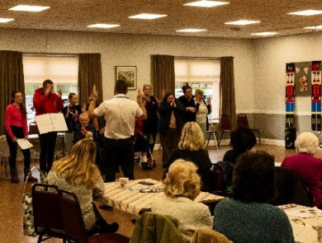
Although we had a low turnout for the party, everyone who went had an enjoyable morning, with quizzes games and lots of lovely food. The Oaklands choir came and sang to us for half an hour and at the invitation of the choir for some songs we sang along with them.




Christmas lunch at the hostess
About thirty of us had a very enjoyable lunch at The Hostess ,there was plenty of choice on the menu. Followed by entertainment from a singer, good voice but I thought he should have sung more Christmas songs as it was Christmas. But maybe that’s just me.

GROUP NEWS
COULD ALL GROUP LEADERS PLEASE COLLECT THEIR BADGES WHEN THEY COLLECT THEIR LANYARDS. THEN MEMBERS CAN SEE WHO TO SPEAK TO ABOUT A GROUP.THANK YOU
May I ask everyone attending group meetings to be extra careful in these wintry conditions. Group co-coordinators, please keep records of any accidents which may occur in venue car parks or on outside steps which may be slippery.
Thank you, Jen.
The Friendship Group 
Wishing everyone a happy New Year.
The next meeting of the Friendship Group will be held on 7th February at the Plough at 2.00 p.m.
Betty

Tai Chi
The Tai Chi group met on 3rd January and had a really good class learning some new movements although most of us find we don’t remember them ! Phil our trainer is very patient so new members can join any time without any problems. We meet every Friday at St Teresa’s hall from 10.30 to 11.30am but we do tend to overrun our time. Anne.

Theatre Group 
This Photo by Unknown Author is licensed under CC BY-NC-ND
The Theatre Group is currently without a co-ordinator. I may organise occasional trips as Social Events, and had hoped to arrange such an event to see Calamity Jane at Nottingham's Theatre Royal in March. Unfortunately, there are very few seats still available for matinee performances.

Bridge Club
The Dukeries u3a Bridge Group meet on the Second and Fourth Tuesday of each month at the Jubilee Hall (NG22 9AP) from 1 – 4PM. The cost of each session is currently £3.
All U3a members are welcome to attend.

Natural History, Science and Technology.
WE HAVE MOVED----- FROM NOW ON THE GROUP WILL BE MEETING AT ST TERESA’S CATHOLIC CHURCH.( unless we have a visit) THE MEETING IS STILL EVERY SECOND THURSDAY 2-3.30

Unfortunately the January meeting had to be cancelled. We will look at the Periodic Table sometime later this year.

2025
February 13th | The Changing Earth- A Journey through time
March 13th | VISIT to Mansfield Museum
April 10th | Warsop wildlife rescue----Hedgehogs

Strollers 
Details of proposed walks for January to June 2025 are as follows:-
22nd January Kings Mill Res
26th February Sherwood Forest
26th March. Thoresby Country Park
23rd April. Rufford Park
28th May. Vicar Water
25th June. Cresswell Crags "

On Jan 22nd please meet at the Carrs at 10am for car share to Kings Mill Reservoir. All Welcome.

Craft Group 
Unfortunately the January Craft Club had to be cancelled.

PLEASE NOTE THE NEW VENUE
The craft group meets the first Monday of the month 10am – 12noon St Theresa’s catholic church, Clumber Stret, Warsop. NG20 0LX. The carpark is on Ridgeway and there is a set of steps down to the hall. If you do have mobility issues it may be better to park in either the library or main car park in Warsop.
Future itinerary 2025
February 2025 – Paper flowers
March 2025 – Rag dolls
April 2025 – Stitch embroidery cards
Zena
Garden Group 
The garden group went out for lunch in December and 12 of us had a really nice meal at the Rose Cottage. We don’t have anything planned for January but are hoping to go out and look for snowdrops in February weather permitting. We shall plan our visits for the rest of the year over lunch that day.
We meet on the second Tuesday of the month at the car park by the Mill dam at 10am, so it will be 11th February . Anne
Photography Group
The Photography Group had intended to visit Hardwick Hall on Friday 18th Dec 24 to see and photograph this years festive displays. However on arrival we found that the main gates were firmly locked, after a while we found a sign at a different entrance stating that the estate was closed due to very high winds caused by a passing storm!
After a quick change of plan we visited Bolsover Castle instead, it was a bit breezy but remained dry during our visit, and a good time was had by all!

Joanne Wheatley – Bolsover Castle

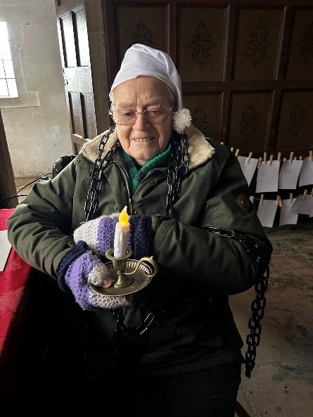
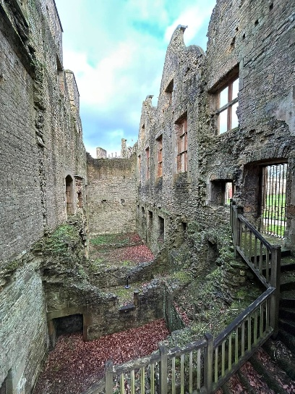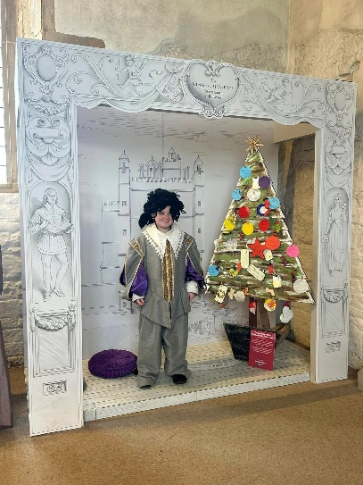

Bob Thomson – Bolsover Castle



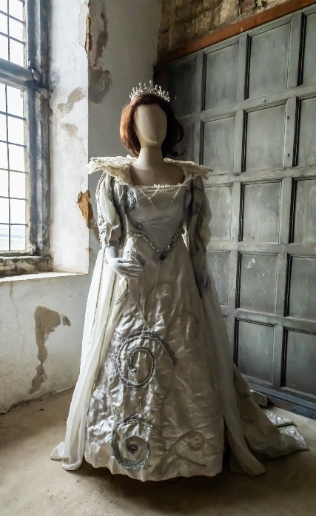

The online ‘Themed’ challenge this month was ‘Anything Festive’.

Chris Shervey – 74 year old Xmas Tree, Xmas baubles & outdoor decorations!





Joanne Wheatley – Santa Brogger, Christmas Clock, Panto & Missy & presents!




Joyce O’Neill – Xmas Dinner, Hyacinth & Passion flower


Bob Thomson - Baubles, Xmas trees & Panto



The next online ‘Themed’ challenge is ‘Anything beginning with A’.
Once again any u3a member can join in, and there are more photos on the Warsop.u3asite.uk website.


Walking Group
The walking group meets the 3rd Thursday of the month.
Meeting at The Carrs and we leave at 10.00 am prompt.
Date. Walk Leader. Walk. Distance
20th February. Val/Sonja. Clumber. 4.5 miles
20th March. Brenda. Nettleworth. 4.5 miles
17th April. Brenda. Warsop/Cuckney. 4 miles
15th May. Val/Jen. Idle Valley. 4 miles
19th June. Brenda. Rowthorne/Hardwick. 4.5 miles
Walks can be subject to change please check the newsletter.
Brenda & Pam

History Group
Happy New Year everyone.
The history group will be meeting on Tuesday 21st January at 10am at St Teresa’s Church hall. James Wright will be giving a talk entitled, ‘In Search of Britain’s Oldest Pubs,’ and telling us about his new book.
We look forward to seeing you there.
Barbara & Tamar
Below is the proposed calendar of events for next year.
21st Jan 2025 | James Wright.  In search of Britain’s oldest pubs. | St Theresa’s Church Hall 10am
18th Feb 2025 | In house talk | St Theresa’s Church Hall 10am
18th Mar 2025 | Visit – Newark Governor’s House | Meet TBA
15th Apr 2025 | Denis Hill – Kirkby Castle | St Theresa’s Church Hall 10am
20th May 2025 | Chris Weir Bygone Shopping in Nottm | St Theresa’s Church Hall 10am
17th Jun 2025 | Visit to Lincoln Castle and Cathedral | Meet TBA
15th July 2025 | Chris Weir – Lace, Slums and the Occasional Riot. Victorian Nottm | St Theresa’s Church Hall 10am
19th Aug 2025 | Denis Hill The Life of Lord Byron the Poet | St Theresa’s Church Hall 10am
16th Sept 2025 | Visit Denby Pottery Museum?
21st Oct 2025 | Chris Weir Mud, Munitions and Memorial WW1 | St Theresa’s Church Hall 10am
18th Nov 2025 | In house | St Theresa’s Church Hall 10am
16th Dec 2025 | No meeting as very close to Christmas

Group | Leaders Name | Tel
NATURAL HISTORY SCIENCE AND TECHNOLOGY | Chris Shervey
WALKING GROUP | Brenda Pearce  Pam Hick
STROLLERS | Janet Harford  Pat Magness
HISTORY GROUP | Barbara Spybey
CRAFTS | Zena Inger
GARDENING | Ann Poultney
PHOTOGRAPHY | Rob Thomson
FRIENDSHIP GROUP | Betty Trinder
THEATRE GROUP
TAI CHI | Ann Poultney

Speakers for the main meetings
2025
January Concealed Objects and Written Charms, Protection in the Medieval Period. Elaine Perkins

February Knitters, Nailers and Traitors David Skillen

March Oprah Winfrey Touched My Elbow Graham Keal

April Easter Monday-Social time

May Tax, Care and Toy Boys. Oliver Hill, Co-op Estate Planning.

June To be arranged.

July Warsop Wildlife Rescue Team
A look back to WWRT the 1st year Glenn Slaney

August Footpads, Kings and Highwaymen Ian Morgan

September Annual General Meeting

October The Royal British Legion. Who set it up and what does it do? Gareth Howell

November To be arranged.

December Christmas Party

INTEREST GROUP TIMETABLE
 | MONDAY | TUESDAY | WEDNESDAY | THURSDAY | FRIDAY
1st | 10am – 12pm  CRAFTS GROUP  St Teresa’s Catholic Church hall. Warsop |  |  |  | 2pm  FRIENDSHIP GROUP  The Plough Warsop
2nd |  | 10am  GARDENING GROUP  Venue agreed by members |  | 2 – 3.30  NATURAL HISTORY  SCIENCE AND  TECHNOLOGY  St Teresa’s Catholic Church Hall Warsop
3rd | MAIN MEETING 10.15  Oaklands Centre  Warsop | 10am– 12pm  HISTORY GROUP  St Teresa’sCatholic Church hall. Warsop |  | 10am  WALKING GROUP  Carrs Car Park | 11.am  PHOTOGRAPHY  Venue to be agreed by the members.
4th | 10.30 -12.30  DICUSSION GROUP  Forest Lodge  Edwinstowe |  | 10.am  STROLLERS  Carrs Car Park
THEATRE GROUP - Location and time as announced.
PHOTOGRAPHY GROUP-Please see Newsletter for the online challenge.
TAI CHI Every Friday 10.30am St Teresa’s Catholic Church hall

Committee Members | Role
Lynne Hutchinson | Chairperson
Mel Mitchell | Deputy Chairperson
Irene Clay | Business Secretary
Linda Crossley | Treasurer
Zena Inger | Membership Secretary
Jim Shervey | Speaker Seeker
Jennifer Thomson | Groups co-ordinator
Chris Shervey | Newsletter editor
Ann Ayodele | Social Events
Jennifer Thomson | Welfare Officer
Rob Thomson | Website & Facebook manager
Ann Ayodele | Refreshments rota
June Whittle | Raffle
Betty Trinder | Social events assistant

January quiz---- flowers work out the name of
A flower from the clues.

1Part of a rifle
2 Part of the eye
3 Sounds like a lot of sheep
4 Photograph the monster
5 Coloured Ringer
6 Christmas decoration with German wine
7 Land of the automobile
8 Reynards hand covering
9 Without a dancing partner
10 Stick of Midas
11 Kentish Ringer
12 Sugary Vegetable
13 Card game from the fire
14 Head covering of a friar
15 Sounds like wedding of precious metal
16 Capital, lots of lions
17 Early risers with cats noise
18 Spread on bread, used for drink
19 According to song seen on a bicycle for made for two
20 Also a chocolate

Well I didn’t know that!

As there is a birthstone for each month there are also flowers.

JAN Carnation/Snowdrop FEB Violet/Primrose
MAR Daffodil/ Jonquil APR Daisy/ Sweetpea
MAY Lily of the Valley JUN Roses/ Honeysuckle
JUL Larkspur/ Water lily AUG Poppy/ Gladioli
SEP Aster/ Morning Glory OCT Marigold/ Cosmos
NOV Chrysanthemum DEC Holly/ Narcissus

January Quick quiz all answers start with p except for one

1 Dog friend of Mickey Mouse ?
2 Name of lady driver in Whacky Races cartoon?
3 British jockey, roe first winner aged 12yrs? (surname)
4 Highest British decoration for civilian bravery?
5 A bear who is very fond of marmalade?
6 Landlocked country in South America?
7 An organism that lives in/on another organism?
8 Italian Opera singer 1936-2007?
9 An arrangement of elements with atomic numbers?
10 Title of rulers in ancient Egypt?

January riddles

1 What time is it when an elephant sits on the fence?

2 What gets wet while drying?

3 What has lots of eyes but can’t see?

ANSWERS TO XMAS QUIZ
M Mexico E Eypgt R Robbie Burns R Roosevelt Y Yule

C Christmas Crackers H Holiday Inn R Rockin I Italy S St Stephens day T Tiny Tim M Magi A After Eights S Six

W Widow Twankey A Advent R Robin S Silver bells O Orange
P Poland

U Unwrap 3 Donner Dasher Dancer A Angels from the realms of glory

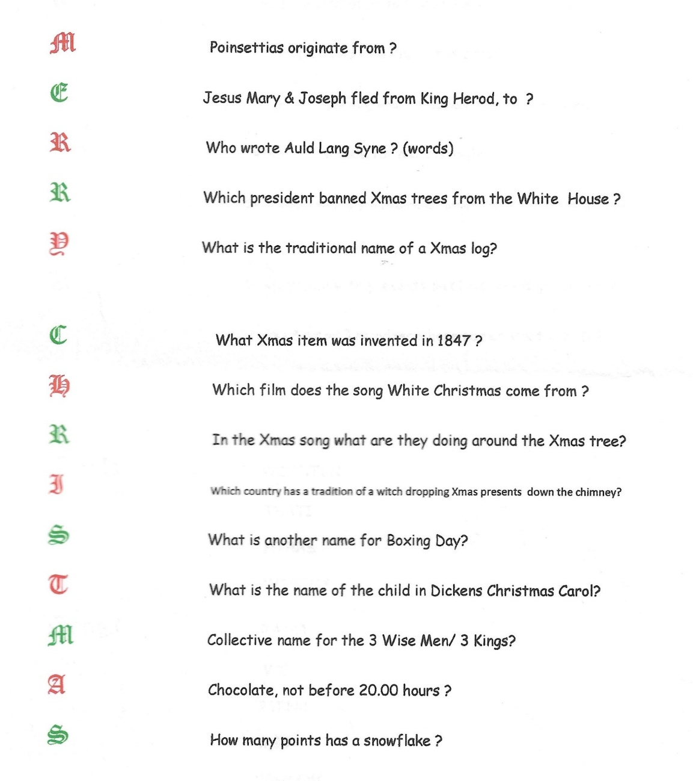
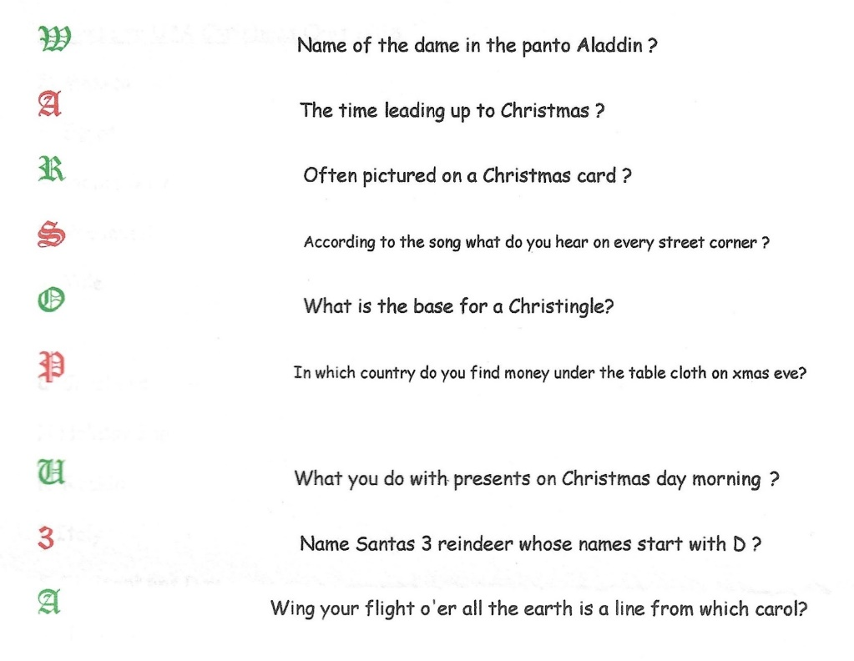

North Notts Neighbourhood group
This means that you as a member of Warsop & District can ask to join an interest group in another U3A that is also in the NNNG, as long as the group is not oversubscribed at the time of your request you can join the group without joining the host u3a
The u3as in the NNNG are Mansfield, Sherwood, Dukeries, Rainworth, Forest Town, Ashfield, Sutton in Ashfield, Hucknall, Worksop and Warsop.

Facebook
Warsop & District U3A has a Facebook Group. It is a private group which can be seen by the public but only members can see who’s in the group and what they post.
What this means is that you have to be invited to join the group or have your request to join accepted. Also you need to be on Facebook which some of you may not be. As a member of the group you will be able to put your own posts on the page, please keep them relevant to the U3A and what it stands for. We would ask that you don't put anything on that is in anyway party political or anything that may be offensive to others who may be of a different creed or religion. Hopefully everyone will join, use the page and find it useful.
One of the things that puts people ‘off’ Facebook, is the ‘bad press’ some of the Social sites get. You can join Facebook, choose only to join the Warsop Facebook page and not be involved in any other site, or Friends requests (usually from people that you have never heard of!) The choice is entirely yours.
To request to join the Warsop u3a Facebook page, contact Bob Thomson.

Warsop & District U3A is committed to treating all people equally.
Anyone wishing to see the Privacy and Data Protection policies may view them on the Warsop.u3asite.uk alternatively please ask Rob.

Website & Facebook
The Warsop & District u3a website can be found at Warsop.u3asite.uk . If any of the group leaders/facilitators would like to advertise/ promote any of their future activities or change the information shown, please contact Bob Thomson

