
Issue 85 December 2024
Warsop & Distict

MERRY CHRISTMAS








Wreaths made by the Craft Group

Notes from the Chair
Hi to you all
Well where did that year go? I'm sure I've missed a few months somewhere!
Great talk from Mel last month wasn't it? Who'd have believed that so many famous people began their careers in Chesterfield Civic Theatre. She did however shatter my illusions regarding one of my heartthrobs, Lewis Collins!
No speaker this month as it's PARTY TIME so hope you enjoy today's entertainment and have a great time.
So from the Committee and I may I wish you all a wonderful Christmas and a Happy New Year.

Lynne

I would like to thank the members for all the help and assistance I was given during my time as Chairperson. Especially to the committee who are always supportive and work very hard ensuring things are as they should be. Also thank you for the kind words I received from many as I stepped down from the role.
Lastly I would like to wish Lynne all the best in her time as Chairperson.

Jim

The deadline for including articles/information in the next newsletter is Friday 10th January Send contributions to Chris Shervey. If you have any ideas for new items to include in the newsletter please let me know.

Rota for refreshments and greeting.
This is the rota for the next four months, any problems please contact me, Ann Ayodele.
Thank you to all those who have volunteered to help, without you our meetings would not be enjoyable.

Date | Refreshments 1 | Refreshments 2 | Meet and Greet 1 | Meet and Greet 2
16th Dec | Karen Breed | Beatrix Kirby | Raymond White | Ann Barnes
20th Jan | Vera Walker | Janet Harford | Chris Wilson | Brenda Pearce
17th Feb | Gillian Allsop | Beatrix Kirkby | Jill Greer | Yvonne Brown

ITEMS OF INTEREST
Quiz Night
We have had to change the date for the quiz night to Wednesday 22nd January, 7.30pm at the Oaklands.
There will be no food served, but the bar will be open.
Please give your names to me to put on the list at the December or January meetings. Those who have already put their names on the list have been transferred to the list for 22nd January.

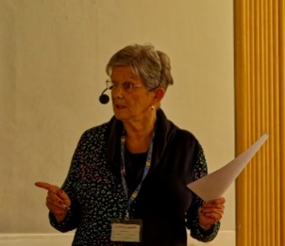
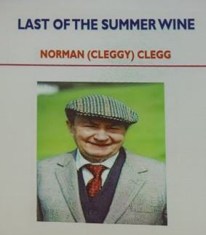
Before they were famous
This was the title of a most interesting talk that we were entertained with at the November meeting Mel shared her love of the theatre regaling us with information of famous actors that began their careers at Chesterfield theatre. The before and after of just one of the many actors discussed are shown here.
Next month the speaker is Elaine Perkins. With a talk titled ‘Concealed Objects and Written Charms, Protection in the Medieval Period’.

Christmas Lunch
Christmas Lunch, Friday 20th December at the Hostess, 11.45am for 12.00.
Most people have now paid the balance for their lunch, those few who haven't may give me their remaining payment at our next meeting or on the day.
If anyone needs a lift please let me know and I can ask if anyone is able to offer to pick them up.
Jen

Table Tennis Club- Warsop Health Hub-Mondays 1.30-3.30pm
If you would like to have a go at playing table tennis then please do join Pam Hick and Ian James at the Health Hub each Monday from 1.30-3.30pm. The cost is £4 per person. Bats and balls are provided.
Vibrant Warsop has supported this venture with the purchase of 2 brand new tables. Both Pam and Ian are also members of the U3a (Pam-Warsop & Ian- Forest Town)
You do not need to be a member of the Health Hub- just turn up!
Cups Please will as many of you as
possible bring your own mug for your tea or coffee. This is not only more environmentally friendly but also would save us a lot of money as the paper disposable cups we use are surprisingly expensive. Ann.
Robin Hood Lottery 
Warsop and District U3A is a cause registered with the Robin Hood Lottery.
To buy a ticket you can now register on line at www.robinhoodlottery.co.uk and set up regular payments. If you buy a ticket every week for a year Warsop U3A will receive £26.
Remember the more members that have a go (specifying Warsop & District U3A) the more money we get for our funds.

Raffle. The November Raffle raised £53
RAFFLE PRIZES NEEDED .
RAFFLE PRIZES NEEDED .

Books and Jigsaws 50p. We made £9.50 at the November meeting. The books are sorted into genres making it easier to find a book you like.

Welfare
We sincerely hope our members can all look forward to a healthy New Year. However, please let me know if anyone has a spell of ill health or suffers a bereavement so that we may send good wishes from everyone in Warsop and District u3a.
Thanks, Jen.

Group News
COULD ALL GROUP LEADERS PLEASE COLLECT THEIR BADGES WHEN THEY COLLECT THEIR LANYARDS. THEN MEMBERS CAN SEE WHO TO SPEAK TO ABOUT A GROUP.THANK YOU
Any group leader who has not yet sent me a list of current members please bring it to the meeting or let me have it in advance.
Thank you, Jen.
The Friendship Group 
The Friendship Group met on Friday, 6th December for an afternoon playing cards and a couple of Beetle games. It was decided that a meet on the 3rd January should go ahead and will be held at The Plough as usual at 2.00p.m. Sending best wishes to all for a happy Christmas and New Year.
Betty

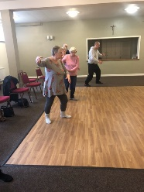
Tai Chi

Tai Chi takes place every Friday at St Theresa’s hall from 10.30 - 11.30 and is £5 per class .
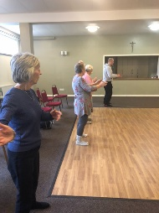
We are beginning to learn the first few moves now and it’s really enjoyable, although you don’t seem to move much it really does make a difference and we are doing some moves to help improve balance and prevent falls. New members always welcome. Thanks.
Anne.

Theatre Group 
This Photo by Unknown Author is licensed under CC BY-NC-ND
A disappointing end to the year for some of our group as the recent snowfall and freezing temperatures prevented us from travelling to Newark to see The Nutcracker.
I have decided to step down as group co-ordinator . However, if no one decides to take on this role I may organise a couple of theatre trips next year as social events open to all members.
Thanks, Jen.

Bridge Club
The Dukeries u3a Bridge Group meet on the Second and Fourth Tuesday of each month at the Jubilee Hall (NG22 9AP) from 1 – 4PM. The cost of each session is currently £3.
All U3a members are welcome to attend.

Natural History, Science and Technology.
WE HAVE MOVED----- FROM NOW ON THE GROUP WILL BE MEETING AT ST TERESA’S CATHOLIC CHURCH.( unless we have a visit) THE MEETING IS STILL EVERY SECOND THURSDAY 2-3.30

2024
December | No Meeting
January 9th | Periodic Table – Bingo!
February 13th | To be arranged
March 13th | VISIT to Mansfield Museum

Strollers 
"Strollers - there will be no walk in December due to the proximity to Christmas and New Year. Details of proposed walks for January to June 2025 are as follows:-
22nd January Kings Mill Res
26th February Sherwood Forest
26th March. Thoresby Country Park
23rd April. Rufford Park
28th May. Vicar Water
25th June. Cresswell Crags "
Pat

Craft Group 
During the meeting the group made Christmas wreathes, you can see from the pictures that each one was different. We had an enjoyable time with lots of chatter and laughter. We also enjoyed refreshments with chocolate brownies (thank you Lisa).
If you would like to join us the only thing you need to bring is a basic sewing kit and a willingness to have a go at anything. All materials are available for a very small donation to the person who brings them, if anything more specialised is required you will be given the opportunity to purchase any item needed yourself, or you can borrow from other group members.

PLEASE NOTE THE NEW VENUE
The craft group meets the first Monday of the month 10am – 12noon St Theresa’s catholic church, Clumber Stret, Warsop. NG20 0LX. The carpark is on Ridgeway and there is a set of steps down to the hall. If you do have mobility issues it may be better to park in either the library or main car park in Warsop.
Future itinerary 2025
January 2025 – Card teapot boxes
February 2025 – Paper flowers
March 2025 – Rag dolls
April 2025 – Stitch embroidery cards

Garden Group 
There is no garden group report this month.

Photography Group
The online ‘Themed’ challenge of ‘Anything that begins with either W, X , Y or Z’ rolled over from last month.
Jim – W = A cold winters day.
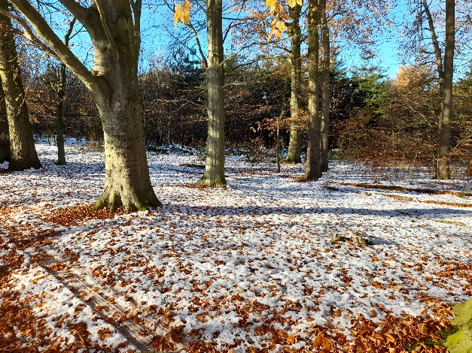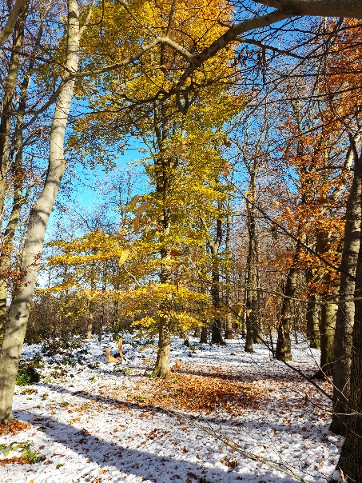

Chris – W = Winters night
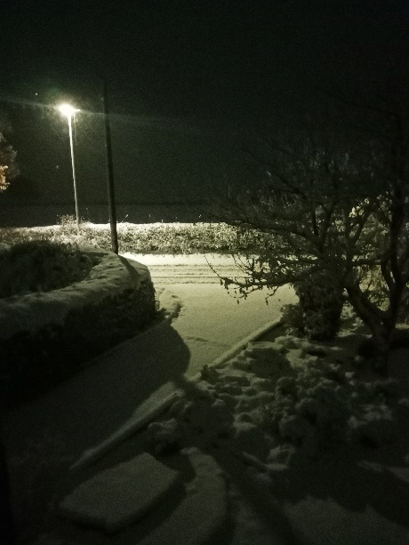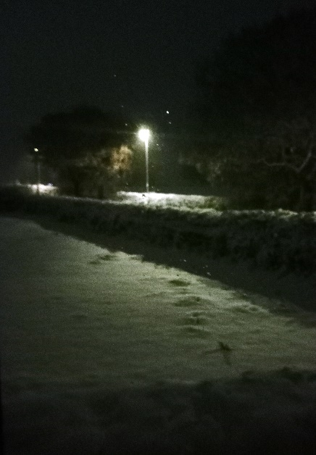

Bob Thomson – W = Winter woodland, X = Xenia pottery, Y = Yellow Stained glass window and Z = Zells’ Black Cat statue

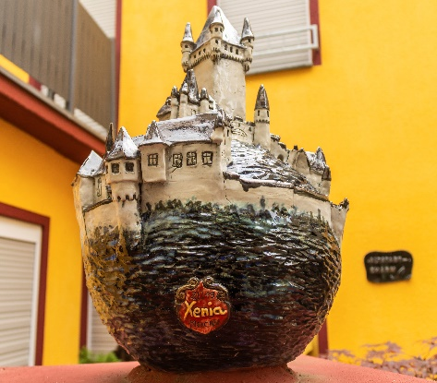

The next online ‘Themed’ challenge is ‘Festive Season’, these photos can be of anything celebrated at this time of year.
Once again this challenge is open to All u3a members.
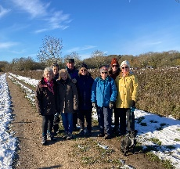



Walking Group
On a cold and icy November morning 8 of us plus a well- behaved dog met at the Carrs. We decided to do a circular walk going by the Meden river, through to the Hills & Hollows heading towards Warsop Vale and back again. In parts it was very icy or muddy and the last leg we walked across the Carrs in the deep crisp snow to clean our muddy shoes. The 4 ¼ mile walk was enjoyed by all. Our next walk will be in January.

The walking group meets the 3rd Thursday of the month.
Meeting at The Carrs and we leave at 10.00 am prompt.
Date. Walk Leader. Walk. Distance
16th January Brenda Vicar Water. 3.5 miles
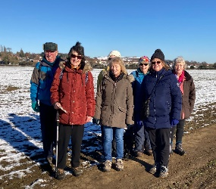
20th February. Val/Sonja. Clumber. 4.5 miles
20th March. Brenda. Nettleworth. 4.5 miles
17th April. Brenda. Warsop/Cuckney. 4 miles
15th May. Val/Jen. Idle Valley. 4 miles
19th June. Brenda. Rowthorne/Hardwick. 4.5 miles

Walks can be subject to change please check the newsletter.
Brenda & Pam

History Group
Unfortunately, heavy snow meant our November meeting had to be cancelled at short notice. However, I’m pleased to say that Colin, our speaker, was able to reschedule and will be visiting us in February to speak about the many houses of Bess of Hardwick.
We do not have a meeting in December as it is so close to Christmas. Our next meeting is on Tuesday 21st January 2025 when James Wright will be giving a talk entitled, ‘In Search of Britain’s Oldest Pubs’, the title of a chapter in his new book.
Wishing you all a very merry Christmas and we look forward to seeing you in January.
Barbara & Tamar

Below is the proposed calendar of events for next year.
17th Dec 2024 | No meeting
21st Jan 2025 | James Wright. | St Theresa’s Church Hall 10am
18th Feb 2025 | In house talk | St Theresa’s Church Hall 10am
18th Mar 2025 | Visit – Newark Governor’s House | Meet TBA
15th Apr 2025 | Denis Hill – Kirkby Castle | St Theresa’s Church Hall 10am
20th May 2025 | Chris Weir Bygone Shopping in Nottm | St Theresa’s Church Hall 10am
17th Jun 2025 | Visit to Lincoln Castle and Cathedral | Meet TBA
15th July 2025 | Chris Weir – Lace, Slums and the Occasional Riot. Victorian Nottm | St Theresa’s Church Hall 10am
19th Aug 2025 | Denis Hill The Life of Lord Byron the Poet | St Theresa’s Church Hall 10am
16th Sept 2025 | Visit Denby Pottery Museum?
21st Oct 2025 | Chris Weir Mud, Munitions and Memorial WW1 | St Theresa’s Church Hall 10am
18th Nov 2025 | In house | St Theresa’s Church Hall 10am
16th Dec 2025 | No meeting as very close to Christmas

Speakers for the main meetings
2024
December Christmas Party

2025
January Concealed Objects and Written Charms, Protection in the Medieval Period. Elaine Perkins

February Knitters, Nailers and Traitors David Skillen

March Oprah Winfrey Touched My Elbow Graham Keal

April Easter Monday-Social time

May Tax, Care and Toy Boys. Oliver Hill, Co-op Estate Planning.

June To be arranged.

July To be arranged.

August Footpads, Kings and Highwaymen Ian Morgan

September Annual General Meeting

October The Royal British Legion. Who set it up and what does it do? Gareth Howell

November To be arranged.

December Christmas Party

Group | Leaders Name | Tel
NATURAL HISTORY SCIENCE AND TECHNOLOGY | Chris Shervey
WALKING GROUP | Brenda Pearce  Pam Hick
STROLLERS | Janet Harford  Pat Magness
HISTORY GROUP | Barbara Spybey
CRAFTS | Zena Inger
GARDENING | Ann Poultney
PHOTOGRAPHY | Rob Thomson
FRIENDSHIP GROUP | Betty Trinder
THEATRE GROUP | Jennifer Thomson
TAI CHI | Ann Poultney
DISCUSSION GROUP | Mary Morris

INTEREST GROUP TIMETABLE
 | MONDAY | TUESDAY | WEDNESDAY | THURSDAY | FRIDAY
1st | 10am – 12pm  CRAFTS GROUP  St Teresa’s Catholic Church hall. Warsop |  |  |  | 2pm  FRIENDSHIP GROUP  The Plough Warsop
2nd |  | 10am  GARDENING GROUP  Venue agreed by members |  | 2 – 3.30  NATURAL HISTORY  SCIENCE AND  TECHNOLOGY  St Teresa’s Catholic Church Hall Warsop
3rd | MAIN MEETING 10.15  Oaklands Centre  Warsop | 10am– 12pm  HISTORY GROUP  St Teresa’sCatholic Church hall. Warsop |  | 10am  WALKING GROUP  Carrs Car Park | 11.am  PHOTOGRAPHY  Venue to be agreed by the members.
4th | 10.30 -12.30  DICUSSION GROUP  Forest Lodge  Edwinstowe |  | 10.am  STROLLERS  Carrs Car Park
THEATRE GROUP - Location and time as announced.
PHOTOGRAPHY GROUP-Please see Newsletter for the online challenge.
TAI CHI Every Friday 10.30am St Teresa’s Catholic Church hall

Committee Members | Role
Lynne Hutchinson | Chairperson
Mel Mitchell | Deputy Chairperson
Irene Clay | Business Secretary
Linda Crossley | Treasurer
Zena Inger | Membership Secretary
Jim Shervey | Speaker Seeker
Jennifer Thomson | Groups co-ordinator
Chris Shervey | Newsletter editor
Ann Ayodele | Social Events
Jennifer Thomson | Welfare Officer
Rob Thomson | Website & Facebook manager
Ann Ayodele | Refreshments rota
June Whittle | Raffle
Betty Trinder | Social events assistant

December quiz. Answers begin with the letter in front of the question.
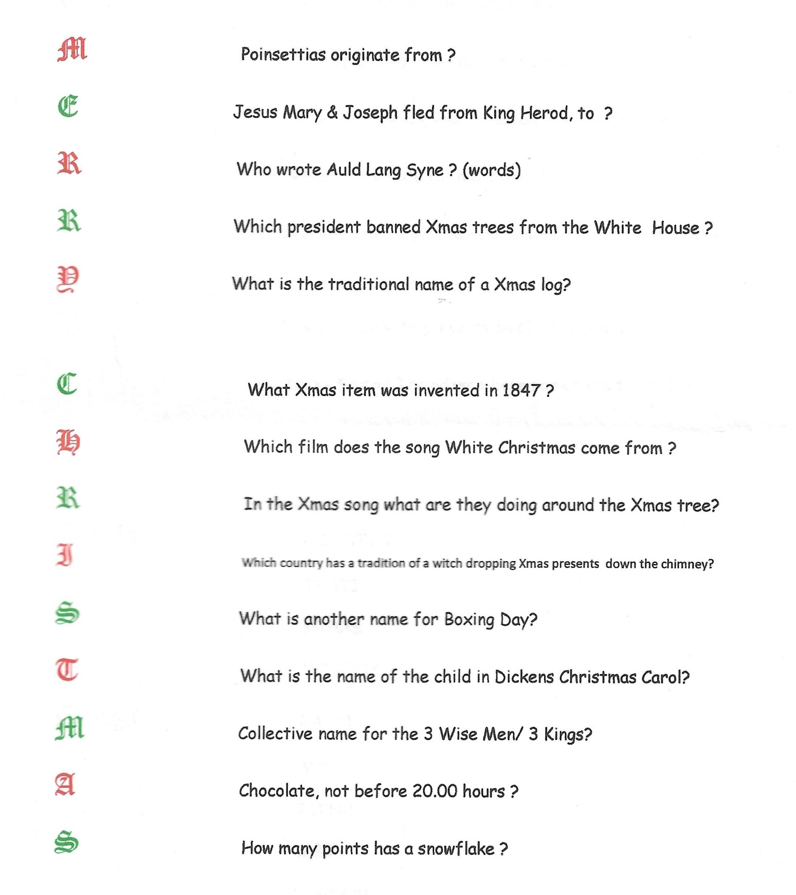
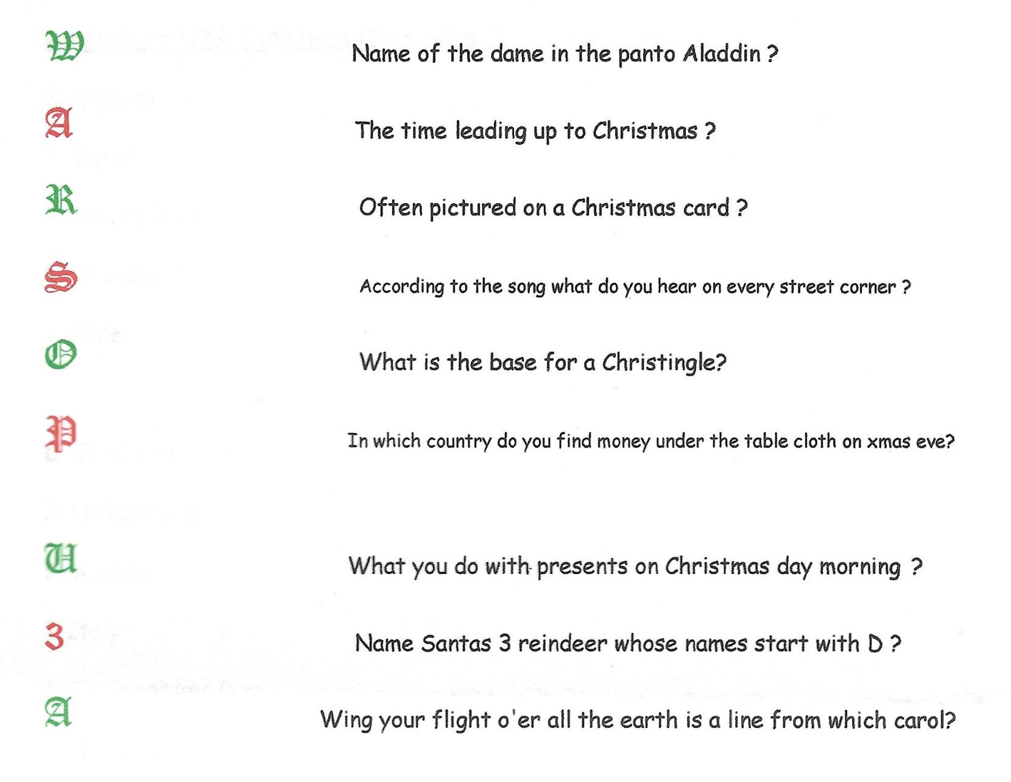

Answers to November film stars picture quiz
1 Steve McQueen 2 James Stewart 3 Rita Hayworth 4 Doris Day

5 Marlon Brando 6 Peter Ustinov 7 Katherine Hepburn

8 Barbra Streisand 9 Morgan Freeman 10 Orson Wells 11 John Wayne

12 Sylvester Stallone 13 Patrick Swayze 14 Harrison Ford

15 Bette Davis 16 Sydney Potier 17 Sean Connery

18 Burt Reynolds 19 Jodie Foster 20 Marlon Brando

21 Janet Leigh 22 Marilyn Monroe 23 Pierce Brosnan

24 Charlie Chaplin 25 Hayley Mills 26 Daniel Day Lewis

27 Peter O Toole 28 Audrey Hepburn 29 Mel Gibson

30 Elizabeth Taylor

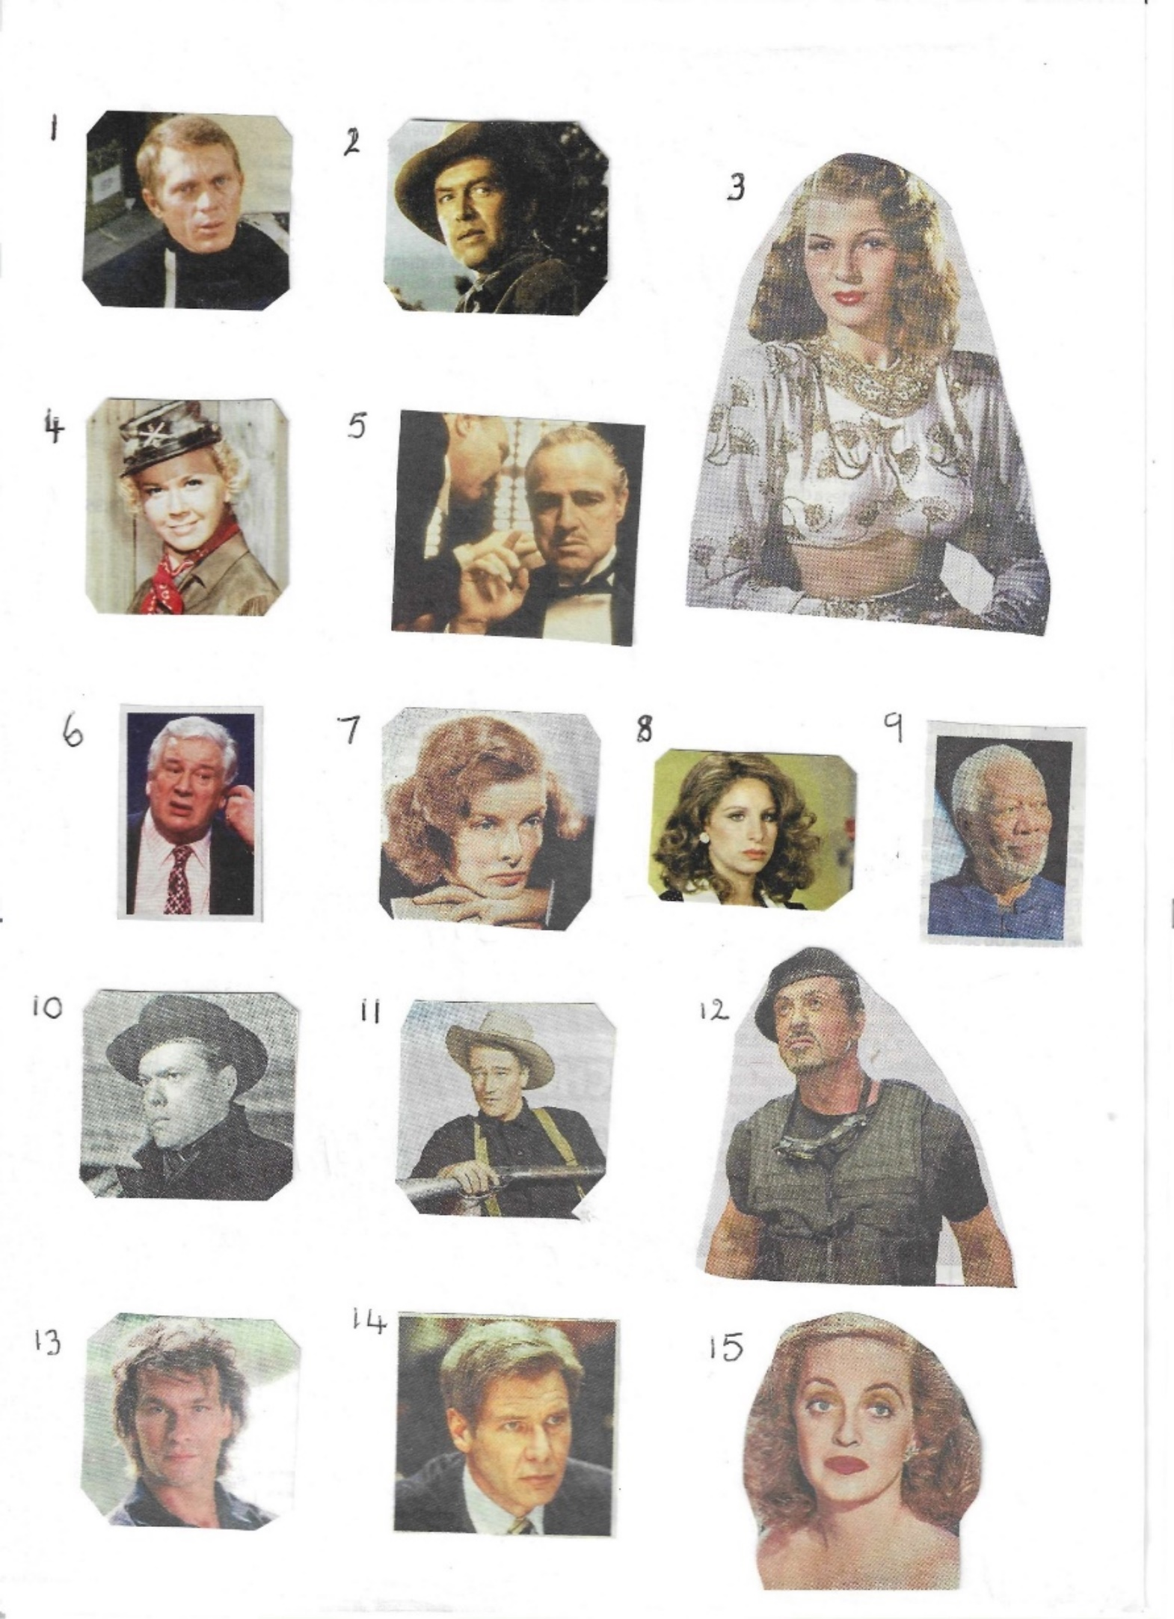



Answers November quick quiz All the answers are colours
1 Surname of actor who played Pike in Dads Army? Ian LAVENDER
2 Song by The Scaffold? Lily the PINK
3 Professor PLUM in Cluedo?
4 Who did they seek him here and seek him there? The SCARLET Pimpernel
5 Permit to work in the USA? A GREEN Card
6 Novel by Anne Bronte Agnes GREY
7 Name of horse in TV programme Lone Ranger? SILVER
8 Ireland is known as The EMERALD Isle?
9 Parliaments Man with the “ stick “? BLACK Rod
10 Former snooker player? Jimmy WHITE

Answers November Riddles
1 What has many teeth but cannot bite? A COMB

2 What thrives when you feed it but dies when you water it? A FIRE

3 Where is the only place where today comes before yesterday? A DICTIONARY

North Notts Neighbourhood group
This means that you as a member of Warsop & District can ask to join an interest group in another U3A that is also in the NNNG, as long as the group is not oversubscribed at the time of your request you can join the group without joining the host u3a
The u3as in the NNNG are Mansfield, Sherwood, Dukeries, Rainworth, Forest Town, Ashfield, Sutton in Ashfield, Hucknall, Worksop and Warsop.

Facebook
Warsop & District U3A has a Facebook Group. It is a private group which can be seen by the public but only members can see who’s in the group and what they post.
What this means is that you have to be invited to join the group or have your request to join accepted. Also you need to be on Facebook which some of you may not be. As a member of the group you will be able to put your own posts on the page, please keep them relevant to the U3A and what it stands for. We would ask that you don't put anything on that is in anyway party political or anything that may be offensive to others who may be of a different creed or religion. Hopefully everyone will join, use the page and find it useful.
One of the things that puts people ‘off’ Facebook, is the ‘bad press’ some of the Social sites get. You can join Facebook, choose only to join the Warsop Facebook page and not be involved in any other site, or Friends requests (usually from people that you have never heard of!) The choice is entirely yours.
To request to join the Warsop u3a Facebook page, contact Bob or Jen Thomson.
Warsop & District U3A is committed to treating all people equally.
Anyone wishing to see the Privacy and Data Protection policies may view them on the Warsop.u3asite.uk alternatively please ask Rob.
Website & Facebook
The Warsop & District u3a website can be found at Warsop.u3asite.uk . If any of the group leaders/facilitators would like to advertise/ promote any of their future activities or change the information shown, please contact Bob Thomson

