
Issue 84 November 2024
Warsop & Distict
Notes from the Chair
Hi to you all
As you are aware our previous chairperson, Jim Shervey, has now stepped down from this position but is still continuing in other roles within the group. So firstly I would like to thank him for the fantastic job he has done.
I decided to step into his ,albeit larger, shoes as I could not let our lovely group fold and I hope you will all bear with me while I feel my way in.
For those who don't know me I was born and bred in Warsop attending Hetts Lane and Sherwood Street school before going off to Manor with my partner in crime,Jen Thomson or Long as she was then. After a few years in the wilderness i.e. Clipstone I came home just over 2 years ago but more about me and my roots in later newsletters.
If I can only do half as good a job as my predecessor I will be happy and I am looking forward to working with you all in my new role in the future so we can continue with our wonderful group.
Lynne

The deadline for including articles/information in the next newsletter is Friday 6th Dec Send contributions to Chris Shervey. If you have any ideas for new items to include in the newsletter please let me know.

Rota for refreshments and greeting.
This is the rota for the next four months, any problems please contact me, Ann Ayodele.
Thank you to all those who have volunteered to help, without you our meetings would not be enjoyable.

Date | Refreshments 1 | Refreshments 2 | Meet and Greet 1 | Meet and Greet 2
18th Nov | Ann Harris Lock | Yvonne Pannifer | Roy Harris Lock | William Taylor
16th Dec | Karen Breed | Beatrix Kirby | Raymond White | Ann Barnes
20th Jan | Vera Walker | Janet Harford | Chris Wilson | Brenda Pearce
17th Feb | Gillian Allsop | Beatrix Kirkby | Jill Greer | Yvonne Brown

ITEMS OF INTEREST

Quiz Night
Our next quiz night will be on Wednesday 29th January at 7.30 to 10.30, in addition to the quiz we will also have a bingo session. It will be held at the Oaklands and the bar will be available, we will not be serving any food. The room rental will be paid for, so there is no charge for tickets. Tickets will be available at our December and January monthly meetings. Ann Ayodele.
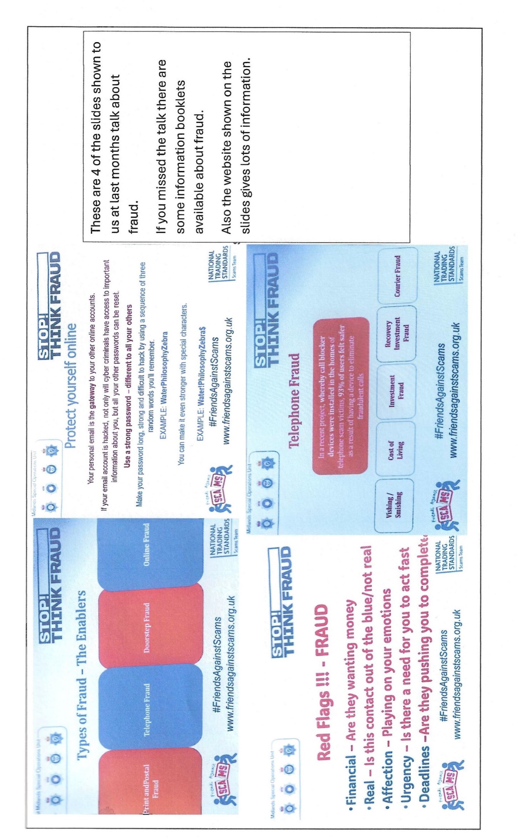
Christmas Lunch
34 of us have booked for this event at The Hostess on Friday 20th December, 11.45am for 12.00.
The majority have now paid the balance, anyone who has not yet done so should pay me at the November monthly meeting. Jen
Cups Please will as many of you as
possible bring your own mug for your tea or coffee. This is not only more environmentally friendly but also would save us a lot of money as the paper disposable cups we use are surprisingly expensive. Ann.
Robin Hood Lottery 
Warsop and District U3A is a cause registered with the Robin Hood Lottery.
To buy a ticket you can now register on line at www.robinhoodlottery.co.uk and set up regular payments. If you buy a ticket every week for a year Warsop U3A will receive £26.
Remember the more members that have a go (specifying Warsop & District U3A) the more money we get for our funds.

Raffle. The October Raffle raised £56
RAFFLE PRIZES NEEDED .
RAFFLE PRIZES NEEDED .

Books and Jigsaws 50p. We made £12.50 at the October meeting. The books are sorted into genres making it easier to find a book you like.

Welfare
Since the last newsletter good wishes have been sent to three of our members who are unwell.
Don't forget to let me know about members who are not well or who have suffered a bereavement so that I may send messages on behalf of Warsop and District u3a.
Thanks, Jen.

Group News
COULD ALL GROUP LEADERS PLEASE COLLECT THEIR BADGES WHEN THEY COLLECT THEIR LANYARDS. THEN MEMBERS CAN SEE WHO TO SPEAK TO ABOUT A GROUP.THANK YOU
A reminder for group leaders, we shall be having a short meeting immediately after the November monthly meeting on 18th November in the bar area of the Oaklands.
There will be cake!
Any group leader who has not yet sent me a list of current members please bring it to the meeting or let me have it in advance.
Thank you, Jen.
The Friendship Group 
The Friendship Group met on Friday, 1st November, when 7 members enjoyed a board game called Harry Potter Sequence. It was a change from our usual games and I hope everyone enjoyed the change. The majority of us had not played this before so some concentration was required. We ended the afternoon with a few games of UNO which was more familiar to all of us. The next meeting will be on Friday, 6th December at 2.00 p.m. in The Plough Inn.
Betty

Theatre Group 
This Photo by Unknown Author is licensed under CC BY-NC-ND
9 members are going to see The Nutcracker at Newark Palace Theatre on Tuesday 19th November.
This is our final outing of 2024 and my last as Group Leader. I have decided to step back from this role and hope someone from the group will be willing to take up the reins. Please get in touch if you are interested.
Thanks, Jen.

Bridge Club
The Dukeries u3a Bridge Group meet on the Second and Fourth Tuesday of each month at the Jubilee Hall (NG22 9AP) from 1 – 4PM. The cost of each session is currently £3.
All U3a members are welcome to attend.


Garden Group 
Six members of the gardening group went to the Blue Diamond garden centre at East Bridgford. We began with coffee of course and carried on to a very nice lunch followed by a wander around the shop and garden centre. Some of us indulged in the fashions and picked up a few Christmas gifts. We did buy a few plants and the spring bulbs were reduced to half price which was a bonus. A very nice day was had by all. Anne.
Silver Screeners
Savoy cinema Worksop. For the over 50’s. Every Wednesday at 11.30. Tickets £5.00, includes a drink and free raffle.
The Last Front (15)
During the First World War, a farmer, Leonard Lambert leads a group of fellow villagers to safety, while they are followed by the ruthless German lieutenant Laurentz.

Natural History, Science and Technology.
WE HAVE MOVED----- FROM NOW ON THE GROUP WILL BE MEETING AT ST TERESA’S CATHOLIC CHURCH. THE MEETING IS STILL EVERY SECOND THURSDAY 2-3.30

Today was our first meeting at St Teresa’s and it didn’t start well the caretaker forgot we were going and so we were 15 mins late starting. But everyone prefers the new venue and hopefully next time will be better. The group discussed plans for next year and then had a talk on Birds In The Garden. A wide variety of birds were covered from Wrens to Woodpeckers.

2024
December | No Meeting
January 9th | Periodic Table – Bingo!
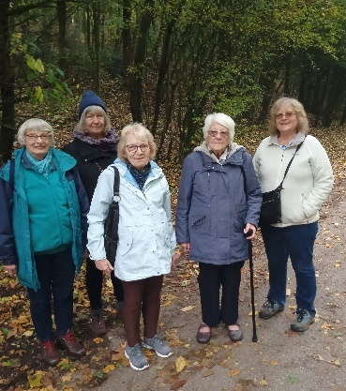
Strollers 
Strollers - 27th November 2024 - Kings Mill Reservoir
Meet 10.00 am at the Carrs car park for car share to Kings Mill Res.

Our walk in October took 6 members to Vicar Water for a stroll around both the large and small lakes, followed by refreshments and a chat in the cafe. A very pleasant way to spend an October morning. Why not join us in November (the cafe at Kings Mill Res has a good reputation!!!). Everyone is welcome

NOV Kings Mill Reservoir
DEC No Stroll


Craft Group 






In the November meeting the group made 3D Xmas cards.

If you would like to join us the only thing you need to bring is a basic sewing kit and a willingness to have a go at anything. All materials are available for a very small donation to the person who brings them, if anything more specialised is required you will be given the opportunity to purchase any item needed yourself, or you can borrow from other group members.
PLEASE NOTE THE NEW VENUE

The craft group meets the first Monday of the month 10am – 12noon St Theresa’s catholic church, Clumber Stret, Warsop. NG20 0LX. The carpark is on Ridgeway and there is a set of steps down to the hall. If you do have mobility issues it may be better to park in either the library or main car park in Warsop.
Future itinerary 2024/2025

December 2024 – Christmas wreaths

January 2025 – Card teapot boxes
February 2025 – Paper flowers
March 2025 – Rag dolls
April 2025 – Stitch embroidery cards
Zena

Photography Group
Warsop & District u3a Photography Group update – Nov 24
The Photography Group met on the Carrs, Monday 4th November 24 to record this years Silhouette display by the Warsop Poppy gang. It was a very overcast morning, but fortunately the rain held off! Due to the dullness of the day we decided to try some Monochrome photography!
The online ‘Themed’ challenge was ‘Anything that begins with either W,X,Y or Z’
Once again a Big THANK YOU to Jen Thomson. Jim & Chris Shervey for their contributions!

Joyce O’Neil – W = Water , Y = Yacht



Jim & Chris Shervey – W = Winter & Winter sports
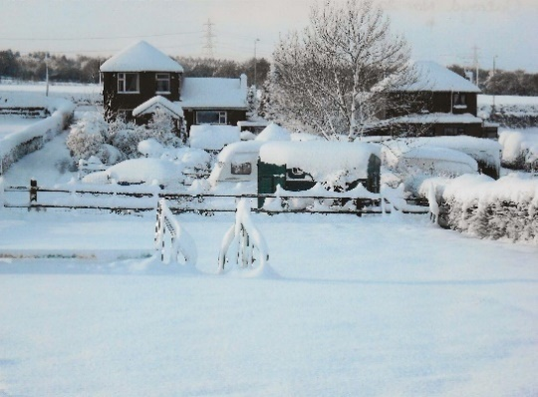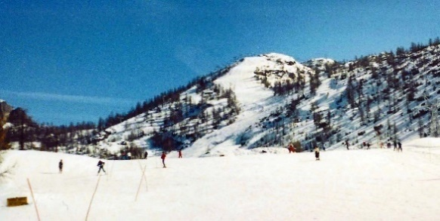

Joanne Wheatly – W = Wire, Y = Yellow, Z = Zip & Zebra Fish
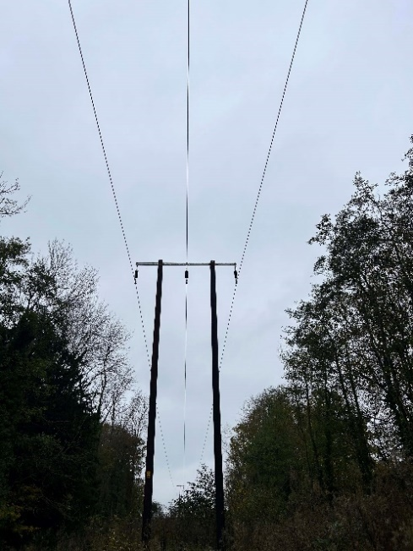

Jen Thomson – W = Winter garden
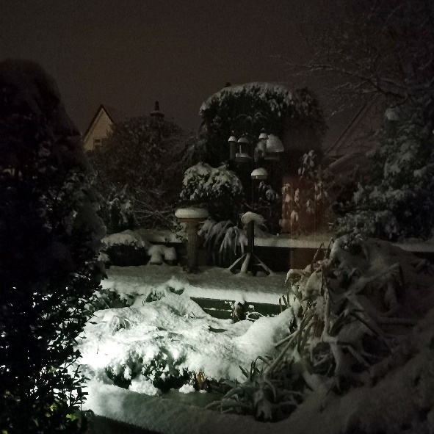

Bob Thomson – W = Waterfall, Warsop u3a, Warsop in olden days.
Z = Zebra
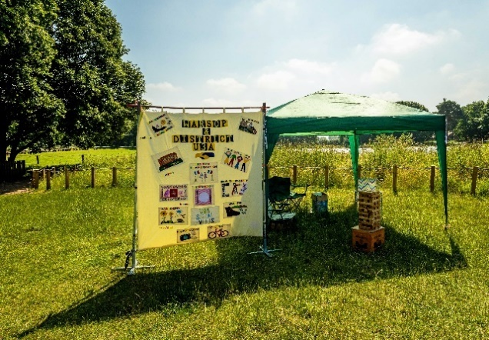
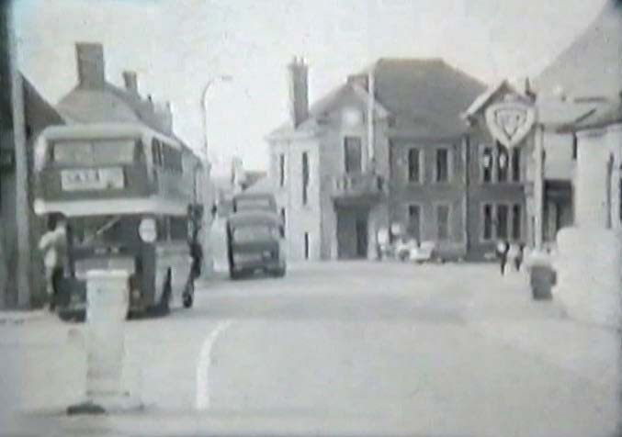

Warsop Poppy Gang Silhouettes display
Betty Trinder

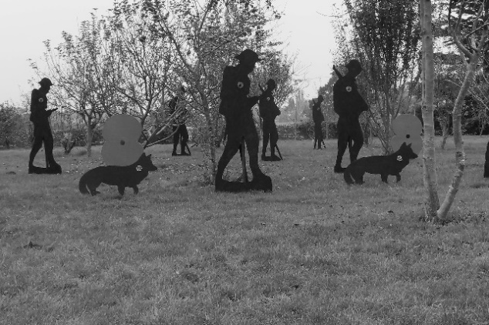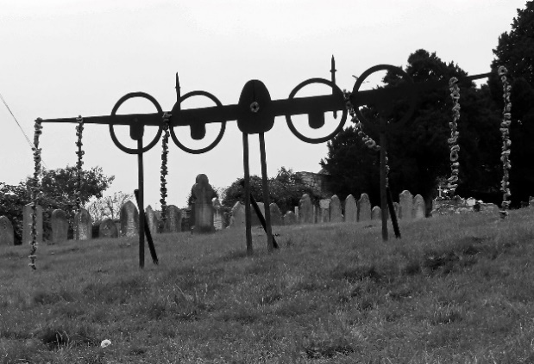
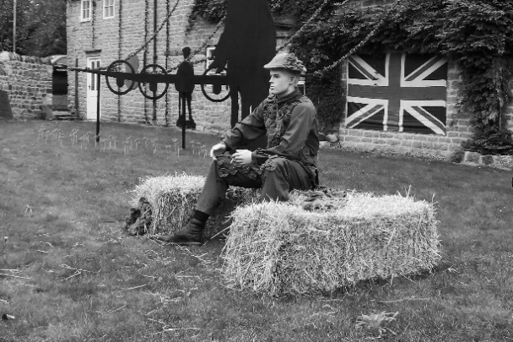

Bob Thomson
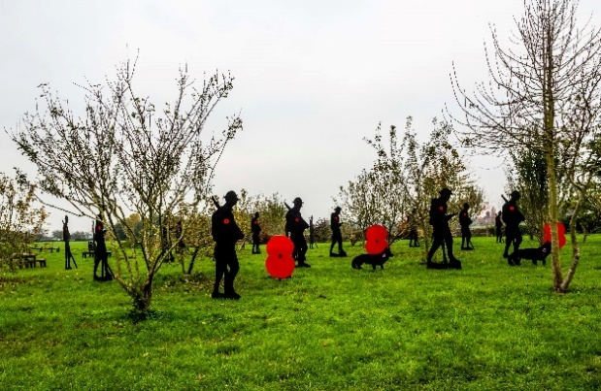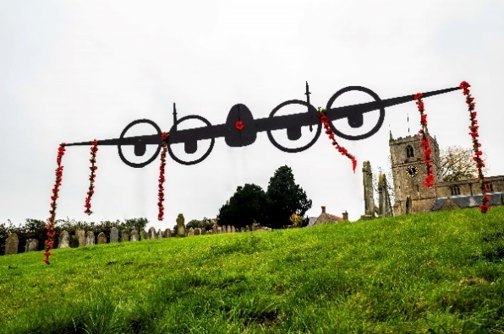

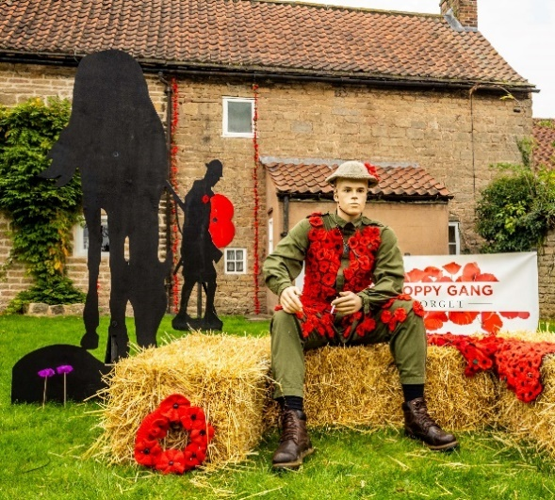
More photos can be found on the Photography group Webpage at Warsop.u3asite.uk

The ‘Anything beginning with either W,X,Y or Z’ themed challenge will continue this month, All u3a members are welcome to join in!

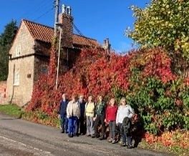


Walking Group
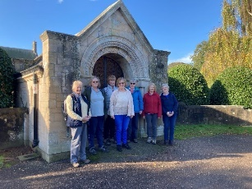
The walk took us, 8 girls, from the Church in Cuckney to the water meadows between Cuckney and Norton. From there we went through the fields towards the Welbeck estate where we followed the road through the Deer Park. From there to Lady Margaret Hall where we crossed the road to Holbeck. Through the lane along the beautiful old church and then into the Welbeck estate again. We had a drink and a bite in the courtyard and enjoyed the sunshine. We were very lucky because it was a beautiful Indian summer day, perfect for our walk. We went back, almost the same way as we came. We all could feel that it had been a good long walk, a bit more than 7 miles, but we had a great time!

WALKING GROUP - 3RD THURSDAY OF THE MONTH 2024
Date | Walk Leader | Walk | Distance
21st November |  | Local Walk
December |  | No Walk in December
History Group

On Tuesday 15th October we enjoyed another fascinating talk given by Chris Weir. Chris worked for the Nottingham Archives for several years.
His talk this month, entitled ‘The Dark Side,’ had a seasonal Halloween feel to it; not one for the squeamish!
From local witch trials in the 1600s to a Mansfield farmer, John Darrell, born in 1562, who made a name for himself as an exorcist. He was much in demand until he was exposed as a fraud.
Local ghosts made an appearance. Sophia Hyatt, the white lady at Newstead, and poor Lizzy Sheppard murdered on the road at Harlow Wood.
There were accounts of murders most foul: the notorious William Saville of Sneinton, also Anne Castledine, a poor young woman who was executed in 1784 whose dead body was ‘exposed to public curiosity’.
For any of you living in the Ravenshead area, beware of the red-eyed ravens of Newstead (as seen by the poet Lord Byron), who are believed to be possessed by the black monks who once inhabited the area – not something the estate agents would bring to potential house buyers’ notice in the area, I’m sure!
Next month we welcome Colin, who will be telling us all about the many houses of Bess of Hardwick. We hope you can join us.
Below is the proposed calendar of events for next year.
19th Nov 2024 | Colin – The Houses of Bess of Hardwick | St Theresa’s Church Hall 10am
17th Dec 2024 | No meeting
21st Jan 2025 | James Wright. | St Theresa’s Church Hall 10am
18th Feb 2025 | In house talk | St Theresa’s Church Hall 10am
18th Mar 2025 | Visit – Newark Governor’s House | Meet TBA
15th Apr 2025 | Denis Hill – Kirkby Castle | St Theresa’s Church Hall 10am
20th May 2025 | Chris Weir Bygone Shopping in Nottm | St Theresa’s Church Hall 10am
17th Jun 2025 | Visit to Lincoln Castle and Cathedral | Meet TBA
15th July 2025 | Chris Weir – Lace, Slums and the Occasional Riot. Victorian Nottm | St Theresa’s Church Hall 10am
19th Aug 2025 | Denis Hill The Life of Lord Byron the Poet | St Theresa’s Church Hall 10am
16th Sept 2025 | Visit Denby Pottery Museum?
21st Oct 2025 | Chris Weir Mud, Munitions and Memorial WW1 | St Theresa’s Church Hall 10am
18th Nov 2025 | In house | St Theresa’s Church Hall 10am
16th Dec 2025 | No meeting as very close to Christmas

Speakers for the main meetings
2024

November Before They Were Famous Mel Mitchell

December Christmas Party

Group | Leaders Name | Tel
NATURAL HISTORY SCIENCE AND TECHNOLOGY | Chris Shervey
WALKING GROUP | Brenda Pearce  Pam Hick
STROLLERS | Janet Harford  Pat Magness
HISTORY GROUP | Barbara Spybey
CRAFTS | Zena Inger
GARDENING | Linda Crossley
PHOTOGRAPHY | Rob Thomson
FRIENDSHIP GROUP | Betty Trinder
THEATRE GROUP | Jennifer Thomson
TAI CHI | Ann Poultney
DISCUSSION GROUP | Mary Morris

INTEREST GROUP TIMETABLE
 | MONDAY | TUESDAY | WEDNESDAY | THURSDAY | FRIDAY
1st | 10am – 12pm  CRAFTS GROUP  St Teresa’s Catholic Church hall. Warsop |  |  |  | 2pm  FRIENDSHIP GROUP  The Plough Warsop
2nd |  | 10am  GARDENING GROUP  Venue agreed by members |  | 2 – 3.30  NATURAL HISTORY  SCIENCE AND  TECHNOLOGY  St Teresa’s Catholic Church Hall Warsop
3rd | MAIN MEETING 10.15  Oaklands Centre  Warsop | 10am– 12pm  HISTORY GROUP  St Teresa’sCatholic Church hall. Warsop |  | 10am  WALKING GROUP  Carrs Car Park | 11.am  PHOTOGRAPHY  Venue to be agreed by the members.
4th | 10.30 -12.30  DICUSSION GROUP  Forest Lodge  Edwinstowe |  | 10.am  STROLLERS  Carrs Car Park
THEATRE GROUP - Location and time as announced.
PHOTOGRAPHY GROUP-Please see Newsletter for the online challenge.
TAI CHI Every Friday 10.30am St Teresa’s Catholic Church hall

November quiz Can you name these famous film stars?
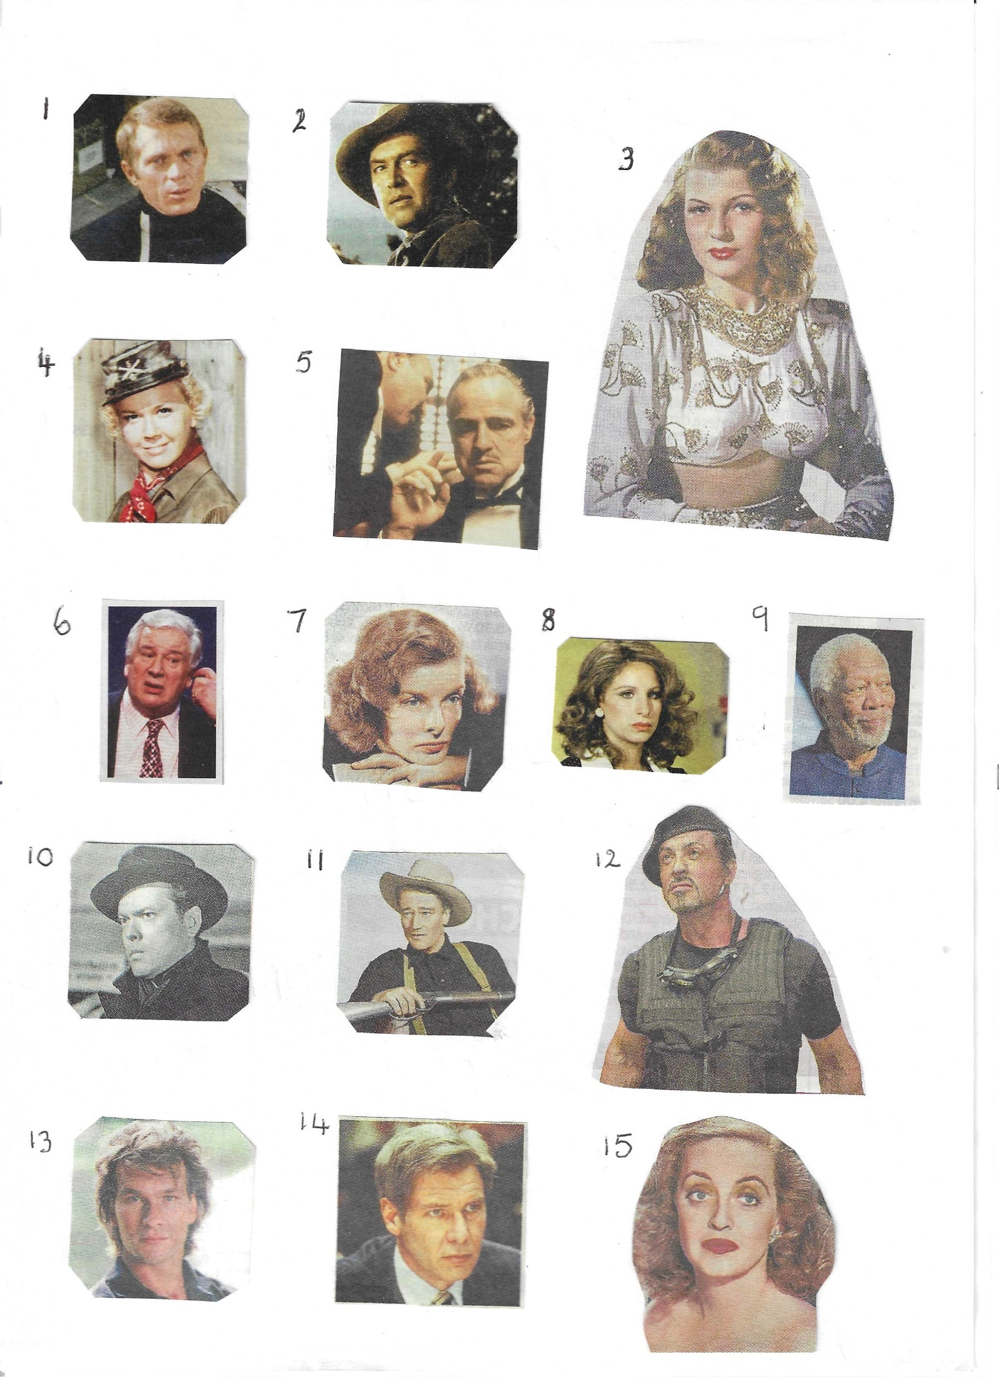
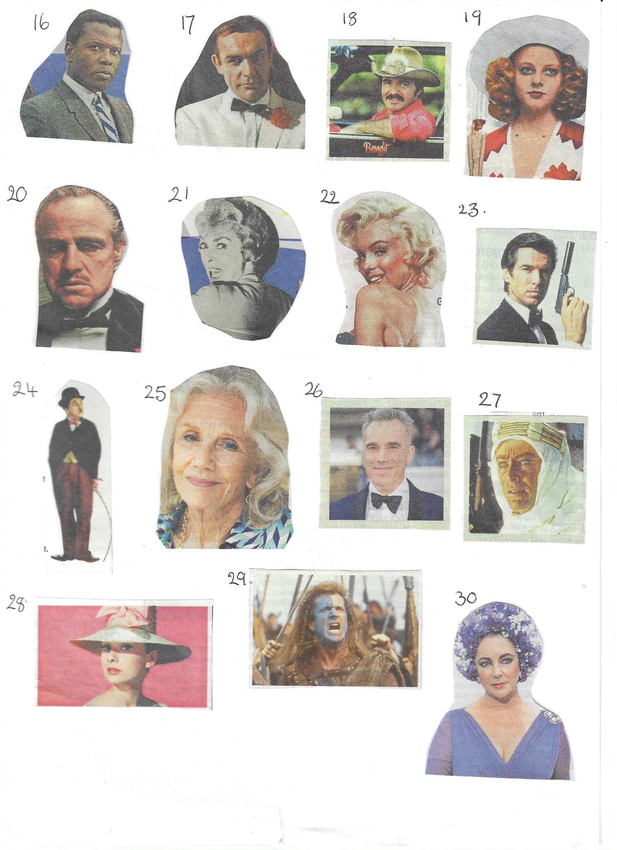

November quick quiz All the answers are colours

1 Surname of actor who played Pike in Dads Army?
2 Song by The Scaffold?
3 Professor ------- in Cluedo?
4 Who did they seek him here and seek him there?
5 Permit to work in the USA?
6 Novel by Anne Bronte
7 Name of horse in TV programme Lone Ranger?
8 Ireland is known as The -------- Isle?
9 Parliaments Man with the “ stick “?
10 Former snooker player?

November Riddles
1 What has many teeth but cannot bite?

2 What thrives when you feed it but dies when you water it?

3 Where is the only place where today comes before yesterday?

Answers October quiz Famous Dates in British History
1 1415 B of A Battle of Agincourt
2 2012 LO London Olympics
3 1922 T of T D Tomb of Tutenkahmum discovered
4 1066 B of H Battle of Hastings
5 1936 A of KE Abdication of King Edward VIII
6 1215 MC Magna Carta
7 1588 The S A Spanish Armanda
8 1805 B of T Battle of Trafalgar
9 1666 G F of L Great Fire of London
10 1954 F F M M First Four Minute Mile
11 1642 S of E C W Start of English Civil War
12 1977 S J of QE Silver Jubilee of Queen Elizabeth
13 1939 S of WW T Start of World War II
14 1815 B of W Battle of Waterloo
15 1981 W of C and D Wedding of Charles and Diana
16 1926 G S General Strike
17 1348 The B D The Black Death
18 1587 E of MQ of S Execution of Mary Queen of Scots
19 1940 E at D Evacuation of Dunkirk
20 1660 R of C the S Restoration of Charles II
21 1918 E of WW O End of World War I
22 1605 G P Gunpowder Plot
23 1928 V for W Votes for Women
24 1897 D J of QV Diamond Jubilee of Queen Victoria
25 1912 S of the T Sinking of the Titanic

Answers October quick quiz All answers start with O except one.

- A Womble who shares his name with a river? ORINOCO
- A South American wild cat? OCELOT
- King of the faries in Shakesperes Midsummer Nights Dream OBERON
- Name of a Norse God? ODIN
- Long distance walk on Welsh/English border? OFFAS DYKE
- The first President of USA? GEORGE WASHINGTON
- Town in Lacashire? OLDAM
- Nickname of Central Criminal Court in London? OLD BAILEY
- British actor famous for his Shakesperean roles? ( Surname O ) LAURENCE OLIVIER
- An American chat show ? ( first name O ) OPRAH WINFREY

Answers October riddles
1 I cannot talk but I always reply when spoken to? AN ECHO

2 What is it that no one wants but no one wants to lose either? A LAWSUIT

3 What can go through light without breaking it? LIGHT

North Notts Neighbourhood group
This means that you as a member of Warsop & District can ask to join an interest group in another U3A that is also in the NNNG, as long as the group is not oversubscribed at the time of your request you can join the group without joining the host u3a
The u3as in the NNNG are Mansfield, Sherwood, Dukeries, Rainworth, Forest Town, Ashfield, Sutton in Ashfield, Hucknall, Worksop and Warsop.

Warsop & District U3A is committed to treating all people equally.
Anyone wishing to see the Privacy and Data Protection policies may view them on the Warsop.u3asite.uk alternatively please ask Rob.

Facebook
Warsop & District U3A has a Facebook Group. It is a private group which can be seen by the public but only members can see who’s in the group and what they post.
What this means is that you have to be invited to join the group or have your request to join accepted. Also you need to be on Facebook which some of you may not be. As a member of the group you will be able to put your own posts on the page, please keep them relevant to the U3A and what it stands for. We would ask that you don't put anything on that is in anyway party political or anything that may be offensive to others who may be of a different creed or religion. Hopefully everyone will join, use the page and find it useful.
One of the things that puts people ‘off’ Facebook, is the ‘bad press’ some of the Social sites get. You can join Facebook, choose only to join the Warsop Facebook page and not be involved in any other site, or Friends requests (usually from people that you have never heard of!) The choice is entirely yours.
To request to join the Warsop u3a Facebook page, contact Bob Thomson.

Committee Members | Role
Lynne Hutchinson | Chairperson
Mel Mitchell | Deputy Chairperson
Irene Clay | Business Secretary
Linda Crossley | Treasurer
Zena Inger | Membership Secretary
Jim Shervey | Speaker Seeker
Jennifer Thomson | Groups co-ordinator
Chris Shervey | Newsletter editor
Ann Ayodele | Social Events
Jennifer Thomson | Welfare Officer
Rob Thomson | Website & Facebook manager
Ann Ayodele | Refreshments rota
June Whittle | Raffle
Betty Trinder | Social events assistant
Website & Facebook
The Warsop & District u3a website can be found at Warsop.u3asite.uk . If any of the group leaders/facilitators would like to advertise/ promote any of their future activities or change the information shown, please contact Bob Thomson.

