
Issue 83 October 2024
Warsop & Distict
Notes from the Chairman
Hi
The talk this month is by Richard Kubon. A Police Fraud Protection Officer. He is giving us a talk on ‘How to avoid Fraud’.
Please feel free to bring a visitor with you if you wish. This is an important topic and should be of interest to many.
The more the merrier with a topic like this.

Jim Shervey

The deadline for including articles/information in the next newsletter is Friday 8th Nov Send contributions to Chris Shervey. If you have any ideas for new items to include in the newsletter please let me know.

Rota for refreshments and greeting.
This is the rota for the next five months, any problems please contact me, Ann Ayodele.
Thank you to all those who have volunteered to help, without you our meetings would not be enjoyable.

Date | Refreshments 1 | Refreshments 2 | Meet and Greet 1 | Meet and Greet 2
21st Oct | Audrey Gilbert | Zena Inger | Moira Heslop | Ann Poultney
18th Nov | Wendy Sterland | Yvonne Pannifer | Roy Harris Lock | William Taylor
16th Dec | Karen Breed | Beatrix Kirby | Raymond White | Janice Richardson
20th Jan | Vera Walker | Janet Harford | Chris Wilson | Brenda Pearce
17th Feb | Gillian Allsop | Beatrix Kirkby | Jill Greer | Yvonne Brown
Those on the rota please be there around 9.30am.

ITEMS OF INTEREST

Silent Auction Thank you to everyone who bought items at the Silent Auction we raised £170.


Christmas Lunch
I shall be collecting the balance of £15 each from everyone who has paid a deposit during November's meeting.
Anyone wishing to pay this month may, of course, do so.
There is one place available for this event. If anyone would like to join us at the Hostess, or bring a friend, please see me at the October general meeting. A £5 deposit will be required, Thank you, Jen.

Cups Please will as many of you as
possible bring your own mug for your tea or coffee. This is not only more environmentally friendly but also would save us a lot of money as the paper disposable cups we use are surprisingly expensive. Ann.
Robin Hood Lottery 
Warsop and District U3A is a cause registered with the Robin Hood Lottery.
To buy a ticket you can now register on line at www.robinhoodlottery.co.uk and set up regular payments. If you buy a ticket every week for a year Warsop U3A will receive £26.
Remember the more members that have a go (specifying Warsop & District U3A) the more money we get for our funds.

Raffle. No Raffle, books or puzzles in Sept – Silent Auction
RAFFLE PRIZES NEEDED .

Welfare
Since the last newsletter get well wishes have been sent to one member who is currently unwell.
Don't forget to let me know about members who are ill or who have been bereaved so that I may let them know that their friends at Warsop and District u3a are thinking of them. Thanks, Jen.
Group News
COULD ALL GROUP LEADERS PLEASE COLLECT THEIR BADGES WHEN THEY COLLECT THEIR LANYARDS. THEN MEMBERS CAN SEE WHO TO SPEAK TO ABOUT A GROUP.THANK YOU
By the time you read this, the first meeting of the Tai Chi Group will have been held. Many thanks to Anne Poultney for organising this, I hope the group thrives.
The group will meet at 10.30am every Friday in St Teresa's Church Hall. The cost is initially £5 each but this may be revised depending on attendance figures.
I am hoping to arrange a meeting of all group leaders in the Oaklands immediately after the November general meeting.
Could all group leaders please let me have an up to date membership list at or before this meeting please? Thanks to those who have already done so.
Jen
The Friendship Group 
The Friendship Group did not meet in October unfortunately due to some members having other commitments. but we will be meeting again on Friday, 1st November at The Plough at 2.00 p.m.
Betty
Theatre Group 
This Photo by Unknown Author is licensed under CC BY-NC-ND
I shall be bringing tickets for The Nutcracker to October's meeting, as usual there, is a 10p charge for printing.

Discussion Group 
This Photo by Unknown Author is licensed under CC BY-SA
The discussion group will run as usual at 10.30 0n the 4th Monday of the month, Forest Lodge Edwinstowe.

Bridge Club
The Dukeries u3a Bridge Group meet on the Second and Fourth Tuesday of each month at the Jubilee Hall (NG22 9AP) from 1 – 4PM. The cost of each session is currently £3.
All U3a members are welcome to attend.

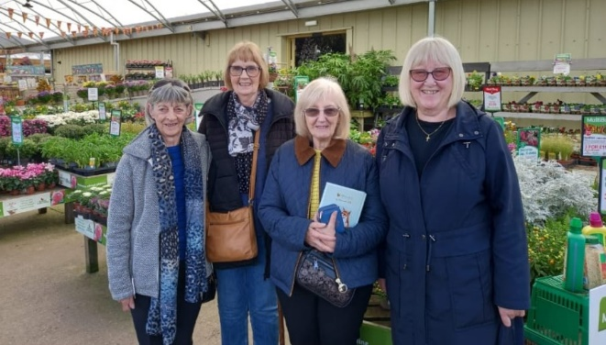
Garden Group 
Four of the gardening group went to Woodboro’/Timmermans this month. We enjoyed our walk round indoors and out. All the Xmas displays are out already!
We had a lite bite in the café before returning home. The weather was good and we had a good day.
Irene.

Silver Screeners
Savoy cinema Worksop. For the over 50’s. Every Wednesday at 11.30. Tickets £5.00, includes a drink and free raffle.
Beetlejuice Beetlejuice (12a)
Beetlejuice is back! After an unexpected family tragedy, three generations of the Deetz family return home to Winter River. Still haunted by Beetlejuice, Lydia's life is turned upside down when her rebellious teenage daughter, Astrid, discovers the mysterious model of the town in the attic and the portal to the Afterlife is accidentally opened. With trouble brewing in both realms, it's only a matter of time until someone says Beetlejuice's name three times and the mischievous demon returns to unleash his very own brand of mayhem.

Natural History, Science and Technology.
Jodie from Mansfield Museum brought several old implements and we split into 2 teams and spent an enjoyable hour discussing their use. Some we easily identified as our mothers or grandmothers had used them. Others were more difficult. One large heavy metal object had both teams puzzled. What was it I can’t tell you because even the museum don’t know! ! See how many you recognise from the photos.
WE HAVE MOVED----- FROM NOW ON THE GROUP WILL BE MEETING AT ST TERESA’S CATHOLIC CHURCH. THE MEETING IS STILL EVERY SECOND THURSDAY 2-3.30

2024
November 14th | Birds in your garden | Chris Shervey
December | No Meeting
January 9th | Periodic Table – Bingo!

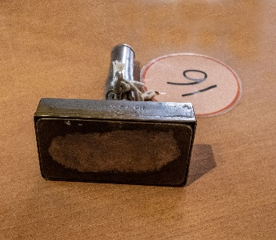
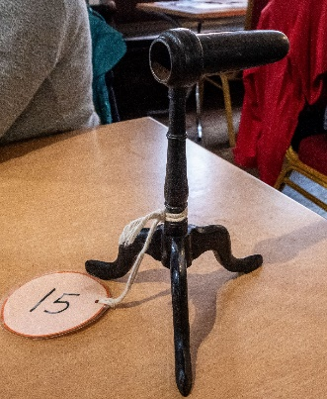


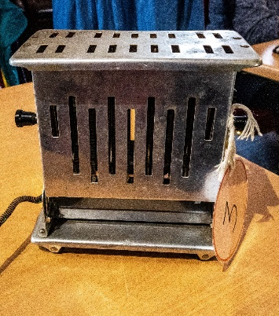
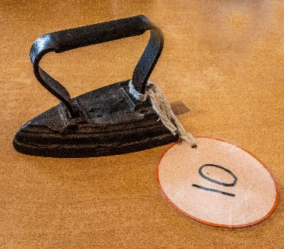

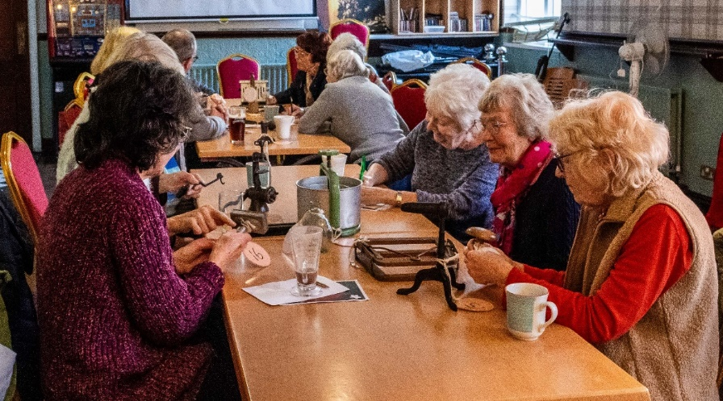
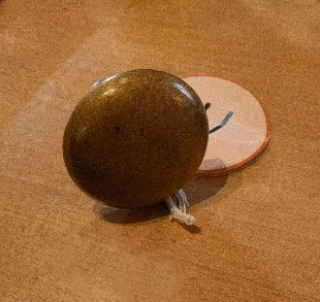
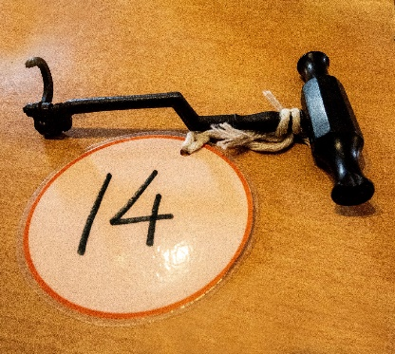
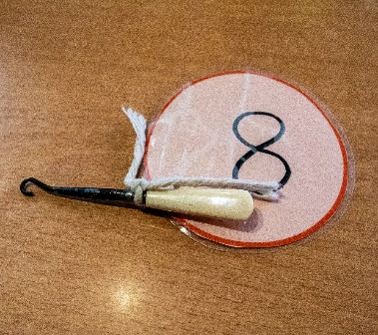
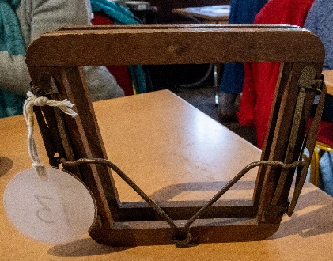

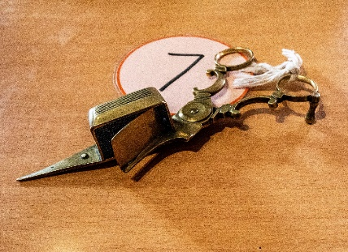

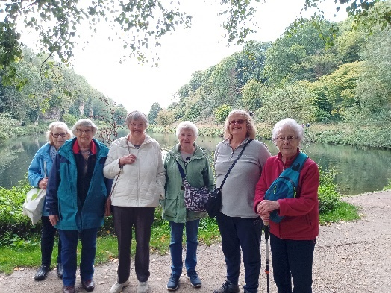
Strollers 
The September stroll was from the Dukeries car park to Cresswell Crags. A stroll around the lake, then to the café and back to the car park.
23rd October 2024 - Vicar Water Meet at 10.00 am at The Carrs car park for car share to Vicar Water. (Please note the stroll this month does unusually fall l in the same week as the October meeting)"
OCT Vicar Water
NOV Kings Mill Reservoir
DEC No Stroll

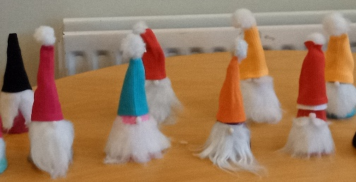
Craft Group 
There were nine of us at the group, we had a cheerful morning making sock gonks, you can see from the pictures that we had a variety of colours and they all had their own personality.
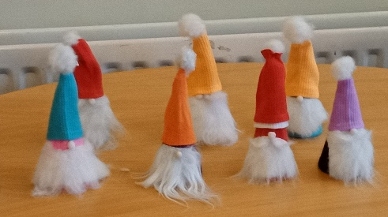
In the November meeting the group will be making cards. Cards - Christmas, Easter, Birthday, anything you fancy really.
If you would like to join us the only thing you need to bring is a basic sewing kit and a willingness to have a go at anything. All materials are available for a very small donation to the person who brings them, if anything more specialised is required you will be given the opportunity to purchase any item needed yourself, or you can borrow from other group members.
PLEASE NOTE THE NEW VENUE
The craft group meets the first Monday of the month 10am – 12noon St Theresa’s catholic church, Clumber Stret, Warsop. NG20 0LX. The carpark is on Ridgeway and there is a set of steps down to the hall. If you do have mobility issues it may be better to park in either the library or main car park in Warsop.
Future itinerary 2024/2025
November 2024 – Christmas cards
December 2024 – Christmas wreaths
January 2025 – Card teapot boxes
February 2025 – Paper flowers
March 2025 – Rag dolls
April 2025 – Stitch embroidery cards
Zena.

Photography Group
The Photography Group continues online with the ‘Themed’ challenges.
This last months challenge was ‘Anything beginning with either U or V.

Joanne Wheatley : U = Ugly fruit, Undertaker, UV lighting and Vulture.


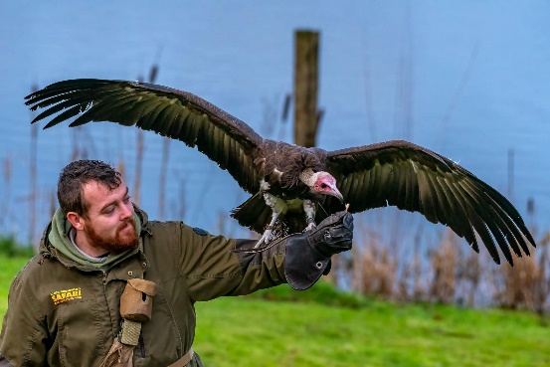

Chris Shervey: Uniforms – Back to school



Bob Thomson: Vintage Vehicles, Uniforms

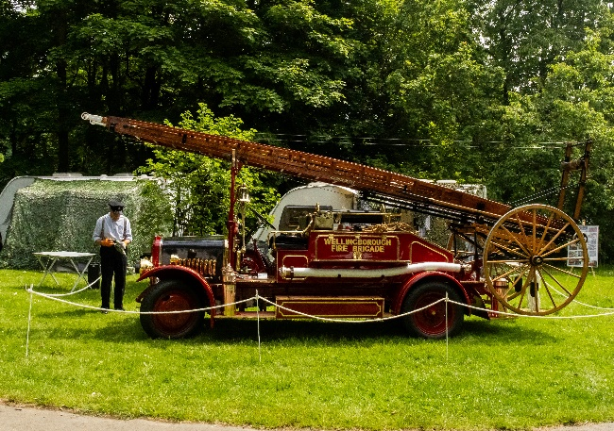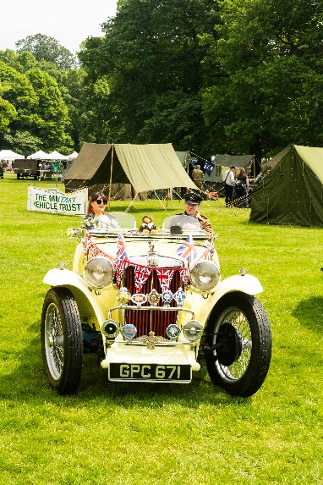

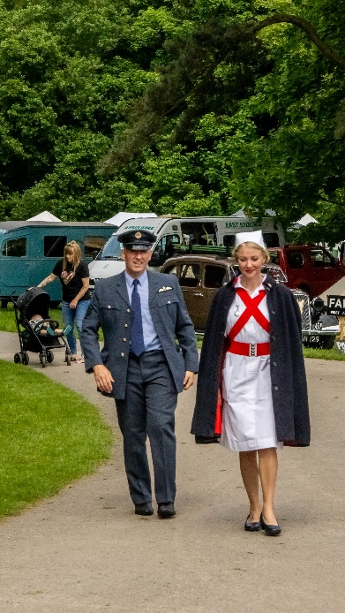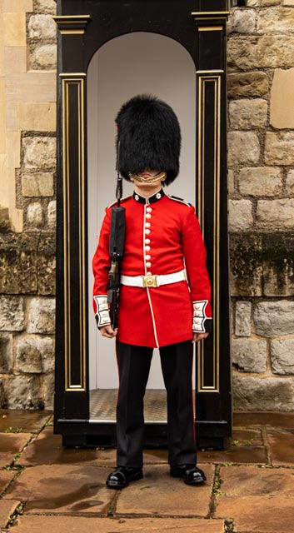

Joyce O’Neil : U = Utensils, Underwear
V = Vehicles, Veg





The next online ‘Themed’ Challenge is ‘ Anything that begins with either W, X, Y or Z’

Once again this challenge is open to All u3a members.

Just in case you thing that you can’t join in as you only have the camera on your phone, remember that ALL of Joannes photos are taken on her phone, and this was taken on mine.
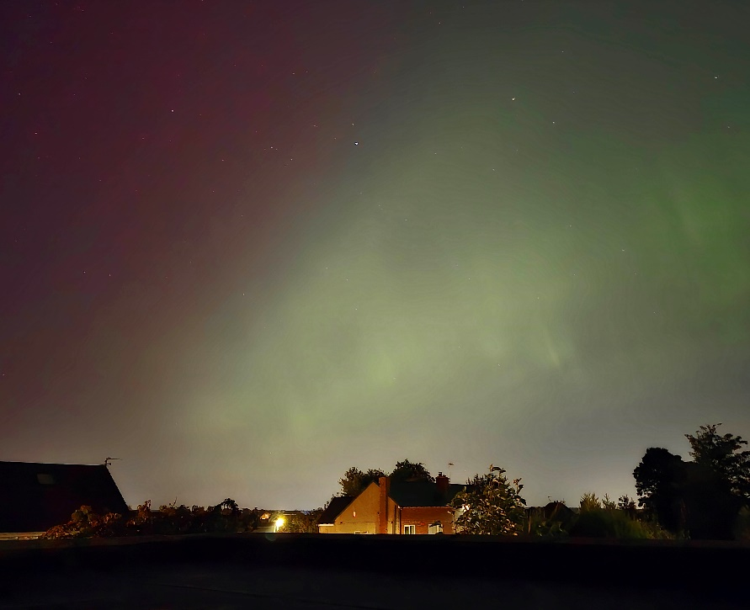
Arora Borealis 10-10-24


Walking Group
September Walk - Creswell Loop
The walk started from the car park at Welbeck garden centre. From there we made our way to Creswell Crags and did a half tour of the lake before heading towards Steetley Quarry.
In past centuries, the Parish of Whitwell has contained many small quarries, which have provided stone for building, road making and lime burning.
One of these early quarries, a dolomite quarry, was worked at Steetley; it might have remained a small quarry except for two important factors. First, the Industrial Revolution, which brought into being a new steel-making process requiring a heat-resisting furnace for which dolomite proved the most suitable material. Second, the steel-making centre of Sheffield was only a few miles away. So, in 1885, a new company called Steetley was formed and, from a modest beginning, a vast industrial organisation has developed.
Many of us knew about the quarry but not the vast expanse it covered.
After a short detour we followed the bridle path and headed back towards our start point. With a welcome drink and sausage roll at the end.
2024 Calendar Change
October walk
From Cuckney to Welbeck and back. In total +/- 6,5 miles.
Bring some drink and food if you want to, there will be a break at the Welbeck farmshop/ tearoom /garden centre.
Brenda

WALKING GROUP - 3RD THURSDAY OF THE MONTH 2024
Date | Walk Leader | Walk | Distance
17th October | Sonja Vlaming | Cuckney to Welbeck and back. | 6.5 miles+/-
21st November |  | Local Walk
December |  | No Walk in December

History Group
The history group met Denis Hill outside the Palace Theatre in Mansfield for a fascinating tour of Mansfield town. We learned that Mansfield has a wealth of historic buildings. Within a 300 yard radius of the town centre there are 75 pre Victorian buildings! Some dating back to the 1600s are still there, often hidden away. Also, that old buildings were literally cut in half to make way for new buildings when the market square was developed in the 1800s and many other interesting facts.

Barbara and I have been busy planning our proposed next year’s calendar. We will be sharing it with you shortly.

2024 - Proposed Calendar of Events for Warsop & District U3A History Group
19th Nov | The houses of Bess of Hardwick | St Teresa’s Church Hall 10am
17th Dec | No meeting as very close to Christmas

Speakers for the main meetings
2024

October How to avoid Fraud Richard Kubon
Police Fraud Protection Officer

November Before They Were Famous Mel Mitchell

Group | Leaders Name | Tel
NATURAL HISTORY SCIENCE AND TECHNOLOGY | Chris Shervey
WALKING GROUP | Brenda Pearce  Pam Hick
STROLLERS | Janet Harford  Pat Magness
HISTORY GROUP | Barbara Spybey
CRAFTS | Zena Inger
GARDENING | Linda Crossley
PHOTOGRAPHY | Rob Thomson
FRIENDSHIP GROUP | Betty Trinder
THEATRE GROUP | Jennifer Thomson
TAI CHI | Ann Poultney
DISCUSSION GROUP | Mary Morris

INTEREST GROUP TIMETABLE
 | MONDAY | TUESDAY | WEDNESDAY | THURSDAY | FRIDAY
1st | 10am – 12pm  CRAFTS GROUP  St Teresa’s Catholic Church hall. Warsop |  |  |  | 2pm  FRIENDSHIP GROUP  The Plough Warsop
2nd |  | 10am  GARDENING GROUP  Venue agreed by members |  | 2 – 3.30  NATURAL HISTORY  SCIENCE AND  TECHNOLOGY  St Teresa’s Catholic Church Hall Warsop
3rd | MAIN MEETING 10.15  Oaklands Centre  Warsop | 10am– 12pm  HISTORY GROUP  St Teresa’sCatholic Church hall. Warsop |  | 10am  WALKING GROUP  Carrs Car Park | 11.am  PHOTOGRAPHY  Venue to be agreed by the members.
4th | 10.30 -12.30  DICUSSION GROUP  Forest Lodge  Edwinstowe |  | 10.am  STROLLERS  Carrs Car Park
THEATRE GROUP - Location and time as announced.
PHOTOGRAPHY GROUP-Please see Newsletter for the online challenge.

October quiz Famous Dates in British History

1 1415 B of A
2 2012 LO
3 1922 T of T D
4 1066 B of H
5 1936 A of KE
6 1215 MC
7 1588 The S A
8 1805 B of T
9 1666 G F of L
10 1954 F F M M
11 1642 S of E C W
12 1977 S J of QE
13 1939 S of WW T
14 1815 B of W
15 1981 W of C and D
16 1926 G S
17 1348 The B D
18 1587 E of MQ of S
19 1940 E at D
20 1660 R of C the S
21 1918 E of WW O
22 1605 G P
23 1928 V for W
24 1897 D J of QV
25 1912 S of the T

October quick quiz All answers start with O except one.
- A Womble who shares his name with a river?
- A South American wild cat?
- King of the faries in Shakesperes Midsummer Nights Dream/
- Name of a Norse God?
- Long distance walk on Welsh/English border?
- The first President of USA?
- Town in Lacashire?
- Nickname of Central Criminal Court in London?
- British actor famous for his Shakesperean roles? ( Surname O )
- An American chat show ? ( first name O )
October riddles
1 I cannot talk but I always reply when spoken to?

2 What is it that no one wants but no one wants to lose either?

3 What can go through light without breaking it?
Answers SEPTEMBER QUIZ Geographical Trivia.

1 Which is the only country in the world( European) that has the word LOVE in it’s name? SLOVENIA
2 Which is the only city to straddle 2 continents? ISTANBUL
3 Which of the original 7 Wonders of the world is still standing? PYRAMIDS
4 On which island do descendants of the mutineers on HMS Bounty live? PITCAIRN ISLANDS
5 Which commonwealth country (Africa) has never been a British colony? MOZAMBIQUE
6 Hans Christian Anderson wrote the fairy tale The Little Mermaid, where is the statue of the little mermaid? COPENHAGEN HARBOUR
7 Where is the only place in the world you can select Latin on a ATM? VATICAN
8 Which dog breed shares it’s name with a beach in Croatia? DALMATIAN
9 Which USA city is nicknamed the Windy City? CHICAGO
10 The language of which country has 27 words for moustache? ALBANIA
11 In the USA a well known bus company is named after which dog breed? GREYHOUND
12 Which 2 South American countries have no coastline? BOLIVIA PARAGUAY
13For which activity/sport is the Kawaru bridge in New Zealand famous? BUNGEE JUMPING
14 Which country is made up of 7,000 islands? PHILIPPINES
15 Which European country was the last to give women the vote? SWITZERLAND
16 Machu Picchu in Peru discovered in 1911, is the lost city of which people? INCAS
17 Which is the largest Mediterranean island? SICILY
18 Which railway passes through 7 time zones? TRANS SIBERIAN RAILWAY
19 In 1981 the pop group Ultravox released a song about which European city? VIENNA
20 On which mountain in USA are the faces of 4 presidents carved? MOUNT RUSHMORE

Answers September quick quiz All answers start with the letter N except for one.

1 Blue Peter presenter with a dog called Shep? JOHN NOAKES
2 Fourth largest city in Japan? NAGOYA
3 Areas of the UK maintained as far as possible in their natural state? NATIONAL PARKS
4 USA--- home of country and western music? NASHVILLE
5 Short legged toad? NATTERJACK
6 Late night BBC news programme? NEWS NIGHT
7 Landlocked country in the Himalayas? NEPAL
8 Ball game with 7 players on a side? NETBALL
9 27 books that make up the second half of the Bible? NEW TESTEMENT
10 Game played on ice, usually associated with Scotland? CURLING

Answers September riddles

1 I sometimes run but I can’t walk, what am I? A NOSE

2 It has keys but no locks, space but no room and you can enter but not go inside? KEYBOOARD

3 What gets broken without being held? A PROMISE

North Notts Neighbourhood group
This means that you as a member of Warsop & District can ask to join an interest group in another U3A that is also in the NNNG, as long as the group is not oversubscribed at the time of your request you can join the group without joining the host u3a
The u3as in the NNNG are Mansfield, Sherwood, Dukeries, Rainworth, Forest Town, Ashfield, Sutton in Ashfield, Hucknall, Worksop and Warsop.

Warsop & District U3A is committed to treating all people equally.
Anyone wishing to see the Privacy and Data Protection policies may view them on the Warsop.u3asite.uk alternatively please ask Rob.

Website & Facebook
The Warsop & District u3a website can be found at Warsop.u3asite.uk . If any of the group leaders/facilitators would like to advertise/ promote any of their future activities or change the information shown, please contact Bob Thomson.

Facebook
Warsop & District U3A has a Facebook Group. It is a private group which can be seen by the public but only members can see who’s in the group and what they post.
What this means is that you have to be invited to join the group or have your request to join accepted. Also you need to be on Facebook which some of you may not be. As a member of the group you will be able to put your own posts on the page, please keep them relevant to the U3A and what it stands for. We would ask that you don't put anything on that is in anyway party political or anything that may be offensive to others who may be of a different creed or religion. Hopefully everyone will join, use the page and find it useful.
One of the things that puts people ‘off’ Facebook, is the ‘bad press’ some of the Social sites get. You can join Facebook, choose only to join the Warsop Facebook page and not be involved in any other site, or Friends requests (usually from people that you have never heard of!) The choice is entirely yours.
To request to join the Warsop u3a Facebook page, contact Bob Thomson.

Committee Members | Role
Jim Shervey | Chairperson
Mel Mitchell | Deputy Chairperson
Irene Clay | Business Secretary
Linda Crossley | Treasurer
Zena Inger | Membership Secretary
Jim Shervey | Speaker Seeker
Jennifer Thomson | Groups co-ordinator
Chris Shervey | Newsletter editor
Vacant | Social Events
Jennifer Thomson | Welfare Officer
Rob Thomson | Website & Facebook manager
Ann Ayodele | Refreshments rota /Quiz
June Whittle | Raffle
Betty Trinder | Social events assistant
Pat Magness | Co-opted member

