
Issue 79 June 2024
Warsop & Distict

Notes from the Chairman
Hi
This months speaker is Martin Perry, talking to us about ‘The Magic of the Guitar’ he was recommended to us as a good speaker/entertainer, I am looking forward to hearing him.

The big event this month is the ‘Picnic in the Forest’ a free event organized by the NNNG on 26th June, all you need to do is turn up with a picnic and enjoy yourself. As you can see from the poster below there is musical entertainment and activities to do.

The next Quiz night has been arranged for 4th July.

The organization for the bar-b-cue is well under way, all you have to do is make sure you have a ticket. It is taking place on Saturday 3rd August.

On Saturday September 7th there is an afternoon of entertainment in the Oaklands, with a local celebrity entertaining us. Tickets are available at the main meetings, if you can’t make the main meetings give us a call.

The AGM is on the horizon, paperwork can be found at the end of the newsletter. The AGM will again be combined with a silent auction, so begin collecting items for the auction.

More details on all the above are in the newsletter.

Lastly with the AGM coming up many of you will be aware that my time as chair is coming to an end. We have to have a chairperson to operate as a u3a. So if you feel like having a go come and have a chat to see what I get up to as chair.

Jim Shervey
Chair

The deadline for including articles/information in the next newsletter is Friday 5th July Send contributions to Chris Shervey

Rota for refreshments and greeting.
This is the rota for the next five months, any problems please contact me, Ann Ayodele.
Thank you to all those who have volunteered to help, without you our meetings would not be enjoyable.

Date | Refreshments 1 | Refreshments 2 | Meet and Greet 1 | Meet and Greet 2
17th June | Angelina Taylor | Ann Harris-Lock | Roy Harris-Lock | William Taylor
15th July | Ann Barnes | Gillian Allsop | Gill Greer | Ann Holland
19th Aug | Karen Breed | Beatrix Kirby | Raymond White | Janice Richardson
16th Sept | Janice Thorlby | Janet Harford | Chris Wilson | Brenda Pearce
21st Oct | Yvonne Pannifer | Zena Inger | Moira Heslop | Ann Poultney
Those on the rota please be there around 9.30am.

ITEMS OF INTEREST
Quiz Night
I am planning a quiz night for Thursday 4th July, 7.00pm, at The Plough, Warsop. I will continue to sell tickets at our next monthly meeting on Monday 17th June.
Tickets are £6.00 each for the supper, with our usual choice of a baked potato with trimmings or pie and peas. Guests are welcome to be included. Ann Ayodele.

Silent Auction We are planning to hold a Silent Auction alongside the AGM in Sept. I will be collecting items for the auction at the July and Aug main meetings. Chris

Bar- b -que To be held on the 3rd Aug at Oakroyd Forest Rd at 12 o clock, food served at 1 o clock. u3a members are free plus ones are £5. Tickets available at the main meetings or contact Jen.
THE 4 ‘B’ s AFTERNOON
For your entertainment we are organising a social afternoon which involves BALLADS, BUTTIES, BAKES & BEETLE/BEATLES.

We have booked local celebrity Oliver Ward who covers a wide variety of tunes.

We are sure you’ll be impressed.

Date: Saturday 7th September 2024
Venue: The Oaklands
Time: 14.00 - 16.30 (Doors open at 13.45)
Cost: £6 per head (on this occasion you are allowed to bring a guest)

Tea and coffee will be served with the buffet (please bring your own mug).
If you prefer something else e.g. Prosecco, wine, beer you are quite welcome to bring it along.

Bookings are being taken at the June, July and August meetings.

Regards
Brenda & Chris


Cups Please will as many of you as
possible bring your own mug for your tea or coffee. This is not only more environmentally friendly but also would save us a lot of money as the paper disposable cups we use are surprisingly expensive. Ann.
Robin Hood Lottery 
Warsop and District U3A is a cause registered with the Robin Hood Lottery.
To buy a ticket you can now register on line at www.robinhoodlottery.co.uk and set up regular payments. If you buy a ticket every week for a year Warsop U3A will receive £26.
Remember the more members that have a go (specifying Warsop & District U3A) the more money we get for our funds.

Raffle. The April Raffle raised £42
RAFFLE PRIZES NEEDED .

Books and Jigsaws 50p. We made £6 at the April meeting. The books are sorted into genres making it easier to find a book you like.

Group News
Interest Groups
Interest Groups
I shall be contacting the "Bistro," High Street, Warsop as soon as I return from my upcoming holiday to see if we can hold a meeting there for group leaders.

Can I remind members to take a look at the NNNG folder to see if there are groups running in neighbouring u3as which they would like to join.
There are instructions at the front of the folder about how to contact the group leaders.

For your information the COFFEE LOFT on the High Street will let you use their upstairs room for free as long as you buy a coffee. Talking of Coffee, some members have suggested it may be nice to have a group that meets up for coffee/tea/cake and a chat. If you are interested in this idea, please see Jen at the main meeting.

The Friendship Group
The friendship group meets on the first Friday of the month at the Plough Inn, Warsop. At 2.00pm.

Theatre Group
Sadly, the Majestic Theatre in Retford has had to cancel the production of "Oklahoma!" which we were looking forward to.
I shall issue refunds to those who had paid for tickets at the group's next meeting, which will be held in the Plough on Friday 5th July at 2pm.
Please get in touch if you can't attend this meeting.( I can't attend the next main meeting on 17th June, so won't be able to issue refunds then.)
Jen.

Welfare
Cards expressing get well wishes or condolences are sent to members who are unwell or who have been bereaved.
Please remember to let me know of members who are, sadly, in these circumstances, so that I may send them our best wishes.
Thank you, Jen.

International Dining

For our next outing we are going to an Indian restaurant in Mansfield

Venue: The Chand, 8 Toothill Rd, Mansfield NG18 1NW
Time: 6.45pm for 7.00pm
Date: 16th July 2024 (Tuesday)

Note: There is a council car park opposite the venue at a cost of £3 after 6.30pm.

We will be taking bookings at the June meeting together with a £5 deposit (non refundable)

Chris & Brenda

Discussion Group
The discussion group will run as usual at 10.30 0n the 4th Monday of the month, Forest Lodge Edwinstowe.

Bridge Club
The Dukeries u3a Bridge Group meet on the Second and Fourth Tuesday of each month at the Jubilee Hall (NG22 9AP) from 1 – 4PM. The cost of each session is currently £3.
All U3a members are welcome to attend.

Silver Screeners

Savoy cinema Worksop. For the over 50’s. Every Wednesday at 11.30. Tickets £5.00, include a drink and free raffle.

Wednesday 19th June


The Watched

A group of people are trapped in a room located in a strange forest where they are subjected to the attentions of supernatural beings.

Garden Group
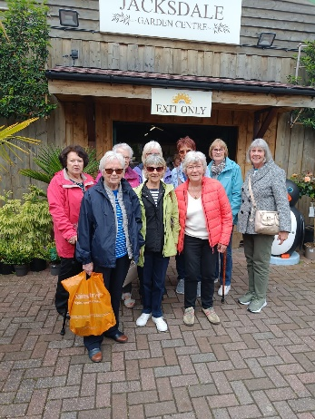
On Tuesday 11th June, nine members of the gardening group went to Felley Priory for a coffee and wander round the garden centre to buy plants. We then went to Jacksdale garden centre for lunch.
Our next trip is on Tuesday 9th July to Chatsworth Garden Centre.

Strollers
"Strollers - 26th June 2024 - Sherwood Forest

Meet at the Carrs car park at 10.00 am for car share to Sherwood Forest visitor centre car park. "

Thanks, Pat

STROLLERS TIMETABLE FOR 2024

June 26th | Sherwood Forest, our usual stroll and then those who wish to can go to the u3a picnic.


Natural History, Science and Technology.
Had an excellent talk from Jake the paramedic.
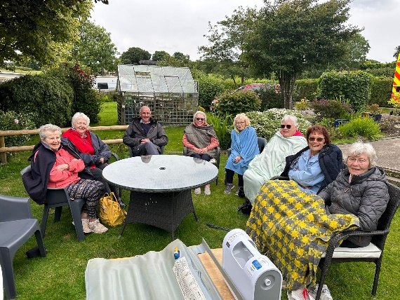
He showed us a defribulator and explained about regular and irregular heart rhythms. He also showed and explained the equipment paramedics use for resuscitation. Joyce had a go on a cushion for lifting people off the floor who cannot get up. Then we all had a look in the ambulance.
It was an informative and enjoyable 2 hours.
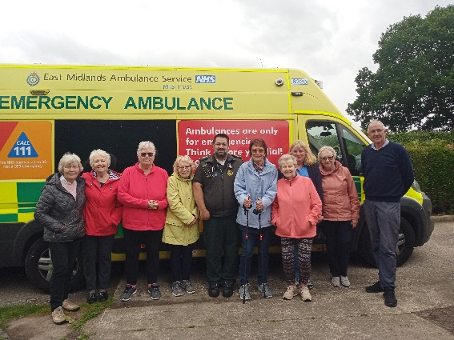

2024
Thursday 11th July | St Johns | CPR and use of DEFRIBULATOR
Thursday 8th Aug | Visit to Woollaton Hall
Thursday 12th Sept | To be decided
Thursday 10th Oct | To be decided
Thursday 14th Nov | Birds in your garden
December | No Meeting

Craft Group
The craft group meets the first Monday of the month (unless it falls on a Bank Holiday and then it is the second Monday) 10am – 12noon at THE SHED (behind the Dr’s surgery) Wood Street, Warsop. NG20 0AX.

This year’s itinerary.
5th August 2024 – Garden ornaments
2nd Sept, 7th Oct, 4th Nov - TBC
December 2024 – Christmas cards/calendars or wreaths
Zena

Photography Group

The Photography Groups ‘Face to Face’ meeting was a visit to the Spirit of Wartime
- 1940 event held at Thoresby Park on Saturday 18th May 24.

It was a warm sunny day and there were a large number of stands and activities taking place. There were characters in period dress, Military vehicles and weapons, a mock battle and a fly past by a Spitfire!

The online ‘Themed’ challenge was ‘Anything that begins with either
M or N’

Jo-Anne Wheatley = Mushrooms, Mellons & Mosques

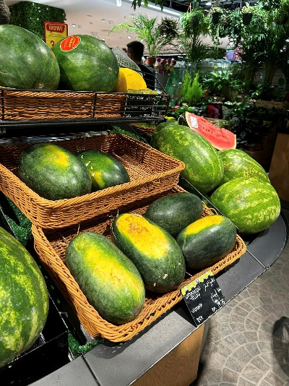

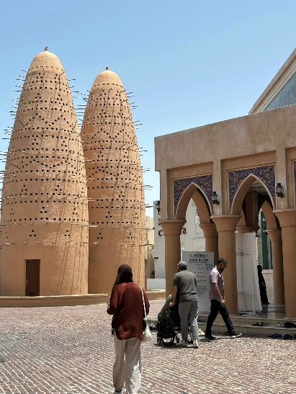
Bob Thomson = Spirit of Wartime – 1940
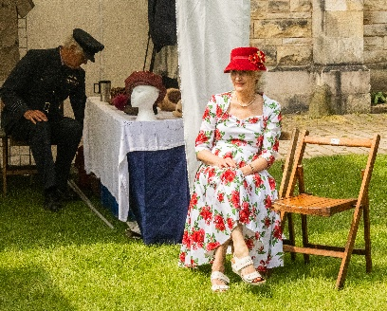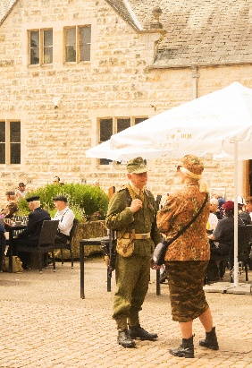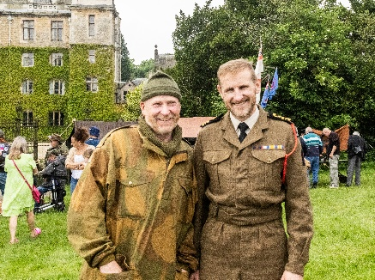
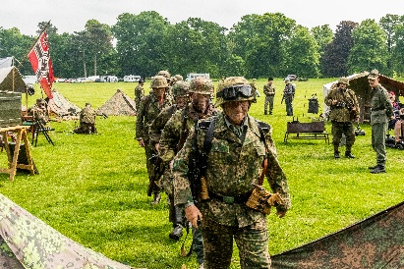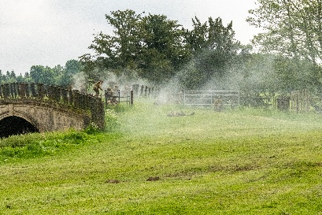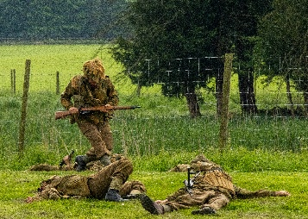

M or N = Moorhen & Chick , Night sky
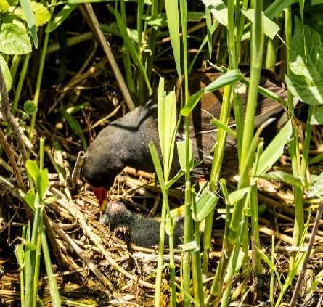
The next ‘Themed’ online challenge is ‘Anything that begins with either O or P’.
As usual this challenge is open to All u3a member!

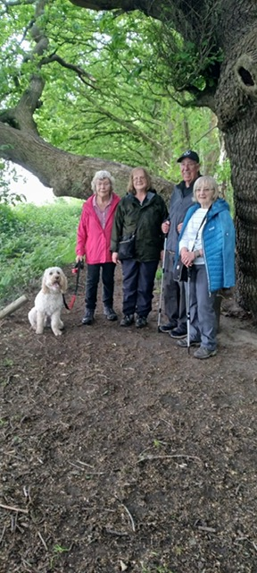
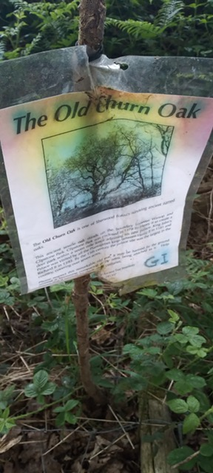
Walking Group

HERE COMES THE RAIN AGAIN. That should have been our title for the May walk. It was however listed as a Mansfield Woodhouse walk. We started from New Mill Lane and took the route along the footpath into Peafield Park we then continued through woodland to reach Churn Oak. Like the Parliament Oak, this was one of the original boundary trees of the Clipstone Park, the royal hunting park attached to King John’s Palace, enclosed in 1180. It is thought that it gets its name from Church Oak as nonconformists used it as an outside meeting place. It is another example of a very old tree regenerating itself with new trunks. We then looped back onto Peafield Lane/Park. Approximately 5 miles in total. Wet and bedraggled we all enjoyed the walk and it would be nice to do it again in fine weather. Thanks to Gerald our leader for the day. Brenda

WALKING GROUP - 3RD THURSDAY OF THE MONTH 2024
Date | Walk Leader | Walk | Distance
20th June | Val Buckinger | Clumber Lake | 4 miles
18th July | Jen Long | Gleadthorpe | 4 miles
15th August |  | TBC
19th September |  | TBC
17th October | Brenda Pearce | Ault Hucknall | 3.5 or 5 miles
21st November |  | TBC
 |  | Walks can be subject to change

History Group
At our meeting on Tuesday 21st May we welcomed Chris Weir who spoke about the history of Boots the Chemist. His talk was very well received. Chris was commissioned by Boots to research their history and produce a book which was sold in their stores some years back. Chris worked for many years at Nottingham Archives.
We look forward to seeing Chris again later in the year around Halloween when he will be speaking about Nottingham’s darker side. Tales of body snatchers and villains.
Our next meeting on Tuesday 18th June is a visit. We are going to Richard 111 Visitor Centre in Leicester.
Please may I remind those members of our group who are going on the visit that we need to be at Richard 111 Visitor Centre in Leicester for 11.30am.
Barbara &Tamar

2024 - Proposed Calendar of Events for Warsop & District U3A History Group
18th Jun | Visit to Richard 3rd Museum Leicester or Lincoln Castle and Cathedral.
16th July | Early History of Mansfield  Denis Hill | St Teresa’s Church Hall 10am
20th Aug | In house presentation  Eminent Local Sporting Personalities  Roger Holland | St Teresa’s Church Hall 10am
17th Sept | Historic Mansfield Trail  Denis Hill | Meet in Mansfield Town Square 10am
15th Oct | Nottinghamshire’s Dark Side  Chris Weir | St Teresa’s Church Hall 10am
19th Nov | Medieval Buildings & the English Civil War  James Wright TBA | St Teresa’s Church Hall 10am
17th Dec | No meeting as very close to Christmas

Speakers for the main meetings

2024

June 17th The Magic of the Guitar Martin Perry

July 15th More Funny Turns! Dave Moylan

August 19th Medieval superstitions and science. Gareth Howell

September 16th Annual General Meeting/ Silent Auction

October

November Before They Were Famous Mel Mitchell

Group | Leaders Name | Tel
NATURAL HISTORY SCIENCE AND TECHNOLOGY | Chris Shervey
WALKING GROUP | Brenda Pearce  Pam Hick
STROLLERS | Janet Harford  Pat Magness
HISTORY GROUP | Barbara Spybey
CRAFTS | Zena Inger
GARDENING | Linda Crossley
PHOTOGRAPHY | Rob Thomson
FRIENDSHIP GROUP | Betty Trinder
INTERNATIONAL DINING GROUP | Chris Wilson  Brenda Pearce
THEATRE GROUP | Jennifer Thomson
SOCIAL EVENTS ORGANISER
DISCUSSION GROUP | Mary Morris
COULD GROUP LEADERS PLEASE COLLECT THEIR BADGES WHEN COLLECTING THEIR LANYARDS. (Then members at the meeting can identify who they may need/want to talk to).

INTEREST GROUP TIMETABLE
 | MONDAY | TUESDAY | WEDNESDAY | THURSDAY | FRIDAY
1st | 10am – 12pm  CRAFTS GROUP  The Adam Eastwood Building. Warsop |  |  |  | 2pm  FRIENDSHIP GROUP  The Plough Warsop
2nd |  | 10am  GARDENING GROUP  Venue agreed by members |  | 2pm  NATURAL HISTORY  SCIENCE AND  TECHNOLOGY  Plough Warsop
3rd | MAIN MEETING 10.15  Oaklands Centre  Warsop | 10am– 12pm  HISTORY GROUP  Catholic Church Warsop |  | 10am  WALKING GROUP  Carrs Car Park | 11.am  PHOTOGRAPHY  Venue to be agreed by the members.
4th | 10.30 -12.30  DICUSSION GROUP  Forest Lodge  Edwinstowe |  | 10.am  STROLLERS  Carrs Car Park
INTERNATIONAL DINING -Location and time as announced.
THEATRE GROUP - Location and time as announced.
PHOTOGRAPHY GROUP-Please see Newsletter for the online challenge.

JUNE QUIZ Famous Williams and Henrys
1 Famous for working towards the abolition of slavery?
2 Father of Henry VIII ?
3 Famous sixteenth century playwright?
4 Swiss version of Robin Hood?
5 Famous twentieth century sculptor.
6 British boxer who fought Muhammed Ali?
7 Poet who wrote The Daffodils ?
8 Early car manufacturer?
9 School boy in books by Richmael Crompton?
10 Hollywood actor, father of Peter and Jane?
11 Victor at the Battle of Hastings?
12 Former USA Secretary of State and Nobel Peace prize winner?
13 Astronomer who discovered Uranus?
14 Childrens book character – full of mischief?
15 Advertised as worlds biggest betting organisation?
16 American author whose books include Turn of the Screw Daisy Miller ?
17 Actor who played Captain Kirk in original Star Trek TV programe?
18 Comedian and co founder of Comic Relief?
19 King and husband of Queen Mary II?
20 Actor who played the first Dr Who?
21 Youngest British Prime Minister?
22 Founder of 57 Varities?
23 Scottish hero in the film Braveheart?
24 Tennis playing sisters?
25 The uncle Queen Victoria succeeded as monarch?

June quick quiz All the answers are numbers.

1Year of the Great Fire of London?
2 Book by Jules Verne?
3 Anne Boleyn was Queen for a ------- days ?
4 Song ------ coins in a fountain?
5 British film ------- Weddings and a funeral?
6 How many times did Elizabeth Taylor marry?
7 A decahedron had how many sides?
8 There are ------ hills in Rome?
9 How many cards in a Tarot pack?
10 Western film The Magnificent ----?

June riddles
1 What has hands but cannot clap?
2 What is the longest word in the dictionary?

3 What is at the end of a rainbow?

Curious customs June

NETTLE EATING CONTEST Marsham Dorset. Around the 18th of June the challengers meet at the Bottle Inn, each are given a 2ft nettle. They have an hour to eat it and the winner is the one with the longest length of empty stalk! ! !

BAWMING THE THORN Appleton Thorn Cheshire third Saturday in June. Bawing means decorating, and the villagers decorate the hawthorn tree that stands by the church with ribbons and garlands. There is also a procession and singing of the Bawming Song.

ANSWERS May quick quiz except for one.All the answers start with K

1Name a Shakesperean play? KING LEAR
2 The Northern part of India? KASHMIR
3 Famous British poet 1795-1821? KEATS
4 Australian Outlaw 1855-80 ? NED KELLY
5 Large sea weed found in cold seas? KELP
6 Volcanic mountain in Tanzania? KILIMANJARO
7 Capital of Ukraine? KIEV
8 Austrian Composer born in Salzberg 1756-91? MOZART
9 Black civil rights leader 1929-1968? MARTIN LUTHER KING
10 Fastenings formed by looping and tying e.g. rope KNOTS

ANSWERS May quiz In which County would you find these places?
- Haworth Parsonage YORKSHIRE
- Luton Airport BEDFORDSHIRE
- Stonehenge WILTSHIRE
- Blenheim Palace OXFORDSHIRE
- National Football Museum LANCASHIRE
- Bodmin moor CORNWALL
- Eton College BERKSHIRE
- Jodrell Bank CHESHIRE
- Wookey Hole Cave SOMERSET
- Sandringham NORFOLK
- Angel of the North Co DURHAM
- Lake Windermere CUMBRIA
- Gatcombe Park GLOUCESTERSHIRE
- Alton Towers STAFFORDSHIRE
- Bamburgh Castle NORTHUMBERLAND
- Aintree race course LANCSHIRE
- Runnymede meadows SURREY
- Blackpool Tower LANCASHIRE
- Ribblehead Viaduct YORKSHIRE
- Belton House LINCOLNSHIRE
- Silverstone NORTHAMPTONSHIRE
- White Cliffs of Dover KENT
- Clifton Suspension Bridge GLOUCESTERSHIRE
- Blue John mines DERBYSHIRE
- Cerne Abbas Giant DORSET
- HMS Victory HAMPSHIRE
- The Needles ISLE OF WIGHT (Hampshire)
- Ely Cathedral CAMBRIDGESHIRE
- Chartwell House KENT
- Kinderscout DERBYSHIRE

ANSWERS May riddles

1 How do you spell cow in 13 letters? SEE O DOUBLE YOU

2 How can you drop an egg on a concrete floor without cracking it? CONCRETE FLOORS ARE HARD TO CRACK

3 Who has married many women but is not married? A VICAR

North Notts Neighbourhood Group
This means that you as a member of Warsop & District can ask to join an interest group in another U3A that is also in the NNNG, as long as the group is not oversubscribed at the time of your request you can join the group without joining the host u3a
The u3as in the NNNG are Mansfield, Sherwood, Dukeries, Rainworth, Forest Town, Ashfield, Sutton in Ashfield, Hucknall, Worksop and Warsop.

Data Protection Rules
Warsop & District U3A is committed to treating all people equally.
Anyone wishing to see the Privacy and Data Protection policies may view them on the Warsop & District U3A website, www.u3asites.org.uk/warsop, alternatively please ask Rob.

Website & Facebook
The Warsop & District u3a website can be found at the address below. If any of the group leaders/facilitators would like to advertise/ promote any of their future activities or change the information shown, please contact Bob Thomson.

Facebook
Warsop & District U3A has a Facebook Group. It is a private group which can be seen by the public but only members can see who’s in the group and what they post.
What this means is that you have to be invited to join the group or have your request to join accepted. Also you need to be on Facebook which some of you may not be. As a member of the group you will be able to put your own posts on the page, please keep them relevant to the U3A and what it stands for. We would ask that you don't put anything on that is in anyway party political or anything that may be offensive to others who may be of a different creed or religion. Hopefully everyone will join, use the page and find it useful.
One of the things that puts people ‘off’ Facebook, is the ‘bad press’ some of the Social sites get. You can join Facebook, choose only to join the Warsop Facebook page and not be involved in any other site, or Friends requests (usually from people that you have never heard of!) The choice is entirely yours.
To request to join the Warsop u3a Facebook page, contact Bob Thomson, email addresses as per the Website.

Committee Members | Role
Jim Shervey | Chairperson
Mel Mitchell | Deputy Chairperson
Irene Clay | Business Secretary
Linda Crossley | Treasurer
Carolyn Brankin | Membership Secretary
Jim Shervey | Speaker Seeker
Jennifer Thomson | Groups co-ordinator
Chris Shervey | Newsletter editor
Vacant | Social Events
Jennifer Thomson | Welfare Officer
Rob Thomson | Website & Facebook manager
Ann Ayodele | Refreshments rota /Quiz
June Whittle | Raffle
Betty Trinder | Social events assistant
Pat Magness | Co-opted member

Notice of Warsop and District Annual General Meeting (AGM)
Monday 16th September 2024 10.15am at Oaklands, Oaklands Lane,Warsop, NG20 OJE
It will soon be time for the AGM and these papers are in preparation for the event.
At the AGM the membership has to vote in the four Honorary officer posts of Chair, Vice-Chair, Treasurer and Business Secretary.
The current officers, Jim Shervey - Chair, Mel Mitchell - Vice-Chair, Irene Clay - Business secretary Linda Crossley – Treasurer
All of these positions are open for nominations and the nominating and seconding process is necessary for each office. More positions are available and nominations would be most welcome from members wishing to join the committee in a non-officer role. Which means that you would be able to take on a role or be available to help other committee members as needed, which will ultimately lessen the load on each individual.
The nomination forms are included with this document, the completed forms must be returned to June Whittle at 18 Normanton Close, Edwinstowe, Notts. NG21 9PF by the 14thAugust 2022. The votes will then be taken at the AGM.
The committee holds at least 3 meetings a year, sometimes more, usually lasting about 2 hours.
The role of the committee is to ensure that Warsop & District u3a runs as well as it can for the members. If you feel that you would like to join the committee come and talk to one of the current team.
The current positions are (there can be up to 15 committee members):
Committee Members | Role
Jim Shervey | Chairperson & Speaker Organiser
Mel Mitchell | Vice Chairperson
Irene Clay | Business Secretary
Linda Crossley | Treasurer
Carolyn Brankin | Membership Secretary
Chris Shervey | Newsletter Editor
Ann Ayodele | Refreshments & Meeters + Greeters
Jennifer Thomson | Groups co-ordinator
Betty Trinder | Social Events
June Whittle | Raffle organiser
Bob Thomson | Website and Face-book manager
Pat Magness | Committee Member
 | Social Events Organiser

NOMINATION FOR HONORARY OFFICER- Chair/Vice chair/Business secretary/Treasurer
NOMINATION FOR COMMITTEE MEMBER- Committee member or named role

Post nominated for (Choose from above)-

Name of Nominee-

Signature

Address

Telephone

Email

Name of proposer

Signature

Name of Seconder

Signature

Return to the Business Secretary - Irene Clay.

