
Issue 80 July 2024
Warsop & Distict

Notes from the Chairman
Hi
The ‘Picnic in the Forest was a good day out, fantastic weather, good entertainment and company. There are pictures in the newsletter.

The speaker this month is Dave Moylan. With a talk titled ‘More Funny Turns!’ This is a return visit after a great original talk from Dave.


Now to other matters. The AGM is only 2 months away. And there are several roles that need to be filled.
Chair, Treasurer, Speaker Seeker and Social Events Organiser (social events could be organised by more than one person working together to share the workload).

Chair and Treasurer are roles that must be filled for Warsop u3a to operate.

If you feel you may be able to help out with any of the roles have a chat with any committee member to see what goes on behind the scenes.
u3a
Don’t forget to book your place/ticket for the upcoming BBQ and 4B’s events. Details are in the newsletter.

Jim Shervey
Chair

The deadline for including articles/information in the next newsletter is Friday 9th August Send contributions to Chris Shervey.

Rota for refreshments and greeting.
This is the rota for the next five months, any problems please contact me, Ann Ayodele.
Thank you to all those who have volunteered to help, without you our meetings would not be enjoyable.

Date | Refreshments 1 | Refreshments 2 | Meet and Greet 1 | Meet and Greet 2
15th July | Ann Barnes | Gillian Allsop | Gill Greer | Ann Holland
19th Aug | Karen Breed | Beatrix Kirby | Raymond White | Janice Richardson
16th Sept | Janice Thorlby | Janet Harford | Chris Wilson | Brenda Pearce
21st Oct | Yvonne Pannifer | Zena Inger | Moira Heslop | Ann Poultney

Those on the rota please be there around 9.30am.

ITEMS OF INTEREST
Two members of the Theatre Group were planning to see "Hairspray" at The Theatre Royal, Nottingham, on Saturday 9th November. Matinee performance. One has had to drop out, would anyone like to buy her ticket? Please see me or Irene Clay at the next monthly meeting. Thanks, Jen.

Silent Auction We are planning to hold a Silent Auction alongside the AGM in Sept. I will be collecting items for the auction at the July and Aug main meetings. Chris

Bar- b -que To be held on the 3rd Aug at Oakroyd Forest Rd at 12 o clock, food served at 1 o clock. u3a members are free plus ones are £5. Tickets available at the main meetings or contact Jen.
MENU- Burgers Sausage Chicken Cobs
Salads Coleslaw
Half Jacket Potato New Potatoes
Fruit salad and ice cream
Tea and Coffee
You may bring other drinks if you wish to.
IF YOU HAVE ANY SPECIAL DIETRY NEEDS PLEASE LET US KNOW.
If you have suitable chair, bring it with you in case we have a shortage.

THE 4 ‘B’ s AFTERNOON
For your entertainment we are organising a social afternoon which involves BALLADS, BUTTIES, BAKES & BEETLE/BEATLES.

Date: Saturday 7th September 2024
Venue: The Oaklands
Time: 14.00 - 16.30 (Doors open at 13.45)
Cost: £6 per head (on this occasion you are allowed to bring a guest)

Tea and coffee will be served with the buffet (please bring your own mug).
If you prefer something else e.g. Prosecco, wine, beer you are quite welcome to bring it along.

We have booked local celebrity Oliver Ward who covers a wide variety songs

Bookings are being taken at the July and August meetings.

Regards
Brenda & Chris

Picnic in the Forest
Despite a poor turn out from Warsop u3a the picnic was a success and enjoyed by all who attended. The weather was great, maybe too hot for some but it was pleasant under the gazebos and trees.
We were entertained by a steel band, ukeleles guitars and a choir from Southwell. There were various activities to take part in, including badminton and rounders for the more energetic.
Jim won the wellie wanging with a very impressive throw that nearly went in the trees!
Well done NNNG, on an enjoyable event.

Picnic in the Forest pictures
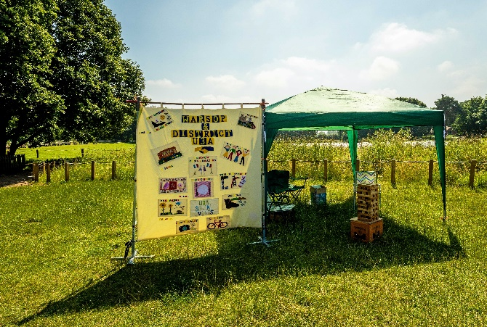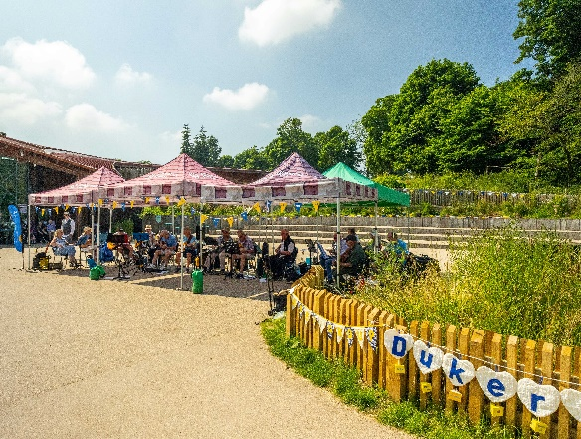

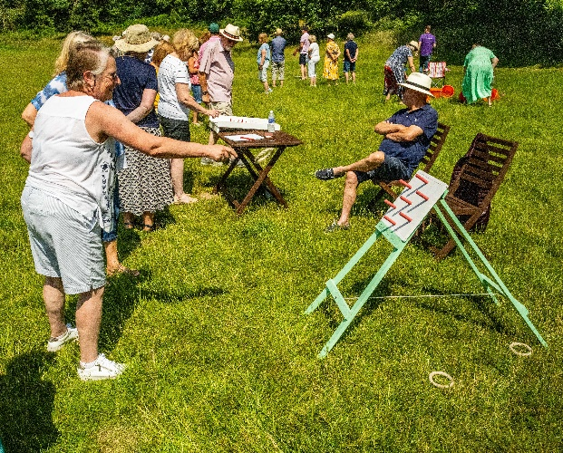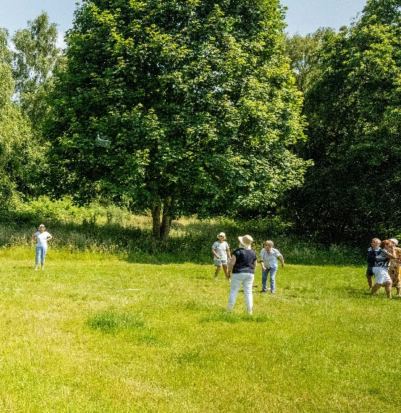
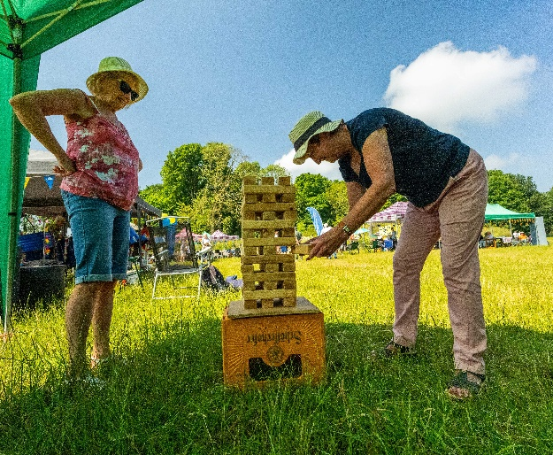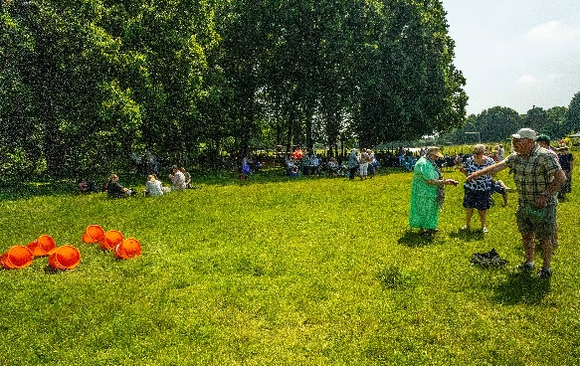
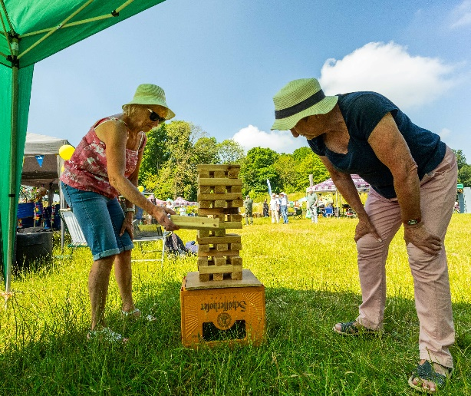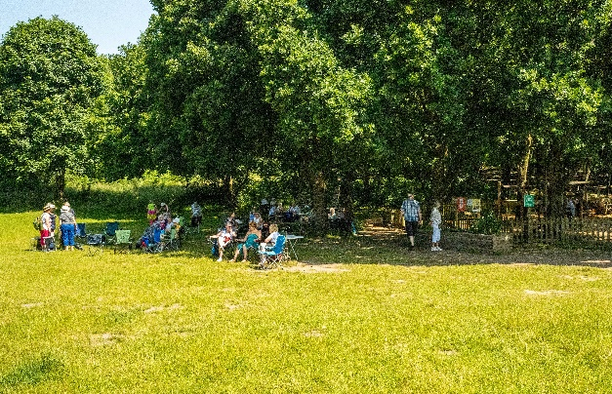
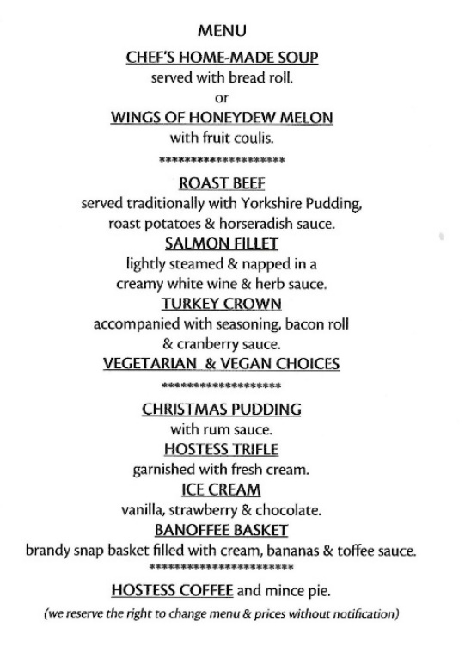

Christmas Lunch
I have made a provisional booking for 20 u3a members at The Hostess on Friday 20th December. 11.45am for 12.00.
The cost for Senior Citizens is £20 and I shall collect a deposit of £5 from anyone wishing to go at our meeting on 15th July.
Menu attached.



Cups Please will as many of you as
possible bring your own mug for your tea or coffee. This is not only more environmentally friendly but also would save us a lot of money as the paper disposable cups we use are surprisingly expensive. Ann.
Robin Hood Lottery 
Warsop and District U3A is a cause registered with the Robin Hood Lottery.
To buy a ticket you can now register on line at www.robinhoodlottery.co.uk and set up regular payments. If you buy a ticket every week for a year Warsop U3A will receive £26.
Remember the more members that have a go (specifying Warsop & District U3A) the more money we get for our funds.

Raffle. The June Raffle raised £42
RAFFLE PRIZES NEEDED .

Books and Jigsaws 50p. We made £6.50 at the Junel meeting. The books are sorted into genres making it easier to find a book you like.

Group News
Interest Groups
Sorry the folders weren't available for the June meeting, I was at the GP 's surgery! They will be there this month so take a look and see what the groups are up to!

Can I remind members to take a look at the NNNG folder to see if there are groups running in neighbouring u3as which they would like to join.
There are instructions at the front of the folder about how to contact the group leaders.

For your information the COFFEE LOFT on the High Street will let you use their upstairs room for free as long as you buy a coffee. Talking of Coffee, some members have suggested it may be nice to have a group that meets up for coffee/tea/cake and a chat. If you are interested in this idea, please see Jen at the main meeting.

The Friendship Group
The Friendship Group met on Friday, 5th July. I am pleased to say that 9 members were present and I think everyone had a very enjoyable afternoon. The next meeting will be on Friday, 2nd August, 2.00 p.m. at The Plough.

Betty

Theatre Group
The production of Oklahoma which we were going to see this month has been cancelled.
By the time this newsletter reaches everyone the group will have met to decide our next outing and refunds for Oklahoma will have been issued.

Welfare
Don't forget to let me know if any members are ill or suffer a bereavement, so that I may send get well wishes or condolences on behalf of us all .
I have, sadly, sent a couple of messages of condolence since our last meeting.
Jen

International Dining
For our next outing we are going to an Indian restaurant in Mansfield

Venue: The Chand, 8 Toothill Rd, Mansfield NG18 1NW
Time: 6.45pm for 7.00pm
Date: 16th July 2024 (Tuesday)

Note: There is a council car park opposite the venue at a cost of £3 after 6.30pm.

We will be taking bookings at the June meeting together with a £5 deposit (non refundable)

Chris & Brenda

Discussion Group
The discussion group will run as usual at 10.30 0n the 4th Monday of the month, Forest Lodge Edwinstowe.

Bridge Club
The Dukeries u3a Bridge Group meet on the Second and Fourth Tuesday of each month at the Jubilee Hall (NG22 9AP) from 1 – 4PM. The cost of each session is currently £3.
All U3a members are welcome to attend.

Silver Screeners

Savoy cinema Worksop. For the over 50’s. Every Wednesday at 11.30. Tickets £5.00, include a drink and free raffle.

Wednesday 17th July

Before Dawn (15)
Based on real life war diaries, Before Dawn is an epic retelling of one of Australia’s biggest military victories during World War I. Jim Collins (Levi Miller), a young man from the outback, leaves his family-run sheep station to join the soldiers on the western front with hopes of making a difference. But soon, the realities of the muddy, ruthless, and entirely unforgiving war take their toll on a guilt-ridden Jim.

As the men in the battalion are whittled away and hope becomes a distant memory, a final chance at redemption arises amid one of Australia’s greatest battles. Jim must risk death, or forever carry the burden of leaving yet another man behind.

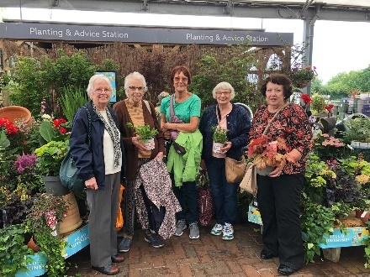
Garden Group
As the weather was so bad we decided not to go to Chatsworth and went to Dobbies instead. As you can see a some of us bought a few plants, some of them reduced of course. We also indulged in retail therapy at Cotton Traders, Leading Labels and Hotters. We had a nice lunch and a good time was had by all. Anne

Strollers
Strollers - Wednesday 24th July 2024 Meet 10.00 am at Carrs car park. Walk to be arranged. A short meeting of the Group will be held after the speaker at the next monthly meeting to discuss walks for the rest of the year.
Thanks, Pat

Natural History, Science and Technology.
The title this month was Do you know your Tibia from your Fibula?
It was part quiz and part talk. Quiz --- Everyone had a picture of a skeleton to mark on the positions of the bones. Talk – where the bones are located and the function of the bones. The person who placed the most bones correctly was Joyce who won the prize of a chocolate orange!

2024
Thursday 8th Aug | Visit to Woollaton Hall
Thursday 12th Sept | To be decided
Thursday 10th Oct | What is it? | From Mansfield Museum £2,50 per person
Thursday 14th Nov | Birds in your garden
December | No Meeting

Craft Group

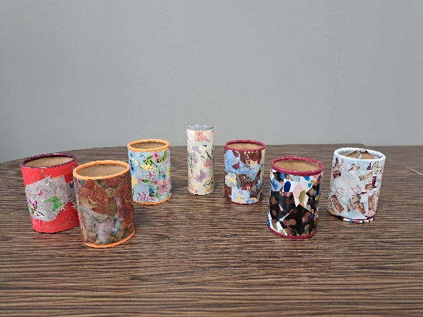
This month we made decoupage pen pots. We recycled used cardboard pots from gravy and sweets and cut up old wrapping paper which we stuck with PVA glue. Once we had finished we had a cuppa and biscuits and a good old natter.
Going forward, September, October and November still need to be sorted but there will be more information in the next newsletter.
December we will be making Christmas cards/calendars.
If you would like to join us the only thing you need to bring is a basic sewing kit and a willingness to have a go at anything. All materials are available for a very small donation to the person who brings them, if anything more specialised is required you will be given the opportunity to purchase any item needed yourself, or you can borrow from other group members.
The craft group meets the first Monday of the month 10am – 12noon at THE SHED (behind the Dr’s surgery) Wood Street, Warsop. NG20 0AX.
The next meeting is on Monday 5th August when we’ll be making suncatchers.
Zena

This year’s itinerary.
5th August 2024 – Suncatchers
2nd Sept, 7th Oct, 4th Nov - TBC
December 2024 – Christmas cards/calendars or wreaths
Zena

Photography Group
Warsop & District u3a Photography Group – July 24 update
The Photography group did not meet ‘Face to Face’ in June 24, due to various reasons, but the online ‘Themed’ challenge continued.
The ‘Themed’ challenge was ‘Anything that begins with either O or P’
Thanks to Jim & Chris Shervey, once again for their contributions!
Joanne Wheatley - P = Playing Cards, Pen, Puma
O = Oranges
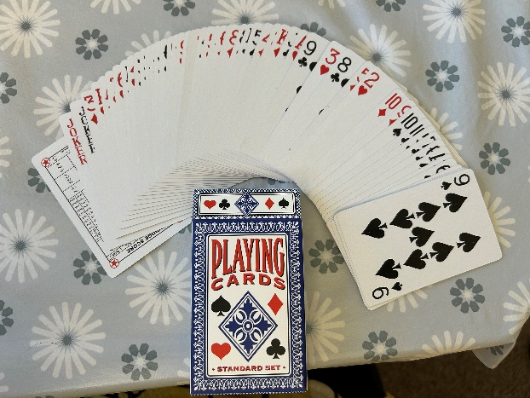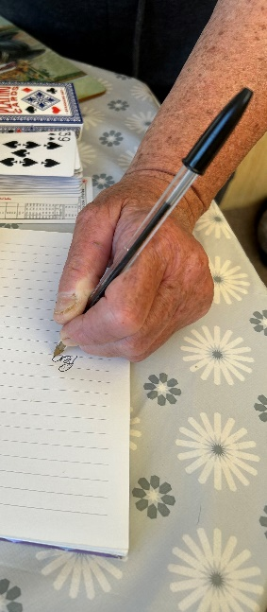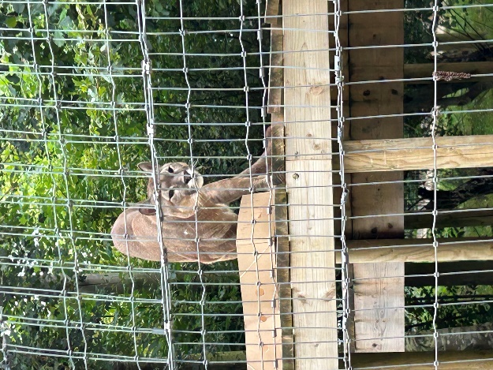

Jim & Chris Shervey – P = Puzzle the Piebald pony
O = Orange Rose
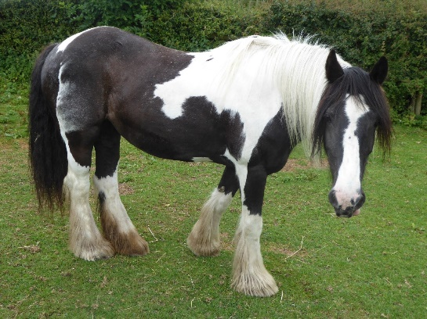
Bob Thomson – P = Piper, Pelargonium
O = Organ, Otter
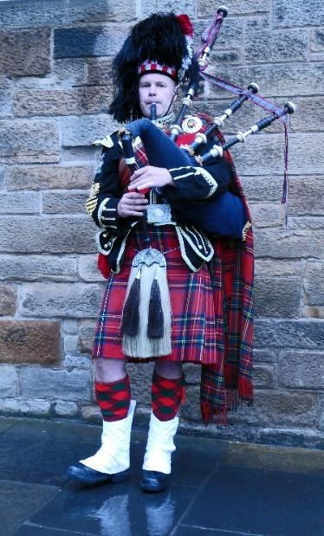
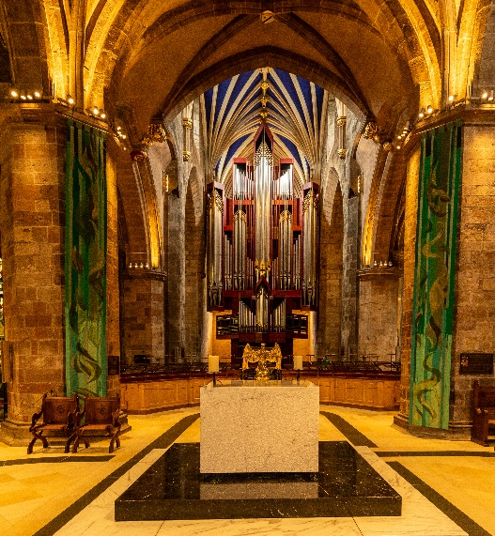
The next online ‘Themed’ challenge is ‘ Anything that begins with either Q or R’.
As usual these challenges are open to ALL u3a members to take part in!

Walking Group
Here comes the sun at last. After the past few walks it made a pleasant change to walk in dry weather. As always we weren’t disappointed with the Clumber Park walk. Taking the route around the lake and a little detour, we took in the beautiful views and sat chatting half way round. We were even given a rendition of ‘I saw a mouse’ in Dutch by Sonja. At the end of the walk we went to view the walled garden. Thanks to Val for a very pleasant walk.
Brenda
WALKING GROUP - 3RD THURSDAY OF THE MONTH 2024
Date | Walk Leader | Walk | Distance
18th July | Jen Long | Gleadthorpe | 4 miles
15th August |  | TBC
19th September |  | TBC
17th October | Brenda Pearce | Ault Hucknall | 3.5 or 5 miles
21st November |  | TBC
 |  | Walks can be subject to change

History Group
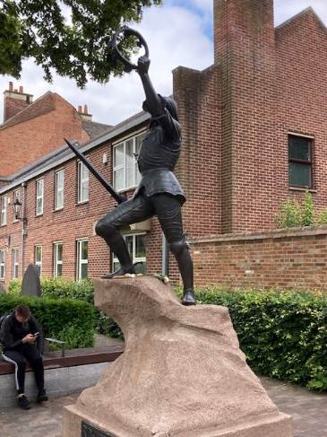
At our June meeting 19 of the group visited the Richard III Visitor Centre in Leicester – site of the Friary, and later a car park, where in 2012 Philippa Langley and a team of archaeologists unearthed the remains of Richard III, last Plantagenet king and the last king to die on the battlefield.
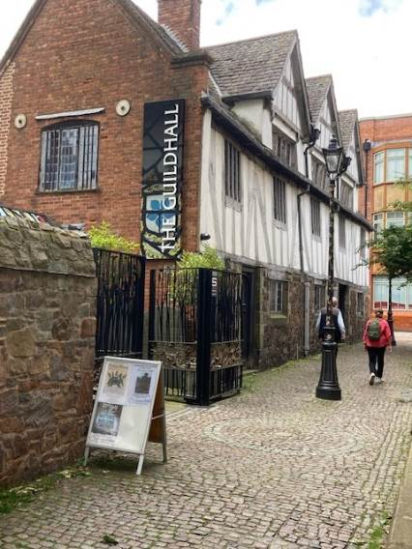
Following a tour of the centre which related the events of the Wars of the Roses in the C15th culminating in Richard III’s death at Bosworth Field and his body being brought back to Leicester, alongside interactive displays which explained how the science used DNA analysis to confirm the remains were those of Richard III and how facial reconstruction was carried out, we visited the cathedral where his remains now lay. A series of stained-glass windows in the cathedral tell his story.
We also had the opportunity to visit Leicester Guildhall, a beautifully maintained Tudor building. Exhibits within the building included a history of Leicester’s trades and a history of the city’s crime and punishment. Some members undertook a self-guided walk of mediaeval Leicester.
An enjoyable day out and the weather was kind to us!
Our next meeting is on Tuesday 16th July, 10am at St Teresa’s Church Hall, Warsop when we will be joined by Denis Hill who will be speaking about the early history of Mansfield. We hope to see you there.
Barbara & Tamar

2024 - Proposed Calendar of Events for Warsop & District U3A History Group
16th July | Early History of Mansfield  Denis Hill | St Teresa’s Church Hall 10am
20th Aug | In house presentation  Eminent Local Sporting Personalities  Roger Holland | St Teresa’s Church Hall 10am
17th Sept | Historic Mansfield Trail  Denis Hill | Meet in Mansfield Town Square 10am
15th Oct | Nottinghamshire’s Dark Side  Chris Weir | St Teresa’s Church Hall 10am
19th Nov | Medieval Buildings & the English Civil War  James Wright TBA | St Teresa’s Church Hall 10am
17th Dec | No meeting as very close to Christmas

Speakers for the main meetings
2024

July 15th More Funny Turns! Dave Moylan

August 19th Medieval superstitions and science. Gareth Howell

September 16th Annual General Meeting/ Silent Auction

October How to avoid Fraud Richard Kubon
Police Fraud Protection Officer

November Before They Were Famous Mel Mitchell

Group | Leaders Name | Tel
NATURAL HISTORY SCIENCE AND TECHNOLOGY | Chris Shervey
WALKING GROUP | Brenda Pearce  Pam Hick
STROLLERS | Janet Harford  Pat Magness
HISTORY GROUP | Barbara Spybey
CRAFTS | Zena Inger
GARDENING | Linda Crossley
PHOTOGRAPHY | Rob Thomson
FRIENDSHIP GROUP | Betty Trinder
INTERNATIONAL DINING GROUP | Chris Wilson  Brenda Pearce
THEATRE GROUP | Jennifer Thomson
SOCIAL EVENTS ORGANISER
DISCUSSION GROUP | Mary Morris
COULD GROUP LEADERS PLEASE COLLECT THEIR BADGES WHEN COLLECTING THEIR LANYARDS. (Then members at the meeting can identify who they may need/want to talk to).

INTEREST GROUP TIMETABLE
 | MONDAY | TUESDAY | WEDNESDAY | THURSDAY | FRIDAY
1st | 10am – 12pm  CRAFTS GROUP  The Adam Eastwood Building. Warsop |  |  |  | 2pm  FRIENDSHIP GROUP  The Plough Warsop
2nd |  | 10am  GARDENING GROUP  Venue agreed by members |  | 2pm  NATURAL HISTORY  SCIENCE AND  TECHNOLOGY  Plough Warsop
3rd | MAIN MEETING 10.15  Oaklands Centre  Warsop | 10am– 12pm  HISTORY GROUP  Catholic Church Warsop |  | 10am  WALKING GROUP  Carrs Car Park | 11.am  PHOTOGRAPHY  Venue to be agreed by the members.
4th | 10.30 -12.30  DICUSSION GROUP  Forest Lodge  Edwinstowe |  | 10.am  STROLLERS  Carrs Car Park
INTERNATIONAL DINING -Location and time as announced.
THEATRE GROUP - Location and time as announced.
PHOTOGRAPHY GROUP-Please see Newsletter for the online challenge.

July quiz Scrambled Flowers, unscramble the letters to find the name of a flower.

1 YASDI
2 EORS
3 MSPTNONEE
4 LAGIQUAA
5 OKCSTS
6 YPPOP
7 PLNIU
8 MNARUGEI
9 SRII
10 TREPBTUCU
11 LHYHOKLOC
12 SOTAH
13 LAMUPIR
14 GEBANOI
15 TIAPUNE
16 RETSA
17 FUNWOSLER
18 VALIAS
19 LEZAAA
20 NOYPE

JULY QUICK QUIZ All answers begin with L except for one.
1 Which is the correct spelling of Lavender or Lavendar?
2 Which is the second largest city in Pakistan?
3 Which female scientist discovered Radium?
4 The sudden downward movement of rock or earth is called a ?
5 Fore runner of the United Nations?
6 Largest city in Yorkshire?
7 England’s first garden city in 1903?
8 The river that flows through Dublin?
9 A common sedimentary rock?
10 Island of the coast of Northumberland?

July riddles

1 What kind of tree can you carry in your hand?

2 What 2 things can’t you eat for breakfast?

3 I am orange, wear a green hat and sound like a parrot, what amI?

Answers JUNE QUIZ Famous Williams and Henrys
1 Famous for working towards the abolition of slavery? WILLIAM WILBERFORCE
2 Father of Henry VIII ? HENRY V11
3 Famous sixteenth century playwright? WILLIAM SHAKESPERE
4 Swiss version of Robin Hood? WILLIAM TELL
5 Famous twentieth century sculptor. HENRY MOORE
6 British boxer who fought Muhammed Ali? HENRY COOPER
7 Poet who wrote The Daffodils ? WILLIAM WRDSWORTH
8 Early car manufacturer? HENRY FORD
9 School boy in books by Richmael Crompton? JUST WILLIAM
10 Hollywood actor, father of Peter and Jane? HENRY FONDA
11 Victor at the Battle of Hastings? WILLIAM 1
12 Former USA Secretary of State and Nobel Peace prize winner? HENRY KISSENGER
13 Astronomer who discovered Uranus? WILLIAM HERSCHEL
14 Childrens book character – full of mischief? HORRID HENRY
15 Advertised as worlds biggest betting organisation? WILLIAM HILL
16 American author whose books include Turn of the Screw Daisy Miller ? HENRY JAMES
17 Actor who played Captain Kirk in original Star Trek TV programe? WILLIAM SHATNER
18 Comedian and co founder of Comic Relief? LENNY HENRY
19 King and husband of Queen Mary II? WILLIAM III
20 Actor who played the first Dr Who? WILLIAM HARTNELL
21 Youngest British Prime Minister? WILLIAM PITT
22 Founder of 57 Varities? HENRY HEINZ
23 Scottish hero in the film Braveheart? WILLIAM WALLACE
24 Tennis playing sisters? SERENA & VANESSA WILLIAMS
25 The uncle Queen Victoria succeeded as monarch? WILLIAM IV

ANSWERS June quick quiz All the answers are numbers.

1Year of the Great Fire of London? 1666
2 Book by Jules Verne? 20,000 LEAGUES UNDER THE SEA
3 Anne Boleyn was Queen for a 1000 days ?
4 Song 3 coins in a fountain?
5 British film 4 Weddings and a funeral?
6 How many times did Elizabeth Taylor marry? 8
7 A decahedron had how many sides? 10
8 There are 7 hills in Rome?
9 How many cards in a Tarot pack? 78
10 Western film The Magnificent 7 ?

Answers June riddles
1 What has hands but cannot clap? A CLOCK

2 What is the longest word in the dictionary? SMILES Because there is a mile between the s’s

3 What is at the end of a rainbow? Letter w

This means that you as a member of Warsop & District can ask to join an interest group in another U3A that is also in the NNNG, as long as the group is not oversubscribed at the time of your request you can join the group without joining the host u3a
The u3as in the NNNG are Mansfield, Sherwood, Dukeries, Rainworth, Forest Town, Ashfield, Sutton in Ashfield, Hucknall, Worksop and Warsop.

Data Protection Rules
Warsop & District U3A is committed to treating all people equally.
Anyone wishing to see the Privacy and Data Protection policies may view them on the Warsop & District U3A website, www.u3asites.org.uk/warsop,alternatively please ask Rob.

Website & Facebook
The Warsop & District u3a website can be found at the address below. If any of the group leaders/facilitators would like to advertise/ promote any of their future activities or change the information shown, please contact Bob Thomson.

www.u3asites.org.uk/warsop

Facebook
Warsop & District U3A has a Facebook Group. It is a private group which can be seen by the public but only members can see who’s in the group and what they post.
What this means is that you have to be invited to join the group or have your request to join accepted. Also you need to be on Facebook which some of you may not be. As a member of the group you will be able to put your own posts on the page, please keep them relevant to the U3A and what it stands for. We would ask that you don't put anything on that is in anyway party political or anything that may be offensive to others who may be of a different creed or religion. Hopefully everyone will join, use the page and find it useful.
One of the things that puts people ‘off’ Facebook, is the ‘bad press’ some of the Social sites get. You can join Facebook, choose only to join the Warsop Facebook page and not be involved in any other site, or Friends requests (usually from people that you have never heard of!) The choice is entirely yours.
To request to join the Warsop u3a Facebook page, contact Bob Thomson, email addresses as per the Website.

Committee Members | Role
Jim Shervey | Chairperson
Mel Mitchell | Deputy Chairperson
Irene Clay | Business Secretary
Linda Crossley | Treasurer
Carolyn Brankin | Membership Secretary
Jim Shervey | Speaker Seeker
Jennifer Thomson | Groups co-ordinator
Chris Shervey | Newsletter editor
Vacant | Social Events
Jennifer Thomson | Welfare Officer
Rob Thomson | Website & Facebook manager
Ann Ayodele | Refreshments rota /Quiz
June Whittle | Raffle
Betty Trinder | Social events assistant
Pat Magness | Co-opted member

Notice of Warsop and District Annual General Meeting (AGM)
Monday 16th September 2024 10.15am at Oaklands, Oaklands Lane,Warsop, NG20 OJE
It will soon be time for the AGM and these papers are in preparation for the event.
At the AGM the membership has to vote in the four Honorary officer posts of Chair, Vice-Chair, Treasurer and Business Secretary.
The current officers, Jim Shervey - Chair, Mel Mitchell - Vice-Chair, Irene Clay - Business secretary Linda Crossley – Treasurer
All of these positions are open for nominations and the nominating and seconding process is necessary for each office. More positions are available and nominations would be most welcome from members wishing to join the committee in a non-officer role. Which means that you would be able to take on a role or be available to help other committee members as needed, which will ultimately lessen the load on each individual.
The nomination forms are included with this document, the completed forms must be returned to - Irene Clay. By the 14thAugust 2024. The votes will then be taken at the AGM.
The committee holds at least 3 meetings a year, sometimes more, usually lasting about 2 hours.
The role of the committee is to ensure that Warsop & District u3a runs as well as it can for the members. If you feel that you would like to join the committee come and talk to one of the current team.
The current positions are (there can be up to 15 committee members):

Committee Members | Role
Jim Shervey | Chairperson & Speaker Organiser
Mel Mitchell | Vice Chairperson
Irene Clay | Business Secretary
Linda Crossley | Treasurer
Carolyn Brankin | Membership Secretary
Chris Shervey | Newsletter Editor
Ann Ayodele | Refreshments & Meeters + Greeters
Jennifer Thomson | Groups co-ordinator
Betty Trinder | Social Events
June Whittle | Raffle organiser
Bob Thomson | Website and Face-book manager
Pat Magness | Committee Member
 | Social Events Organiser

NOMINATION FOR HONORARY OFFICER- Chair/Vice chair/Business secretary/Treasurer
NOMINATION FOR COMMITTEE MEMBER- Committee member or named role

Post nominated for (Choose from above)-

Name of Nominee-

Signature

Address

Telephone

Email

Name of proposer

Signature

Name of Seconder

Signature

Return to the Business Secretary - Irene Clay.

