
Issue 72 November 2023
Warsop & Distict
Notes from the Chairman
Hi
Welcome to the November newsletter. The speaker last month was good with his magic tricks, stories and jokes (even if they were a little risky in their content), he is booked for another visit next summer. The speaker this month is Ian Morgan with a talk titled ‘Inspector Hopkinsons Discovery’.

The new discussion group is working well and still has space for members to join it. The recently restarted Science, Natural History and Technology group goes from strength to strength as well with 15 members present, more are welcome. As you read the newsletter you will see that more groups are publishing what they are planning to do at their meetings for the months ahead.

Next month is our Christmas party meeting, food will be provided, sandwiches, savouries and cake (can’t wait) so put it in your diary and don’t miss it. It is planned that there will be craft items on sale as well.

A request for help. Is there anyone out there with any skills/knowledge in the art of poster design, we really need posters to promote our u3a. Let anyone on the committee know if you are willing to help.

Jim Shervey
Chair

The deadline for including articles/information in the next newsletter is Friday 8th Dec Send contributions to Chris Shervey.

Rota for refreshments and greeting.
Please be there around 9.30am, any problems please let me know, thanks Ann.

November 20th
Refreshments – Angelina Taylor, Julia Easom
Meet & Greet – Glenys Fearn, Ruth Murphy
December 18th
Refreshments – Ann Ayodele, Maureen Long
Meet & Greet – Kate Guest, Jean Hayes
January 15th
Refreshments – Ann Holland, Please Someone Volunteer
Meet & Greet – Yvonne Brown, Ann Barnes
February 19th
Refreshments – Karen Breed, Pat Scattergood
Meet & Greet – Ray White, Sandra Bradley
March 18th
Refreshments – Janice Thorlby, Anne Poultney
Meet & Greet – Brenda Pearce, Chris Wilson

ITEMS OF INTEREST
Murder! Mystery!
“NOT SO CIVIL WAR”
The Olde Barn Hotel, Toll Bar Road,
Marston, Lincolnshire, NG32 2HT
Sunday 17 March to Monday 18 March 2024
Fancy yourself as Miss Marple or Hercule Poirot?
Then come and join in the fun!
The details are:-
Arrive any time after 3pm on Sunday 17 March. Check-in and access your bedrooms.
Relax in the hotel, bring games to play, use the swimming pool, steam room, jacuzzi, sauna
(Beauty treatments may be pre-booked, additional cost).
Dress Code Smart. Sparkle if you want!
6.45pm Assemble for group photo. Buy your own pre dinner drinks.
Take your seats by 7.15pm.
7.30pm Start of the mysterious happenings.
8.00pm Service begins for 3 Course Meal.
After the murder has been solved there will be music to dance to until midnight!
On Monday morning, have a leisurely breakfast (hot and cold buffet from 7am to 10am) and check out before 11am
The price for the above is £119 for two people sharing in a double or twin room, single rooms £99 for one person.
To secure your place on this event, telephone the hotel on 01400 250909, reservations. Tell them the name of your u3a. Please tell the receptionist if you require specific room requirements or dietary needs.
Payment in full is required. In the event that you are unable to attend, you need to give 48 hours notice and you can transfer your bookings to another event on another date. No refunds are given.

Robin Hood Lottery 
Warsop and District U3A is a cause registered with the Robin Hood Lottery.
To buy a ticket you can now register on line at www.robinhoodlottery.co.uk and set up regular payments. If you buy a ticket every week for a year Warsop U3A will receive £26.
Remember the more members that have a go (specifying Warsop & District U3A) the more money we get for our funds.

Raffle. The October Raffle raised £61. RAFFLE PRIZES NEEDED PLEASE ESPECIALLY ONES SUITABLE FOR MEN.

Cups Please will as many of you as
possible bring your own mug for your tea or coffee. This is not only more environmentally friendly but also would save us a lot of money as the paper disposable cups we use are surprisingly expensive. Ann.

Craft Fair
As at the Christmas party last year we are hoping to have craft items on sale. If there is anyone who has any craft items you wish to sell at the Christmas party let Chris know you are taking part, they don’t have to necessarily be Christmas crafts. All income is yours.

Books and Jigsaws 50p. We made £11 at the October meeting .(The books are sorted into genres e.g. Crime Non- Fiction Historical etc so it is easier to find a book you like).

Group News

Theatre Group 
This Photo by Unknown Author is licensed under CC BY-NC-ND
The group will be holding its first meeting of 2024 on Friday 2nd February at 2pm in The Plough. This will be to decide which shows we'd like to see in the Spring. One possibility to be discussed will be an overnight stay in London taking in two West End Shows.
New members are very welcome to join us, especially car drivers, as transport to different venues can sometimes be a little problematic!

Welfare
Condolences have been sent to one of our members who has recently been bereaved.
Please remember to let me know of any members in a similar situation, or who have had to miss at least two consecutive monthly meetings due to illness. This is so that I can let them know that their u3a friends are thinking of them.
Thank you, Jen.

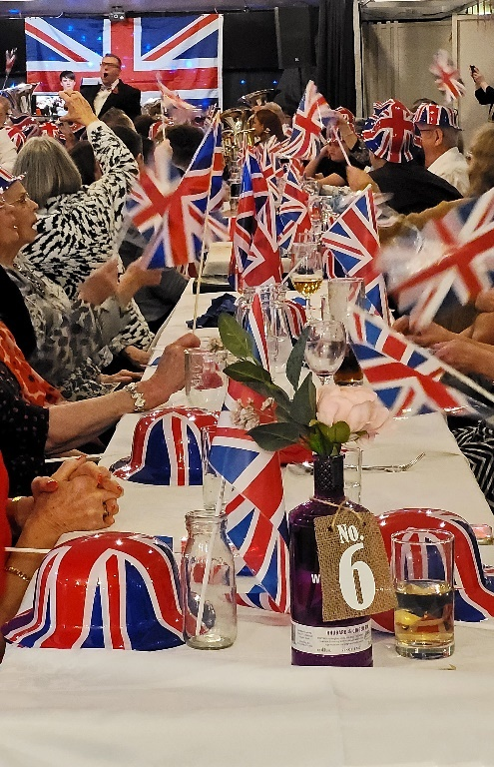
Social Events
Our next Quiz night will be on Thursday 30th November, at the Plough, arriving for 7.00pm, to eat at 7.15. The choice of food is as before, pie and peas or baked potato and toppings. Tickets are £6.00 and I will be selling them again at our November meeting on 20th November. Thank you to all those who have already signed up and paid, it looks as though we will have a good turn out. After previous comments we are endeavouring to make the questions more easily answerable (but not too easy!).
Ann Ayodele.

Fifteen members enjoyed an entertaining evening at the Hostess on the 11th November at ‘The Last Night of the Proms’, good food and a brass band to entertain us, along with lots of flag waving and singing.
The Friendship Group 
Five members of the Friendship Group met on the 3rd November and enjoyed an afternoon playing dominoes and the card game Uno. The next meeting will be on Friday, 1st December at The Plough from 2-4p.m.
Betty


International Dining
The next evening excursion for the International Dining group will probably be in the new year.

Silver Screeners

Savoy cinema Worksop. For the over 50’s. Every Wednesday at 11.30. Tickets £4.50, include a drink and free raffle.

Dream Scenario 
Hapless family man Paul Matthews (Nicolas Cage) finds his life turned upside down when millions of strangers suddenly start seeing him in their dreams. But when his nighttime appearances take a nightmarish turn, Paul is forced to navigate his newfound stardom, in this wickedly entertaining comedy from writer-director Kristoffer Borgli (Sick of Myself) and producer Ari Aster.


Walking Group
Due to the uncertain weather it was decided that the walk be cancelled in October. We will endeavour to do the Gleadthorpe walk in 2024.
Our last walk of the year is around Norton/ Cuckney. Thursday 16th November leaving The Carrs at 10.00. a.m. prompt
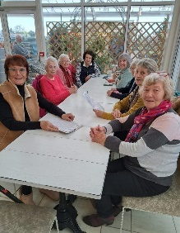
Garden Group 
This month nine members of the Garden Group had a trip out to Blue Diamond garden centre at East Bridgeford. The weather was quite nice and all the Christmas goodies were on display. We had a lovely lunch as usual.
Discussion Group 
This Photo by Unknown Author is licensed under CC BY-SA
The next meeting of the discussion group is at the forest Lodge Edwinstowe,10.30 till 12.30.monday November 23rd. we still have a few spare places. so come along and see what we're all about.

Regards Mary Morris

Bridge Club
The Dukeries u3a Bridge Group meet on the Second and Fourth Tuesday of each month at the Jubilee Hall (NG22 9AP) from 1 – 4PM. The cost of each session is currently £3.
All U3a members are welcome to attend.

Photography Group
The Warsop & District u3a Photography Group did not have a ‘Face to Face’ meeting this month due to Storm Babet and other unfavourable weather conditions!
The online ‘Themed’ challenge did continue however, with this months challenge being ‘Sunrise / Sunset’ or ‘Faces in Strange places’.
Joanne Wheatley – Sunset / Faces in Strange Places.

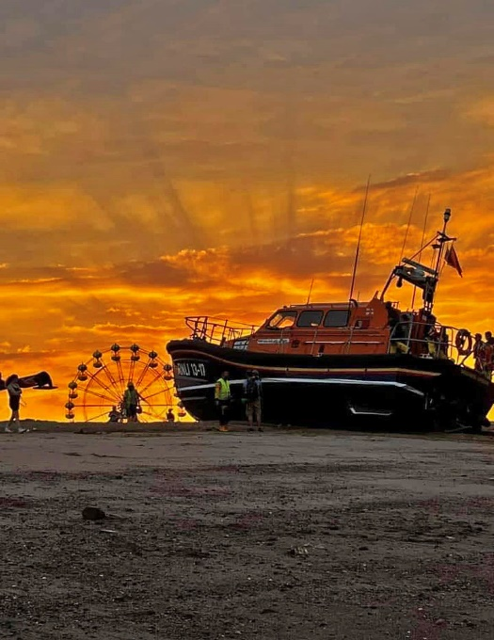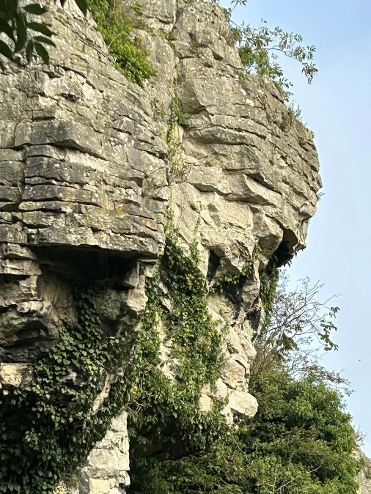

Chris & Jim Shervey – Sunset over a Golf course / A Face in a strange place.

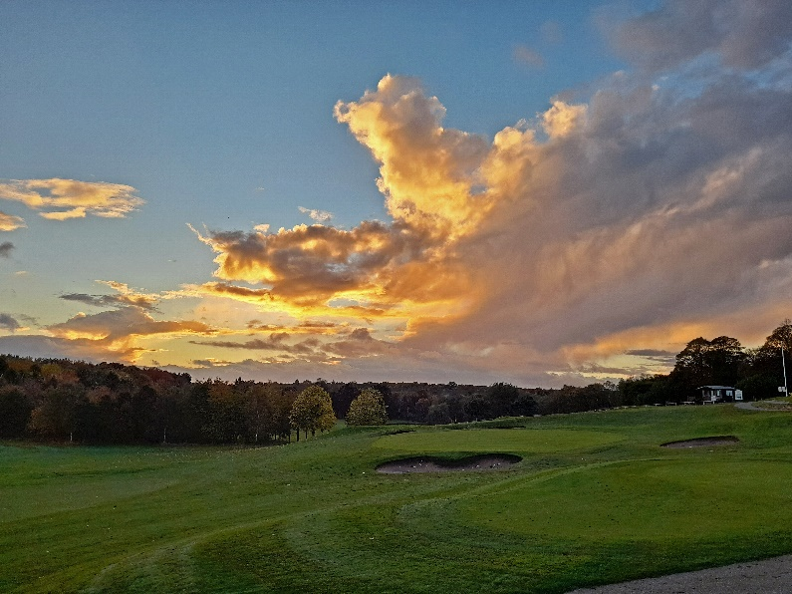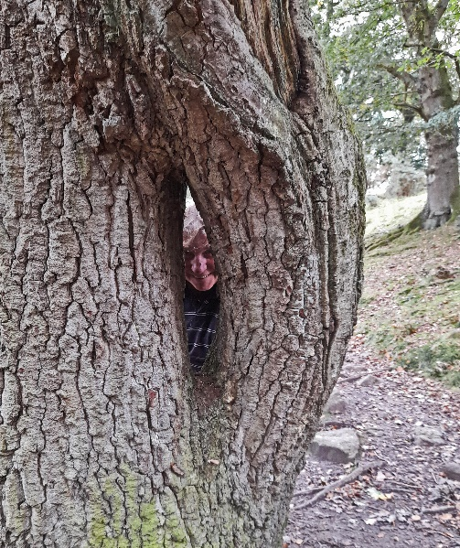

Bob Thomson – Sunrise / Face in a strange Place.

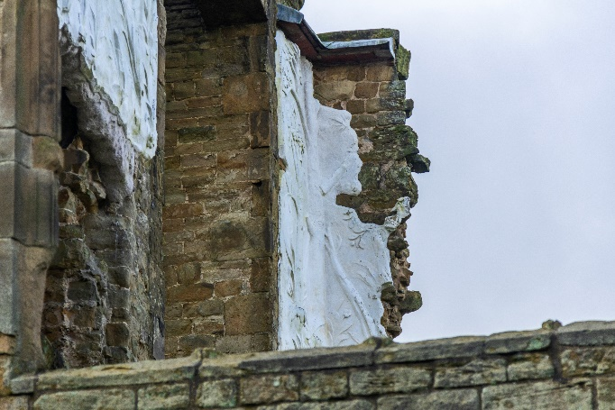

The next ‘Themed’ challenges are back to the alphabet, statring with ‘Anything beginning with A or B’
Once again these challenges are open to ALL u3a members!

Strollers 
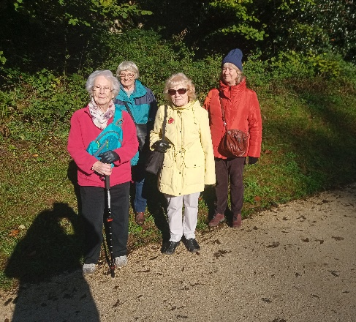
On a lovely sunny day five of us enjoyed a stroll from the Dukeries car park to Cresswell Crags and around the lake. We learnt while we were there that half the crags are in Nottinghamshire and the other half in Derbyshire! Which was news to all of us who have been going there for years!
The next stroll is on Nov 22nd, meet at the Carrs for a car share to Thoresby Hall.
The strollers will be having a quick meeting during coffee time at the main meeting on Monday.

Craft Group 
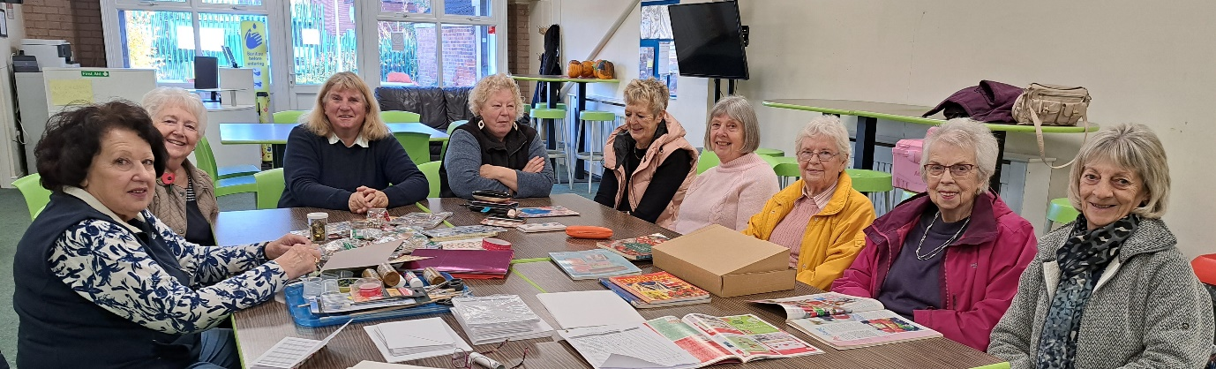

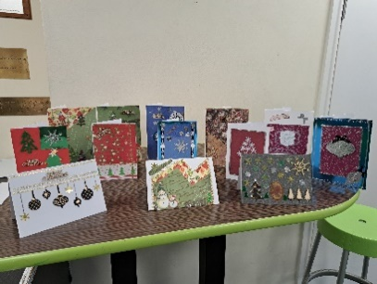
The craft group met on Monday 6th November at the Adam Eastwood centre (THE SHED) this was the last meeting of 2023.
Ann Poultney brought in boxes with all of the ingredients to make some lovely handmade cards. Most were Christmas Cards but there was also a Birthday card and a Thank You card.

The group had a good discussion at the beginning of the meeting and the following crafts will be attempted in 2024 (these are subject to change if necessary).

December 2023 & January 2024 | No meeting
5th February 2024 | Felt Lavender Bags
4th March 2024 | Twiggy Easter Trees
April 2024 | Toiletry bags made from face flannels
May 2024 – | Stone Painting
3rd June 2024 | Jewelry
1st July 2024 | Button Pictures/collages
5th August 2024 | Garden ornaments
September, October & November | To be decided
2nd December | Christmas cards/calendars

If you would like to join us for any of the above Monday mornings you will be made very welcome. We always have a good time, with refreshments and biscuits. The only thing you need to bring is just a basic sewing kit and a willingness to have a go at anything. All materials are available for a very small donation to the person who brings them. If anything more specialised is required you will be given the opportunity to get it yourself or borrow from other group members.
We are not holding a meeting in December. The next meeting is at THE SHED (behind the Dr’s surgery) Wood Street, Warsop. NG20 0AX, on Monday 5th February 2024 at 10am, when subs will be discussed.
Zena – zenainger.u3a999@gmail.com

History Group 
The History Group met on Tuesday 17th October when our visitor, James Wright, spoke to us on the topic of ‘Hidden Tunnels and Passageways.’
We have all heard fascinating stories of secret tunnels leading from ancient buildings and used as escape routes during troubled times or as hiding places for the persecuted. But how many of these are true and how many are myths? If they are myths, why have they emerged?
It would appear the local archives receive many reports of such tunnels. The majority turn out to be nothing more sinister than an old drainage channel or a storage place. We have our local ‘secret’ tunnels which were used as tunnels, although perhaps not so secret. There are those under the Welbeck Estate built on the instruction of the Fifth Duke of Portland. There is also the famous Mortimer’s Hole, used by Edward III’s men to enter Nottingham Castle and arrest Queen Isabella, Edward’s mother and her lover, Roger Mortimer, thus enabling Edward to take his place as king. The real Mortimer’s Hole has been discovered on The Park side of the castle. Nottingham is built upon a network of caves, with there being a maze of tunnels under the city. The old Saxon name for Nottingham was Tigguo Cobauc, ‘City of Caves’.
James spoke about other well-known stories of secret tunnels and passageways, including one 3 miles long, allegedly running from Tattershall Castle to Kirkstead Abbey, Lincolnshire; another one from Aston Hall and one supposedly linking Stone Priory to Aston. Some are claimed to stretch for long distances or under lakes, which would require considerable engineering expertise and expense, which brings into question their credibility. Yet, all these stories of secret tunnels and escapes under the cover of darkness grab our imagination and play on our emotions. So, if these tunnels don’t exist or are simply mis-read archaeology and are nothing more sinister than a drain why have these stories become embedded in our folklore? It is this which turns out to be even more interesting than the tunnel stories themselves and is explored in James’ new book which is due out in 2024.
Our next meeting is on Tuesday 21st November 2023 at 10.00am at St Theresa’s Church Hall. The topic for this meeting is ‘Curious Occupations.’ Please come along and join us. We look forward to seeing you there.
Barbara, Sue and Tamar

Warsop & District U3A History Group Calendar of Events 2023
21st November 2023 | Presentation – Curious Occupations?  Denis Hill | St Theresa’s Church Hall 10am
December | No meeting as very close to Christmas

2024 - Proposed Calendar of Events for Warsop & District U3A History Group
16th Jan | Hayman Rooke - Denis Hill | St Theresa’s Church Hall 10am
20th Feb | Four Kings. Chris Shervey | St Theresa’s Church Hall 10am
19th Mar | Visit to Hardwick Hall -
16th Apr | Mining Communities  Denis Hill | St Theresa’s Church Hall 10am
21st May | The Story of Boots  Chris Weir | St Theresa’s Church Hall 10am
18th Jun | Visit to Richard 3rd Museum Leicester or Lincoln Castle and Cathedral.
16th July | Early History of Mansfield  Denis Hill | St Theresa’s Church Hall 10am
20th Aug | In house presentation  Eminent Local Sporting Personalities  Roger Holland | St Theresa’s Church Hall 10am
17th Sept | Historic Mansfield Trail  Denis Hill | Meet in Mansfield Town Square 10am
15th Oct | Nottinghamshire’s Dark Side  Chris Weir | St Theresa’s Church Hall 10am
19th Nov | Medieval Buildings & the English Civil War  James Wright TBA | St Theresa’s Church Hall 10am
17th Dec | No meeting as very close to Christmas


Natural History, Science and Technology.
The group had a talk on the development and use of Anaesthetics Antiseptics and Antibiotics.
Learning how the development was a lot of trial and error and sometimes luck taking many years. In some cases over two different centuries. We looked at how the development of the first two led to improvements in the survival rates of patients undergoing surgery.
Before the meeting we had a chat about possible talks and visits for next year with several interesting ideas. Watch this space!
2023
Thurs 14th Dec | No meeting
2024
Thursday 8th Jan | To be decided
Thursday 15th Feb | Habitats around us
Thursday 14th March | Bats
Thursday 18th April | Visit to Veolia 2.00pm | Note this is not our usual meeting date
Thursday 6th May | To be decided
Thursday 14th June | To be decided
Thursday 11th July | St Johns | CPR and use of DEFRIBULATOR

Group | Name | Tel
NATURAL HISTORY SCIENCE AND TECHNOLOGY | Chris Shervey
WALKING GROUP | Brenda Pearce  Pam Hick
STROLLERS | Sue Cox  Pat Magness
HISTORY GROUP | Barbara Spybey
CRAFTS | Zena Inger
GARDENING | Linda Crossley
PHOTOGRAPHY | Rob Thomson
FRIENDSHIP GROUP | Betty Trinder
INTERNATIONAL DINING GROUP | Chris Wilson  Brenda Pearce
THEATRE GROUP | Jennifer Thomson
SOCIAL EVENTS ORGANISER
DISCUSSION GROUP | Mary Morris
 | Ann Ayodele
COULD GROUP LEADERS PLEASE COLLECT THEIR BADGES WHEN COLLECTING THEIR LANYARDS. (Then members at the meeting can identify who they may need/want to talk to)

INTEREST GROUP TIMETABLE
 | MONDAY | TUESDAY | WEDNESDAY | THURSDAY | FRIDAY
1st | 10am – 12pm  CRAFTS GROUP  The Adam Eastwood Building. Warsop |  |  |  | 2pm  FRIENDSHIP GROUP  The Plough Warsop
2nd |  | 10am  GARDENING GROUP  Venue agreed by members |  | 2pm  NATURAL HISTORY  SCIENCE AND  TECHNOLOGY  Plough Warsop
3rd | MAIN MEETING 10.15  Oaklands Centre  Warsop | 10am– 12pm  HISTORY GROUP  Catholic Church Warsop |  | 10am  WALKING GROUP  Carrs Car Park | 11.am  PHOTOGRAPHY  Venue to be agreed by the members.
4th | 10.30 -12.30  DICUSSION GROUP  Forest Lodge  Edwinstowe |  | 10.am  STROLLERS  Carrs Car Park
INTERNATIONAL DINING -Location and time as announced.
THEATRE GROUP - Location and time as announced.
PHOTOGRAPHY GROUP-Please see Newsletter for the online challenge.

Speakers for the main meetings

2023
November 20th Inspector Hopkinsons Discovery Ian Morgan

December 18th Christmas Party

2024
January 15th Wild West with Songs Steve Allen

February 19th A Family History(Title to be confirmed) Peter Slater

March 18th ‘Mind Your Motoring Manners 1928’ Paula Cornwell

April 15th Knickers a Brief History Janet Stain

May 20th Social time

June 17th (Title to be confirmed) Mel Mitchell

July 15th More Funny Turns! Dave Moylan

August 19th Medieval superstitions and science. Gareth Howell

September 16th Annual General Meeting

November Quiz - Where in the world? In which town/city will you find
these famous landmarks?

1 Golden Gate Bridge
2 Statue of Christ the Redeemer?
3 The Alhambra Palace?
4 Raffles Hotel?
5 The Wailing Wall?
6 The Cutty Sark?
7 Arthur's Seat?
8 The Sears Tower?
9 Colosseum?
10 The Golden Temple?
11 Sangrada Famillia?
12 Bridge of Sighs?
13 Taj Mahal?
14 HMS Victory?
15 Angel of the North?
16 Statue of Liberty?
17 Arche de Triomphe?
18 St Basil's Cathedral?
19 Royal Yacht Britannia?
20 Hermitage Museum?
21 Albert Memorial?
22 Great Pyramid?
23 Angkor Wat?
24 Brandenburg Gate?
25 Tyne Bridge?
26 Acropolis?
27 Clifton Suspension Bridge?

Well I didn't know that!
The Goebekll Tepe in Turkey is the oldest building in the world, built 9500-7500 BC
( now a ruin)

The Burj Khalifa in Dubai is the tallest building in the world at 830 metres , built 2004-2009. ( If you wish to go to the top a ticket will cost you £50)

The oldest building in Britain is St Martins Church, Canterbury built in 597.( still being used as a church)

The tallest building in Britain is The Shard in London. Completed in 2012 and is 310 metres high. ( in fine weather you can see a distance of 40 miles)

November quick quiz All the answers start with E except one.
1 A city famous for it's Fringe Festival
2 A country in South America?
3 Name of a former British Triple Jumper ( surname E)
4 King who was victorious at Agincourt?
5 Tesla is a make of?
6 Famous marble sculptures in the British Museum?
7 The French call it La Manche, what do we call it?
8 Famous racecourse in Surrey?
9 County town of Devon?
10 The Greek god of love?

NOVEMBER RIDDLES
1 What goes up and down but doesn't move?
2 What has one eye and cannot see?
3 What is cut on a table but never eaten?

Answers OCTOBER QUIZ Three of a kind --------
- Name 3 Shakespeare plays with a female name in the title? Romeo and JULIET Troilus and CRESSIDA Anthony and CLEOPATRA
- In which fictional towns are these set?
Postman Pat GREENDALE
All Creatures Great and Small DARROWBY
Fireman Sam PONTYPANDY
- What 3 events make up a Triathlon? SWIMMING CYCLING RUNNING
- Name 3 US States of five letters? TEXAS IDAHO MAINE
- Name 3 racecourses where the classic flat races are run? NEWMARKET EPSOM DONCASTER
- Name 3 woodwind instruments that start with the letter T? TUBA TRUMPET TROMBONE
- Which are the 3 longest bridges in the UK? HUMBER FIRTH OF FORTH SEVERN
- In the childrens programme Playschool what shape were the windows? SQUARE CIRCLE ARCHED
- What were the first names of the Gibb brothers/BeeGees? ROBIN MAURICE BARRY
- Name the 3 actresses in the film The witches of Eastwick? MICHELLE PFEIFFER CHER SUSAN SARADON
- Name the 3 largest lakes in the world? LAKE VICTORIA CASPIAN SEA LAKE SUPERIOR
- Name 3 countries that have borders with China and start with M? MONGOLIA MACAU MAYAMAR
- In the Nursery Rhyme Three Men In A Tub what are their jobs? BUCTHER BAKER CANDLESTICK MAKER
- Who wrote the book Three Men In a Boat? JEROME K JEROME
- Who were the first 3 Presidents of the USA? WASHINGTON ADAMS JEFFERSON
- Name the 3 sons of Noah? JAPETH SHEM HAM
- Who wrote the book The Three Musketeers? ALEXANDER DUMAS
- The actor James Dean made 3 films, can you name them? GIANT REBEL WITHOUT A CAUSE EAST OF EDEN
- What are the 3 most common surnames in Britain? SMITH JONES WILLIAMS
- What was the first names of the Bronte sisters? ANNE EMILY CHARLOTTE
- Which were the first 3 countries to issue stamps? GRT BRITAIN U.S.A. SWITZERLAND
- In Shakespeare’s King Lear what are the names of the daughters? GONERIL REGAN CORDELIA
- What are the last 3 words of Queen’s Bohemian Rapsody? THE WIND BLOWS
- Which are the 3 longest rivers in Britain? SEVERN THAMES WYE
- Only 3 films on 20th century won 10 Oscars or more, name them? TITANIC WEST SIDE STORY BEN HUR

ANSWERS October quick quiz All the answers start with the letter D except one.

1 Which river according Johann Strauss is blue? DANUBE
2 What is the spiritual /political leader of Tibet called? DALI LAMA
3 Childrens author whose works include Matilda? (surname) ROALD DAHL
4 Which is the correct spelling DECIDUOUS or DECCIDUOUS?
5 Writer of the poem The Daffodils? WILLIAM WORDSWORTH
6 Name of a type of tea? DARJEELING
7 Another name of the deadly plant Belladonna? DEADLY NIGHTSHADE
8 Serious condition resulting from lack of fluids in the body? DEHYDRATION
9 Local Derbyshire pottery? DENBY
10 Famous French designer? (surname)CHRISTIAN DIOR

October riddles?

1 What has many keys but can’t open a lock? A PIANO

2 What gets bigger when more is taken away? A HOLE

3 Where does today come before yesterday? A DICTIONARY

North Notts Neighbourhood Group
This means that you as a member of Warsop & District can ask to join an interest group in another U3A that is also in the NNNG, as long as the group is not oversubscribed at the time of your request you can join the group without joining the host u3a
The u3as in the NNNG are Mansfield, Sherwood, Dukeries, Rainworth, Forest Town, Ashfield, Sutton in Ashfield, Hucknall and Warsop.

Data Protection Rules
Warsop & District U3A is committed to treating all people equally.
Anyone wishing to see the Privacy and Data Protection policies may view them on the Warsop & District U3A website, alternatively please ask Rob.

Website & Facebook
The Warsop & District u3a website can be found at the address below. If any of the group leaders/facilitators would like to advertise/ promote any of their future activities or change the information shown, please contact Bob Thomson.

Facebook
Warsop & District U3A has a Facebook Group. It is a private group which can be seen by the public but only members can see who’s in the group and what they post.
What this means is that you have to be invited to join the group or have your request to join accepted. Also you need to be on Facebook which some of you may not be. As a member of the group you will be able to put your own posts on the page, please keep them relevant to the U3A and what it stands for. We would ask that you don't put anything on that is in anyway party political or anything that may be offensive to others who may be of a different creed or religion. Hopefully everyone will join, use the page and find it useful.
One of the things that puts people ‘off’ Facebook, is the ‘bad press’ some of the Social sites get. You can join Facebook, choose only to join the Warsop Facebook page and not be involved in any other site, or Friends requests (usually from people that you have never heard of!) The choice is entirely yours.
To request to join the Warsop u3a Facebook page, contact Bob Thomson, email addresses as per the Website.

Committee Members | Role
Jim Shervey | Chairperson
Mel Mitchell | Deputy Chairperson
Irene Clay | Business Secretary
Linda Crossley | Treasurer
Mel Mitchell | Membership Secretary
Jim Shervey | Speaker Seeker
Jennifer Thomson | Groups co-ordinator
Chris Shervey | Newsletter editor
Vacant | Social Events
Jennifer Thomson | Welfare Officer
Rob Thomson | Website & Facebook manager
Ann Ayodele | Refreshments rota/Quiz
June Whittle | Raffle
Betty Trinder | Social events assistant
Carolyn Brankin | Co-opted member
Pat Magness | Co-opted member

