
Issue 78 May 2024
Warsop & Distict

Notes from the Chairman
Hi
Welcome to the May newsletter. There is plenty to read about this month so enjoy.

Firstly there is a change to the speaker in June. Mel will give her planned talk to us in November. Instead instead in June Martin Perry is going to talk to us on ‘The Magic of the Guitar’

Coming up there is the ‘Picnic in the Forest’ a free event organized by the NNNG on 26th June, all you need to do is turn up with a picnic and enjoy yourself.

The next Quiz night has been arranged for 4th July.

We are having a barbeque this year rather than a garden party. On Saturday 3rd August.

The AGM is on the horizon, paperwork will be in next months newsletter. The AGM will again be combined with a silent auction, so begin collecting items for the auction.

More details on all the above are in the newsletter.

The committee has a request for a bit of help. We need the accounts checking before the AGM by someone not on the committee. If you feel you are able to help us with this speak to Linda or myself.

Lastly with the AGM coming up many of you will be aware that my time as chair is coming to an end. As we have to have a chairperson to operate as a u3a. So if you feel like having a go come and have a chat to see what I get up to as chair.

Jim Shervey
Chair

The deadline for including articles/information in the next newsletter is Friday 7th June Send contributions to Chris Shervey.

Rota for refreshments and greeting.
This is the rota for the next six months, any problems please contact me, Ann Ayodele.
Thank you to all those who have volunteered to help, without you our meetings would not be enjoyable.

Date | Refreshments 1 | Refreshments 2 | Meet and Greet 1 | Meet and Greet 2
20th May | Pauline Wright | Barbara Hartshorn | Yvonne Brown | Glenys Fearn
17th June | Angelina Taylor | Ann Harris-Lock | Roy Harris-Lock | William Taylor
15th July | Jillian Greer | Gillian Allsop | Ann Barnes | Ann Holland
19th Aug | Karen Breed | Beatrix Kirby | Raymond White | Janice Richardson
16th Sept | Janice Thorlby | Janet Harford | Chris Wilson | Brenda Pearce
21st Oct | Yvonne Pannifer | Zena Inger | Moira Heslop | Ann Poultney
Those on the rota please be there around 9.30am.

ITEMS OF INTEREST
Quiz Night
I am planning a quiz night for Thursday 4th July, 7.00pm, at The Plough, Warsop. I will start to sell tickets at our next monthly meeting on Monday 20th May, and again at the June monthly meeting.
Tickets are £6.00 each for the supper, with our usual choice of a baked potato with trimmings or pie and peas. Guests are welcome to be included. Ann Ayodele.

Silent Auction We are planning to hold a Silent Auction alongside the AGM in Sept. I will be collecting items for the auction at the July and Aug main meetings. Chris
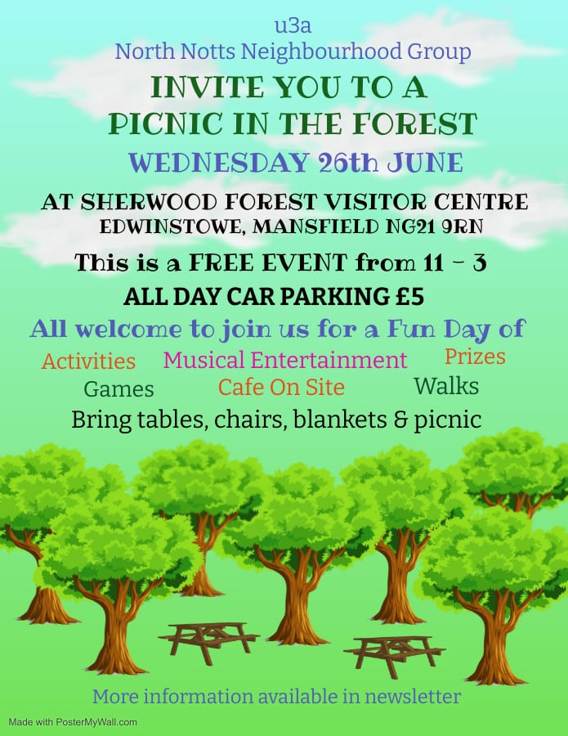
Bar- b -que To be held on the 3rd Aug at Oakroyd Forest Rd. u3a members are free plus ones are £5. Tickets available from Jen at main meetings.
Robin Hood Lottery 
Warsop and District U3A is a cause registered with the Robin Hood Lottery.
To buy a ticket you can now register on line at www.robinhoodlottery.co.uk and set up regular payments. If you buy a ticket every week for a year Warsop U3A will receive £26.
Remember the more members that have a go (specifying Warsop & District U3A) the more money we get for our funds.

Books and Jigsaws 50p. We made £4.50 at the April meeting. The books are sorted into genres making it easier to find a book you like.

Cups Please will as many of you as
possible bring your own mug for your tea or coffee. This is not only more environmentally friendly but also would save us a lot of money as the paper disposable cups we use are surprisingly expensive. Ann.

Raffle. The April Raffle raised £43
RAFFLE PRIZES NEEDED PLEASE ESPECIALLY ONES SUITABLE FOR MEN.

A member of our u3a has a pair of good as new walking boots for sale, size 5. The price of the boots is a donation to our u3a. See Chris S

Group News
Interest Groups
There will be a new folder on the table at the next monthly meeting. I have compiled brief details of all the groups in neighbouring u3as.
Our members are able to join groups at neighbouring u3as, providing they aren't over subscribed. Similarly, u3a members from other branches in North Nottinghamshire may join our groups.
There are dozens of active interest groups in the area so please take a look, something may appeal. Better still, you may be inspired to start a similar group for Warsop and District u3a.
Help may be given to anyone thinking of starting a new group, including financial help to get a group started.
I shall be arranging a meeting of group leaders in the next few weeks, I'll be in touch via WhatsApp.
Jen.

For your information the COFFEE LOFT on the High Street will let you use their upstairs room for free as long as you buy a coffee. Talking of Coffee, some members have suggested it may be nice to have a group that meets up for coffee/tea/cake and a chat. If you are interested in this idea, please see Jen at the main meeting.
The Friendship Group
Four members of the Friendship Group met at The Plough on Friday, 3rd May and enjoyed a friendly social afternoon. As there will not be a reminder in the next Newsletter please make a note in your diaries that the July meeting will be on the 5th at 2.00 p.m. usual venue. There will be a meeting on Friday 7th June.
Betty
Theatre Group
Our latest outing was to see "The Hound of the Baskervilles" at Newark Palace Theatre. It wasn't quite what we were expecting, being presented as a radio play. It was still enjoyable though and interesting to see the sound effects in operation.
Our next outing will be on Sunday 21st July to see "Oklahoma!" at the Majestic Theatre in Retford. Tickets cost £20.50 and I shall be collecting this at our June meeting.
I shall also be asking everyone going to this show if they would like to meet for a meal before the show.
After this we have nothing planned until November, so I'm calling a meeting on Friday 1st June at 2pm in The Plough. We will decide if we'd like to see another show before November and will also sort out travel arrangements for our trip to Retford.
Jen.

Welfare
Cards expressing get well wishes or condolences are sent to members who are unwell or who have been bereaved.
Please remember to let me know of members who are, sadly, in these circumstances, so that I may send them our best wishes.
Thank you, Jen.

International Dining

Discussion Group
The discussion group will run as usual at 10.30 0n the 4th Monday of the month, Forest Lodge Edwinstowe.

Bridge Club
The Dukeries u3a Bridge Group meet on the Second and Fourth Tuesday of each month at the Jubilee Hall (NG22 9AP) from 1 – 4PM. The cost of each session is currently £3.
All U3a members are welcome to attend.

Silver Screeners

Savoy cinema Worksop. For the over 50’s. Every Wednesday at 11.30. Tickets £5.00, include a drink and free raffle.
Wednesday 22nd May.
The Fall Guy. 12A. He's a stuntman, and like everyone in the stunt community, he gets blown up, shot, crashed, thrown through windows and dropped from the highest of heights, all for our entertainment. And now, fresh off an almost career-ending accident, this working-class hero has to track down a missing movie star, solve a conspiracy and try to win back the love of his life while still doing his day job. What could possibly go right?
Garden Group
Nine members of the gardening group went to Woodborough Green Garden Centre in a change to our planned day out, because of the rain. We had morning coffee before buying a few plants and then had a lovely lunch.
Our next trip out will either go to our cancelled venue of Cascade Gardens at Matlock or Felley Priory. Meeting at the Carrs at 10.00am.

Walking Group
MUD MUD GLORIOUS MUD, what more can I say. We started the walk from the Rowthorne Trail car park near Glapwell on a beautiful April morning. Everything looked so fresh and lush with pockets of bluebells, wood anemone, pink campion along the way. We then turned onto the Teversal Trail leaving it near the village of Newton. The public footpath took us back through a field before heading into the wood which was a carpet of bluebells. Unfortunately that is where the walk turned into a bit of an assault course as underfoot had turned into a quagmire, holding onto branches, trying to keep in our boots as the mud tried to pull them off our feet and hoping to stay upright . Unfortunately one of the party sampled the mud at close quarters but was unhurt. The walk was approximately 4 miles, next time we do the walk we are doing a slightly longer version and taking in the grounds of Hardwick Hall. Gerald will lead the next walk, where we are doing part of the Maun Valley Park/Trail on Thursday 16th May. Leaving The Carrs at 10.00 am or the Maun Valley Trail car park on Old Mill Lane, Mansfield Woodhouse approx 10.15 am Brenda

WALKING GROUP - 3RD THURSDAY OF THE MONTH 2024
Date | Walk Leader | Walk | Distance
16th May | Gerald Weston | Grounds of Hardwick Hall
20th June | Val Buckinger | Clumber Lake | 4 miles
18th July | Jen Long | Gleadthorpe | 4 miles
15th August |  | TBC
19th September |  | TBC
17th October | Brenda Pearce | Ault Hucknall | 3.5 or 5 miles
21st November |  | TBC
 |  | Walks can be subject to change

Strollers
We had a lovely stroll through the woods at Thoresby and saw the bluebells in bloom. Then walked down to the mill returning on the path along the lake.
Finishing the morning with a lovely cup of coffee and a chat at the café.

STROLLERS TIMETABLE FOR 2024

May 22nd | Warsop, walk from the Carrs
June 26th | Sherwood Forest, our usual stroll and then those who wish to can go to the u3a picnic.

Natural History, Science and Technology.

The trip to Veolia on the 18th April was a very interesting and informative two hours. It began with a presentation from Lesley the Education officer who explained how our green bins are sorted and the paper tins and plastics are prepared to go to the various facilities that recycle them. Tins can be recycled over and over, plastics and paper can only be recycles so many times.Lesley also told us how much unwanted stuff they get, duvets clothes nappies and things that are recyclable but not in Notts. Wearing our hard hats and earphones we made our way to the actual plant. From a viewing platform we could see tins plastics and paper being sorted and baled. From the lorry dumping our recycling to it being sorted and baled takes 15mins!

On 9th May Jim gave a talk on Investigating the influence of rock types on vegetation, looking at limestone chalk and granite areas. He also discussed the influence of climate and topography on the vegetation. The talk gave us plenty to think about,and raised many questions. The conclusion was that there is still a lot of study to be done in this area.

2024
Thursday 13th June | Paramedic with ambulance | Because of parking the ambulance this meeting will be held at Oakroyd NG20 0EP
Thursday 11th July | St Johns | CPR and use of DEFRIBULATOR
Thursday 8th Aug | Visit to Woollaton Hall
Thursday 12th Sept | To be decided
Thursday 10th Oct | To be decided
Thursday 14th Nov | Birds in your garden
December | No Meeting

Craft Group
This month the group had a go at pebble painting (an activity we have done before) Everyone had two large pebbles and did their own design using permanent marker pens. We had butterflies bees boats flowers and many other pictures.
The craft group meets the first Monday of the month( unless it falls on a Bank Holiday and then it is the second Monday) 10am – 12noon at THE SHED (behind the Dr’s surgery) Wood Street, Warsop. NG20 0AX.
This year’s itinerary.
3rd June 2024 – Button Pictures/collages
5th August 2024 – Garden ornaments
2nd Sept, 7th Oct, 4th Nov - TBC
December 2024 – Christmas cards/calendars or wreaths
Zena

Photography Group
The Photography Group visited the Military Museum in Thoresby Park Court yard on Friday 19th May 24. It tells the history of how the Dragoons, Lancers and Nottinghamshire Yeoman regiments came into being. One display is dedicated to the ‘Charge of the Light Brigade’ and explains how events unfolded on that terrible / historic day!
The online ‘Themed’ challenge this last month was ‘Anything beginning with either K or L’
A BIG THANK YOU to Jim & Chris Shervey, and Jen Thomson for their contributions to the challenge!

Jo – Anne Wheatley: Military Museum
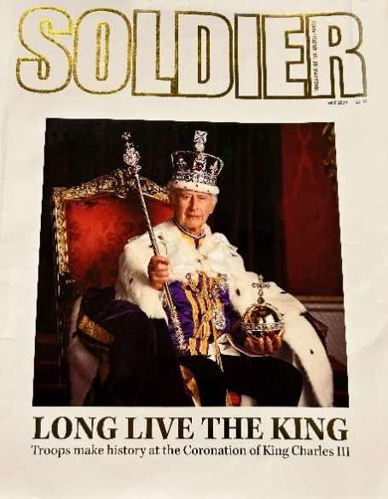

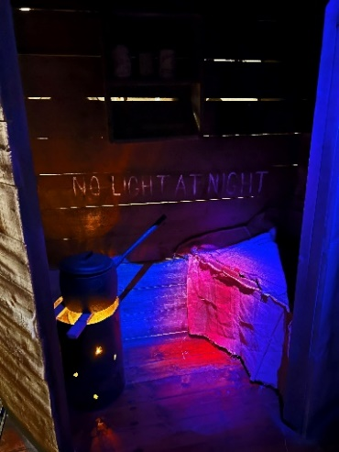
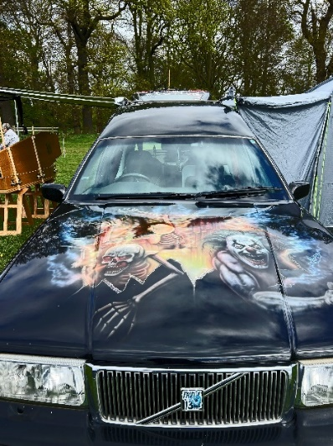
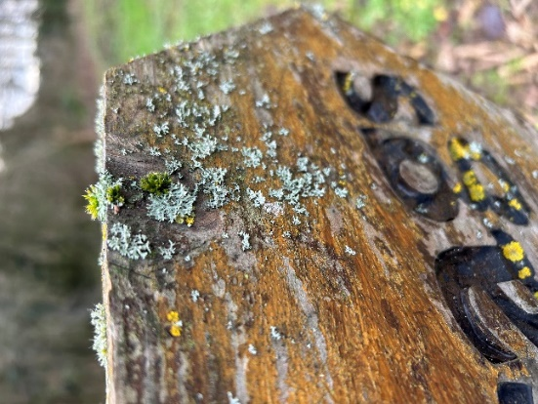
K or L =
Night of the Living dead / Lichen

Chris Shervey: Kettles / Lavatera
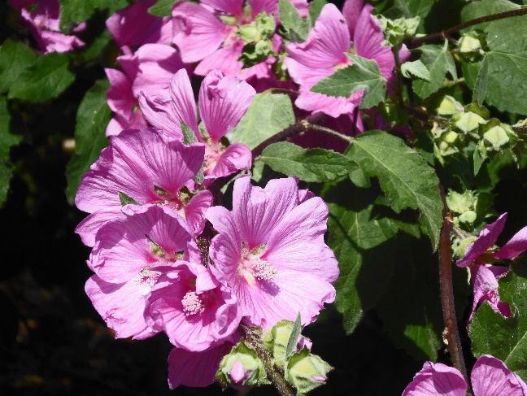
Jim Shervey: Lambs Tea Time
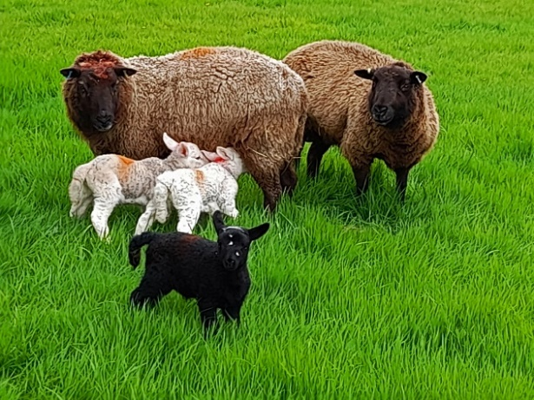
Jen Thomson: King Fisher purse
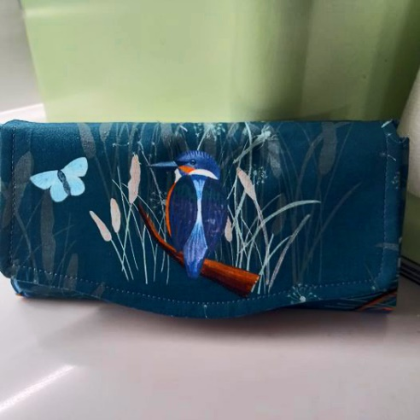

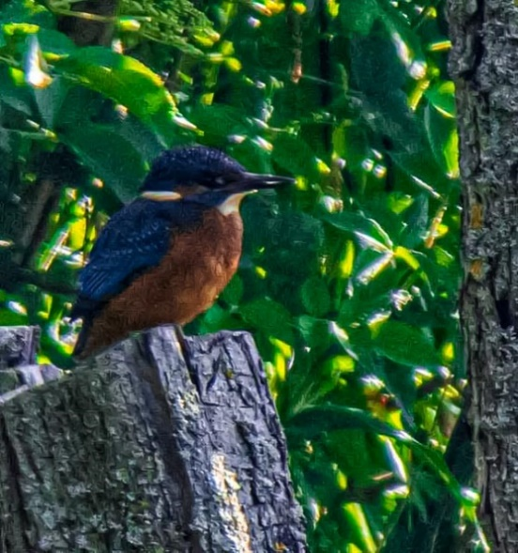
K or L= King Fisher / Ladders (trench)


Bob Thomson: Military Museum
m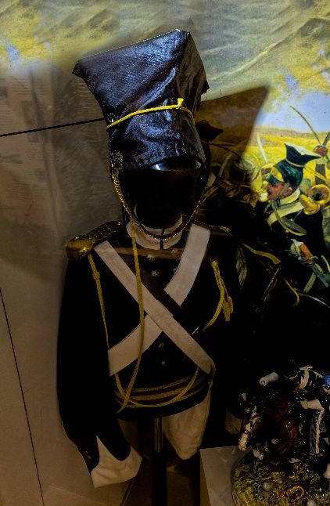 

The next online ‘Themed’ challenge is ‘Anything beginning with either M or N’, once again this challenge is open to ALL u3a members!

History Group
The history group met on Tuesday 16th April when Dennis Hill came to give a very interesting talk about the history of mining communities.

Our next meeting is on Tuesday 21st May at 10am at St Teresa’s church hall, Warsop. Chris Weir will be telling us the story of Boots the Chemist.

We will also be discussing the arrangements for our forthcoming visit on Tuesday 18th June to Leicester when we will be visiting the Richard III Visitors’ Centre, situated on the friary site (where King Richard III’s remains were found), the Cathedral and the Guildhall.
We look forward to seeing you at the meeting.
Barbara & Tamar 😊

2024 - Proposed Calendar of Events for Warsop & District U3A History Group
21st May | The Story of Boots  Chris Weir | St Teresa’s Church Hall 10am
18th Jun | Visit to Richard 3rd Museum Leicester or Lincoln Castle and Cathedral.
16th July | Early History of Mansfield  Denis Hill | St Teresa’s Church Hall 10am
20th Aug | In house presentation  Eminent Local Sporting Personalities  Roger Holland | St Teresa’s Church Hall 10am
17th Sept | Historic Mansfield Trail  Denis Hill | Meet in Mansfield Town Square 10am
15th Oct | Nottinghamshire’s Dark Side  Chris Weir | St Teresa’s Church Hall 10am
19th Nov | Medieval Buildings & the English Civil War  James Wright TBA | St Teresa’s Church Hall 10am
17th Dec | No meeting as very close to Christmas

Speakers for the main meetings

2024

May 20th Social time

June 17th The Magic of the Guitar Martin Perry

July 15th More Funny Turns! Dave Moylan

August 19th Medieval superstitions and science. Gareth Howell

September 16th Annual General Meeting

October

November Before They Were Famous Mel Mitchell

INTEREST GROUP TIMETABLE
 | MONDAY | TUESDAY | WEDNESDAY | THURSDAY | FRIDAY
1st | 10am – 12pm  CRAFTS GROUP  The Adam Eastwood Building. Warsop |  |  |  | 2pm  FRIENDSHIP GROUP  The Plough Warsop
2nd |  | 10am  GARDENING GROUP  Venue agreed by members |  | 2pm  NATURAL HISTORY  SCIENCE AND  TECHNOLOGY  Plough Warsop
3rd | MAIN MEETING 10.15  Oaklands Centre  Warsop | 10am– 12pm  HISTORY GROUP  Catholic Church Warsop |  | 10am  WALKING GROUP  Carrs Car Park | 11.am  PHOTOGRAPHY  Venue to be agreed by the members.
4th | 10.30 -12.30  DICUSSION GROUP  Forest Lodge  Edwinstowe |  | 10.am  STROLLERS  Carrs Car Park
INTERNATIONAL DINING -Location and time as announced.
THEATRE GROUP - Location and time as announced.
PHOTOGRAPHY GROUP-Please see Newsletter for the online challenge.

Group | Leaders Name | Tel
NATURAL HISTORY SCIENCE AND TECHNOLOGY | Chris Shervey
WALKING GROUP | Brenda Pearce  Pam Hick
STROLLERS | Janet Harford  Pat Magness
HISTORY GROUP | Barbara Spybey
CRAFTS | Zena Inger
GARDENING | Linda Crossley
PHOTOGRAPHY | Rob Thomson
FRIENDSHIP GROUP | Betty Trinder
INTERNATIONAL DINING GROUP | Chris Wilson  Brenda Pearce
THEATRE GROUP | Jennifer Thomson
SOCIAL EVENTS ORGANISER
DISCUSSION GROUP | Mary Morris
COULD GROUP LEADERS PLEASE COLLECT THEIR BADGES WHEN COLLECTING THEIR LANYARDS. (Then members at the meeting can identify who they may need/want to talk to).
May quick quiz All the answers start with K except for one.

1Name a Shakesperean play?
2 The Northern part of India?
3 Famous British poet 1795-1821?
4 Australian Outlaw 1855-80 ?
5 Large sea weed found in cold seas?
6 Volcanic mountain in Tanzania?
7 Capital of Ukraine?
8 Austrian Composer born in Salzberg 1756-91?
9 Black civil rights leader 1929-1968?
10 Fastenings formed by looping and tying e.g. rope

May quiz In which County would you find these places?

- Haworth Parsonage
- Luton Airport
- Stonehenge
- Blenheim Palace
- National Football Museum
- Bodmin moor
- Eton College
- Jodrell Bank
- Wookey Hole Cave
- Sandringham
- Angel of the North
- Lake Windermere
- Gatcombe Park
- Alton Towers
- Bamburgh Castle
- Aintree race course
- Runnymede meadows
- Blackpool Tower
- Ribblehead Viaduct
- Belton House
- Silverstone
- White Cliffs of Dover
- Clifton Suspension Bridge
- Blue John mines
- Cerne Abbas Giant
- HMS Victory
- The Needles
- Ely Cathedral
- Chartwell House
- Kinderscout

May riddles

1 How do you spell cow in 13 letters?

2 How can you drop an egg on a concrete floor without cracking it?

3 Who has married many women but is not married?

Answers April quiz Can you name these films?

1Butch Cassidy and the Sundance kid
2 Reservoir Dogs
3 Henry V
4 Toy Story
5 Zulu
6 Gone with the wind
7 Oliver
8 High Noon
9 Thelma and Louise
10 Indiana Jones- Raiders of the lost Ark

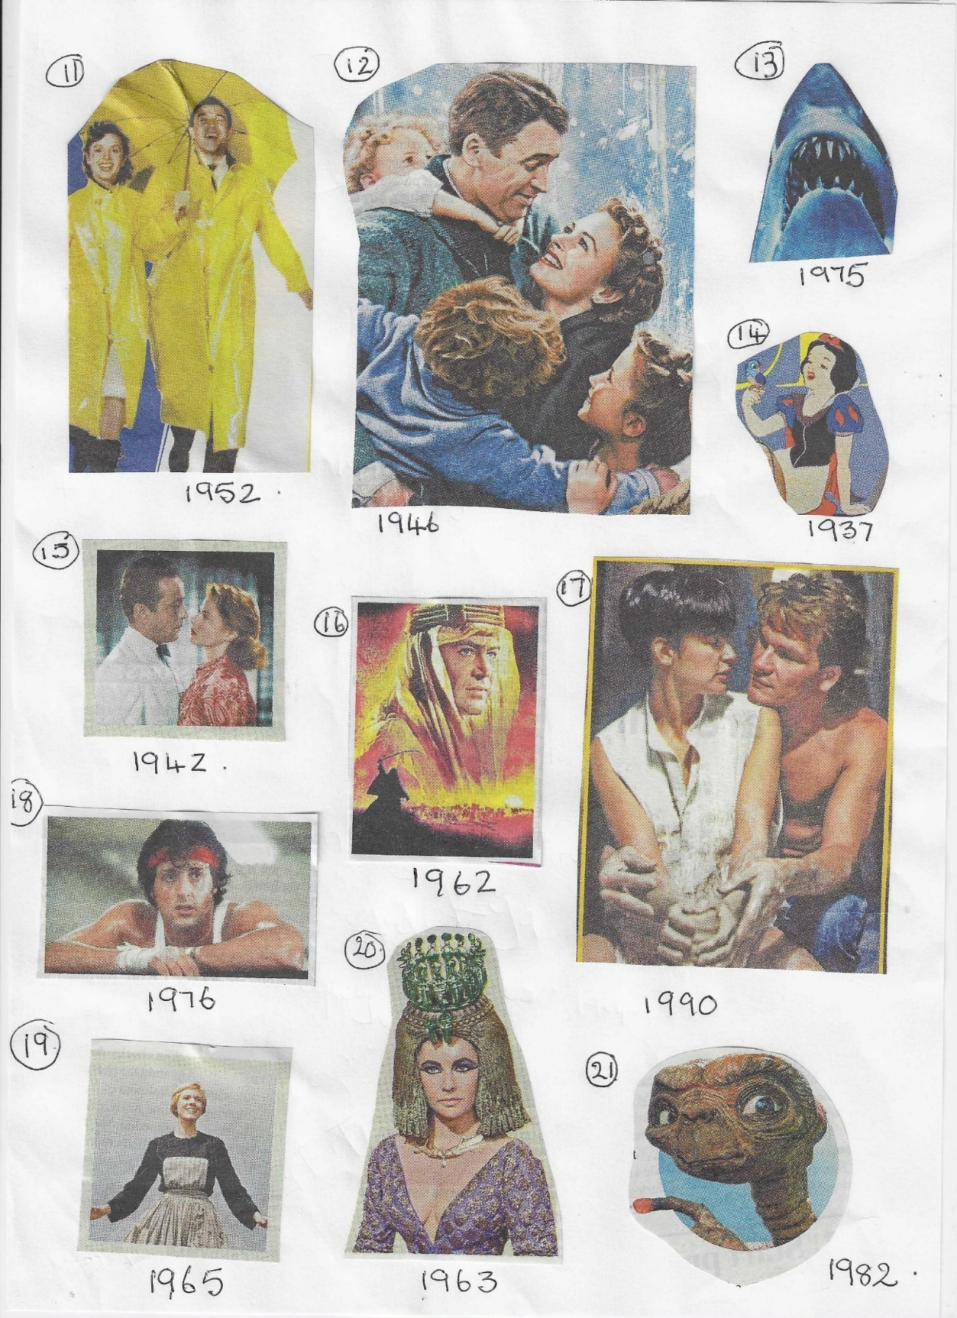
- Singing in the rain
- It’s a Wonderful Life
- Jaws
- Snow White and the 7 Dwarfs
- Casablanca
- Lawrence of Arabia
- Ghost
- Rocky 1
- Sound of Music
- Cleopatra
21 ET

Answers April riddles

1What 5 letter word typed in Capitals can be read the same upside down.? SWIMS

2 The more you take the more you leave behind? FOOTSTEPS

3Why is Europe like a frying pan? BECAUSE GREECE IS A THE BOTTOM

answersApril quick quiz All answers start with J except for one.

- A South American big cat ? JAGUAR
- Books by Richmael Crompton about a schoolboy? JUST WILLIIAM
- Small terrier breed? JACK RUSSELL
- Seventh President of the USA , Andrew------? JACKSON
- Carnivorous mammal, related to the dog. Found in Asia and Africa? JACKAL
- Pack of 78 cards for Fortune Telling? TAROT CARDS
- Island in the Caribbean? JAMICA
- Horse riding trousers? JODPHURS
- King who signed The Magna Carta? JOHN
- Naval battle of WWI ? JUTLAND

North Notts Neighbourhood Group
This means that you as a member of Warsop & District can ask to join an interest group in another U3A that is also in the NNNG, as long as the group is not oversubscribed at the time of your request you can join the group without joining the host u3a
The u3as in the NNNG are Mansfield, Sherwood, Dukeries, Rainworth, Forest Town, Ashfield, Sutton in Ashfield, Hucknall, Worksop and Warsop.

Data Protection Rules
Warsop & District U3A is committed to treating all people equally.
Anyone wishing to see the Privacy and Data Protection policies may view them on the Warsop & District U3A website, alternatively please ask Rob.

Website & Facebook
The Warsop & District u3a website can be found at the address below. If any of the group leaders/facilitators would like to advertise/ promote any of their future activities or change the information shown, please contact Bob Thomson. www.u3asites.org.uk/Warsop

Facebook
Warsop & District U3A has a Facebook Group. It is a private group which can be seen by the public but only members can see who’s in the group and what they post.
What this means is that you have to be invited to join the group or have your request to join accepted. Also you need to be on Facebook which some of you may not be. As a member of the group you will be able to put your own posts on the page, please keep them relevant to the U3A and what it stands for. We would ask that you don't put anything on that is in anyway party political or anything that may be offensive to others who may be of a different creed or religion. Hopefully everyone will join, use the page and find it useful.
One of the things that puts people ‘off’ Facebook, is the ‘bad press’ some of the Social sites get. You can join Facebook, choose only to join the Warsop Facebook page and not be involved in any other site, or Friends requests (usually from people that you have never heard of!) The choice is entirely yours.
To request to join the Warsop u3a Facebook page, contact Bob Thomson, email addresses as per the Website.

Committee Members | Role
Jim Shervey | Chairperson
Mel Mitchell | Deputy Chairperson
Irene Clay | Business Secretary
Linda Crossley | Treasurer
Carolyn Brankin | Membership Secretary
Jim Shervey | Speaker Seeker
Jennifer Thomson | Groups co-ordinator
Chris Shervey | Newsletter editor
Vacant | Social Events
Jennifer Thomson | Welfare Officer
Rob Thomson | Website & Facebook manager
Ann Ayodele | Refreshments rota /Quiz
June Whittle | Raffle
Betty Trinder | Social events assistant
Pat Magness | Co-opted member

