
Issue 77 April 2024
Warsop & Distict

Notes from the Chairman
Hi
I’ve sat down to write this on a cold wet and windy day, hat and gloves weather, far too cold for the 9th April. Lets hope the weather improves soon.

Don’t forget if you have not already done so membership renewals are due.

The talk at the meeting on Monday sounds good, I have had good reports about it from a variety of places. It was even suggested that any male members present make sure they have taken their blood pressure tablets before the meeting, so be warned!!!!!! The talk is titled ‘Knickers a Brief History’ and will be given by Janet Stain.

For those of you not at the last monthly meeting it was decided to trial a different format for the monthly meeting. Refreshments will be available at the start of the meeting with the speaker 10-15 minutes later than usual.

Don’t forget to check and see what is happening in the future with the groups, I am always surprised with what members come up with for the photography group monthly challenge. This month it is the letters K and L, so any photograph with kingfishers, a set of knives or llamas for example will do. Just send it to Bob Thomson about 2 weeks before the monthly meeting to get it in the newsletter. You don’t have to consider yourself to be an expert photographer to join in.

What else is happening this month, oh yes, there is a walk and a stroll, a trip to the theatre and a visit by the Science, technology and Natural History group to the Veolia processing plant. Also lots else besides.

I mentioned a u3a Barbecue in the last newsletter, planning has moved on we have a firm date, chef and the venue organized. The date is Saturday 3rd August. Put it in your diary.

Lastly from me the NNNG are organizing a ‘Picnic in the Forest’ have a look at the poster in the items of interest section.

Jim Shervey
Chair

The deadline for including articles/information in the next newsletter is Friday 10th May Send contributions to Chris Shervey.

Rota for refreshments and greeting.
Those on the rota please be there around 9.30am. Any problems let me know, thank you.
April 15th
Refreshments:- Audrey Gilbert and Zena Inger
Meet and Greet:- Jill Greer and Barbara Hartshorn

ITEMS OF INTEREST
Membership renewals 2024
Hi. If you have not already done so it is time to be thinking about renewing your membership.
You will be pleased to hear that we are able to keep the cost of membership at £20.00, Or £16.00 with proof of membership where the TAT levy has been paid at another u3a.

You will be able to renew your membership at the April meeting. If you can’t make the meetings let me know and we can make arrangements to renew. The current membership year ends at the end of March, so anyone who has not renewed after the April meeting will be taken off the circulation lists (this does not prevent you rejoining at a later date).
Carolyn Brankin

Sutton in Ashfield u3a event.
Our u3a is having a 60's, 70's 80's disco on Saturday 27th April would it be possible please for you
to advertise this in your newsletter, website and facebook page and at your meetings. Our u3a would be very great fully.
Venue is Polly Bowls Social Club, Unwin Road, Sutton in Ashfield NG17 4HN 7.30pm to 11.00pm there is DJ , refreshments and a full bar.
tickets are £6.00 per ticket.
Please if any of your members are interested could they contact me.
Kind regards
June Hall
Sutton in Ashfield u3a

Robin Hood Lottery 
Warsop and District U3A is a cause registered with the Robin Hood Lottery.
To buy a ticket you can now register on line at www.robinhoodlottery.co.uk and set up regular payments. If you buy a ticket every week for a year Warsop U3A will receive £26.
Remember the more members that have a go (specifying Warsop & District U3A) the more money we get for our funds.

Books and Jigsaws 50p. We made £12.00 at the March meeting. The books are sorted into genres making it easier to find a book you like.

Cups Please will as many of you as
possible bring your own mug for your tea or coffee. This is not only more environmentally friendly but also would save us a lot of money as the paper disposable cups we use are surprisingly expensive. Ann.

Raffle. The March Raffle raised £52
RAFFLE PRIZES NEEDED PLEASE ESPECIALLY ONES SUITABLE FOR MEN.

A member of our u3a has a pair of good as new walking boots for sale, size 5. The price of the boots is a donation to our u3a. See Chris S

Group News
Interest Group News
The leader of our Discussion Group is no longer a member of Warsop and District u3a, but will continue to run the interest group as a member of Dukeries u3a. Anyone from Warsop may continue going to this group or join it. This is because u3a branches in North Nottinghamshire have an agreement whereby members may join interest groups at different branches if there are vacancies.
I hope to put together an up to date list of interest groups throughout North Nottinghamshire. In the meantime anyone wishing to see what's available elsewhere may check out each u3a's web site.
Finally, anyone interested in Bowls? Longden Terrace Bowls Club are happy to welcome new members, from the beginning of May to the end of September they have "Roll-up Days" on Tuesdays and Fridays, 2pm - 5pm. No need to book. It costs £3 including refreshments.
Anyone wishing to try out bowling for the first time may go along during the last week in April and the first week in May, weather permitting. A qualified coach will be available. Contact Ian Munro for more information.
Who knows, this could lead to a new interest group!

For your information the COFFEE LOFT on the High Street will let you use their upstairs room for free as long as you buy a coffee. Talking of Coffee, some members have suggested it may be nice to have a group that meets up for coffee/tea/cake and a chat. If you are interested in this idea, please see Jen at the main meeting.

The Friendship Group
The Friendship Group met on Friday, 5th April for an afternoon of fun and laughter, come and join us at our next meeting on Friday, 3rd May 2.00 p.m. at The Plough.
Betty

Theatre Group
Several members of the group recently went to see Evita, and tickets have been bought for 12 of us to see "The Hound of the Baskervilles" later this month. I shall be issuing refunds to those who booked for this; as we got 1 free ticket for booking 12 seats.
At the next monthly meeting I shall continue to take payment from anyone wishing to see "Oklahoma!" on 21st July. Tickets cost £20.50. I shall also be collecting £0.26 from everyone who saw "Evita." This is to cover printing and booking fees. (I forgot last month.)
Jen,

Welfare
Don't forget to let me know of any ill or bereaved members. This is so that I can let them know that their u3a friends are thinking of them. Jen

International Dining
About 40 people met up in St Theresa’s Church Hall on Wednesday 10th April for a fish and chip lunch. We all arrived around 12 o’clock but the food wasn’t arriving until 1pm so Chris and Brenda had organised entertainment for us! There was a “Who can toss a 2p coin nearest the wine bottle” game, won by Joanne, followed by Stand up Bingo and then regular Bingo, won by a new member. Winners chose prizes from a prize table.
Alongside these events each table had quiz sheets to fill in as and when. These included celebrity identification, anagrams and general knowledge. The number of correct answers for each table was totalled resulting in a tie between our table and one other but they won the tiebreaker!
Fish, chips and peas arrived on time, all nice and hot and very tasty! Salt and vinegar on the tables, tartare sauce brought by some, what more could you want? When everyone had eaten their fish and chips Chris and Brenda brought round a choice of cupcakes and tea and coffee were served by helpers at the hatch. Some had to leave after this but others stayed on for more Bingo! All in all a very enjoyable and successful afternoon.
Many thanks to Chris and Brenda.
Wendy

The Games winners at the ‘Fish & Chips and Fun’ event were-
2p Nearest the Bottle - Joanne Wheatley
Bingo Line - Marilyn Stubbs
x 2 Full House - Angelina Taylor Ann Barnes Barbara Greaves
Thanks Brenda & Chris

Discussion Group
The discussion group will run as usual at 10.30 0n the 22nd April, Forest Lodge Edwinstowe. Look forward to seeing you there. Mary Morris

Bridge Club
The Dukeries u3a Bridge Group meet on the Second and Fourth Tuesday of each month at the Jubilee Hall (NG22 9AP) from 1 – 4PM. The cost of each session is currently £3.
All U3a members are welcome to attend.

Silver Screeners

Savoy cinema Worksop. For the over 50’s. Every Wednesday at 11.30. Tickets £4.50, include a drink and free raffle.

Upcoming Movie – Seize Them! (15)
Brimming with warmth, humour and swordfights, SEIZE THEM! is a comedy road movie set in the dark ages. The egotistical and clueless Queen Dagan is toppled from her throne. She’ll need help to survive as a fugitive and win back her kingdom. With her new friends, a castle worker and a **** shoveler, she begins her quest for justice.

Garden Group
Nine members of the gardening group went to Reg Taylor’s at Southwell for a browse and a coffee. We then went to Southwell Garden centre for lunch and bought a few plants.
Our next meeting is on May 14th to Cascade Gardens at Matlock.

Walking Group
Just a brief report from our walk yesterday. Seven members recently took part in a lovely walk starting by walking along Edwinstowe High Street and then taking the path along side the river eventually passing Archway House which was built by the 4th Duke of Portland in 1842 then to Centre tree in Sherwood Forest and back to the R.S.P.B. Visitors centre for a cuppa. Our next walk will be 18th April meeting at The Carrs for 10am when we will drive to Glapwell and then walk to Hardwick.

WALKING GROUP - 3RD THURSDAY OF THE MONTH 2024
Date | Walk Leader | Walk | Distance
18th April | Brenda Pearce | Glapwell to Hardwick Circular
16th May | Gerald Weston | Mansfield Woodhouse
20th June | Val Buckinger | Clumber Lake | 4 miles
18th July | Jen Long | Gleadthorpe | 4 miles
15th August |  | TBC
19th September |  | TBC
17th October | Brenda Pearce | Ault Hucknall | 3.5 or 5 miles
21st November |  | TBC
 |  | Walks can be subject to change

Strollers
Seven of us had a very pleasant walk around Poultney Park at Langwith. Followed by a coffee/tea at the Jug and Glass pub. The pub even opened early for us “weary” walkers! The next walk is to Rufford, led by Janet. Please meet at the Carrs as usual to leave at 10am.

STROLLERS TIMETABLE FOR 2024

Apr 24th | Rufford
May 22nd | Thoresby
June 26th | Cresswell Crags


Natural History, Science and Technology.

The report on the Veolia visit will appear in the May newsletter.

2024
Thursday 18th April | Visit to Veolia 2.00pm | Note this is not our usual meeting date
Thursday 9th May | Investigating the influence of rock types on vegetation.
Thursday 13th June | Paramedic with ambulance | Because of parking the ambulance this meeting will be held at Oakroyd NG20 0EP
Thursday 11th July | St Johns | CPR and use of DEFRIBULATOR
Thursday 8th Aug | To be decided
Thursday 12th Sept | To be decided
Thursday 10th Oct | To be decided
Thursday 14th Nov | Birds in your garden
December | No Meeting

Craft Group
This month we were led by Brenda who showed us how to make beads from rolls of paper. The results were very surprising and pleasing. Looking at the finished necklaces and bracelets you would never think they were paper.
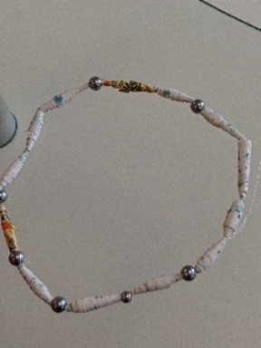

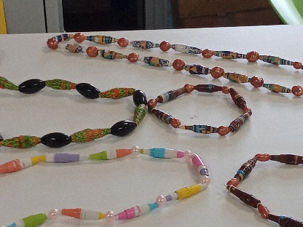

The craft group meets the first Monday of the month( unless it falls on a Bank Holiday and then it is the second Monday) 10am – 12noon at THE SHED (behind the Dr’s surgery) Wood Street, Warsop. NG20 0AX.
This year’s itinerary.
13th May 2024 – Pebble Painting
3rd June 2024 – Button Pictures/collages
5th August 2024 – Garden ornaments
2nd Sept, 7th Oct, 4th Nov - TBC
December 2024 – Christmas cards/calendars or wreaths

Zena

Photography Group
The Photography Group did not hold a ‘Face to Face’ meeting in March due to group members other commitments.
The online ‘Themed’ challenge continued, with the ‘Theme’ being ‘Anything that begins with either I or J’. It was obviously more of a challenge than previous ones as we had fewer entries.
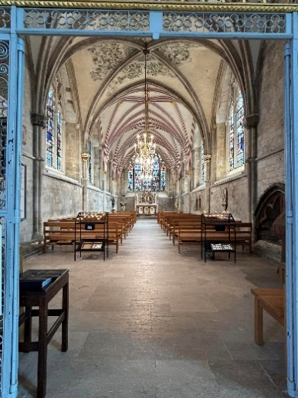
Joanne Wheatley – Ice house, Inside Church, Jam Jars & Jigsaw
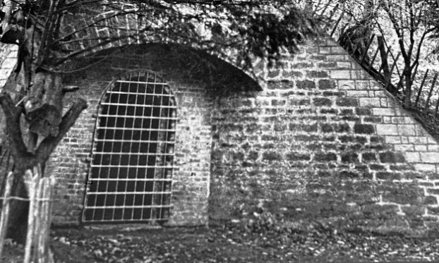


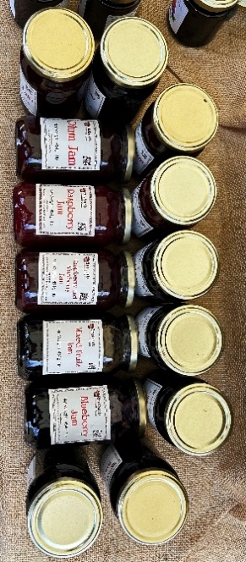

Bob Thomson – Italian herbs, Inca Tern, Jerk seasoning & Jesters

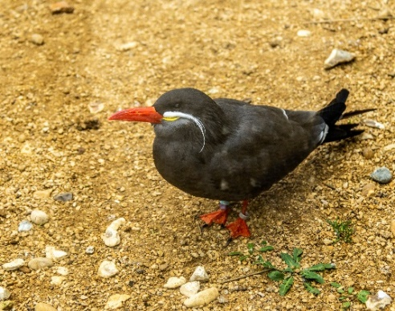

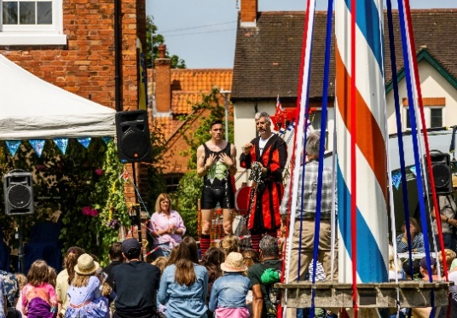


The next ‘Themed’ challenge is ‘Anything beginning with either K or L’.
Once again all u3a members are welcome to join in!
The next ‘Face to Face’ photography group meeting will be at 11am Friday 19th April 24, meeting in Thoresby Court yard to visit the Military Museum.

History Group
Our last meeting on the 19th March was very well attended. Barbara took us on an excellent and exciting virtual tour of Hardwick Hall telling us the story of Bess of Hardwick and the history behind key features of the magnificent hall Bess was responsible for building. Barbara works as a volunteer at Hardwick and is very knowledgeable about this topic. Our thanks go to her.
Our next meeting is on Tuesday 16th April at 10am at St Teresa’s Church Hall. Denis Hill will be visiting us to speak about Mining Communities.
Barbara will be collecting £6 subscriptions from those members who attend regularly at this meeting.
We hope to see you there. All welcome.
Barbara & Tamar

2024 - Proposed Calendar of Events for Warsop & District U3A History Group
16th Apr | Mining Communities  Denis Hill | St Teresa’s Church Hall 10am
21st May | The Story of Boots  Chris Weir | St Teresa’s Church Hall 10am
18th Jun | Visit to Richard 3rd Museum Leicester or Lincoln Castle and Cathedral.
16th July | Early History of Mansfield  Denis Hill | St Teresa’s Church Hall 10am
20th Aug | In house presentation  Eminent Local Sporting Personalities  Roger Holland | St Teresa’s Church Hall 10am
17th Sept | Historic Mansfield Trail  Denis Hill | Meet in Mansfield Town Square 10am
15th Oct | Nottinghamshire’s Dark Side  Chris Weir | St Teresa’s Church Hall 10am
19th Nov | Medieval Buildings & the English Civil War  James Wright TBA | St Teresa’s Church Hall 10am
17th Dec | No meeting as very close to Christmas
Speakers for the main meetings 2024

April 15th Knickers a Brief History Janet Stain

May 20th Social time

June 17th Before They Were Famous Mel Mitchell

July 15th More Funny Turns! Dave Moylan

August 19th Medieval superstitions and science. Gareth Howell

September 16th Annual General Meeting

INTEREST GROUP TIMETABLE
 | MONDAY | TUESDAY | WEDNESDAY | THURSDAY | FRIDAY
1st | 10am – 12pm  CRAFTS GROUP  The Adam Eastwood Building. Warsop |  |  |  | 2pm  FRIENDSHIP GROUP  The Plough Warsop
2nd |  | 10am  GARDENING GROUP  Venue agreed by members |  | 2pm  NATURAL HISTORY  SCIENCE AND  TECHNOLOGY  Plough Warsop
3rd | MAIN MEETING 10.15  Oaklands Centre  Warsop | 10am– 12pm  HISTORY GROUP  Catholic Church Warsop |  | 10am  WALKING GROUP  Carrs Car Park | 11.am  PHOTOGRAPHY  Venue to be agreed by the members.
4th | 10.30 -12.30  DICUSSION GROUP  Forest Lodge  Edwinstowe |  | 10.am  STROLLERS  Carrs Car Park
INTERNATIONAL DINING -Location and time as announced.
THEATRE GROUP - Location and time as announced.
PHOTOGRAPHY GROUP-Please see Newsletter for the online challenge.

Group | Leaders Name | Tel
NATURAL HISTORY SCIENCE AND TECHNOLOGY | Chris Shervey
WALKING GROUP | Brenda Pearce  Pam Hick
STROLLERS | Janet Harford  Pat Magness
HISTORY GROUP | Barbara Spybey
CRAFTS | Zena Inger
GARDENING | Linda Crossley
PHOTOGRAPHY | Rob Thomson
FRIENDSHIP GROUP | Betty Trinder
INTERNATIONAL DINING GROUP | Chris Wilson  Brenda Pearce
THEATRE GROUP | Jennifer Thomson
SOCIAL EVENTS ORGANISER
DISCUSSION GROUP | Mary Morris
REFRESHMENTS  QUIZ | Ann Ayodele
COULD GROUP LEADERS PLEASE COLLECT THEIR BADGES WHEN COLLECTING THEIR LANYARDS. (Then members at the meeting can identify who they may need/want to talk to)

April riddles

1What 5 letter word typed in Capitals can be read the same upside down.?

2 The more you take the more you leave behind?

3Why is Europe like a frying pan?

April quick quiz All answers start with J except for one.

- A South American big cat ?
- Books by Richmael Crompton about a schoolboy?
- Small terrier breed?
- Seventh President of the USA , Andrew------?
- Carnivorous mammal, related to the dog. Found in Asia and Africa?
- Pack of 78 cards for Fortune Telling?
- Island in the Caribbean?
- Horse riding trousers?
- King who signed The Magna Carta?
- Naval battle of WWI ?

Well I didn’t know That!

Whoopi Goldberg’s real name is CARYN ELAINE JOHNSON
Meg Ryan’s real name is MARGARET MARY EMILY ANNE HYRA
Wiona Ryder’s real name is WINONA LAURA HOROWITZ
Demi Moore’s real name is DEMETRIA GENE GUYNES
Brad Pitt’s real name is WILLIAM BRADLEY PITT
Nicholas Cage’s real name is NICHOLAS KIM COPPOLA

April quiz Can you name these films?

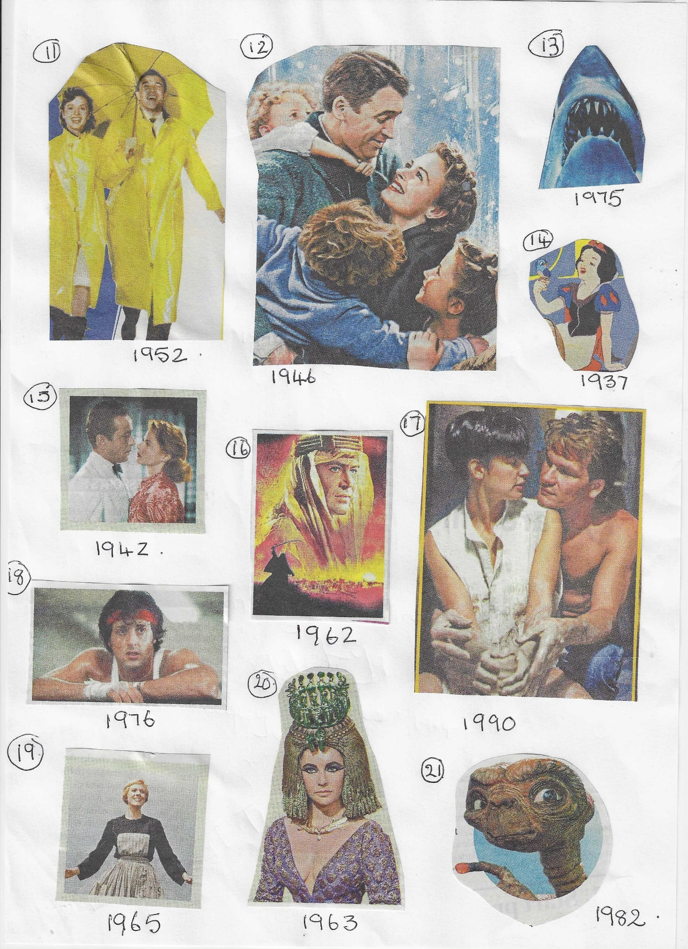

Answers MARCH RIDDLES
1 What is the most expensive fish? A Goldfish

2 What goes, up but never comes down? Age

3 A cowboy rode into town on Friday, he stayed 3 days and left on Friday. How is
this possible? His horse is called Friday

Answers March Quick Quiz All the answers start with I except for one.

1Which Island off the coast of Scotland is also known as St Colomba’s island? IONA
2 Which sport has 6 per side and is played on an ice rink? ICE HOCKEY
3 Name a long necked wading bird? IBIS
4 USA State dominated by the Rockie Mountains? IDAHO
5 Highly infectious skin disease? IMPETIGO
6 Modern name of Constantinople? ISTANBUL
7 Italian city home of the annual Palio (horse race through the streets)? SIENA
8 Large breed of hunting dog? IRISH WOLFHOUND
9 A shade of blue? INDIGO
10 Ancient Peruvian civilisation? INCA

Answers March Quiz SPELL CHECK Which is the correct spelling of these words? Answers underlined in blue.

1 Microprocessor Microprocesor

2 Hallucinate Halucinate

3 Afirmative Affirmative

4 Antirrhinum Antirhinum

5 Behaviorism Behaviourism

6 Calendar Calander

7 Audience Audience

8 Belligerent Beligerent

9 Binoculars Binoculers

10 Doppelganger Dopellganger

11 Catermaran Catarmaran

12 Emphazise Emphasise

13 Flautist Flutist

14 Hypocondriac Hypochondriac

15 Idiosyncrasy Indiocyncrasy

16 Kumquat Komquat

17 Fluorescent Flurescent

18 Misdemeanour Misdemenour

19 Doberman Dobermann

20 Volunteer Volunter

21 Scandalize Scandalise

22 Percolater Percolator

23 Neolithic Neolitthic

24 Pekingese Pekingnese

25 Judicial Judical

North Notts Neighbourhood Group
This means that you as a member of Warsop & District can ask to join an interest group in another U3A that is also in the NNNG, as long as the group is not oversubscribed at the time of your request you can join the group without joining the host u3a
The u3as in the NNNG are Mansfield, Sherwood, Dukeries, Rainworth, Forest Town, Ashfield, Sutton in Ashfield, Hucknall, Worksop and Warsop.

Data Protection Rules
Warsop & District U3A is committed to treating all people equally.
Anyone wishing to see the Privacy and Data Protection policies may view them on the Warsop & District U3A website, alternatively please ask Rob.

Website & Facebook
The Warsop & District u3a website can be found at the address below. If any of the group leaders/facilitators would like to advertise/ promote any of their future activities or change the information shown, please contact Bob Thomson.

Facebook
Warsop & District U3A has a Facebook Group. It is a private group which can be seen by the public but only members can see who’s in the group and what they post.
What this means is that you have to be invited to join the group or have your request to join accepted. Also you need to be on Facebook which some of you may not be. As a member of the group you will be able to put your own posts on the page, please keep them relevant to the U3A and what it stands for. We would ask that you don't put anything on that is in anyway party political or anything that may be offensive to others who may be of a different creed or religion. Hopefully everyone will join, use the page and find it useful.
One of the things that puts people ‘off’ Facebook, is the ‘bad press’ some of the Social sites get. You can join Facebook, choose only to join the Warsop Facebook page and not be involved in any other site, or Friends requests (usually from people that you have never heard of!) The choice is entirely yours.
To request to join the Warsop u3a Facebook page, contact Bob Thomson, email addresses as per the Website.

Committee Members | Role
Jim Shervey | Chairperson
Mel Mitchell | Deputy Chairperson
Irene Clay | Business Secretary
Linda Crossley | Treasurer
Carolyn Brankin | Membership Secretary
Jim Shervey | Speaker Seeker
Jennifer Thomson | Groups co-ordinator
Chris Shervey | Newsletter editor
Vacant | Social Events
Jennifer Thomson | Welfare Officer
Rob Thomson | Website & Facebook manager
Ann Ayodele | Refreshments rota /Quiz
June Whittle | Raffle
Betty Trinder | Social events assistant
Pat Magness | Co-opted member

