

Issue 73 December 2023
Warsop & Distict
Notes from the Chairman
Hi
With Christmas fast approaching I trust that you have all got your tinsel and baubles out ready to decorate with if you have not already got them in place.

Don’t forget that for the crafty ones amongst you there is space available for you at the Christmas party to show and sell your creations (see more detail in items of interest).

The Christmas party this year is a ‘simple’ affair, with background music, sandwiches, cakes and a table quiz to keep you brain cells ticking over, with plenty of time to chat and swap bad Christmas cracker jokes. There is a picture review of the year where photos from as many activities as possible have been gathered and will be projected throughout the morning and of course there will be the usual raffle. All are welcome just turn up, you don’t need to bring anything.

The recent quiz night was very good, good food and good questions. Look out for the date of the next quiz, it’s a good night out.

Merry Christmas and a Happy New Year
Jim Shervey
Chair

The deadline for including articles/information in the next newsletter is Friday 5th Jan Send contributions to Chris Shervey

Rota for refreshments and greeting.
Please be there around 9.30am, any problems please let me know 07460760870, thanks Ann.
December 18th
Refreshments – Ann Ayodele, Maureen Long
Meet & Greet – Kate Guest, Jean Hayes
January 15th
Refreshments – Ann Holland, Wendy Sterland
Meet & Greet – Yvonne Brown, Sandra Bradley
February 19th
Refreshments – Karen Breed, Pat Scattergood
Meet & Greet – Ray White, Ann Barnes
March 18th
Refreshments – Janice Thorlby, Anne Poultney
Meet & Greet – Brenda Pearce, Chris Wilson

ITEMS OF INTEREST
Cups Please will as many of you as
possible bring your own mug for your tea or coffee. This is not only more environmentally friendly but also would save us a lot of money as the paper disposable cups we use are surprisingly expensive. Ann.
Robin Hood Lottery 
Warsop and District U3A is a cause registered with the Robin Hood Lottery.
To buy a ticket you can now register on line at www.robinhoodlottery.co.uk and set up regular payments. If you buy a ticket every week for a year Warsop U3A will receive £26.
Remember the more members that have a go (specifying Warsop & District U3A) the more money we get for our funds.

Books and Jigsaws 50p. We made £9 at the November meeting. There will be NO jigsaws or books at the Dec meeting.

Craft Fair
As at the Christmas party last year we have craft items on sale. If there is anyone who has any craft items you wish to sell at the Christmas party bring them along. They don’t have to necessarily be Christmas crafts. All income is yours.

Raffle. The November Raffle raised £52. RAFFLE PRIZES NEEDED PLEASE ESPECIALLY ONES SUITABLE FOR MEN.

Christmas Quiz SEASONS GREETINGS TO ALL The answers begin with the letter opposite the question.
S You will find 7 of these in "The 12 Days of Christmas" ?
E A traditional Christmas drink?
A Reindeer Headgear! ?
S The song "Floating in the Air" is from The ?
O From which carol are these words Yea Lord We Greet Thee" ?
N Another name for Christmas?
S What did the Magi follow ?

G Who visited Mary?
R A Christmas bird?
E Christian name of Scrooge?
E Mother of John the Baptist (cousin of Mary)
T In the carol how many ships came sailing in?
I Where is Christmas Island?
N Mary and Joseph travelled from here?
G A present given to Baby Jesus?
S The fountain in the carol Good King Wenceslas?

T Composer of the ballet The Nutcracker?
O In which carol are these words " How still we see thee lie" ?

A The time leading up to Christmas?
L Shining everywhere at Christmas ?
L A Christmas song by Wham?

Group News
Theatre Group
Our run of shows in the lead up to Christmas is now complete.
We shall meet on Friday 2nd February at 2 pm in The Plough, to decide which shows we'd like to see in 2024. New members welcome.

Welfare
So that I may let members know that they are in our thoughts when they are ill or bereaved, please let me know of any members in this situation. Thank you, Jen.

The Friendship Group
The Friendship Group met on Friday 1st December for another enjoyable afternoon. The next meeting will be on 5th January, 2024. Looking ahead the February meeting will be on Friday the 2nd. Make a note in your new diary. Wishing everybody a happy Christmas and all the best for 2024.
Betty

International Dining
The next evening excursion for the International Dining group will be in the new year.

Silver Screeners

Savoy cinema Worksop. For the over 50’s. Every Wednesday at 11.30. Tickets £4.50, include a drink and free raffle.
Upcoming Movies in January:
Wednesday 3rd Jan - Bolan’s Shoes
A love letter to 70s glam rock told through the eyes of two children who grew up in a children’s home and were involved in an accident after attending a T-Rex concert.

Wednesday 10th Jan - And Then Come the Nightjars
A heart-warming story of friendship and survival set against the backdrop of the 2001 Foot and Mouth outbreak.
Discussion Group
We still have a few spare places. so come along and see what we're all about.

Regards Mary Morris

Bridge Club
The Dukeries u3a Bridge Group meet on the Second and Fourth Tuesday of each month at the Jubilee Hall (NG22 9AP) from 1 – 4PM. The cost of each session is currently £3.
All U3a members are welcome to attend.

Walking Group

For our last walk of the year we did a circular walk starting from Cuckney we headed towards Norton and into part of Welbeck Estate. Our walk took us past the White Deer Park before heading back via the Cuckney Water Meadow.
Welbeck continues to be a working estate. It contains a Grade 2 historic park, designed in 1748, ancient woodlands and forestry, lakes, farmland, grazing and a deer park. It also has some of the country’s most important rural heritage buildings
We are in the process of finalising our 2024 programme but for our January walk we are staying local due to the shorter days and uncertainty of the weather. Leaving The Carrs at 10.00 a.m. prompt (Thursday 18th January)
WALKING GROUP - 3RD THURSDAY OF THE MONTH 2024
Date | Walk Leader | Walk | Distance
18th January | Brenda Pearce | Carrs - Local Walk | 3.5 miles
15th February | Pam Hick | Sherwood RSPB
21st March | Val Buckinger | Edwinstowe
18th April | Brenda Pearce | Glapwell to Hardwick Circular
16th May | Gerald Weston | Mansfield Woodhouse
20th June | Val Buckinger | Clumber Lake | 4 miles
18th July | Jen Long | Gleadthorpe | 4 miles
15th August |  | TBC
19th September |  | TBC
17th October | Brenda Pearce | Ault Hucknall | 3.5 or 5 miles
21st November |  | TBC
 |  | Walks can be subject to change

Strollers
The last stroll of the year was around the grounds of Thoresby Hall. Followed by coffee and a chat in the courtyard café, We even had time for a look in the Courtyard shops.There will be no stroll in December due to it's proximity to Christmas. The next stroll will be the24th January .Details in January newsletter. Best wishes Pat.

TIMETABLE FOR 2024

Jan 24th | Sherwood Forest
Feb 28th | Vicar Water
Mar 27th | Poulter Park
Apr 24th | Rufford Rufford
May 22nd | Thoresby
June 26th | Cresswell Crags

Photography Group
The Photography Group held its last ‘Face to Face’ meeting of the year at Clumber Park.
It was a glorious sunny, dry but slightly breezy day and the trees and bushes were showing their autumnal colours. And to our surprise Shaun the Sheep and his pals were also visiting!
The online ‘Themed’ challenge was ‘Anything that starts with either A or B’

Betty Trinder – Clumber park
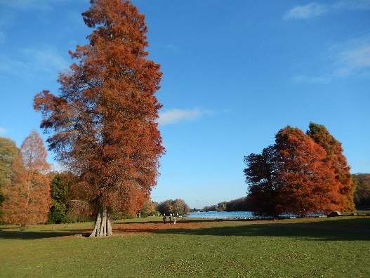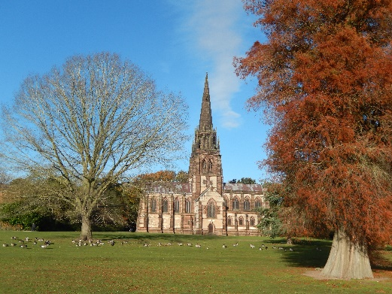
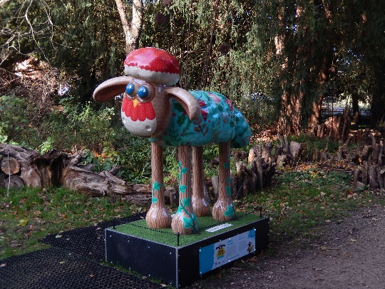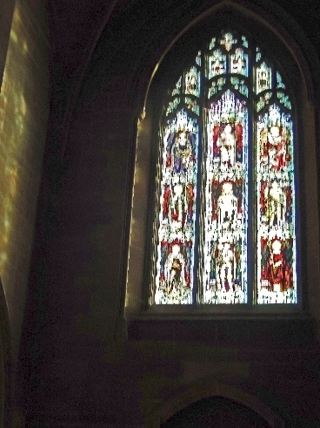
Joanne Wheatley B= Berries & Bonfire / Clumber park
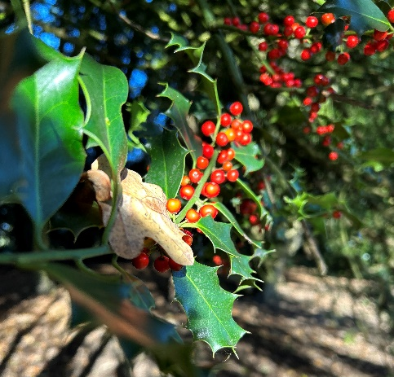
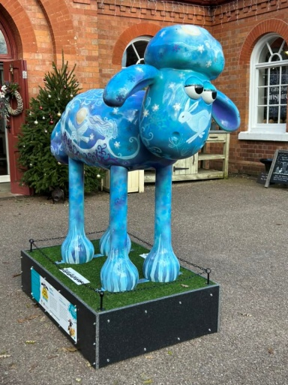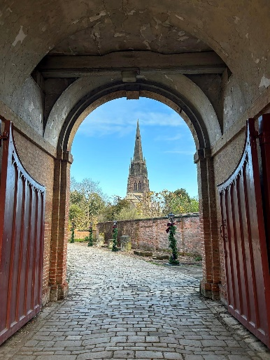
Bob Thomson A =Archway B= Baubles / Clumber park
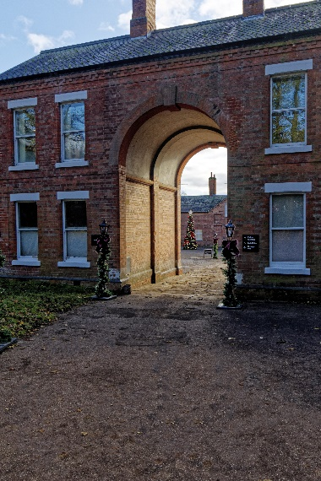
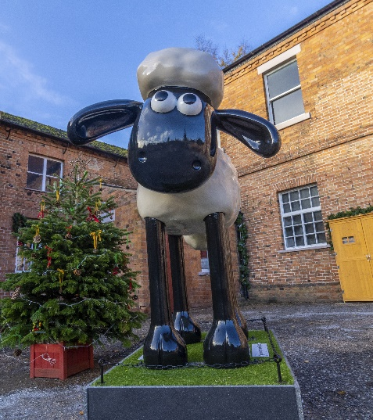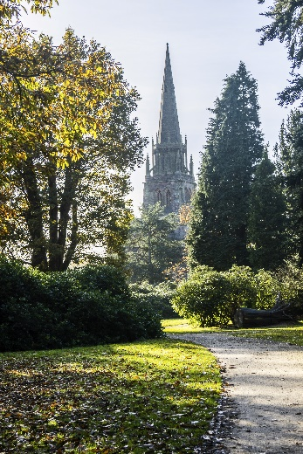
The next online ‘Themed’ challenge is ‘Anything that begins with either C or D’.
Once again this challenge is open to All u3a members, it shouldn’t be difficult to find something that fits at this time of Year!
From the Photography Group MERRY CHRISTMAS EVERYONE, AND A HAPPY NEW YEAR!

Craft Group
Timetable for 2024 (these are subject to change if necessary).

December 2023 & January 2024 | No meeting
5th February 2024 | Felt Lavender Bags
4th March 2024 | Twiggy Easter Trees
April 2024 | Toiletry bags made from face flannels
May 2024 – | Stone Painting
3rd June 2024 | Jewelry
1st July 2024 | Button Pictures/collages
5th August 2024 | Garden ornaments
September, October & November | To be decided
2nd December | Christmas cards/calendars

If you would like to join us for any of the above Monday mornings you will be made very welcome. We always have a good time, with refreshments and biscuits. The only thing you need to bring is just a basic sewing kit and a willingness to have a go at anything. All materials are available for a very small donation to the person who brings them. If anything more specialised is required you will be given the opportunity to get it yourself or borrow from other group members.
The next meeting is at THE SHED (behind the Dr’s surgery) Wood Street, Warsop. NG20 0AX, on Monday 5th February 2024 at 10am, when subs will be discussed.
Zena.

History Group
The history group met on the 21st of November when local historian, Denis Hill, spoke to us about ‘Old and Curious Occupations.’
Denis’ talk featured many occupations from Medieval times through to the Victorian age, including some now obsolete and others which have changed considerably over time due to technological and industrial advancement.
Here is a selection:
Cordwainer: this was someone who mainly made shoes using only the finest Spanish leather. Other leather items were also made, including belts and bags.
Brazier: someone who made utensils and ornaments using brass and copper, sometimes joining both metals together.
Executioner: In the 1820s there were 120 crimes for which the perpetrator could be executed. The Executioner was also given license to torture and punish. The Gibet was used as a particularly cruel form of execution, taking up to three days to deliver a slow and agonising death. The stocks were a common form of public punishment in Medieval and Tudor times.
Ale Conner: this was a quality control beer taster - nice work if you could get it! In the early 19th Century there were 33 malt mills in Mansfield, but by the late 1880s they had drastically reduced in number.
Denis also informed us that in past times many occupations were known by a different name. For example, a schoolteacher was a ‘philomathmaticus.’
I would like to thank our group ‘nutter,’ Roger for taking notes of Denis’ talk to share with you in this newsletter. I kid you not, apparently this was the name given to a note taker in bygone days!
We take a break from our meetings in December but have an exciting calendar of talks and visits planned for 2024.In the meantime if you are reading any good history books or have visited any historic sites or exhibitions you would like share with us, please let me know the details.
Our first meeting of the year is on January 16th at 10am in St Theresa’s church hall when our talk is about a Hayman Rooke, a local man who was involved in local archaeology and paved the way for some of today’s archaeological work.
We look forward to seeing you at our January meeting, everyone welcome.
In the meantime, we wish you a very merry Christmas.
Barbara, Sue & Tamar

Warsop & District U3A History Group Calendar of Events 2023
December | No meeting as very close to Christmas

2024 - Proposed Calendar of Events for Warsop & District U3A History Group
16th Jan | Hayman Rooke - Denis Hill | St Theresa’s Church Hall 10am
20th Feb | Four Kings. Chris Shervey | St Theresa’s Church Hall 10am
19th Mar | Visit to Hardwick Hall -
16th Apr | Mining Communities  Denis Hill | St Theresa’s Church Hall 10am
21st May | The Story of Boots  Chris Weir | St Theresa’s Church Hall 10am
18th Jun | Visit to Richard 3rd Museum Leicester or Lincoln Castle and Cathedral.
16th July | Early History of Mansfield  Denis Hill | St Theresa’s Church Hall 10am
20th Aug | In house presentation  Eminent Local Sporting Personalities  Roger Holland | St Theresa’s Church Hall 10am
17th Sept | Historic Mansfield Trail  Denis Hill | Meet in Mansfield Town Square 10am
15th Oct | Nottinghamshire’s Dark Side  Chris Weir | St Theresa’s Church Hall 10am
19th Nov | Medieval Buildings & the English Civil War  James Wright TBA | St Theresa’s Church Hall 10am
17th Dec | No meeting as very close to Christmas

Natural History, Science and Technology.
There is no meeting in Dec, our next meeting is Jan 11th when Joyce is giving a talk on the Immune System.
2024
Thursday 11th Jan | Anti- gen and Anti- bodies  Your Immune System
Thursday 8th Feb | Habitats around us
Thursday 14th March | Bats
Thursday 18th April | Visit to Veolia 2.00pm | Note this is not our usual meeting date
Thursday 9th May | To be decided
Thursday 13th June | To be decided
Thursday 11th July | St Johns | CPR and use of DEFRIBULATOR

A Politically Correct Christmas In a world that has gone politically correct mad I hope these will make you smile as they made me smile when I read them.
The Rocking Carol
Little Jesus sweetly sleep do not stir
We will lend you a coat of fur
We will rock you rock you
We will rock you rock you---

Fur is no longer appropriate therefore faux fur or a nice blanket should be used. Persons must have clearance before being allowed to rock the baby!!!

Jingle Bells
Dashing through the snow
In a one horse open sleigh
O'er the fields we go
Laughing all the way---

A risk assessment must be carried out to see if the sleigh is safe to travel on. Permission must be granted from the land owners before going o'er the fields. Please make sure the laughter does not create a noise nuisance !!!!

While Shepherds watched their flocks by night
While Shepherds watched
Their flocks by night
All seated on the ground-----

The union for shepherds has complained the it breaches Health and safety for them not to have appropriate seating arrangements.Therefore benches and chairs will be provided in future !!!!

Rudolph the red nosed reindeer
Rudolph the red nosed reindeer
Had a very shiny nose
And if you ever saw him
You would even says it glows

You are advised under the equal opportunities policy that it is inappropriate to make a comment on the redness of any part of Mr R Reindeer. Further the exclusion of Mr R Reindeer from the games is considered discriminatory.

Speakers for the main meetings

2023
December 18th Christmas Party

2024
January 15th Wild West with Songs Steve Allen

February 19th A Family History(Title to be confirmed) Peter Slater

March 18th ‘Mind Your Motoring Manners 1928’ Paula Cornwell

April 15th Knickers a Brief History Janet Stain

May 20th Social time

June 17th (Title to be confirmed) Mel Mitchell

July 15th More Funny Turns! Dave Moylan

August 19th Medieval superstitions and science. Gareth Howell

September 16th Annual General Meeting

Group | Name
NATURAL HISTORY SCIENCE AND TECHNOLOGY | Chris Shervey
WALKING GROUP | Brenda Pearce  Pam Hick
STROLLERS | Sue Cox  Pat Magness
HISTORY GROUP | Barbara Spybey
CRAFTS | Zena Inger
GARDENING | Linda Crossley
PHOTOGRAPHY | Rob Thomson
FRIENDSHIP GROUP | Betty Trinder
INTERNATIONAL DINING GROUP | Chris Wilson  Brenda Pearce
THEATRE GROUP | Jennifer Thomson
SOCIAL EVENTS ORGANISER
DISCUSSION GROUP | Mary Morris
 | Ann Ayodele
COULD GROUP LEADERS PLEASE COLLECT THEIR BADGES WHEN COLLECTING THEIR LANYARDS. (Then members at the meeting can identify who they may need/want to talk to)

INTEREST GROUP TIMETABLE
 | MONDAY | TUESDAY | WEDNESDAY | THURSDAY | FRIDAY
1st | 10am – 12pm  CRAFTS GROUP  The Adam Eastwood Building. Warsop |  |  |  | 2pm  FRIENDSHIP GROUP  The Plough Warsop
2nd |  | 10am  GARDENING GROUP  Venue agreed by members |  | 2pm  NATURAL HISTORY  SCIENCE AND  TECHNOLOGY  Plough Warsop
3rd | MAIN MEETING 10.15  Oaklands Centre  Warsop | 10am– 12pm  HISTORY GROUP  Catholic Church Warsop |  | 10am  WALKING GROUP  Carrs Car Park | 11.am  PHOTOGRAPHY  Venue to be agreed by the members.
4th | 10.30 -12.30  DICUSSION GROUP  Forest Lodge  Edwinstowe |  | 10.am  STROLLERS  Carrs Car Park
INTERNATIONAL DINING -Location and time as announced.
THEATRE GROUP - Location and time as announced.
PHOTOGRAPHY GROUP-Please see Newsletter for the online challenge.

Answers TO November Quiz - Where in the world? In which town/city will you find these famous landmarks?
1 Golden Gate Bridge SAN FRANCISCO
2 Statue of Christ the Redeemer? RIO DE JANERIO
3 The Alhambra Palace? GRANADA
4 Raffles Hotel? SINGAPORE
5 The Wailing Wall? JERUSALEM
6 The Cutty Sark? GREENWICH
7 Arthur's Seat? EDINBURGH
8 The Sears Tower? CHICAGO
9 Colosseum? ROME
10 The Golden Temple? AMRITSAR
11 Sangrada Famillia? BARCELONA
12 Bridge of Sighs? VENICE
13 Taj Mahal? AGRA
14 HMS Victory? PORTSMOUTH
15 Angel of the North? GATESHEAD
16 Statue of Liberty? NEW YORK
17 Arche de Triomphe? PARIS
18 St Basil's Cathedral? MOSCOW
19 Royal Yacht Britannia? EDINBURGH
20 Hermitage Museum? ST PETERSBURG
21 Albert Memorial? LONDON
22 Great Pyramid? GIZA
23 Angkor Wat? SIEM REAP
24 Brandenburg Gate? BERLIN
25 Tyne Bridge? NEWCASTLE
26 Acropolis? ATHENS
27 Clifton Suspension Bridge? BRISTOL
ANSWERS TO November quick quiz All the answers start with E except one.
1 A city famous for it's Fringe Festival EDINBURGH
2 A country in South America? ECUADOR
3 Name of a former British Triple Jumper ( surname E) JOHNATHAN EDWARDS
4 King who was victorious at Agincourt? HENRY 1V
5 Tesla is a make of? ELECTRIC CAR
6 Famous marble sculptures in the British Museum? ELGIN
7 The French call it La Manche, what do we call it? ENGLISH CHANNEL
8 Famous racecourse in Surrey? EPSOM
9 County town of Devon? EXETER
10 The Greek god of love? EROS

Answers to NOVEMBER RIDDLES
1 What goes up and down but doesn't move? A STAIRCASE
2 What has one eye and cannot see? A NEEDLE
3 What is cut on a table but never eaten? A DECK OF CARDS

North Notts Neighbourhood Group
This means that you as a member of Warsop & District can ask to join an interest group in another U3A that is also in the NNNG, as long as the group is not oversubscribed at the time of your request you can join the group without joining the host u3a
The u3as in the NNNG are Mansfield, Sherwood, Dukeries, Rainworth, Forest Town, Ashfield, Sutton in Ashfield, Hucknall, Worksop and Warsop.

Data Protection Rules
Warsop & District U3A is committed to treating all people equally.
Anyone wishing to see the Privacy and Data Protection policies may view them on the Warsop & District U3A website, alternatively please ask Rob.

Website & Facebook
The Warsop & District u3a website can be found at the address below. If any of the group leaders/facilitators would like to advertise/ promote any of their future activities or change the information shown, please contact Bob Thomson.

Facebook
Warsop & District U3A has a Facebook Group. It is a private group which can be seen by the public but only members can see who’s in the group and what they post.
What this means is that you have to be invited to join the group or have your request to join accepted. Also you need to be on Facebook which some of you may not be. As a member of the group you will be able to put your own posts on the page, please keep them relevant to the U3A and what it stands for. We would ask that you don't put anything on that is in anyway party political or anything that may be offensive to others who may be of a different creed or religion. Hopefully everyone will join, use the page and find it useful.
One of the things that puts people ‘off’ Facebook, is the ‘bad press’ some of the Social sites get. You can join Facebook, choose only to join the Warsop Facebook page and not be involved in any other site, or Friends requests (usually from people that you have never heard of!) The choice is entirely yours.
To request to join the Warsop u3a Facebook page, contact Bob Thomson, email addresses as per the Website.

Committee Members | Role
Jim Shervey | Chairperson
Mel Mitchell | Deputy Chairperson
Irene Clay | Business Secretary
Linda Crossley | Treasurer
Mel Mitchell | Membership Secretary
Jim Shervey | Speaker Seeker
Jennifer Thomson | Groups co-ordinator
Chris Shervey | Newsletter editor
Vacant | Social Events
Jennifer Thomson | Welfare Officer
Rob Thomson | Website & Facebook manager
Ann Ayodele | Refreshments rota/Quiz
June Whittle | Raffle
Betty Trinder | Social events assistant
Carolyn Brankin | Co-opted member
Pat Magness | Co-opted member

