
Issue 71 October 2023
Warsop & Distict
Notes from the Chairman
Hi Everyone.
This year is flying past how has it got to October so soon.
The AGM and silent auction went we last month, for what set out as a bit of fun to run alongside the AGM the silent auction raised a decent amount of money. See the report below.
One request that came out of the AGM is instead of a speaker at our main meetings could we occasionally have social time, where members can just sit and chat, the first of these is next May.
It was disappointing to have the Veolia visit postponed at short notice, it was something to do with industrial action. A new date is in the diary for next year.
The speaker this month is David Moylan, with a talk titled ‘Funny Turn’. I have seen good reviews for David and am looking forward to hearing him speak.

Look out for the next quiz, Ann is now organizing these and has 30th November as a date for the next quiz. They are always a good evening out.

Also a reminder that payments for the ‘Last Night of the Proms’ are due. This brings me to the organization of our Social events. With Jen stepping away from this roll we are in need of a person or a group of people to take over organizing social events. Please let us know if you are able to help.

Jim Shervey
Chair

The deadline for including articles/information in the next newsletter is Friday 10th Nov. Send contributions to Chris Shervey.

Rota for refreshments and greeting.
Please be there around 9.30am, any problems please let me know, thanks Ann.
October 16th
Refreshments - Audrey Gilbert, Zena Inga
Meet & Greet – Jill Greer, Barbara Hartsholm
November 20th
Refreshments – Angelina Taylor, Patricia Scattergood
Meet & Greet – Glenys Fearn, Ruth Murphy
December 18th
Refreshments – Julia Easom, Maureen Long
Meet & Greet – Kate Guest, Jean Hayes
January 15th
Refreshments – Ann Holland, Pauline Wright
Meet & Greet – Yvonne Brown, Moira Heslop
February 19th
Refreshments – Karen Breed, Ann Barnes
Meet & Greet – Ray White, Sandra Bradley
March 18th
Refreshments – Janice Thorlby, Anne Poultney
Meet & Greet – Brenda Pearce, Chris Wilson
ITEMS OF INTEREST
Thank you to everyone who brought / bought items at the Silent Auction it was very successful and hopefully a bit of fun. We made £259.60. THANK YOU

Group Folders- At each main meeting the group folders are out for members to see what each group has been doing and they also give you an insight if you think you may wish to join that group. The first page of each folder is the sign up sheet if you would like to join or just wish for more information. If anyone has an idea for a group they would like to start let Jen know. From the 12th of this month Jen Thomson is taking over as Group Co-ordinator.

Robin Hood Lottery 
Warsop and District U3A is a cause registered with the Robin Hood Lottery.
To buy a ticket you can now register on line at www.robinhoodlottery.co.uk and set up regular payments. If you buy a ticket every week for a year Warsop U3A will receive £26.
Remember the more members that have a go (specifying Warsop & District U3A) the more money we get for our funds.

Bottle Tops
NO MORE BOTTLE TOPS THANKYOU, THE HOSPICE IS NO LONGER
COLLECTING THEM. THANK YOU TO EVERYONE WHO BROUGHT SOME. Barbara Hartshorn
Cups Please will as many of you as possible bring your own mug for your tea or coffee. This is not only more environmentally friendly but also would save us a lot of money as the paper disposable cups we use are surprisingly expensive. Ann.

Raffle. RAFFLE PRIZES NEEDED PLEASE ESPECIALLY ONES SUITABLE FOR MEN.

Books and Jigsaws 50p. WE HAVE HAD LOTS OF NEW BOOKS AND JIGSAWS GIVEN SO PLEASE HAVE A LOOK. The books are sorted into genres e.g. Crime Non- Fiction Historical etc so it is easier to find a book you like.

Group News

Theatre Group 
This Photo by Unknown Author is licensed under CC BY-NC-ND
There are no meetings planned until the New Year, as the group has a busy schedule ahead with tickets bought for several shows.
However, if anyone is interested in joining us please take a look at our group folder and let me know if you would like to be added to our mailing list and invited to our next meeting.
Welfare
So that we may send greetings to any members unable to attend at least 2 consecutive monthly meetings due to personal illness, please let me know of anyone meeting this criterion.
Similarly, let me know if any of our members suffer a bereavement so that we may send condolences. Thank you, Jen.

Social Events
Barn Dance
I shall be issuing refunds to anyone who had paid for this event at the October meeting.

Last Night at the Proms, Saturday 11th November at The Hostess. 6.30pm for 7pm.
The balance of payment for this event is now due, and I need to collect this at the October meeting. For most people this will be £25 each.

The October meeting will be my last one as Social Events Organiser so I'd like to thank everyone for their support over the last few years.
Jen.

Quiz Night
Our next quiz night will be on Thursday 30th November, at the Plough, arriving for 7.00pm, to eat at 7.15. The choice of food is as before, pie and peas or baked potato and toppings. Tickets are £6.00 and I will be selling them at our October meeting on Monday October 16th. After previous comments we are endeavouring to make the questions more easily answerable (but not too easy!). Ann Ayodele.

The Friendship Group 

By the time you read this the Friendship Group will have held their October meeting so get out your diaries and make a note that we will be meeting at the Plough on Friday, 3rd November at 2.00 p.m. We would welcome any members who would like to join us for a very friendly social afternoon, perhaps you could bring some new games or ideas to the group. Look forward to seeing you. Betty


International Dining
The next evening excursion for the International Dining group will probably be in the new year. But don’t worry there was talk of a lunchtime visit for the group. Watch this space.

Silver Screeners

Savoy cinema Worksop. For the over 50’s. Every Wednesday at 11.30. Tickets £4.50, include a drink and free raffle.

The Equaliser 3 

Since giving up his life as a government assassin, Robert McCall (Denzel Washington) has struggled to reconcile the horrific things he’s done in the past and finds a strange solace in serving justice on behalf of the oppressed. Finding himself surprisingly at home in Southern Italy, he discovers his new friends are under the control of local crime bosses. As events turn deadly, McCall knows what he has to do: become his friends’ protector by taking on the mafia.

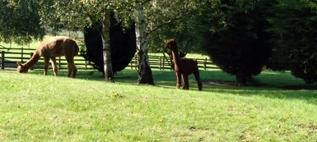

Walking Group
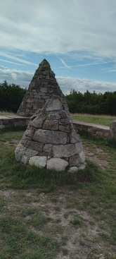
Leaving the car park at Poulter Park we made our way towards Scarcliffe taking in part of the Sculpture Trail and the Archaeological Way before reaching the Alpaca farm.
From there we we made our way to the highest point known as ‘Top of the World’ where we enjoyed views towards the Trent Valley and Lincoln. In all we saw 4 of the sculptures on display Dragonfly, Scimitar Flower, Top of the World and Bridging the Gap. We all agreed it was a lovely steady walk .
As the weather was so nice we called for refreshments at The Jug & Glass which made a perfect end to a very enjoyable mornings walk.
The October walk will be Gleadthorpe Pumping Station and surrounding area.
Date: Thursday 19th October. Leaving The Carrs at 10.00 a.m. prompt
The final walk of the year in November will be Cuckney/Norton Circular.
We are in the process of planning the walk program for 2024. Any ideas for a route or if you could lead a walk please let us know.
Brenda & Pam

Garden Group 
Six members of the garden group went to East Bridgeford garden centre. It’s not a very big place, but we had our lunch there and a few members bought plants. A very pleasant outing.
Novembers visit is yet to be decided, probably a big centre with Christmas stuff and plenty of indoor space in case the weather is bad.
Linda

Discussion Group 
This Photo by Unknown Author is licensed under CC BY-SA
The discussion group met Monday 28th and the conversation flowed really well. There are maximum of 6 places left. The next date will be Monday 23rd November, 10.30am at the forest Lodge Edwinstowe.
Regards Mary Morris

Photography Group
The Photography Group did not have a ‘Face to Face’ meeting in September 23 due to holidays.
The ‘Themed’ challenge did continue online though, with the ‘Theme’ being ‘Signs of Autumn’ and ‘Reflections’
Joyce O’Neill – Autumn / Reflections


Joanne Wheatley – Autumn / Reflections
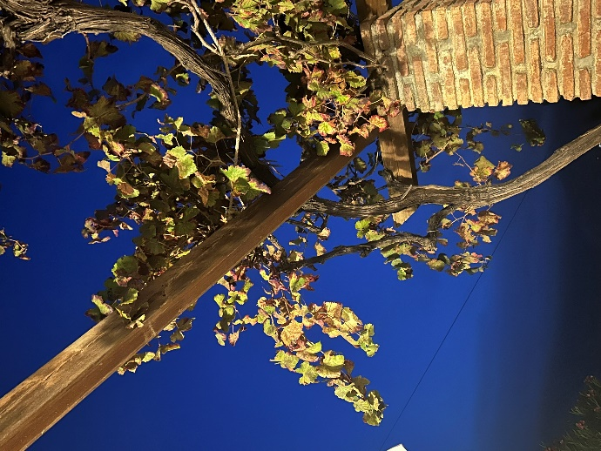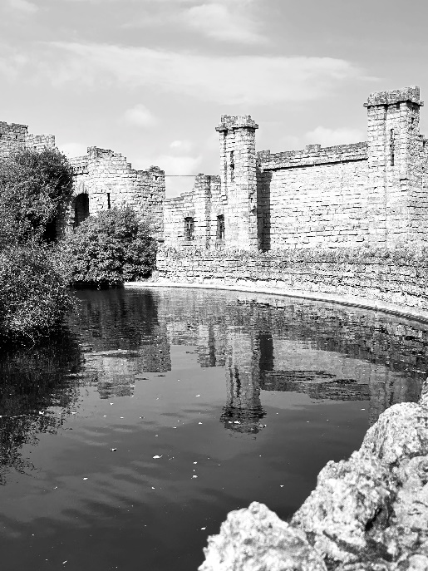

Chris Shervey – Autumn
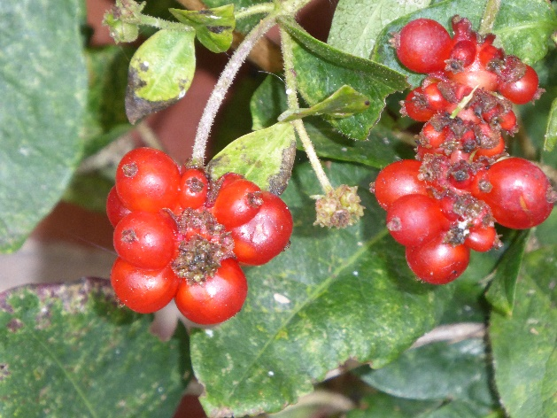

Jim Shervey – Reflections
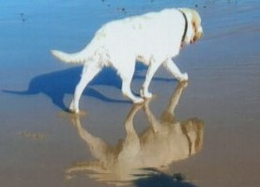

Bob Thomson – Autumn / Reflections
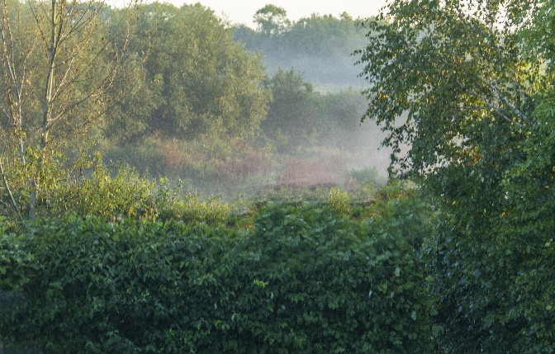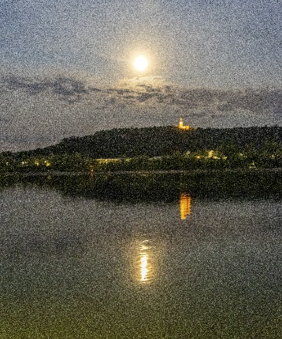
This is just a selection of the photos from the ‘Themed’ challenge, to see more either see the Photography group Folder, or visit the Warsop u3a Facebook page.
Once again a BIG THANK YOU to Jim & Chris Shervey for taking part in the challenge. Just a reminder that the ‘Themed’ challenges are open to ALL u3a members. If you have photos that you would like to enter, but don’t want to use Facebook, email them to me, and I will upload them for you, and put them in the Newsletter!
The next ‘Themed’ challenge is 'Sunrise/Sunset' or 'Faces in unusual places'.

Strollers 
Unfortunately we were not able to go on the planned stroll to Thoresby as we did not have enough transport. So we had a stroll across the fields at Warsop and then to the café on the High Street for a coffee and a chat. The next stroll will be on Wednesday, 25th October walking from the Dukeries car park to Creswell Crags.
Meet at the Carrs car park 10.00am for car share to Dukeries car park.
New members most welcome.
Pat and Sue"
Bridge Club
The Dukeries u3a Bridge Group meet on the Second and Fourth Tuesday of each month at the Jubilee Hall (NG22 9AP) from 1 – 4PM. The cost of each session is currently £3.
All U3a members are welcome to attend.

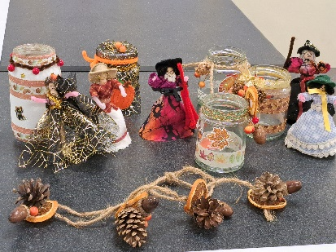
Craft Group 
Ten people met for the craft group on Monday 2nd October, we made peg dolls, decorated glass jars for battery lights and one wreath. We had lots of laughs a cuppa and biscuits.
Next month, Monday 6th November, will be the last meeting of the year when we will be making 3D Christmas cards and folded paper snowflakes.
We will resume the group on Monday 5th February 2024. We would love to see more members in the new year.

History Group 

On Tuesday 19th September 2023 eighteen members of the history group visited Bakewell Old House Museum. We were welcomed by Mark, the manager of BOHM who gave us a brief history of the house before we looked at the many exhibits on show in the museum.
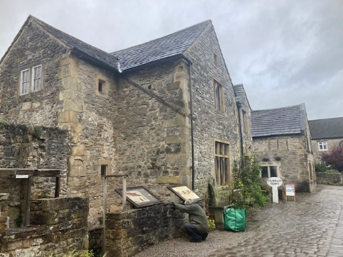
The museum is housed in a Tudor house, built by the Gell family in the 1500s to house their steward, Christopher Plant, who was responsible for collecting the tithes owed by local people to the Gell family.
The house was later used by Arkwright to house his mill workers at his third cotton mill built on the river Wye close to Bakewell. The house was altered with many of the Tudor features being covered over to make a multi occupancy dwelling.
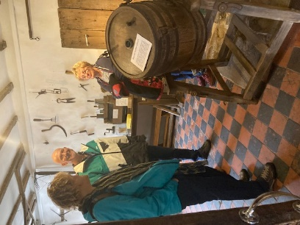
By the twentieth century the house was in bad repair and unfit to house people. The Council wanted to demolish the building in 1954 but a local builder examined the building and found the original Tudor fireplace which had been boarded over, wattle and daub walls and Tudor windows. The site was too valuable historically to demolish so a group of local people formed the Bakewell & District Historic Society. They raised money to repair the building and in 1959 it was opened as a museum.
Following out visit to the museum we visited the town for lunch and eight members braved the rain to do the Secrets and Legends of Bakewell Heritage Walk. We visited six points around the town with our guide Michael, the stone bridge, the old arcaded market, Bath Gardens and Rutland Square, the original town centre, and the hillside church of All Saints.
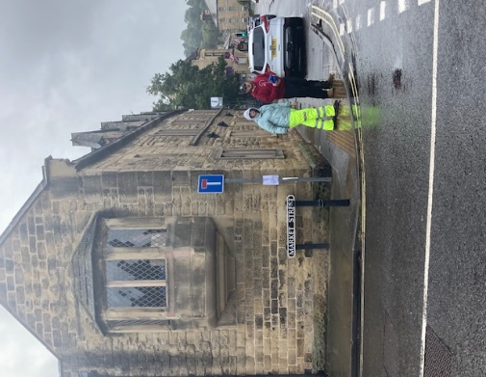
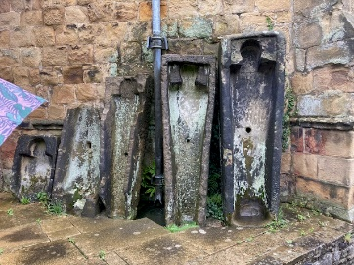
We learned Bakewell was an Anglo-Saxon town and its name derived from the springs in the town. It was originally called Baedeca’s Wella, meaning Baedeca’s Springs. We heard stories of witchcraft and elopements and we saw gritstone sarcophagi and Saxon stonework. If you would like to know more about this topic a full write up of our visit is available upon request.
Our next meeting is on Tuesday 17th October at 10am at St Theresa’s church hall when we welcome James Wright who will be presenting a talk entitled, ‘Secret Tunnels and Passageways.’ We look forward to seeing you there. All welcome.
Barbara, Sue and Tamar

Warsop & District U3A History Group Calendar of Events 2023
17th October 2023 | Presentation - Secret Passages and Hidden Tunnels  By James Wright | St Theresa’s Church Hall 10am
21st November 2023 | Presentation – Curious Occupations?  Denis Hill | St Theresa’s Church Hall 10am
December | No meeting as very close to Christmas

2024 - Proposed Calendar of Events for Warsop & District U3A History Group
16th Jan | Hayman Rooke - Denis Hill | St Theresa’s Church Hall 10am
20th Feb | Four Kings. Chris Shervey | St Theresa’s Church Hall 10am
19th Mar | Visit to Hardwick Hall -
16th Apr | Mining Communities  Denis Hill | St Theresa’s Church Hall 10am
21st May | The Story of Boots  Chris Weir | St Theresa’s Church Hall 10am
18th Jun | Visit to Richard 3rd Museum Leicester or Lincoln Castle and Cathedral.
16th July | Early History of Mansfield  Denis Hill | St Theresa’s Church Hall 10am
20th Aug | In house presentation  Eminent Local Sporting Personalities  Roger Holland | St Theresa’s Church Hall 10am
17th Sept | Historic Mansfield Trail  Denis Hill | Meet in Mansfield Town Square 10am
15th Oct | Nottinghamshire’s Dark Side  Chris Weir | St Theresa’s Church Hall 10am
19th Nov | Medieval Buildings & the English Civil War  James Wright TBA | St Theresa’s Church Hall 10am
17th Dec | No meeting as very close to Christmas


Natural History, Science and Technology.
Unfortunately the visit to Veolia has been cancelled due to Industrial Action at the Veolia plant. The visit has been rearranged for April next year.

2023
Weds 18th Oct afternoon | Visit to Veolia | Cancelled
Thurs 9th Nov | The 3 A’s Anaesthetics Antibiotics and Antiseptics.  Discussion of programme for 2024
Thurs 14th Dec | No meeting
Thursday 8th Jan | To be decided
Thursday 15th Feb | Habitats around us
Thursday 14th | Bats
Thursday 18th April | Visit to Veolia 2.00pm | Note this is not our usual meeting date

Group Co-ordinators
Group | Name | Email | Tel
NATURAL HISTORY SCIENCE AND TECHNOLOGY | Chris Shervey
WALKING GROUP | Brenda Pearce  Pam Hick
STROLLERS | Sue Cox  Pat Magness
HISTORY GROUP | Barbara Spybey
CRAFTS | Zena Inger
GARDENING | Linda Crossley
PHOTOGRAPHY | Rob Thomson
FRIENDSHIP GROUP | Betty Trinder
INTERNATIONAL DINING GROUP | Chris Wilson  Brenda Pearce
THEATRE GROUP | Jennifer Thomson
SOCIAL EVENTS ORGANISER
DISCUSSION GROUP | Mary Morris
QUIZ NIGHTS | Ann Ayodele
COULD GROUP LEADERS PLEASE COLLECT THEIR BADGES WHEN COLLECTING THEIR LANYARDS. (Then members at the meeting can identify who they may need/want to talk to)

INTEREST GROUP TIMETABLE
 | MONDAY | TUESDAY | WEDNESDAY | THURSDAY | FRIDAY
1st | 10am – 12pm  CRAFTS GROUP  The Adam Eastwood Building. Warsop |  |  |  | 2pm  FRIENDSHIP GROUP  The Plough Warsop
2nd |  | 10am  GARDENING GROUP  Venue agreed by members |  | 2pm  NATURAL HISTORY  SCIENCE AND  TECHNOLOGY  Plough Warsop
3rd | MAIN MEETING 10.15  Oaklands Centre  Warsop | 10am– 12pm  HISTORY GROUP  Catholic Church Warsop |  | 10am  WALKING GROUP  Carrs Car Park | 11.am  PHOTOGRAPHY  Venue to be agreed by the members.
4th | 10.30 -12.30  DICUSSION GROUP  Forest Lodge  Edwinstowe |  | 10.am  STROLLERS  Carrs Car Park
INTERNATIONAL DINING -Location and time as announced.
THEATRE GROUP - Location and time as announced.
PHOTOGRAPHY GROUP-Please see Newsletter for the online challenge.

Speakers for the main meetings

2023
October 16th Funny Turns David Moylan

November 20th Inspector Hopkinsons Discovery Ian Morgan

December 18th Christmas Party

2024
January 15th Wild West with Songs Steve Allen

February 19th A Family History(Title to be confirmed) Peter Slater

March 18th ‘Mind Your Motoring Manners 1928’ Paula Cornwell

April 15th Knickers a Brief History Janet Stain

May 20th Social time

OCTOBER QUIZ Three of a kind --------
- Name 3 Shakespeare plays with a female name in the title?
- In which fictional towns are these set?
Postman Pat
All Creatures Great and Small
Fireman Sam
- What 3 events make up a Triathlon?
- Name 3 US States of five letters?
- Name 3 racecourses where the classic flat races are run?
- Name 3 woodwind instruments that start with the letter T?
- Which are the 3 longest bridges in the UK?
- In the childrens programme Playschool what shape were the windows?
- What were the first names of the Gibb brothers/BeeGees?
- Name the 3 actresses in the film The witches of Eastwick?
- Name the 3 largest lakes in the world?
- Name 3 countries that have borders with China and start with M?
- In the Nursery Rhyme Three Men In A Tub what are their jobs?
- Who wrote the book Three Men In a Boat?
- Who were the first 3 Presidents of the USA?
- Name the 3 sons of Noah?
- Who wrote the book The Three Musketeers?
- The actor James Dean made 3 films, can you name them?
- What are the 3 most common surnames in Britain?
- What was the first names of the Bronte sisters?
- Which were the first 3 countries to issue stamps?
- In Shakespeare’s King Lear what are the names of the daughters?
- What are the last 3 words of Queen’s Bohemian Rapsody?
- Which are the 3 longest rivers in Britain?
- Only 3 films on 20th century won 10 Oscars or more, name them?

October quick quiz All the answers start with the letter D except one.

1 Which river according Johann Strauss is blue?
2 What is the spiritual /political leader of Tibet called?
3 Childrens author whose works include Matilda? (surname)
4 Which is the correct spelling DECIDUOUS or DECCIDUOUS?
5 Writer of the poem The Daffodils?
6 Name of a type of tea?
7 Another name of the deadly plant Belladonna?
8 Serious condition resulting from lack of fluids in the body?
9 Local Derbyshire pottery?
10 Famous French designer? (surname)

October riddles?

1 What has many keys but can’t open a lock?

2 What gets bigger when more is taken away?

3 Where does today come before yesterday?

Curious October customs

BRITISH LAWN MOWER RACING GRAND PRIX
This is held at Wisborough Green in West Sussex on the first weekend in October. It was begun in 1973 when a group in a pub thought it would be a good idea! The first meeting was held in a farmers field with 80 entries. Today as many as 250 participate. There are 12 meetings throughout the year starting in May and ending in October with the meeting at Wisborough Green. They have several categories in the races from manually operated to sit on mowers.

WORLD CONKER CHAMPIONSHIPS
These are held at Aston in Northamptonshire on the second Sunday in October. Started in 1965 there are sperate competitions for men ladies and juniors starting at 10am. The winners being decided by a knockout system i.e. if your conker is destroyed you are out of the competition, the winner of the match goes onto play other opponents till one conker is left.

Answer September riddles
1 There is a bus filled with people yet there isn’t a single person on board?
THEY ARE ALL MARRIED
2 I have branches but no trunk no leaves and no fruit?
A BANK
3 What can’t talk but will reply when spoken to?
AN ECHO

ANSWERS September quiz Can you work out the names of these RIVERS?
1 ------ Corleone -Marlon Brando character? DON
2 Smallest Telly Tubby? PO
3 Internet Shopping Company? AMAZON
4 Chopping tool? AXE
5 Jewel of the --------- 1980’s film? NILE
6 Egyptian Godess? ISIS
7 Look at me I’m Sandra ---- song from Grease. DEE
8 Colour of Trotters Reliant Robin? YELLOW
9 Bird of Peace ? DOVE
10 ----- and Daly? USA cop show TYNE
11 Dog associated with Yorkshire? AIRE
12 A large bird flying? SOAR
13 This one rhymes with a Channel Island? MERSEY
14 when you spilt up that person is your ? EXE
16 Golfers use these to start off? TEES
17 Party dance replace the a with an o? CONGO
18 The home of Adam and Eve? EDEN
19 Midge ---- singer with Ultravox? URE
20 To ask a question? WYE
21 ----- street where newspapers where printed? FLEET

ANSWERS September quick quiz All the answers start with C except one.
1 From which language does the word tea come? CHINESE
2 Saffron comes from a? CROCUS
3 Name of a sailing vessel with two hulls? CATAMARAN
4 A pure white sedimentary rock? CHALK
5 A famous silent film star? CHARLIE CHAPLIN
6 Colourless liquid used as an anaesthetic? CHLOROFORM
7 The largest planet orbiting the sun? JUPITER
8 The symbol at the beginning of a piece of music? CLEF
9 Picture made of glued scraps? COLLAGE
10 Fifth wife of Henry VIII? CATHERINE (Howard)

North Notts Neighbourhood Group
This means that you as a member of Warsop & District can ask to join an interest group in another U3A that is also in the NNNG, as long as the group is not oversubscribed at the time of your request you can join the group without joining the host u3a
The u3as in the NNNG are Mansfield, Sherwood, Dukeries, Rainworth, Forest Town, Ashfield, Sutton in Ashfield, Hucknall and Warsop.

Data Protection Rules
Warsop & District U3A is committed to treating all people equally.
Anyone wishing to see the Privacy and Data Protection policies may view them on the Warsop & District U3A website, alternatively please ask Rob.

Website & Facebook
The Warsop & District u3a website can be found at the address below. If any of the group leaders/facilitators would like to advertise/ promote any of their future activities or change the information shown, please contact either Bob Thomson.

Facebook
Warsop & District U3A has a Facebook Group. It is a private group which can be seen by the public but only members can see who’s in the group and what they post.
What this means is that you have to be invited to join the group or have your request to join accepted. Also you need to be on Facebook which some of you may not be. As a member of the group you will be able to put your own posts on the page, please keep them relevant to the U3A and what it stands for. We would ask that you don't put anything on that is in anyway party political or anything that may be offensive to others who may be of a different creed or religion. Hopefully everyone will join, use the page and find it useful.
One of the things that puts people ‘off’ Facebook, is the ‘bad press’ some of the Social sites get. You can join Facebook, choose only to join the Warsop Facebook page and not be involved in any other site, or Friends requests (usually from people that you have never heard of!) The choice is entirely yours.
To request to join the Warsop u3a Facebook page, contact Bob Thomson, email addresses as per the Website.

Committee Members | Role
Jim Shervey | Chairperson
Mel Mitchell | Deputy Chairperson
Irene Clay | Business Secretary
Linda Crossley | Treasurer
Mel Mitchell | Membership Secretary
Jim Shervey | Speaker Seeker
Jennifer Thomson | Groups co-ordinator
Chris Shervey | Newsletter editor
 | Social Events
Jennifer Thomson | Welfare Officer
Rob Thomson | Website & Facebook manager
Ann Ayodele | Refreshments rota/Quiz
June Whittle | Raffle
Betty Trinder | Social events assistant

