
Issue 64 March 2023
Warsop & Distict
Notes from the Chairman
Hi
It seems to have been a busy month since the last time I wrote my notes.
There was an enjoyable quiz night with 40 people booked in with good food and a good quiz. Thanks Chris.
Earlier this week there was an evening of international dining, this time it was Indian fare, all very tasty, look out for the details of the next outing of the international dining group.

Michela from Asthma + Lung UK has sent ‘a huge thank you for your donation of £95 following Mike Storr’s talk last month.

Unfortunately the speaker for March has had to rearrange, instead we have Peter Slater coming to talk to us about his life as a sports journalist. Even if you are not sports minded the reviews are all good.

There is plenty to look forward to in the coming months, make sure you have a look at the upcoming social events and the activities the different interest groups are getting up to. It was unfortunate the Natural History, Science and Technology fell foul to the weather last week, looking forward to it when it gets rearranged.

Don’t forget renew your memberships if you haven’t already done so. Details from Mel, in items of interest.

See you all on Monday.
Jim Shervey
Chair

The deadline for including articles/information in the next newsletter is Friday 7th April. Send contributions to Chris Shervey .
Rota for refreshments and greeting.
Starting Monday 19th December at the Oaklands
Please be there around 9.30 am. Any problems please let me know - thanks Ann.
Date | Refreshments 1 | Refreshments 2 | Meet & Greet 1 | Meet & Greet 2
20th March | Zena Inger | Barbara Hartshorn | Jean Hayes | Pat England
17th April | Janice Thorlby | Audrey Gilbert | Ann Ballinger | Betty Trinder

Items of interest
Membership renewals
Hello Member’s, well it’s that time of year again and your membership subscription is up for renewal.

I am delighted to inform you that even under the pressure of rising cost for room hire, speakers etc we are still able to maintain next year’s subscription at £20.

The Committee have worked incredibly hard at fund raising in order for us to do this.

However, you the members have also played your part in supporting us, with both providing raffle prizes and buying raffle tickets, also donations towards the refreshments have helped and I’m sure we can count on your continued support going forwards.

You can renew your subscription for 2023-24 at the monthly meeting in March. I’m sure you will recall that subscriptions need to be paid by 31st March.

At the March meeting arrangements will be made for you to complete your Membership Form. For those of you who are able to print the form off one is attached with this newsletter and you may find it easier to print it off and bring the completed form to the meeting.

Payment can be made in cash or by cheque.
I look forwards to seeing you soon.
Regards

Mel Mitchell
Membership Secretary

We will be holding a Silent Auction at the AGM in Sept if you have any items for the auction could you please bring them to the July and August main meeting. All proceeds to our u3a funds.

Joint u3A social events
Invitations from Dukeries u3a
Warsop and District u3a is part of the North Notts Neighbourhood group of u3a branches. This means our members are welcome to join interest groups of other u3as in the neighbourhood, assuming those groups have vacancies. We may also join in their social events and invite them to ours.
Dukeries u3a are keen to welcome members from Warsop and District u3a to any of their 19 interest groups and to their social events and trips.
Details of all their interest groups may be found on their website and a few of their upcoming activities are listed here.
If you are interested in any of their activities please let me know and I can make enquiries on your behalf. Alternatively you can contact their chairperson, Leslye.

COACH TRIP TO DAVID AUSTEN ROSES, SHROPSHIRE
Friday 9th June

Coach leaves Jubilee Hall (free car parking), Wellow Road, Ollerton 8.00am

£25 for coach (price will reduce if all tickets sell)

Tour of Gardens with Guide £10 per person Booking required with payment.

Tea rooms available or bring a picnic.

Stopping on return journey for a meal (buy your own).

Register your interest at Warsop u3a meeting.

Payment in full to Dukeries u3a by 1st April.

Mah Jong is an interesting game which originated in China. 3 or 4 players play together using small tiles which depict the different suits Tuition for Beginners is available at each session in March. New members are very welcome, contact us to register your name Refreshments available £1 - £2 per session depending on numbers attending, for further information, contact Christine Yates, Group or
Leslye Henstock du3achair.

DUKERIES U3A PRESENT – A RIGHT ROYAL KNEES UP!
CELEBRATE THE CORONATION MONDAY 8 MAY 2023
DRESS TO IMPRESS FOR THIS ROYAL OCCASION
JUBILEE HALL, WELLOW ROAD, OLLERTON, NG22 9AP
4.15 Doors open 4.45 Fun and Games 5.30 Hot Meal
British Favourite by Culinary Delights Catering Company
Bangers & mash, peas, gravy,
Cornflake tart or apple crumble with custard
Tea and coffee (vegetarian and gluten free options available)
Bring your own drinks
EASY THOMAS BLUES BAND play for entertainment and dancing 6.30
These professional musicians play music to get your feet tapping!!
TICKETS U3A MEMBERS £15 GUESTS £16
All welcome!
(This clashes with the garden party being held by us Warsop u3a, although there may be just enough time to attend both!)

Milk Bottle Tops
Could you please keep collecting plastic tops from bottles of milk to raise money for the JOHN EASTWOOD HOSPICE. Bring to the main meetings. Thank you Barbara Hartshorn.

NO MORE WALLPAPER FOR THE PRESENT TIME THANK YOU.

Cups Please will as many of you as possible bring your own mug for your tea or coffee. This is not only more environmentally friendly but also would save us a lot of money as the paper disposable cups we use are surprisingly expensive. Ann.

Raffle The February raffle raised £53 pounds for funds. Thank You.
RAFFLE PRIZES NEEDED PLEASE ESPECIALLY ONES SUITABLE FOR MEN.

Books and Jigsaws 50p The books are sorted into genres e.g. Crime Non- Fiction Historical etc so it is easier to find a book you like. £10.50 was made from the books and jigsaws in February.

Website & Facebook
The Warsop & District u3a website can be found at the address below. If any of the group leaders/facilitators would like to advertise/ promote any of their future activities or change the information shown, please contact either Bob Thomson or Ann Ballinger.
www.u3asites.org.uk/Warsop

Facebook
Warsop & District U3A has a Facebook Group. It is a private group which can be seen by the public but only members can see who’s in the group and what they post.
What this means is that you have to be invited to join the group or have your request to join accepted. Also you need to be on Facebook which some of you may not be. As a member of the group you will be able to put your own posts on the page, please keep them relevant to the U3A and what it stands for. We would ask that you don't put anything on that is in anyway party political or anything that may be offensive to others who may be of a different creed or religion. Hopefully everyone will join, use the page and find it useful.
One of the things that puts people ‘off’ Facebook, is the ‘bad press’ some of the Social sites get. You can join Facebook, choose only to join the Warsop Facebook page and not be involved in any other site, or Friends requests (usually from people that you have never heard of!) The choice is entirely yours.
To request to join the Warsop u3a Facebook page, contact either Ann Ballinger or Bob Thomson, email addresses as per the Website.

Group News

The first meeting of the Natural History Science and Technology unfortunately had to be cancelled due to bad weather and both speakers were ill. The group was due to meet at the Plough on 13th march at 2pm. See you all when we have a new date for the meeting.
Chris

Theatre Group 
This Photo by Unknown Author is licensed under CC BY-NC-ND
Nothing to report this month.

The Friendship Group 
Seven members of the Friendship Group met at The Plough on Friday, the 3rd March and enjoyed a natter and a few games of UNO, for those not familiar with this game it is a card game, very easy to play once you get the hang of it but it also causes a laugh, come and have a go, or bring some new games to the table. Everyone is welcome, and a drink, hot or cold, can be bought if desired. The next meeting should be on the 7th April which is Good Friday - for those wanting to attend please let me know or whether we should not have a meeting in April or move it to another day.

Betty

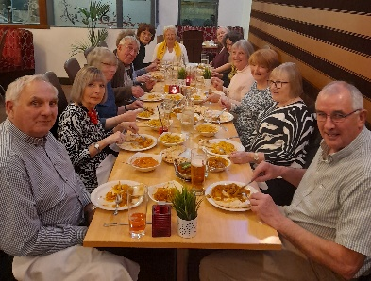

International Dining
I just wanted to say that the meal at the Mangrove Indian Restaurant on Tuesday 14th March organised by Chris and Brenda was a very pleasant evening, good company and a very good Banquet plenty to eat with many different dishes to sample really nice could not fault it. Barbara
For our second outing of the year we will be going to the TAP HAUS in Mansfield Woodhouse.
They offer a selection of home cooked dishes from around Europe to create an array of much loved classics of British and European dishes. In addition there are 19 draught beers and ciders, including four local hand pulls.

Venue: The Tap Haus
Location: 219 Leeming Street, Mansfield Woodhouse. NG19 9EU (The local 11 or 12 bus stops outside the venue)
Date: Thursday 4th May
Time: 5.30 pm for 6.00pm

The menu can be viewed online or at the meeting.

We will be taking bookings at the March and April meetings together with a non refundable £5 deposit. Additionally we will need to know your Starter and Main Meal choice at time of booking.

Regards
Brenda & Chris


Walking Group
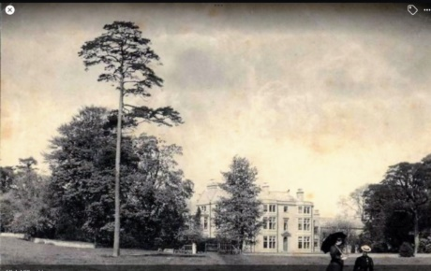
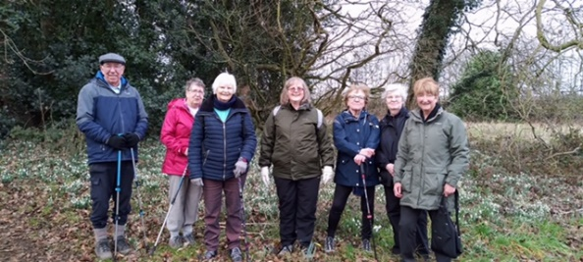
Our February walk started from The Manor Complex from where we did a circular walk via Nettleworth approximately 3 miles. The snowdrops and aconites made a fabulous display during part of the walk. Although rather muddy at times we all managed to stay upright.
Nettleworth is a Manor in the parish of Warsop. Located to the south of Sookholme. Nettleworth Hall was the centre piece of the Manor and was built in 1566 by William Wylde. The Hall was rebuilt following a fire in 1785. It was sold by the Wylde family to Sir Henry Gally Knight, and later passed to Sir Henry Fitzherbert of the Fitzherbert Baronets. When the Rev. Richard Fitzherbert inherited the baroncy in 1896 he resigned as the rector of Warsop and moved from the rectory to Nettleworth Manor. The nearby Nettleworth Farm was also part of the holdings. The Hall by 1939-40 was in the ownership of the Neville family, who then dismantled it to prevent the military taking possession of it for war purposes. The service wing was left standing on site which has since been converted into residential quarters, together with many of the former buildings on site.
Please note our 2023 programme of walks is displayed in the ‘Walking Group’ folder which is available to view at the monthly meeting. For our April walk (20th) we will be staying local taking in both Church Warsop and Cuckney woods where hopefully we will catch the bluebells in full bloom.
Pam & Brenda

Bowls

The Welbeck Bowling Club is now closed until April 2023.

Photography Group 
The photography group has continued on line with the ‘Themed’ challenge ‘Anything beginning with either M or N’.
Thank you for the contributions from Jen Thomson, great photos!

Joyce O’Neill – Manvers Street & Microphone.
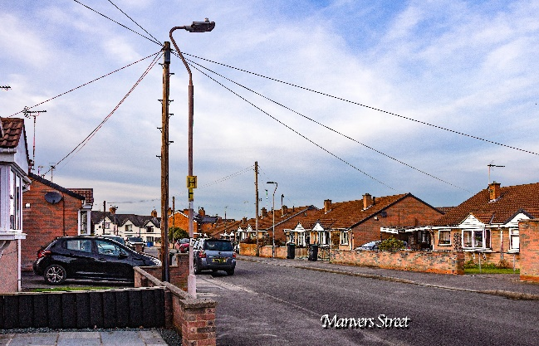

Joanne Wheatley – Masks & Nose
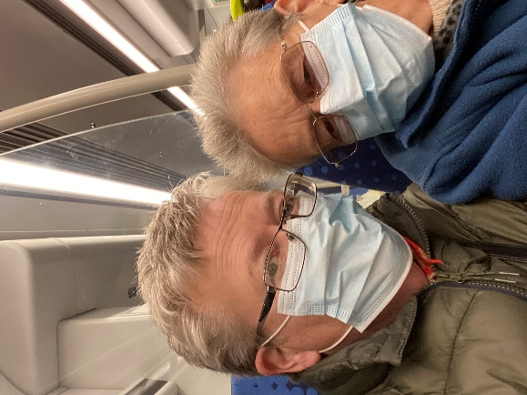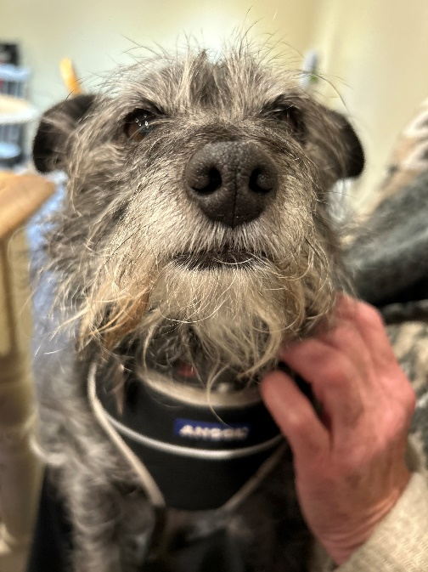

Betty Trinder – Monument & Needle craft.
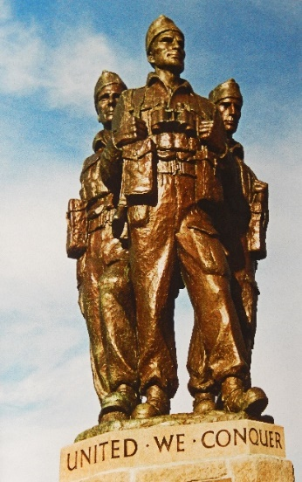
Yvonne Pannifer Rospaw
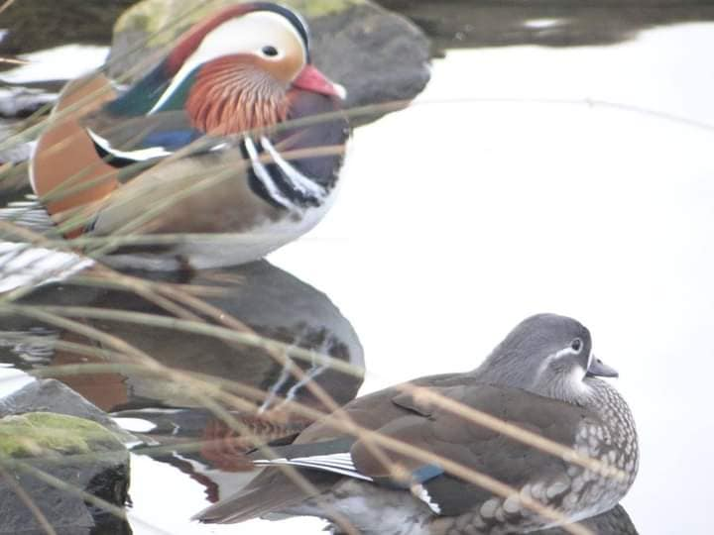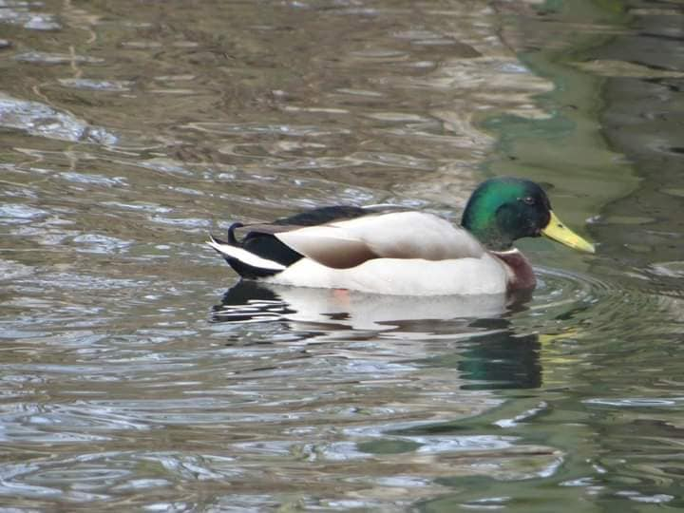
Jen Thomson – Molly & Martha & Molly’s Nose
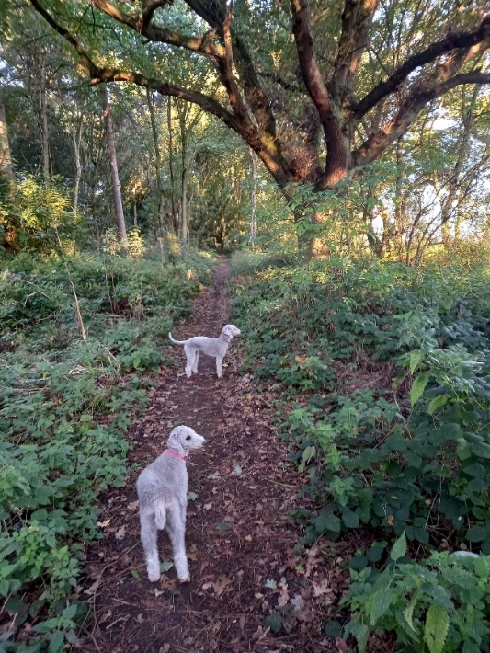

Bob Thomson – Meerkat & Moon

The next ‘Themed’ online challenge is ‘Anything beginning with either O or P’.
As usual this challenge is open to ALL u3a members. If you have photos that you want to enter but don’t know how to upload them onto Facebook, send them to Bob Thomson and I will do it for you!

Garden Group 
Our first garden group of the year is on 11th April and is a visit to Southwell Garden Centre. Meet at the Carr’s at 10.00am.
Linda
If anyone would like some well rotted horse manure (FREE OF CHARGE) please see Jim

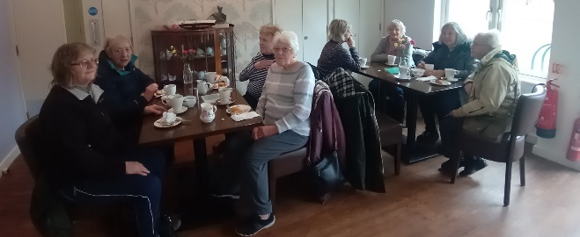
Strollers 
Vicar Water was our stroll in February., when 9 members walked round the lake. A very pleasant stroll followed by a visit to Rumbles café for morning coffee, cake and chat.
March 22nd 2023
Meet at the Carrs car park at 10.00 am for car share to Dukeries Car Park. Our stroll will be to Cresswell Crags.
Pat and Sue"


CALLING ALL BOOKWORMS!!!

The members of the Book Group met at the Plough on Wednesday 1 March.


Of all the books we discussed the following was chosen for the Newsletter Review.

THE SECRETS OF STRANGERS BY Charity Norman
A regular weekday morning veers drastically off-course for five strangers whose paths cross in a London café – their lives never to be the same again when an apparently crazed gunman holds them hostage.
This armed siege in a London café is the basis of this novel. Five strangers’ lives become intertwined in a tightly written novel. The author reports this situation with great sensitivity moving backwards in time to fill in the detail and explain the circumstances that have led to this. At the same time, we get to know all five and their stories and secrets. It’s not only the gun man who has demons. The story unfolds so the reader is looking at the world through the eyes of the man we first meet as a deranged killer and what led to his life-changing actions.
A real psychological thriller
If you would like more Information please contact me Merryll Group Co-ordinator.
Regards
Mel ………

Silver Surfers
Champions. Wednesday 22nd March 11.30am. Savoy cinema Worksop.
Woody Harrelson stars in the hilarious and heart-warming story of a former minor-league basketball coach who, after a series of missteps, is ordered by the court to manage a team of players with intellectual disabilities. He soon realizes that despite his doubts, together, this can go further than they ever imagined.
Free tea/coffee and raffle.

Bridge Club
The Dukeries u3a Bridge Group meet on the Second and Fourth Tuesday of each month at the Jubilee Hall (NG22 9AP) from 1 – 4PM. The cost of each session is currently £3.
All U3a members are welcome to attend.

History Group 
The history group met on Tuesday 21st February at St Theresa’s Church hall. The meeting was well attended. Steve Horne, a group member, shared some of his extensive knowledge of local history with us by presenting a very interesting talk about The Cult of St Edwin. This topic is of interest to many in our group due to the possible links between this 7th century king and the local area.
Steve began by looking at Edwin’s family tree and explaining who Edwin was, his claim to the throne of Deira (modern day York and surrounding area) and an outline of his life, making specific reference to events in his life linked with the local area, for example, the Battle of the River Idle, believed to have taken place in Nottinghamshire. This probably occurred at Littleborough where the old Roman road crosses the Trent. This significant battle saw Edwin’s enemy, AEthelfrith, defeated and killed with the help of Raedwald (Sutton Hoo). Edwin’s power grew following the death of Raedwald in 624AD. His second wife, AEthelburgh, was a Christian and Edwin converted to Christianity in 627AD.
In 633AD Edwin was defeated at the Battle of Hatfield by the pagan Lord Penda and King of the Britons, Cadwallan. Edwin’s sons, Osfrith and Eadfrith also died whilst Ethelburgh fled to Kent. Edwin’s head was taken to York and his body to Whitby. Despite the Pagan victory this was not the end of Edwin’s line as in 671AD his grandson, Eggfrith, became King of Northumbria.
Steve went on to explore the evidence which may support a close connection between this area and St Edwin.
The Battle of Hatfield has traditionally thought to have taken place at Hatfield near Doncaster, but there is no evidence of this. The site was identified due to its position on the great north/south route. Current investigations are being carried out that may link this battle site with nearby Cuckney as Hatfield was a division of the Bassetlaw Wapentake – High Hatfield. The discovery of around 200 skeletons in burial pits close to the church in the 1950s which antedate the building of the church in 1150 led to speculation that these may be burials from a battle – possibly the Battle of Hatfield. Unfortunately, no record was made as to where these bodies were reburied and finding them in a graveyard is difficult. Even if found and permission was obtained to exhume them the cost of testing these to date them would be immense and unless battle injuries were obvious it could not just be assumed they were killed in battle. If they died in battle they could be bodies from a battle during the Anarchy in the reign of King Stephen.
The place name of Edwinstowe may be linked to King Edwin. There have been many derivations over time of this name. It could derive from the personal name ‘Edin.’ However, the proximity of St Edwin’s Chapel gives credence to the view that Edwinstowe may be named after Edwin.
Local legend states Edwinstowe Church is built on the spot where Edwin’s headless body lay after the Battle of Hatfield. The 12th of October 633AD was the date of the Battle of Hatfield and so the Catholic Church recognised the 12th October as St Edwin’s saint day. Mercian Archaeology discovered that the church, built in 1175, is aligned with the sunrise of St Edwin’s saint’s day.
In 1380 King Richard 11 gave a Grant of Special Grace to the people of Edwinstowe to hold a vigil and fair over the night before St Edwin’s Day – acknowledging a special link between Edwinstowe and St Edwin.
St Edwin’s Chapel in Birchwude was known and financed initially by King John in 1205 and subsequent kings up until the Dissolution of the Monasteries during the reign of Henry V111. A cross was erected on this site in 1912 by the Duke of Portland.
The Victorian pulpit at Southwell Minster depicts Edwin, Ethelburga and the priest Paulinus. The lost Church of St Ethelburga near Langar may be named after Edwin’s Christian wife – however there are three St Ethelburga, all who lived in the seventh century.
This fascinating talk certainly gave food for thought. We thank Steve for his excellent presentation.
We meet again on Tuesday 12th March at St Theresa’s Church hall at 10am when we welcome Adrian Gray who will be speaking to us about The Top Ten Scandals of Sherwood Forest. We will also be giving details of our April visit to Crich Tram Museum so we hope you will come along and join us.
Barbara, Sue and Tamar

Revised History Group Meeting Plan
21st March 2023  H | Presentation - Top Ten Scandals of Sherwood Forest  Adrian Gray | St Theresa’s Church Hall 10am
18th April 2023  V | Crich tram museum | Meet at 10am at The Carrs Warsop
16th May 2023  H | Presentation -Wellow History and Heritage  Denis Hill | St Theresa’s Church Hall 10am
20th June 2023  H | Presentation - Kill or Cure  Chris Weir | St Theresa’s Church Hall 10am
18th July2023  V | In house – hall booking switched from August | St Theresa’s Church Hall 10am
15th August 2023  H | Visit to Southwell Workhouse | Meet at 10am at The Carrs Warsop
19th September 2023 V | Visit to Richard III Museum Leicester | Meet at 10am at The Carrs Warsop
17th October 2023 | Presentation - Secret Passages and Hidden Tunnels  By James Wright | St Theresa’s Church Hall 10am
21st November 2023 | Presentation – Curious Occupations?  Denis Hill | St Theresa’s Church Hall 10am

Craft Group 
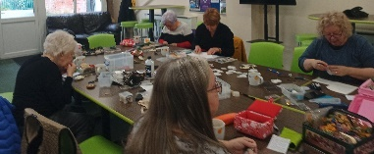
Karen Breed showed us how to make felt animals. She had been busy cutting all the shapes for us plus the instructions for the individual animals.
Some of us had to think hard about how to do blanket stitch and after a few false starts and muttering, we all did a really good job.


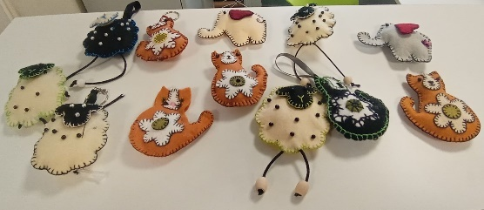
The next meeting is on Monday 3rd April at 10am, if you fancy a chat, laugh and a cup of tea, plus biscuits, then come along, we would love to see you.
Zena.

Social Events
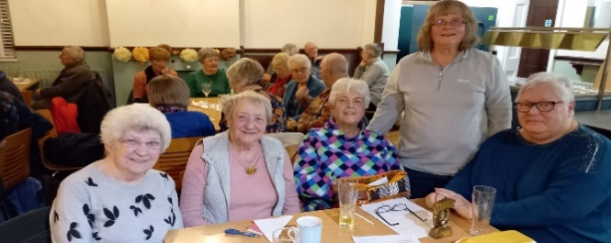
Our most recent quiz night was held at the Plough on 2nd March and 40 members booked for this.
After supper the fun began with our quiz master, Jim, doing his best to keep order, thanks Jim.
The winning team this time was the Mixed Bunch, who will guard the trophy with their lives until the next quiz is held, (date to be confirmed.)
Many thanks to Chris for setting an interesting and varied set of questions.

Coronation Garden Party Monday 8th May 2-4pm
This is to be held at Oakroyd, Forest Road, Warsop. There will be a small charge for refreshments and there will be plenty of fun, games and a prize for the best home made crown. (This clashes with the celebration being held by Dukeries u3a, although there may be just enough time to attend both!)

Cruise and afternoon tea on the River Trent Friday 9th June
11.30am for 12.00 sailing from River Lodge, Princess Park, 100 Racecourse Rd, Colwick NG2 4RF. 15 of us have paid their deposits for this event, the balance of £17.75 must be paid on or before 26th May, so I need to collect this over the next 3 monthly meetings.

Last Night of the Proms Saturday 11th November 6.30pm for 7.00
This is to be held at The Hostess restaurant and the price of £30.00 includes a 3 course meal.
Entertainment by the Shirebrook Miners Welfare Band.
I need to collect deposits of £5 each as soon as possible please to secure our booking at this popular event. Remember, each member may bring a non member as their guest.

I hope to arrange another quiz night, probably in early July and perhaps another Barn Dance in September.

Welfare
Since our last monthly meeting I have delivered flowers and get well cards to 2 members and sent a card to a recently bereaved member.
Don’t forget to notify me if you know of any members who have had to miss 2 or more meetings due to illness or who have been bereaved so that I may send them our best wishes. Thank you, Jen.

Group Co-ordinators
Group | Name | Email | Tel
WALKING GROUP | Brenda Pearce  Pam Hick
STROLLERS | Sue Cox  Pat Magness
HISTORY GROUP | Barbara Spybey
BOOK GROUP | Mel Mitchell
CRAFTS | Zena Inger
GARDENING | Linda Crossley
FRIENDSHIP GROUP | Betty Trinder
INTERNATIONAL DINING GROUP | Chris Wilson  Brenda Pearce
THEATRE GROUP | Jennifer Thomson
SOCIAL EVENTS  ORGANISER | Jennifer Thomson

INTEREST GROUP TIMETABLE
 | MONDAY | TUESDAY | WEDNESDAY | THURSDAY | FRIDAY
1st | 10am – 12pm  CRAFTS GROUP  The Adam Eastwood Building. Warsop |  | .  2pm  BOOKS & LITERATURE GROUP  The Plough Warsop |  | 2pm  FRIENDSHIP GROUP  The Plough Warsop
2nd |  | 10am  GARDENING GROUP  Venue agreed by members
3rd | MAIN MEETING 10.15  Oaklands Centre  Warsop | 10am– 12pm  HISTORY GROUP  Catholic Church Warsop |  | 10am  WALKING GROUP  Carrs Car Park  10am | 11.am  PHOTOGRAPHY  Venue to be agreed by the members.
4th |  |  | 10.am  STROLLERS  Carrs Car Park  10am
INTERNATIONAL DINING -Location and time as announced
THEATRE GROUP - Location and time as announced
PHOTOGRAPHY GROUP-Please see Newsletter for the on line challenge.

Speakers for the main meetings
2023

March 20th Don’t you know who I am: (45 years of being Peter Slater
ignored by the sports rich and famous)

April 17th Weird + Wonderful Ways of Predicting the Future Elaine Parkins

May 15th Road safety (more interesting than it sounds) Autumn Rose

June 19th Baroness Bolsovers Afternoon Tea + Etiquette Baroness Bolsover
Demonstration. Participation required!!

July 17th Bees, Ants and Wasps Graham Appleby

August 21st Lesley Taylor Talks Rubbish Lesley Taylor

September 18th Annual General Meeting

October 16th Funny Turns David Moylan

November 20th Inspector Hopkinsons Discovery Ian Morgan

December Christmas Party

2024
January 15th Wild West With Songs Steve Allen

North Notts Neighbourhood Group
This means that you as a member of Warsop & District can ask to join an interest group in another U3A that is also in the NNNG, as long as the group is not oversubscribed at the time of your request you can join the group without joining the host u3a
The u3as in the NNNG are Mansfield, Sherwood, Dukeries, Rainworth, Forest Town, Ashfield, Sutton in Ashfield, Hucknall and Warsop.

Data Protection Rules
Warsop & District U3A is committed to treating all people equally.
Anyone wishing to see the Privacy and Data Protection policies may view them on the Warsop & District U3A website, alternatively please ask Rob.

Robin Hood Lottery 
Warsop and District U3A is a registered cause with the Robin Hood Lottery.
To buy a ticket you can now register on line at www.robinhoodlottery.co.uk and set up regular payments. If you buy a ticket every week for a year Warsop U3A will receive £26.
Remember the more members that have a go (specifying Warsop & District U3A) the more money we get for our funds.

Riddles for March

1 What does a house wear?

2 Where would you take a sick boat?

3 Why did the fly not land on the computer?

MARCH quick quiz All the answers are numbers

1According to the poem by Tennyson how rode in the Charge of the light Brigade?
2 How old was Elizabeth II when she became Queen?
3 How many players in a netball team?
4 Name of the 1990’s film starring Brad Pritt and Morgan Freeman?
5 Write one billion in numbers?
6 In total how many presents were given in the song 12 Days of Christmas?
7 how many keys on a piano?
8 How many sides does a duodecahedron have?
9 1940’s film starring Henry Fonda -------- Angry Men?
10 Childrens story ------ Children and It by Edith Nesbit ?

Well I didn’t know that!

1 the earliest form of numbers were tally marks found on prehistoric bones century

2 Zero is the only number that does not have a Roman numeral

3 The Hindu-Arabic number system we use originated in India in the 6th century
BC

4 We regard 13 as unlucky but in parts of Asia it is number 4 that is unlucky

5 Triskaidephobia is the fear of number 13

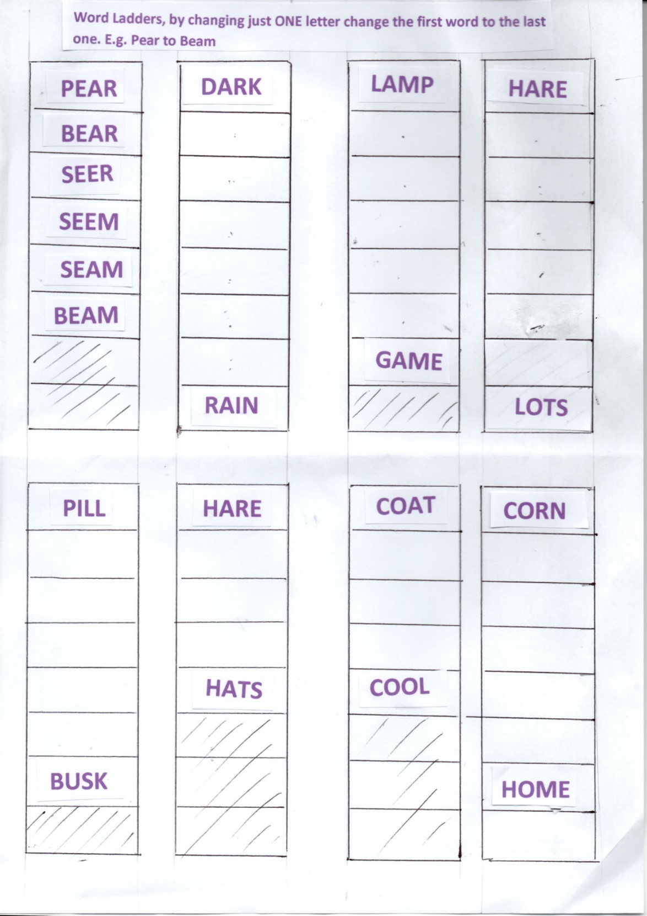
ANNSWERS TO FEBRUARY Riddles
I have keys but no locks, what am I? PIANO/KEYBOARD

You have me today and tomorrow you will have more, I don’t take up space but I am only in one place. What am I? MEMORIES

Sara has 4 daughters and each daughter has a brother . How many children does Sara have? FIVE

ANSWERS TO FEBRUARY Quick quiz All the answers start with the letter z

- Name of a Greek God? ZEUS
- Which film made Omar Sharif famous? DR ZHIVAGO
- What do Americans call a postcode? ZIP CODE
- When the sun is at it’s highest point it is at it’s ZENITH
- Name of the airship built in 1906? ZEPPLIN
- A stringed instrument originally from Bavaria? ZITHER
- The scientific study of animals? ZOOLOGY
- Another name for a fanatic? ZEALOT
- An African quadruped? ZEBRA
- Harare is the capital city of ZIMBABWE

Answers to febRUARY QUIZ
1 Richard Nixon 2 Elizabeth I 3 Jane Austen
4 Richard III 5 JFK 6 Queen Victoria
7 Napoleon 8 Anne Boleyn 9 Edward VII
10 Abraham Lincoln 11 Robert Burns 12 Barack Obama
13 Haile Selassie 14 Donald Trump 15 WG Grace
16 Albert Einstein 17 Al Capone 18 William Shakespeare
19 Nelson 20 Martin Luther King 21 Florence Nightingale
22 Sitting Bull 23 Joseph Stalin 24 Duke of Wellington
25 Leo Tolstoy 26 James I 27 David Livingstone
28 Idi Amin 29 Winston Churchill 30 Ken Livingstone
31 John Major 32 Henry VIII 33 Jaqueline Kennedy/Onassis
34 Ted Heath 35 Henrich Himmler

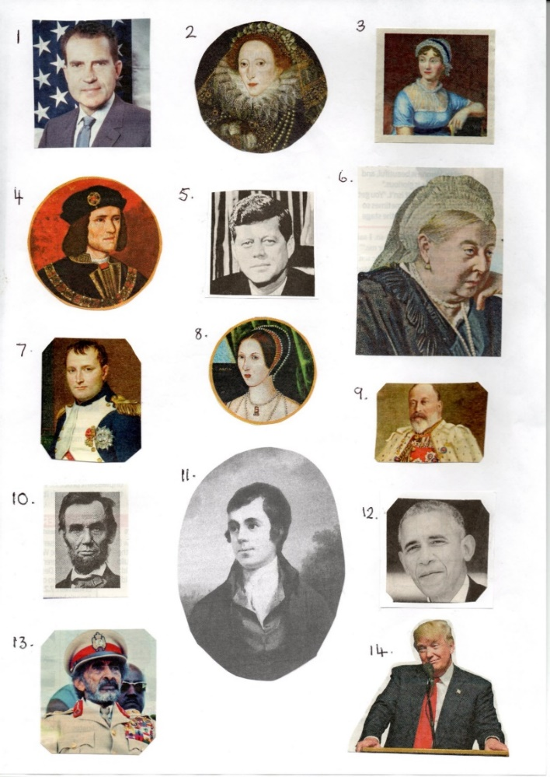
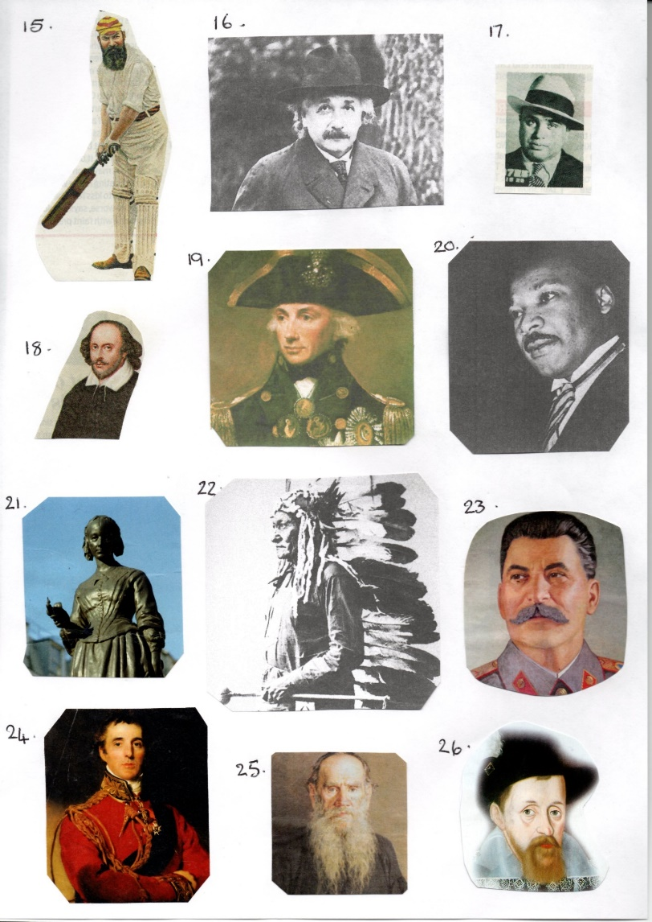
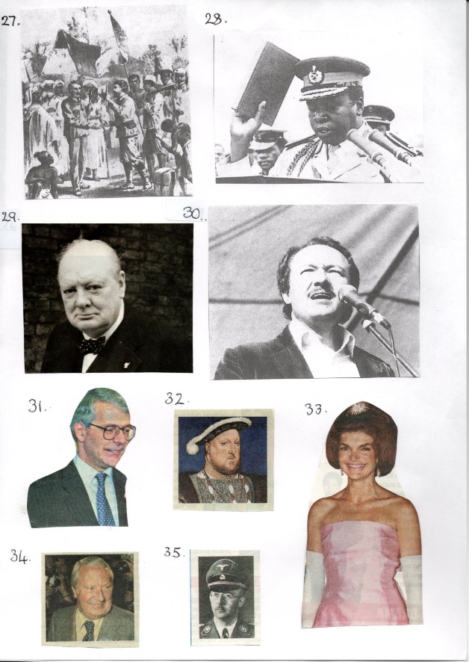

Committee Members | Role
Jim Shervey | Chairperson
Mel Mitchell | Deputy Chairperson
Irene Clay | Business Secretary
Linda Crossley | Treasurer
Mel Mitchell | Membership Secretary
Jim Shervey | Speaker Seeker
Chris Shervey | Groups co-ordinator
Chris Shervey | Newsletter editor
Jennifer Thomson | Social Events
Jennifer Thomson | Welfare Officer
Rob Thomson | Website & Facebook manager
Ann Ayodele | Refreshments rota
June Whittle | Raffle
Betty Trinder | Social events assistant
Ann Ballinger | Assistant IT manager

