
Issue 81August 2024
Warsop & Distict

Notes from the Chairman
Hi

August Already!!! The talk this month is ‘Medieval superstitions and science’ provided for us by Gareth Howell. One not to be missed.

The BBQ on the 3rd August went well, good weather and even better food provided by our very own Roy and Ann. A big thanks to them for all the effort they must have put in to prepare the feast we had. The afternoon was very pleasant and made even better by the several helpers that were there before and after the BBQ to prepare and tidy away. A big thanks to them as well.

Now to other matters. The AGM is only 2 months away. And there are several roles that need to be filled.

If you haven’t already done so now is the time to get your nomination form to Irene. Or let her know that you will get your form to her at Mondays meeting.

The roles are Chair, Speaker Seeker and Social Events Organiser (social events could be organised by more than one person working together sharing the role).

The position of chair is a role that must be filled for Warsop u3a to operate.

If you feel you may be able to help out with any of the roles have a chat with any committee member to see what goes on behind the scenes.
u3a

Also at the AGM there will be a Silent Auction, see items of interest. This was very popular with members last year.

There is an agenda for the AGM at the end of the newsletter.

Don’t forget to book your ticket for the upcoming 4B’s event. Details are in the newsletter.

Jim Shervey
Chair

The deadline for including articles/information in the next newsletter is Friday 6th Sept Send contributions to Chris Shervey. If you have any ideas for new items to include in the news letter please let me know.

Rota for refreshments and greeting.
This is the rota for the next three months; any problems please contact me, (Ann Ayodele).
Thank you to all those who have volunteered to help, without you our meetings would not be so enjoyable.

Date | Refreshments 1 | Refreshments 2 | Meet and Greet 1 | Meet and Greet 2
19th Aug | Karen Breed | Beatrix Kirby | Raymond White | Janice Richardson
16th Sept | Sonja Attwood | Janet Harford | Chris Wilson | Brenda Pearce
21st Oct | Yvonne Pannifer | Silvia Ellis | Moira Heslop | Ann Poultney

Those on the rota please be there around 9.30am.

ITEMS OF INTEREST

Silent Auction We are planning to hold a Silent Auction alongside the AGM in Sept. I will be collecting items for the auction at the Aug main meeting. Chris

THE 4 ‘B’ s AFTERNOON
LAST CHANCE - LAST CHANCE -LAST CHANCE
To get your tickets for the social afternoon
THE 4 ‘B’ s AFTERNOON

For your entertainment we are organising a social afternoon which involves BALLADS, BUTTIES, BAKES & BEETLE/BEATLES.
Date: Saturday 7th September 2024
Venue: The Oaklands

Time: 14.00 - 16.30 (Doors open at 13.45)
Cost: £6 per head (on this occasion you are allowed to bring a guest)

Tea and coffee will be served with the buffet (please bring your own mug).
If you prefer something else e.g. Prosecco, wine, beer you are quite welcome to bring it along.

We have booked local celebrity Oliver Ward who covers a wide variety songs.

Bookings are being taken at the August meeting.
Regards
Brenda & Chris
Christmas Lunch
Christmas Lunch, Friday 20th December, at The Hostess
The non refundable deposits have been paid, and 34 of us have this to look forward to.
I shall collect the balance of £15 each during the November meeting. Jen
Cups Please will as many of you as
possible bring your own mug for your tea or coffee. This is not only more environmentally friendly but also would save us a lot of money as the paper disposable cups we use are surprisingly expensive. Ann.

Robin Hood Lottery 
Warsop and District U3A is a cause registered with the Robin Hood Lottery.
To buy a ticket you can now register on line at www.robinhoodlottery.co.uk and set up regular payments. If you buy a ticket every week for a year Warsop U3A will receive £26.
Remember the more members that have a go (specifying Warsop & District U3A) the more money we get for our funds.

Books and Jigsaws 50p. We made £10 .50 at the July meeting. The books are sorted into genres making it easier to find a book you like.

Raffle. The July Raffle raised £56
RAFFLE PRIZES NEEDED .

A few scenes from the BBQ.
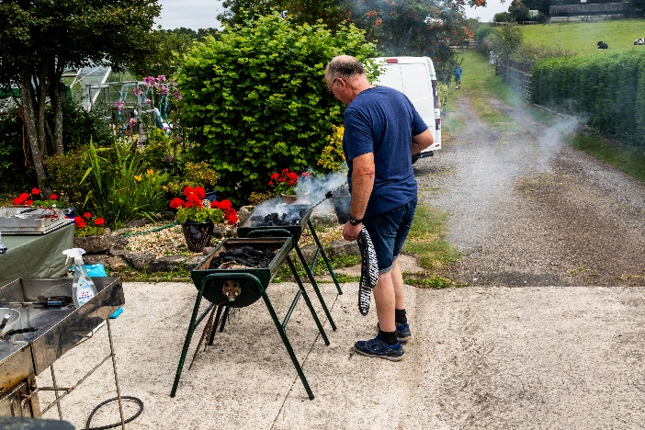

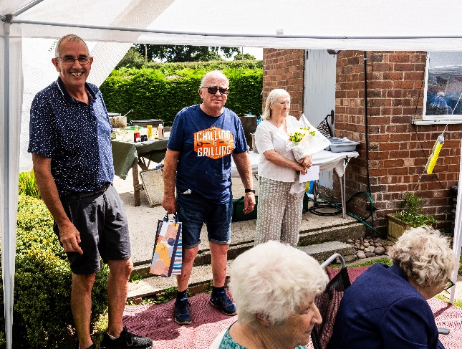


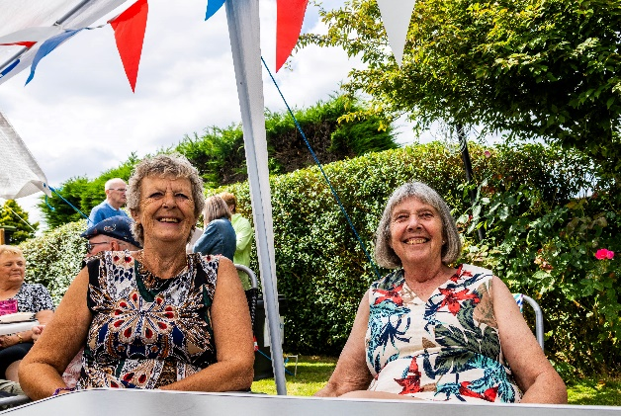
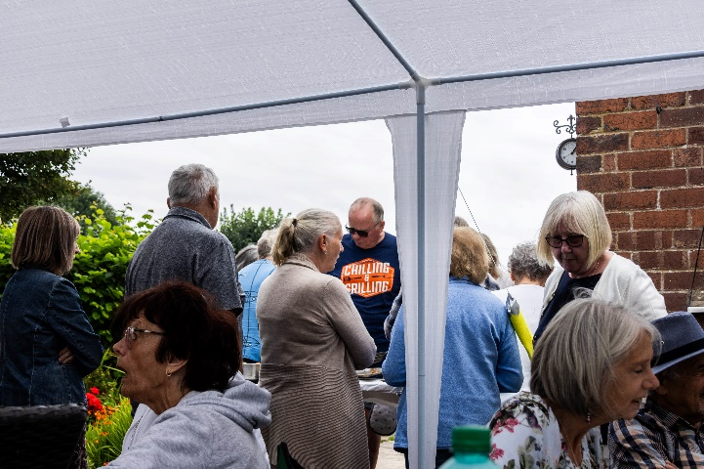
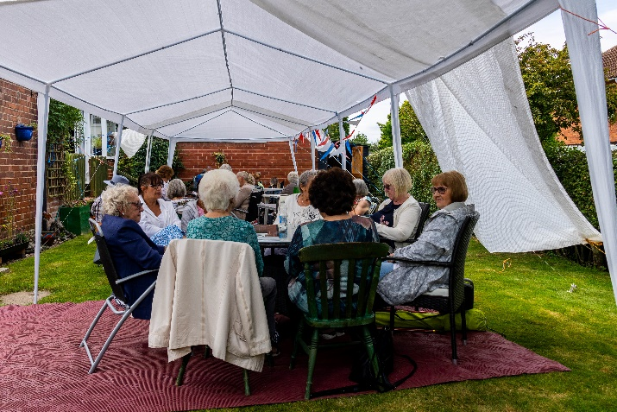
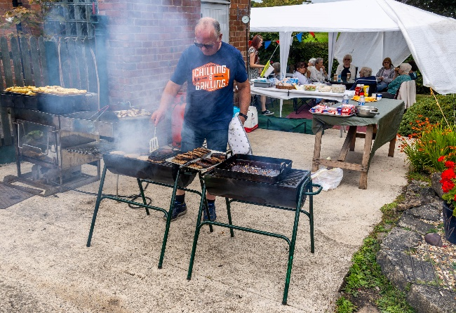

Group News
Apologies to group leaders, I haven't yet had chance to book a venue for a meeting, I'll let you all know via WhatsApp when I've booked somewhere.
A suggestion has been made that we have a Tai Chi group, we did have one previously but the instructor retired. If anyone else would be interested in such a group, or if anyone knows a Tai Chi instructor, please let me know.
Jen
The Friendship Group 
The Friendship Group met on the 2nd August for another enjoyable afternoon playing the card games Uno and Newmarket. Six members attended and we also had some friendly discussion on various topics including of course the Olympic Games. The next meeting will be at The Plough on Friday, 6th September at 2.00 p.m.
Betty

Theatre Group 
This Photo by Unknown Author is licensed under CC BY-NC-ND
A few members are going to see The Drifters in Nottingham on 7th September, I'm sure they'll enjoy themselves.
We have also been planning to see The Nutcracker in Newark on 19th November. I shall be taking full payment for this at the August meeting, it's £26 each for seniors.

Theatre tickets for sale
There are two tickets to see the matinee performance of Hairspray in Nottingham on Saturday 9th November available. The tickets have a face value of £97 but are available for £70. A bargain! Please let me know if you would like these. Jen

Welfare
Don't forget to let me know if any members are ill or suffer a bereavement, so that I may send get well wishes or condolences on behalf of us all .
I have, sadly, sent a couple of messages of condolence since our last meeting.
Jen

Discussion Group 
This Photo by Unknown Author is licensed under CC BY-SA
The discussion group will run as usual at 10.30 0n the 4th Monday of the month, Forest Lodge Edwinstowe.

Bridge Club
The Dukeries u3a Bridge Group meet on the Second and Fourth Tuesday of each month at the Jubilee Hall (NG22 9AP) from 1 – 4PM. The cost of each session is currently £3.
All U3a members are welcome to attend.

Garden Group 
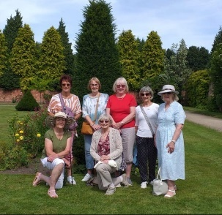
On Tuesday 13th August seven members of the group went to Newstead Abbey and visited the Japanese garden and the walled garden. We had a coffee and a bite to eat in the cafe. The weather was good and there was a bit of a breeze to keep us cool. Everyone enjoyed the trip.

Silver Screeners

Savoy cinema Worksop. For the over 50’s. Every Wednesday at 11.30. Tickets £5.00, include a drink and free raffle.

Wednesday 21st August
Trap (15)
A father and teen daughter attend a pop concert, where they realize they're at the centre of a dark and sinister event.

Strollers 
28th August - Thoresby Park Meet 10.00 am at the Carrs car park for car share to Thoresby Park. "

SEPT Cresswell Crags
OCT Vicar Water
NOV Kings Mill Reservoir
DEC No Stroll

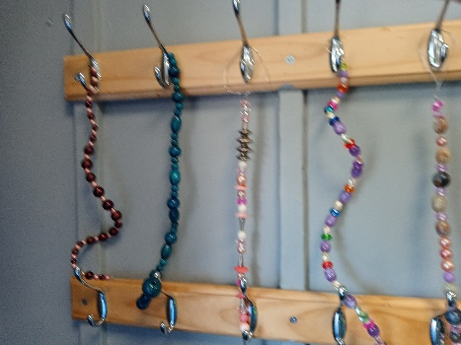
Craft Group 
The group spent an enjoyable morning making sun catchers to hang in the garden and discussing a variety of things while crafting away.
PLEASE NOTE THAT FUTURE MEETINGS WILL BE AT ST TERESA’S CHURCH HALL STARTING ON 2ND SEPT

The hall is under the church down the steps from the car park. Usual time 10.00 – 12 .00 If you are walking St Tereas’s is at the end of High St , if you are driving the car park is just of the main road.

Natural History, Science and Technology.
This month the group went on a trip to Wollaton Hall, we visited the Natural History Museum where there are a variety of preserved animals. The museum has a display that explains how taxidermy is achieved. The museum also has a very good collection of gems rocks and fossils. Those of you who have been to one of Jims NHST talks will know he was really interested in this room.
It is worth a trip to see The World In Miniature, sculptures in the eye of needles which you have to view through a microscope.
After lunch some of us went to The Museum of Industry which tells the story of local firms such as Boots and Raleigh and the history of lace making in Nottingham.
An informative and enjoyable trip.
2024
Thursday 12th Sept | Special Educational Needs and Coping Strategies. | Looking at the characteristics of SEN and how it is managed. Ann Harris- Lock
Thursday 10th Oct | What is it? | Jodie manager of Mansfield Museum £2,50 per person
Thursday 14th Nov | Birds in your garden | Chris Shervey
December | No Meeting

Pictures from the Wollaton visit
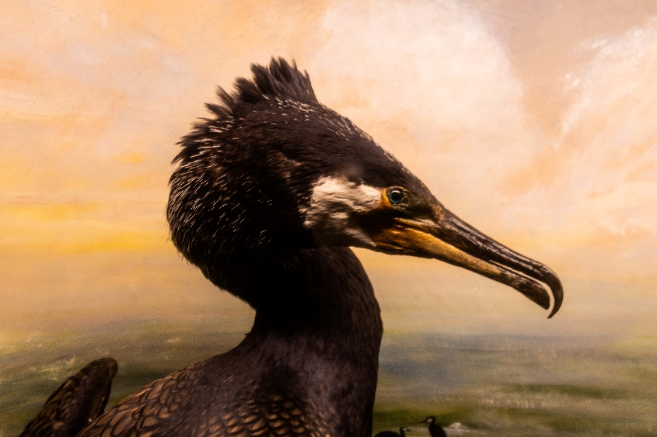
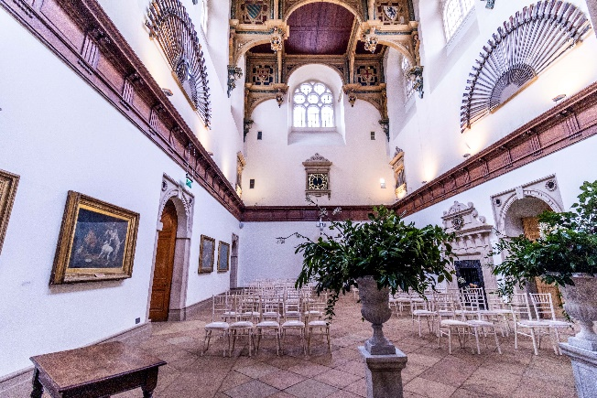

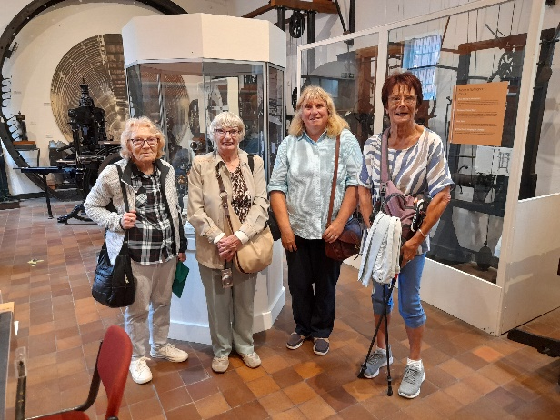

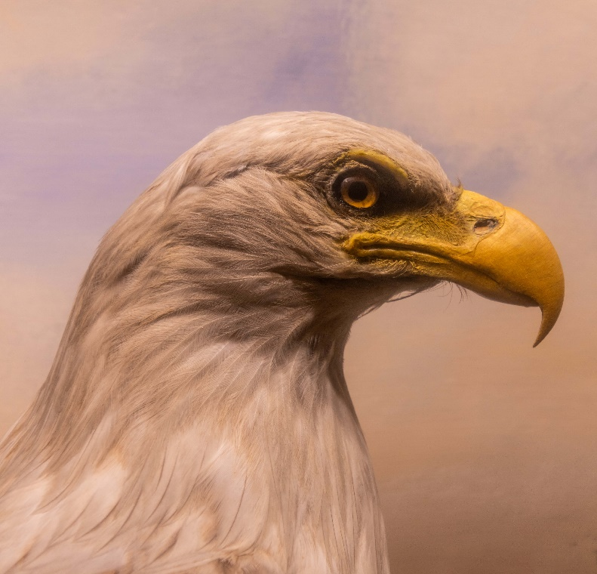

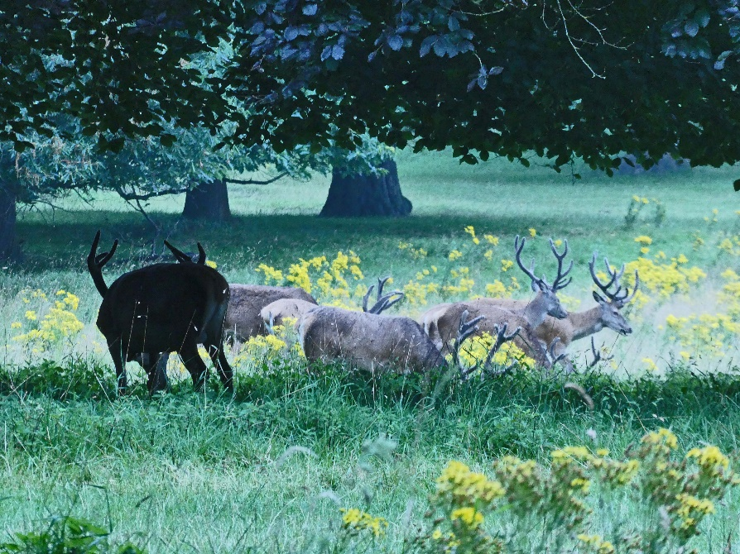

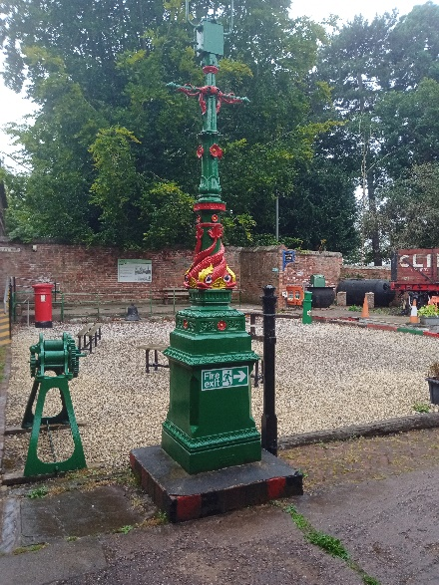

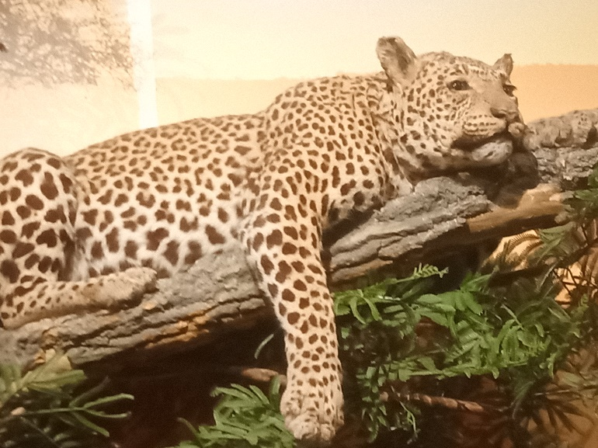
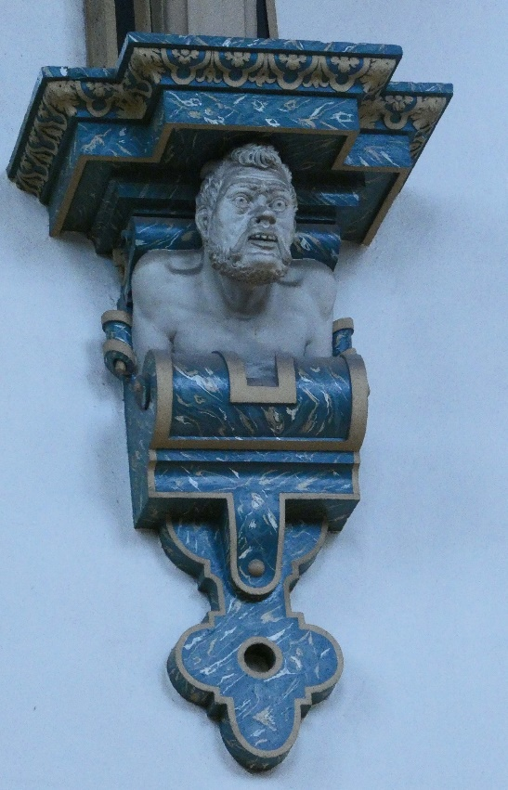

Photography Group
Last months online ‘Themed’ challenge was ‘Anything that begins with either Q or R’
Once again a BIG THANK YOU to Jim & Chris Shervey for joining in!
Joanne Wheatly : Q = Qatar / R = Reindeer.
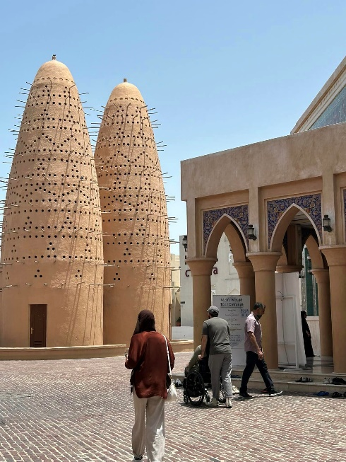

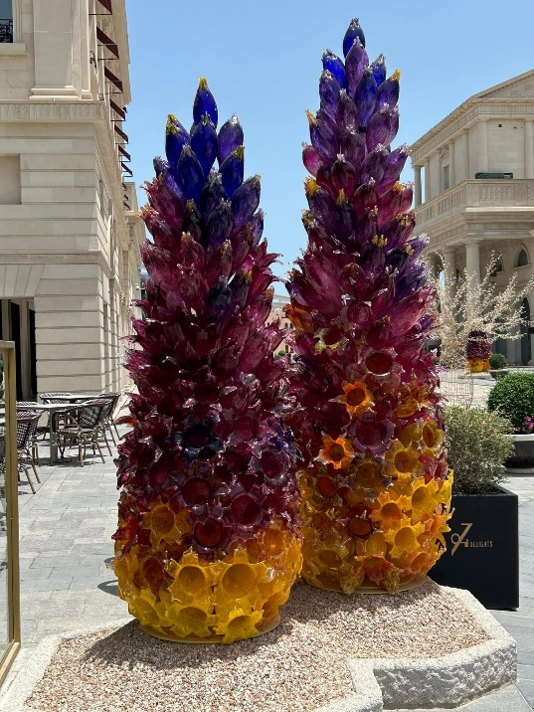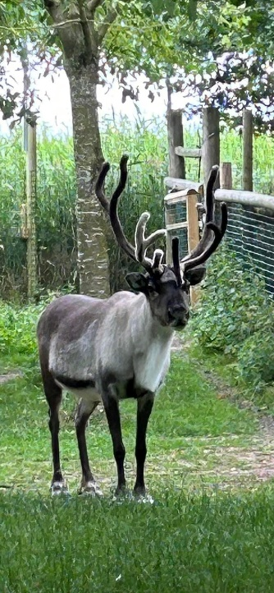
Betty Trinder: R = Rubiks Clock, Rolls Royce
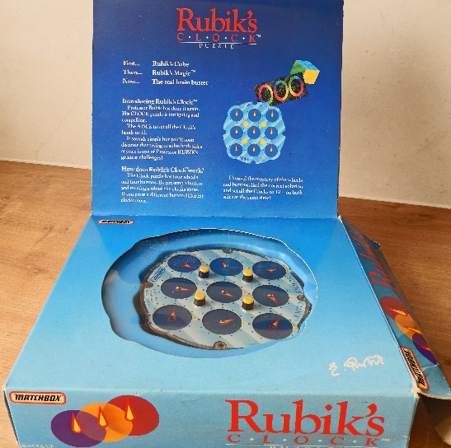

Jim & Chris Shervey: R = Rabbits, Rhododendron
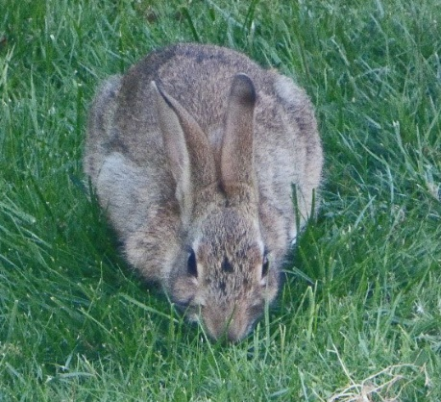

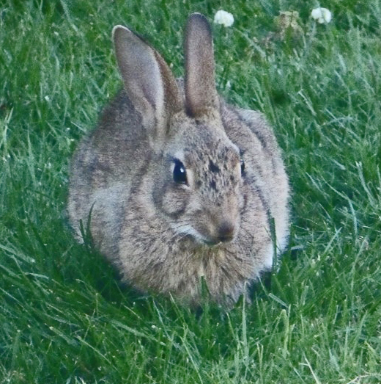

Bob Thomson: Q = Qwerty key board, Question mark / R = Red Admiral, Rowan berries.



The next online ‘Themed’ challenge is ‘Anything that begins with either S or T’
As usual this challenge is open to All u3a members.


Walking Group
The sun was blazing for the July walk. 9 of us made it for the walk though. Starting from Gleadthorpe
P.S. we followed various track’s within the R.S.P.B. Site. The woodland shade was much appreciated, in total approximately 4 miles. We were on the lookout for wildlife along the route no ‘bares’ were roaming the tracks however we did see a Buzzards nest with chicks. A very pleasant walk was had by all. Thanks to Jen for navigating and planning the walk.

Brenda
WALKING GROUP - 3RD THURSDAY OF THE MONTH 2024
Date | Walk Leader | Walk | Distance
19th September |  | TBC
17th October | Brenda Pearce | Ault Hucknall | 3.5 or 5 miles
21st November |  | TBC
 |  | Walks can be subject to change

History Group
On 16th July at St Teresa’s Catholic Church Hall, 16 members of the History Group were in attendance to hear a talk by Dennis Hill on ‘The Early History of Mansfield.’ Dennis’ talk was dedicated to Thomas Halford Knighton (1914-41), who was born on Titchfield Street in the town, and was the author of ‘The Early History of Mansfield’, written in 1937. Dennis’ talk gave us an insight into the history of Mansfield and Sherwood Forest from the time of the Roman occupation to the Middle Ages. Several fascinating aspects were highlighted, these included agriculture, commerce, industry, labour, education, royal influence, law and order. Our next meeting will be at St Teresa’s CCH at 10:00am on Tuesday 20th August, when we will have an in-house presentation on ‘Eminent Sporting Personalities of Nottinghamshire’, given by Roger Holland.
Barbara Spybey and Tamar Holland

2024 - Proposed Calendar of Events for Warsop & District U3A History Group
20th Aug | In house presentation  Eminent Local Sporting Personalities  Roger Holland | St Teresa’s Church Hall 10am
17th Sept | Historic Mansfield Trail  Denis Hill | Meet in Mansfield Town Square 10am
15th Oct | Nottinghamshire’s Dark Side  Chris Weir | St Teresa’s Church Hall 10am
19th Nov | Medieval Buildings & the English Civil War  James Wright TBA | St Teresa’s Church Hall 10am
17th Dec | No meeting as very close to Christmas

Speakers for the main meetings
2024

August 19th Medieval superstitions and science. Gareth Howell

September 16th Annual General Meeting/ Silent Auction

October How to avoid Fraud Richard Kubon
Police Fraud Protection Officer

November Before They Were Famous Mel Mitchell

Group | Leaders Name | Tel
NATURAL HISTORY SCIENCE AND TECHNOLOGY | Chris Shervey
WALKING GROUP | Brenda Pearce  Pam Hick
STROLLERS | Janet Harford  Pat Magness
HISTORY GROUP | Barbara Spybey
CRAFTS | Zena Inger
GARDENING | Linda Crossley
PHOTOGRAPHY | Rob Thomson
FRIENDSHIP GROUP | Betty Trinder
INTERNATIONAL DINING GROUP | Chris Wilson  Brenda Pearce
THEATRE GROUP | Jennifer Thomson
SOCIAL EVENTS ORGANISER
DISCUSSION GROUP | Mary Morris
COULD GROUP LEADERS PLEASE COLLECT THEIR BADGES WHEN COLLECTING THEIR LANYARDS. (Then members at the meeting can identify who they may need/want to talk to).

INTEREST GROUP TIMETABLE
 | MONDAY | TUESDAY | WEDNESDAY | THURSDAY | FRIDAY
1st | 10am – 12pm  CRAFTS GROUP  St Tereas’s Catholic Church hall. Warsop |  |  |  | 2pm  FRIENDSHIP GROUP  The Plough Warsop
2nd |  | 10am  GARDENING GROUP  Venue agreed by members |  | 2pm  NATURAL HISTORY  SCIENCE AND  TECHNOLOGY  Plough Warsop
3rd | MAIN MEETING 10.15  Oaklands Centre  Warsop | 10am– 12pm  HISTORY GROUP  St Tereas’sCatholic Church hall. Warsop |  | 10am  WALKING GROUP  Carrs Car Park | 11.am  PHOTOGRAPHY  Venue to be agreed by the members.
4th | 10.30 -12.30  DICUSSION GROUP  Forest Lodge  Edwinstowe |  | 10.am  STROLLERS  Carrs Car Park
INTERNATIONAL DINING -Location and time as announced.
THEATRE GROUP - Location and time as announced.
PHOTOGRAPHY GROUP-Please see Newsletter for the online challenge.

August quiz All the answers are places on an original MONOPOLY board

1 Who was the original presenter of Question of Sport on BBC1?
2 Where did Jack the Ripper commit his murders?
3 Who wrote the Paddington Bear books?
4 The main shopping street in London?
5 Where is the statue of Lord Nelson?
6 The name of a London jail?
7 Square famous for it’s theatres and cinemas?
8 An area of London of luxury hotels and casinos?
9 A game similar to croquet?
10 Original name of policemen, the -------- -------- runners?
11 Named after George IV when he was Prince------- ?
12 Former home of National newspapers ?
13 Reputation as the high end of London?
14 In the Harry Potter books students catch the Hogwarts express on platform nine and a half at ------- ?
15 Mentioned in a famous WWI song, saying farewell?

Well I didn’t know that !

To become a London Taxi driver you must pass the KNOWLEDGE OF LONDON which started in 1865. The knowledge involves learning thousands of streets buildings and landmarks. They learn by driving the streets in a 6 mile area around Charing Cross with approximately 25,000 streets . It takes 3 -5 yrs of study and being tested. It is one of the hardest taxi driver tests in the world and costs 4-5,000 pounds. London taxi drivers don’t use Sat Navs!

August quick quiz All the answers start with the letter M except for one.
1 The name of the boy in the Jungle Book?
2 South African country called Nyasaland until 1963?
3 Island in the Mediterranean, popular with tourists?
4 Town in S Africa besieged for 217 days during the Boer War?
5 Principal Chapel of the Vatican?
6 English playwright 1564-93 wrote The Jew of Malta, Tamburlaine the Great?
7 USA state on the eastern coast?
8 A book written by Roald Dahl?
9 Politican imprisoned on Robben Island, near Cape Town?
10 Technique of veneering furniture with different woods?

August riddles
1 What runs around a back yard but never moves?

2 If 2 is company and 3 a crowd what are 4 and 5?

3 What has many rings but no fingers?

Answers July Quiz Scrambled flowers
1 YASDI Daisy
2 EORS Rose
3 MSPTNONEE Penstemon
4 LAGIQUAA Aqualiga
5 OKCSTS Stocks
6 YPPOP Poppy
7 PLNIU Lupin
8 MNARUGEI Geranium
9 SRII Iris
10 TREPBTUCU Buttercup
11 LHYHOKLOC Hollyhock
12 SOTAH Hosta
13 LAMUPIR Primula
14 GEBANOI Begonia
15 TIAPUNE Petunia
16 RETSA Aster
17 FUNWOSLER Sunflower
18 VALIAS Salvia
19 LEZAAA Azalea
20 NOYPE Peony

JULY QUICK QUIZ aNSWERS All answers begin with L except for one.
1 Which is the correct spelling of Lavender or Lavendar? LAVENDER
2 Which is the second largest city in Pakistan? LAHORE
3 Which female scientist discovered Radium? MARIE CURIE
4 The sudden downward movement of rock or earth is called a ? LANDSLIDE
5 Fore runner of the United Nations? LEAGUE OF NATIONS
6 Largest city in Yorkshire? LEEDS
7 England’s first garden city in 1903? LETCHWORTH
8 The river that flows through Dublin? LIFFEY
9 A common sedimentary rock? LIMESTONE
10 Island of the coast of Northumberland? LINDISFARNE

July riddles ANSWERS
1 What kind of tree can you carry in your hand? A PALM !

2 What 2 things can’t you eat for breakfast? LUNCH AND DINNER

3 I am orange, wear a green hat and sound like a parrot, what am I? A CARROT

North Notts Neighbourhood group
This means that you as a member of Warsop & District can ask to join an interest group in another U3A that is also in the NNNG, as long as the group is not oversubscribed at the time of your request you can join the group without joining the host u3a
The u3as in the NNNG are Mansfield, Sherwood, Dukeries, Rainworth, Forest Town, Ashfield, Sutton in Ashfield, Hucknall, Worksop and Warsop.

Data Protection Rules
Warsop & District U3A is committed to treating all people equally.
Anyone wishing to see the Privacy and Data Protection policies may view them on the Warsop & District U3A website, www.u3asites.org.uk/warsop, alternatively please ask Rob.

Website & Facebook
The Warsop & District u3a website can be found at the address below. If any of the group leaders/facilitators would like to advertise/ promote any of their future activities or change the information shown, please contact Bob Thomson.

Facebook
Warsop & District U3A has a Facebook Group. It is a private group which can be seen by the public but only members can see who’s in the group and what they post.
What this means is that you have to be invited to join the group or have your request to join accepted. Also you need to be on Facebook which some of you may not be. As a member of the group you will be able to put your own posts on the page, please keep them relevant to the U3A and what it stands for. We would ask that you don't put anything on that is in anyway party political or anything that may be offensive to others who may be of a different creed or religion. Hopefully everyone will join, use the page and find it useful.
One of the things that puts people ‘off’ Facebook, is the ‘bad press’ some of the Social sites get. You can join Facebook, choose only to join the Warsop Facebook page and not be involved in any other site, or Friends requests (usually from people that you have never heard of!) The choice is entirely yours.
To request to join the Warsop u3a Facebook page, contact Bob Thomson, email addresses as per the Website.
Committee Members | Role
Jim Shervey | Chairperson
Mel Mitchell | Deputy Chairperson
Irene Clay | Business Secretary
Linda Crossley | Treasurer
Carolyn Brankin | Membership Secretary
Jim Shervey | Speaker Seeker
Jennifer Thomson | Groups co-ordinator
Chris Shervey | Newsletter editor
Vacant | Social Events
Jennifer Thomson | Welfare Officer
Rob Thomson | Website & Facebook manager
Ann Ayodele | Refreshments rota /Quiz
June Whittle | Raffle
Betty Trinder | Social events assistant
Pat Magness | Co-opted member

Warsop and District U3A
ANNUAL GENERAL MEETING
Monday 16th September 2024 10.15am
Oaklands Centre, Warsop, Notts
Agenda
Open Meeting
Welcome, Introduction and Apologies
Minutes of previous AGM (18th September 2023)
Matters arising from minutes, approved, seconded and signed
Chairman’s Report
Treasurer’s Report and Annual Accounts
Approval and signing of accounts
Any other reports
Election of Officers and Committee Members
Adoption of Officers and Committee Members
Welcome and Introduction of newly elected and returning committee
Announcements from the Chair
Any other business
Date and time of AGM 2025 15th September 2025
Close AGM
Refreshments/ Silent Auction/ Social time

Notice of Warsop and District Annual General Meeting (AGM)
Monday 16th September 2024 10.15am at Oaklands, Oaklands Lane,Warsop, NG20 OJE
It will soon be time for the AGM and these papers are in preparation for the event.
At the AGM the membership has to vote in the four Honorary officer posts of Chair, Vice-Chair, Treasurer and Business Secretary.
The current officers, Jim Shervey - Chair, Mel Mitchell - Vice-Chair, Irene Clay - Business secretary Linda Crossley – Treasurer
All of these positions are open for nominations and the nominating and seconding process is necessary for each office. More positions are available and nominations would be most welcome from members wishing to join the committee in a non-officer role. Which means that you would be able to take on a role or be available to help other committee members as needed, which will ultimately lessen the load on each individual.
The nomination forms are included with this document, the completed forms must be returned to - Irene Clay. By the 14thAugust 2024. The votes will then be taken at the AGM.
The committee holds at least 3 meetings a year, sometimes more, usually lasting about 2 hours.
The role of the committee is to ensure that Warsop & District u3a runs as well as it can for the members. If you feel that you would like to join the committee come and talk to one of the current team.
The current positions are (there can be up to 15 committee members):
Committee Members | Role
Jim Shervey | Chairperson & Speaker Organiser
Mel Mitchell | Vice Chairperson
Irene Clay | Business Secretary
Linda Crossley | Treasurer
Carolyn Brankin | Membership Secretary
Chris Shervey | Newsletter Editor
Ann Ayodele | Refreshments & Meeters + Greeters
Jennifer Thomson | Groups co-ordinator
Betty Trinder | Social Events
June Whittle | Raffle organiser
Bob Thomson | Website and Face-book manager
Pat Magness | Committee Member
 | Social Events Organiser

NOMINATION FOR HONORARY OFFICER- Chair/Vice chair/Business secretary/Treasurer
NOMINATION FOR COMMITTEE MEMBER- Committee member or named role

Post nominated for (Choose from above)-

Name of Nominee-

Signature

Address

Telephone

Email

Name of proposer

Signature

Name of Seconder

Signature

Return to the Business Secretary - Irene Clay.

